**GitHub Username**: cchevalier

**PhotoSplash**

Table of Contents

Description 2

Intended User 2

Features 2

User Interface Mocks 3

"Browse photos" activity 3

Phone version 4

Tablet version 4

"View photo" activity 6

Phone version 6

Tablet version 6

Key Considerations 7

How will your app handle data persistence? 7

Describe any corner cases in the UX. 7

Describe any libraries you’ll be using and share your reasoning for including them. 7

Next Steps: Required Tasks 8

Task 1: Project Setup 8

Task 2: “Browse photos” activity implementation 8

Task 3: “View Photo” activity implementation 8

Task 4: “Favorite photos” implementation 8

Task 5: Widget implementation 8

Task 6: Google Play Services implementation 8

Task 7: Project finalization 9

# Description

PhotoSplash helps you discover latest high-resolution photos from [unsplash.com](https://unsplash.com/)

# Intended User

The PhotoSplash app is designed for photos lovers.

# Features

With PhotoSplash you can:

* discover latest photos from [unsplash.com](https://unsplash.com/)
* browse photos by different categories
* explore photo details (zoom & pan features)
* add photos to your favorite list

# User Interface Mocks

The PhotoSplash app has two screens (activities):

* “Browse photos”
* “View photos”

## "Browse photos" activity

“Browse photos” is the main activity (master):

* It allows user to discover several photos from a given category.
* Category selection is achieved using the Navigation Drawer

The 3 main categories are:

* New (corresponds to <https://unsplash.com/new>)
* Featured (corresponds to <https://unsplash.com>)
* (user) Favorites

Some additional categories (available through the unsplash full JSON official API [here](https://unsplash.com/documentation)):

* Buildings
* Food & Drinks
* Nature
* Objects
* People
* Technology

### Phone version

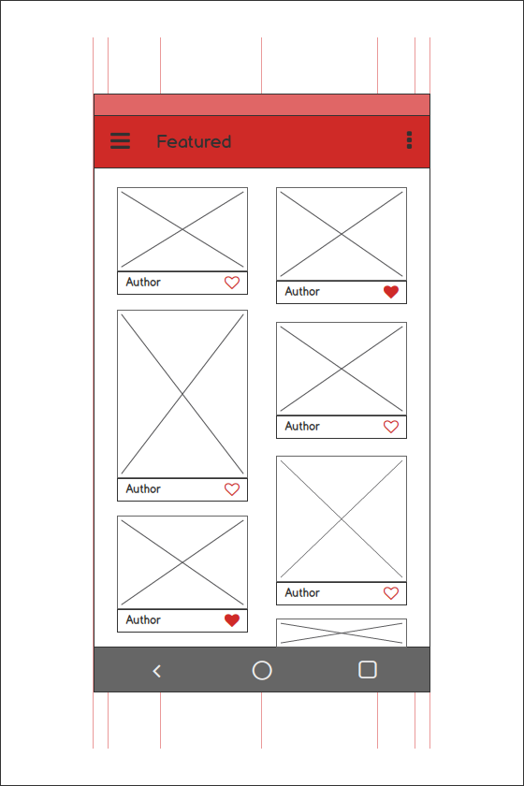 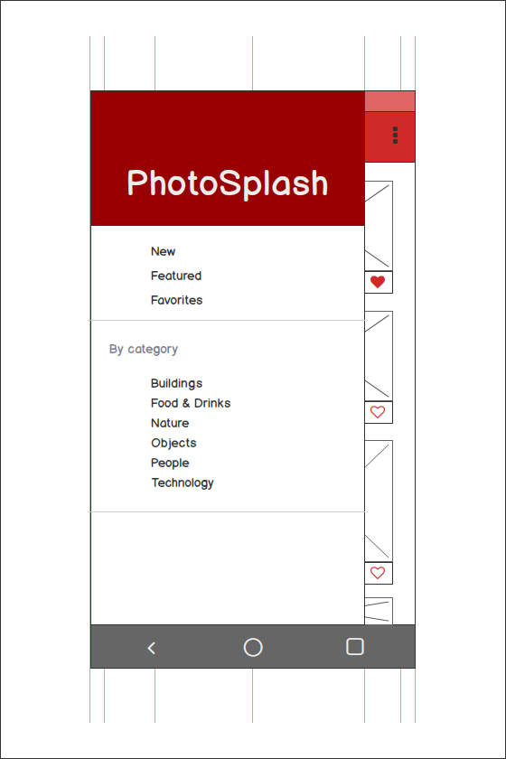

### Tablet version

From Google’s Material Design recommendations for Layout - Responsive UI:

“For optimal user experience, material design user interfaces should adapt layouts for the following breakpoint widths: 480, 600, 840, 960, 1280, 1440, and 1600dp.”

<https://www.google.com/design/spec/layout/responsive-ui.html#responsive-ui-breakpoints>

The PhotoSplash app will accommodate the above recommendation by adjusting the number of columns displayed on the “Browse photos” screen:

* from 2 columns for phone in portrait mode
* up to 4 (or even 5) columns for bigger tablets in landscape mode

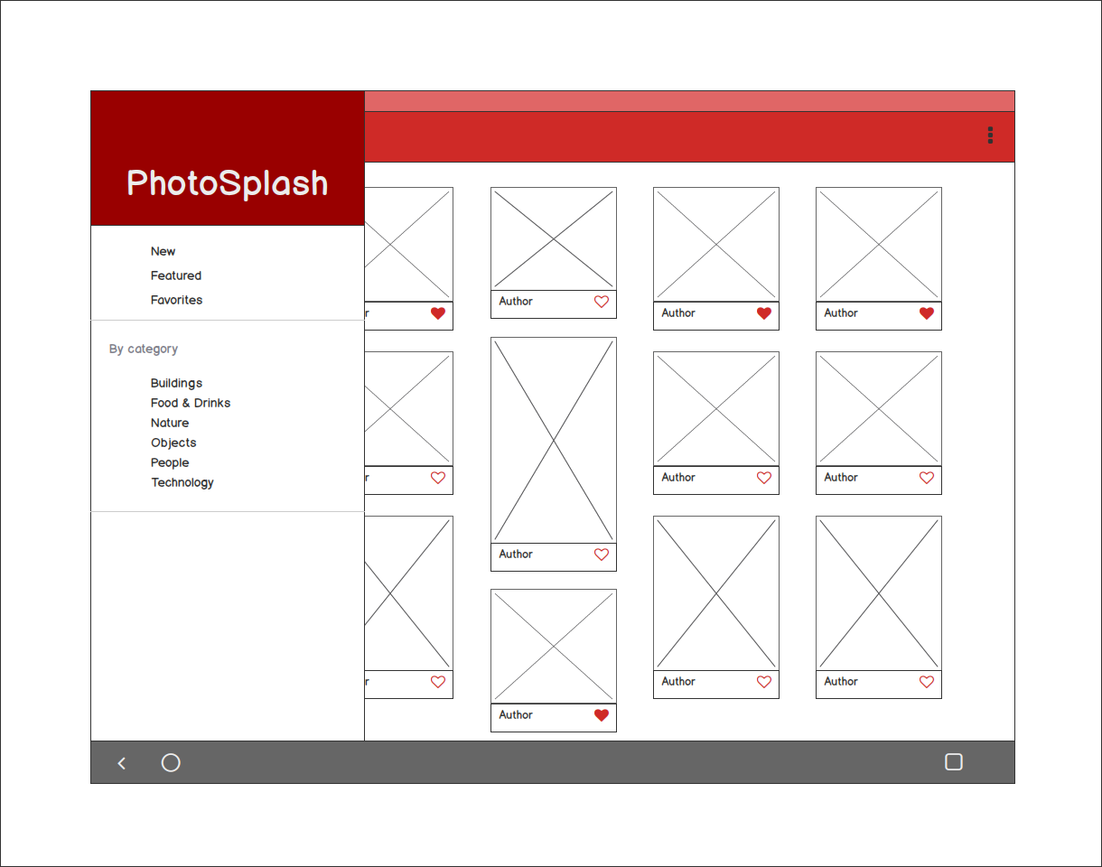

## 

## "View photo" activity

“View photo” is a kind of detail activity where the user can see a bigger version of a selected photo.

* By default the photo is displayed at the biggest scale based on the screen type / orientation.
* It is possible to zoom in/out and pan.
* The user can add the photo to his favorite list (using the FAB “Love” view)

### Phone version

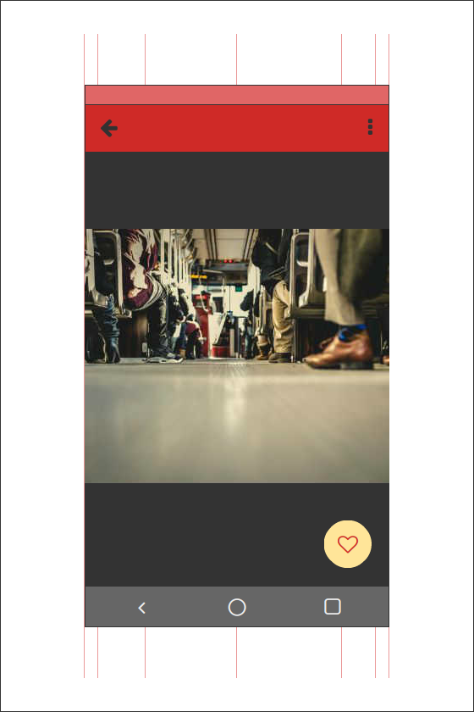 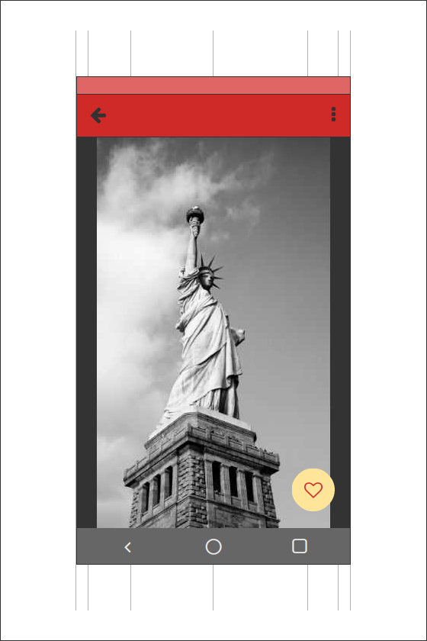

### Tablet version

There is no specific version of this activity for tablets. Selected photo will be displayed at maximum resolution depending on the mobile device.

# Key Considerations

## How will your app handle data persistence?

The user favorite’s photos are saved in a local SQL database, accessible via a Content Provider. Other photos (from the different other categories) are retrieved on user demand basis by using the unsplash full JSON API.

## Describe any corner cases in the UX.

The workflow (kind of master/detail) of the PhotoSplash app is simple and shouldn’t lead to any major UX problem I believe.

## Describe any libraries you’ll be using and share your reasoning for including them.

Aside from the Design Support library, I am planning to use the following 3rd party libraries:

* [Retrofit 2](https://github.com/square/retrofit) / Gson
* [Picasso](http://square.github.io/picasso/)
* [PhotoView](https://github.com/chrisbanes/PhotoView)

The first two libraries (both from Square) simplify greatly the consumption of data through REST API, parsing JSON response files and downloading images in an asynchronous way. PhotoView (from Chris Banes) allows zooming in/out and panning of image views which seems a great feature to explore in more details high resolution photos provided by unsplash.com.

# Next Steps: Required Tasks

## Task 1: Project Setup

* Start from a new project in Android Studio (2.0+)
* Use Navigation Drawer Activity template as Main Activity
* Add AppCompat dependency and extend theme with some personal colors
* Enable Git source control and host project on GitHub

## Task 2: “Browse photos” activity implementation

* Retrieve photos from [unsplash.com](https://unsplash.com/) using the official API and Retrofit 2 (only the first page, 20 photos max)
* Populate photos to a RecyclerView
* Handle category change from the Navigation Drawer
* Handle onClick event on the RecyclerView items to launch the correspondent “View Photo” activity

## Task 3: “View Photo” activity implementation

* User selected photo is displayed on the “View Photo activity”
* Implement zooming and panning using the [PhotoView](https://github.com/chrisbanes/PhotoView) library.

## Task 4: “Favorite photos” implementation

* Favorite photos are saved in a local SQL database, accessible via a Content Provider
* On the “View photo” activity, clicking on the FAB “Love” will toggle add / remove to (local) favorites
* Likewise, clicking on the “Love” indicator of any item of the “Browse photo” activity will toggle add / remove to (local) favorites
* Selecting “Favorites” on the Navigation Drawer will display the user favorite’s photos.

## Task 5: Widget implementation

The envisioned widget will display a new random photo from unsplash.com at a defined period of time. Clicking on this widget will launch the “View Photo” activity.

## Task 6: Google Play Services implementation

* AdMob (implement a banner Ad at the bottom of the “Browse photo” activity)
* Analytics

## Task 7: Project finalization

* Check building requirement and define a signing configuration
* Review PhotoSplash development against grading [rubric](https://review.udacity.com/?_ga=1.46512039.1074506352.1427378694#!/projects/4307513821/rubric)
* Final submission