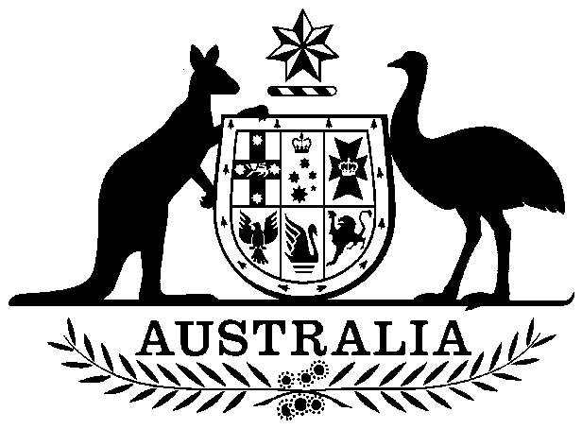

Loan (War Service Land Settlement) Act 1970

No. 40 of 1970

An Act to authorize the Raising and Expending of a sum not exceeding Four million five hundred thousand dollars for a Defence Purpose, namely, Financial Assistance to the States of South Australia, Western Australia and Tasmania in connexion with War Service Land Settlement

Contents
1 Short title 2
2 Commencement 2
3 Authority to borrow $4,500,000 2
4 Application of moneys 2



Loan (War Service Land Settlement) Act 1970

No. 40 of 1970

An Act to authorize the Raising and Expending of a sum not exceeding Four million five hundred thousand dollars for a Defence Purpose, namely, Financial Assistance to the States of South Australia, Western Australia and Tasmania in connexion with War Service Land Settlement
[Assented to 24 June 1970]
BE it enacted by the Queen’s Most Excellent, Majesty, the Senate, and the House of Representatives of the Commonwealth of Australia, as follows:—

1 Short title
This Act may be cited as the Loan (War Service Land Settlement) Act 1970.

2 Commencement
This Act shall come into operation on the day on which it receives the Royal Assent.

3 Authority to borrow $4,500,000
The Treasurer may, from time to time, in accordance with the provisions of the Commonwealth Inscribed Stock Act 1911-1966, or in accordance with the provisions of any Act authorizing the issue of Treasury Bills, borrow moneys not exceeding in the whole Four million five hundred thousand dollars.

4 Application of moneys
Moneys borrowed under this Act shall be issued and applied only for the expenses of borrowing and for the purpose of financial assistance to the States of South Australia, Western Australia and Tasmania in accordance with the provisions of subsection (1) of section 2 of the States Grants (War Service Land Settlement) Act 1952-1953.

