UM TAGUM COLLEGE
BACHELOR OF SCIENCE IN COMPUTER SCIENCE
Department of Computing Education
Visayan Village, Tagum City, Philippines



Course Requirements in
CST 9/L

CS Professional Track 3

Title: FitRoutine for Newbie Fitness Enthusiast

Submitted to:

IRIS MAE C. MENDOZA, MIT

Submitted by:

Chicote, Clark Vincent Frondoza, Kobi M. Desonia, Leo Rafael A.

October 18, 2025
Updated: November 9, 2026

PROJECT DOCUMENTATION FORMAT

I. Project Overview
FitRoutine is a web-based, data-driven exercise recommendation application designed for beginner fitness enthusiasts. Its purpose is to help a user who already knows one or more exercises discover other exercises that are frequently performed on the same workout day in a large collection of workout programs. Instead of searching for related exercises one at a time, the user selects one or more exercises and receives up to five related exercises, each displayed with its rank, exercise name and, when one can be matched, an exercise image.
The intended users are beginners who know some exercises but are unsure which other exercises are commonly combined with them when arranging a workout session.
Recommendation approach. Recommendations are produced in two stages. The primary method is the Apriori algorithm, which was run offline on workout-day transactions to produce association rules of the form antecedent → consequent, each with support, confidence and lift. When the user selects exercises, the Flask backend searches the stored rules for antecedents contained in the selection, ranks the matching consequents by confidence and then lift, and selects up to five. If Apriori produces fewer than five recommendations, a second method, Observed Pairs, fills the remaining slots using historical workout-day co-occurrences. Observed Pairs is a separate and simpler method; it is not an Apriori result.
Classification model. Separately from the recommender, FitRoutine includes a text classifier that predicts the muscle region of an exercise: Upper Body, Lower Body, Core or Neck. The classifier combines TF-IDF text features with Logistic Regression (scikit-learn) and was trained on exercise names and instructions from the Free Exercise DB. Its performance is evaluated independently of the recommender (Section III.6.B) and must not be read as a measure of recommendation quality.
Web technologies. The user interface is built with React (Vite) and the backend with Python Flask, which serves the exercise list and the stored recommendation data as JSON.
Scope. FitRoutine recommends exercises based on historical workout relationships. It does not guarantee workout effectiveness, exercise safety, muscle growth, weight loss or medical suitability for any individual.
Dataset counts, model settings and evaluation results in this document are taken from two Google Colab notebooks, FitRoutine_Apriori.ipynb (recommender) and Fitroutine_LogisticReg.ipynb (classifier), and from the backend file app.py.

II. Problem Statement
Difficulty of discovering related exercises. A beginner who knows one exercise, such as the barbell bench press, may not know which other exercises are commonly performed alongside it. Searching manually for related exercises takes time, and the number of options is large: the workout dataset analysed in this project contains 3,178 distinct cleaned exercise names, many of which differ only by an equipment qualifier (for example, “bench press (barbell)” and “bench press (dumbbell)”).
How Apriori addresses exercise discovery. Association rule mining treats each workout day as a transaction, that is, the set of exercises performed on that day. Apriori finds exercise sets that occur together often and derives rules of the form X → Y. When a user selects X, the rules supply exercises Y that were frequently performed on the same days. Confidence states the share of workout days containing X that also contained Y, and lift compares that share with how common Y is overall, so that a very popular exercise does not automatically appear to be strongly related to everything.
Why limited rule coverage occurs. Apriori only keeps itemsets that reach a minimum support threshold. In this project the threshold was 0.003 on 98,818 workout-day transactions, which produced 1,189 frequent itemsets (up to three exercises) and 636 association rules. Among 3,178 exercises, only 119 (3.74%) appear as the sole antecedent of at least one rule, so most exercises cannot trigger a recommendation when selected alone. Rules also match exercise names exactly: in the notebook, a lookup for “bench press” found no rules because the dataset names carry equipment qualifiers such as “bench press (barbell)”. A user who selects a rarely performed exercise may therefore receive fewer than five recommendations, or none.
Why the Observed-Pairs fallback was integrated. To reduce this gap, an Observed-Pairs fallback counts how many workout days each pair of exercises shared, without any support or confidence threshold. In the training portion of the data, 2,563 of 2,591 exercises (98.92%) were observed together with at least one other exercise on the same day, so the fallback can offer candidates for far more exercises than the stored rules can. The trade-off is that it ranks partners by raw co-occurrence counts and does not take the overall popularity of the partner into account.
Need for understandable labels. Users also benefit from simple labels that describe what an exercise works. FitRoutine therefore includes a TF-IDF and Logistic Regression classifier that assigns exercise text to one of four muscle regions. This is a classification task on exercise descriptions and is independent of the recommendation process.
Limits of the approach. Association in historical workout data does not prove that two exercises are safe, medically appropriate or effective for any particular person.

III. Methodology

1. Development Tools
Table 1. Development tools and technologies
Component | Technology / details | Basis
Frontend | React [9], built with Vite [11] | Frontend project
Frontend languages | JavaScript, CSS, HTML | Frontend project
Backend | Python with Flask [10]; Flask-CORS for cross-origin requests. Endpoints in app.py: GET / and GET /api/health (status and data counts), GET /api/exercises (exercise list), POST /api/recommend (recommendations), POST /api/classify-muscle (muscle-region prediction) and POST /api/variations (a hard-coded list of variations for one exercise). The frontend calls the backend at http://127.0.0.1:5000. | app.py (backend)
Data files used by the application | fitroutine_exercises.json (3,178 exercise names); fitroutine_rules.json (636 Apriori rules); fitroutine_exercise_pairs.json (Observed Pairs: 2,563 exercises, top 10 partners each in the notebook export); fitroutine_muscle_region_classifier.joblib and fitroutine_classifier_info.json (classifier and its metadata). All five files are loaded by app.py when the server starts. | Exported by the notebooks; loaded in app.py
Model development environment | Google Colab notebooks (Python 3; library paths in the Apriori notebook show Python 3.13) | Notebook outputs
Machine learning libraries | pandas 2.2.3 [7], mlxtend 0.23.4 [6] (Apriori and association rules), scikit-learn 1.6.1 [5] (TF-IDF, Logistic Regression, cross-validation, metrics), NumPy 2.4.6, SciPy 1.16.3, joblib 1.6.0, Matplotlib 3.10.0. Versions are those recorded in the Colab environment of the Apriori notebook. The saved classifier was pickled with scikit-learn 1.6.1, so the backend should use the same version. | Apriori notebook, cell 1
Classification dataset access | Free Exercise DB exercises.json, loaded with pandas.read_json from raw.githubusercontent.com (yuhonas/free-exercise-db, main branch) [8] | Logistic Regression notebook, cell 28
Exercise images | The frontend matches exercise names with images from the Free Exercise DB GitHub repository [8] and shows a placeholder when no image is found | Frontend project

2. Machine Learning Component
FitRoutine contains two machine learning components that are developed, evaluated and interpreted separately.

A. Recommendation component (Apriori with Observed-Pairs fallback)
The recommendation component is trained offline. In the Apriori notebook, workout-day transactions are built from the workout dataset, frequent itemsets and association rules are mined with mlxtend, and the rules are exported to fitroutine_rules.json. A separate step counts exercise pairs that share a workout day and exports the ten most frequent partners of each exercise to fitroutine_exercise_pairs.json. The Flask backend (app.py) loads the stored files when it starts; it does not run Apriori or train a model when a request arrives.
The /api/recommend endpoint in app.py applies the stored rules as follows (the notebook function recommend_exercises uses the same logic):
1. Selected exercise names are stripped of whitespace, converted to lowercase and passed through a small alias table (currently one entry).
2. A rule applies only if all of its antecedent exercises are contained in the selection.
3. Consequents that the user already selected are skipped.
4. For each candidate exercise, only the strongest matching rule is kept (highest confidence, then highest lift).
5. Candidates are sorted by confidence (descending), then lift (descending), then exercise name, and the top five are kept.
When Apriori returns fewer than five recommendations, app.py fills the remaining slots with Observed Pairs. For each selected exercise it reads the stored partners, skips exercises already selected or already recommended, and adds up a score for each partner across the selected exercises. The score is the partner’s similarity value when the stored record has a similarity field (the code comment describes it as a damped cosine similarity) and otherwise the number of shared workout days. Partners are sorted by score and the best ones fill the empty slots. Each returned item carries a source label (apriori or observed_pairs), and the response reports an overall method of apriori, observed_pairs or hybrid. The notebook evaluation of the combined method, however, uses Observed Pairs only when Apriori returns nothing and ranks by raw counts, so it does not evaluate this deployed behaviour (see Section III.6.A).

B. Classification component (TF-IDF with Logistic Regression)
The classification component is a supervised, multi-class text classifier. Its input is the text of an exercise (name followed by instructions), and its output is one of four muscle regions: Upper Body, Lower Body, Core or Neck. It is trained and evaluated on the Free Exercise DB, which provides a labelled primary muscle for each exercise. The component does not take part in ranking recommendations; it predicts a label for an exercise. In app.py, the /api/classify-muscle endpoint receives an exercise name and its instruction text, joins them as name + space + instructions (the same format as in training), and returns the predicted region, the class probabilities and the highest probability as a confidence. A prediction with confidence of at least 0.40 is labelled “accepted”; otherwise it is labelled “uncertain”.

3. Algorithm Used

A. Apriori algorithm (association rule mining)
Apriori discovers frequent itemsets by growing candidate sets level by level and discarding any set whose support falls below a minimum threshold, because a set cannot be frequent if one of its subsets is not [1]. Association rules X → Y are then generated from the frequent itemsets [2]. In FitRoutine, a transaction is one workout day of one program, an item is an exercise, X is the antecedent (the selected exercise or exercises) and Y is the consequent (the suggested exercise). The measures are:
- Support = proportion of all transactions that contain both X and Y.
- Confidence = support(X ∪ Y) / support(X), the proportion of transactions containing X that also contain Y.
- Lift = confidence / support(Y). A value above 1 indicates that Y occurs more often with X than expected if the two were independent.
The notebook uses the apriori and association_rules functions of the mlxtend library [6].

B. Observed Pairs
Observed Pairs is a co-occurrence counting method and is not Apriori. For every workout-day transaction, each ordered pair of different exercises (a, b) in the transaction increases a counter by one. For a selected exercise, its partners are ranked by the number of shared workout days, and the ten most frequent partners per exercise are stored. No support, confidence or lift threshold is applied. The notebook stores the count under the key shared_workout_days. The backend ranks partners by a similarity field when one exists in the stored file (commented in app.py as a damped cosine similarity) and by shared workout days otherwise. The notebook export contains only the shared-day counts, so the similarity values come from the deployed pairs file and are not evaluated in the notebooks.

C. TF-IDF (term frequency–inverse document frequency)
TF-IDF converts text into numeric features. Each term is weighted by how often it appears in a document and down-weighted when it appears in many documents, so that words which distinguish exercises receive more weight than words common to all exercises [3]. The notebook uses scikit-learn’s [5] TfidfVectorizer, fitted inside a Pipeline so that the vocabulary and weights are learned from training text only.

D. Logistic Regression
Logistic Regression is a supervised linear classifier that models the probability of each class from a weighted combination of the input features [4]. For more than two classes, scikit-learn’s default lbfgs solver fits a multinomial (softmax) model. The model is regularised with an L2 penalty whose strength is controlled by the parameter C (smaller C means stronger regularisation). The notebook sets class_weight="balanced", which weights each class inversely to its frequency in the training data.

4. Dataset Description
Three data sources appear in the notebooks. Only the first two are used by the final system.

A. Workout dataset used for Apriori and Observed Pairs (fitroutine.csv)
Table 2. Workout dataset summary (Apriori notebook)
Property | Value
Source | Kaggle dataset “600K Fitness Exercise & Workout Program Dataset” (uploader handle adnanelouardi), as supplied by the group; see reference [12]. The notebook loads this data as fitroutine.csv.
Licence / terms of use | As stated on the Kaggle dataset page [12]
Size | 605,033 rows × 16 columns
Programs (unique title values) | 2,598
Unique exercise names after cleaning | 3,178
Workout-day transactions (title, week, day) | 98,818
Exercises per transaction | Minimum 1, maximum 40, mean 5.89
Rows with missing values (per column) | description 819; equipment 16; program_length 16; created 16; last_edit 41; all other columns 0
Exact duplicate rows | 904 (detected, not removed)

Table 3. Columns of fitroutine.csv
Column | Observed content (from notebook output)
title | Program name (no missing values)
description | Free-text program description (819 missing)
level, goal | Text that looks like a Python list, for example "['Beginner', 'Novice', 'Intermediate', …]"
equipment | Equipment category, for example "Garage Gym" (16 missing)
program_length, time_per_workout | Numeric values, for example 7.0 and 50.0 in the first rows
week, day, number_of_exercises | Numeric position of the workout day within a program and the number of exercises listed
exercise_name | Exercise performed; 3,178 distinct values after lowercasing and trimming
sets, reps, intensity | Numeric values. The first rows contain negative reps values (−180.0, −18.0); these columns are not used for Apriori.
created, last_edit | Date-time text (16 and 41 missing, respectively)

Some exercise names carry a parenthetical prefix, such as “(abs)” or “(back)”, and many carry an equipment qualifier in parentheses, such as “(barbell)”. The notebook does not use these prefixes as labels.

B. Free Exercise DB (classification dataset)
Table 4. Free Exercise DB summary (Logistic Regression notebook)
Property | Value
Source | GitHub repository yuhonas/free-exercise-db [8], file dist/exercises.json on the main branch, loaded with pandas.read_json
Version / commit | Main branch at the time of the experiments (no commit recorded; the repository may change over time)
Licence | As stated in the repository [8]
Records | 876 exercises
Columns | name, force, level, mechanic, equipment, primaryMuscles, secondaryMuscles, instructions, category, images, id
Missing primary-muscle labels | 0
Primary muscles per exercise | 875 exercises have exactly one; 1 exercise has two
Primary-muscle classes (single-label exercises) | 17: quadriceps 148, shoulders 128, abdominals 93, chest 84, hamstrings 79, triceps 72, biceps 53, lats 38, middle back 34, calves 28, lower back 27, forearms 25, glutes 22, traps 15, adductors 13, neck 8, abductors 8

C. Program-level dataset used only in exploratory experiments (fitroutine_recreated.csv)
The Logistic Regression notebook begins with experiments on a second file, fitroutine_recreated.csv (544,509 rows × 16 columns, 2,537 programs, 300 distinct exercise names). It was used to try to predict program-level labels (equipment category, goals, difficulty level and workout duration) and is not used by the final muscle-region classifier. The notebooks do not state how this file relates to fitroutine.csv.

5. Data Preprocessing

A. Workout data for Apriori and Observed Pairs
1. Load the CSV and inspect its shape, missing values and exact duplicate rows (Table 2).
2. Copy the data and drop rows missing title, week, day or exercise_name. No rows were removed (605,033 before and after).
3. Standardise exercise names: convert to text, trim leading and trailing whitespace and convert to lowercase.
4. Remove blank exercise names. No rows were removed.
5. Exact duplicate rows were counted (904) but not dropped. Their effect on the transactions is neutralised in the next step because the exercises of a day are collapsed into a set.
6. Build transactions: group rows by (title, week, day) and keep the sorted set of exercise names. This gives 98,818 workout-day transactions with no duplicate keys, containing 1 to 40 exercises (mean 5.89).
7. One-hot encode the transactions with mlxtend’s TransactionEncoder as a sparse matrix (98,818 × 3,178). This full-data matrix was used to mine the rule set that was exported for the application.
8. Split by program for evaluation: the 2,598 unique program titles were divided with train_test_split (test_size = 0.20, random_state = 2026, shuffle = True) into 2,078 training and 520 test programs, giving 78,744 training and 20,074 test transactions. The notebook asserts that no program appears in both sets. The training matrix has 2,591 exercise columns. Splitting by program prevents days of the same program from appearing in both training and test data.
9. Observed Pairs counts were computed from the training transactions only (2,563 exercises with at least one partner).
The notebook does not filter programs by difficulty level or goal, so the transactions include programs written for all levels, not only beginners.

B. Classification data and label preparation
1. Load the 876 Free Exercise DB records and keep the 875 exercises that have exactly one primary muscle; the one exercise with two primary muscles is excluded.
2. Build the input text: the exercise name, a space, and the instruction steps joined by spaces. This text is called model_text.
3. Construct the target: the 17 primary-muscle labels were mapped by hand to four muscle regions (Table 5). Every muscle was mapped; no label was left unmapped.
4. Split the data into training and validation sets with train_test_split (test_size = 0.20, random_state = 42), stratified by the 17-class primary muscle. This gives 700 training and 175 validation exercises. The four region labels were then derived for the same rows.
5. Text preprocessing is performed inside the TfidfVectorizer: lowercasing and removal of English stop words. No other cleaning (such as stemming) is documented.
6. The TF-IDF vectoriser is fitted inside a scikit-learn Pipeline, so cross-validation refits it on each training fold, and the final fit uses the 700 training exercises only.
Table 5. Mapping of primary muscles to muscle regions and class distribution
Region | Primary muscles mapped to it | All (875) | Train (700) | Validation (175)
Upper Body | chest, shoulders, triceps, biceps, lats, middle back, traps, forearms | 449 | 359 | 90
Lower Body | quadriceps, hamstrings, glutes, calves, adductors, abductors | 298 | 238 | 60
Core | abdominals, lower back | 120 | 97 | 23
Neck | neck | 8 | 6 | 2

Counts for All and Train come from notebook output; Validation counts are taken from the per-class support in the final classification report. The majority class (Upper Body) makes up 51.31% of the 875 exercises, which is the accuracy of a model that always predicts Upper Body. The Neck class has very few examples.

C. Preprocessing of the exploratory program-level data
For the exploratory experiments, equipment labels were cleaned at program level: programs with a missing label or more than one equipment category were excluded (2,537 programs reduced to 2,527). Exercises were encoded as 300 binary presence features with MultiLabelBinarizer, and the programs were split 80/20 with stratification (random_state = 42) into 2,021 training and 506 validation programs. Some experiments added six program-level statistics (total exercise entries, unique exercises, average sets, average program length, total workout days and exercises per day), scaled with training statistics only.

6. Model Training and Testing
This section describes how each model was trained and evaluated in the notebooks and reports the results exactly as printed there. All results come from offline evaluation on historical data; no user study was performed. Recommendation metrics (Section 6.A) and classification metrics (Section 6.B) measure different tasks and must not be compared with each other.

A. Apriori and Observed Pairs
Table 6. Apriori configuration used in the Apriori notebook
Setting | Value
Library / functions | mlxtend 0.23.4: apriori() and association_rules()
Minimum support | 0.003 (about 297 of 98,818 workout days on the full data; about 237 of 78,744 on the training data)
Maximum itemset length (max_len) | 3 (so rules have one or two antecedent exercises, because only single-exercise consequents are kept)
Rule metric and minimum threshold | Confidence ≥ 0.20
Rule filtering | Only rules with exactly one consequent exercise are kept. No minimum lift is applied.
Rule ordering | Confidence (descending), then lift (descending)
Number of recommendations | Up to 5 (top_n = 5)
Frequent itemsets / rules, full data (98,818 transactions) | 1,189 itemsets; 636 rules (exported to fitroutine_rules.json)
Frequent itemsets / rules, training programs only (78,744 transactions) | 1,194 itemsets; 621 rules (used for evaluation)
Selection of the thresholds | No tuning experiments are recorded in the notebook

Mining code (excerpt from the notebook).
frequent_itemsets = apriori(basket, min_support=0.003, use_colnames=True,
max_len=3, low_memory=True)
rules = association_rules(frequent_itemsets, metric="confidence", min_threshold=0.20)
rules = rules[rules["consequents"].apply(len) == 1] # one recommended exercise per rule
rules = rules.sort_values(["confidence", "lift"], ascending=[False, False])

Training and validation procedure.
1. Deployed rule set. Apriori was run once on all 98,818 transactions to produce the 636 rules exported for the application. These rules include information from programs that were later used as test programs in the evaluation, so they cannot themselves be evaluated on unseen data.
2. Program-level split. For evaluation, Apriori was re-run on the 2,078 training programs only (621 rules). The 520 test programs were not used for mining.
3. Five-fold cross-validation. Within the 2,078 training programs, KFold (n_splits = 5, shuffle = True, random_state = 42) divided program titles into training and validation folds of about 1,662 and 416 programs. In each fold, Apriori was re-run on the fold’s training programs and evaluated on 500 validation transactions with at least two exercises, sampled with seed 2026 + fold number.
4. Final held-out test. The rules mined from all training programs were evaluated once on 2,500 transactions sampled (seed 2026) from the 19,183 test transactions that contain at least two exercises.
5. Comparison of methods. A second evaluation used a single selected exercise to compare Apriori only, Apriori with the Observed-Pairs fallback, and a popularity baseline on all 19,183 eligible test transactions.
Evaluation protocols. Two protocols were used. They define the task differently, so their numbers must not be compared with each other.
- Protocol 1 (leave-one-out, multi-exercise input; Apriori only). For each sampled transaction, one exercise is hidden at random as the target and the remaining exercises are treated as the user’s selection. The Apriori rules produce up to five recommendations. Hit Rate@5 is the share of cases in which the hidden exercise is among the five. Because exactly one exercise is hidden, Precision@5 equals hits divided by 5 × cases, which is always one fifth of Hit Rate@5. Coverage is the share of cases that receive at least one recommendation. The baseline recommends the five most frequent training exercises that are not already selected.
- Protocol 2 (single selected exercise; three methods). For each eligible test transaction, the alphabetically first exercise is the selected exercise and all other exercises of that day are the relevant items. Hit Rate@5 is the share of cases with at least one relevant exercise in the top five; Precision@5 is the average of correct recommendations divided by 5; Coverage is the share of cases with at least one recommendation. Apriori only uses the training rules that have a single antecedent. Apriori + Observed Pairs returns the Apriori result when it is not empty and otherwise the top Observed-Pairs partners by raw shared workout days. (The deployed app.py differs: it fills remaining slots and ranks by a similarity field; see Section III.2.A.) The popularity baseline returns the same five most frequent training exercises for every input.
Table 7. Five-fold cross-validation results (Protocol 1, training programs only)
Fold | Train / validation programs | Itemsets | Rules | Coverage (%) | Hit Rate@5 (%) | Precision@5 (%) | Popularity Hit Rate@5 (%)
1 | 1,662 / 416 | 1,220 | 672 | 94.0 | 19.0 | 3.80 | 13.4
2 | 1,662 / 416 | 1,245 | 663 | 94.6 | 18.2 | 3.64 | 12.6
3 | 1,662 / 416 | 1,234 | 658 | 93.8 | 20.6 | 4.12 | 12.2
4 | 1,663 / 415 | 1,148 | 610 | 94.4 | 18.6 | 3.72 | 12.6
5 | 1,663 / 415 | 1,225 | 649 | 96.4 | 22.4 | 4.48 | 14.0
Mean |  |  |  | 94.64 | 19.76 | 3.95 | 12.96
Std. dev. |  |  |  | 1.03 | 1.73 | 0.35 | 0.73

Each fold evaluated 500 validation transactions. Source: Apriori notebook, five-fold cross-validation cell. Values converted from decimals to percentages.
Table 8. Independent held-out test result (Protocol 1)
Item | Value
Training / test programs | 2,078 / 520
Frequent itemsets / association rules (training only) | 1,194 / 621
Minimum support / minimum confidence | 0.003 / 0.20
Test transactions evaluated | 2,500 (sampled from 19,183 eligible)
Coverage | 94.00%
Hit Rate@5 (Apriori) | 20.36%
Precision@5 (Apriori) | 4.07% (= 20.36 ÷ 5)
Hit Rate@5 (popularity baseline) | 14.48%

Table 9. Comparison of methods with a single selected exercise (Protocol 2, 19,183 test transactions)
Method | Hit Rate@5 (%) | Precision@5 (%) | Coverage (%) | Avg. recommendations
Apriori only | 33.37 | 9.06 | 74.29 | 1.65
Apriori + Observed Pairs | 43.05 | 11.85 | 95.27 | 2.69
Popularity baseline | 49.42 | 12.32 | 100.00 | 5.00

Source: Apriori notebook, “FINAL HELD-OUT TEST RESULTS” cell. The popularity baseline achieves the highest Hit Rate@5 and Precision@5 in this protocol.
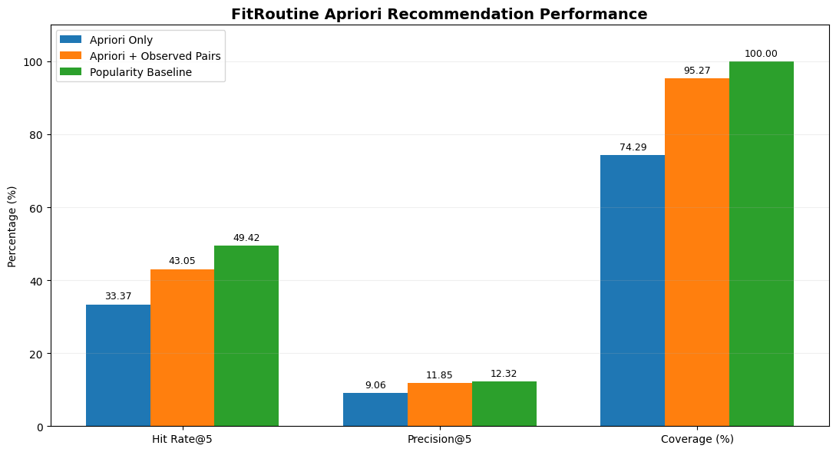
Figure 1. Hit Rate@5, Precision@5 and Coverage for the three methods (Protocol 2). Chart generated by the Apriori notebook (last cell) from the values in Table 9.
Table 10. Coverage analysis
Analysis (notebook output) | Exercises considered | Exercises with candidates | Share
Deployed Apriori rules (full data): exercises that are the sole antecedent of at least one rule | 3,178 | 119 | 3.74% (3,059 without)
Exploratory lower thresholds on training data (support 0.001, confidence 0.10, max_len 2): sole-antecedent rules. Not adopted; hit rate not evaluated. | 2,591 | 269 | 10.38% (3,655 itemsets; 1,846 rules)
Observed Pairs on training data: exercises seen with at least one partner | 2,591 | 2,563 | 98.92% (28 without)

Exercises with no observed partner include entries such as “break day”, “nothing” and “competition (placeholder)”, which suggests that the dataset contains non-exercise entries that the notebook does not remove.
Table 11. Illustrative recommendation examples (not evaluation results)
Selected exercise(s) | Recommendation | Confidence | Lift | Support
pike push up | push up | 0.7246 | 16.67 | 0.004685
leg curl + hack squat | 1. leg extension  2. squat (barbell)  3. standing calf raise  4. romanian deadlift (barbell)  5. leg press | 0.7466  0.3604  0.3073  0.2948  0.2909 | 4.93  2.42  3.12  3.06  4.49 | 0.007843  0.028234  0.003228  0.003097  0.003056
knee-to-wall ankle dorsiflexion test | No matching association rules found | — | — | —

These outputs were produced with the deployed (full-data) rules in the notebook to demonstrate how recommend_exercises behaves. They show that the function runs and illustrate the measures; they do not measure recommendation quality. For Observed Pairs, the notebook shows the most frequent partners in the training data: for “bench press (barbell)” these are incline bench press (dumbbell), 2,859 shared workout days; lateral raise (dumbbell), 2,500; squat (barbell), 1,906; tricep pushdown (cable), 1,727; overhead press (barbell), 1,638. For “plank”: squat (barbell), 452; push up, 434; leg extension, 410; side plank, 380; sit up, 320.
Interpretation. Under Protocol 1, which uses the multi-exercise selections the application is designed for, the Apriori recommender placed the hidden exercise in its top five in about one case in five (19.76% in cross-validation, 20.36% on the held-out programs) and returned at least one recommendation in 94% of cases. It exceeded the popularity baseline in every cross-validation fold and on the held-out test (20.36% versus 14.48%). Under Protocol 2, Apriori alone gave recommendations for only 74.29% of cases and averaged 1.65 recommendations; adding Observed Pairs raised Hit Rate@5 from 33.37% to 43.05% and coverage to 95.27%. However, in this protocol the popularity baseline scored higher than the combined method on both Hit Rate@5 (49.42% versus 43.05%) and Precision@5 (12.32% versus 11.85%). These results are discussed further in Section V.

B. TF-IDF and Logistic Regression (muscle-region classification)
Table 12. Configuration of the final muscle-region classifier
Item | Value (Logistic Regression notebook)
Task | Four-class classification of exercise text: Core, Lower Body, Neck, Upper Body
Data | 875 single-primary-muscle exercises from the Free Exercise DB; 700 training, 175 validation (stratified split, random_state = 42)
Input text | Exercise name followed by the instruction steps
TF-IDF (TfidfVectorizer) | lowercase = True; stop_words = "english"; ngram_range = (1, 1); min_df = 5; max_features = 300
Logistic Regression | C = 0.5; max_iter = 3000; class_weight = "balanced"; random_state = 42 (scikit-learn defaults otherwise: L2 penalty, lbfgs solver)
Class balancing | Yes: class_weight = "balanced". No resampling is documented.
Model selection | Five-fold StratifiedKFold (shuffle = True, random_state = 42) on the 700 training exercises, comparing C, n-gram range, min_df, vocabulary size, input text variants and alternative classifiers
Final evaluation | Pipeline fitted on the 700 training exercises and evaluated on the 175 validation exercises
Saved artifacts | fitroutine_muscle_region_classifier.joblib; fitroutine_classifier_info.json (classes, sizes and metrics)
Target criteria in the notebook | Validation accuracy ≥ 85% and training–validation gap ≤ 5 percentage points (labelled in the notebook as the professor’s requirements)

Training code (excerpt from the notebook).
final_region_model = Pipeline([
("tfidf", TfidfVectorizer(lowercase=True, stop_words="english",
ngram_range=(1, 1), min_df=5, max_features=300)),
("classifier", LogisticRegression(C=0.5, max_iter=3000,
class_weight="balanced", random_state=42))])
final_region_model.fit(X_train_region, y_train_region) # 700 training exercises
val_predictions_region = final_region_model.predict(X_val_region) # 175 validation exercises

Training and testing procedure. We first trained a 17-class primary-muscle model (bigrams, min_df = 2, C = 1.0), which reached 92.57% training and 67.43% validation accuracy (gap 25.14 points; balanced accuracy 64.16%; majority-class baseline 16.91%). Its most frequent errors included confusions between neighbouring muscles (for example, hamstrings predicted as quadriceps in 4 validation cases). The notebook then groups the 17 muscles into four broader regions (Table 5); the reason for the grouping is not stated. The four-region pipeline was tuned with five-fold cross-validation on the training exercises only, and the selected configuration (Table 12) was fitted once on the 700 training exercises and evaluated on the 175 validation exercises.
Table 13. Accuracy of the final classifier
Evaluation | Training accuracy (%) | Validation accuracy (%) | Gap (points) | Balanced accuracy (%)
Held-out validation (175 exercises) | 88.57 | 90.86 | 2.29 | 90.95
Five-fold cross-validation (700 training exercises, same configuration) | 89.43 | 84.14 | 5.29 | 77.99
Majority-class baseline (always Upper Body; whole dataset) | — | 51.31 | — | —

The held-out validation result meets both target criteria stated in the notebook (≥ 85% and gap ≤ 5 points). The cross-validation estimate of the same configuration does not (84.14% and 5.29 points). On the held-out set, validation accuracy was slightly higher than training accuracy; the notebook reports the gap as an absolute difference.
Table 14. Per-class results on the 175 held-out validation exercises
Muscle region | Precision | Recall | F1-score | Support
Core | 0.64 | 0.78 | 0.71 | 23
Lower Body | 0.93 | 0.93 | 0.93 | 60
Neck | 0.67 | 1.00 | 0.80 | 2
Upper Body | 0.99 | 0.92 | 0.95 | 90
Accuracy |  |  | 0.91 | 175
Macro average | 0.81 | 0.91 | 0.85 | 175
Weighted average | 0.92 | 0.91 | 0.91 | 175

Table 14A. Confusion matrix of the final classifier on the 175 held-out validation exercises (rows: actual region; columns: predicted region)
Actual \ Predicted | Core | Lower Body | Neck | Upper Body | Total
Core | 18 | 3 | 1 | 1 | 23
Lower Body | 4 | 56 | 0 | 0 | 60
Neck | 0 | 0 | 2 | 0 | 2
Upper Body | 6 | 1 | 0 | 83 | 90

Source: confusion-matrix cell added at the end of the Logistic Regression notebook (cell 58). Correct predictions are on the diagonal: 159 of 175 (90.86%). The per-class precision and recall in Table 14 follow from this matrix.
Table 15. Per-class results from five-fold cross-validation (700 training exercises)
Muscle region | Precision | Recall | F1-score | Support
Core | 0.62 | 0.65 | 0.63 | 97
Lower Body | 0.83 | 0.87 | 0.85 | 238
Neck | 0.80 | 0.67 | 0.73 | 6
Upper Body | 0.92 | 0.88 | 0.90 | 359
Accuracy |  |  | 0.84 | 700
Macro average | 0.79 | 0.77 | 0.78 | 700
Weighted average | 0.84 | 0.84 | 0.84 | 700

This report was produced with the earlier four-region pipeline (unigrams, min_df = 2, no vocabulary cap, C = 0.5), which differs slightly from the saved final pipeline (min_df = 5, max_features = 300). In cross-validation, 34 of the 97 Core exercises were predicted as another region.
Table 16. Held-out predictions filtered by prediction confidence (175 validation exercises)
Probability threshold | Accepted | Uncertain | Share accepted (%) | Accuracy of accepted predictions (%)
0.40 | 155 | 20 | 88.57 | 94.84
0.50 | 128 | 47 | 73.14 | 96.88
0.60 | 82 | 93 | 46.86 | 98.78
0.70 | 47 | 128 | 26.86 | 97.87
0.80 | 17 | 158 | 9.71 | 100.00

The notebook examines these thresholds on the validation set. The web application (app.py) applies a threshold of 0.40, labelling predictions at or above it “accepted” and others “uncertain”.
Table 17. Alternatives compared by five-fold cross-validation on the 700 training exercises
Variant | CV training (%) | CV validation (%) | Gap | CV balanced acc. (%)
Final: Logistic Regression, unigrams, min_df = 5, 300 features, C = 0.5 | 89.43 | 84.14 | 5.29 | 77.99
Same, C = 0.4 | 88.82 | 83.43 | 5.39 | 77.45
Same, max_features = 100 / 200 / 500 / 800 | 85.07 / 87.93 / 90.71 / 91.32 | 79.29 / 82.57 / 84.00 / 84.43 | 5.79 / 5.36 / 6.71 / 6.89 | 77.82 / 76.27 / 77.53 / 77.81
Input: exercise name only (1–2-grams, min_df = 2) | 89.50 | 78.14 | 11.36 | 73.13
Input: instructions only | 89.14 | 81.71 | 7.43 | 75.55
Input: name repeated three times + instructions | 91.18 | 83.43 | 7.75 | 76.56
Multinomial Naive Bayes, α = 0.1 | 85.29 | 78.86 | 6.43 | 55.72
Multinomial Naive Bayes, α = 1.0 | 81.25 | 77.00 | 4.25 | 45.79
Multinomial Naive Bayes, α = 5.0 | 77.64 | 76.57 | 1.07 | 44.11
Linear SVM (C = 0.5, class_weight = "balanced") | 95.82 | 85.14 | 10.68 | 77.10

The Linear SVM reached 85.14% validation accuracy but with a 10.68-point gap and was not selected. Across the SVM values of C that were tried (0.01–0.5), none met both target criteria. The name-only run used different TF-IDF settings (1–2-grams, min_df = 2, no vocabulary cap) from the final pipeline, so that comparison is not perfectly controlled.
Table 18. Exploratory program-level experiments (fitroutine_recreated.csv; not part of the final system)
Experiment (target) | Training (%) | Validation (%) | Gap | Balanced acc. (%) | Evaluation
Equipment (4 classes): Decision Tree, depth 8 | 77.29 | 72.33 | 4.96 | 51.16 | 506 val. programs
Equipment: Random Forest (100 trees, depth 12) | 83.77 | 71.94 | 11.83 | 64.82 | 506 val. programs
Equipment: Logistic Regression, binary exercise features, C = 0.1 | 84.02 | 79.25 | 4.77 | 56.31 | 506 val. programs
Equipment: Logistic Regression + six program statistics | 83.67 | 80.24 | 3.43 | 59.97 | 506 val. programs
Equipment: Logistic Regression, chi-square top 150 features + statistics (C = 0.2) | 83.20 | 78.08 | 5.12 | 56.39 | 5-fold CV
Equipment: Logistic Regression + goal features | 82.87 | 78.08 | 4.79 | 53.22 | 5-fold CV
Workout duration (3 classes): Logistic Regression + statistics | 65.28 | 57.88 | 7.41 | 42.21 | 5-fold CV

In the equipment task, always predicting “Full Gym” would be correct for 367 of 506 validation programs (72.53%), so the best Logistic Regression model (80.24%) improved on that baseline by about 7.7 points and recognised the minority classes poorly (balanced accuracy 59.97%). For workout duration, the majority class was 52.23%. None of these experiments reached the 85% target, and the final system uses the muscle-region classifier instead.
Interpretation. The four-region classifier separated Upper Body and Lower Body exercises well (F1 0.95 and 0.93 on the held-out set) and was clearly better than the 51.31% majority baseline. Core was the weakest region (F1 0.71 held-out, 0.63 in cross-validation). In the held-out confusion matrix (Table 14A), 5 of 23 Core exercises were predicted as another region, and 6 of 90 Upper Body exercises were predicted as Core, which accounts for Core’s lower precision. The Neck class contains only eight exercises in total, so its scores rest on two validation exercises and should not be treated as reliable. The held-out accuracy (90.86%) is higher than the cross-validation accuracy of the same configuration (84.14%); with only 175 validation exercises, the held-out figure carries noticeable uncertainty (a rough standard error of about 2 percentage points, our own estimate) and the cross-validation figure is the more conservative estimate.

IV. System Output and Screenshots
This section shows the FitRoutine web interface and the model training and evaluation outputs. Figures 2 to 6 are screenshots of the running application; Section IV.6 lists the evaluation outputs reproduced from the notebooks.

1. Home page
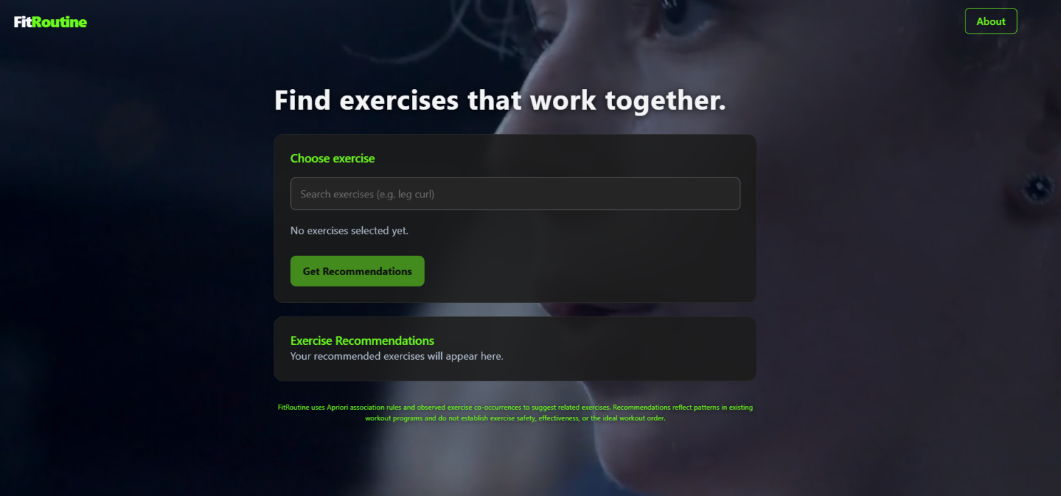
Figure 2. FitRoutine home page, the entry screen of the React web application.

2. Exercise search and selection
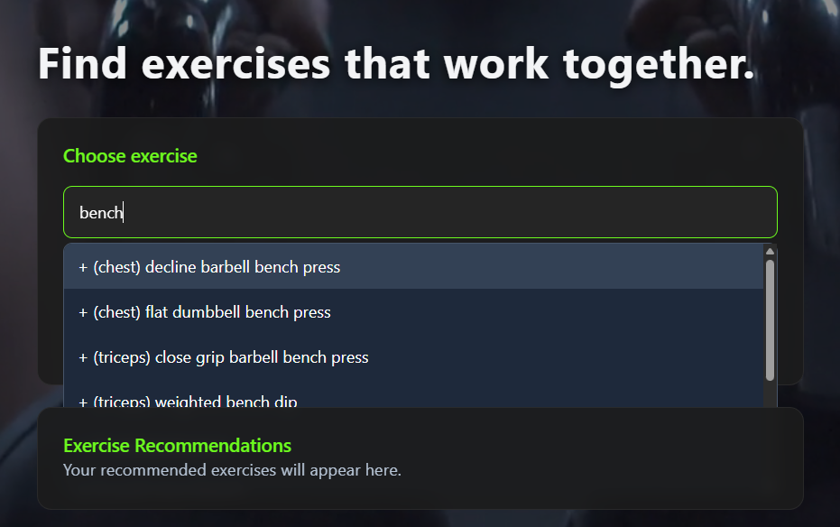
Figure 3. Exercise search and selection. The frontend filters the list of 3,178 exercise names by the typed text and hides exercises that are already selected. The selected names are sent to the backend, which trims and lowercases them before matching.

3. Apriori recommendation results
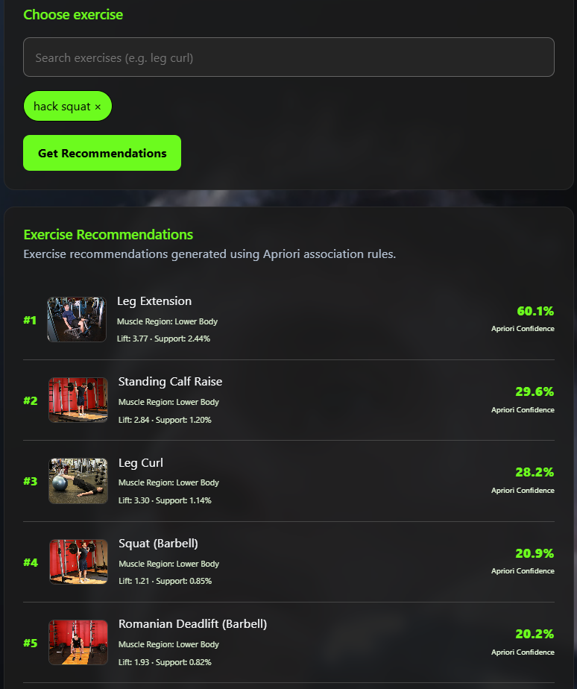
Figure 4. Apriori recommendation results: up to five exercises ranked by confidence and then lift, displayed with their support, confidence and lift values from the stored rules.

4. Observed-Pairs fallback results
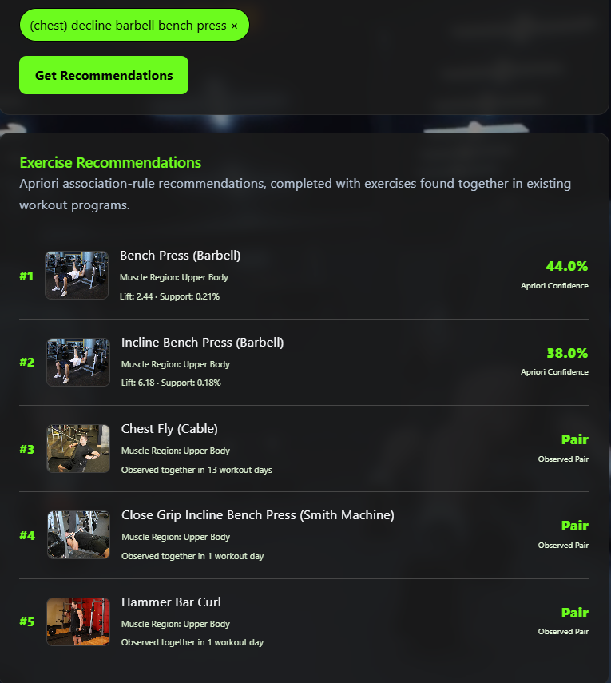
Figure 5. Observed-Pairs fallback results: when Apriori returns fewer than five recommendations, the remaining slots are filled with exercises that shared workout days with the selected exercises, ranked by a co-occurrence-based similarity score. These items carry the label source = observed_pairs in the backend response.

5. Muscle-region classification
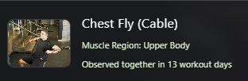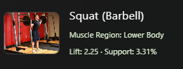
Figure 6. Muscle-region classification. The backend returns the predicted region (Upper Body, Lower Body, Core or Neck), the class probabilities and the confidence; predictions with confidence below 0.40 are labelled uncertain. The label is a model prediction, not a verified anatomical classification.

6. Model training and evaluation outputs
The following notebook outputs are reproduced in this document. They are real outputs, not illustrations:
- Figure 1 (Section III.6.A): bar chart of Hit Rate@5, Precision@5 and Coverage for Apriori only, Apriori + Observed Pairs and the popularity baseline. It was produced by the last cell of the Apriori notebook.
- Tables 7 to 9: five-fold cross-validation, held-out test and method comparison for the recommender.
- Tables 13 to 17 (including Table 14A): accuracy, per-class report, confusion matrix, confidence-threshold analysis and model comparison for the muscle-region classifier.
Table 14A shows the confusion matrix of the final four-region classifier on the held-out exercises.

V. Results and Discussion

1. Implementation outcome
FitRoutine consists of a React user interface, a Flask backend that serves the exercise list and recommendations, and data artifacts exported from the notebooks: 3,178 exercise names, 636 Apriori rules, Observed-Pairs partners for 2,563 exercises and a trained muscle-region classifier. In the backend (app.py), /api/recommend applies Apriori and fills remaining slots with Observed Pairs, and /api/classify-muscle applies the saved classifier with a 0.40 confidence threshold.

2. Apriori recommendation results
Under Protocol 1, which matches how the application is used (one or more selected exercises), Apriori achieved a Hit Rate@5 of 19.76% in five-fold cross-validation (standard deviation 1.73 points) and 20.36% on the held-out test programs. In other words, when one exercise of a real workout day was hidden, it appeared among the five recommended exercises about one time in five. The popularity baseline reached 12.96% in cross-validation and 14.48% on the held-out test, and Apriori was higher in each of the five folds. Coverage was about 94%. Precision@5 (3.95% and 4.07%) is numerically low because only one hidden exercise can be a correct answer, so it can never exceed 20% in this protocol; it should be read together with Hit Rate@5 rather than as a sign of poor accuracy. The notebook does not report a statistical significance test.
The ranking by confidence tends to favour popular exercises. Nine of the ten highest-confidence rules in the deployed rule set recommend “leg extension”, one of the most frequent exercises in the data (it appears in about 15% of workout days). The lift values in the same rules (about 4.8 to 5.7) show that the association is stronger than chance, but ranking by confidence first means that frequently performed exercises appear often in the results.

3. Observed Pairs and the combined method
Using a single selected exercise (Protocol 2), Apriori alone returned recommendations for 74.29% of cases and only 1.65 recommendations on average, which confirms the limited rule coverage described in Section II. Adding Observed Pairs raised coverage to 95.27%, Hit Rate@5 from 33.37% to 43.05% and Precision@5 from 9.06% to 11.85%. The fallback therefore delivered the improvement for which it was designed.
The popularity baseline performed better on both accuracy metrics in this protocol. It reached a Hit Rate@5 of 49.42% and a Precision@5 of 12.32%, compared with 43.05% and 11.85% for the combined method, and it covers every input. This result should be acknowledged honestly: in Protocol 2, FitRoutine did not outperform a method that suggests the same five frequent exercises to every user. Several features of the protocol may contribute to this, although the notebook does not test them. Every other exercise of the day counts as relevant (about five on average), which rewards frequently performed exercises; the selected exercise is the alphabetically first one of the day, which is not how a user would choose; and the notebook’s Observed-Pairs ranking uses raw counts, which also favours popular partners. The metric also does not measure relatedness to the selected exercise, which is the purpose of the application. Hit Rate@5 and Precision@5 values from Protocol 1 and Protocol 2 must not be compared with each other, because the tasks differ.
In addition, the combined method in the notebook uses Observed Pairs only when Apriori returns no result and ranks partners by raw counts. The deployed backend instead fills all remaining slots up to five and ranks partners by a similarity field intended to reduce the dominance of very popular exercises. That deployed behaviour was not evaluated in the notebooks, so the results above describe the notebook’s version of the fallback, not the exact deployed one.

4. Muscle-region classification results
On the 175 held-out exercises, the classifier reached 90.86% accuracy and 90.95% balanced accuracy, compared with a 51.31% majority-class baseline, and the training–validation gap was 2.29 points. Upper Body and Lower Body were identified reliably (F1 0.95 and 0.93). Core was the least reliable region (precision 0.64, F1 0.71; 5 of 23 Core exercises were misclassified and 6 Upper Body exercises were predicted as Core), and the Neck class consists of only eight exercises, so its perfect recall rests on two validation examples. The five-fold cross-validation estimate for the same configuration was lower (84.14% accuracy, 5.29-point gap) and did not meet both target criteria, so the held-out result may be optimistic. In cross-validation, 34 of 97 Core exercises were predicted as another region; examples listed in the notebook, such as “Deficit Deadlift”, “Seated Barbell Twist” and “Side Bridge”, are movements that involve several body regions, which is a plausible but untested reason for the confusion.
When predictions were restricted to a confidence of at least 0.40, 88.57% of the held-out exercises were accepted and 94.84% of those were correct. This shows that the model’s probabilities carry useful information, but the notebook does not state whether the application uses such a threshold.
Classification accuracy is not recommendation performance. The accuracy figures above describe how well exercise text is assigned to a muscle region. They say nothing about whether the recommended exercises are relevant, useful or appropriate for a user. The recommendation metrics are Hit Rate@5, Precision@5 and Coverage (Section V.2 and V.3).
The classifier was trained on Free Exercise DB names and instructions, and the backend expects the same format: it receives a name and instruction text. The workout dataset contains exercise names without instructions, and the name-only experiment gave a lower cross-validation accuracy (78.14%). The endpoint requires instruction text in addition to the exercise name, so accuracy may be lower when only a name is available, and accuracy on the exercise names used in the application was not measured separately.

5. Strengths and limitations of the methods
Table 19. Strengths and limitations
Method | Strengths | Limitations
Apriori | • Rules are interpretable and carry support, confidence and lift.  • Supports selections of several exercises.  • Mined offline, so the application only needs a quick lookup.  • Higher Hit Rate@5 than the popularity baseline in Protocol 1 (all five folds and the held-out test). | • Only 119 of 3,178 exercises (3.74%) can trigger a rule on their own.  • Names must match exactly (“bench press” returned no rules).  • Ranking by confidence favours popular exercises.  • Thresholds (0.003, 0.20, max_len 3) were not tuned in the notebook.  • Programs are not filtered for beginners.
Observed Pairs | • Simple, transparent counts of shared workout days.  • Partners found for 98.92% of training exercises.  • Raised coverage from 74.29% to 95.27% and Hit Rate@5 by 9.68 points in Protocol 2. | • Notebook version ranks by raw counts, favouring popular partners; the deployed similarity ranking was not evaluated.  • No measure of association strength such as lift.  • Only the top 10 partners per exercise are stored.  • Did not beat the popularity baseline in Protocol 2 (notebook version).
TF-IDF + Logistic Regression | • Simple, fast and based on a standard linear model.  • 90.86% held-out accuracy versus a 51.31% baseline.  • Gives class probabilities that can flag uncertain predictions. | • Small dataset (875 exercises); Neck has 8 examples.  • Manual 17-to-4 label mapping; one label per exercise.  • Core is the weakest region.  • Cross-validation (84.14%) is lower than the held-out result.  • Trained on text with instructions; accuracy on names alone was not measured on the final model.

6. General limitations of the study
- The transactions come from workout programs in a public dataset, not from observed training sessions or outcomes.
- The programs are not filtered by level, although the application targets beginners.
- The deployed rules (636) were mined from all programs, whereas the reported metrics come from rules mined from training programs only (621 rules). The reported results therefore describe a closely related, not identical, rule set.
- All evaluation is offline and based on whether hidden exercises reappear. It does not measure whether recommendations are useful, safe or effective, and no user study was performed.
- Hyperparameters of the classifier were chosen by repeated cross-validation experiments against the 85% and 5-point target criteria, and the 175 validation exercises were also used for later analyses; the held-out figure should be treated as a validation result.
- The dataset contains non-exercise entries (for example “break day” and “nothing”) that were not removed.
- The image lookup depends on an external GitHub-hosted database and network access.

VI. Conclusion and Recommendations
FitRoutine is a working prototype of a web-based exercise recommendation system. We built a pipeline that converts 605,033 workout records into 98,818 workout-day transactions, mines 636 Apriori association rules, computes Observed-Pairs partners for 2,563 exercises and trains a TF-IDF and Logistic Regression classifier that assigns exercises to four muscle regions. Offline evaluation by program-level splits and cross-validation showed that Apriori recommendations outperform a popularity baseline when several exercises are selected (20.36% versus 14.48% Hit Rate@5 on held-out programs), that the Observed-Pairs fallback increases coverage and hit rate when a single exercise is selected, and that the classifier reaches 90.86% accuracy on 175 held-out exercises (84.14% in cross-validation).
The three components work together as follows. Apriori is the primary recommender and supplies ranked, interpretable suggestions when the selected exercises match a stored rule. Observed Pairs supplies historical co-occurrence candidates when Apriori produces too few. The Logistic Regression classifier is separate from both: it predicts the muscle region of an exercise so that the user can understand what an exercise works.
The work has clear limitations. Apriori covers few exercises on its own; in a single-exercise test the popularity baseline scored higher than the combined method; the classifier is trained on a small dataset with a weak Core class and an almost empty Neck class; and no evidence was collected about user benefit. FitRoutine suggests exercises that have often appeared together in historical workout programs. It does not provide scientifically optimised or guaranteed-effective routines and does not assess safety or suitability for an individual.
Recommendations for future work
1. Document the licence and collection method of the Kaggle workout dataset, and record the Free Exercise DB version used.
2. Evaluate the combined method exactly as it is deployed (Observed Pairs filling remaining slots) under several protocols, including random selection of input exercises and multi-exercise inputs, and report significance or confidence intervals.
3. Tune the Apriori thresholds with cross-validation. An exploratory run on training data (support 0.001, confidence 0.10, itemset length 2) raised single-exercise coverage from 3.74% to 10.38% (on different exercise sets), but its recommendation quality was not evaluated.
4. Normalise exercise names (for example, map “bench press” to its equipment variants) so that matching does not depend on exact strings, and remove non-exercise entries.
5. Evaluate the deployed similarity-based Observed-Pairs ranking against the raw-count version, and document how the similarity values are computed and stored.
6. Filter or weight programs by difficulty level to align the data with beginners.
7. Strengthen the classifier with more labelled data, evaluate it on the exercise names used by the application, and consider finer muscle labels.
8. Collect user feedback or expert review of recommendation relevance, and keep a visible notice that suggestions do not replace professional advice.

VII. References
[1] R. Agrawal and R. Srikant, “Fast Algorithms for Mining Association Rules,” in Proc. 20th Int. Conf. Very Large Data Bases (VLDB), Santiago, Chile, 1994, pp. 487–499.
[2] R. Agrawal, T. Imieliński, and A. Swami, “Mining association rules between sets of items in large databases,” in Proc. ACM SIGMOD Int. Conf. Management of Data, Washington, DC, USA, 1993, pp. 207–216.
[3] K. Spärck Jones, “A statistical interpretation of term specificity and its application in retrieval,” J. Documentation, vol. 28, no. 1, pp. 11–21, 1972.
[4] D. W. Hosmer, S. Lemeshow, and R. X. Sturdivant, Applied Logistic Regression, 3rd ed. Hoboken, NJ, USA: Wiley, 2013.
[5] F. Pedregosa et al., “Scikit-learn: Machine learning in Python,” J. Mach. Learn. Res., vol. 12, pp. 2825–2830, 2011.
[6] S. Raschka, “MLxtend: Providing machine learning and data science utilities and extensions to Python’s scientific computing stack,” J. Open Source Softw., vol. 3, no. 24, p. 638, 2018.
[7] W. McKinney, “Data structures for statistical computing in Python,” in Proc. 9th Python in Science Conf. (SciPy), 2010, pp. 56–61.
[8] yuhonas, “Free Exercise DB.” GitHub repository. [Online]. Available: https://github.com/yuhonas/free-exercise-db. [Accessed: Nov. 8, 2026].
[9] Meta Platforms, “React Documentation.” [Online]. Available: https://react.dev/learn. [Accessed: Nov. 8, 2026].
[10] Pallets Projects, “Flask Documentation.” [Online]. Available: https://flask.palletsprojects.com/. [Accessed: Nov. 8, 2026].
[11] Vite, “Vite Documentation.” [Online]. Available: https://vite.dev/guide/. [Accessed: Nov. 8, 2026].
[12] A. Elouardi (Kaggle user “adnanelouardi”), “600K Fitness Exercise & Workout Program Dataset,” Kaggle. [Online]. Available: https://www.kaggle.com/datasets/adnanelouardi/600k-fitness-exercise-and-workout-program-dataset/data.

Appendix A. Traceability of Key Values to the Notebooks
Cell numbers count code and text cells from the top of each notebook, starting at 1. “Apriori” is FitRoutine_Apriori.ipynb and “LogReg” is Fitroutine_LogisticReg.ipynb.
Table A1. Where each reported value appears
Value reported in this document | Notebook and cell
605,033 rows × 16 columns; missing-value counts; 904 duplicate rows | Apriori, cell 3
605,033 rows after cleaning; 3,178 unique exercise names | Apriori, cell 4
98,818 transactions; 1–40 exercises, mean 5.89 | Apriori, cells 5 and 6
Transaction matrix 98,818 × 3,178 | Apriori, cell 7
Support 0.003, max_len 3, 1,189 frequent itemsets | Apriori, cell 8
Confidence 0.20, single consequent, 636 rules | Apriori, cell 9
Example recommendations (pike push up; leg curl + hack squat; no-rule case) | Apriori, cells 11 to 13
Rules and exercise list exported (636; 3,178) | Apriori, cells 14 and 15
2,598 programs; 2,078 / 520 split; 78,744 / 20,074 transactions | Apriori, cell 20
Training matrix 2,591 columns; 1,194 itemsets; 621 rules | Apriori, cells 22 to 24
19,183 eligible test transactions; 2,500 sampled | Apriori, cell 26
Five-fold cross-validation (Table 7) | Apriori, cells 30 and 31
Held-out Protocol 1 result (Table 8) | Apriori, cells 33 and 36
“bench press” antecedent returned 0 rules | Apriori, cell 35
119 of 3,178 exercises with single-antecedent rules (3.74%) | Apriori, cell 37
Lower-threshold exploration: 3,655 itemsets, 1,846 rules, 10.38% | Apriori, cell 38
2,563 of 2,591 exercises with an observed partner (98.92%) | Apriori, cell 39
Observed-pair examples (bench press (barbell), plank) | Apriori, cell 40
Observed-Pairs file with 2,563 exercises | Apriori, cell 41
Protocol 2 comparison (Table 9) and Figure 1 | Apriori, cells 46 and 47
Endpoints, alias table, slot-filling, similarity ranking and 0.40 threshold | Backend file app.py (/api/recommend, /api/classify-muscle)
Saved classifier settings (C = 0.5, 300 features, min_df = 5) | Saved classifier file (fitroutine_muscle_region_classifier.joblib)
Free Exercise DB: 876 exercises, columns, 0 missing labels | LogReg, cell 28
875 single-label exercises; 17 muscles; 16.91% baseline | LogReg, cell 29
17-class model: 92.57% / 67.43% | LogReg, cell 30
Muscle-region mapping; 449 / 298 / 120 / 8; 51.31% baseline | LogReg, cell 33
Cross-validation of four-region pipelines and comparisons (Table 17) | LogReg, cells 34 to 38, 49, 50, 52, 53, 55 to 57
Final held-out evaluation (Tables 13 and 14) | LogReg, cell 39
Saved model and metadata; classes | LogReg, cell 40
Confidence-threshold analysis (Table 16) | LogReg, cell 42
Confusion matrix (Table 14A) | LogReg, cell 58
Cross-validation per-class report (Table 15); 34 Core errors | LogReg, cells 44 and 45
Exploratory program-level experiments (Table 18) | LogReg, cells 1 to 24

