LAB EXPERIMENTS
EXP 1:
CODE:
INTEGER TO FLOAT:
#include <stdio.h>

int main()
{
int a = 10;
float b;

b = (float)a;

printf("Integer value = %d\n", a);
printf("Float value = %.2f\n", b);

return 0;
}

Output:
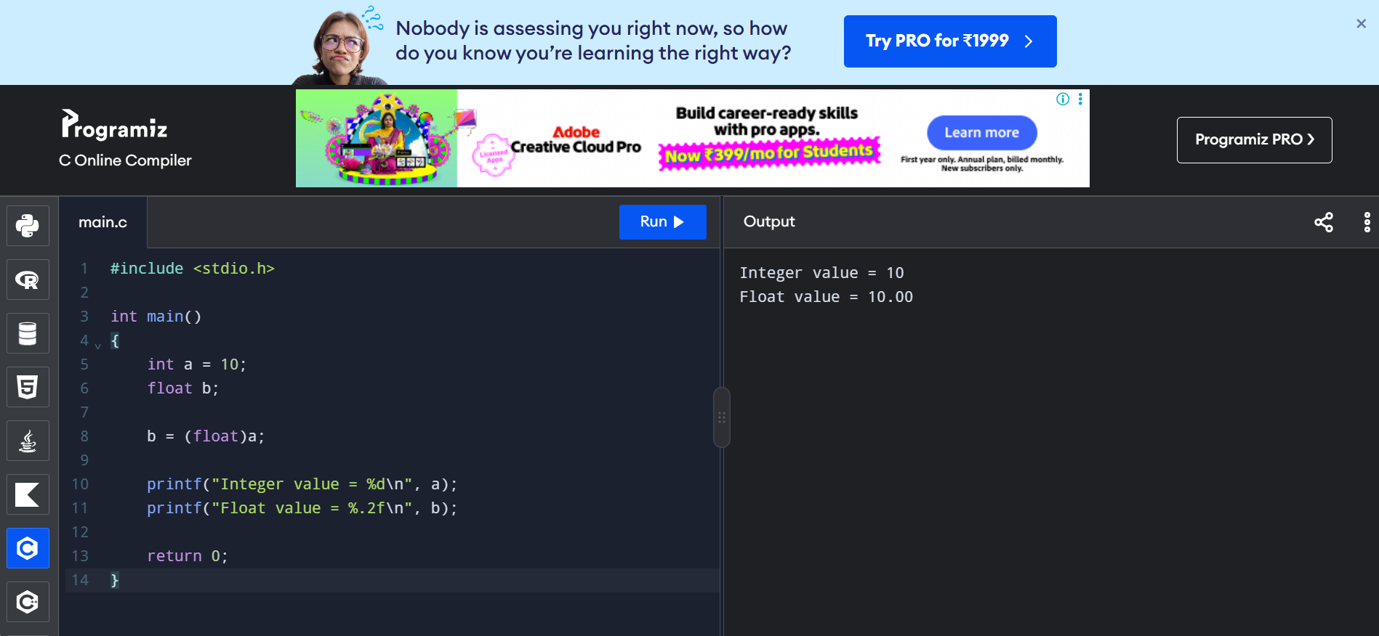

Exp 2:
FLOAT TO INTEGER:
Code:
#include <stdio.h>

int main()
{
float a = 10.75;
int b;

b = (int)a;

printf("Float value = %.2f\n", a);
printf("Integer value = %d\n", b);

return 0;
}
Output:
