Test Case #1: For my first test case I used the client request text file that we received and the inventory text file also and ran it through the code to see if my program functioned as designed. Which would receive the clients request check the inventory if we have it and then it we don’t create a Bike Order list and keep track of which bikes we need to buy.

BikeOrder (what the company needs to order)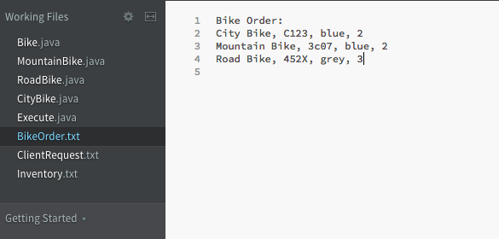

Inventory: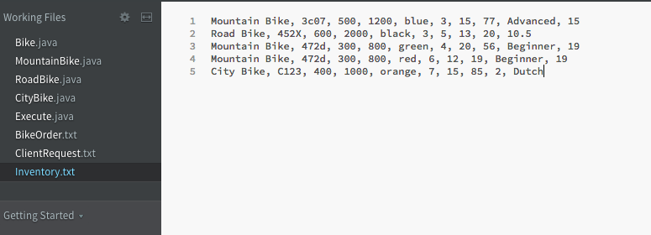

Client Request: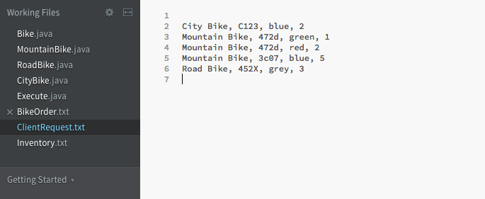

Inventory:

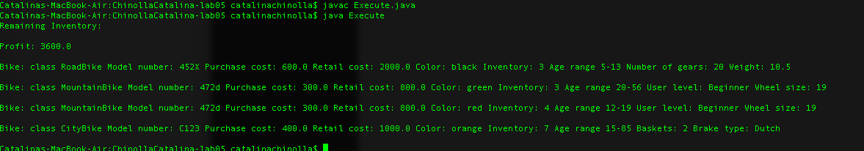

Everything did go as planned the program kept track of the inventory, profit which was 3600, and which bikes the company needed to order.

Test Case #2: For my second test case I decided to have the client request all of bikes that is in inventory that way the program can make note that the remaining inventory will be empty for there is no bikes left

Client request all of bikes in inventory

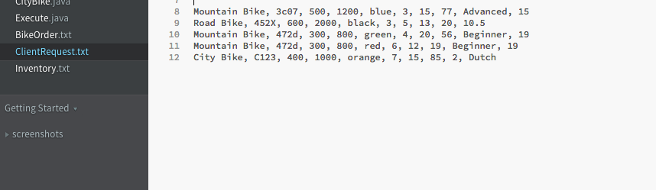Program Executes and displays that inventory only has one bike of each and does not make profit

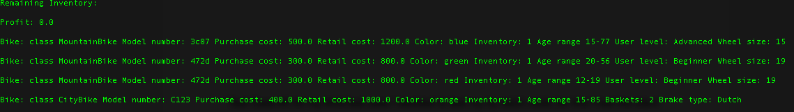

Test Case #3 for my third test case I decided to test my try catch code, for this I had the client skip the 1st line on the client request text file. This results in receiving an array index out of bounds array which I had as one of my exceptions

Client Request Form

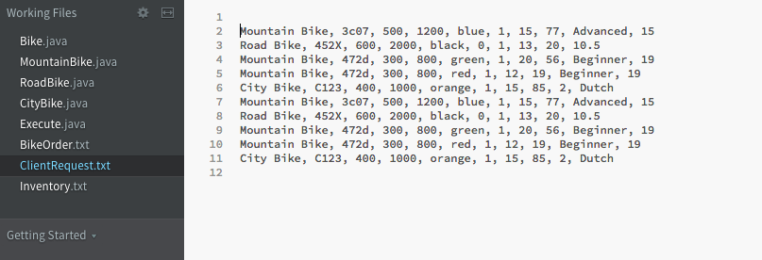

Array Index out of Bound exception

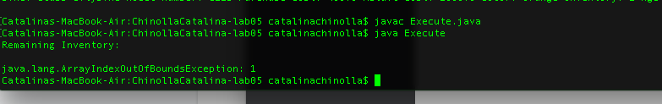

Test Case #4 for my fourth test case I wanted to have the customer order a large amount of bikes to test if the BikeOrder file would update and keep track of all the bikes it needed to order. I requested in the Client Request file 20 bikes and checked if the BikeOrder updated itself

Client Request:

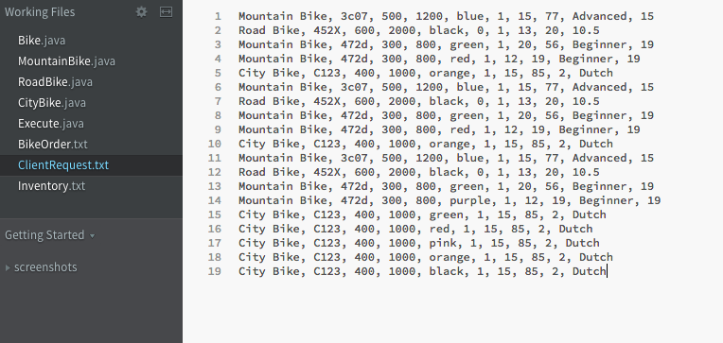Bike Order Before Request: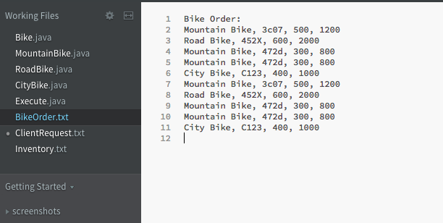Bike Order After request: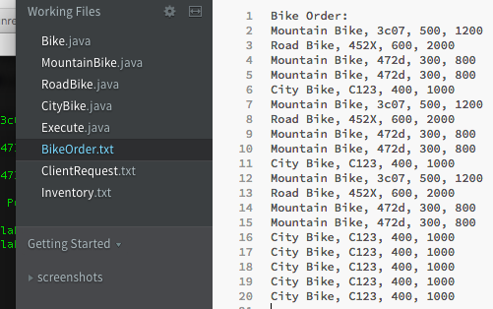

This resulted in the Bike Order text file updating itself to keep track that the company wants to order these additional bikes that the customer requested but the company did not have. The program did work and the files were updated.