Coursera - Johns Hopkins University - Data Science Specialization - Module 5 - Reproducible Research - Peer Assessment 1

Date: 05/12/2015 Author: Chakra C

# 1.1 Loading and processing input data

The data for this assignment can be downloaded from the course web site:  
- Dataset: [Activity monitoring data](https://d396qusza40orc.cloudfront.net/repdata%2Fdata%2Factivity.zip)

The variables included in this dataset are:  
- steps: Number of steps taking in a 5-minute interval (missing values are coded as NA)  
- date: The date on which the measurement was taken in YYYY-MM-DD format  
- interval: Identifier for the 5-minute interval in which measurement was taken

The dataset is stored in a comma-separated-value (CSV) file and there are a total of 17,568 observations in this dataset. 61 days, 24 * 12 = 288 samples / day => 61 * 288 = 17.568 data points.

# The following libraries need to be installed on this system to enable running this knitr script  
library(ggplot2)

## Warning: package 'ggplot2' was built under R version 3.1.2

library(dplyr)

## Warning: package 'dplyr' was built under R version 3.1.2

##   
## Attaching package: 'dplyr'  
##   
## The following object is masked from 'package:stats':  
##   
## filter  
##   
## The following objects are masked from 'package:base':  
##   
## intersect, setdiff, setequal, union

# The dataset used has to exist on the same directory as where this R script is stored  
setwd('C:/Coursera/Data_Science/Reproducible_Research/ReproducibleResearch/data/')  
  
df <- read.csv("activity.csv")

# 1.2 Process input data

names(df)

## [1] "steps" "date" "interval"

head(df)

## steps date interval  
## 1 NA 2012-10-01 0  
## 2 NA 2012-10-01 5  
## 3 NA 2012-10-01 10  
## 4 NA 2012-10-01 15  
## 5 NA 2012-10-01 20  
## 6 NA 2012-10-01 25

summary(df)

## steps date interval   
## Min. : 0.00 2012-10-01: 288 Min. : 0.0   
## 1st Qu.: 0.00 2012-10-02: 288 1st Qu.: 588.8   
## Median : 0.00 2012-10-03: 288 Median :1177.5   
## Mean : 37.38 2012-10-04: 288 Mean :1177.5   
## 3rd Qu.: 12.00 2012-10-05: 288 3rd Qu.:1766.2   
## Max. :806.00 2012-10-06: 288 Max. :2355.0   
## NA's :2304 (Other) :15840

No of transformations necessary.  
Reasoning for transformations: only 5 minute data (non-NA's) needed: could create a subset for that excluding date info.

# 2. Mean total number of steps taken per day

# 2.1 Total number of steps taken per day

df.steps <- tapply(df$steps, df$date, Fun=sum, na.rm=True)  
  
## Computes a summary of the total number of steps taken each day  
by_day <- aggregate(steps ~ date, data = df, sum)  
  
summary(by_day)

## date steps   
## 2012-10-02: 1 Min. : 41   
## 2012-10-03: 1 1st Qu.: 8841   
## 2012-10-04: 1 Median :10765   
## 2012-10-05: 1 Mean :10766   
## 2012-10-06: 1 3rd Qu.:13294   
## 2012-10-07: 1 Max. :21194   
## (Other) :47

# 2.2 Histogram of total number of steps taken per day

Histogram showing total number of steps each day:

# 2.2 Histogram of total number of steps taken per day. Plot using ggplot2  
ggplot(by_day, aes(steps)) + geom_histogram(fill = "steelblue2", colour = "steelblue4",   
 breaks = c(0, 5000, 10000, 15000, 20000, 25000)) + labs(y = expression("frequency")) +   
 labs(x = expression("number of steps per day")) + labs(title = expression("Fig 1"))

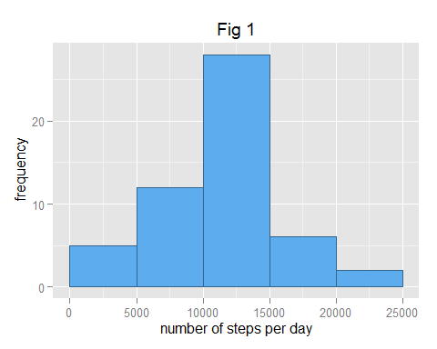

# 2.3 Mean and median of total number of steps taken per day

Mean:

# 2.3 Mean and median of the total number of steps taken per day  
mean1<-mean(by_day$steps)  
mean1

## [1] 10766.19

Median:

## Median   
median1<-median(by_day$steps)  
median1

## [1] 10765

# 3.1 Average daily activity pattern

Make a time series plot (i.e. type = "l") of the 5-minute interval (x-axis) and the average number of steps taken, averaged across all days (y-axis) # 3.1 Time-series plot of 5 minute intervals vs steps taken

# 3. Average daily activity pattern  
# 3.1 time-series plot of 5 minute intervals vs steps taken  
## Computes a summary of the average by 5minute interval across all days  
by_interval <- aggregate(steps ~ interval, data = df, FUN = function(x) {  
 mean(x, na.rm = TRUE)  
})  
  
## Time series plot  
ggplot(by_interval, aes(interval, steps)) + geom_line(colour = "steelblue4",   
 lwd = 2) + labs(title = expression("Fig 2"))

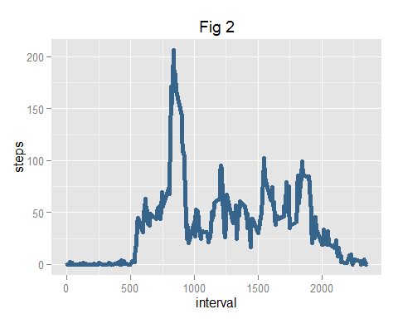

# 3.2 5 minute max value of daily activity pattern

Which 5-minute interval, on average across all the days in the dataset, contains the maximum number of steps?

# 3.2 time interval of maxiumum number of steps  
## Maximum interval  
by_interval$interval[which.max(by_interval$steps)]

## [1] 835

## Maximum value  
max(by_interval$steps)

## [1] 206.1698

# 4. Imputing missing values

Note that there are a number of days/intervals where there are missing values (coded as NA). The presence of missing days may introduce bias into some calculations or summaries of the data.

# 4.1 Total number of missing values:

# 4. Imputing missing values  
na<-sum(is.na(df))  
rate<-paste(round(100*(na/nrow(df)), 3), "%")  
# 4.1 Number of missing values in original dataset:  
rate

## [1] "13.115 %"

# 4.2 Replace missing values by mean of 5 minute intervals

We can replace the missing values with the mean value of the 5-minute intervals by using a function that is conditional on the is.na and number of steps.

# 4.2 Use average number of non-NA steps per 5 minute interval over all days in dataset  
# save original dataset first  
dates <- strptime(df$date, "%Y-%m-%d")  
uniqueDates <- unique(dates)  
stepsSplit <- split(df$steps, dates$yday)  
totalStepsPerDay <- sapply(stepsSplit, sum, na.rm=TRUE)  
head(totalStepsPerDay)

## 274 275 276 277 278 279   
## 0 126 11352 12116 13294 15420

for (i in 1:length(df$steps)) {  
 if (is.na(df[i, 1])) {  
   
 ## Corresponding 5-minute interval, computed before as by_interval  
 steps_average <- subset(by_interval, by_interval$interval == as.numeric(df[i,3]))$steps  
   
 ## Replaces the value  
 df[i, 1] <- steps_average  
 } else {  
 df[i, 1] <- df[i, 1]  
 }  
 df  
}

# 4.3 Create a new dataset including adapted missing data:

Update dataset:

# 4.3 Dataset df updated with average values per 5 minute interval in case original was NA  
head(df)

## steps date interval  
## 1 1.7169811 2012-10-01 0  
## 2 0.3396226 2012-10-01 5  
## 3 0.1320755 2012-10-01 10  
## 4 0.1509434 2012-10-01 15  
## 5 0.0754717 2012-10-01 20  
## 6 2.0943396 2012-10-01 25

tail(df)

## steps date interval  
## 17563 2.6037736 2012-11-30 2330  
## 17564 4.6981132 2012-11-30 2335  
## 17565 3.3018868 2012-11-30 2340  
## 17566 0.6415094 2012-11-30 2345  
## 17567 0.2264151 2012-11-30 2350  
## 17568 1.0754717 2012-11-30 2355

# 4.4 Histogram of new dataset including adapted missing data:

Show the histogram of the new dataset:

# 4.4 Histogram, mean and median of updated dataset  
by_date <- aggregate(steps ~ date, data = df, sum)  
  
ggplot(by_date, aes(steps)) + geom_histogram(fill = "steelblue2", colour = "steelblue4",   
 breaks = c(0, 5000, 10000, 15000, 20000, 25000)) + labs(y = expression("frequency")) +   
 labs(x = expression("number of steps per day")) + labs(title = expression("Fig 3"))

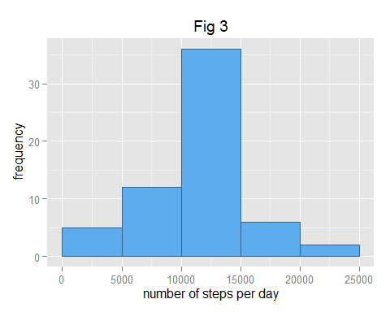

The distribution in Fig 3 visually looks identical to the original in Fig 1.  
Add two daily steps graphs to see the differences due to NA resolving:

# Make plot where the x-axis denotes the day  
# and the y-axis denotes the total number of steps taken for each day  
par(mfcol=c(2,1))  
  
# by_date0 <- aggregate(steps ~ date, data = df0, sum)  
plot(uniqueDates, totalStepsPerDay, main="Steps taken each day before imputing",   
 xlab="Date (October to November 2012)", ylab="Frequency", type="h", lwd=4, col="blue")  
  
plot(uniqueDates, by_date$steps, main="Steps taken each day after imputing",  
 xlab="Date (October to November 2012)", ylab="Frequency", type="h", lwd=4, col="blue")

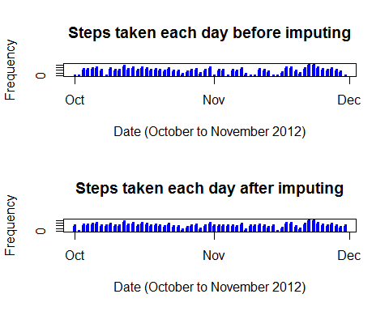

It can be clearly seen that there is an effect on the first and last day (both entirely NA days).

Mean and median of this dataset are:

mean2<-mean(by_date$steps)  
mean2

## [1] 10766.19

median2<-median(by_date$steps)  
median2

## [1] 10766.19

# Analyze possible differences with original dataset  
## Variation of the mean due to the missing value imputing strategy in percent  
delta_mean<-(mean1-mean2)/mean1  
paste(round(100*delta_mean, 4), "%")

## [1] "0 %"

## Variation of the mean due to the missing value imputing strategy in percent  
delta_median<-(median1-median2)/median1  
paste(round(100*delta_median, 4), "%")

## [1] "-0.011 %"

# The mean is the same, the median has shifted a bit, though.

The mean is the same, the median has shifted a bit, though.

# 5. Differences in activity patterns between weekdays and weekends

Using the filled-in dataset the differences between weekdays and weekends are determined.  
# 5.1 Weekdays and weekends  
Problems:  
1. date names are language dependent  
2. date recognition also Windows dependant  
Solution: use day numbers, i.e. Sunday = 0, Saturday = 6

# 5. Activity patterns per weekday or weekend  
  
# Disadvantage of orignal solution using day names like 'Saturday' is   
# that the name of the day is Windows Language Settings dependant.  
# So preferrably use day numbers: 0 = Sunday, 6 = Saturday  
  
# http://stackoverflow.com/questions/9216138/find-the-day-of-a-week-in-r  
# The wday component of a POSIXlt object is the numeric weekday (0-6 starting on Sunday).  
# library(dplyr) needed  
df <- mutate(df, day = as.POSIXlt(df$date)$wday)  
  
# Add column 5 = Weekday or Weekend  
# 1-10-2012 = Monday = 1 OK; 30-11-2012 = Friday = 5 OK:  
for (i in 1:length(df$day)) {  
 if (df[i, 4] == 6 || df[i, 4] == 0) {  
 df[i, 5] <- "Weekend"  
   
 } else {  
 df[i, 5] <- "Weekday"  
   
 }  
}  
colnames(df)[5] <- "Weekdays"  
names(df)

## [1] "steps" "date" "interval" "day" "Weekdays"

df$Weekdays <- as.factor(df$Weekdays)  
head(df,10)

## steps date interval day Weekdays  
## 1 1.7169811 2012-10-01 0 1 Weekday  
## 2 0.3396226 2012-10-01 5 1 Weekday  
## 3 0.1320755 2012-10-01 10 1 Weekday  
## 4 0.1509434 2012-10-01 15 1 Weekday  
## 5 0.0754717 2012-10-01 20 1 Weekday  
## 6 2.0943396 2012-10-01 25 1 Weekday  
## 7 0.5283019 2012-10-01 30 1 Weekday  
## 8 0.8679245 2012-10-01 35 1 Weekday  
## 9 0.0000000 2012-10-01 40 1 Weekday  
## 10 1.4716981 2012-10-01 45 1 Weekday

tail(df,10)

## steps date interval day Weekdays  
## 17559 0.0000000 2012-11-30 2310 5 Weekday  
## 17560 0.8301887 2012-11-30 2315 5 Weekday  
## 17561 0.9622642 2012-11-30 2320 5 Weekday  
## 17562 1.5849057 2012-11-30 2325 5 Weekday  
## 17563 2.6037736 2012-11-30 2330 5 Weekday  
## 17564 4.6981132 2012-11-30 2335 5 Weekday  
## 17565 3.3018868 2012-11-30 2340 5 Weekday  
## 17566 0.6415094 2012-11-30 2345 5 Weekday  
## 17567 0.2264151 2012-11-30 2350 5 Weekday  
## 17568 1.0754717 2012-11-30 2355 5 Weekday

# 5.2 Panel plot

A panel plot is created containing a time series plot (i.e. type = "l") of the 5-minute interval (x-axis) and the average number of steps taken, averaged across all weekday days or weekend days (y-axis).

summary <- aggregate(df$steps, list(interval = df$interval, day = df$Weekdays), mean)  
names(summary) <- c("interval", "Weekdays", "steps")  
  
## Plot using ggplot2  
ggplot(summary, aes(interval, steps)) + geom_line(color = "steelblue4", lwd = 2) +   
 facet_wrap(~Weekdays, ncol = 1) + labs(title = expression("Fig 4"))

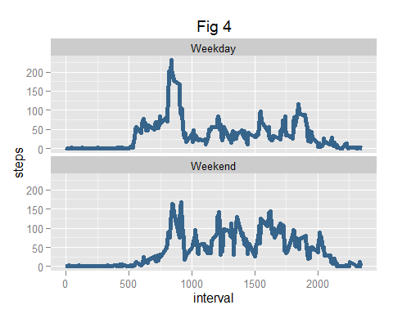

From the graph we see that weekday steps start out similar to the weekend steps. The early morning weekday peak activity is lower than during a weekend. The overall weekend activity during the day is higher than during the week.