Homework 4
CS-673 – Software Engineering
10/20/2008

Team EasyX10
SOFTWARE REQUIREMENTS SPECIFICATION
(SRS)
Version 0.2a
Bruce Deyle
Jim Duda
Damon Gabrielle
John Winderbaum

Revision | Date | Author | Change Description
0.1 | 09/29/08 | Jduda | Initial Revision
0.2 | 10-5-08 | Deyle | Capture each person’s section into single document, clean up fonts added Damon’s material

1 Introduction 4
1.1 Purpose 4
1.2 Document Conventions 4
1.3 Intended Audience and Reading Suggestions 4
1.4 Project Scope 4
1.5 Definitions, Acronyms and Abbreviations 5
1.6 References 7
2 Product Description 7
3 39
4 39
5 39
6 Requirements Definition 40
6.1 Functional Requirements (option 1) 40
6.1.1 User Interface 40
6.1.2 Appliance Devices 45
6.1.3 Motion Devices 45
6.1.4 Timer Controls 46

Table of Contents

Introduction

Purpose
This document provides the System Requirements Specification (SRS) for the EasyX10 project.

Document Conventions
1.2.1 – All documents follow the naming standards outlined in the Configuration Mgt Plan.
1.2.2 – A definition of any term used in this document is defined in Section 1.5..

Intended Audience and Reading Suggestions
This document is written for the benefit of the stakeholders of the EasyX10 project.

- EasyX10 development team
- CS673 Professor

The reader is encouraged to read these external documents.

- Software Project Management Plan (SPMP)
Author: EasyX10 Project Team

Project Scope
The EasyX10 project is a web-based application designed to manage a network of X10 home automation devices. The application supports both manual and automatic control of X10 home lighting. The application interfaces with an X10 control module which is physically attached to a serial port on the computer which hosts the application. The X10 control module interfaces with external X10 appliance devices and motion detectors using the X10 protocol through a home’s A/C wiring.
The application allows a user to manage X10 devices, manually control lighting conditions, and configure automatic lighting control based upon time events or motion events.

The diagram below shows the environment in which the easyX10 Software operates:
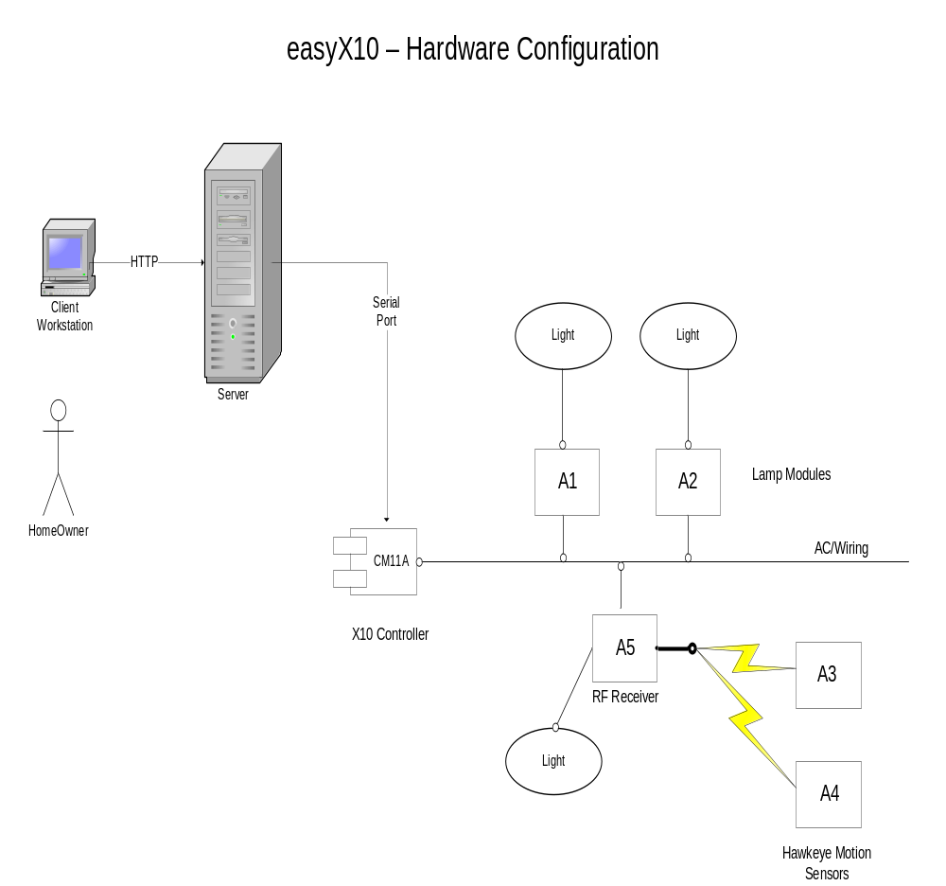

Definitions, Acronyms and Abbreviations

Term/Acronym/Abbreviation | Definition
CM11a | X10 Interface Control Module
CSS | Cascading Style Sheets
Device | An Appliance or Motion Detector device, external to the system, which is controller and/or monitored using the X10 protocol.
GUI | Graphical User Interface
HTTP Post | Method of sending HTML form data from a web browser to a web server using the hyper text transfer protocol.
HTML | Hypertext Markup Language
House Code | ? - see section 6.1
JSP | Java Server Pages
RF signal | Radio frequency signal; a wireless signal. In the context of this document it’s in reference to communication between the Hawkeye motion sensor and aTM751 Transceiver Module.
RIA | Rich Internet Application
SRS | System Requirements Specification
TM751 Transceiver Module | An X10 hardware plug-in module that can receive an RF signal and retransmit it across the electrical wiring in the X10 protocol.
TOD | Time of Day
UI | User Interface
Unit Code | See Section 6.1
X10 | International and open industry standard for communication among electronic devices primarily using power line wiring. A wireless radio based protocol transport is also provided.

References
- The CM11a protocol document:
ftp://ftp.x10.com/pub/manuals/cm11a_protocol.txt

Product Description

2.1 Functional Overview

The EasyX10 project is a web-based application designed to manage a network of X10 home automation devices. The application supports both manual and automatic control of X10 home lighting. (BED chg)The application interfaces with an X10 control module which is physically attached to a serial port on the computer which hosts the application. The X10 control module interfaces with external X10 lighting devices and motion detectors using the X10 protocol through the home A/C wiring. The application allows a user to manage X10 devices, manually control lighting conditions, and configure automatic lighting control based upon time events or motion events.

Major Inputs:

User Interactions (Login/Add Appliance/Modify Appliance)
Motion Sensor Activities

Major Outputs:

System Status
X10 Commands

Core Functionality:

Load Configuration Data
Manage Users (Login/Logout)
Add X10 Devices
Remove X10 Devices
Report Status of X10 Devices
Modification and Control of X10 Devices (i.e. State Changes)
Accept X10 Events (i.e. Process Motion Detection)
Process timer Events (i.e. Turn Device on/off at Selected Time)
2.2 User Interface
2.2.1 Overview
EasyX10 is a Rich Internet Application (RIA) that presents data to the user through a standard web browser (i.e. Firefox or IE7(BED-does this assume we only support Windows based client?). The user interface (UI) is built using the following web technologies:
- HTML (Hypertext Markup Language)
- CSS (Cascading Style Sheets)
- JavaScript
- JSP (Java Server Pages)
The UI displays a simple outline of each floor for the configured building (typically the user’s home) to an authenticated user. The user can then add new devices (appliances and motion detectors) to a floor (through an HTML form). Once devices exist in the system the user can update them (i.e. Change their status to ON), delete them, modify their characteristics and monitor their status using the UI.
2.2.2 Details
The following screenshots illustrate the general user interface concept for the EasyX10 application.
Login Screen
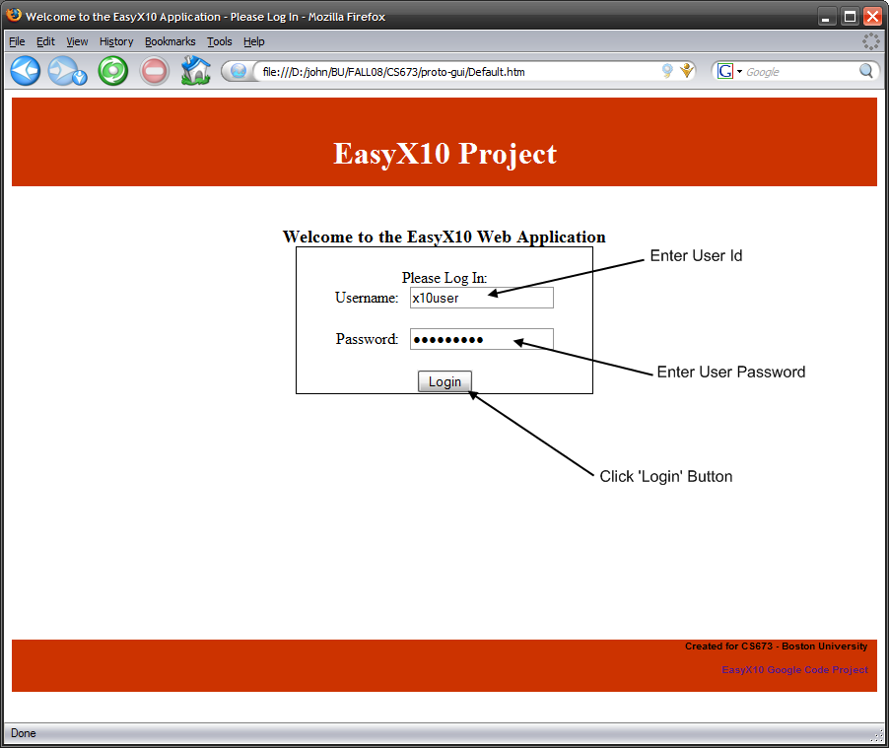
Main Status Screen
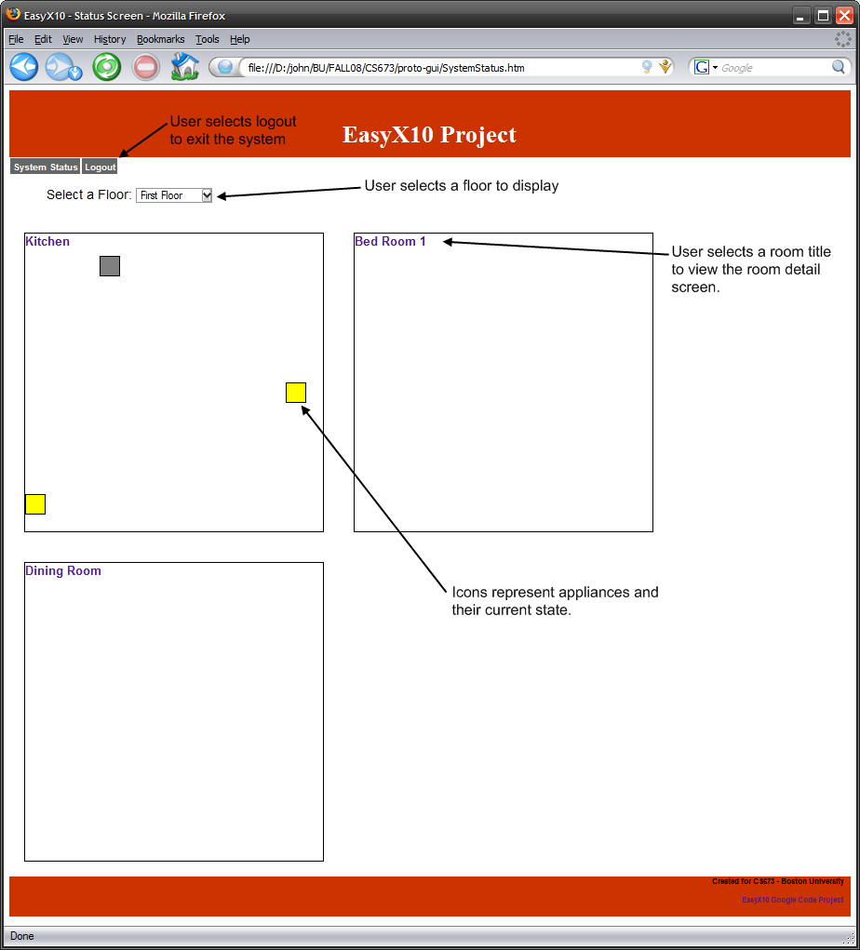

Room Screen
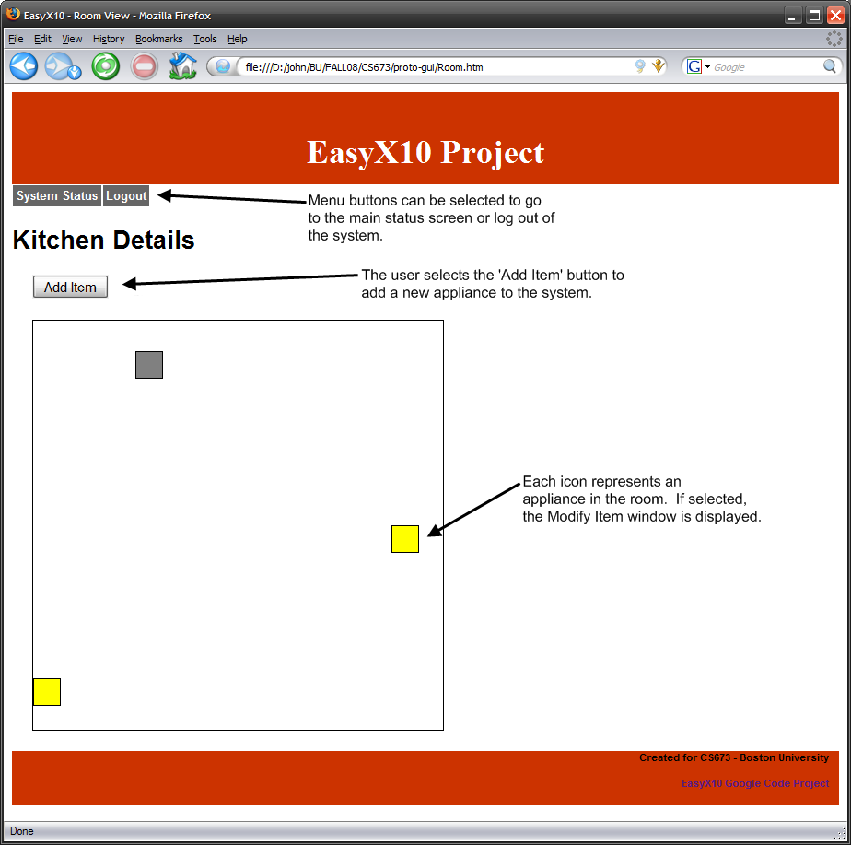

Add/Modify Appliance Screen
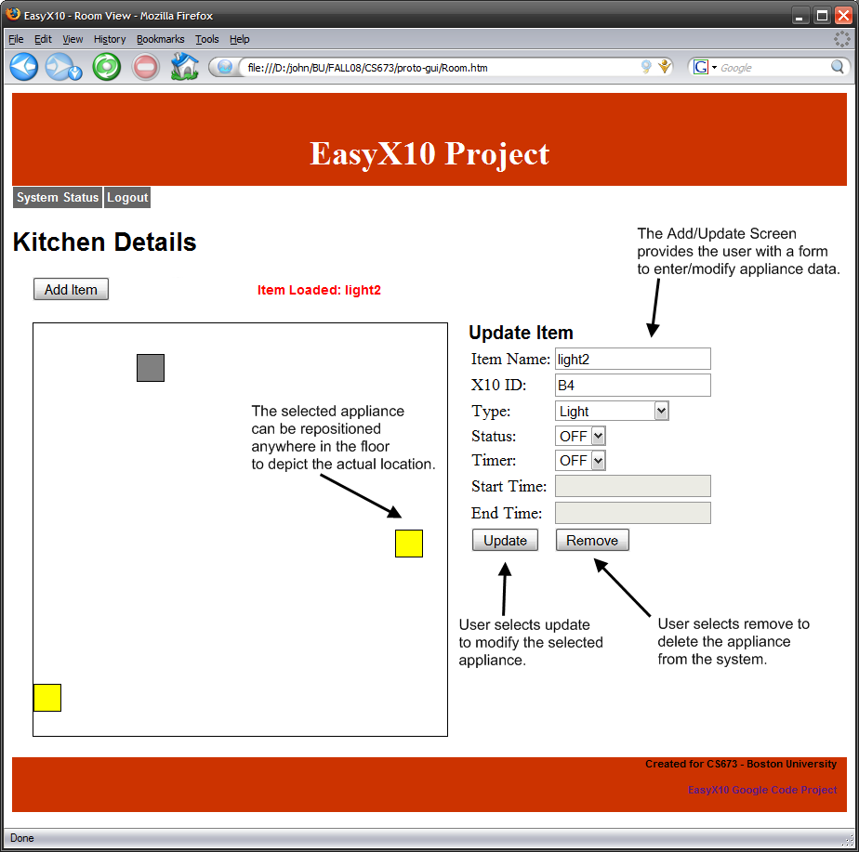

3.0 Functional Model
This section provides usage scenarios for the software
3.1 User profiles
User – The customer who owns the system. A home owner can act on the system either by tripping a motion sensor, or by interacting with the web user interface to manually turn an appliance on or off.
Timer – The timer acts on the system by triggering an event to change the state of an appliance. A timer may turn a device on or off at a specific time or turn on or off for a specified duration.
Motion Sensor – The motion sensor acts on the system by triggering a wireless signal to a TM751 wireless transceiver, which repeats it across the electrical wiring to a listening CM11A interface. The easy10 application is listening for events received by the CM11A and will carry out applicable actions from that point.

3.2 Use-cases
USE CASE: 1 | User Login
Primary actor | User
Goal in Context | To log in to the EasyX10 Web Application.
Preconditions | System Configuration contains user name and password information
Success End Condition | User is authenticated and the browser navigates to the system status screen.
Failed End Condition | User is denied access to application and error message is displayed.
Trigger | User decides to utilize the EasyX10 web application.
Scenario | Step | Action
 | 1 | User: Navigates to the EasyX10 URL in a Web Browser (http://localhost:8080/easyx10)  System Response: Sends HTML data for login screen to user’s browser.
 | 2 | User: Enters Username
 | 3 | User: Enters Password
 | 4 | User: Clicks on the “Login” button  System Response: The system then processes the button selection and attempts to log the user into the system.
Priority | Normal
Frequency | Periodically as users access the system throughout the day.
Exceptions | 1. Application is not running: The user is provided with a standard browser error in the application is not running on the server machine.  2. Username/Password is incorrect: An error message is displayed indicating that the username/password combination is invalid. The user is then prompted to re-enter their login information.  3. User is already logged into the system: The login is successful but the status page provides an indication that the user was already logged in to the system.
Open Issues | 1. Should the system allow multiple users?  2. Should the system provide multiple user roles? (i.e. Monitoring User vs. Administrator)  3. How do users get added to the system? Does this need to be documented?

USE CASE: 2 | Add a Device
Primary actor | User
Goal in Context | To add a new device to the system. Choice of devices are an Appliance or Motion Detector.
Preconditions | User Login authentication successful
Success End Condition | New Device added to the system
Failed End Condition | 1) Configuration file not properly updated  2) User adds wrong device.  3) Device Name already exists  4) Failed Validation
Trigger | User decides to add new device to the system.
Scenario | Step | Action
 | 1
 | 2
 | 3 | User: selects “add device” button
 | 4 | User: selects “add motion” button  A) Appliance/Timer, (go to Step5) B) Appliance Motion Detector (go to Step 10)
 | 5 | User: Completes Add Panel for Appliance-Name,refer to functional requirements)
 | 6
 | 7
 | 8 | User: Saves new Device.
 | 9
 | 10 | User: Completes Add Panel –Motion Detector (must flush out details of date elements to add)
 | 11
 | 12 | User: Saves new Device
 | 13
 | 14 | End of use Case
Priority | High
Frequency | On Demand
Exceptions | 1. Device Name is already in the system.  2. Validation Failed  2.
Open Issues | 1. If the Appliance is already in the system – can it be controlled by both a timer and Motion Detector?-(Answer-Yes)  2. How many devices can a Motion Detector manage?(Answer 255)

USE CASE: 3 | Remove a Device
Primary actor | User
Goal in Context | -same as user 2To remove a device to the system. Choices of devices to remove are 1) Appliance controlled by Timer or 2) Appliance controlled by Motion Detector.
Preconditions | User Login authentication successful, device exists in the system.
Success End Condition | Device removed from the system
Failed End Condition | 1) Device not removed from configuration file.
Trigger | User decides to remove a device from the system.
Scenario | Step | Action
 | 1
 | 2
 | 3 | User: selects “device”
 | 4 | User Reviews device to remove and selects Delete button
 | 5 | System: Prompts User to confirm selection
 | 6 | User: Confirms selection
 | 7 | System: Removes device from System/configuration file.
 | 8
 | 9
 | 10 | System: Returns user to system status screen
 | 11 | End of Case
Priority | Medium
Frequency | On Demand
Exceptions | 1. Device not found in system  2. User selects wrong devices and catches mistake.(Cancel button)  3. User selects wrong device and does not catch mistake.(Must add back in manually)
Open Issues | 1) How to recover from error conditions

USE CASE: 4 | User Modify Device
Primary actor | User
Goal in Context | To update the properties of a device (appliance or motion sensor) that already exists in the System. This includes activities such as turning a light or motion senor on by modifying the device’s ‘Status’ Property.  The user can modify the following device properties:  Common Properties:  - X10 House Code: Single Alpha Character  - X10 Unit Code: Single Numeric Character  - Status (ON/OFF)  - Position of the Device in the floor plan.  Appliance Properties:  - Timer Option (ON/OFF)  - On Time (hh:mm)  - Off Time (hh:mm)  Motion Sensor Properties:  - Activation Window  - Start Time (hh:mm)  - End Time (hh:mm)  - Associated Appliances (a dropdown list of appliances that can be controlled by this sensor)
Preconditions | User is logged into the system and modifiable devices exist in the system.
Success End Condition | Device is modified as requested by the User and a success indication is displayed.
Failed End Condition | Device modification fails and error is reported to the User.
Trigger | User decides that a device needs to be modified.
Scenario | Step | Action
 | 1 | User: Observes the EasyX10 status screen.  System Response: Displays the state of various devices in the house.
 | 2 | User: Selects a device to modify.  System Response: The details of the device are presented to the user.
 | 3 | User: Modifies any of the properties specific to the selected device type.
 | 4 | User: Selects the ‘Update’ button when finished modifying the data.  System Response: The System will process the updates and respond with a success of failure indication.
Priority | Normal
Frequency | Periodically as modifications to devices become necessary.
Exceptions | - Entered Data does not pass validation (i.e. X10 House Code does not match correct format): An error is displayed to the user that indicates which field caused the validation error to occur. The user is then prompted to correct the error.
Open Issues | 1. Can we move Association of lights to a motion detector into this use case? (as a Motion Sensor Property)  2 –BED - Is any history of the device properties retain so that a user could go back to the original or review the original/previous?

USE CASE: 5 | User Monitors Status
Primary actor | User
Goal in Context | To be able to determine whether an appliance is on or off and if a room is occupied.
Preconditions | The User must have already added a device through the web interface before they can monitor it.
Success End Condition | The real time status of a configured device is visibly apparent on the status web page and is accurate within 5 minutes of the last page refresh.(BED This # seems high)
Failed End Condition | A devices status cannot be determined. A visual indicator on the status page will convey this.
Trigger | User logs into the system from a remote location to determine if a room is occupied or if anyone left a light on.
Scenario | Step | Action
 | 1 | User: logs in to the web interface with correct username and password. Status page is displayed by default.
 | 2 | User: looks to see if any appliances or lights are in the on state.
 | 3 | User: finds that several lights are in the on state.
 | 4 | User: looks at the status of the configured motion sensors.
 | 5 | User: Determines that none of the motion sensors have detected motion.
 | 6 | User: Navigates to Remote control page and manually attempts to shut the light off.
 | 7 | User: Answers Yes. Light goes off.
Priority | Medium
Frequency | Once a week
Exceptions | 1. Determining the state of the system will not function properly if someone has manually turned an appliance off. (I.E a light switch or fan switch). If this happens the state of the X10 module will no longer actually reflect the state of the device plugged into it.
Open Issues | None

USE CASE: 6 | Timer Controls Appliance Device – Time of Day Event
Primary actor | System Time Keeper
Goal in Context | Each Appliance Device can optionally be configured with a programmable ON time, a programmable OFF time, or both. The programmable features are provided by the GUI. Each Appliance Device can be programmable with a unique pair of ON and OFF times.
Preconditions | Each Appliance Device, desired to have an automatic ON or OFF time event, must be pre-configured in the GUI with the desired ON and OFF times.
Success End Condition | The System successfully changes the state of an Appliance Device to either ON or OFF based upon the programmable time values. The user finds joy in that the appliance state is automatically changed without human intervention.
Failed End Condition | Undetectable: The system is unable to detect that an expected ON or OFF device state was not properly executed since the appliance devices do not support the communication of status.
Trigger | The system continuously monitors the host system Time of Day clock. When the current Time of Day clock value reaches either the programmed ON or OFF times, the system will cause a device state change to occur. A state change is performed by sending an X10 message to the device, via the X10 controller and power line, to set the device to either the ON or OFF state.
Scenario | Step | Action
 | 1 | User: Configures Appliance Device ON/OFF times in the GUI. The ON/OFF time units are simple time of day units. For example, the user wants to control the ON/OFF time for an external Driveway Light.  ON time = 6:15PM; OFF time = 10:30 PM.
 | 2 | System: The system recognizes that the current time of day clock indicates that the time of day matches the configured ON time for a specific device. The system sends an X10 “Device ON” message to that specific device to change its state to ON.
 | 3 | Device: The device turns on. The ON state can be observed by looking at the appliance or examining the system status display.  For example, the Driveway Light turns ON when the time of day reaches 6:15PM.
 | 4 | System: The system recognizes that the current time of day clock indicates that the time of day matches the configured OFF time for a specific device. The system sends an X10 “Device OFF” message to that specific device to change its state to OFF.
 | 5 | Appliance Device: The device turns OFF. The OFF state can be observed by looking at the light or examining the system status display.  For example, the Driveway Light turns OFF when the time of day reaches 10:30PM.
Priority | Normal: This event has no higher importance than any other device control mechanism.
Frequency | This action typically occurs twice a day, assuming the User configures both ON and OFF times for any device. This action will occur only once a day if only ON or OFF times are configured. Finally, this action will never occur if neither ON or OFF times are configured.
Exceptions | None
Open Issues | Are multiple ON and OFF times required to make the EasyX10 system functional?

USE CASE: 7 | Timer Controls Appliance Device – Motion Inactivity
Primary actor | System Time Keeper
Goal in Context | Each Appliance Device can transition to the ON state by virtue of a Motion Detector motion event (separate use case describes this functionality; refer to use case #4). A system timer is used to transition the Appliance Device back to the OFF state when a programmed amount of time has expired without any additional motion events.
Preconditions | The User associates an Appliance Device with a Motion Detector using the GUI. The User configures the value of the Motion Inactivity Timer using the GUI.
Success End Condition | System successfully changes the state of an Appliance Device to OFF, in the absence of motion events, based upon the programmable timeout value. The user finds joy in that the appliance state is automatically changed after motion events end.
Failed End Condition | Undetectable: The system is unable to detect that an expected OFF device state was not properly executed since the appliance devices do not support the communication of status.
Trigger | Each time the System sets an Appliance Device to the ON state due to motion activity, a timer is started. The initial timer value is defined by the Motion Sensor timeout value configured in the GUI. The timer continuously decrements as time advances. Each new motion event causes the timer to be reset to its initial timeout value. If the timer is allowed to decrement to zero (absence of any new motion events), then the System will change the Appliance Device to the OFF state. A state change is performed by sending an X10 message to the device, via the X10 controller and power line, to set the device to either the OFF state.
Scenario | Step | Action
 | 1 | User: Configures the Motion Sensor Device motion inactivity timeout value in the GUI. For example, the User desires the Appliance Devices associated with the Hallway Motion Sensor go off after 60 seconds of motion inactivity.  Hallway Motion Sensor Timeout set to 60 seconds.
 | 2 | Motion: A Motion Device motion event results in an Appliance Device to transition to the ON state.
 | 3 | System: The System starts a timer to track the amount of motion inactivity since the last motion event. The System timer immediately begins to track time by decrementing its value.
 | 4 | Motion: A Motion Device motion event occurs before the inactivity timer can decrement to zero. The System timer is reset to the initial timeout value. This event can repeat an infinite number of times.
 | 5 | System: The motion inactivity timer is able to decrement to zero (expire) due to an absence of any new motion events from the Motion Device. The System will change the Appliance Device to the OFF state. A state change is performed by sending an X10 message to the device, via the X10 controller and power line, to set the Appliance Device to the OFF state.
 | 6 | Appliance Device: The device turns OFF. The OFF state can be observed by looking at the light or examining the system status display.  Example: All the Appliance Devices associated with the Hallway Motion Device will be set to the OFF state after 60 seconds of no additional motion events from the Hallway Motion Device.
Priority | Normal: This event has no higher importance than any other device control mechanism.
Frequency | This action can occur frequently over the course of a day. The timer will be activated for each and every motion event. An Appliance Device will be set to the OFF state each time the timer expires without any additional motion events.
Exceptions | None
Open Issues | None

USE CASE: 8 | Motion Device turns ON Appliance Device
Primary actor | Motion Device
Goal in Context | Motion Devices provide motion events. Appliance Devices can be associated to Motion Devices. When a motion event is detected, an Appliance Device can automatically be set to the ON state.
Preconditions | The User associates an Appliance Device with a Motion Detector using the GUI. The User configures the Motion Device Activation Window in the GUI. The Activation Window is a FROM/TO set of Time Of Day coordinates which describe at which times the Motion Device is allowed to trigger Appliance Devices.
Success End Condition | System successfully changes the state of an Appliance Device to ON as a result of a motion event. The user finds joy in that the appliance state is automatically changed after a Motion Device is triggered.
Failed End Condition | Undetectable: The system is unable to detect that an expected ON device state was not properly executed since the appliance devices do not support the communication of status.
Trigger | A Motion Device detects a motion event. A motion event is communicated when the Motion Device transmits an X10 message on the power line. The X10 controller receives the message and provides the message to the System. The System examines the current time of day. If the time of day is within the Activation Window attached to the Motion Device, then all Appliance Devices which are associated with the Motion Device are transitioned to the ON state. A state change is performed by sending an X10 message to each of the associated Appliance Devices, via the X10 controller and power line, to set the devices to the OFF state.
Scenario | Step | Action
 | 1 | User: Associates one or more Appliance Devices with a Motion Device using the GUI. The User configures the Activation Window for the Motion Device. The Activation Window is a set (FROM/TO) of time of day values. The Activation Window defines the time when motion events can trigger Appliance Devices.  Example: The Bathroom Motion Device is configured to control the Bathroom Light between 12AM and 6AM.
 | 2 | Motion Device: Detects a motion event. The Motion Device transmits an X10 message to identify the motion event. The X10 message is transmitted via radio. An external radio receiver (attached to the power line) receives the X10 message, and forwards the message to the power line. The X10 controller receives the X10 message from the power line and provides the message to the system.
 | 3 | System: The system decodes the message and determines which Motion Device the message originated with.
 | 4 | System: The system compares the current time of day to the Motion Device Activity Window.
 | 5a | System: If the time of day is within the Activity Window, the System sends an X10 ON message to each Appliance Device associated with the Motion Device. The X10 message is sent to the power line through the X10 controller.
 | 5b | System: If the time of day is outside the Activity Window, the motion event is simply ignored by the system for the purposes of controlling the Appliance Devices. The motion event however will still be displayed in the system status for the Motion Device.
 | 6 | Appliance Device: The device turns ON. The ON state can be observed by looking at the light or examining the system status display.  Example: The Bathroom Light turns ON because a Bathroom motion event is detected at 1AM.
Priority | Normal: This event has no higher importance than any other device control mechanism.
Frequency | This action can occur frequently over the course of a day. An Appliance Device can be turned ON each time a motion event is detected and the time of day is within the Activity Window.
Exceptions | None
Open Issues | Are multiple Activity Windows required to make the EasyX10 system functional?

3.3 Use-case Diagram

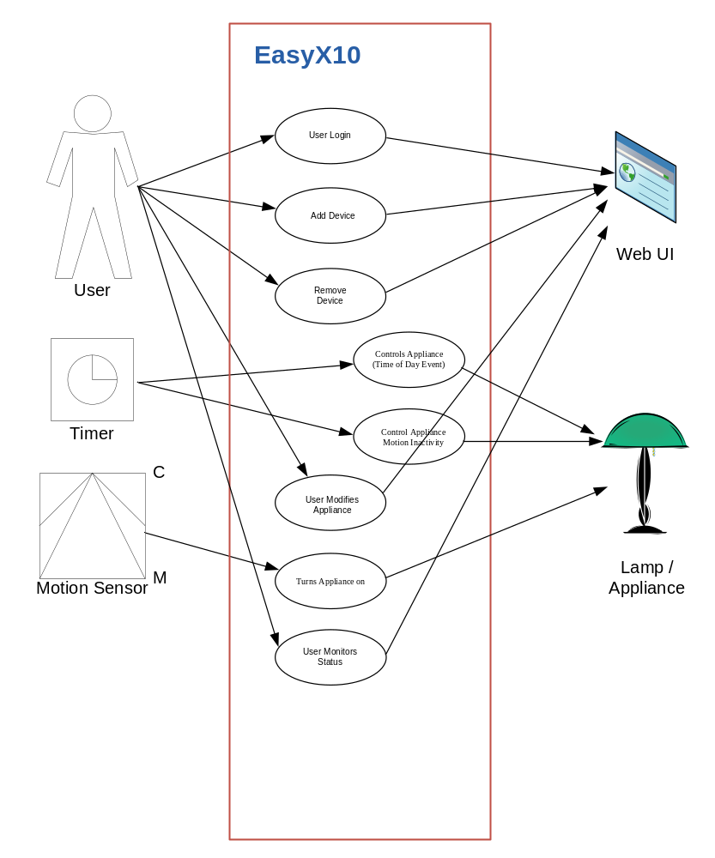
3.4 Activity Diagrams
Activity diagrams for selected use-cases.
4.0 Structural Model
This section describes the structure and logical organization of the data supporting the system. It describes analysis classes/objects, their responsibilities and relationships. Class diagrams, object diagrams and CRC cards are used to represent the structural model
4.1 Class/Object List
Potential Classes | Type | Matching Criteria | Include
User Interface | Things | Retained Information, Needed Services, Multiple Attributes, Essential Requirements | Yes
X10 Control Module | External Entity | Retained Information, Needed Services, Multiple Attributes, Common Operations, External Entity | Yes
Device | Things | Retained Information, Needed Services, Multiple Attributes, Common Attributes, Common Operations | Yes
Appliance Device | Things | Retained Information, Needed Services, Multiple Attributes, | Yes
Motion Device | Things | Retained Information, Needed Services, Multiple Attributes, | Yes
Event | Occurrence | Retained Information, Needed Services, Multiple Attributes, Common Attributes, Common Operations | Yes
Timer Event | Occurrence | Retained Information, Needed Services, Multiple Attributes, | Yes
Motion Event | Occurrence | Retained Information, Needed Services, Multiple Attributes, | Yes

4.2 Class Diagram
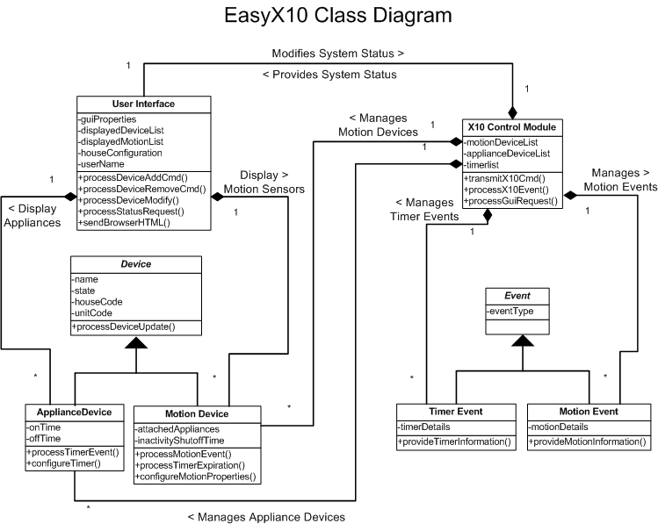

4.3 Object Diagram
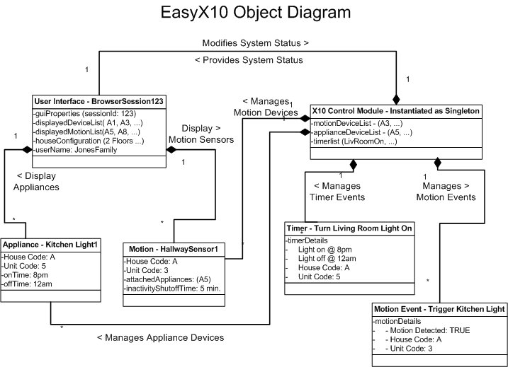
4.4 CRC Cards
N/A

5.0 Behavioral Model and Description
A description of the internal behavior (i.e. dynamic view) of the software system is presented.
5.1 Description for software behavior
A detailed description of major events and states is presented in this section.
5.1.1 Events

1. User authenticates – When the user navigates to the login page using their web browser, they are presented with a log in screen. After entering a username and password, the user clicks the login button. This sends an HTTP post request to the tomcat web server. Tomcat then passes off the request to XXXXXX and the system compares the username and password entered with the one stored in the easy10 properties file. If the user provided valid login information then tomcat responds to the POST request by displaying the Monitor web page. If the username and or password was invalid the login page is redisplayed an “Invalid login Credentials” message.

2. User adds an appliance with a Timer – When a user adds an appliance, they have the option to set a time to turn the device on and off. Upon submitting the necessary data to the easy10 system through the web UI, tomcat receives the post request and hands the data to the X10 Control Module. The X10 Control module creates an appliance object and a timer object that continuously checks to see if the system time matches the Timer objects On or Off Time attribute. If the times match, the timer sends an X10 event to the CM11A subsystem, which then sends an X10 event out to the physical CM11A interface, across the house electrical wiring and into the appliance device where it’s state is either changed to on or off.

3. User deletes a device – When a user presses the delete button on a device displayed within the web UI, it triggers an http post request to the tomcat web server. Tomcat passes the unique ID of the device to delete (in this case the unique ID is the device name) to the X10 Control Module. The module then looks up the device Id in its appliance list and deletes it. The updated device monitor page is then redisplayed to the user.
See User monitors status event for how the monitor page is displayed.

4. User monitors status – When the user requests the monitor status page from the Tomcat Web server, the web application must first retrieve the state of all the devices in the system from the X10 Control Module. The X10 Control module maintains a list of all device objects and queries them for their state. Once retrieved, the web UI displays device status.

5. Motion sensor detects motion – When a Hawkeye motion sensor detects motion it sends and RF signal containing its house and unit code to a TM751 Transceiver Module. The transceiver translates the signal into and X10 message and broadcasts it across the house electrical wiring. The CM11A module receives the message and passes a Motion Event to the X10 Control Module. The X10 control Module looks up the device in its list and passes the event to all motion sensor objects with a matching house and unit code. The motion sensor object checks to see if it’s supposed to be active during this time period. If no, it ignores the event. If yes it sends an X10 event (On or Off) to the CM11A Module. The CM11A repeats the X10 event (containing the appliance house and unit codes) across the electrical wiring to a listening X10 module and the appliance will turn on.

6. Timer changes appliance state – When an internal system timer matches the current time in the system, it sends the scheduled X10 event (On or Off) to the X10 control Module. The X10 Controller module then looks up the device in its list of appliances and passes the event to all devices with matching unit and house codes. The event is then processed by the appliances objects. They initiate sending the X10 command to the CM11a and update their states accordingly. When the CM11A receives the event object, (containing the appliance house and unit codes and what function to perform) it broadcasts it out in the form of an X10 message across the electrical wiring to any listening X10 module. The module then turns on or off depending on the contents of the message.

7. Timer detects absence of motion – Timer objects contain an attribute called an inactivity Timer that indicates how long to wait after motion is detected before it determines a room unoccupied. When a timer object detects motion it may trigger an event (see #6 above.) In addition to this, it starts the inactivity timer. If no motion is detected after the inactivity duration has elapsed, then a motion event is triggered and the events in #6 take place. If motion is sensed before the inactivity duration expires, then the timer is to zero and it starts over again.

5.1.2 States
A listing of states (modes of behavior) that will result as a consequence of events is presented.
Classes | Potential States
User Interface | Displaying, sending, receiving, comparing (uname/pw)
X10 Control Module | Sending state / receiving state  Sending event /receiving event  Comparing, deleting
X10 Appliance Module | Receiving X10, on, off
Hawkeye Motion Sensor | Detecting motion, waiting, sending RF
Appliance Object | On, Off, validating, receiving event, sending event
Motion Sensor Object | Active, inactive, sending event, receiving event
Event | processed
Timer | waiting for event / comparing times, resetting, receive event, send event
Motion Event | processed
Timer Event | processed

5.2 State Transition Diagrams
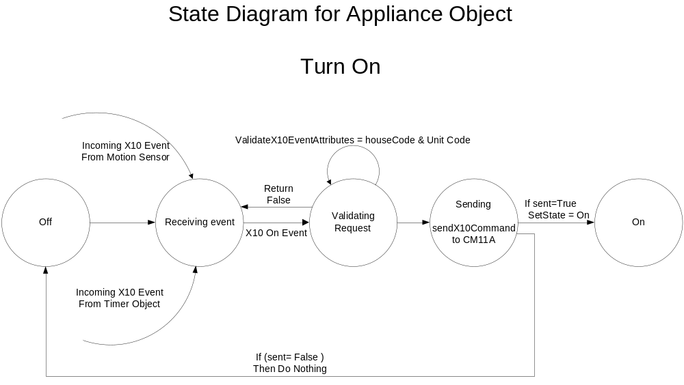
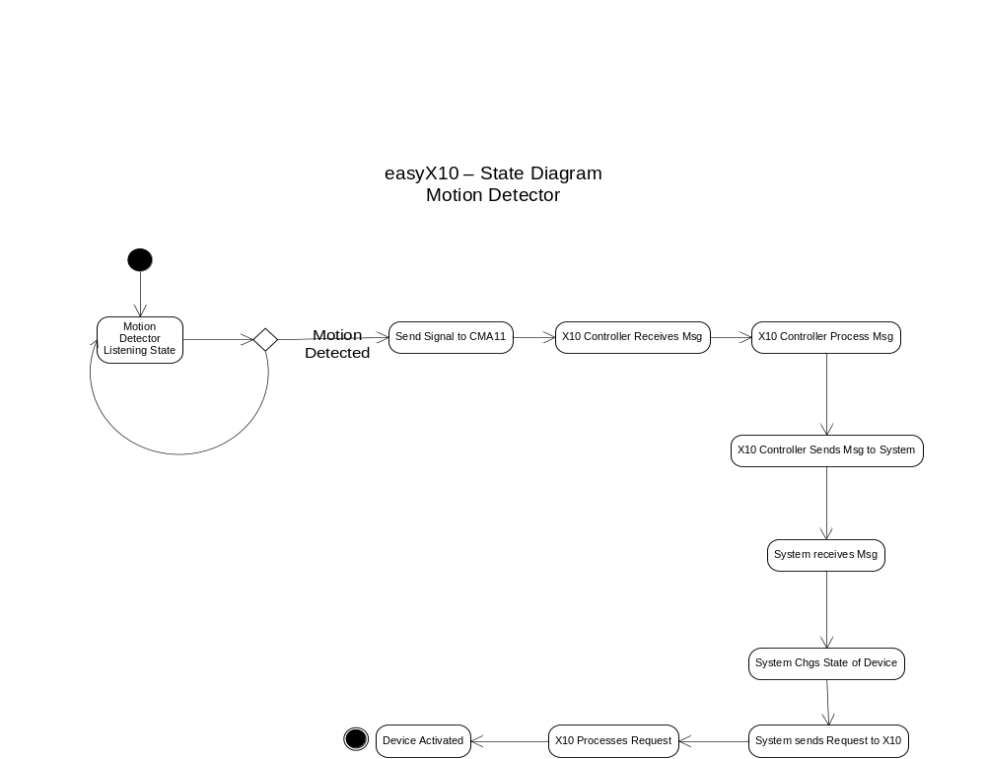
5.3 Sequence Diagrams
Depict the manner in which control is managed by the software.

Requirements Definition
This section details the functional and nonfunctional requirements of the system, in narrative text format.

Functional Requirements (option 1)
This section describes the details of the functional requirements of the EasyX10 application.

User Interface
This section describes the functional requirements for the User interface. The User interface is presented through a standard web-browser. The interface allows the user to configure and monitor the status of the system.

User enters ID and Password
- By default, the user is provided with a Login Screen.
- The user must enter a valid user ID and associated password.
- The user ID and password information is stored within the system control software.-
- The User ID is limited to 25 characters.
- The password is limited to 25 characters. The password characters have no restrictions.
- The user must press the Login Button to process the user ID and password.
- The user is only allowed to pass the login screen when a valid user ID and password pair have been entered.
- The user is allowed to attempt to enter an unlimited number of user ID and password pairs.
- Once the user enters a valid user ID and password pair, the Login Screen is replaced with the Main Status Screen.

User Selects Logout
- Each screen in the EasyX10 web application must have a Logout button.
- Selecting the logout button causes the screen to transition to the Login Screen with a blank user ID and password field.

User Selects System Status button
- Each screen in the EasyX10 web application must have a System Status button.
- Selecting the system status button causes the screen to transition to the Main Status Screen.

User Selects Floor to display
- The Main Status Screen provides a drop-down box to allow the user to select one of many possible floor layouts.
- The drop-down box provides these options:
- First Floor
- Second Floor

- Selecting a floor from the drop down box causes the screen display to transition to a new display for the selected floor. If the currently displayed floor is selected, the screen does not transition from the current display.

User Selects Room Tile for room detail
- The Main Status Screen provides multiple outlines. Each outline represents a room on the currently displayed floor.
- Each room can have either zero or many Icons displayed within the outline for any given room. Each Icon represents a Device assigned to the room. Each Icon identifies the Name of the Device in addition to the current State of the Device by virtue of Text or Icon shape/style. (Note: For an Icon, do we nail down some specifics to describe how it should look?).
- A user can select a Room Tile in order to drill down and view more specific details in regards to the devices assigned to the room. The user must double clock on the Room Tile title, located in the upper left hand portion of the Room Tile.
- When a Room Tile is selected, the screen transitions to the Room Screen.
- The Room Screen displays a single outline for the selected Room.
- Only the Icons associated with a specific room are shown within the outline on the Room Screen. Similar to the Main Status Screen, each Icon in the Room Screen identifies the current State of the Device(s) by virtue of Text or Icon shape/style.

User Repositions Icons in Room Screen
- The Room Screen displays all the Devices assigned to a room as individual Icons. Using the mouse, the user can reposition any of the Icons to any location within the defined outline. Icons cannot overlap each other.
- Note: Can the user move Icons on the System Status Screen too?

User Adds Device
- The Room Screen provides a Add Device button.
- Selecting the Add Device button causes a new Icon to appear in the Room outline. The new Icon will be highlighted to identify it.
- Coincident with a new Icon appearing, a Data Entry box will appear adjacent to the room outline.
- By default, the Data Entry box will display fields associated with an Appliance Device.
- The user chooses which type of Device is being added by virtue of the Type drop down box. The choices in the Type drop down box are:
- Appliance
- Motion Detector
- After changing the drop down box, the appearance of the Data Entry box will change if the Type field changes. If the Type field doesn't change, the Data Entry box will remain the same.
- For Appliance Devices, the following fields are displayed:
- Device Name. The Device Name must be unique for each Device defined in the EasyX10 application. Duplicate Device names are not allowed. The Device Name is limited to 25 characters.
- House Code. The House Code is provided by a drop down box. The drop down box provides the alpha characters A through P inclusive (16 possible selections).
- Unit Code. The Unit Code is provided by a drop down box. The drop down box provides the numbers 1 through 16 inclusive (16 possible selections).
- Status. The Status is provided by a drop down box. The drop down box provides two choices, ON or OFF.
- Timer. The Timer field is provided by a drop down box. The drop down box provides two choices, ON or OFF.
- On Time: The On Time field contains three fields, Hour, Minute, and AM/PM. The Hour is provided by a drop down box. The drop down box provides the numbers 1 through 12 inclusive. The Minute field is provided by a drop down box. The drop down box provides choices of 0, 5, 10, 15,...55 in increments of 5 minutes. The AM/PM field is provided by a drop down box. The drop down box provides two choices AM or PM.
- Off Time. The Off Time field has the same rule set as On Time.
- For Motion Detector Devices, the following fields are displayed:
- Device Name. The Device Name must be unique for each Device defined in the EasyX10 application. Duplicate Device names are not allowed. The Device Name is limited to 25 characters.
- House Code. The House Code is provided by a drop down box. The drop down box provides the alpha characters A through P inclusive (16 possible selections).
- Unit Code. The Unit Code is provided by a drop down box. The drop down box provides the numbers 1 through 16 inclusive (16 possible selections).
- Activity Window. The Activity Window field is provided by a drop down box. The drop down box provides two choices, ON or OFF.
- Activity From. The Activity From field has the same rules set as defined for the On Time of the Appliance Device.
- Activity To. The Activity To field has the same rule set as Activity From.
- Inactivity Timer. The Timer field is provided by a drop down box. The drop down box provides two choices, ON or OFF.
- Inactivity Timeout. The Inactivity Timeout has the same rule set as the Minute field of Activity From.
- Associated Appliances. This field is provided by a drop down list. The drop down list provides a list of all Appliance Devices. Appliance Devices are associated with the Motion Detector using a Check Box.
- The user is required to section all necessary fields.
- After filling in the necessary fields, the user must select the Add button below the Data Entry box in order to complete the Add transaction.
- Upon recognizing the Add button, the system is required to validate the fields.
- If all fields are validated, the Room Screen is updated by removing the Data Entry box. The highlighted Icon is un-highlighted and the new Icon is updated with its new name and current state display.
- If the fields are not validated, the user is informed of the invalid fields by: Note: How are we going to handle this?
- The user can select the Cancel button at any time to abandon the Add Device function. When the Cancel button is selected, the screen is updated by removing the Data Entry box.
- The user can select the Cancel button at any time to abandon the Add Device function. When the Cancel button is selected, the screen is updated by removing the Data Entry box.

User Modifies Device
- The user can modify the parameters of a Device by double clicking on the Device Icon from the Room Screen.
- After selecting a Device Icon on the Room Screen, a Data Entry box will appear adjacent to the room outline.
- The fields of the Data Entry box will default to the current values assigned to the selected Device.
- The user is allowed to change all fields except for:
- After changing any necessary fields, the user is required to select the Update button to accept the changes.
- Upon recognizing the Add button, the system is required to validate the fields.
- If all fields are validated, the Room Screen is updated by removing the Data Entry box. The highlighted Icon is un-highlighted and updated with current state display.
- If the fields are not validated, the user is informed of the invalid fields by: Note: How are we going to handle this?

User Removes Device
- The user can remove a Device by double clicking on the Device Icon from the Room Screen.
- After selecting a Device Icon on the Room Screen, a Data Entry box will appear adjacent to the room outline. The behavior is identical to Modify Device.
- The user can remove the device by selecting the Remove button in lieu of the Update button.
- When the Remove button is selected, a verification pop up window will be provided.
- The user must select either Yes or No in the verification pop up window.
- If the user chooses the Yes button, the screen is updated by removing the Data Entry box and the associated Device Icon from the screen.
- If the user chooses the No, the screen is restored to its state prior to the confirmation pop up window.
- The user can select the Cancel button at any time to abandon the Add Device function. When the Cancel button is selected, the screen is updated by removing the Data Entry box.

User Monitors Status
- The user can monitor the status of any device by simply referring to the Icon displayed on either the Main Status Screen or the Room Screen.
- The Icon state must be updated within one minute of the device state changing.
- Appliances Devices display these possible states:
- ON
- OFF
- Motion Detector Devices display these possible states:
- MOTION
- STILL

Appliance Devices
This section describes the functional requirements for Appliance Devices.
- Appliance Devices have the following parameters:
  - Name (25 characters)
  - House Code (A-P)
  - Unit Code (1-16)
  - Status (ON, OFF)
  - Timer (ON, OFF)
  - On Time (Hour, Minute, AM/PM)
  - Off Time (Hour, Minute, AM/PM)
- Appliance Devices can turn ON or OFF with user control by virtue of the Status drop down field in the Data Entry box provided by the Room Screen when a Device is selected using a double click. After the Status field is changed and the Update button is selected, the Device will transition to either ON or OFF. An X10 message is transmitted and the real Device must follow the ON or OFF state within five seconds of pressing the Update button.

Motion Devices
This section describes the functional requirements for Motion Detector Devices.
- Motion Detector Devices have the following parameters:
  - Name (25 characters)
  - House Code (A-P)
  - Unit Code (1-16)
  - Status (MOTION, STILL)
  - Activity Window (ON, OFF)
  - Activity From (Hour, Minute, AM/PM)
  - Activity To (Hour, Minute, AM/PM)
  - Inactivity Timer (ON, OFF)
  - Inactivity Timeout (Minutes)
  - Associated Appliances (List of Appliances)
- Motion Detectors turn ON Appliance Devices after a Motion Detector Device transmits a Motion Event.
  - Appliance Devices are associated with Motion Detector Devices by virtue of the Appliance Associated drop down box available in the Data Entry box made visible when the Motion Detector Device is selected from the Room Screen.
  - If the Activity Window field for the Motion Detector is set to NO, then each Appliance Device associated with the Motion Detector Device will transition to the ON state after receiving a Motion Event.
  - If the Activity Window field for the Motion Detector is set to YES, then the current system time is compared to the Activity Window From and Activity Window to fields. If the current system time is within the range of the Activity Window, then each Appliance Device associated with the Motion Detector Device will transition to the ON state.
  - If either (a) or (b) occur, an X10 message is transmitted and the real Device(s) must follow the ON or OFF state within five seconds of the current system time.

Timer Controls
This section describes the functional requirements for Timer Controls.
- Appliance Devices can turn ON or OFF with automatic timer control by virtue of the Timer, On Time, and Off Time fields available in the Data Entry box made visible when the Appliance Device is selected from the Room Screen.
  - When the Timer field is set to ON and the current system time matches the time found in the On Time field, the Device state will change to ON.
  - When the Timer field is set to ON and the current system time matches the time found in the Off Time field, the Device state will change to OFF.
  - If either (a) or (b) occur, an X10 message is transmitted and the real Device must follow the ON or OFF state within five seconds of the current system time.
- Motion Detector Inactivity Timer turns OFF Appliance Device after motion inactivity.
  - This feature is controlled by virtue of the Inactivity Timer and Inactivity Timeout fields available in the Data Entry box made visible when the Motion Detector Device is selected from the Room Screen.
  - If Inactivity Timer field is set to ON for a Motion Detect Device, then the system will monitor the amount of time since the last Motion Event is transmitted by the Motion Detector. If the amount of time exceeds the time defined by Inactivity Timeout, then the Appliance Device state will transition to OFF. Each Appliance Device associated with the Motion Detector Device will transition to the OFF state. An X10 message is transmitted to each device and the real Device(s) must follow the OFF state within five seconds of the current system time.
  - The units of measure for Inactivity Timeout are minutes.
  - If the Inactivity Timer field is set to OFF for a Motion Detector Device, then the system must not turn an Appliance OFF which was turned ON by a Motion Detector Device.

6.2 Non-Functional Requirements
A list of non-functional requirements for the system (as discussed in class), including performance, reliability, security, etc. Requirements listed should be specific, quantifiable and verifiable.
6.2.1 Performance
Metrics:
A) Number of transactions to be processed per second
B) Response time to user input.
6.2.1.1 The User Interface
Number of transaction will be low and dependent on the number of devices installed by the User.
The system will respond to user requests in 5 seconds or less.
6.2.1.2 The Appliance Devices
Will respond to commands in 5 seconds or less.
6.2.1.3 The Motion Devices
Will respond to commands/activity in 5 seconds or less.
6.2.1.4 The Timer Controls
Will respond to commands in 5 seconds or less.
6.2.2 Reliability
Metrics:
A) Mean time to failure
B) Rate of occurrence of failure
6.2.2.1 The User Interface
The System will only be – offline – if some external event forces the Server to be rebooted.
6.2.2.2 The Appliance Devices
6.2.2.3 The Motion Devices
Motion Devices have a life expectancy of xxxx hrs.
6.2.2.4 The Timer Controls
6.2.3 Availability
Metrics:
A) Probability of failure on demand
6.2.3.1 The User Interface
The system will be available 7x24 – or as long as the Server hosting the application is fully operational.
6.2.3.2 The Appliance Devices
Lights are expected to last a minimum of 12 months before requiring bulb replacement.
6.2.3.3 The Motion Devices
Motion Devices will be operational 7 x 24.
Based on manufactures specifications, these devices have a expected life of xxxxx.
6.2.3.4 The Timer Controls
Time Controls will be operational 7 x 24.
6.2.4 Usability
Metrics:
A) Time take to learn 75% of user facilities
B) Average number of errors made by users in a given time period
6.2.4.1 The User Interface
The User will be able to manage the system after spending 30 minutes reviewing the Installation Documentation and System Overview Documentation
The number of user errors will be with the range of 1 for every 300 times the user interacts with the system. (This error rate could increase if the user fails to spend the recommended 30 minutes reviewing product documentation and instructions.)

6.2.4.2 The Appliance Devices
6.2.4.3 The Motion Devices
6.2.4.4 The Timer Controls
6.2.5 Robustness
Metrics:
A) Time to re-start after system failure
The system is designed/configured to automatically re-start at system boot-up time.
6.2.5.1 The User Interface
The User can manually shutdown the system from the User Interface should maintenance be needed on the server hosting the application.
6.2.5.2 The Appliance Devices
6.2.5.3 The Motion Devices
6.2.5.4 The Timer Controls
6.2.6 Integrity
Metrics:
A) Maximum permitted data loss after system failure.
There will be no data lost as the result of a system failure, because changes are written to the single configuration file, by the User whenever a configuration change is made.
A Power failure due to weather or man-made accident will make the service in-operable. To recover from this situation, the User must restart the server hosting the application.

6.2.6.1 The User Interface
6.2.6.2 The Appliance Devices
6.2.6.3 The Motion Devices
6.2.6.4 The Timer Controls

