Homework 6
CS-673 – Software Engineering
12/02/2008

Team EasyX10
SOFTWARE PROGRAM OVERVIEW

Version 0.2
Bruce Deyle
Jim Duda
Damon Gabrielle
John Winderbaum

Revision | Date | Author | Change Description
0.1 | 11/26/08 | BDeyle | Initial Creation
0.2 | 11/26/08 | Jduda | Added some additional directory structure

TABLE OF CONTENTS
1 Overview of Software Programs and Project Artifacts 3
2 Src Directory Definition 7
3 Test Directory Definition 11
4 Web Directory Definition 12

TABLE OF FIGURES
Figure 1 - EasyX10 Project Directory Structure 3
Figure 2 - EasyX10_Application Directory Structure 5

Overview of Software Programs and Project Artifacts
All project documentation including program source code has been retained in a SVN Repository on Google. The directory structure for the Repository is shown below in Figure 1 - EasyX10 Project Directory Structure.
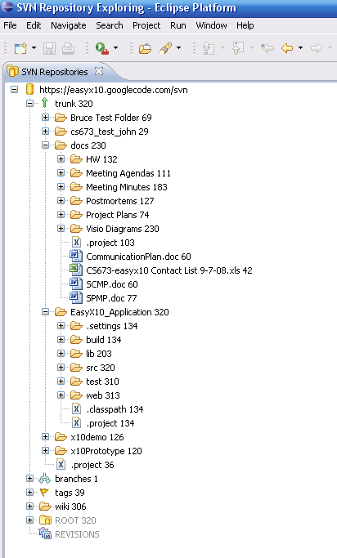
Figure 1 - EasyX10 Project Directory Structure
The EasyX10 application is stored in the source repository in the EasyX10_Application tree. The directory structure for the application is shown below in Figure 2 - EasyX10_Application Directory Structure.

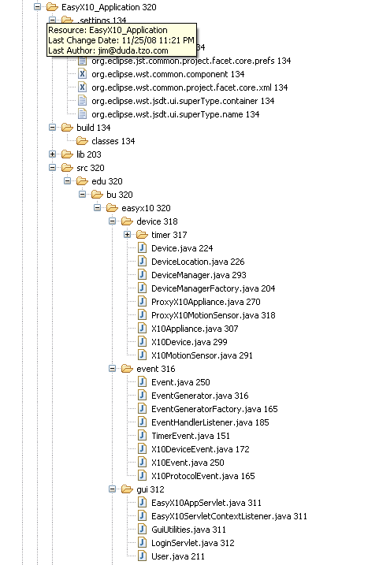
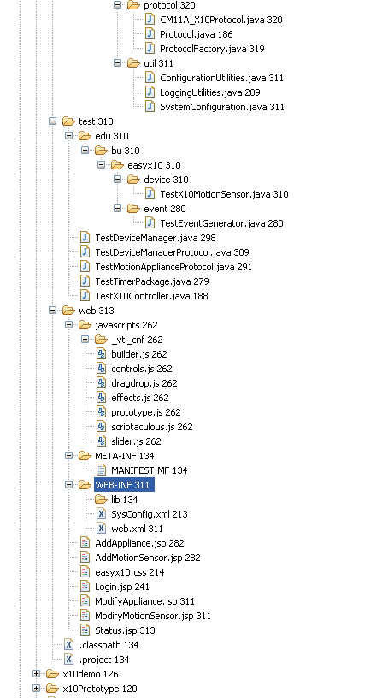
Figure 2 - EasyX10_Application Directory Structure
The lib directory contains various library components which support the application. These components in include jar files and shared object files. The lib directory is organized according to operating system.

The src directory contains all of the various java classes which support the EasyX10 application. Section 2 Src Directory Definition, provides a brief description of all the class files in the src directory.

The test directory contains all the Junit and system level test applications which are used to test various individual classes (Junit) and system integration testing. Section 3 Test Directory Definition, provides a brief description of all the application files in the test directory.

The web directory contains all the various artifacts used to construct the web based user interface. Section 4 Web Directory Definition, provides a brief description of all the application files in the web directory.

Src Directory Definition
This section provides a brief description of all the components in the src directory.
File Name | File Description
src/edu/bu/easyx10/device/timer | The device/timer directory contains all the class definitions which provide timer services for the device classes.
DeviceTimer.java | The DeviceTimer class is the base class of the Timer package. It is an abstract class used by the device class to perform time related events. It is only responsibility is to firing events to the EventGenerator at a specific moment in time. Actual device Timer implementation is handled by the derived classes. Timer contains only one attribute; Event EventToFire and contains two methods to get and set EventToFire. It also contains an abstract method called startTimer() that must be overridden by the derived class.
TriggerTimer.java | TriggerTimer is derived from Timer. It’s purpose is to Trigger events at a specific time of day. When instantiating a triggerTimer, you must pass in an event to fire. You must also set the trigger time after instantiation and then call startTimer() to turn on the timer.
WaitTimer.java | This is the concrete class for the WaitTimer class. This version of the DeviceTimer provides a very simple function. The object is given a number of seconds to wait. Once the number of seconds has occurred, the Event defined by eventToFire is sent to the EventGenerator.
src/edu/bu/easyx10/device | The device directory contains all the class definitions for the X10 objects which are used to model the state of the real X10 components.
Device.java | The Device class is an abstract base class that’s used to model physical devices within the EasyX10 system. A device has only two attributes; a name and a location. The name is the unique identifier amongst other devices in the system, and the location is a string representing its physical location in the GUI.
DeviceLocation.java | Class used to store the location of a device in a building. Note that the Origin of the Coordinate System is in the upper left corner of the floor.
DeviceManager.java | DeviceManager is the interface between the GUI and the device class.  Its main function is to simplify interaction and management of devices for the GUI Package. It does this by providing access to a list of devices and proxy's changes from the GUI to the device objects themselves using proxy devices. It also allows or rejects the creation of devices with duplicate names, and regularly saves configuration data out to disk so that it persists between system restarts.
DeviceManagerFactory.java | This class provides the singleton generator for the DeviceManager class. All classes which desire to use the DeviceManager should fetch the object reference using the getDeviceManager method.
ProxyX10Applicance.java | ProxyX10Appliance is derived from and identical to X10Appliance except that it overrides the X10Appliance constructor such that they don’t instantiate TriggerTimer OnTime and OffTime objects. Instead, ProxyX10Appliancejust sets two Time object attributes with the same names; OnTime on OffTime. ProxyX10Appliance objects are instantiated in the GUI and are passed off to DeviceManager. DeviceManager then creates X10Appliance Objects by passing a proxy object into the constructor. ProxyX10Appliance does not contain any of it’s own methods; only overridden ones.
ProxyX10MotionSensor.java | The ProxyX10MotionSensor class is an extension of the X10MotionSensor class. It's purpose is to provide a vehicle to import and export the various attributes of the X10MotionSensor class to the GUI layer.
X10Appliance.java | The X10Appliance class is derived from the abstract class X10DeviceClass.  It's purpose is to model the state and behavior of X10 appliance modules. The state of X10 devices are controlled either by device updates coming down from the Device manager from the GUI package, or from incoming DeviceEvents published by EventGenerator. X10Applianc objects also implement TriggerTimers to turn lights on and off during a particular time period. It's important to note that incoming events are processed regardless of whatever Period is set in a TriggeTimer.
X10Device.java | The X10Device class is the second level of abstraction above the Device base class. All X10Devices have attributes State, DeviceCode and a HouseCode. Real X10 modules have house and device codes as well. The getters and setters for DeviceCode and HouseCode are implemented in this class, while setState is implemented in a Derived Class since states are Device Specific.
X10MotionSensor.java | The X10MotionSensor is a concrete implementation of the X10Device class. The X10MotionSensor is configured with an X10 house and device code. This class listen to DeviceEvents from the Protocol module. When a DeviceEvent matches the house and device code, then a motion event occurs. The activity window is checked if necessary. Motion events cause X10 ON events to be delivered to each of the Appliances stored in the appliance list. A timer is activated to wait a certain number of seconds. When the timer expires, and X10 OFF event is sent to the same set  of appliances which where previously turned on when the original motion event occurred.
src/edu/bu/easyx10/event | The event directory contains all the classes which support events. Events are passed between disassociated objects via the EventGenerator class to the EventListener class. Collectively, this system employ the Observer design pattern.
Event.java | This is the abstract base class for the Event class. Concrete Event types must extended from this class.
EventGenerator.java | This class provides the Event Generator. Events to be transmitted are provided to the fireEvent method. The fireEvent method distributes the  Event to the proper EventHandlerListener method for reception. The EventGenerator maintains a list of objects which are listening to events.
EventGeneratorFactory.java | This class provides the singleton generator for the EventGenerator class. All classes which desire to use the EventGenerator should fetch the object reference using the getEventGenerator method.
EventHandlerListener.java | The EventHandlerListener class is an implementation which provides the receive methods for Events which are delivered from the EventGenerator class.
TimerEvent.java | This is the concrete class for the TimerEvent class. This class inherits all attributes and methods from the abstract base Event class.
X10DeviceEvent.java | This is the concrete class for the X10DeviceEvent class. This class inherits all attributes and methods from the abstract base X10Event class.
X10Event.java | This is the abstract base class for the X10Event class. Concrete X10Event types must extended from this class. This class inherits all attributes and methods from the abstract base Event class.
X10ProtocolEvent.java | This is the concrete class for the X10ProtocolEvent class. This class inherits all attributes and methods from the abstract  base X10Event class.
src/edu/bu/easyx10/gui | The gui directory contains all the classes which support the Gui package.
EasyX10AppServlet.java | The EasyX10AppServlet represents the main controller for the GUI package. Once a user has logged into the system all of their requests go through this servlet. The servlet will identify the type of request and perform the necessary processing.  The EasyX10AppServlet is a typical Java Servlet that extends HttpServlet.
EasyX10ServletContextListerner.java | This class implements a ServletContextListener for the EasxyX10 Application. The class only implements the contextInitialized() method that is called on application initialization.
GuiUtilities.java | This class implements several static helper methods for the EasyX10 user interface. This includes methods to generate html code and create devices based on user input.
LoginServlet.java | The LoginServlet class implements the functionality to process a user’s request to log into the EasyX10 System. The main method of the class doPost() is called when the user submits a request to log in.  LoginServlet is a typical Java Servlet that extends HttpServlet.
User.java | This class stores data about a user.
src/edu/bu/easyx10/protocol | The protocol directory contains all the classes which support the Protocol package.
CM11A_X10Protocol.java | This class implements the controller interface for the CM11A X10 controller. Input messages come in via the processProtocolEvent( ) method, which is an implementation of the EventHandlerListener interface. Output messages are provided to the EventGenerator:fireEvent( ) method. During construction, we register with the EventGenerator to listen for inbound events.
Protocol.java | This class provides the abstract base class for the protocol package. All concrete protocol classes must be derived from this class. This base class provides a Queue for inbound transmit messages. Inbound transmit messages arrive via the EventHandlerListener interface,  specifically, the processProtocolEvent( ) method.
ProtocolFactory.java | This class provides the singleton generator for the Protocol class.  The initProtocol( ) must be called at least once to cause all the protocols to be instantiated.
src/edu/bu/easyx10/util | The util directory contains all the classes which support the Utilities package.
ConfigurationUtilities.java | This class implements static methods that provide access to the EasyX10  * configuration data.
LoggingUtilities.java | This class implements a couple of static methods that provide the  * EasxyX10 application a way to log error and informational messages.
SystemConfiguration.java | This class stores the general system configuration data  * required for the EasxyX10 Application.

Test Directory Definition
This section provides a brief description of all the components in the test directory.
File Name | File Description
test | The test directory contains all the system integration tests which test various classed in combination.
TestDeviceManager.java | The purpose of the TestDeviceManager class is to test Device manager methods.  * It creates a proxyX10Appliance and runs through all the available methods  * in DeviceManager.
TestDeviceManagerProtocol.java | Application which exercises an integrated test of Protocol, X10Appliance, and X10MotionSensor.
TestMotionApplianceProtocol.java | Application which exercises an integrated test of Protocol, X10Appliance, and X10MotionSensor.
TestTimerPackage.java | The purpose of this package is to test TriggerTimer Events. It instantiates a  * Calendar date and then passes it into the TriggerTimer.
TestX10Controller.java | Application which exercises the Protocol package, specifically, the CM11A_X10Protocol class. A simple API allows an operator to send/receive commands to X10.
test/edu/bu/easyx10/event | The event directory contains all the Junit tests for the Event package.
TestEventGenerator.java | This Junit test provides a fully randominzed test of all the classes in the Event package.
test/edu/bu/easyx10/device | The event directory contains all the Junit tests for the Device package.
TestX10MotionSensor.java | This Junit test provides a fully randomized test of the X10MotionSensor class. This test also tests the ProxyX10MotionSensor class.

Web Directory Definition
This section provides a brief description of the components in the web directory. Note that only the files that are relevant to the EasyX10 application have been included. Some files that are generic to a web application and are auto generated have been omitted.
File Name | File Description
web/javascript | This directory contains the Javascript files for the Scriptaculous open source library. (http://script.aculo.us/) The library provides functionality to enhance the EasyX10 User Interface.
web/WEB-INF | This directory contains configuration files for the application.
SysConfig.xml | XML file that stores configuration data such as the list of users, the Serial Port Name and other required application data.
Web.xml | The configuration file for the web application. Defines the servlets and other web application data.
AddAppliance.jsp | The AddAppliance JSP page displays the floor plan and a form to enter new Appliance data. The user can enter all of the details of the new appliance and reposition the new appliance to the desired location on the floor. When the user submits a request to add a new device it is processed by the EasyX10AppServlet.
AddMotionSensor.jsp | The AddMotionSensor JSP page displays the floor plan and a form to enter new motion sensor data. The user can enter all of the details of the new motion sensor and reposition the new motion sensor to the desired location on the floor. When the user submits a request to add a new device it is processed by the EasyX10AppServlet.
Easyx10.css | This file is a standard Cascading Style Sheet that contains style information for the various EasyX10 JSP pages.
Login.jsp | The Login JSP page is the entry point for the EasyX10 Application. It presents a form where the user must enter a username and password. When the form is submitted the LoginServlet is called to process the request.
ModifyAppliance.jsp | The ModifyAppliance JSP page displays the floor plan and a form to modify appliance data. The user can modify details of the appliance and reposition the appliance to a new location on the floor. When the user submits a request to modify a device it is processed by the EasyX10AppServlet.
ModifyMotionSensor.jsp | The ModifyMotionSensor JSP page displays the floor plan and a form to modify motion sensor data. The user can modify details of the motion sensor and reposition the motion sensor to a new location on the floor. When the user submits a request to modify a device it is processed by the EasyX10AppServlet.
Status.jsp | The Status JSP page displays a floor of the house and all of the devices on that floor. Each device displays an indication of its current status. The user can select a device to modify its properties or add a new device through the menu bar.
web/resources | This directory contains images used on the EasyX10 JSP pages.
Project Tracking Appendix

Project Time Line Estimates and Actuals:

HW # | Milestone/Deliverable | Due  Date | Estimated Hours | Actual Hours
1) | Communication Plan | 9/9/08 | 20 hours | 35.5
2) | Software Configuration Mgt Plan (SPMP) | 9/16/08 | 32 hours | 39 hours
3) | Software Project Mgt Plan | 9/23 | 35 hours | 44.5 Hours
4) | Software Requirements Specification (SRS) | 10/21/08 | 80 hours | 110 hours
5 | Software Detailed Design Document(SDD) | 11/04/08 | 80 hours | 130
6 | Operational System/Prototype | 12/02/08 | 120 hours | 188
7 | Individual Project Assessments | TDB | 25 hours | TDB
8 | Final Project Presentations | TDB | 40 hours | TDB

Exercise 6 - Team Contributions

Activity | Bruce | John | Damon | Jim | Total
Brainstorming | 0 | 0 | 0 | 0 | 0
Meetings | 10 | 10 | 10 | 10 | 40
Coding | 0 | 30 | 35 | 23 | 88
Unit Testing | 0 | 4 | 5 | 13 | 22
System Integration Testing | 0 | 2 | 2 | 12 | 16
Final Presentation | 12 | 0 | 0 | 0 | 12
Document Editing | 2 | 1 | 0 | 1 | 4
Document Review | 3 | 1 | 1 | 1 | 6
Total | 27 | 48 | 52 | 60 | 188

* While Jim, John and Damon developed code, Bruce worked on final presentation.

