Team EasyX10
Software Configuration Management Plan
(SCMP)
9/16/2008

Bruce Deyle
Jim Duda
Damon Gabrielle
John Winderbaum

Software Configuration Management Plan
Acceptance of the Software Configuration Management Plan requires signoff from each project team member:
Approvals: Bruce Deyle ____Bruce Deyle date: 9/16/08
Jim Duda ____Jim Duda date: 9/16/08
Damon Gabrielle ____Damon Gabrielle date: 9/16/08
John Winderbaum ____John Winderbaum date: 9/16/08

1. Introduction
This Software Configuration Management Plan (SCMP) describes how the easyX10 Project is to be managed.

1.1 Acronyms
- COTS – Commercial, off the shelf (referring to readily available hardware and software products)
- IDE – Integrated Development Environment
- SVN – Subversion Source Management Software
- SLOC – Source Lines of Code
- SME – Subject Matter Expert
- SQA – Software Quality Assurance
- CI – Configuration Item
- CM – Configuration Management
- SCM – Software Configuration Management
- SCMP – Software Configuration Management Plan
- ROI – Return on Investment

1.2 Terms
- Trunk – SVN term for root of repository.
- Branch – A copy of the Trunk for private file editing.
- Subversion – An Open Source Configuration management Software.
- Eclipse – A Java IDE
- Artifact - A final or interim product of the project e.g., a document, source code, object code, test result

2. SCM Management

2.1 Organization
Role | Name
Executive Sponsor(s) | Prof. Bernstein
Project Leader | Will rotate among project team members
Software Engineers / Developers | All Team Members
Configuration Leader | John W.
Configuration Support Personnel | Jim D.
SQA Representative | Damon G.

2.2 SCM responsibilities
Role | Responsibilities
Executive Sponsor(s) | -Executive Project Oversight
Project Leader | -Publishes Mtg Minutes  -Publishes Mtg Agenda  -Coordinates work of all project team participants  -Prepares Chg Control Board Agenda  -Responsible for approval/disapproval of major issues  -Participates in Design Review Sessions
Software Engineers / Developers | -Develops and Unit Tests Software  -Creates Technical Design Documents  -Participates in Design Review Sessions  -Unit Test Changes before adding to repository  -Update repository in a timely manner
Configuration Leader | -Manages the repositories used to store all software and project management artifacts  -Develops the Methods and Procedures for managing- the repositories.  -Develops Replacement Tool Strategy in the event an existing product is taken off the market.  -Performs Audits on the SCMP to ensure accuracy throughout the life of the project.  -Maintain the CM log  -Performing Backups  -Coordinates Tagging and Release management  -Communicates major CM changes  -Installs CM tools  -Coordinates implementation of major changes to the baseline  -Reviews suggested SCMP change requests at team meetings.
Configuration Support Personnel | -Responsible for assisting new users with questions or problems with the repositories.  -Maintains CM wiki  -Serves as support/backup for configuration leader.
SQA Representative | -Ensures SCMP is adhered to  -Champions quality considerations during audits

2.3 Applicable policies, directives and procedures
- All configuration items are stored in Google code under the easyx10 project.
- Only easyx10 project members will have write access to the repository.
- Wiki will document processes and procedures for setting up CM environments.
- The Eclipse IDE with subversive plug-in is the approved mechanism for accessing the Google code repository.
- All current and previous versions of CI will be retained.
- Project Managers are responsible for including CM items in the meeting agenda in accordance with the schedule defined in section 4.
- Regular backups will be performed on the repository in accordance with section 4.
- Regular audit will be performed in accordance with section 4.
- Regular tagging of CIs will be performed in section 4.
- The team will follow the conventions defined in section 3.1.2

3. SCM Activities
The following section is grouped into six parts that describe the CM functions and tasks required for the easyx10 software project.
- Configuration Identification – Describes the process of how CIs come into being.
- Configuration Control – States the SCM approved methods for implementing changes to the project data.
- Configuration Status Accounting – Provides the mechanism for recording changes to all items under CM.
- Configuration audits and reviews – Methods used to conduct audits and reviews of the easyx10 CM structure.
- Interface Control - does not apply to this project.
- Subcontractor/Vendor Control – Describes the process to put versions of COTS products under CM.

3.1 Configuration identification
This section describes how easyx10 CIs are generated and their associated naming conventions.

3.1.1 Identifying configuration items
The process of identifying configuration items in the easyx10 project is a democratic one. As potential CIs are identified, team members have the responsibility to communicate (by email for auditing purposes) their existence to the configuration leader.
It is the configuration leader’s job to present the list of new artifacts to the team once per week. The team will come to a consensus of which items should become CIs with the project leader having the final say. If the project leader is not present then the configuration leader assumes the project leader’s duties for this task.
After the meeting the configuration leader will coordinate the creation of each new CI with its corresponding author.

3.1.2 Naming configuration items
It is the responsibility of each team member to name a configuration item using the following conventions:

Root Directory:

All documentation resides in the “docs” directory in the Subversion repository.

Source/Data files should reside in the “easyx10_project” directory in the Subversion repository.

Sub Directories:

When the configuration leader deems it necessary subdirectories shall be created to store all data files associated with a particular subject.

i.e. The “/docs/SRS/” subdirectory contains all material associated with the System Requirements Specification. This includes Use Cases, Visio Diagrams and other associated CIs.

File Name:

Files should have concise names that describe their contents.

Name should not contain version information. (This is recorded through the use of tags).

All meeting minutes and agenda items will have the date appended to the name of the document.

Version Tagging:

SVN tags are used to identify versions of particular CIs.

Every CI that is part of a release must have a tag.
The role of the configuration leader is to verify that each new CI is created using these conventions.

The excel spreadsheet ‘version_record.xls’ exists in the docs directory and maintains data about each major version of the project and the tag that exists on all elements to identify a version.

The ‘version_record.xls’ file has the following structure:

Milestone Name | SVN Tag | SRS version | ….
Initial Prototype | PROTO_DELIVERY_0.3 | 1.2 | ….

3.1.3 Repository Layout
The layout of the repository is as follows:

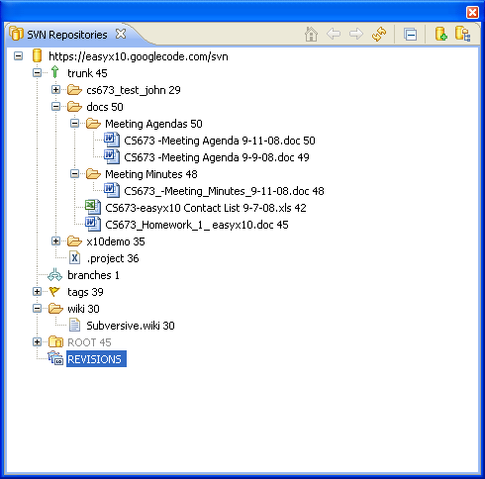
The trunk is the root of the project repository. The number after the trunk or any folder is an id number that’s dynamically assigned by the repository as versions change.
Within the Docs folder there are several subfolders. Meeting agenda and minutes have separate folders since there will be a large number of them. All remaining document will be stored directly in docs.

3.1.4 Acquiring configuration items
CI’s are accessed through the easyx10 Google Code Subversion Repository. The web page for the repository can be accessed at http://code.google.com/p/easyx10/ (read only versions of the CIs can be accessed via this site)

The Eclipse IDE is the only SQA approved method of acquiring a CI from the repository. In order to connect to the project the Subversive Eclipse Plug-in must be installed. For more information on installation see the Subversive Wiki entry. (Located at the project website noted above.)

When setup successfully each team member shall update/create/delete CIs through the eclipse interface.

3.2 Configuration control
This section describes the actual details of the CM process on the easyx10 project. The following steps are essential to ensuring version integrity of each easyx10 release.

3.2.1 Requesting changes
There are two main types of CIs that exist in the easyx10 repository. These are documents and source code (including associated data/configuration files).

Document changes shall be requested in the form of an email to the easyx10 Google Group (easyx10@googlegroups.com). The configuration leader will then approve the change and reply to the request with an email indicating approval or rejection (with an associated explanation).

Software related changes shall be requested at the object/package level in the form of an email to the easyx10 Google Group. This email must include the associated compilation units required to make a change and a description about the change. The configuration leader will consult the project leader and any necessary team members. The changes can only be implemented in the main trunk when the code has been reviewed and approval has been granted.

3.2.2 Evaluating changes
Changes will be evaluated by a subset of the project team that includes a designated SME (Subject Matter Expert).

Minor Changes (less than 100 SLOC) – The project leader designates a SME to review the changes.

Major Changes - For substantial changes a formal review must be held with at least half of the project team present.

The responsible engineer must fix all defects identified in the review before inclusion into the baseline will be considered.

Defect metrics shall be recorded at all major reviews. The metrics are then used to determine if the code needs to be re-reviewed after action items have been incorporated.

3.2.3 Approving or disapproving changes
Before changes can be approved for inclusion into the baseline, the associated engineer must complete a unit test activity. The engineer should also complete a subset of the easxyx10 regression test that applies to the particular changes.

Changes are to be approved by the project team via a valid communication method (email or in a project meeting). Ultimately, it is the duty of the project leader to approve a modification to the project. If the project leader is unavailable to approve changes, another member of the team shall be designated.

3.2.4 Implementing changes
Once a CI has been approved by the project leader for inclusion in the baseline, the configuration leader will coordinate this activity with the responsible engineer.

The engineer shall use the eclipse IDE to commit and merge the changes into the baseline version of the project (the trunk.) Once the trunk has been updated the engineer shall re-test the changes to verify no breakage has occurred. This activity shall be periodically audited by the configuration leader to ensure baseline integrity.

When the trunk is ready for a version release, the configuration leader shall tag all files associated with the release and update the version record.

3.3 Configuration status accounting
A CM log will be managed by the CM leader. This log is updated weekly to record any major CM activities that have taken place. This report will be stored in the ‘docs’ directory of the repository.

3.4 Configuration audits and reviews
CM audits and reviews are conducted in accordance with the schedule outlined in section 4. Audits shall be conducted every two weeks.

As part of an audit the CM leader shall review the configuration log and the version record for consistency. The CM leader also performs periodic reviews of merges from branches to the baseline. All audit/review findings are added to the CM log. If any major issues are discovered that could impact the integrity of the project’s baseline, a meeting will be called to address the CM leader’s concerns.

3.5 Interface control
Interface control does not apply to this project.

3.6 Subcontractor/vendor control
It is the responsibility of each team member to communicate software updates to the CM leader. The following COTS products will be archived in the repository for the production version of easyx10:

- Java SDK
- Eclipse IDE

The CM leader shall create a plan to handle the discontinuation of any of the above products. (Requirement of the production environment)

4. SCM Schedules
The schedule for configuration management reporting, archiving and upgrading is shown below:
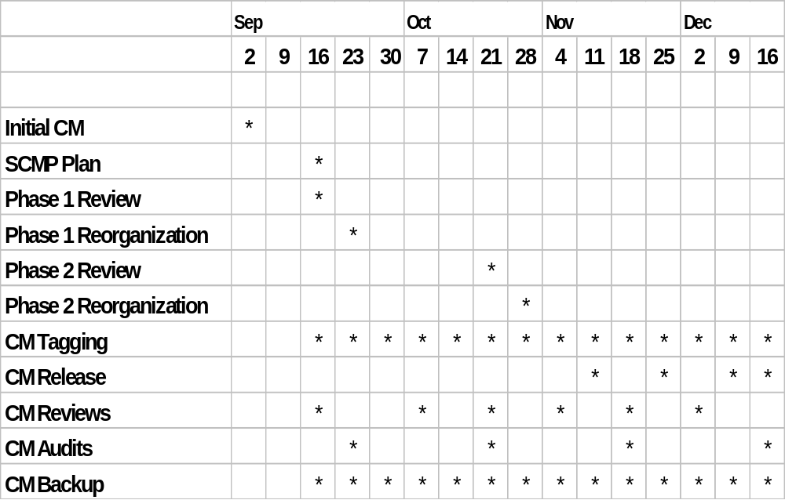
Configuration Management Schedule

The detail items for Configuration Management are defined as follows:

Initial CM
The initial CM database is created.

SCMP Plan
The Software Configuration Management Plan (SCMP) is created.

CM Reviews
Phase 1 - The documented SCMP is used to review the content of CM and decisions are made as to how the current content should be reorganized to meet the SCMP.
Phase 2 – Major review planned before project coding begins.
Regular Periodic reviews held to insure CM is meeting the team requirements.
CM Reorganization
The results of the CM review are used to execute changes to CM. All team members are aware than reorganization may be in progress. The team is required to insure all CM items are installed before the reorganization takes place. CM will be frozen during the reorganization.

CM Tagging & Backup
Weekly tagging and backup of the CM is done.

CM Release
Major releases are executed in preparation for project completion.

CM Audits
Periodic audits are done to insure what that all items in CM are accounted for.

5. SCM Resources
Each member of the team is responsible for communicating to the CM leader suggested updates / improvements to the SCMP. This will ensure that the SCMP accurately reflects the current process. To build this verification step into the software process, a schedule has been created to indicate when and what type of updates will be made. Please refer to the schedule in section 4 to see when periodic updates to the SCMP will be done.
The estimated time per week for SCMP roles are:

- Project Leader – 1hr
- Software Engineers / Developers – 1hr per developer
- Configuration Leader - 2hrs
- Configuration Support Personnel – 2hrs
- SQA Representative - 1hr
Usage of each team member’s time will be measured in hours per team member. For instance if all 4 team members attend a 1 hour meeting, the actual meeting cost is 4 hours. This data is recorded in the weekly effort chart and submitted with each homework.

It’s expected that all team members have reviewed and follow the practices in the latest revision of the communication plan defined in CSC673_Homework_1_easyx10.doc.

5.2 Schedules, and other non-code resources
Section 4 of this document contains the schedule for updating this plan.
Documents relative to this plan include:
- Communication Plan
- Software Project Management Plan
- Software Requirements Spec
- Software Design Document
- Test Plan
- Final presentation slides
- Weekly Postmortem Surveys
- Meeting Minutes
- Google Group easyx10@googlegroups.com email content
- Project Wiki

6. SCM plan maintenance
Plan maintenance will be ongoing and led by the CM leader scheduled in the Communication plan. Periodic audits of the SCMP are scheduled in section 4 of this document and will take place according to the schedule. The team will run through the following checklist as part of the audit for each item. The ROI must be considered in whether or not the change adds value:
- Reevaluate SCMP effectiveness
- Review processes improvements from postmortems – impact to document or source code repository structure
- Review schedule CM dates in section 4 and look for items that might change them.
- Identify efficiency improvements – Does the branching strategy or document creation process need adjusting to better accommodate working in parallel?
- Tool re-evaluation – new tool or additional feature available in an existing tool that could improve the process.

