Homework 4
CS-673 – Software Engineering
10/20/2008

Team EasyX10
SOFTWARE REQUIREMENTS SPECIFICATION
(SRS)
Version 0.5
Bruce Deyle
Jim Duda
Damon Gabrielle
John Winderbaum

Revision | Date | Author | Change Description
0.1 | 09/29/08 | JDuda | Initial Revision
0.2 | 10-5-08 | BDeyle | Capture each person’s section into single document, clean up fonts added Damon’s material
0.3 | 10-10-08 | BDeyle | Captured revised materials from Sunday review
0.4 | 10/12/08 | JDuda | Updated Device Interaction State Diagram
0.5 | 10/13/08 | BDeyle | Updated Activity Diagrams to match Use Cases 2 and 3 (includes Damon’s updates)

Table of Contents

1.0 Introduction 5
1.1 Purpose 5
1.2 Document Conventions 5
1.3 Intended Audience and Reading Suggestions 5
1.4 Project Scope 5
1.5 Definitions, Acronyms and Abbreviations 6
1.6 References 7
2.0 Product Description 8
2.1 Functional Overview 8
2.2 User Interface 10
2.2.1 Overview 10
2.2.2 Details 10
3.0 Functional Model 15
3.1 User profiles 15
3.2 Use-cases 16
3.4 Activity Diagrams 33
4.0 Structural Model 35
4.1 Class/Object List 35
4.2 Class Diagram 36
4.3 Object Diagram 37
5.0 Behavioral Model and Description 38
5.1 Description for software behavior 38
5.1.1 Events 38
5.1.2 States 39
5.2 State Transition Diagrams 40
6.0 Requirements Definition 44
6.1 Functional Requirements 44
6.1.1 User Interface 44
6.1.2 Appliance Devices 47
6.1.3 Motion Devices 48
6.1.4 Timer Controls 49
6.2 Non-Functional Requirements 50
6.2.1 Performance 50
6.2.2 Reliability 50
6.2.3 Availability 50
6.2.4 Usability 50
6.2.5 Integrity 50
6.2.6 Fault Management/Error Handling 50
6.2.7 Security 50
6.2.8 Installation/Upgrade/Fallback 51
6.2.9 Maintainability 51
6.2.10 Portability 51
6.2.11 Packaging 51
6.2.12 Management 51
6.2.13 Legal 51
6.2.14 Constraints 51
Project Tracking Appendix 52

SOFTWARE REQUIREMENTS SPECIFICATION

1.0 Introduction

Purpose
This document provides the System Requirements Specification (SRS) for the EasyX10 project.

Document Conventions
1.2.1 – All documents follow the naming standards outlined in the Configuration Management Plan.
1.2.2 – A definition of any term used in this document is defined in Section 1.5.

Intended Audience and Reading Suggestions
This document is written for the benefit of the stakeholders of the EasyX10 project.

- EasyX10 development team
- CS673 Professor
- Users of the Google Code EasyX10 open source application.

The reader is encouraged to read these external documents.

- System Configuration Management Plan (SCMP)
Author: EasyX10 Project Team
- Software Project Management Plan (SPMP)
Author: EasyX10 Project Team

Project Scope
The EasyX10 project is a web-based application designed to manage a network of X10 home automation devices. The application supports both manual and automatic control of X10 home lighting. The application interfaces with a CM11A control module, which is physically attached to a serial port on the computer, which hosts the application. The X10 control module interfaces with external X10 appliance devices and motion detectors using the X10 protocol through the home A/C wiring.
The application allows a user to manage X10 devices, manually control lighting conditions, and configure automatic lighting control based upon time events or motion events.

Definitions, Acronyms and Abbreviations

Term/  Acronym/  Abbreviation | Definition
CM11a | X10 Interface Control Module
CSS | Cascading Style Sheets
Device | An Appliance or Motion Detector device, external to the system, which is controller and/or monitored using the X10 protocol.
GUI | Graphical User Interface
HTTP Post | Method of sending HTML form data from a web browser to a web server using the hypertext transfer protocol.
HTML | Hypertext Markup Language
House Code | Alphanumeric character in the set A-P which is used to address an X10 Device. The House Code is used with the Unit Code.
JSP | Java Server Pages
RF signal | Radio frequency signal; a wireless signal. In the context of this document it’s in reference to communication between the Hawkeye motion sensor and aTM751 Transceiver Module.
RIA | Rich Internet Application
SRS | System Requirements Specification
TM751 Transceiver Module | X10 hardware plug-in module that can receive an RF signal and retransmit it across the electrical wiring in the X10 protocol.
Tomcat | Java Web Server
TOD | Time of Day
UI | User Interface
Unit Code | Numeric value in the integer range 1 through 16 which is used to address an X10 device. The Unit Code is used with the House Code.
X10 | International and open industry standard for communication among electronic devices primarily using power line wiring. A wireless radio based protocol transport is also provided.

References
- The CM11a protocol document:
ftp://ftp.x10.com/pub/manuals/cm11a_protocol.txt
- The EasyX10 discussion group at Google Groups
http://groups.google.com/groups/easyx10
- The EasyX10 project at Google Code
http://code.google.com/easyx10

2.0 Product Description

2.1 Functional Overview
The figure below provides a system of the EasyX10 diagram.
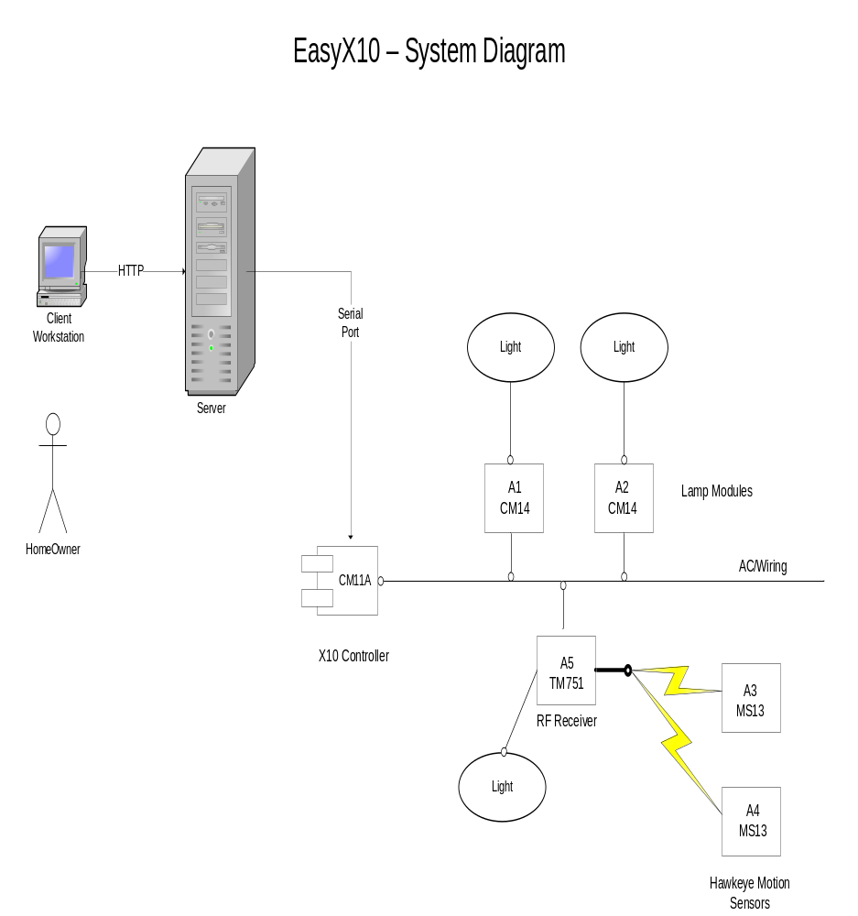
- The EasyX10 application runs on the server.
- Users interface with the EasyX10 using an HTML browser on client workstations.
- The EasyX10 application interfaces with the X10 devices through the CM11A X10 controller module, which is attached to a serial port on the server.
- Lamp (LM14) and Motion Sensor (MS13) devices are supported on the X10 home wiring network.
- The TM751 receiver is responsible for relaying the RF signals from the MS13 motion sensors to the power line for transmission back to the CM11A controller.

Major Inputs:

User Interactions (Login/Add Device/Modify Device/Remove Device/Monitor Status)
Motion Sensor Activities
Time Based Events

Major Outputs:

System Status
X10 Commands

Core Functionality:

Load Configuration Data
Manage Users (Login/Logout)
Add X10 Devices
Remove X10 Devices
Report Status of X10 Devices
Modification and Control of X10 Devices (i.e. State Changes)
Accept X10 Events (i.e. Process Motion Detection)
Process timer Events (i.e. Turn Device on/off at Selected Time)

2.2 User Interface

2.2.1 Overview
EasyX10 is a Rich Internet Application (RIA) that presents data to the user through a standard web browser. The user interface (UI) is built using the following web technologies:
- HTML (Hypertext Markup Language)
- CSS (Cascading Style Sheets)
- JavaScript
- JSP (Java Server Pages)
The UI displays a simple outline of each floor for the configured building (typically the user’s home) to an authenticated user. The user can then add new devices (appliances and motion detectors) to a floor (through an HTML form). Once devices exist in the system the user can update them (i.e. Change their status to ON), delete them, modify their characteristics and monitor their status using the UI.

2.2.2 Details
The following screenshots illustrate the general user interface concept for the EasyX10 application.
Login Screen
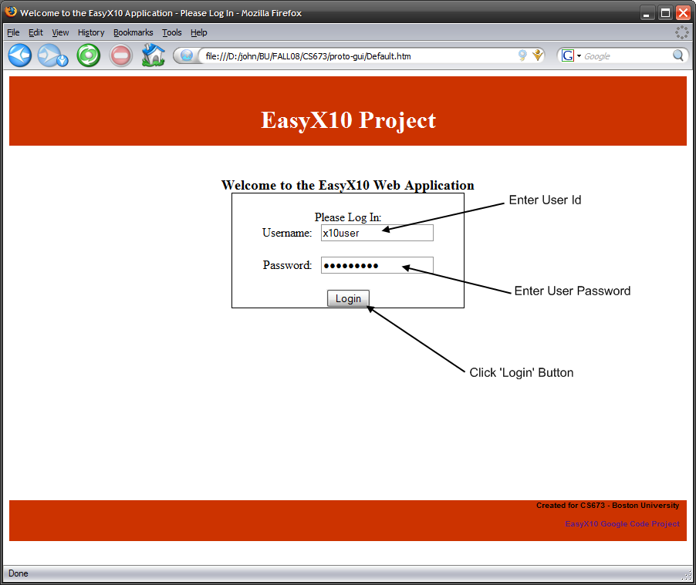
Main Status Screen
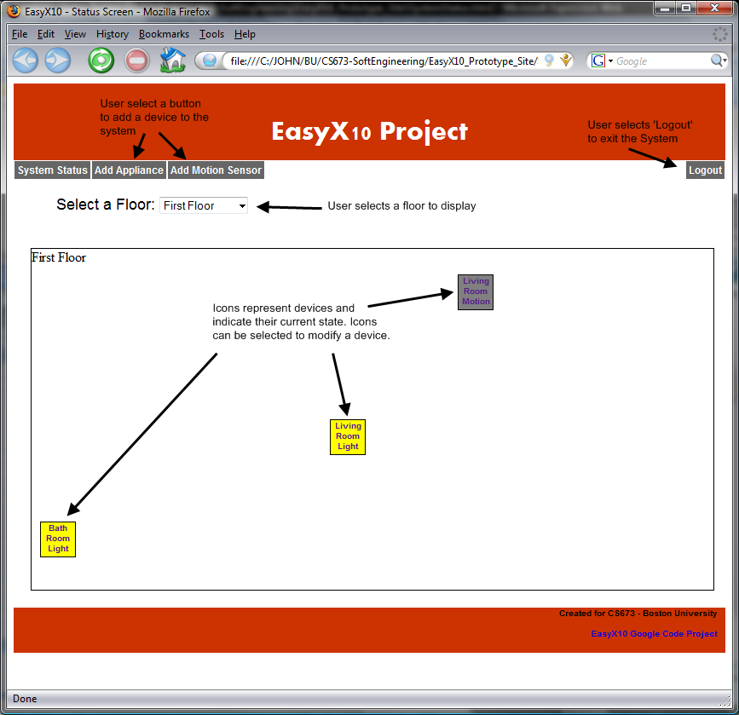
Add Appliance Screen (Note: Add Motion Sensor is Similar)
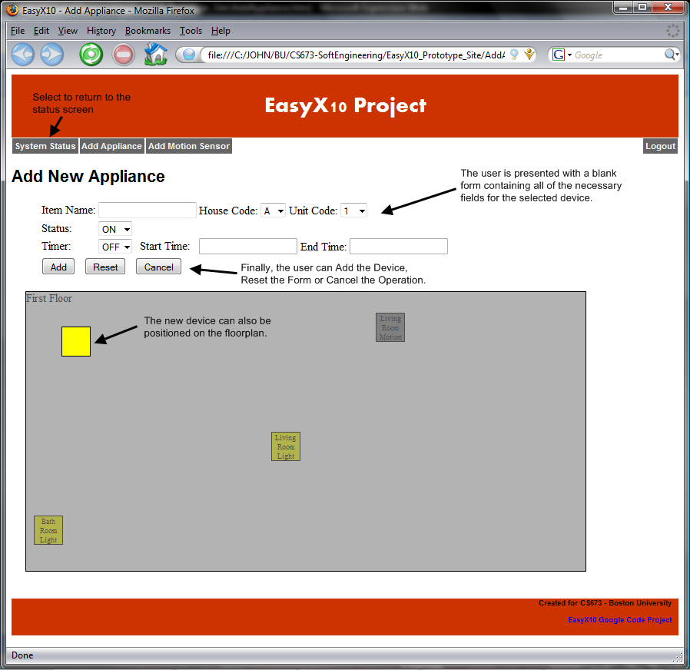

Modify Motion Sensor Screen (Note: Modify Appliance is Similar)

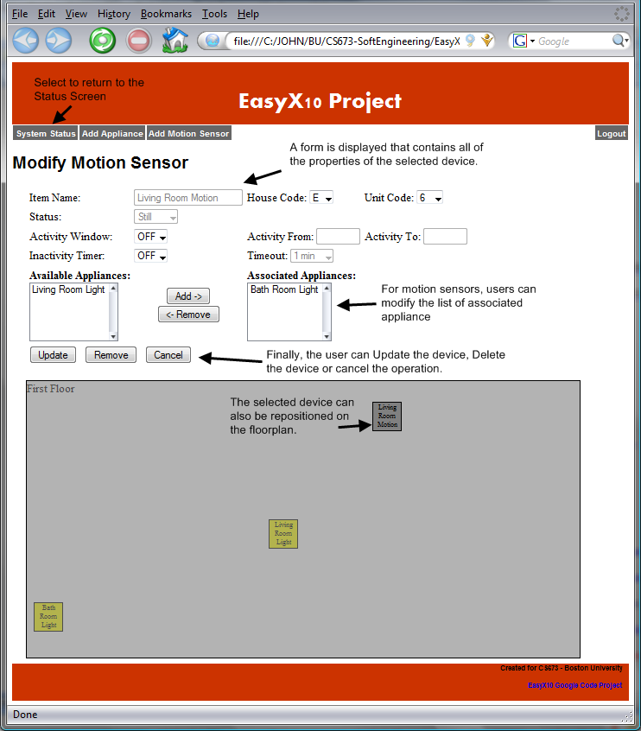

3.0 Functional Model

3.1 User profiles
User – The customer who owns the system. A user can act on the system either by tripping a motion sensor, or by interacting with the web user interface.
Timer – The timer acts on the system by triggering an event to change the state of an appliance. A timer may turn a device on or off at a specific time.
Motion Sensor – The motion sensor acts on the system by triggering a wireless signal to a TM751 wireless transceiver, which repeats it across the electrical wiring to a listening CM11A interface. The easy10 application is listening for events received by the CM11A and will carry out applicable actions from that point. .

3.2 Use-cases
This section provides eight use cases for the EasyX10 project.

USE CASE: 1 | User Login
Primary actor | User
Goal in Context | To log in to the EasyX10 Web Application.
Preconditions | System Configuration contains user name and password information. (Note: login data is stored in an XML file on the server. Users can be added to/removed from the system by editing this file.)
Success End Condition | User is authenticated and the browser navigates to the system status screen.
Failed End Condition | User is denied access to application and error message is displayed.
Trigger | User decides to utilize the EasyX10 web application.
Scenario | Step | Action
 | 1 | User: Navigates to the EasyX10 URL in a Web Browser (http://localhost:8080/easyx10)  System Response: Sends HTML data for login screen to user’s browser.
 | 2 | User: Enters Username
 | 3 | User: Enters Password
 | 4 | User: Clicks on the “Login” button  System Response: The system then processes the button selection and attempts to log the user into the system.
Priority | Normal
Frequency | Periodically as users access the system throughout the day.
Exceptions | 1. Application is not running: The user is provided with a standard browser error indicating the application is not running on the server machine.  2. Username/Password is incorrect: An error message is displayed indicating that the username/password combination is invalid. The user is then prompted to re-enter their login information.  3. User is already logged into the system: The login is successful, but the status page provides an indication that the user was already logged in to the system.
Open Issues | 1. Should the system allow multiple users? (Yes, they can be added via an XML file)  2. Should the system provide multiple user roles? (i.e. Monitoring User vs. Administrator) (No, This is a potential feature for a future release)  3. How do users get added to the system? Does this need to be documented? (Users can be added by editing an XML file on the server.)

USE CASE: 2 |  | Add a Device
Primary actor |  | User
Goal in Context |  | To add a new device to the system. The choice of devices is either an appliance device or a motion device.
Preconditions |  | User Login authentication successful
Success End Condition |  | New Device added to the system
Failed End Condition |  | 1) Configuration file not properly updated  2) User adds wrong device.  3) Device Name already exists  4) Failed Validation
Trigger |  | User decides to add new device to the system.
 | Scenario |  | Step | Action
 |  |  | 1 | User: selects either “Add Appliance” or “Add motion sensor” button to display the corresponding Add panel.
 |  |  | 2 | User: Fills in the Add Panel for an Appliance Device. Fields include: name, ID, status (on or off) and the optional ability to set a timer.  Or  User: Fills in the Add Panel for a Motion Device. Fields include: name, ID of device to turn on, status (on or off), an inactivity timer and the optional ability to set a timer.
 |  |  | 3 | User: Saves new Device
 |  |  | 4 | System: Saves information on New Device to Configuration File.
 |  |  | 5 | System: Returns user to Main Menu Screen.
 | Priority |  | High
 | Frequency |  | On Demand
 | Exceptions |  | 1. Device Name is already in the system.  2. Validation Failed
 | Open Issues |  | 1. If the Appliance is already in the system – can it be controlled by both a timer and Motion Detector?-(Answer-Yes)  2. How many devices can a Motion Detector manage? (Answer 255)

USE CASE: 3 | Remove a Device
Primary actor | User
Goal in Context | To remove a device from the system. Choices of devices to remove are an appliance controlled by Timer or appliance controlled by a Motion Detector.
Preconditions | User Login authentication successful, device exists in the system.
Success End Condition | Device removed from the system
Failed End Condition | 1) Device not removed from configuration file.
Trigger | User decides to remove a device from the system.
Scenario | Step | Action
 | 1 | User: Navigates to Selection Screen.
 | 2 | User: User selects device to delete.
 | 3 | System: Changes to Modify Screen.
 | 4 | User: Chooses Remove Button
 | 5 | System: Prompts User to confirm selection.
 | 6 | User: Confirms selection
 | 7 | System: Removes device from System/configuration file.
 | 8 | System: Returns user to system status screen
Priority | Medium
Frequency | On Demand
Exceptions | None.
Open Issues | 1) How to recover from error conditions

USE CASE: 4 | User Modify Device
Primary actor | User
Goal in Context | To update the properties of a device (appliance or motion sensor) that already exists in the System. This includes activities such as turning a light on by modifying the device’s ‘Status’ Property.  The user can modify the following device properties:  Common Properties:  - X10 House Code: Single Alpha Character  - X10 Unit Code: Single Numeric Character  - Position of the Device in the floor plan: The user can drag the device to any location on the floor using the mouse.  Appliance Properties:  - Status (ON/OFF)  - Timer Option (ON/OFF)  - On Time (hh:mm)  - Off Time (hh:mm)  Motion Sensor Properties:  - Inactivity Timer (minutes)  - Activation Window  - Start Time (hh:mm)  - End Time (hh:mm)  - Associated Appliances (a dropdown list of appliances that can be controlled by this sensor)
Preconditions | User is logged into the system and modifiable devices exist in the system.
Success End Condition | Device is modified as requested by the User and a success indication is displayed.
Failed End Condition | Device modification fails and error is reported to the User.
Trigger | User decides that a device needs to be modified.
Scenario | Step | Action
 | 1 | User: Observes the EasyX10 status screen.  System Response: Displays the state of various devices in the house.
 | 2 | User: Selects a device to modify.  System Response: The details of the device are presented to the user.
 | 3 | User: Modifies any of the properties specific to the selected device type.
 | 4 | User: Selects the ‘Update’ button when finished modifying the data.  System Response: The System will process the updates and respond with a success or failure indication.
Priority | Normal
Frequency | Periodically as modifications to devices become necessary.
Exceptions | - Entered Data does not pass validation (i.e. X10 House Code does not match correct format): An error is displayed to the user that indicates which field caused the validation error to occur. The user is then prompted to correct the error.
Open Issues | 1 – Is any history of the device properties retained so that a user could go back to the original or review the original/previous? (Out of Scope for Release 1)

USE CASE: 5 | User Monitors Status
Primary actor | User
Goal in Context | To be able to determine whether an appliance is on or off and if a room is occupied.
Preconditions | The User must have already added a device through the web interface before they can monitor it.
Success End Condition | The real time status of a configured device is visibly apparent on the status web page and is accurate within 1 minute.
Failed End Condition | A device’s status cannot be determined. A visual indicator on the status page will convey this.
Trigger | User logs into the system from a remote location to determine if a room is occupied or if anyone left a light on.
Scenario | Step | Action
 | 1 | User: looks to see if any appliances or lights are in the on state.
 | 2 | User: finds that several lights are in the on state.
 | 3 | User: looks at the status of the configured motion sensors.
 | 4 | User: Determines that none of the motion sensors have detected motion.
 | 5 | User: Navigates to Remote control page and manually attempts to shut the light off.
 | 6 | User: Answers Yes. Light goes off.
Priority | Medium
Frequency | Once a week
Exceptions | 1. Determining the state of the system will not function properly if someone has manually turned an appliance off. (I.E a light switch or fan switch). If this happens the state of the X10 module will no longer actually reflect the state of the device plugged into it.
Open Issues | None

USE CASE: 6 | Timer Controls Appliance Device – Time of Day Event
Primary actor | System Time Keeper
Goal in Context | Each Appliance Device can optionally be configured with a programmable ON time, a programmable OFF time, or both. The programmable features are provided by the GUI. Each Appliance Device can be programmable with a unique pair of ON and OFF times.
Preconditions | Each Appliance Device, desired to have an automatic ON or OFF time event, must be pre-configured in the GUI with the desired ON and OFF times.
Success End Condition | The System successfully changes the state of an Appliance Device to either ON or OFF based upon the programmable time values. The user finds joy in that the appliance state is automatically changed without human intervention.
Failed End Condition | Undetectable: The system is unable to detect that an expected ON or OFF device state was not properly executed since the appliance devices do not support the communication of status.
Trigger | The system continuously monitors the host system Time of Day clock. When the current Time of Day clock value reaches either of the programmed ON or OFF times, the system shall cause a device state change to occur. A state change is performed by sending an X10 message to the device, via the X10 controller and power line, to set the device to either the ON or OFF state.
Scenario | Step | Action
 | 1 | System: The system recognizes that the current time of day clock matches either the configured ON or OFF time for a specific device. The system sends an X10 “Device ON/OFF” message to that specific device to change its state to match the internal state.
 | 2 | Device: The X10 device turns ON or OFF. The new state can be observed by looking at the appliance or examining the system status display.  For example, the Driveway Light turns ON when the time of day reaches 6:15PM.
Priority | Medium
Frequency | This action typically occurs twice a day, assuming the User configures both ON and OFF times for any device. This action shall occur only once a day if only ON or OFF times are configured. Finally, this action shall never occur if neither ON or OFF times are configured.
Exceptions | None
Open Issues | Are multiple ON and OFF times required to make the EasyX10 system functional? (Answer: NO)

USE CASE: 7 | Timer Controls Appliance Device – Motion Inactivity
Primary actor | System Time Keeper
Goal in Context | Each Appliance Device can transition to the ON state by virtue of a Motion Detector motion event (separate use case describes this functionality, refer to use case #8). A system timer is used to transition the Appliance Device back to the OFF state when a programmed amount of time has expired without any additional motion events.
Preconditions | The User associates an Appliance Device with a Motion Detector using the GUI. The User configures the value of the Motion Inactivity Timer using the GUI.  The Motion Device is in the Motion State.
Success End Condition | System successfully changes the state of an Appliance Device to OFF, in the absence of motion events, based upon the programmable timeout value. The user finds joy in that the appliance state is automatically changed after motion events end.
Failed End Condition | Undetectable: The system is unable to detect that an expected OFF device state was not properly executed since the appliance devices do not support the communication of status.
Trigger | Each time the System sets an Appliance Device to the ON state due to motion activity, a timer is started. The initial timer value is defined by the Motion Sensor timeout value configured in the GUI. The timer continuously decrements as time advances. Each new motion event causes the timer to be reset to its initial timeout value. If the timer is allowed to decrement to zero (absence of any new motion events), then the System shall change the Appliance Device to the OFF state. A state change is performed by sending an X10 message to the device, via the X10 controller and power line, to set the device to either the OFF state.
Scenario | Step | Action
 | 1 | Motion: A Motion Device motion event results in an Appliance Device to transition to the ON state.
 | 2 | System: The System starts a timer to track the amount of motion inactivity since the last motion event. The System timer immediately begins to track time by decrementing its value.
 | 3 | Motion: A Motion Device motion event occurs before the inactivity timer can decrement to zero. The System timer is reset to the initial timeout value. This event can repeat an infinite number of times.
 | 4 | System: The motion inactivity timer is able to decrement to zero (expire) due to an absence of any new motion events from the Motion Device. The System shall change the Appliance Device to the OFF state. A state change is performed by sending an X10 message to the device, via the X10 controller and power line, to set the Appliance Device to the OFF state.
 | 5 | Appliance Device: The device turns OFF. The OFF state can be observed by looking at the light or examining the system status display.  Example: All the Appliance Devices associated with the Hallway Motion Device shall be set to the OFF state after 60 seconds of no additional motion events from the Hallway Motion Device.
Priority | Normal: This event has no higher importance than any other device control mechanism.
Frequency | This action can occur frequently over the course of a day. The timer shall be activated for each and every motion event. An Appliance Device shall be set to the OFF state each time the timer expires without any additional motion events.
Exceptions | None
Open Issues | None

USE CASE: 8 | Motion Device turns ON Appliance Device
Primary actor | Motion Device
Goal in Context | Motion Devices provide motion events. Appliance Devices can be associated to Motion Devices. When a motion event is detected, an Appliance Device can automatically be set to the ON state.
Preconditions | The User associates an Appliance Device with a Motion Detector using the GUI. The User configures the Motion Device Activation Window in the GUI. The Activation Window is a FROM/TO set of Time Of Day coordinates which describe at which times the Motion Device is allowed to trigger Appliance Devices.
Success End Condition | System successfully changes the state of an Appliance Device to ON as a result of a motion event. The user finds joy in that the appliance state is automatically changed after a Motion Device is triggered.
Failed End Condition | Undetectable: The system is unable to detect that an expected ON device state was not properly executed since the appliance devices do not support the communication of status.
Trigger | A Motion Device detects a motion event.
Scenario | Step | Action
 | 1 | Motion Device: Detects a motion event. The Motion Device transmits an X10 message to identify the motion event. The X10 message is transmitted via radio. An external radio receiver (attached to the power line) receives the X10 message, and forwards the message to the power line. The X10 controller receives the X10 message from the power line and provides the message to the system.
 | 2 | System: The system decodes the message and determines which Motion Device the message originated from.
 | 3 | System: The system compares the current time of day to the Motion Device Activity Window.
 | 4 | System: If the time of day is within the Activity Window, the System sends an X10 ON message to each Appliance Device associated with the Motion Device. The X10 message is sent to the power line through the X10 controller. Skip #5 and proceed to #6.
 | 5 | System: If the time of day is outside the Activity Window, the motion event is simply ignored by the system for the purposes of controlling the Appliance Devices. The motion event however shall still be displayed in the system status for the Motion Device.
 | 6 | Appliance Device: The device turns ON. The ON state can be observed by looking at the light or examining the system status display.  Example: The Bathroom Light turns ON because a Bathroom motion event is detected at 1AM.
Priority | Normal: This event has no higher importance than any other device control mechanism.
Frequency | This action can occur frequently over the course of a day. An Appliance Device can be turned ON each time a motion event is detected and the time of day is within the Activity Window.
Exceptions | None
Open Issues | Are multiple Activity Windows required to make the EasyX10 system functional? (NO). [It was further observed that this feature could be accomplished by creating multiple Motion Sensors, each with a different name and Activity Window, however, using the same House and Unit code.]

3.3 Use-case Diagram
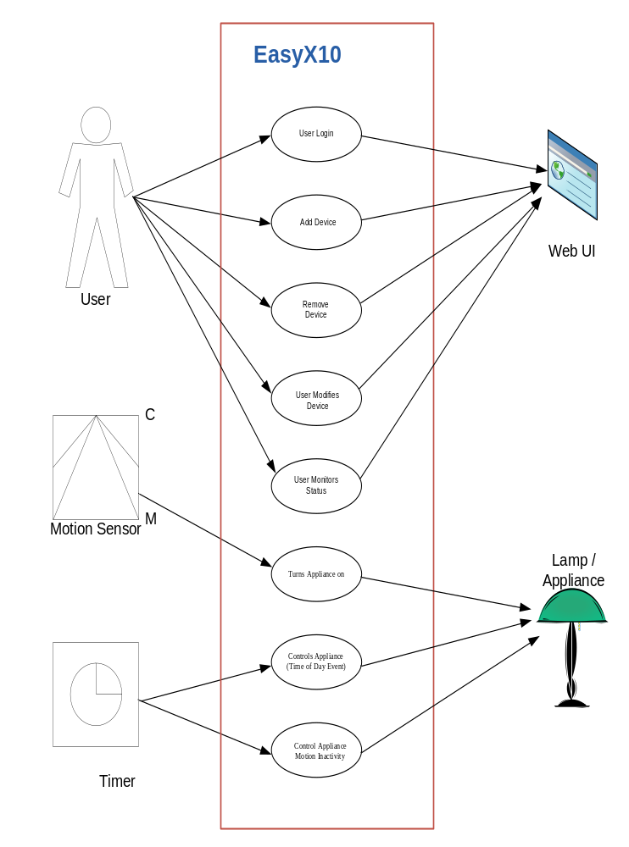
The above image depicts a summary of use cases described in the previous section. From Left to right, top to bottom, this includes:
- A user logs in through the Web UI
- A user adds devices through the web UI
- A use removes a device through the web UI
- A user modifies the attributes of an existing device through the web UI
- The user monitors device status through the web UI
- A motion sensor turns an appliance on
- A timer controls an lamp / appliance based upon the time of day
- A timer controls an appliance as a result of motion sensor inactivity

3.4 Activity Diagrams

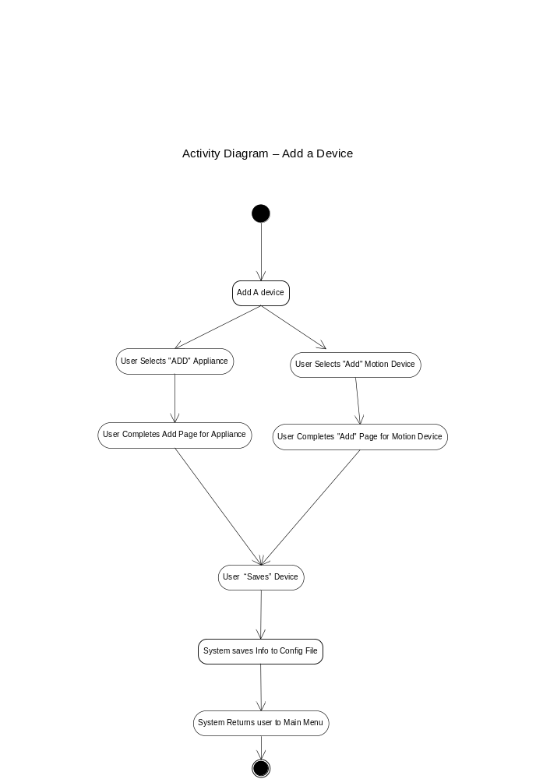

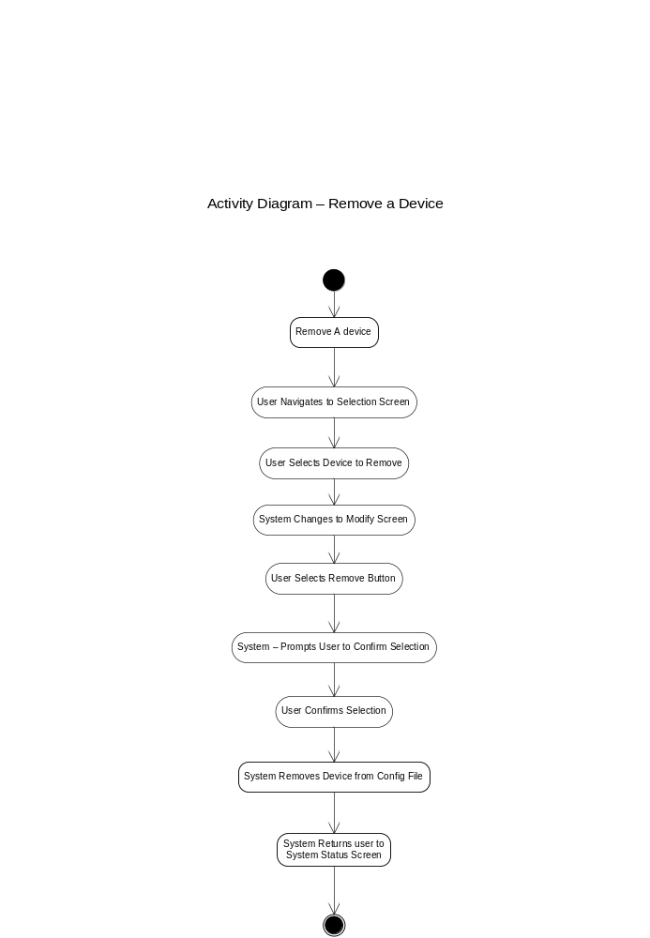

4.0 Structural Model
This section describes the structure and logical organization of the data supporting the system. It describes analysis classes/objects, their responsibilities and relationships. Class diagrams, object diagrams and CRC cards are used to represent the structural model

4.1 Class/Object List
The following table shows the list of potential classes for the EasyX10 software. The table also provides information about how the final list of classes was chosen.
Potential Classes | Type | Matching Criteria | Include
User Interface | Things | Retained Information, Needed Services, Multiple Attributes, Essential Requirements | Yes
Network | Structure | Essential Requirements | No
Home | Place | Essential Requirements | No
X10 Control Module | External Entity | Retained Information, Needed Services, Multiple Attributes, Common Operations, External Entity | Yes
X10 Home Lighting | External Entity | Essential Requirement | No
Device | Things | Retained Information, Needed Services, Multiple Attributes, Common Attributes, Common Operations | Yes
Appliance Device | Things | Retained Information, Needed Services, Multiple Attributes, | Yes
Motion Device | Things | Retained Information, Needed Services, Multiple Attributes, | Yes
Event | Occurrence | Retained Information, Needed Services, Multiple Attributes, Common Attributes, Common Operations | Yes
Timer Event | Occurrence | Retained Information, Needed Services, Multiple Attributes, | Yes
Motion Event | Occurrence | Retained Information, Needed Services, Multiple Attributes, | Yes
User | External Entity/ Role | Essential Requirement | No
Status | Things | Retained Information | No

4.2 Class Diagram
The following diagram outlines the top level class structure for the EasyX10 software application. The main controlling classes are the User Interface and the X10 Control Module. These two classes work with the Device and Timer classes to manage the state of devices in the system.
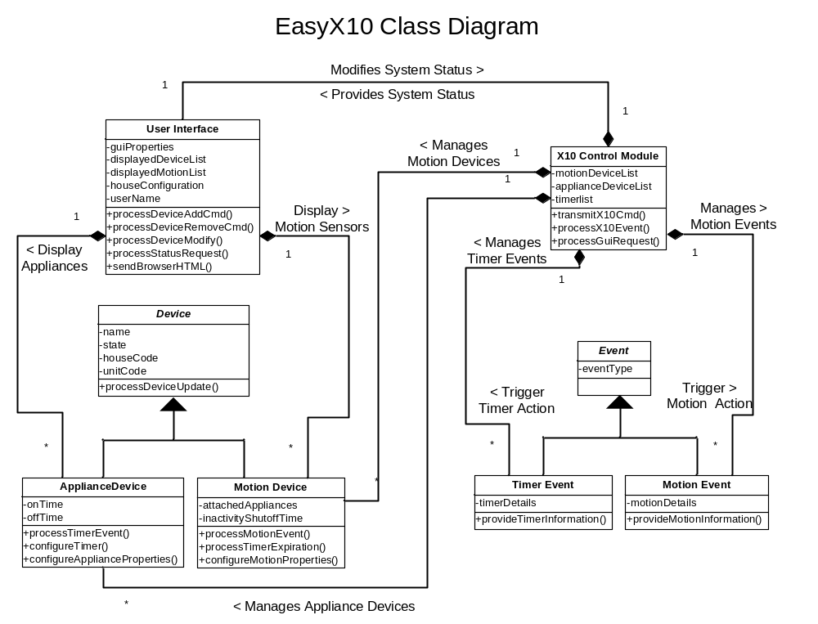

4.3 Object Diagram
The following object diagram fills in sample data for the EasyX10 classes. Each instance of the classes described in section 4.2 can have data similar to that in the diagram below.
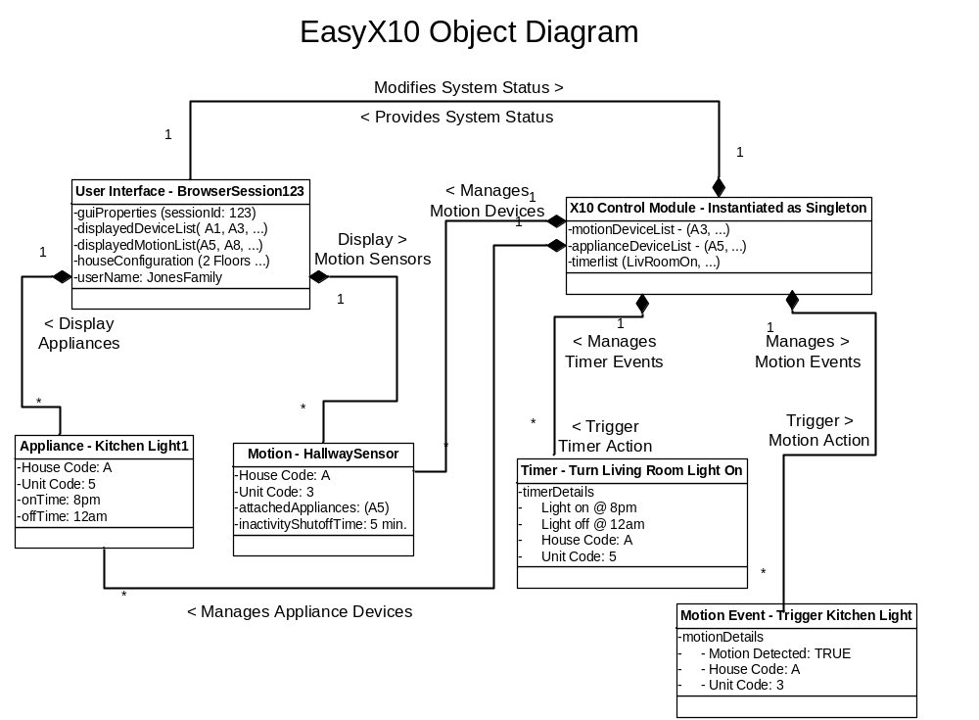

5.0 Behavioral Model and Description

5.1 Description for software behavior

5.1.1 Events

1. User authenticates – When the user navigates to the login page using their web browser, they are presented with a log in screen. After entering a username and password, the user clicks the login button. This sends an HTTP post request to the tomcat web server. The username and password entered is compared with the one stored in the easy10 system. If the user provided valid login information then tomcat responds to the POST request by displaying the Monitor web page. If the username and or password was invalid the login page is redisplayed along with a “Invalid login Credentials” message.

2. User adds device – When a user adds either a motion sensor or an appliance, they have the option to set a time to turn the device on and off. Upon submitting the necessary data to the easy10 system through the web UI, tomcat receives the post request and hands the data to the System Manager. The System Manager creates an appliance object or a motion sensor object and adds it to it’s list.

3. User deletes a device – When a user presses the delete button on a device displayed within the web UI, it triggers an http post request to the tomcat web server. Tomcat passes the unique ID of the device to delete (in this case the unique ID is the device name) to the System Manager. The module then looks up the device Id in its appliance list and deletes it. The updated device monitor page is then redisplayed to the user.
See User monitors status event for how the monitor page is displayed.

4. User monitors status – When the user requests the monitor status page from the Tomcat Web server, the web application must first retrieve the state of all the devices in the system from the System Manager. The System Manager maintains a list of all device objects and queries them for their state. Once retrieved, the web UI displays device status.

5. Motion sensor detects motion – When a Hawkeye motion sensor detects motion it sends and RF signal containing its house and unit code to a TM751 Transceiver Module. The transceiver translates the signal into and X10 message and broadcasts it across the house electrical wiring. The CM11A module receives the message and passes a Motion Event to the System Manager. The System Manager looks up the device in its list and passes the event to all motion sensor objects with a matching house and unit code. The motion sensor object checks to see if it’s supposed to be active during this time period. If no, it ignores the event. If yes it sends an X10 event (On or Off) to the CM11A Module. The CM11A repeats the X10 event (containing the appliance house and unit codes) across the electrical wiring to a listening X10 module and the appliance will turn on.

6. Timer changes appliance state – When an internal system timer matches the current time in the system, it sends the scheduled X10 event (On or Off) to the System Manager. The X10 Controller module then looks up the device in its list of appliances and passes the event to all devices with matching unit and house codes. The event is then processed by the appliances objects. They initiate sending the X10 command to the CM11a and update their states accordingly. When the CM11A receives the event object, (containing the appliance house and unit codes and what function to perform) it broadcasts it out in the form of an X10 message across the electrical wiring to any listening X10 module. The module then turns on or off depending on the contents of the message.

7. Timer detects absence of motion – Timer objects contain an attribute called an inactivity Timer that indicates how long to wait after motion is detected before it determines a room unoccupied. When a timer object detects motion it may trigger an event (see #6 above.) In addition to this, it starts the inactivity timer. If no motion is detected after the inactivity duration has elapsed, then a motion event is triggered and the events in #6 take place. If motion is sensed before the inactivity duration expires, then the timer is to zero and it starts over again.

5.1.2 States
A listing of states (modes of behavior) that will result as a consequence of events is presented.
Classes | Potential States
User Interface | Displaying, sending, receiving, comparing (uname/pw)
System Manager | Sending state / receiving state  Sending event /receiving event  Comparing, deleting
X10 Appliance Module | Receiving X10, on, off
Hawkeye Motion Sensor | Detecting motion, waiting, sending RF
Appliance Object | On, Off, validating, receiving event, sending event
Motion Sensor Object | Active, inactive, sending event, receiving event
Event | Processed
Timer | waiting for event / comparing times, resetting, receive event, send event
Motion Event | Processed
Timer Event | Processed

5.2 State Transition Diagrams
Figure 5.2.1 below describes the state transitions of an appliance object within the EasyX10 system as it moves from off to on. Initially the device is off. When an incoming X10 event is waiting for an event from either a Timer object or a motion sensor object, the Appliance object is in the receiving state. Once the event is received it validates whether or not the house and unit code match it’s own house and unit code attributes. If they don’t, the calling object is returned “false”. If they do match, the appliance object sends an X10 command to the CM11A object, and if successfully sent, changes its own state to ON.
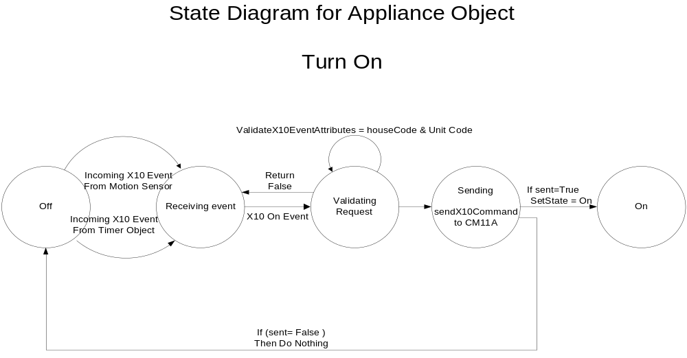
Figure 5.2.1 – Appliance Object State Transition Diagram

Figure 5.2.2 below provides a state diagram which shows the interaction between Applicant Devices, Motions Devices, and Timers. There are five concurrent state diagrams. Applicant devices have major states ON and OFF. Motion Devices have major states STILL and MOTION. The timer device has major states IDLE and COUNTDOWN. Interactions between state diagrams are shown as hashed line arrows.
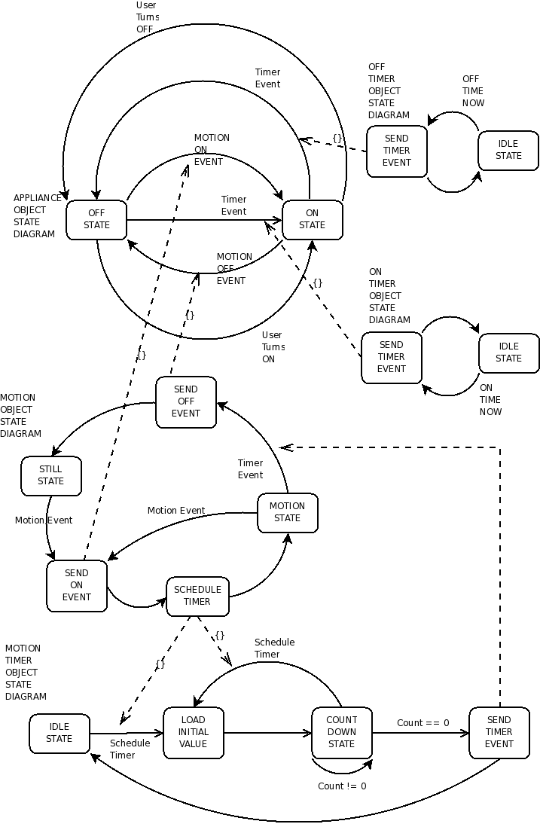

5.3 Sequence Diagrams
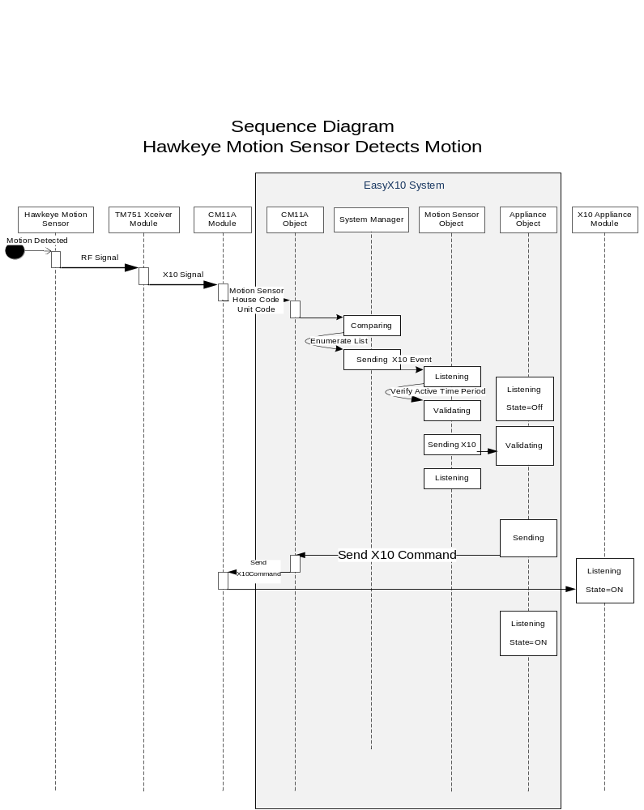

The above sequence diagram depicts the flow of events through all the external and internal components of the system when the Hawkeye motion sensor detects motion. When motion is detected, it sends an RF signal containing its house and unit code to a TM751 Transceiver Module. The transceiver translates the signal into and X10 message and broadcasts it across the house electrical wiring. The CM11A module receives the message and passes a Motion Event to the System Manager. The System Manager looks up the device in its list and passes the event to all motion sensor objects with a matching house and unit code. The motion sensor object is listening for incoming events. When one is received, it checks to see if it’s supposed to be active during this time period. If no, it ignores the event. If yes it sends the X10 event (On or Off) to the appliance object. The appliance object is listening for events. When one is received it validates that the house and unit code in the message match it’s own. If yes, it sends an X10 Event command to the CM11A object and set it’s state to On. The CM11A repeats the X10 event (containing the appliance house and unit codes) across the electrical wiring to a listening X10 module and the appliance will turn on.

6.0 Requirements Definition
This section provides the Functional and Non Functional requirements for the project.

6.1 Functional Requirements
This section describes the details of the functional requirements for the EasyX10 application. Each item defines a requirement that shall be provided in the initial release of the product.

6.1.1 User Interface
This section describes the functional requirements for the User interface. The User interface is presented through a standard web-browser. The interface allows the user to configure and monitor the status of the system.

User enters ID and Password
- By default, the user is provided with a Login Screen.
- The User ID is limited to 25 characters.
- The password is limited to 25 characters. The password characters have no restrictions.
- The user must press the Login Button to process the user ID and password.
- The user is only allowed past the login screen after a valid user ID and password have been entered.
- The user is allowed to attempt to enter an unlimited number of user ID and password pairs.
- Once the user enters a valid user ID and password pair, the Login Screen is replaced with the Main Status Screen.

User Selects Logout
- Each screen ,except for the Login Screen in the EasyX10 web application must have a Logout button.
- Selecting the logout button causes the screen to transition to the Login Screen with a blank user ID and password field.

User Selects System Status button
- Each screen , except for the Login Screen in the EasyX10 web application must have a System Status button.
- Selecting the system status button causes the screen to transition to the Main Status Screen.

User Selects Floor to display
- The Main Status Screen provides a drop-down box to allow the user to select one of many possible floor layouts.
- Selecting a floor from the drop down box causes the screen display to transition to a new display for the selected floor. If the currently displayed floor is selected, the screen does not transition from the current display.
- Each floor can have either zero or many Icons. Each Icon represents a Device assigned to the floor. Each Icon identifies the Name of the Device in addition to the current state of the Device by virtue of Text or Icon shape/style.

User Adds Device
- The Main Status Screen provides both Add Appliance and Add Motion Sensor buttons.
- Selecting either Add button causes a new Icon to appear in the floor outline. The new Icon shall be highlighted to identify it.
- The screen shall change to provide a Data Entry box.
- For Appliance Devices, the following fields are displayed:
- Device Name (must be unique)
- House Code
- Unit Code
- Status
- Timer
- On Time
- Off Time
- For Motion Detector Devices, the following fields are displayed:
- Device Name (must be unique)
- House Code
- Unit Code
- Activity Window
- Activity From
- Activity To
- Inactivity Timer
- Inactivity Timeout
- Associated Appliances (multiple choices provided)
- While the data entry box is available, the user is allowed to move the Icon associated with the selected device to any position on the floor. Overlapping Icons are allowed.
- After filling in the necessary fields, the user must select the Add button below the Data Entry box in order to complete the Add transaction.
- Upon recognizing the Add button, the system is required to validate the fields.
- If all fields are validated, the screen is updated by removing the Data Entry box and returning to the Main Status Screen. The highlighted Icon is un-highlighted and the new Icon is updated with its new name and current state display.
- If the fields are not validated, the user is informed of the invalid fields by virtue of a dialog box.
- The user can select the Cancel button at any time to abandon the Add Device function. When the Cancel button is selected, the screen is updated by removing the Data Entry box.

User Modifies Device
- The user can modify the parameters of a Device by single clicking on the Device Icon from the Main Status Screen.
- After selecting a Device Icon on the Main Status Screen, the screen display transitions to a new screen which provides a data entry box.
- The fields of the Data Entry box shall default to the current values assigned to the selected Device.
- The user is allowed to change all fields except for the Name field.
- While the data entry box is available, the user is allowed to move the Icon associated with the new device to any position on the floor. Overlapping Icons are allowed.
- After changing any necessary fields, the user is required to select the Update button to accept the changes.
- Upon recognizing the Update button, the system is required to validate the fields.
- If all fields are validated, the Main Status Screen is updated by removing the Data Entry box. The highlighted Icon is un-highlighted and updated with current state information.
- If the fields are not validated, the user is informed of the invalid fields by virtue of a dialog box.
- The user can select the Cancel button at any time to abandon the Add Device function. When the Cancel button is selected, the screen is updated by removing the Data Entry box.

User Removes Device
- The user can remove a Device by single clicking on the Device Icon from the Main Status Screen.
- After selecting a Device Icon on the Main Status Screen a new screen shall appear with the Data Entry box. The behavior is identical to Modify Device.
- The user can remove the device by selecting the Remove button in lieu of the Update button.
- When the Remove button is selected, a verification pop up window shall be provided.
- The user must select either Yes or No in the verification pop up window.
- If the user chooses the Yes button, the screen is updated by removing the Data Entry box and the associated Device Icon from the screen.
- If the user chooses the No, the screen is restored to its state prior to the confirmation pop up window.
- The user can select the Cancel button at any time to abandon the Add Device function. When the Cancel button is selected, the screen is updated by removing the Data Entry box.

User Monitors Status
- The user can monitor the status of any device by simply referring to the Icon displayed on either the Main Status Screen or the Main Status Screen.
- The Icon state must be updated within one minute of the device state changing.
- Appliances Devices display these possible states:
- ON
- OFF
- Motion Detector Devices display these possible states:
- MOTION
- STILL

Appliance Devices
This section describes the functional requirements for Appliance Devices.
- Appliance Devices have the following parameters:
  - Name (25 characters)
  - House Code (A-P)
  - Unit Code (1-16)
  - Status (ON, OFF)
  - Timer (ON, OFF)
  - On Time (Hour, Minute, AM/PM)
  - Off Time (Hour, Minute, AM/PM)
- Appliance Devices can turn ON or OFF with user control by virtue of the Status drop down field in the Data Entry box provided by the Main Status Screen when a Device is selected using a single click. After the Status field is changed and the Update button is selected, the Device shall transition to either ON or OFF. An X10 message is transmitted and the real Device must follow the ON or OFF state within five seconds of pressing the Update button.

Motion Devices
This section describes the functional requirements for Motion Detector Devices.
- Motion Detector Devices have the following parameters:
  - Name (25 characters)
  - House Code (A-P)
  - Unit Code (1-16)
  - Status (MOTION, STILL)
  - Activity Window (ON, OFF)
  - Activity From (Hour, Minute, AM/PM)
  - Activity To (Hour, Minute, AM/PM)
  - Inactivity Timer (ON, OFF)
  - Inactivity Timeout (Minutes)
  - Associated Appliances (List of Appliances)
- Motion Detectors turn ON Appliance Devices after a Motion Detector Device transmits a Motion Event.
  - Appliance Devices are associated with Motion Detector Devices by virtue of the Associated Appliances drop down box available in the Data Entry screen made visible when the Motion Detector Device is selected from the Main Status Screen.
  - If the Activity Window field for the Motion Detector is set to NO, then each Appliance Device associated with the Motion Detector Device shall transition to the ON state after receiving a Motion Event.
  - If the Activity Window field for the Motion Detector is set to YES, then the current system time is compared to the Activity Window From and Activity Window To fields. If the current system time is within the range of the Activity Window, then each Appliance Device associated with the Motion Detector Device shall transition to the ON state.
  - If either (b) or (c) occur, an X10 message is transmitted and the real Device(s) must follow the ON or OFF state within five seconds of the current system time.

Timer Controls
This section describes the functional requirements for Timer Controls.
- Appliance Devices can turn ON or OFF with automatic timer control by virtue of the Timer, On Time, and Off Time fields available in the Data Entry box made visible when the Appliance Device is selected from the Main Status Screen.
  - When the Timer field is set to ON and the current system time matches the time found in the On Time field, the Device state shall change to ON.
  - When the Timer field is set to ON and the current system time matches the time found in the Off Time field, the Device state shall change to OFF.
  - If either (a) or (b) occur, an X10 message is transmitted and the real Device must follow the ON or OFF state within five seconds of the current system time.
- Motion Detector Inactivity Timer turns OFF Appliance Device after motion inactivity.
  - This feature is controlled by virtue of the Inactivity Timer and Inactivity Timeout fields available in the Data Entry box made visible when the Motion Detector Device is selected from the Main Status Screen.
  - If Inactivity Timer field is set to ON for a Motion Detect Device, then the system shall monitor the amount of time since the last Motion Event was transmitted by the Motion Detector. If the amount of time exceeds the time defined by Inactivity Timeout, then the Appliance Device state shall transition to OFF. Each Appliance Device associated with the Motion Detector Device shall transition to the OFF state. An X10 message is transmitted to each device and the real Device(s) must follow the OFF state within five seconds of the current system time.
  - The units of measure for Inactivity Timeout are minutes.
  - If the Inactivity Timer field is set to OFF for a Motion Detector Device, then the system must not turn an Appliance OFF which was turned ON by a Motion Detector Device.

6.2 Non-Functional Requirements

6.2.1 Performance
The system will respond to user requests in 3 seconds or less.
The JVM heap memory expectations will be sized during the product development cycle. The max amount of memory allocated to the heap at any given time will not exceed 256MB. Initiate estimates on actual memory usage is expected to be much lower but this is the ceiling. The 90% heap usage over the course of a given day will no exceed 50% of the max heap size. Heap usage will meet or perform well under this level.

CPU usage shall not exceed 50% of the available CPU at any given time during steady state but will still adhere to response requirements during brief spikes of 100% CPU utilization lasting 3 seconds or less.

The following describe the systems expected level of use:

A user typically monitors the system for 1 hour a day.

The system shall support the addition of up to 20 motion sensors and 20 appliance modules and still meet system resource requirements. While the system will not explicitly prevent the addition of more devices, performance degradation is at risk and is unsupported.

The system shall support 1 user logged into the system at a time. While additional logins will not be explicitly prevented this is not a supported operation.

6.2.2 Reliability
The System will only be – offline – if some external event forces the Server to be rebooted.

No system operation should put the system in an unresponsive state as long as the number of devices in the system does not exceed supported numbers. Unresponsive is defined to mean the web page is always accessible and the failure to carry out any use case (with the exception of login) does not prevent the actors (timers, motion sensors or Users) from attempting additional actions.

6.2.3 Availability
The system will be available 7x24 – or as long as the Server hosting the application is fully operational.

6.2.4 Usability
The User will be able to manage the system after spending 30 minutes reviewing the Installation Documentation and System Overview Documentation
The number of user errors will be with the range of 1 for every 300 times the user interacts with the system. (This error rate could increase if the user fails to spend the recommended 30 minutes reviewing product documentation and instructions.)

6.2.5 Integrity
There will be no data lost as the result of a system failure, because changes are written to the single configuration file, by the User whenever a configuration change is made.
A Power failure due to weather or man-made accident will make the service in-operable. To recover from this situation, the User must restart the server hosting the application.

6.2.6 Fault Management/Error Handling
All fault and error management is handled via screen prompts on the GUI.

6.2.7 Security
The System will require a logon id and password.

6.2.8 Installation/Upgrade/Fallback
The system configuration file will maintain backwards compatibility between releases.

6.2.9 Maintainability
The software will be designed using an object-oriented approach to foster reuse, accuracy, and strong data types all of which make for more maintainable software.

6.2.10 Portability
The software will be written in Java which offers high portability between systems and operating systems. The software uses an html server approach which affords extreme flexibility in communicating with web clients on various operating systems

6.2.11 Packaging
The system demonstration will be packaged in a very attractive brown paper bag (biodegradable).

6.2.12 Management
The system requires no ongoing management other than the desired system configuration

6.2.13 Legal
The software adheres to the GNU license and Apache License.

6.2.14 Constraints
The system must operate in a standard environment condition which allows the tomcat server to be operational.
The system is accurate to minute granularity.
The system is constructed using the Java Language.
The system is designed to adhere to the x10 protocol standard.
The system is designed to run on any server system which supports Tomcat and the Java language.

Project Tracking Appendix

Project Time Line Estimates and Actuals:

HW # | Milestone/Deliverable | Due  Date | Estimated Hours | Actual Hours
1) | Communication Plan | 9/9/08 | 20 hours | 35.5
2) | Software Configuration Mgt Plan (SPMP) | 9/16/08 | 32 hours | 39 hours
3) | Software Project Mgt Plan | 9/23 | 35 hours | 44.5 Hours
4) | Software Requirements Specification (SRS) | 10/21/08 | 80 hours | 110 hours
5 | Software Detailed Design Document(SDD) | TDB | 80 hours | TDB
6 | Operational System/Prototype | TDB | 120 hours | TDB
7 | Individual Project Assessments | TDB | 25 hours | TDB
8 | Final Project Presentations | TDB | 40 hours | TDB
Exercise 4 - Team Contributions

Activity | Bruce | John | Damon | Jim | Total
Brainstorming | 0 | 0 | 2 | 0 | 0
Meetings | 10 | 10 | 10 | 10 | 40
SRS authoring | 4 | 5 | 5 | 5 | 19
Application Investigation | 0 | 8 | 2 | 12 | 22
Project Related Training | 3 | 2 | 0 | 0 | 5
Document Editing | 8 | 0 | 2 | 2 | 12
Document Review | 3 | 4 | 2 | 3 | 12
Total | 28 | 29 | 23 | 32 | 110

