Homework 3
CS-673 – Software Engineering
9/23/2008

Team EasyX10

Software Project Management Plan
(SPMP)
Version 3.0

Bruce Deyle
Jim Duda
Damon Gabrielle
John Winderbaum

Version History

Version | Date | Changes Made
1.0 | 09/20/2008 | Initial Draft
2.0 | 9/24/2006 | Sunday Team Meeting Review
3.0 | 9/24/2006 | Bruce – final

1.0 Introduction
The EasyX10 project provides an easy to use front-end control application for an X10 home lighting system.

1.1 Project Scope
The EasyX10 project is a web-based application designed to manage a network of X10 home automation devices. The application supports both manual and automatic control of X10 home lighting. The application interfaces with an X10 control module which is physically attached to a serial port on the computer which hosts the application. The X10 control module interfaces with external X10 lighting devices and motion detectors using the X10 protocol through the home A/C wiring.
The application allows a user to manage X10 devices, manually control lighting conditions, and configure automatic lighting control based upon time events or motion events.

1.2 Major Software Functions
The software is organized into three major software components; Graphical User Interface; Control Logic; and X10 Back-End Logic.

1.2.1 Graphical User Interface
The Graphical User Interface (GUI) can Add, Delete, and Modify objects. The GUI consists of a set of displayed Icons. Each Icon represents an instantiated object of some Class. Example Class types are; Light Item, X10 Control Item, and Motion Item.
When an object is added, all attributes of the object are defaulted to the default values defined by the object class. When an object is modified, the allowable modified attributes are made available in an alternate screen.
The GUI supports these major operations.
Add Allows selection of all possible class types; example Light Item and Motion Item. The new object is instantiated, added to the list, and a new Icon is displayed. The constructor for the object will initialize all attributes to their default state.
Delete Provides the Are you sure ? (Yes/No) option to confirm delete. Upon confirmation of the delete option, the object is deleted from the object list and the Icon is removed from the display.
Modify The modify action will access the objects configuration method. The GUI will provide an alternate screen to provide access to its attributes.
Save This action is used to save the state of the system to a configuration file.
Restore This action is used to restore the state of the system from a configuration file. This action will be done automatically upon application startup.

1.2.2 Control Logic
The Control Logic provides the software used to maintain the current state of the various objects, each object being one of the Icons on the GUI.
The following set of objects is anticipated:
Base Item This is an abstract class which all items are extended from.

Light Item This object maintains the state of an X10 lighting object. Each object is assigned a uniquely addressable X10 House and Unit code. Each object can be configured with an automatic time for either turning ON a light, and/or turning OFF a light. Each object can manually be set to either ON or OFF. Finally, each object can be configured to turn ON or OFF by virtue of an attached Motion Item object which monitors motion within a room. The Light Item communicates with the physical X10 Lighting Module using the X10 back-end Logic. The Light Item will send specific X10 commands to the X10 network when its state changes.
Motion Item This object maintains the state of an X10 motion detector. Each object is assigned a uniquely addressable X10 House and Unit code. Each object communicates with the physical X10 Motion Detector using the X10 back-end logic. The Motion Item will periodically read the state of the physical X10 Motion Detector via the CM11A, and update the object state. The Motion Item will use a timer to determine the absence of motion. The Motion Item state is used to alter the state of an attached Light Item object. When Motion is detected, a Light Item will turn ON. When the absence of motion is detected, a Light Item will turn OFF.
Timer Item This object is used to provide timer services for other items. This object can be set with a specific timeout value. Its state will be updated after the timeout value expires. The timer expiration is used to identify a lack of motion within a room.

1.2.3 X10 Back-End Logic
The X10 Back-End Logic provides the software used to interface with the X10 controller device. The CM11A is attached to the host computer through a serial port. The X10 Back-End logic sends commands to the CM11A through the serial port. The X10 Back-End Logic can also monitor the serial interface in order to receive events from the CM11A. Inbound events from the controller are provided by the X10 motion sensors attached to the X10 network through the serial port.

Section 1.3 Performance / Behavior Issues
The X10 protocol does not have high real-time performance requirements. The system operates with state changes on the order of seconds. Input and state changes come from human interaction at the Graphical User Interface (which is very slow). Input and state changes also come from Motion Sensors. Motion Sensors have very low state change rates, on the order of seconds.

Section 1.4 Management and Technical Constraints
This project suffers from a strict drop-dead completion date due to time limitations resulting from a fixed graduate class schedule.
A demonstration will be performed at the end of the class schedule. For practical reasons, any demonstration within class will require a laptop to be used. The selected X10 control interface must be limited to requiring a single serial port as most laptops only support a single serial port.

Section 2.0 Introduction
This section provides cost, effort and time estimates for the projects.

Section 2.1 Estimation Techniques Applied and Results

Section 2.1.1 Function-Based Metrics
Function Point (FP) metrics requires the gathering of the following information:
- Number of external inputs (EIs)
- Number of external outputs (EOs)
- Number of external inquiries (EQs)
- Number of Internal Logical Files (ILFs)
- Number of External Interface Files (EIFs)
Using the gathered information, the following table can be used to compute the number of function points.

 |  |  | Weighting Factors
Information Domain Value | Count |  | Simple | Average | Complex |  | Total
External Inputs (EIs)  (GUI Action Clicks / Motion Events) | 10 | X | 3 | 4 | 6 |  | 30
External Outputs (EOs)  (X10 Commands) | 3 | X | 4 | 5 | 7 |  | 12
External Inquiries (EIs)  (Status Screens) | 2 | X | 3 | 4 | 6 |  | 6
Internal Logical Files (ILFs)  (None) | 0 | X | 7 | 10 | 15 |  | 0
External Interface Files (EIFs)  (Configuration File) | 1 | X | 5 | 7 | 10 |  | 5
Count Total |  |  |  |  |  |  | 53

FP = count total X [0.65 + 0.01 X ∑ (F_{i})]
F_{i} refers to the Value Adjustment Factors (VAF) based upon answers to the following questions. Each of these questions is answered using a scale that ranges from 0 (not important or not applicable) to 5 (absolutely essential):
- Does the system require reliable backup and recovery? 2
- Are specialized data communications required to transfer information to or from the application? 5
- Are there distributed processing functions? 0
- Is performance critical? 1
- Will the system run in an existing, heavily utilized operational environment? 0
- Does the system require on-line data entry? 2
- Does the on-line data entry require the input transaction to be built over multiple screens or operations? 2
- Are the ILFs updated on-line? 0
- Are the inputs, outputs, files, or inquiries complex? 3
- Is the internal processing complex? 3
- Is the code designed to be reusable? 4
- Are conversion and installation included in the design? 0
- Is the system designed for multiple installations in different organizations? 3
- Is the application designed to facilitate change and for ease of use by the user? 5
FP = 53 X [0.65 + (0.01 X 38)] = 55 Function Points
The industry standard equates 10 FPs per person-month of effort.
This equates to 5.5 person-months (160 hours per person month) of effort.
With a four member team, each member requires 1.4 person-months of work per person.

Section 2.1.2 LOC Based Estimation Method

Major Application Functions

- GUI (edu.bu.easyx10.gui)
  - JSP Pages/Servlets for the following screens
    - Display Items Screen
      - For simplicity it may make sense for this screen to auto-refresh (AJAX would be an option too, nicety)
      - JSP – 200 Lines
      - Servlet – 100 Lines
    - Add / Modify Item Screen
      - 100 Lines
      - 50 Lines
    - View of Individual Item
      - 100 Lines
      - 75 Lines
  - SLOC Total: 625
  - Low Complexity. Using Complexity factor of .8

- Item Objects (edu.bu.easyx10.item)
  - Controllable – interface defining behavior for X10 compatible items.
    - 20 Lines
  - Timeable – interface defining behavior for items requiring timer functionality. (or could be a TimeItem that extends Item)
    - 50 Lines.
  - Item – base class for all x10 controllable items
    - 50 Lines.
  - LightItem – class for controllable lights
    - 50 Lines
  - MotionItem – this might be a base class or interface as well
    - 50 Lines
  - SLOC Total: 220
  - Medium Complexity: Using complexity factor of 1.0

- X10 Interface (edu.bu.easyx10.x10)
  - X10Manager
    - Static factory class that provides the API for the GUI to interface with. (has static methods like: addItem, removeItem, getItems, updateItem(Item) )
    - 200 Lines
  - X10 Driver classes
    - 100 Lines
  - SLOC TOTAL: 300
  - High Complexity: Using complexity factor of 1.4

SLOC Estimates including Complexity Factor:

Function Name | SLOC Estimate | Complexity Factor | Revised SLOC
GUI | 625 | .8 | 500
Item Objects | 220 | 1 | 220
X10 Interface | 300 | 1.4 | 420
 |  | Total | 1140

Productivity Factors:

Productivity Type | Productivity  Factor | Total Hours | loc/mm based on 160hr month | Estimated mm
High | 3 loc/hr | 380 hrs | 480 | 2.4mm
Med | 2 loc/hr | 570 hrs | 320 | 3.6mm
Low | 1 loc/hr | 1140 hrs | 160 | 7.1mm

Section 2.1.3 COCOMO II Application Composition Model estimation
The COCOMO II method offers several different models for estimation depending on the stage of development. At the time of writing this document since we are just beginning the requirements building stage and an architecture design has not been finalized.
Because this estimate is being done prior to architecture design, we have not yet decided whether the screens will be done as a web front end or a Java SWING UI. If a Java swing front end is created then “screens” would be interpreted as sections of the program. If the design is a web application there would literally be different pages. Often times for every function in dynamic web page, there an action page that “commits” a user’s change. Since the functionality is the same in either case the difference between the two on a project this small is negligible. Therefore, action pages won’t be counted.

Step 1: List UI Screens and their complexity weight
- Manage Devices – Screen for adding and removing devices - 1
- Modify Pop-up – Screen for modifying or adding a device - 2
- Status / Control– Screen where status of devices is displayed but also can be manually changed. - 2
- Scheduler – Screen to schedule a time based task. - 3
- Advanced options – screen to manually switch program properties (x10 interface, and other debugging options) - 1

Step 2: Identify underlying architecture components and their complexity weight
- X10 Interface – 3
- X10 Interface Simulator - 1
- Controllable – defines behavior - 2
- Timetable class - 3
- Item – base class - 2
- Light Item - 1
- Motion Item - 1
Step 3: Determine number of Object points

Initial Total
Object Types
 | Simple | Medium | Difficult
# of UI Screens | 2 | 2 | 1
Infrastructure | 3 | 2 | 2

Weight Table
Object Types | Complexity Weight
 | Simple | Medium | Difficult
Screen | 1 | 2 | 3
Infrastructure |  |  | 10

Weighted Total:
Object Types
 | Simple | Medium | Difficult
# of UI Screens | 2 | 4 | 3
Infrastructure | 0 | 0 | 20

NOP = (object points) x [(100 - %reuse) / 100]
Total Object points = 29 (This is the NOP).
(At this point in the project nothing is planned to be reused.)

Step 4: Determine Productivity Rate

Developer Experience (in Java) / capability = John 50, Jim13, Damon 7, Bruce 7
Environment maturity = 13 (Nominal)
Average Productivity rate = 18
Estimated effort in person months = 29 (NOP) / 18 (PROD)
Total estimated effort = 1.6 Person Months or 256 hours
Assuming 160 hours equates to a person month, and taking into account the work divided across 4 development resources it would take 64 hours per person.

2.2 Reconciled Estimate

The strategy behind employing 3 different estimation strategies was to compensate for the lack of historical data we have at our disposal. While much of the data in section 2.2 comes from the teams combined industry experiences, it will still be a challenge to produce an accurate estimate considering it’s a new product with a team that hasn’t previously worked together.
Since LOC based estimation could later be validated with Direct Measurement and Function point and COCOMOII could be validated with indirect measurement metrics, the assumption is that combining the results from several will increase the accuracy of the initial estimate. Since it would be cumbersome and time consuming to maintain data for all three methods, only 1 method will be incorporated into the process going forward.
The average result for LOC based estimation was 4.3 person months (644 hours); and average of 144 hours per team member. The estimate assumes all development is concurrent. For Function Point estimation, the result was 5.5 person months (880 hours) or an average of 224 hours per person. COCOMOII based estimation resulted in a much lower estimate of 1.6 total person months (256 hours) or 64 hours per person. The average of the three methods yields 3.7 man months, (593 hours) or 148 hours per person.

To create the following estimates per project task, a few assumptions needed to be made in order to account for the fact that the work will mainly be done on nights and weekends because all team members work full time. For the sake of scheduling, we’ll convert time in real person months to what will be called “Student Months” – meaning, assuming a full time job, the remaining hours in the day account for personal time and school project time. It is estimated that a student has an average of 12 hours per week to spend on the project. This estimate was derived partially from averaging the last two weeks of the Team contribution appendixes (averaged at just under 10 hour per person) and then added two hours per person to account for the expectation that implementation might result in longer Student Work Weeks: the end result being 12 hours per student per week. This would result in 48 hours for a student month; vs. 160 hours in a person month.
Since it’s estimated to take 3.7 person months to complete the easyX10 project then it would take would take 12.35 Student Months to complete. If you divide this across the 4 team members it is 3.08 student months per person.

Section 2.3 Project Resources

Section 2.3.1 People
The team consists of 4 members. The following is taken from the Communications Plan:
Name | Roles
Bruce Deyle | Project Lead, Architect, Testing, Requirements, Presentation, Documentation
Jim Duda | Project Lead, Architect, Subject matter expert on X10, Coding (back end)
Damon Gabrielle | Project Lead, Architect, Coding (Front, Back end), GUI prototyping, Testing
John Winderbaum | Project Lead, Architect, Coding(Front end), GUI prototyping

Section 2.3.2 Hardware
The following hardware components are required to develop the project and execute a demonstration of the project. Not all developers will require the hardware modules at the same time. All hardware modules are required to support the demonstration.
- (1) CM11A X10 controller module
- (2) Hawkeye X10 CM13 Motion Sensors
- (1) Laptop with Serial Port
- (2) X10 Lamp Module

Section 2.3.3 Tools
The following development tools are required to develop this project.
- Eclipse IDE with Java, JUnit, and Subversion plug-in
- Java JDK
- Windows or Linux workstation with Eclipse and Java JDK tools.
- Serial Port required for developing back-end X10 CM11 interface.
- Google Groups will be used for email communication and conversation archiving.
- Google code repository using SVN

Section 2.3.4 External Software
At the time this document is written, there are 3 potential external software dependencies being considered.
- The java comm. API – used for controlling the CM11a through the pc’s serial port. Available for download from sun at
http://java.sun.com/products/javacomm/
- The CM11a protocol document:
ftp://ftp.x10.com/pub/manuals/cm11a_protocol.txt
- Sample code that will be used as a starting point for creating an X10 CM11A java driver. The code available has already undergone proof of concept testing and was used to control an X10 Firecracker interface connected to the serial port.
http://www.theprescotts.com/software/firecracker/
- If there is an open source java interface for the CM11A device already available and using it would speed up implementation this document will be updated to include it.
- Tomcat will be used as the web server if we create a web front end.

3.0 Project Schedule
3.1 Project task set
The Team will be using a Waterfall process model for this project. The Key milestones as defined in the Project Plan are:
  - Project Conceptualization
  - Configuration Management
  - Software Project Management Plan
  - Requirements Definition
  - Architecture Design
  - Software Testing
  - Demonstration Prep
  - Final Class Presentation
  - Umbrella Activities (Project Mgt)
    - Weekly Meetings
    - Prepare Meeting Agenda
    - Communicate Meeting Minutes
    - Homework Preparation
    - Project Tracking
    - Training/Learning Software

3.2 Functional decomposition
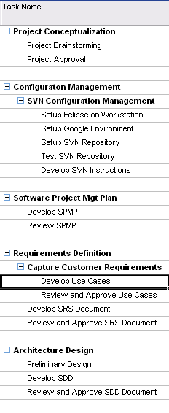
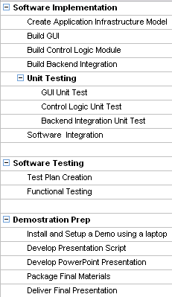
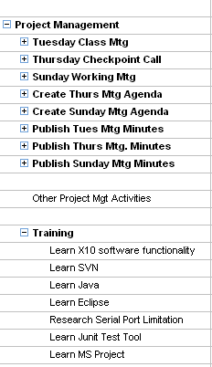
3.3 Timeline chart
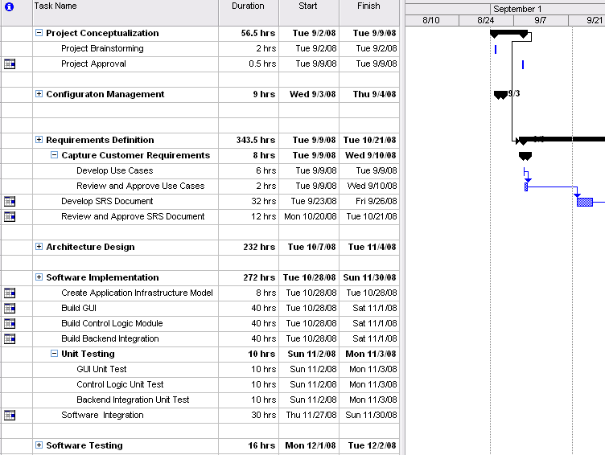See MS Project Plan Document for full details - attached

4.0 Risk Management
This section describes the risks for the EasyX10 Project and plan for mitigating them. The section also addresses the plan for the monitoring and management of the risks.
4.1 Project Risks
The following potential risks have been identified by the EasyX10 Team:
- Team knowledge of certain technologies may be limited. (i.e. Java, Automated Unit Testing)
- Operating System Differences. (Some team members are Linux based while others use windows).
- Hardware Limitations. (The demo is going to require 2 Serial Ports)
- No Prototype Proof of the RF inbound
- Time Constraints (external responsibilities-full time jobs, family care duties) looming deadlines
- Cumbersome Process for such a short development schedule.
- Feature Creep
- Misinterpretation of requirements
- The team is not co-located
- Limited physical test environment

4.2 Risk Table
[Note: highest priority is lowest number]
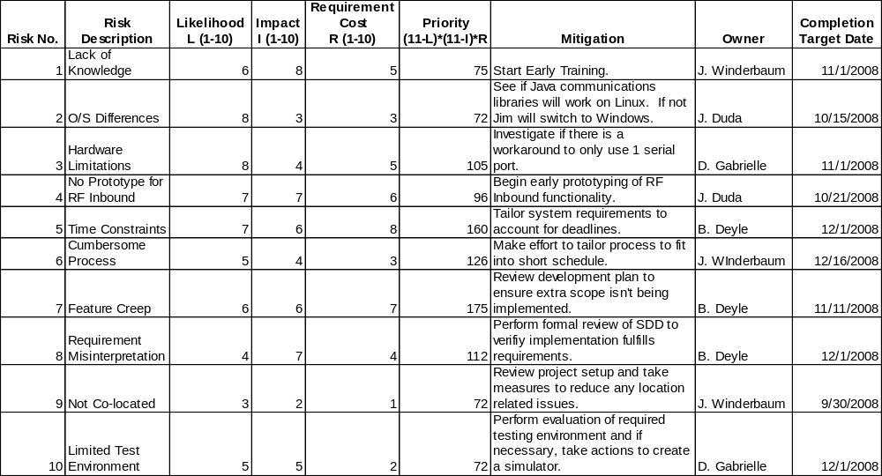

4.3 Risk Mitigation, Monitoring and Management
This section describes the project risks in more detail and the mitigation plans created by the team to address each risk. Additional information has also been included to describe the plan to monitor and manage the project’s risks.
4.3.1 Risk Mitigation
- Lack of Knowledge
Risk - Team members are new to some of the technologies that will be used to implement the easyx10 application. Java programming, the use of automated unit testing and the X10 protocol are new to some team members.
Mitigation Plan – The team has already started training activities and plans to continue through the development phases. Additionally, team members will leverage off each other’s expertise.
- O/S Differences
Risk - There are different operating systems in use across the project team. This presents possible development environment and Java Library issues.
Mitigation Plan – The current plan is to evaluate the feasibility of using both Windows and Linux as development/test environments. If it is decided that only 1 operating system should be used then Windows is the better choice. (This decision was based on a survey of current OS Installations across the team.)
- Hardware Limitations
Risk – The application may require the use of 2 serial ports. This capability is not very common with today’s PCs.
Mitigation Plan – There will be an investigation to determine a workaround to this problem. If a workaround is not found the software requirements will be tailored to only support the availability of 1 serial port.
- No Prototype for RF Inbound
Risk – The team does not have a working prototype of the RF inbound functionality. This creates a general risk of getting this input to work in the initial version of the production system.
Mitigation Plan – The team plans to begin path finding soon to develop a simple RF proof of concept prototype. Once the path finding analysis has been performed the team will meet to decide whether the RF capability should be in the initial version of the production system.
- Time Constraints
Risk – The hard deadline, due to the fact that this application is being developed as part of a Graduate class poses a serious risk.
Mitigation Plan – The initial plan is to perform early prototyping activities to determine the appropriate project scope before the SRS is written. Additionally, the team plans to re-evaluate the scope of the project weekly.
- Cumbersome Process
Risk – The software engineering process isn’t necessarily designed to be executed during offline hours over the course of a couple of months. This poses a risk to meet all deadlines.
Mitigation Plan – The team plans to design the scope of the project to allow for proper execution of the different Waterfall activities.
- Feature Creep
Risk – Application features that were not originally intended to be implemented may start to make it into the design and implementation.
Mitigation Plan – The team must actively review work products to ensure that a development phase does not introduce any un-required features.
- Requirement Misinterpretation
Risk – During the detailed design and coding phases certain software requirements may be misinterpreted and cause a deviation from initial application design.
Mitigation Plan – The team is actively discussing the system’s requirements at meetings and recording major decisions in meeting minutes. The plan is to perform very detailed reviews to verify the detailed design and code matches the requirements specification.
- Not Co-located
Risk – The team is not located at a common facility. Development and Test environments may differ and this presents a potential risk.
Mitigation Plan – The plan is to create a development and testing environment that can be reproduced on any team member’s computer. This will be achieved by creating Wiki entries on the easyx10 project website that demonstrates how to setup the environment.
- Limited Test Environment
Risk – Not all team members will have access to the X10 hardware necessary to run the full application.
Mitigation Plan – Test drivers and simulation tools will be created when necessary to simulate the hardware interface.
4.3.2 Monitoring and Management
The project leader (or delegated team member) will be responsible for reviewing the Risk Mitigation plan once per week. The project leader will add an agenda item for risk management to the Thursday status meeting. If any issues are identified during the weekly review then the project leader will present them at the meeting for discussion.
The Risk Mitigation plan should be updated weekly to close out any risks or add new ones as they arise. Risks can also be re-classified if their priority changes.

5.0 Staff Organization
The manner in which staff is organized and the mechanisms for reporting are noted.
5.1 Team structure
Project Team Leader – This role will be rotated throughout the semester, with each of the 4 project team members taking a 3-4 week assignment. The Project Team Leader is responsible for 1) Mtg. Agendas for the 3 weekly meetings, Mtg. Minutes for the 3 weekly meetings, editing the initial drafts of weekly HW assignments, working with team members to prioritize and address any open issues that would impact project deliverables and the project schedule.
Project Team Architect (Jim/John)
Project Team Configuration Leader – This role is responsible for managing the software artifacts in the SVN Repository. (John)
Software Developer – responsible for develop and unit testing of new software modules. (Primary - Jim, John, Junior Developers (Bruce, Damon)
QA Team Leader – Responsible for ensuring quality in the software process. (Damon)

5.2 Management reporting and communication
Project Team meetings are held Tues nights at the end of class.
Touch point Conference calls are held each Thursday night’s at 7:30pm to answer any outstanding questions individuals may have, assign pre-Working Team meeting tasks to individuals and review any open issues or new items of concern.
Working Team meetings are held every Sunday afternoon at Jim Duda’s employer in Waltham, MA from 1-3pm. At these meeting the team finalizes the weekly HW assignment and assigns tasks to individuals
Email Group List and Wiki Environment on Google.
Project Artifact Document Repository on Google using SVN.

6.0 Tracking and Control Mechanisms
6.1 Quality assurance and control
Continuous review of project metrics and work products will be performed by the team to ensure quality. A designated team member represents the Software Quality Assurance department at each major team meeting. (Including all work product reviews). This person is responsible for identifying any major quality issues.
6.2 Change management and control
A SCMP has been developed for the easyx10 project and can be found in the “docs” directory of the repository. (http://code.google.com/p/easyx10/source/browse/trunk/docs/SCMP.doc) This plan identifies the process for managing changes to all easyx10 configuration items. Refer to this document for all of your configuration management needs.
6.3 Bug Tracking
The team will use the bug tracker feature within the Google code tool.

Project Tracking Appendix

Project Time Line Estimates and Actuals:

HW # | Milestone/Deliverable | Due  Date | Estimated Hours | Actual Hours
1) | Communication Plan | 9/9/08 | 20 hours | 35.5
2) | Software Configuration Mgt Plan (SPMP) | 9/16/08 | 32 hours | 39 hours
3) | Software Project Mgt Plan | 9/23 | 35 hours | 44.5 Hours
4) | Software Requirements Specification (SRS) | TDB | 80 hours | TDB
5 | Software Detailed Design Document(SDD) | TDB | 80 hours | TDB
6 | Operational System/Prototype | TDB | 120 hours | TDB
7 | Individual Project Assessments | TDB | 25 hours | TDB
8 | Final Project Presentations | TDB | 40 hours | TDB
Exercise 4 - Team Contributions

Activity | Bruce | John | Damon | Jim | Total
Brainstorming | 0 | 0 | 0 | 0 | 0
Meetings | 4 | 4 | 4 | 4 | 16
SPMP authoring | 3 | 3 | 4 | 2 | 12
Application Investigation | 0 | 0 | 1 | 3 | 4
Project Related Training | 0 | 2 | 0 | 4 | 6
Document Editing | 1.5 | 0 | 0 | 0 | 1.5
Document Review | 1 | 1 | 2 | 1 | 5
Total | 9.5 | 10 | 11 | 14 | 44.5

