Homework 5
CS-673 – Software Engineering
11/04/2008

Team EasyX10
SOFTWARE DESIGN DESCRIPTION
(SDD)
Version 0.8
Bruce Deyle
Jim Duda
Damon Gabrielle
John Winderbaum

Revision | Date | Author | Change Description
0.1 | 10/13/08 | BDeyle | Initial Creation
0.2 | 10/26/08 | BDeyle | Combine everyone’s work efforts to date, Update use case Seq diagram 2, reformatted Requirements Traceability Matrix.
0.3 | 10/26/08 | Jduda | Updated Section 2, 3, 4.1 with comments from first round of review.
0.4 | 10/30/08 | BDeyle | Updated Diagram for Use Case 3 – Updated Requirements Tracability Matrix
.4 | 11/01/08 | Damon Gabrielle | Added user case diagrams 5 and 8 and additions to section 4.1: Device Package and Physical Architecture.
0.5 | 11/02/08 | Jim Duda | I updated the Event Packge to have deviceName in Event
0.6 | 11/02/08 | John W | Updated two Use Case sequence diagrams, 1 and 4.
0.7 | 11/02/08 | BDeyle | Upgrade Requirements Traceability Matrix
0.8 | 11/03/08 | Jduda | I added Figure numbers to each diagram.

Table of Contents

1 Introduction 1
1.1 Purpose 1
1.2 Scope 1
1.3 Document Conventions 1
1.4 Acronyms and Definitions 1
1.5 References 2
2 Architectural Model 3
2.1 Logical Architecture 3
2.1.1 Architecture Diagram 3
2.1.1.1 GUI Component 4
2.1.1.2 Device Component 4
2.1.1.3 Protocol Component 4
2.1.2 Package Descriptions 5
2.1.2.1 GUI Package 6
2.1.2.2 Device Package 6
2.1.2.3 Timer Package 6
2.1.2.4 Event Package 7
2.1.2.5 Protocol Package 7
2.1.2.6 Configuration Utilities Package 7
2.1.3 Architectural Style 7
2.2 Physical Architecture 8
3 Concurrency Design 10
3.1 Concurrency in X10Appliance 10
3.2 Concurrency in X10Protocol 11
4 Data Model 12
4.1 Class Diagram 12
4.2 Class Descriptions 12
4.2.1 Graphical User Interface (GUI) Package 14
4.2.1.1 Login Servlet 15
4.2.1.1.1 Description 15
4.2.1.1.2 Pseudocode 15
4.2.1.1.3 EasyX10AppServlet 15
4.2.1.1.3.1 Description 15
4.2.1.1.3.2 Pseudocode 16
4.2.1.2 Http Session Data 17
4.2.1.2.1 Description 17
4.2.1.2.2 Pseudocode 17
4.2.1.3 Login<<JSP Page>> 17
4.2.1.3.1 Description 17
4.2.1.4 Status 17
4.2.1.4.1 Description 17
4.2.1.5 AddDevice <<JSP Page>> 17
4.2.1.5.1 Description 17
4.2.1.6 ModifyDevice <<JSP Page>> 17
4.2.1.6.1 Description 17
4.2.2 Event Package 18
4.2.2.1 EventGenerator Class 18
4.2.2.1.1 Pseudo Code 19
4.2.2.2 EventHandlerListener Interface 19
4.2.2.3 Event Class 19
4.2.2.4 X10Event Class 19
4.2.2.5 DeviceEvent Class 20
4.2.2.6 ProtocolEvent Class 20
4.2.2.7 TimerEvent Class 20
4.2.3 Protocol Package 21
4.2.3.1 Protocol Class 21
4.2.3.2 CM11A-X10Protocol Class 23
4.2.3.2.1 Pseudo Code 23
4.2.3.3 OtherProtocol Class 24
4.2.3.4 SerialPort Class 24
4.2.4 Device Package 26
4.2.4.1 Device 27
4.2.4.1.1 Description 27
4.2.4.1.2 Pseudo Code 27
4.2.4.2 X10Device 28
4.2.4.3 X10MotionSensor 28
4.2.4.3.1 Description 28
4.2.4.3.2 Pseudo Code 29
4.2.4.4 ProxyX10MotionSensor 31
4.2.4.5 X10Appliance 31
4.2.4.5.1 Description 31
4.2.4.5.2 Pseudo Code 32
4.2.4.6 ProxyX10Appliance 33
4.2.4.7 DeviceManager 33
4.2.4.7.1 Description 33
4.2.4.7.2 Pseudo Code 34
4.2.5 Timer Package 35
4.2.5.1 Timer 35
4.2.5.1.1 WaitTimer 36
4.2.5.1.2 Description 36
4.2.5.1.3 TriggerTimer 36
4.2.6 Configuration Utilities Package 37
5 Dynamic Model 38
5.1 Use Case 1 – User Login 38
5.2 Use Case 2 – Add Device 40
5.3 Use Case 3 – Remove Device 41
5.4 Use Case 4 42
5.5 Use Case 5: User Monitors system status 43
5.6 Use Case 6 – Timer Controls Appliance Device (Time of Day Event) 44
5.7 Use Case 7 – Timer Control Appliance Device (Motion Inactivity) 45
5.8 Use Case 8: Motion Sensor Detects Motion 46
6 Data Management Model 48
7 Restrictions, Limitations, Constraints 49
7.1 Restrictions 49
7.2 Limitations 49
7.3 Constraints 49
8 Appendixes 50
8.1 Requirements Traceability Matrix 50

Table of Figures

Figure 1 - High Level Software Architecture 3
Figure 2- Package Organization 5
Figure 3 - EasyX10 Physical Architecture Diagram 9
Figure 4 - X10 Appliance Concurrency 10
Figure 5 - X10 Protocol Concurrency 11
Figure 6 - System Class Diagram 13
Figure 7 - GUI Package Class Diagram 14
Figure 8 – Event Package Class Diagram 18
Figure 9 - Protocol Package Class Diagram 22
Figure 10 - Device Package Class Diagram 26
Figure 11 - Timer Package Class Diagram 35
Figure 12 - Use Case 1 - User Login 39
Figure 13 - Use Case 2 - Add Device 40
Figure 14 - Use Case 3 – Remove Device 41
Figure 15 - Use Case 4 - User Modifies Device 42
Figure 16 - Use Case 5 - User Monitors Status 43
Figure 17 - Use Case 6 - Timer Controls Appliance (Time of Day) 44
Figure 18 - Use Case 7 - Timer Controls Appliance Device (Motion Inactivity) 45
Figure 19 - Use Case 8 - Motion Sensor Detects Motion 47

Introduction
This section provides an overview of the design document. This document describes the architectural and component-level design for the software.

Purpose
The purpose of this document is to provide the Developer/System Administrator and Home Owner with the detailed technical specifications for the EasyX10 Project. Understanding this material would allow a technically proficient individual the ability to extend or enhance the product’s functionality.

Scope
This document will provided detailed specifications on the following technical subjects:
- System Architectural Model
- Concurrency Design
- System Data Model
- System Dynamic Model
- System Data Model
- System Restrictions, Limitations and Constraints
UML diagrams will be liberally used throughout this document to support the l technical design for this product.

Document Conventions
- Class names are camel case and first character capitalized.
- Class attributes are in bold italic font
- Class methods are in bold italic font with ( ) suffix.

Acronyms and Definitions
API - Application Programming Interface
CM11A – X10 Device Controller
LM14 - X10 Lamp Module
GUI - Graphical User Interface
HTML - Hyper Text Markup Language
JSP - Java Server Pages
MS13 - X10 Motion Sensor
MVC - Model View Controller
X10 - International and open industry standard for communication among electronic devices primarily using power line wiring. A wireless radio based protocol transport is also provided.
XML - Extensible Markup Language

References
- CM11A Protocol Specification

Architectural Model
This section provides an introduction to the logical and physical architecture of the EasyX10 project.

Logical Architecture
This section describes the logical architecture for the EasyX10 project. First, an architectural diagram is provided which describes the software architecture at a very high level. Next, the software architecture is broken down into cohesive packages; those packages are described in some detail. Finally, the architectural style is described along with the rationale for its choice.

Architecture Diagram
A high-level architectural model for the EasyX10 project is shown in Figure 1 - High Level Software Architecture. The architecture is broken down into 3 high level major components; GUI, Device, and Protocol. These three high level components offer a very high level of cohesion and very low coupling.
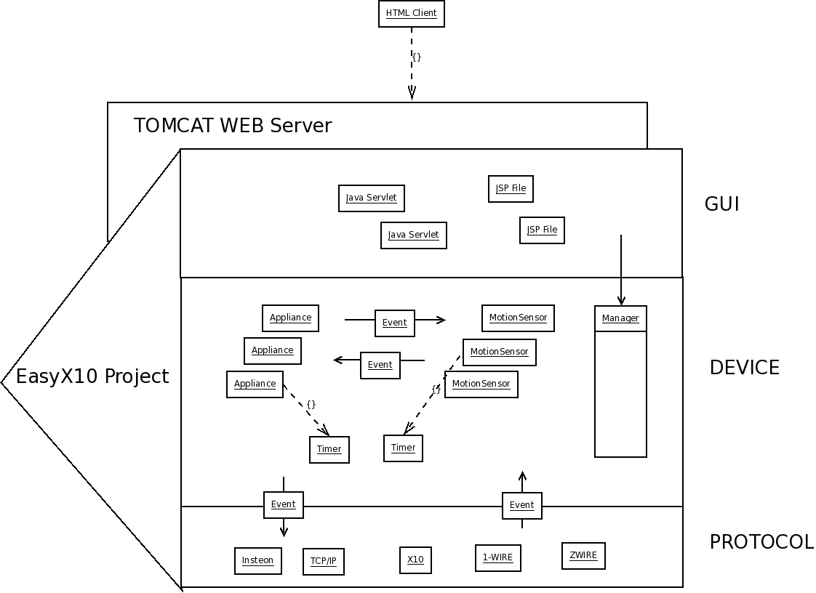
Figure 1 - High Level Software Architecture

GUI Component
The Graphical User Interface (GUI) provides the control interface between the User and the EasyX10 application. The GUI interfaces with the external user via HTML pages served up by a Tomcat web server. The HTML pages are constructed using JSP code files. These JSP files are managed by a set of Java servlets. The Java servlets interface with the Device component using a simple API which passes Device information between the GUI and Device Manager. The API provides very little coupling and high layered cohesion, between the GUI and Device components.

Device Component
The Device component provides the major domain logic for the EasyX10 application. The Device component is designed to perform the real time management of logical device state. The Device component is logically constructed with various objects which capture and emulate the state of real devices external to the system. State changes of internal objects are used to update the state of external devices by sending messages to those external objects. External devices can also transmit messages to update the state of internal objects. The Device component interfaces with external devices using the Protocol component. Internal objects communicate state with each other by broadcasting Events between objects. Events are extensible and can be designed to support any type of state information. The Device component is extensible and can support multiple types of logical devices. The initial release of the EasyX10 project supports two Device types; X10 Appliances and X10 Motion Detectors.

Protocol Component
The Protocol component is designed to interface with external devices. The Protocol component is extensible and can support multiple protocols. The initial release of the EasyX10 project solely supports the X10 protocol for communicating with external X10 devices. The interface between the Device component and Protocol component uses Events. Events are extensible themselves and can convey any type of state information required. Events are transferred from the Device component to the Protocol component in order to update the state of an external device. Events are transferred from the Protocol component to the Device component to communicate state changes in external devices.

Package Descriptions

This section describes the package organization for the EasyX10 project. The EasyX10 project is composed of six different packages as show in Figure 2- Package Organization. This section describes, in detail, how each package interface with each other.

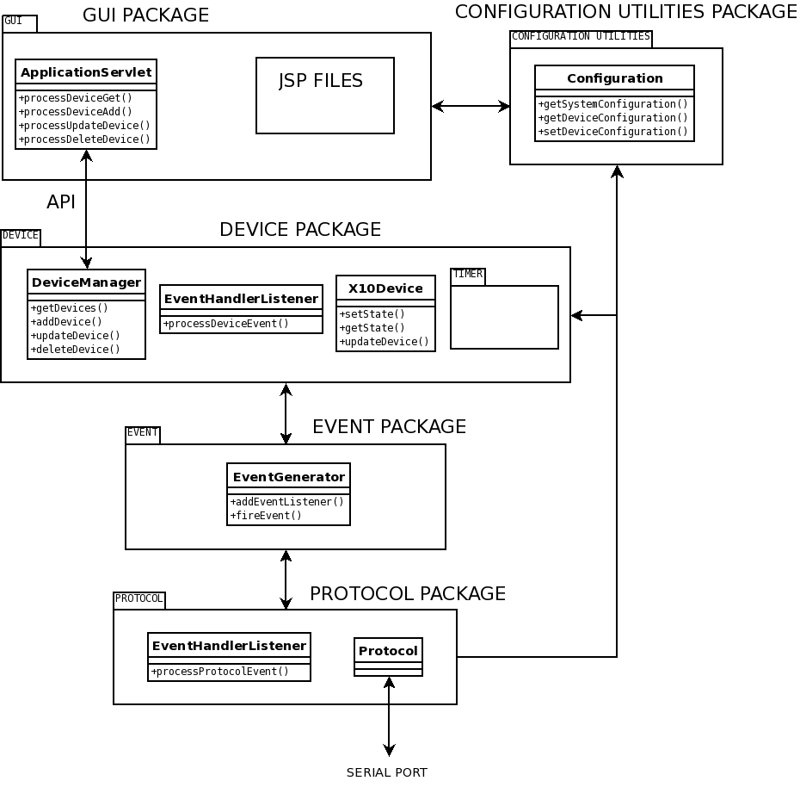
Figure 2- Package Organization

GUI Package
The GUI package provides the user interface to the X10 application. The GUI package is a composition of JSP files and java servlets. The GUI provides the View and Controller portion of the classical Model View Controller (MVC) architecture.
The GUI interfaces with the user through a tomcat web server. The GUI provides the user with JSP pages. An external user interfaces with the tomcat web server, using a standard web browser, in order to interact with the application. The GUI provides the user with the current state of the system as well as providing the user the ability to add, delete, and modify the state of various X10 devices.
The GUI interfaces with the Device package through a simple API. The Device package provides the majority of the domain logic for the application. The GUI package only interfaces with the DeviceManager class within the Device package. The simple API allows the GUI to Add devices, Modify Devices, Delete Devices, and obtain the state of all devices.
For persistent configuration storage, the GUI relies on the Utility Package which provides a configuration function.

Device Package
The Device package provides the major application domain logic. The domain logic is primarily managed by a set of X10Device objects. Each X10Device object represents an actual X10 device which is located in the user's home. Example X10Device objects are LM14 Appliance Modules and MS13 Motion Sensors. Each of these objects stay in lock step with the real-world device by sending and/or receiving X10 protocol messages through the Protocol package.
The DeviceManager instantiates all of the X10Devices based upon either an existing configuration file, or instruction from the GUI package. The DeviceManager interfaces with the GUI package through a simple API, which is discussed in the GUI Package section. The DeviceManager interfaces with the Utility package for persistent configuration storage.
The collection of X10Devices interface with the Protocol package via the EventGenerator and EventListener functionality provided by the Event package (please refer to the Event Package section for more details). Each X10Device sends Events to the EventGenerator. Each X10Device implements the EventHandlerListener to listen to DeviceEvents. The X10Devices also make use of the EventGenerator and EventHandlerListener pair to communicate between each other. The interface between the Device and Event packages uses the Observer design pattern.

Timer Package
The Timer Package contains classes which deal with keeping track of time. Each Timer object runs as a separate processor thread. The X10Device objects instantiate Timer objects for time based events. The Timer objects communicate time based events to the X10Device objects using the EventGenerator functionality.
The Timer package is shown as a sub-package of the Device package. The Timer objects are very different than the Device objects. However, the Timer objects only interface with the Device objects. As such, the best organization is to show the Timer package as a sub-package of Device.

Event Package
The Event package serves as a communications hub between disassociated objects. Any object can send Events through the communication hub by simply calling the fireEvent( ) method in the EventGenerator, which is implemented as a singleton. Any object can receive events from the communication hub by implementing the EventHandlerListener interface and registering with the EventGenerator using the addEventListener( ) method. The EventGenerator and EventHandlerListener pair implement the Observer design pattern.
Various types of Events can be sent through the communication hub. Each type of Event has its own channel to allow some level of routing through the hub.
The Device package and Protocol package utilize the Event package for inter-object communication between the packages. The Device package also uses the Event package for inter-object communication within the Device package.

Protocol Package
The Protocol package interfaces with the external X10 hardware devices through a serial port. X10 protocol commands are sent to/from a CM11A X10 controller attached to the serial port. The Protocol package communicates with the Device package using the EventGenerator and EventHandlerListener facility. X10 commands are received from the CM11A through the serial port, repackaged into DeviceEvents and sent to the Device package for processing. The Device package sends DeviceEvents to the Protocol package. The protocol package repackages the DeviceEvent into an X10 protocol command and delivers the commands to the CM11A through the serial port.
The Protocol package uses the Utility Package Configuration facility for persistent data storage of serial port parameters.

Configuration Utilities Package
The Configuration Utilities package contains miscellaneous functions which are used by other packages. The Configuration Utilities package contains the Configuration utility. The Configuration utility will serialize/deserialize object attributes to an external XML file for persistent storage.

Architectural Style
The architectural style chosen for the EasyX10 project is the Model View Controller (MVC) architecture. The Device and Protocol packages serves as the Model portion while the GUI package serves as the Control and View portion.
The EasyX10 project can also be considered the Layered architecture style. The EasyX10 project can fit into this model since each of the major components, GUI, Device, and Protocol interface with adjacent neighbors, which is a typical signature of a layered architecture approach.
The development team considered adopting the Plugin architectural model to offer best-in-class extensibility for future X10 devices. This architectural style was deemed to difficult to tackle for a class project.

Physical Architecture
Figure 3 - EasyX10 Physical Architecture Diagram illustrates the physical architecture of the EasyX10 system. The three main components are:

- A standard web browser running on a remote host – linux, mac and pc are supported. Communication between the EasyX10 application and the client machine are done over the public internet using HTTP.
- X10 Device modules; Appliance Module CM14, RF Receiver TM751 for receiving wireless transmissions from MS13 Hawkeye Motion Sensors, and the CM11A serial interface module. Please note that while pictures of specific X10 devices are cited, any X10 Motion sensor that sends an X10 On or off event and any X10 appliance device that can receive an X10 On or Off event, is supported in this system.
- A Windows XP computer running the EasyX10 software. As a stretch goal, Linux hosts may be supported if time permits but is not a commitment made in the requirements document.

On the server, there are several packages and components that comprise the EasyX10 system. The JDK 1.6 libraries are the foundation for all the EasyX10 application code. Additionally, the Tomcat web server is built on it as well. In addition to the standard JDK libraries, the EasyX10 X10Protocol package utilizes the Javacomm API to communicate with the CM11A X10 Module through the server’s COM port. This enables two way communication between the EasyX10 application and X10 devices plugged into the power line.
On the front end, the EasyX10 system runs as a web application within the Tomcat web server. Tomcat renders JSP code into HTML pages, and returns them to the remote user’s web browser via HTTP.
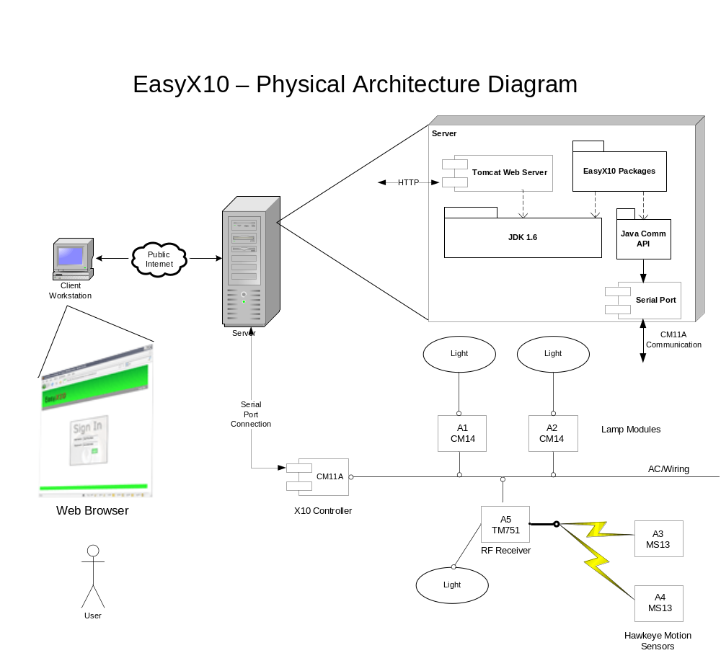
Figure 3 - EasyX10 Physical Architecture Diagram

Concurrency Design
The EasyX10 project has two concurrency issues which can be discussed. The first one concerns the X10Device class, the second concerns the X10Protocol class.

Concurrency in X10Appliance
Figure 4 - X10 Appliance Concurrency provides a sequence diagram which illustrates a potential concurrency issue in the X10Appliance class. In this diagram, there are three separate processes which can simultaneously attempt to change the state of an X10Appliance object.
- GUI – The user can change the state of an X10Appliance at the user interface. The GUI operates using its own thread, keyed off of interaction with the user interface.
- TriggerTimer – A timer can alter the state of an X10Appliance. Timers operate using a separate thread via implementation of the Runnable interface.
- Motion Sensor – An X10 motion device can issue a motion event through the Protocol package, affecting the state of an X10MotionSensor object, which in turn can affect the state of an X10Appliance. The X10Protocol receiver operates using a separate thread.
All three threads can attempt to call the setState( ) method in the X10Appliance object concurrently. To resolve any pitfalls from concurrency issues, the setState( ) method must be guarded with a SYNCHRONIZED qualifier surrounding the enitre method. The SYNCRHONIZED qualifier insures that only one thread can get into the setState( ) method at a time.
A similar two thread scenario occurs at the X10MotionSensor object, the two processes involved are the Protocol package (X10 motion sensor trigger), and a WaitTimer. Like the X10Appliance class, the X10MotionSensor class setState( ) method is guarded with a SYNCRHONIZED qualifier.
Figure 4 - X10 Appliance Concurrency
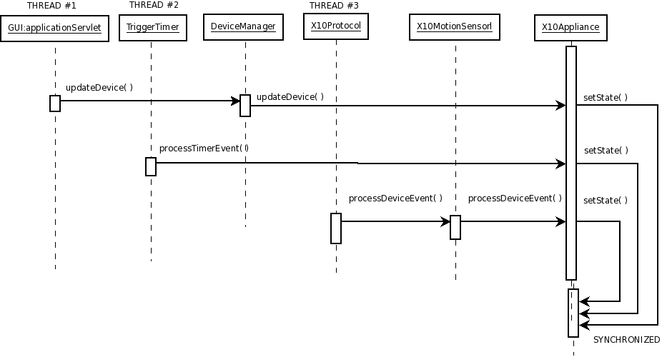

Concurrency in X10Protocol
Figure 5 - X10 Protocol Concurrency provides a sequence diagram which illustrates a potential concurrency issue in the X10Protocol class. The X10Protocol class provides a Queue in the transmit direction in order to detach the slow operating X10 protocol from the remainder of the system. This is done to avoid any sluggishness in the User interface. There are two separate threads operating in this scenario. The first thread is the operation of the X10Device class. When an X10Device state changes, a call is made to the processProtocolEvent( ) method. This method writes the Event into the transmit queue. The other operating thread is the run( ) method which drives the transmit side of the X10Protocol object which interfaces with the external CM11A X10 controller. Two threads are sharing the same transmit queue. All concurrency issues are resolved by simply using a “thread safe” implementation of a Queue object. A thread safe Queue ensures that only one thread can update the state of the Queue at a time, in an orderly fashion.

Figure 5 - X10 Protocol Concurrency
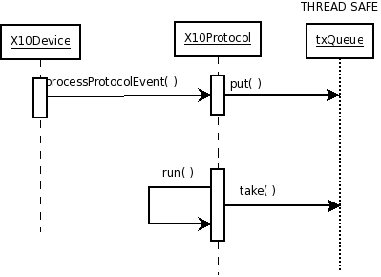

Data Model
This section provides a static view of the EasyX10 software architecture. First, a class diagram showing all the pertinent classes of the EasyX10 software architecture is provided. Later sections describe each of the classes in a higher level of detail. The classes are organized by the major packages defined in Section 2.1 Logical Architecture.

Class Diagram
Figure 6 - System Class Diagram provides a high-level view of the system class diagram. This diagram does not contain the full class diagram for each package. The next section provides a lower level breakdown of all the classes organized by package. Each of the lower level package diagrams provides a very detailed class diagram representing all the classes within each package, as well as pictorial descriptions of the major interfaces to adjacent packages.

Class Descriptions
This section provides details for each of the major classes in the EasyX10 project. The section is organized according to the major packages defined in Section 2.1 Logical Architecture.
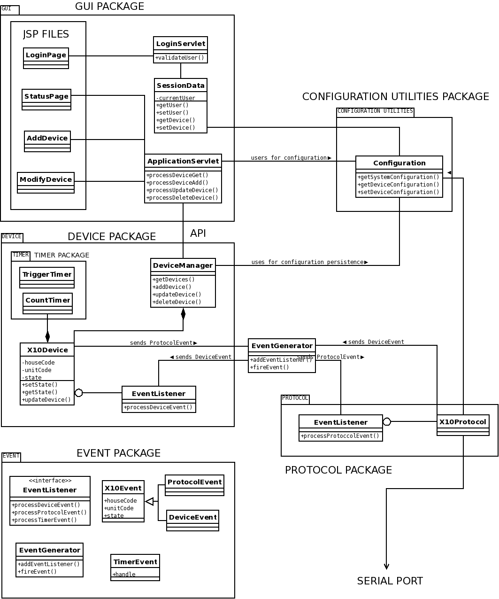
Figure 6 - System Class Diagram

Graphical User Interface (GUI) Package
The GUI package contains all of the classes necessary to enable user interaction with the EasyX10 system. There are two distinct parts to the GUI package. The first part is the java code that performs the processing necessary when a user submits a request to the server. The other part is the collection of web related files. These are primarily a set of Java Server Page (JSP) files that are used by the Tomcat Server to render the GUI in the client’s browser. This section will detail the java classes and give a basic overview of the JSP files (pseudo code is not provided for the JSP files since these are primarily based off of the HTML language and used to render the display). Figure 7 - GUI Package Class Diagram provides the class diagram for the GUI package:
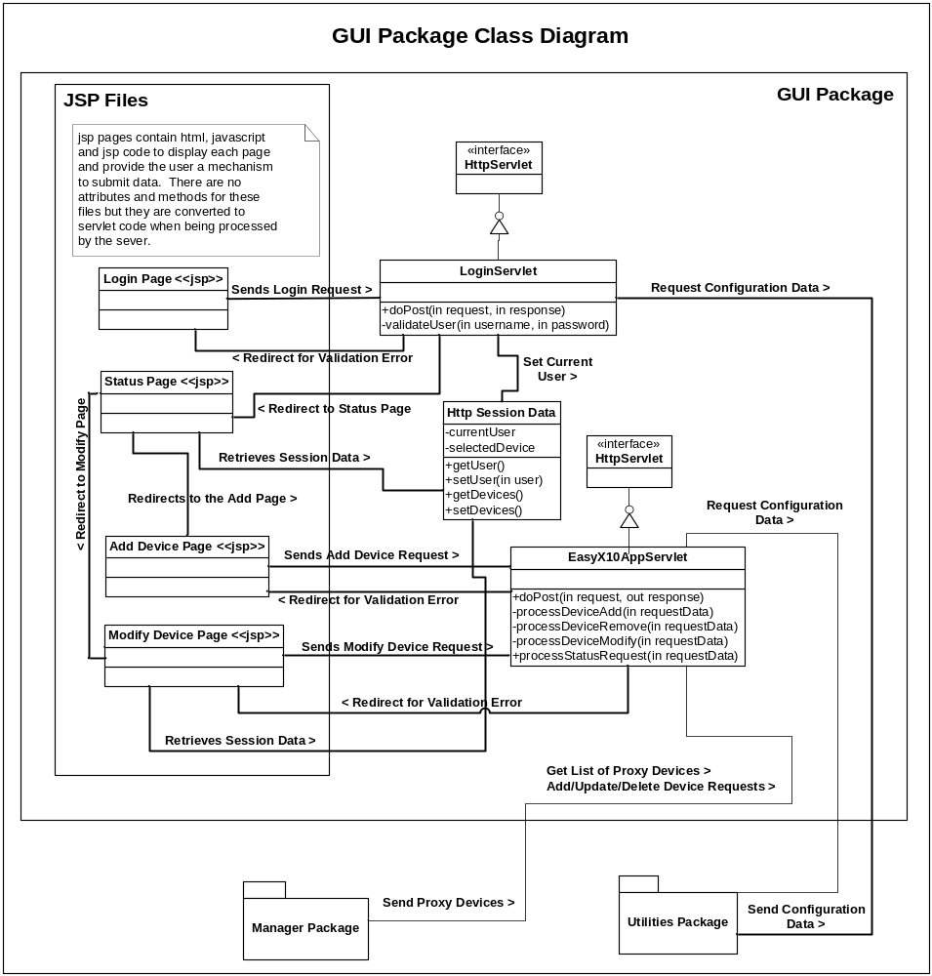
Figure 7 - GUI Package Class Diagram

Login Servlet

Description
The LoginServlet class implements the functionality to process a user’s request to log into the EasyX10 System. The main method of the class doPost() is called when the user submits a request to log in. LoginServlet is a typical Java Servlet that extends HttpServlet.

Pseudocode
doPost(request, response)
Retrieve entered username and password.
IF (username or password not entered) THEN
RETURN ‘Missing Info Error’
ELSE
Retrieve List of Users from Configuration
FOR( Each User in Configuration Data )
IF ( Username Matches Entered Username ) THEN
IF ( Password is Valid ) THEN
Set Current User in SessionData
REDIRECT to Status Page
ELSE
RETURN ‘Wrong Password Error’
ENDIF
ENDIF
ENDFOR
RETURN ‘Invalid User Error’
ENDIF

EasyX10AppServlet

Description
The EasyX10AppServlet represents the main controller for the GUI package. Once a user has logged into the system all of their requests go through this servlet. The servlet will identify the type of request and perform the necessary processing. The EasyX10AppServlet is a typical Java Servlet that extends HttpServlet.
- +doPost() : Routes request to the appropriate method.
- -processDeviceAdd() : Performs processing to add a device.
- -processDeviceModify() : Performs processing to modify a device.
- -processDeviceRemove() : Performs processing to remove a device.
- -processStatusRequest() : Requests status data from DeviceManager

Pseudocode
doPost(request, response)
Retrieve RequestType
SWITCH (RequestType){
case ADD:
processDeviceAdd();
case MODIFY:
processDeviceModify();
case REMOVE:
processDeviceRemove();
case STATUS:
processStatusRequest();
}
processDeviceAdd(request, response)
Retrieve Device Data Fields
IF ( Field Validation Fails ) THEN
Return ‘Validation Error’
ENDIF
Create new Device Object with Form Data
Call the DeviceManager to Add the new Device
Process Any Exceptions
Set Status Message
Redirect to Status Page
processDeviceModify(request, response)
Retrieve Device Data Fields
IF ( Field Validation Fails ) THEN
Return ‘Validation Error’
ENDIF
Update selected Device with Form Data
Call the DeviceManager to Modify the Device
Process Any Exceptions
Set Status Message
Redirect to Status Page
processDeviceRemove(request, response)
Call the Device Manager to Remove the Selected Device
Process Any Exceptions
Set Status Message
Redirect to Status Page
processStatusRequest(request, response)
Retrieve the list of Devices from the Device Manager.
Set the device list in the Session Data
Redirect to the Status Page

Http Session Data

Description

The session data class stores any data that is required over the course of a user’s session. This includes user data, the list of devices and any other data that needs to persist between Http requests.

Pseudocode
The Session Data class is a Java Bean, meaning its purpose is simple to store data that must persist throughout a user’s session. Therefore, it does not perform any real processing.

Login<<JSP Page>>

Description
The Login JSP page is the entry point for the EasyX10 Application. It presents a form where the user must enter a username and password. When the form is submitted the LoginServlet is called to process the request.

Status

Description
The Status JSP page displays a floor of the house and all of the devices on that floor. Each device displays an indication of its type and current status. The user can select a device to modify its properties or add a new device through the menu bar.

AddDevice <<JSP Page>>

Description
The AddDevice JSP page displays the floor plan and a form to enter new device data. The user can enter all of the details of the new device and reposition the new device to the desired location on the floor. When the user submits a request to add a new device it is processed by the EasyX10AppServlet.

ModifyDevice <<JSP Page>>

Description
The ModifyDevice JSP page displays the floor plan and a form to modify device data. The user can modify details of the device and reposition the device to a new location on the floor. When the user submits a request to modify a device it is processed by the EasyX10AppServlet.

Event Package
Figure 8 – Event Package Class Diagram provides the class diagram for the Event package. The Event package provides communication between disassociated objects. The EventGenerator class is a singleton and is responsible for sending Events to other objects. The EventHandlerListener interface must be implemented by any object which desires to receive events. Objects which desire to receive events must also register with the EventGenerator. A typical use case is for the constructor of any object to register with EventGenerator while the object destructor would unregister from the EventGenerator.
Figure 8 – Event Package Class Diagram
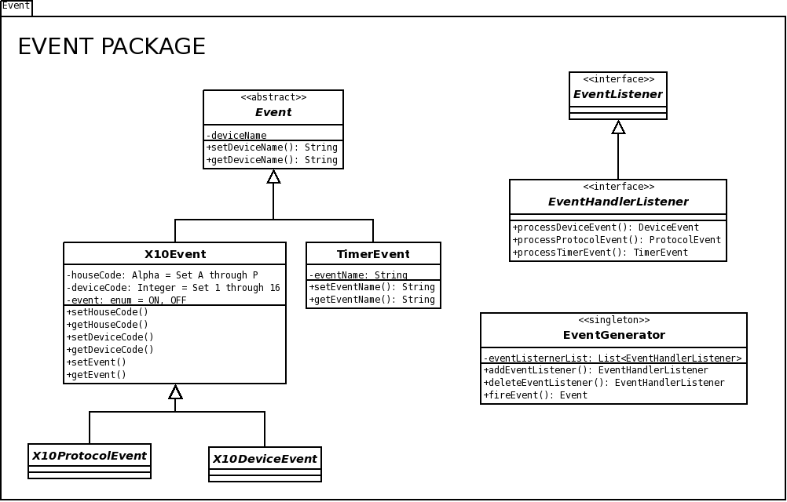

EventGenerator Class
The EventGenerator class contains a list of all objects which desire to receive events. Any object which desires to receive Events must call the addEventListener( ) method. An object which receives events must implement the process*Event( ) methods. One or more of these implementations could be empty, implying the object is not interested in that Event type.
Any object which desires to send an Event simply calls the fireEvent( ) method. The EventGenerator class will forward the Event to all listeners. A call will be made to one of the process*Event( ) methods for each of the listeners. The called method is determined by the Event class type. There is one process*Event( ) method for each class type.
- +addEventListener( ) : provides a reference for receive event processing
- +deleteEventListener( ) : used to delete reference
- +fireEvent( ) : send Event to all registered listeners.

Pseudo Code
addEventListener( Object ):
Add Object to eventListenerList looking to avoid duplicate entries.
deleteEventListener( Object ):
Delete Object from eventListenerList if Object is in the List.
fireEvent( Event ):
For Each Object Of eventListenerList
Call one of the process*Event( ) methods, de-referenced to the Object, based upon the type of Event

EventHandlerListener Interface
Each object which desires to receive events must implement the EventHandlerListener interface. The object must implement each of the process*Event( ) methods. If a specific Event type is not desired, the object can simply provide an empty implementation.

Event Class
The Event class provides the main data type interface between the objects using the event communications hub. The Event class is an abstract base class. Additional concrete Event classes are created as needed. The initial release of the EasyX10 project requires only two Event types, X10Event and TimerEvent. The deviceName attribute is used to route the Event to its matching destination object when Events are sent to Device class objects.
- setDeviceName( ): accessor
- getDeviceName( ): accessor

X10Event Class
The X10Event class is an extension of the abstract Event class. The X10Event is used to support Devices and Protocols which use X10 for communication.
The houseCode and unitCode attributes are used to address an individual X10 device. The event attribute describes the X10 event. The X10 event describes a device state and can be one of two values; ON or OFF.
- setHouseCode( ): accessor
- getHouseCode( ): accessor
- setUnitCode( ): accessor
- getUnitCode( ): accessor
- setEvent( ): accessor
- getEvent( ): accessor

DeviceEvent Class
The DeviceEvent class is a simply extension of the X10Event class. The renaming is solely done for routing purposes through the Event communications hub. When implementing the EventHandlerListener, DeviceEvent objects will arrive through the processDeviceEvent( ) method.

ProtocolEvent Class
The ProtocolEvent class is similar to DeviceEvent class. ProtocolEvent objects will arrive through the processProtocolEvent( ) method.

TimerEvent Class
The TimerEvent class is an abstract extension of the abstract Event class. When implementing the EventHandlerListener, TimerEvent objects will arrive through the processTimerEvent( ) method.
The handle attribute is a String which identifies the timer event. This is required to allow the receiver to differentiate Timer Events.
- setHandle( ) : accessor
- getHandle( ) : accessor

Protocol Package
Figure 9 - Protocol Package Class Diagram provides the class diagram for the Protocol package. The Protocol package interfaces with the Device Package using Event objects and Event communications hub provided by the EventGenerator and EventHandlerListener pair. The Protocol package is also responsible for interfacing with the low level physical interface(s). The Protocol package is extensible. The package can support multiple and disparate protocols. The initial release of the EasyX10 project supports only the X10 protocol used to interface with X10 modules. Extensibility provides support for other protocols in the future (i.e. Insteon, TCP/IP, One Wire, others).

Protocol Class
The Protocol class is an abstract base class for the various Protocol classes. The Protocol class interfaces with the Device package. The Device package provides ProtocolEvent objects to the Protocol class through the EventGenerator. These ProtocolEvents arrive in the Protocol class through the processProtocolEvent( ) method.
Each individual concrete Protocol class interfaces with a set of software and possibly hardware layers using external packages.
In the transmit direction, the processProtocolEvent( ) method deposits new Events into a thread safe Queue. The txQueue provides isolation between the threads running in the caller, through processProtocolEvent( ), and any internal transmit thread (if necessary) required in the Protocol class which supports the baseline protocol.
In the receive direction, the Protocol class sends DeviceEvents to other classes through the EventGenerator. Each time a new Event has been received, the Protocol class will call the fireEvent( ) method in the EventGenerator class.
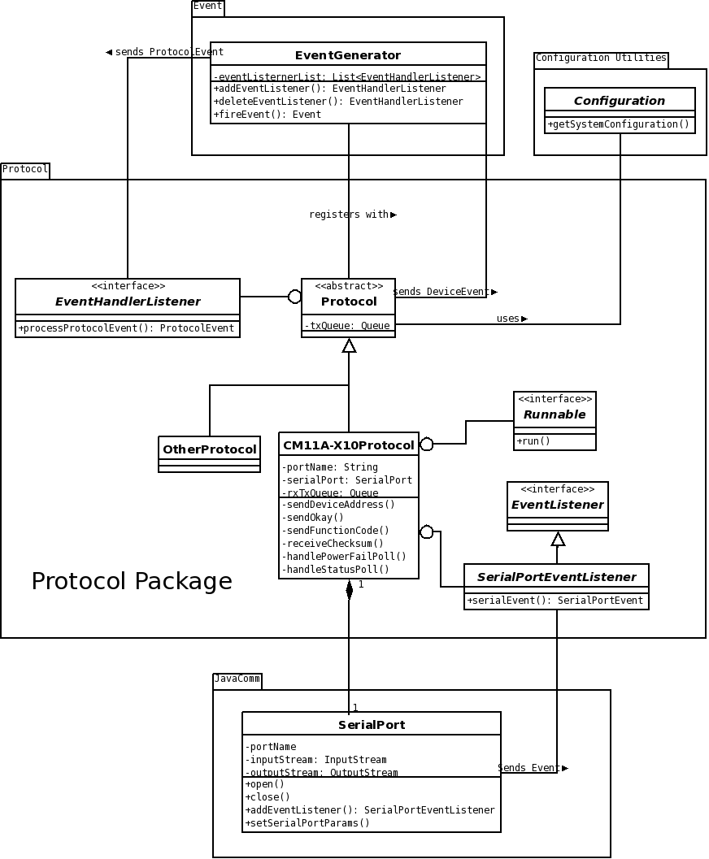
Figure 9 - Protocol Package Class Diagram

CM11A-X10Protocol Class
The CM11A-X10Protocol class is a concrete Protocol class which provides the protocol interface for the X10 network. The CM11A-X10Protocol class interfaces with an external X10 controller referred to as the CM11A. The CM11A attaches to the host computer using a serial port. The CM11A-X10Protocol class instantiates the SerialPort class from the JavaComm Package in order to communicate with the CM11A X10 controller.
The txQueue object stores inbound Event objects. This queue provides decoupling between the external processing thread and the internal transmit thread. Since the X10 protocol can be very slow, this decoupling queue will prevent any issues with delay. The serialPort object provides the logical interface to an external CM11A X10 controller.
The CM11A-X10Protocol class registers with the SerialPort class using addEventListener( ) in order to receive inbound status from the serial port. The CM11A-X10Protocol class implements the SerialPortEventListener class to detect when inbound status is available. The CM11A-X10Protocol interfaces with the SerialPort data stream using the inputStream and outputStream objects.
The rxTxQueue object stores inbound receive characters which are to be consumed by the transmit thread. This path is used to provide the transmit thread with the inbound X10 check sum bytes.
The CM11A-X10Protocol class implements the Runnable interface, which provides a thread to run the CM11A transmit protocol. The transmit thread reads Events from the txQueue and then operates the CM11A protocol to send the X10Event to the CM11A controller module.
- processProtocolEvent( ) : Event object, input to Protocol package
- sendDeviceAddress( ), sendOkay( ), sendFunctionCode( ), receiveChecksum( ), handlePowerFailPoll( ), handleStatusPoll( ) : all of these methods are used to support the X10 protocol using the external CM11A device. Please refer to the cm11a_protocol.txt documentation for more information.
- transmitThread ( ) : separate thread which interfaces with the CM11A transmitter using the serialPort.
- serialEvent( ) : separate thread which interfaces with the CM11A receiver using the serialPort.

Pseudo Code
processProtocolEvent( Event ):
If Event Class Type == X10Event THEN
Insert the Event into the Transmit Queue for processing
handleStatusPoll ( ) :
Send Status Poll Acknowledge to the CM11A through serial port
Read Poll Status Bytes from CM11A through serial port
Decode Poll Status Bytes to obtain House Code, Unit Code, Event
Create an X10Event Object with House Code, Unit Code, Event
Validate X10Event
If X10Event == Good
Send the X10Event to the fireEvent( ) method in the EventGenerator
run ( ) :
While FOREVER
Read X10Event from Transmit Queue
Extract House Code, Unit Code, Event from X10Event
Validate X10Event
If X10Event == GOOD
Send the House Code, Unit Code, and Event to CM11A
Read the return Checksum from the CM11A
Validate checksum (refer to cm11a protocol)
If checksum == OKAY
Send the Event Function Code to CM11A
Read the return Checksum from the CM11A
Validate Checksum
If checksum == OKAY
Send the SendOKAY message to the CM11A
serialEvent ( SerialEvent ):
If SerialEvent == New Data Available
Read Byte from Serial Port
If Read Data == powerFailPoll THEN
Call handlePowerFailPoll()
Else If Read Data == statusPoll THEN
Call handleStatusPoll( )
Else Write the Read Data Byte into the rxTxQueue

OtherProtocol Class
The OtherProtocol class simply demonstrates the extensibility of the abstract Protocol class. Other protocols besides X10 (CM11A) could be supported. Example protocols are Insteon (super set of X10), One Wire (single wire sensor interface), even TCP/IP (networking).

SerialPort Class
The SerialPort class is provided by the JavaComm Package. The SerialPort class provides the logical interface to the actual serial port hardware. A serial port is required to interface with the external CM11A X10 controller.
The portName attribute provides the name of the physical serial port the CM11A is attached to. Examples are COM1 (windows), or /dev/ttyS0 (unix).
The inputStream and outputStream objects provide the byte streaming interface to the serial port.
- write( ) : this method is used to provide outbound characters to the serial port
- read( ) : this method is used to extract inbound characters from the serial port
- serialEvent( ) : this method is used by the serial port to indicate that new data is available in the serial port receive buffer.

Device Package
The Device package contains all of the classes necessary to model all the physical and virtual devices in the system. The package can be broken down into 3 functions; Modeling the state and attributes of the physical devices outside the system, managing a list of devices, and acting as a proxy between the view and model pieces of the MVC architecture. Timers are a sub package of the device package but will be covered in the next section below.
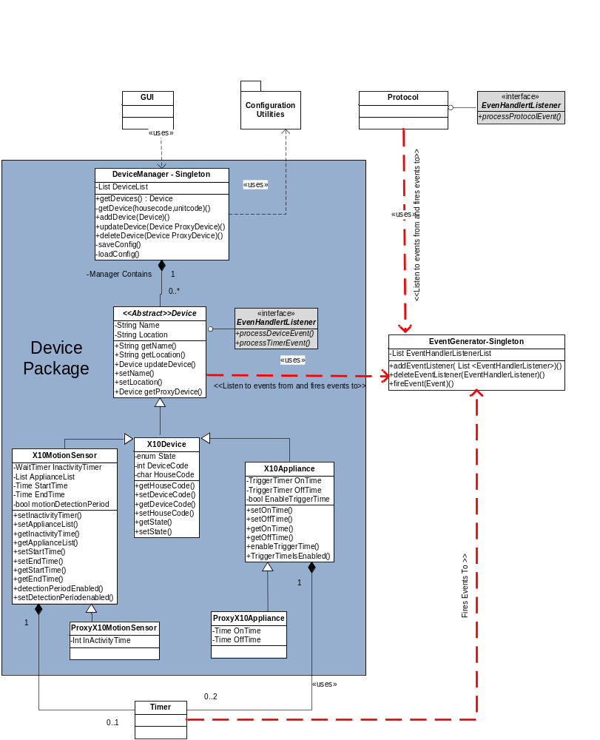
Figure 10 - Device Package Class Diagram

Device

Description
The Device class is an abstract base class that’s used to model physical devices within the EasyX10 system. A device has only two attributes; a name and a location. The name is the unique identifier amongst other devices in the system, and the location is a string representing its physical location in the GUI. For the scope of this project it includes Motion sensors and appliance modules; derived from X10Device. Keep in mind that the Device base class is abstract and could be expanded to support other device types in future releases.
The Device class implements an eventHandlerListener, that listens to events from the EventGenerator and processes DeviceEvents and TimerEvents as they occur. processDeviceEvent() and processTimerEvent() are not implemented in the base class since their implementation would be device specific.

The Device base class includes the following methods:

- +getName() returns the name of the device
- +getLocation() returns a string describing the location in the GUI
- +UpdateDevice() takes in a proxy device and updates it’s attributes to match
- +setName() sets the name of the device
- +setLocation() sets the location of the device in the GUI
- +getProxyDevice() returns a copy of this device to the caller

Pseudo Code

#Note: preventing a duplice Device from being created is the responsibility of the DeviceManager since it contains the list of all devices. A check would be performed prior to attempting to create a device object. Device objects do not have direct knowledge of other device objects.
setName(String deviceName)
Validate Length of deviceName is less than MAX
IF True
set Name=DeviceName
Else
Write out error message to log file
Return False

X10Device
The X10Device class is the second level of abstraction above the Device base class. All X10Devices have attributes State, DeviceCode and a HouseCode. Real X10 modules have house and device codes as well. The getters and setters for DeviceCode and HouseCode are implemented in this class, while setState is implemented in X10MotionSensor and X10Appliance since the values are device specific. The reason for creating the X10Device class, rather than implementing X10MotionSensor and X10Appliance directly from Device, is because it’ provide for reduced coupling and higher cohesion when adding other types of X10Device classes in future versions.

The X10Device class contains the following methods:

- +getHouseCode() returns a char containing the house code of the X10device
- +setHouseCode() set a char representing the house code of the X10Device. Valid values are A thru P
- +getDeviceCode() returns an int containing the device code of the X10Device.
- +setDeviceCode() set an int representing the Device code of the X10Device.
- +getState() Overridden. Not defined here.
- +setState() Overridden. Not defined here.

X10MotionSensor

Description
The X10Motion sensor class is where X10 motion sensor devices are created. In addition to inheriting from X10Device and Device, X10MotionSensor contains a WaitTimer called inactivityTimer, that stores the number of seconds to wait before deeming a motion sensor inactive. When the timer reaches zero, it fires an event that is processed by the X10MotionSensor that sets it’s state to inactive.”. It also contains an ApplianceList, so that it knows what devices to send DeviceEvents to when motion is detected, a StartTime and EndTime to mark the window during which motion events should be processed and a bool so that it can be checked whether a window time has been defined.
- setInactivityTimer() Instantiates the inactivityTimer with a time in seconds passed into the X10MotionSensor’s Constructor.
- setApplianceList() Creates a list of associated Appliance devices.
- getInactivityTime() Return the time in seconds stored in the associated WaitTimer device.
- getApplianceList() Return the list of appliance devices associated with the motion sensor.
- setStartTime() set the start time associated with the detection period.
- setEndTime() set the end time of the detection period.
- getStartTime() retrieve the detection period start time.
- getEndTime() retrieve the detection period end time
- detectionPeriodEnabled() return true or false depending on whether the detection period is enabled.
- setDetectionPeriodEnabled() Enable or disable the detection period.

Pseudo Code
Two key methods for the X10MotionSensor are its constructor and processDeviceEvent(); inherited as part of implementing an EventHandlerListener.

X10MotionSensor (ProxyDevice proxySensor)
{
Run through all getters from proxy device and run the setter in the new device to match…
setName(ProxySensor.getName)
setLocation(ProxySensor.setLocation)
setAppliance=List etc…..

IF ProxySensor.detectionPeriodEnabled = True
{
setDetectionPeriodEnabled( ProxySensor.detectionPeriodEnabled())
}

//Now handle all state related actions.
//Set the state of the Motion Sensor to Inactive initially.
setState(enum inactive);

IF Success (This.addEventListener to listen for incoming events){
InactivityTimer.setSecondsToWait = ProxySensor.getInactivityTime
}
Else Return False
}

processDeviceEvent( Event DeviceEvent)

//All devices listen to all device events. So step one for any device is always to check to //see if the event was intended for it.
If
Name=DeviceEvent.getDeviceName()
HouseCode = DeviceEvent.getHouseCode ()
AND
UnitCode= DeviceEvent.UnitCode()
AND
Any Valid MotionSensor state = DeviceEvent.getEvent ()
THEN This event was intended for this device
//set the state of the motion sensor to Active
this.setState (DeviceEvent.getEvent )
//Reset the inactivityTimer
InactivityTimer.startTime()
IF (detectionPeriodEnabled)
IF Current Time > StartTime AND CurrentTime < EndTime
// Look up corresponding Devices in list
FOR EACH Appliance in List
AppEvent = New DeviceEvent(
List Item X10Appliance.getHouseCode,
X10Appliance.getUnitCode,
On)
fireEvent(AppEvent)
Print to Log – “INFO: Fired Event A1 ON for
X10ApplianceItem.getName()”
ENDLOOP
ELSE Print to Log: “State change ignored. Outside MotionDetectionPeriod
ELSE Detection Period not Enabled
Reuse FOR EACH Loop code above to fire all events

ELSE
Do Nothing
Print to Log – “INFO: Event A1 Off was ignored by this.getName() with code A2 and state Inactive”
}

ProxyX10MotionSensor
ProxyX10MotionSensors are derived from and are identical to X10MotionSensors except that they override the X10MotionSensor constructor such that they don’t instantiate the WaitTimer InactivityTimer object. Instead they just set an Int attribute InactivityTime and override the setInactivityTimer() method to set the attribute value. ProxyMotionSensorObjects are instatiated in the GUI and are passed off to the DeviceManager. The manager then creates X10MotionSensor Objects by passing a proxy object into the constructor.

X10Appliance

Description
The X10Appliance class, just like the X10MotionSensor Class is derived from the X10DeviceClass. It’s attributes, in addition to those it inherits, are a TriggerTimer OnTime that defines what time the appliance will be turned on (by way of firing a TimerEvent) and a TriggerTimer OffTime, indicating when the appliance should automatically turn off (via the firing on another TimerEvent. It also contains a EnableTriggerTime attribute that can be checked via the TriggerTimerIsEnabled() method. It’s important to note that regardless of whether or not a TriggerTimer is enabled, X10Events will still be processed. In other words, if appliance A is set to turn on at 6pm and off at 10pm, On Events received by A at 7pm and 11pm both will be allowed to turn the appliance on.
Just like X10MotionSensor Objects, X10Appliance objects are instantiated by passing a proxy object to its constructor. Within the constructor, additional method calls are made to set the state of the new X10Appliance equal to the values in the proxy device.

The methods in X10Appliance Device are as follows:
- +setOnTime() Instantiates a TriggerTimer OnTime device with the value from the ProxyX10Appliance
- +setOffTime( )Instantiates a TriggerTimer OnTime device with the value from the ProxyX10Appliance
- +getOnTime() Returns the TriggerTimer onTime
- +getOffTime() Returns the TriggerTimer offTime
- +enableTriggerTime() sets the value of EnableTriggerTime to either True or Falue
- +TriggerTimeIsEnbled() Returns the value of enableTriggerTime

Pseudo Code

The key method in X10Device is processDeviceEvent()

processDeviceEvent(DeviceEvent)
{
//All devices listen to all device events. So step one for any device is always to check to //see if the event was intended for it.
IF All of this = True
Name=DeviceEvent.getDeviceName()
AND
HouseCode = DeviceEvent.getHouseCode ()
AND
UnitCode= DeviceEvent.UnitCode()
AND
Any valid X10 state = DeviceEvent.getEvent()
AND
//Drop this event if the appliance is already in this state.
//We don’t wan to unnecessarily fire ProtocolEvent’s
//if we don’t have to.
State != to DeviceEvent.getEvent()
THEN
//set the state of the Appliance to On assuming it was Off
IF(this.setState (DeviceEvent.getEvent )) = TRUE
//Repeat the event back to eventGenerator
NewProtocolEvent = same contents of DeviceEvent
IF { fireEvent(NewProtocolEvent) = TRUE)
Print to Log – “INFO: Successfully Fired Event A1 ON for
this.getName()”
//Now that we know the event was sent successfully it’s ok to
//set the State attribute to match
this.setState (DeviceEvent.getEvent )
}
ELSE
Do Nothing
Print to Log – “INFO: Event A1 Off was ignored by this.getName() with code A2 and state OFF”
}

ProxyX10Appliance
ProxyX10Appliance is derived from and identical to X10Appliance except that it overrides the X10Appliance constructor such that they don’t instantiate TriggerTimer OnTime and OffTime objects. Instead, ProxyX10Appliancejust sets two Time object attributes with the same names; OnTime on OffTime. ProxyX10Appliance objects are instantiated in the GUI and are passed off to DeviceManager. DeviceManager then creates X10Appliance Objects by passing a proxy object into the constructor. ProxyX10Appliance does not contain any of it’s own methods; only overridden ones.

DeviceManager

Description
DeviceManager is the interface between the GUI and the device class. Its main function is to simplify interaction and management of devices for the GUI Package. It does this by providing access to a list of devices and proxy changes from the GUI to the device objects themselves using proxy devices. It also allows or rejects the creation of devices with duplicate names, and regularly saves configuration data out to disk so that it persists between system restarts. The practice of passing proxy devices through the Device manager also eliminates the need for the GUI to worry about concurrency issues with regards to device state changes. The only attribute stored in the Device Manager is DeviceList where the X10Appliances and X10MotionSensors are stored as a single list.

DeviceManager Methods include:
- +getDevices() Returns a list of proxyDevices, created from repeated calls to Device.getProxyDevice()
- +getDevice() a search function that when passed in a proxy device name, returns a single device with a matching name.
- +addDevice() Takes a proxy device as it’s argument and creates a device and adds it to device list if the device name isn’t already in use.
- +updateDevice() Takes a proxy device as its argument and iterates through the device list and hands off the proxy device to the actual device. When the properties of an X10appliance or Motion Device are changed from the GUI, a proxy device is created and passed into this method. If successful it returns a proxy device with the new settings, otherwise an exception is thrown and written to the log. See pseudo code below for further detail.
- deleteDevice() Takes a device name as its argument and deletes the
Device from the list.
- saveConfig() Takes the list of Device objects and hands it off to the configuration Utilities package where it’s written to disk.
- loadConfig() Retrieves the devices list from the Configuration Utilities package and instantiates the device list.

Pseudo Code
The following are key methods for the Device Manager package:

updateDevice( Pass in ProxyDevice){

//Pull the corresponding device from DeviceList using getDevice()
IF RealDevice = this.getDevice(ProxyDevice.getName)
// Check to make sure the devices are the same type
IF RealDevice.getObjectType = ProxyDevice.getObjectType
//Hand off proxyDevice to the RealDevice to complete the update
Try (RealDevice.updateDevice(ProxyDevice))
//Return a ProxyDevice for the updated device
Return RealDevice.getProxyDevice()
//Save out the config.

Catch Exception if it doesn’t work
Throw Exception back to Caller
Print Log: The Device could not be updated. You messed up. Not me.

ELSE throw exception
Print to log: “ERROR:Object Type for ProxyDevice.getName doesn’t match RealDevice.getName

ELSE Throw exception
Print to Log: “Device ProxyDevice.getName not found in Manager list.”
}

Timer Package
Timer is a sub package of the Device Package. While they do not have a corresponding physical device outside the EasyX10 system, devices instantiate timers to initiate time based events and in this sense are virtual devices. To illustrate how they are used in the system, the following section focus on how X10MotionSensor and X10Appliances utilize Timer.

Timer
Timer is base class of the Timer package. It is an abstract class and implements Runnable with a run() method called at construction time. It is responsible for firing events to the EventGenerator after a specific duration or time determined by the derived class. Timer contains only one attribute; Event EventToFire and contains two methods to get and set EventToFire. It also contains an abstract method called startTimer().
- +startTimer() Overridden in the derived class.
- +setEventToFire() Sets the attribute EventToFire
- +getEventToFire() Returns the attribute EventToFire

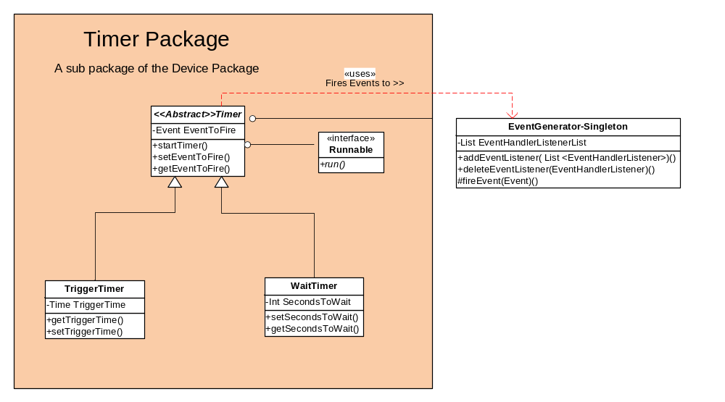
Figure 11 - Timer Package Class Diagram

WaitTimer

Description
The WaitTimer class is derived from Timer. Its purpose is to count down from a given x number of seconds (set by the secondsToWait() method) and fire an event when the counter hits zero.
X10MotionSensor devices instantiate a WaitTimer that will fire an event back to the X10MotionSensor object through EventGenerator that will set the motion sensors state to inactive. This would indicate that a room in the home is unoccupied. If the X10MotionSensor receives an X10MotionEvent before the Timer expires, it calls the overridden method startTimer() within the Wait Timer to reset the Timer back to the value of SecondsToWait.

TriggerTimer
TriggerTimer is derived from Timer. It’s purpose is to Trigger events at a specific time of day. It’s only attribute other than an EventToFire, inherited from Timer, is a Time attribute; TriggerTime. The value of TriggerTime is the time of day in hours and minutes that an event will be fired. The value is set at construction with a call to setTriggerTime() and can be retrieved with getTriggerTime().
An example use of TriggerTimer’s is within the X10Appliance class. X10Appliances contain two TriggerTimers; one fires an event to X10Appliance at TriggerTime to turn the appliance on and the other fires an event at TriggerTime to turn the Appliance off.

Configuration Utilities Package
The main function of the Configuration Utilities package is to provide a mechanism for the rest of the application to retrieve and update configuration data. The EasyX10 configuration data is stored in XML files and the ConfigurationUtilities class provides the methods to retrieve both System and Device Configuration data. Device data can also be saved to file using the ConfigurationUtilities class.
See section 5 for more details of the ConfigurationUtilities class.

Dynamic Model
This section describes the data flow of the system, showing the collaboration and messages between objects. Each of the eight Use Cases described in the System Requirements Specification are described here using UML sequence diagrams.

Use Case 1 – User Login
Figure 12 - Use Case 1 - User Login illustrates the sequence of actions performed by the EasyX10 application when a user attempts to log into the system.
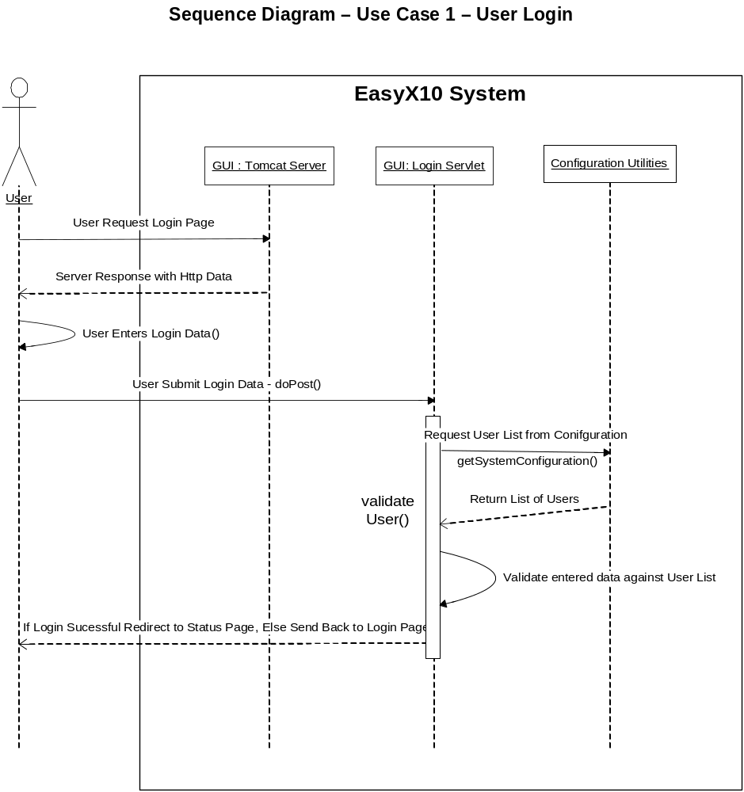
Figure 12 - Use Case 1 - User Login

Use Case 2 – Add Device
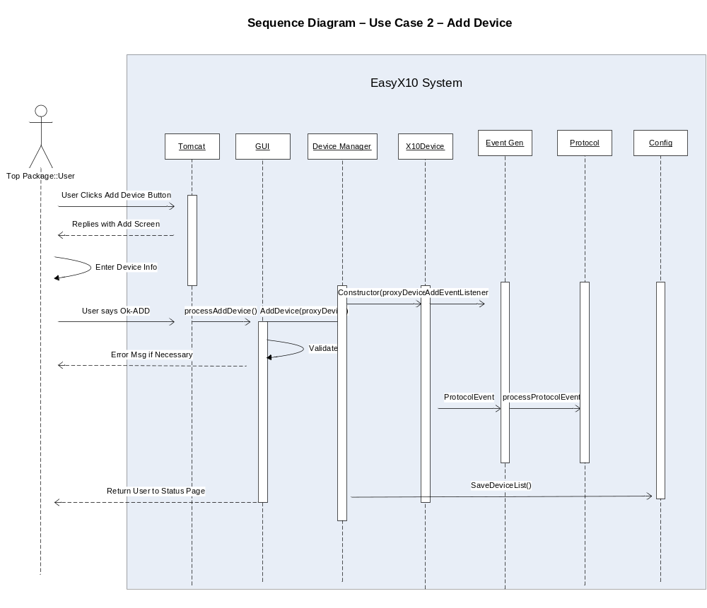

Figure 13 - Use Case 2 - Add Device

Use Case 3 – Remove Device
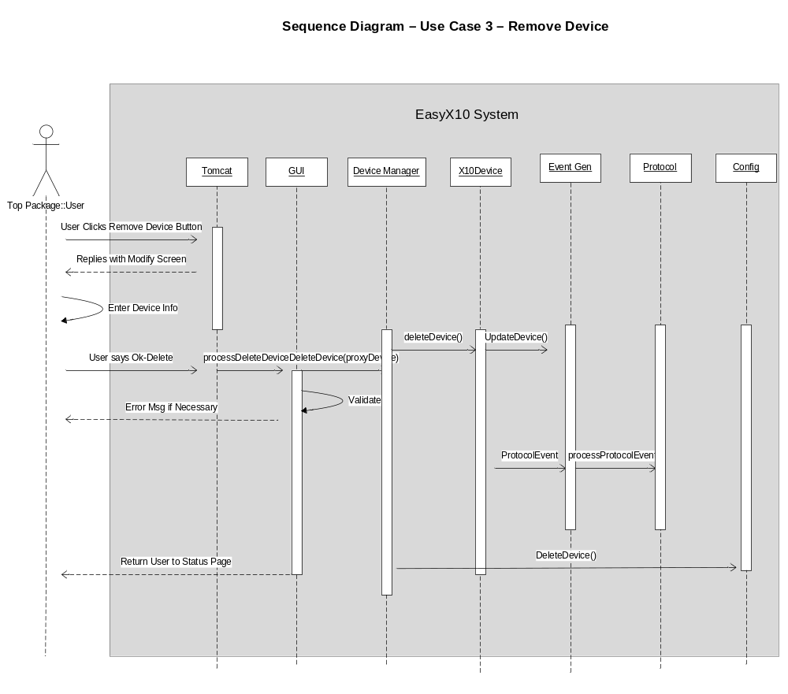
Figure 14 - Use Case 3 – Remove Device

Use Case 4
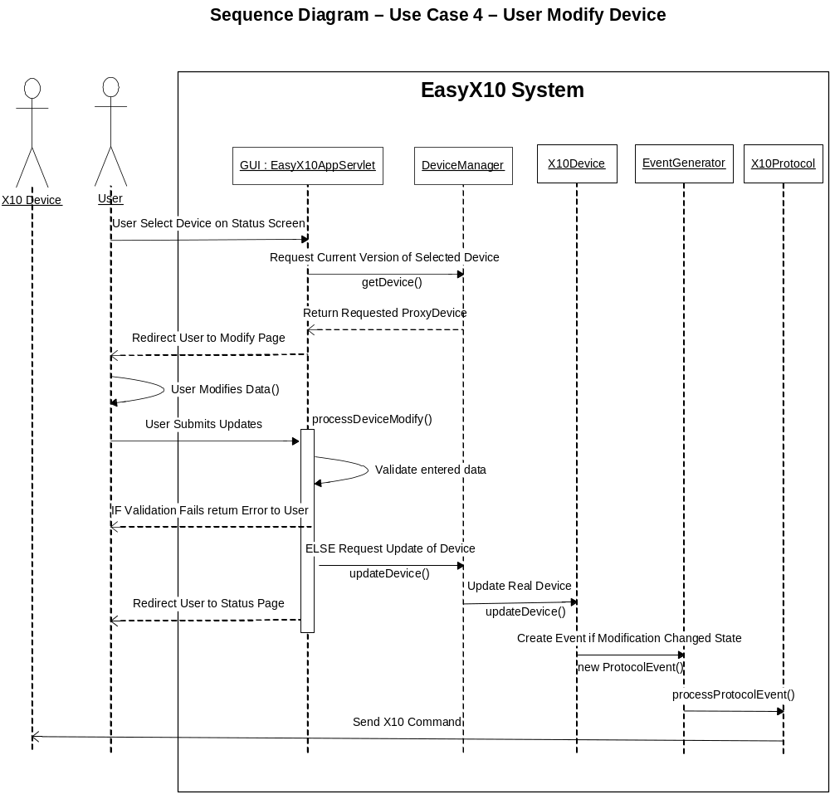Figure 15 - Use Case 4 - User Modifies Device illustrates the sequence of actions performed by the EasyX10 application when a user attempts to modify the properties of a device.

Figure 15 - Use Case 4 - User Modifies Device

Use Case 5: User Monitors system status
Figure 16 - Use Case 5 - User Monitors Status provides the sequence diagram for use case 5: user Monitors system status. It begins when the user requests the status page through a web browser. This causes the status page jsp code to perform an HTTP request to the EasyX10Servlet class. Within here, it processes the post data with doPost(), checks the type of request and determines it’s of type Status, and then runs the ProcessStatusRequest() method. Within here, a call is made to the getDevices() method in the DeviceManager, to return a list of ProxyDevices. The list is then passed off to Session Data for storage and the status page’s JSP code retrieves the list from Session Data and formats it for display back to the User.

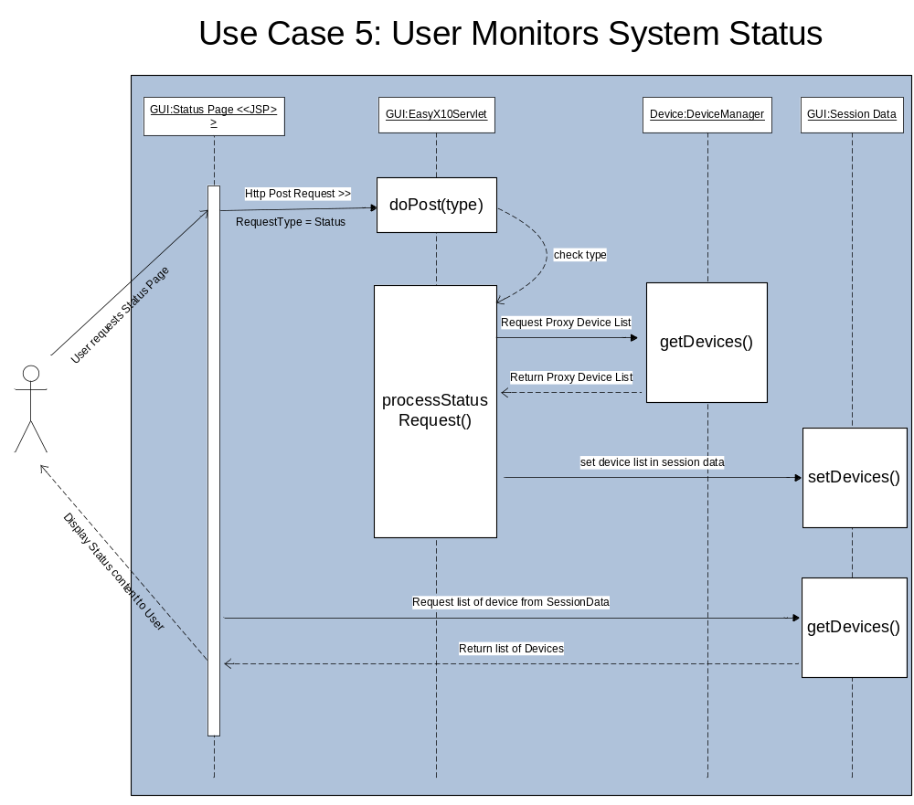

Figure 16 - Use Case 5 - User Monitors Status

Use Case 6 – Timer Controls Appliance Device (Time of Day Event)
Figure 17 - Use Case 6 - Timer Controls Appliance (Time of Day) provides the sequence diagram for this use case. The use case starts with an X10Appliance object having a TriggerTimer attached with either an ON or OFF time. The TriggerTimer encounters the configured time of day. The TriggerTimer starts the process by sending a TimerEvent to the X10Appliance, which then forwards an X10 message to the LM14 through the Protocol package. The use case ends with the LIGHT turning ON or OFF.
Figure 17 - Use Case 6 - Timer Controls Appliance (Time of Day)
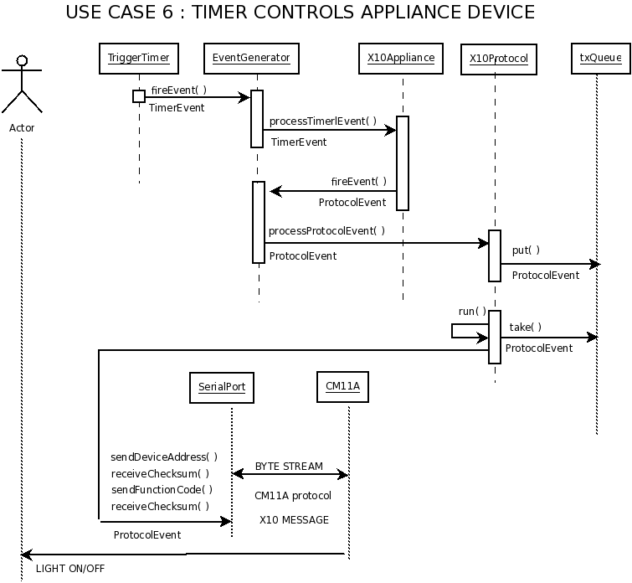

Use Case 7 – Timer Control Appliance Device (Motion Inactivity)
Figure 18 - Use Case 7 - Timer Controls Appliance Device (Motion Inactivity) provides the sequence diagram for this use case. The use case starts with an X10MotionSensor object having a WaitTimer attached with a Motion Inactivity Timeout value. The WaitTimer expires. The WaitTimer starts the process by sending a TimerEvent to the X10MotionSensor, which then forwards an X10 message to the X10Appliance object, when finally sends an X10 OFF message to the LM14 through the Protocol package. The use case ends with the LIGHT turning OFF.

Figure 18 - Use Case 7 - Timer Controls Appliance Device (Motion Inactivity)
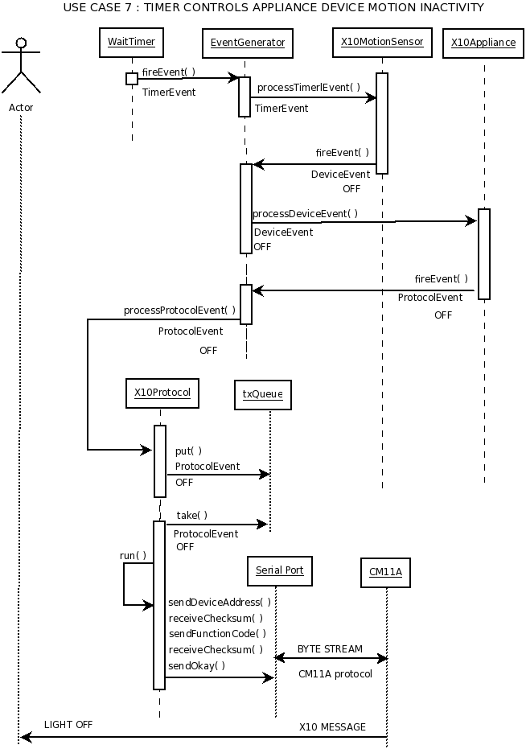

Use Case 8: Motion Sensor Detects Motion
Figure 19 - Use Case 8 - Motion Sensor Detects Motion provides the sequence diagram for use case 8: Motion Sensor Detects Motion. The use case starts with an X10MotionSensor device (A Hawkeye Motion sensor) detecting motion in a room. This triggers an X10 event to be sent across the power line to the CM11A Module.
The message now enters the EasyX10 system. An inbound X10 message causes the X10Protocol Serial Event method to be called. Serial event assembles an X10Event that is passed to fireEvent(). EventGenerator determines that the event received was destined for a Device, and in turn calls processDeviceEvent().
Since all Devices implement EventHandlerListeners to the EventGenerator for their device type, the X10MotionSensor object picks up this event through its subscription. It then executes processDeviceEvent() to handle the event, sets the state to active (since the event indicated so) and calls setInactivityTimer() to restart the clock on the inactivityTimer attribute. It then runs the fireDeviceEvent() method for every associated X10Appliance Device in its list. Each X10Appliance Device run their processDeviceEvent() methods to set their internal state and again fire a ProtocolEvent through fireEvent() back to the EventGenerator. X10Protocol does a put() for the event into txQueue and then a take() to send out a ByteStream through the serial port. The X10Event has now exited the EasyX10 system.
The CM11A module receives the X10Event and repeats it across the power line. All X10 appliance Modules with a matching Unit Code and House code with process the event and turn On.

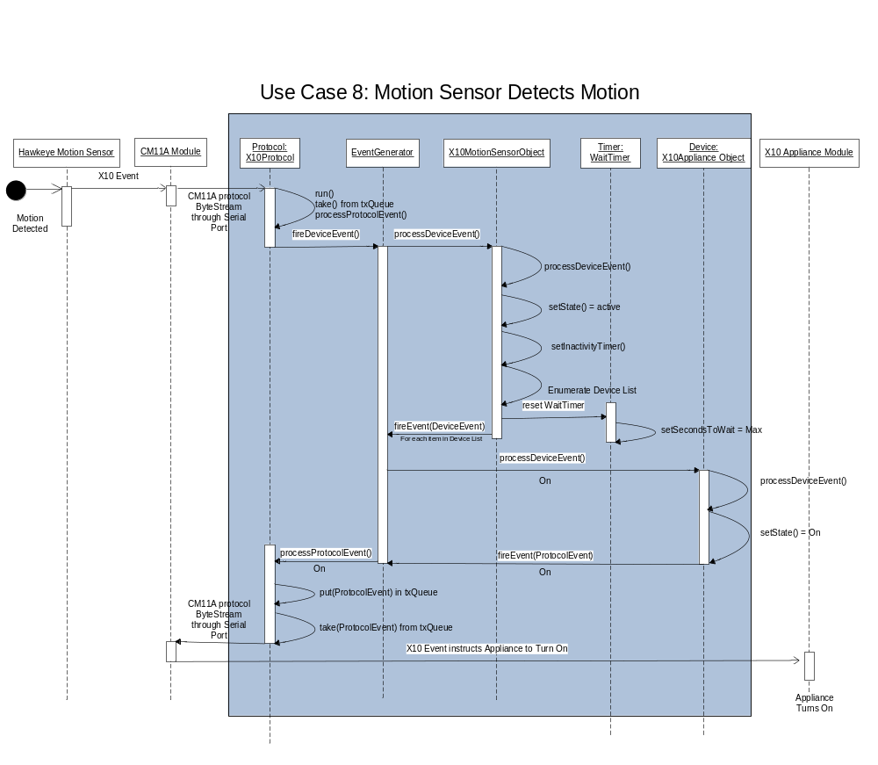

Figure 19 - Use Case 8 - Motion Sensor Detects Motion

Data Management Model
There are two types of objects that the system must store and retrieve. This is User data and the list of Devices.
For the EasyX10 System all persistent data is stored in XML files on the server. These files are read from and written to by the ConfigurationUtilities Class. This class contains the following static methods that can be accessed by any class in the EasyX10 System.
- getSystemConfiguration() – This method returns general system configuration data, which includes the list of configured users and the port information for the Protocol package. This information is stored in the system_configuration.xml file.
- getDeviceConfiguration() – This method returns the list of devices that are stored in the devices.xml file.
- setDeviceConfiguration(List<Device>) – This methods takes the passed in list of devices and writes them out to the devices.xml file. This includes all properties of a device.
To make the job of serializing the application data easy, the software uses the XStream open source library (http://xstream.codehaus.org/).

Restrictions, Limitations, Constraints

Restrictions
- The Software for this System has been tested with Motion Sensors and Applicance items from x10.com. Other X10 compliant products will most likely work with the product, but have not been tested because of time and financial constraints.
- The easyX10 System can manage a maximum of 256 devices. (This limit will not be tested because of time and financial constraints.)
- The system assumes that the HouseHold AC wiring is free of any defects and adheres to all state and federal electrical codes.

Limitations
- The system shall support 1 user logged into the system at a time. While additional logins will not be explicitly prevented this is not a supported operation.
- The system will not support multiple role types. All users will have the same set of functionality.
- To add users to the system, they must be manually added to the XML configuration file.
- Device property history will not be maintained in the system. This was deemed out of scope for the initial release of the software.

- The max amount of memory allocated to the heap at any given time will not exceed 256MB.
- A Power failure due to weather or man-made accident will make the service in-operable. To recover from this situation, the User must restart the server hosting the application.
- Determining the state/status of a device via the GUI will not function properly if someone has manually turned off or unplugged an appliance.

Constraints
- The system must operate in a standard environment condition which allows the tomcat server to be operational.
- The system is accurate to minute granularity.
- The system is constructed using the Java Language.
- The system is designed to adhere to the x10 protocol standard.
- The system is designed to run on any server system which supports Tomcat and the Java language.

Appendixes
There is no minimum login attempts count

Requirements Traceability Matrix

Requirement ID | Requirement Name | Method Call
6.1.1.1 | User enters Id and Password | JSP Files-LoginPage  LoginServlet  validateUser()
6.1.1.1(1) | By default the user is provided with a Login Screen | JSP Files-LoginPage  LoginServlet  validateUser()
6.1.1.1(2) | The user ID is limited to 25 characters | JSP Files-LoginPage  LoginServlet  ValidateUser()
6.1.1.1(3) | The password is limited to 25 Characters | JSP Files-LoginPage  LoginServlet  validateUser()
6.1.1.1(4) | The user must press the Login Button to process the user Id and password | JSP Files-LoginPage  LoginServlet  ValidateUser()
6.1.1.1(5) | The user is only allowed to pass the login screen after a valid user ID and password are entered. | JSP Files-LoginPage  LoginServlet  ValidateUser()  Configuration Class  getSystemConfiguration()  SessionData  setUser()
6.1.1.1(6). | The user is allowed to attempt to enter an unlimited number of user ID and password pairs | JSP Files-LoginPage  LoginServlet  ValidateUser()
6.1.1.1(7) | Once the user enters a valid user ID and password pair, the Login Screen is replaced with the Main Status Screen | JSP Files-LoginPage, Statuspage  LoginServlet  ValidateUser()  ApplicationServlet-  processDeviceGet()
6.1.1.2 | User Selects Logout
6.1.1.2(1) | Each screen, except the Login Screen in the EasyX10 web application must have a Logout button | JSP Files-StatusPage,AddDevice,ModifyDevice
6.1.1.2(2) | Selecting the logout button causes the screen to transition to the Login Screen with a blank user ID and password field | JSP Files-LoginPage,StatusPage,AddDevice,ModifyDevice
6.1.1.3 | User Selects System Status Button
6.1.1.3(1) | Each screen, except for the Login Screen in the EasyX10 web application must have a System Status button. | JSP Files-StatusPage,AddDevice,ModifyDevice
6.1.1.3(2) | Selecting the system status button causes the screen to transition to the Main Status Screen | JSP Files-StatusPage,AddDevice,ModifyDevice  Configuration Class  getSystemConfiguration()  getDeviceConfiguration()
6.1.1.4 | User Selects Floor to display
6.1.1.4(1) | The Main Status Screen provides a drop-down box to allow the user to select one of many possible floor layouts | JSP Files-StatusPage  SessionData Class  getDevice()  Configuration Class  getSystemConfiguration()  getDeviceConfiguration()
6.1.1.4(2) | Selecting a floor from the drop down box causes the screen disply to transition to a new display for the selected floor. If the currently displayed floor is selected, the screen does not transition from the current display | JSP Files-StatusPage  SessionData Class  getDevice()  Configuration Class  getSystemConfiguration()  getDeviceConfiguration()
6.1.1.4(3) | Each floor can have either zero or many Icons. Each Icon represents a Device assigned to the floor. Each Icon identifies the Name of the Device in addition to the current state of the Device by virture of Text or Icon shape/style | JSP Files-StatusPage  SessionData Class  getDevice()  Configuration Class  getSystemConfiguration()  getDeviceConfiguration()
6.1.1.5 | User Adds Device
6.1.1.5(1) | The Main Status Screen provides both Add Appliance and Add Motion Sensor buttons | JSP Files-Add Device Page  ApplicationServlet Class  processDeviceAdd()
6.1.1.5(2) | Selecting either Add button causes a new Icon to appear in the floor outline. The new Icon shall be highlighted to identify it. | JSP Files-AddDevice Page  ApplicationServlet Class  processDeviceAdd()
6.1.1.5(3) | The screen shall change to provide a Data Entry box. | JSP Files-AddDevice Page  ApplicationServlet Class  processDeviceAdd()
6.1.1.5(4) | For Applicance Devices, the following fields are displayed: Device Name, House Code,Unit Code, Status, Timer, OnTime,OffTime | JSP Files-AddDevice Page  ApplicationServlet Class  processDeviceAdd()
6.1.1.5(5) | For Motion Detector Devices the following fields are displayed: Device Name, House Code, Unit Code, Activity Window, Activity From, Activity To, Inactivity Timer, Inactivity Timeout,Associated Applicances | JSP Files-AddDevice Page  ApplicationServlet Class  processDeviceAdd()
6.1.1.5(6) | While the data entry box is available, the user is allowed to move the Icon associated with the selected device to any position on the floor. Overlapping icons are allowed | JSP Files-AddDevice Page  ApplicationServlet Class  processDeviceAdd()
6.1.1.5(7) | After filling in the necessary fields, the user must select the Add button below the Data Entry box in order to complete the Add transaction | JSP Files-AddDevice Page  ApplicationServlet Class  processDeviceAdd()
6.1.1.5(8) | Upon recognizing the Add button, the system is required to validate the fields | JSP Files-AddDevice Page  ApplicationServlet Class  processDeviceAdd()
6.1.1.5(9) | If all fields are validated, the screen is updated by removing the Data Entry box and returning to the Main Status Screen. The highlighted Icon is un-highlighted and the new Icon is updated with it new name and current state display | JSP Files-AddDevice Page  ApplicationServlet Class  processDeviceAdd()  Device Manager Class  AddDevice()  X10Device Class  setState()  EventGenerator  fireEvent()  EventHandlerListener  processProtocolEvent()  X10Protocol  run()  Configuration Class  setDeviceConfiguration()
6.1.1.5(10) | If the fields fail validation, the user is informed of the invalid fields by virtue of a dialog box | JSP Files-AddDevice Page  ApplicationServlet Class  processDeviceAdd()
6.1.1.5(11). | The user can select the Cancel button at any time to abandon the Add Device function | JSP Files-AddDevice Page
6.1.1.6 | User Modifies Device
6.1.1.6(1) | The user can modify the parameters of a Device by single clicking on the Device Icon from the Main Status Screen | JSP Files –StatusPage
6.1.1.6(2) | After selecting a Device Icon on the Main Status Screen, the screen display transitions to a new screen which provides a data entry box. | JSP Files –ModifyDevice Page
6.1.1.6(3) | The fields of the Data Entry box shall default ot the current values assigned to the selected Device | JSP Files –ModifyDevice Page  Session Data Class  processDeviceGet()
6.1.1.6(4) | The user is allowed to change all fields except for the Name field/ | JSP Files –ModifyDevice Page  ProcessUpdateDevice()  DeviceManager Class  updateDevice()
6.1.1.6(5) | While the data entry box is available, the user is allowed to move the Icon associated with the new device to any position on the floor. Overlapping Icons are allowed. | JSP Files –ModifyDevice Page
6.1.1.6(6) | After changing any necessary fields, the user is required to validate the fields. | JSP Files –ModifyDevice Page  Application Servlet Class  processUpdateDevice()
6.1.1.6(7) | Upon recognizing the Update button, the system is required to validate the fields. | JSP Files –ModifyDevice Page
6.1.1.6(8) | The system will validate the input before saving the modification to the config file. | JSP Files –ModifyDevice Page  ApplicationServlet Class  processUpdateDevice()  Device Manager Class  updateDevice()  X10Device Class  setState()  EventGenerator  fireEvent()  EventHandlerListener  processProtocolEvent()  X10Protocol  run()  Configuration Class  setDeviceConfiguration()
6.1.1.6(9) | If the fields fail validation, the user is informed of the invalid fields by virtue of a dialog box | JSP Files –ModifyDevice Page
6.1.1.6(10) | The user can select the Cancel button at any time to abandon the Add Device function. When the Cancel button is selected, the screen is updated by removing the Data Entry box.. | JSP Files –ModifyDevice Page
6.1.1.7 | User Removes Device
6.1.1.7(1) | The user can remove a Device by single clicking on the Device Icon from the Main Status Screen | JSP Files –ModifyDevice Page
6.1.1.7(2) | After selecting a Device Icon on the Main Status Screen a new screen shall appear with the Data Entry box. The behavior is identical to Modify Device | JSP Files –StatusPage, ModifyDevice Page
6.1.1.7(3) | The user can remove the device by selecting the Remove button in lieu of the Update button | JSP Files –ModifyDevice Page  Application Servlet Class  processDeleteDevice()  DeviceManager Class  deleteDevice()
6.1.1.7(4) | When the Remove button is selected, a verification pop up window shall be provided. | JSP Files –ModifyDevice Page
6.1.1.7(5) | The user must select either Yes or No in the verification pop up window | JSP Files –ModifyDevice Page
6.1.1.7(6) | If the user chooses the Yes button, the screen is updated by removing the Data Entry box and the associated Device Icon from the Screen | JSP Files –ModifyDevice Page  processDeleteDevice()  DeviceManger Class  deleteDevice()  Configuration Class  setDeviceConfiguration()
6.1.1.7(7) | If the user chooses the No button, the screen is restored to its state prior to the confirmation pop up window. | JSP Files –ModifyDevice Page  Configuration Class  getSystemConfiguration()
6.1.1.7(8) | The user can select the Cancel button at any time to abandon the Add Device function. When the Cancel button is selected, the screen is updated by removing the Data Entry box. | JSP Files –ModifyDevice Page
6.1.1.8 | User Monitors Status
6.1.1.8(1) | The user can monitor the status of any device by simply referring to the Icon displayed on either the Main Status Screen or the Main Sttus Screen. | JSP Files –StatusPage  Device Manager Class  getDevice()
6.1.1.8(2) | The Icon state must be updated within one minute of the device state changing. | JSP Files –StatusPage  Device Manager Class  getDevice()
6.1.1.8(3) | Appliance Devices display these possible states: ON or OFF | JSP Files –StatusPage  Device Manager Class  getDevice()
6.1.1.8(4) | Motion Detector Devices display these possible states: MOTION or STILL | JSP Files –StatusPage  getState()  Device Manager Class  getDevice()
6.1.2 | Appliance Devices
6.1.2(1) | Appliance Devices have the following parameters: name, House Code, Unit Code, Status,Timer, on Time, Off Time | Application Servlet Class  processDeviceGet()  processDeviceAdd()  processUpdateDevice()  processDeleteDevice()  Device Manager Class  getDevice()  addDevice()  updateDevice()  deleteDevice()  X10 Device Class  getState()  setState()  updateDevice()
6.1.2(2) | Appliance Devices can turn On or OFF with user control by virtue of the Status drop down field in the Data Entry box provided by the main Status Screen when a Device is selected using a single click. After the Status field is changed and the Update button is selected the Device shall transition to either On or Off. An x10 messsage is transmitted and the real Device must follow the On or Off state within 5 seconds of pressing the Update button | Device Manager Class  updateDevice()  X10Device Class  updateDevice()  getState()  setState()  EventGenerator  fireEvent()  EventHandlerListener  processProtocolEvent()  X10Protocol  run()
6.1.3 | Motion Devices
6.1.3(1) | Motion Detector Devices have the following parameters: Name, House Code, Unit Code, Status, Activity Window, Activity From, Activity To, Inactivity Timer, Inactivity Timeout, Associated Applicances. | Application Servlet Class:  processDeviceGet()  processDeviceAdd()  processUpdateDevice()  processDeleteDevice()  Device Manager Class  getDevice()  addDevice()  updateDevice()  deleteDevice()
6.1.3(2)(a,b,c,d) | Motion Detectors turn On Appliance Devices after a Motion Detector Device transmits a Motion Event | DeviceManager Class  updateDevice()  X10Device Class  getState()  setState()  EventGenerator  fireEvent()  EventHandlerListener  processDeviceEvent()  processProtocalEvent()  X10Protocol  run()  Timer Class  run()  X10Protocol  serialEvent()  handleStatusPoll()  X10MotionSensor  getState()  setState()
6.1.4 | Timer Controls
6.1.4(1)(a,b,c) | Appliance Devices can turn On or Off with automatic timer control by virtue of the Timer. On Time and Off Time fields available in the Data Entry box made visible when the Appliance Device is selected from the Main Status Screen. | Timer  run()  EventGenerator  fireEvent( )  EventHandlerListener  processDeviceEvent()  processProtocolEvent()  X10Appliance  set()  X10Protocal  run()
6.1.4(2)(a,b,c,d) | Motion Detector Inactivity Timer turns Off Appliance Device after motion inactivity | Timer  run()  EventGenerator  fireEvent( )  EventHandlerListener  processDeviceEvent()  processProtocolEvent()  X10Appliance  set()  x10Protocal  run()

Project Tracking Appendix

Project Time Line Estimates and Actuals:

HW # | Milestone/Deliverable | Due  Date | Estimated Hours | Actual Hours
1) | Communication Plan | 9/9/08 | 20 hours | 35.5
2) | Software Configuration Mgt Plan (SPMP) | 9/16/08 | 32 hours | 39 hours
3) | Software Project Mgt Plan | 9/23 | 35 hours | 44.5 Hours
4) | Software Requirements Specification (SRS) | 10/21/08 | 80 hours | 110 hours
5 | Software Detailed Design Document(SDD) | 11/04/08 | 80 hours | 130
6 | Operational System/Prototype | TDB | 120 hours | TDB
7 | Individual Project Assessments | TDB | 25 hours | TDB
8 | Final Project Presentations | TDB | 40 hours | TDB

Exercise 4 - Team Contributions

Activity | Bruce | John | Damon | Jim | Total
Brainstorming | 2 | 2 | 2 | 2 | 8
Meetings | 10 | 10 | 10 | 10 | 40
SRS authoring | 5 | 9 | 24 | 12 | 50
Application Investigation | 0 | 0 | 0 | 0 | 0
Project Related Training | 6 | 0 | 0 | 0 | 6
Document Editing | 2 | 2 | 6 | 2 | 12
Document Review | 2 | 4 | 6 | 2 | 14
Total | 27 | 27 | 48 | 28 | 130

