Software Requirements Specification

for

DAITSS DISSEMINATION
Version 1.0 draft
Prepared by P. Caplan
FCLA
7 April 2006
Table of Contents

1.Introduction 1
1.1Purpose 1
1.2Document Conventions 1
1.3Intended Audience and Reading Suggestions 1
1.4Project Scope 1
1.5References 1
2.Overall Description 2
2.1Product Perspective 2
2.2Product Features 2
2.3User Classes and Characteristics 2
2.4Operating Environment 2
2.5Design and Implementation Constraints 2
2.6User Documentation 2
2.7Assumptions and Dependencies 3
3.System Features 3
3.1System Feature 1 3
3.2System Feature 2 (and so on) 4
4.External Interface Requirements 4
4.1User Interfaces 4
4.2Hardware Interfaces 4
4.3Software Interfaces 4
4.4Communications Interfaces 4
5.Other Nonfunctional Requirements 5
5.1Performance Requirements 5
5.2Safety Requirements 5
5.3Security Requirements 5
5.4Software Quality Attributes 5
6.Other Requirements 5

Revision History
Name | Date | Reason For Changes | Version

Introduction

Purpose
This document specifies requirements for the DAITSS Dissemination Service. Dissemination is a DAITSS service, like Ingest, Reporting and Withdrawal. Its main function is to create a Dissemination Information Package (DIP) from some or all of the objects stored in an AIP (Archival Information Package). The DIP may be routed to the content's owner, or may be re-Ingested into the repository in order to effect a format migration.

Document Conventions
No special typographical conventions are used in this document.

Related specifications
SRS for the Ingest service
SRS for Migration on Ingest
SRS for the Access Control function

Overall Description

Product Perspective
Dissemination is a new service to be added to the existing DAITSS system. It corresponds to a portion of the Access function in OAIS (see below).

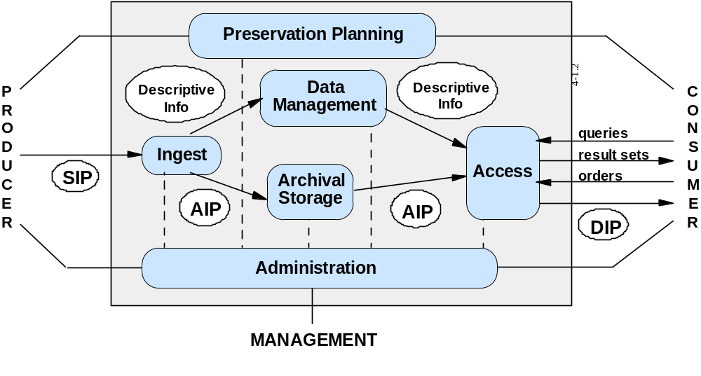

Product Features
Dissemination relies upon the DAITSS Access Control function [is this the correct name?] to validate the dissemination request, which may come from either an external customer of the repository or from repository management. [Although this is a technical not functional point, I think that repository management should be treated as an affiliate: it should have an owner code and list of individual contacts with various authorizations to request withdrawal, dissemination, etc. That way the processing is identical regardless of where the request comes from.]

Dissemination retrieves the appropriate metadata and data files from the AIP and creates a DIP consisting of

a) the originally submitted representation (R0) consisting of data files and the SIP descriptor,
b) the current ("last best") representation (Rc) if different from R0, and
c) a DIP descriptor, which is identical to the current AIP descriptor.

User Classes and Characteristics
The dissemination request can come from repository management or from an authorized contact representing an external repository user. In either case, it is first processed by the Access Control function, which also processes requests for withdrawals and reports.

User Documentation
(Updated) FDA Policy Guide
(Updated) DAITSS Overview
(New) FDA Dissemination Guide

Assumptions and Dependencies
<to be supplied >

System Features

Allow online creation of the dissemination request
3.1.1 Description and Priority
Allow an authorized user to create a dissemination request through a web form. This should be integrated with reporting, so that the user could get a report of (for example) all PDFs deposited in 2006 and transfer that information directly to the dissemination request form. The form requires the requesting individual, the owning institution, and the entityID of at least one AIP in the repository to be specified. An arbitrary number of entityIDs can be specified in a single request. If multiple entityIDs are specified, these are exploded into multiple requests before passing to the validation and processing routine. A date and timestamp is added to each request.

Each output request must contain
a) the owning institution
b) the requesting individual
c) the entityID identifying the package to be disseminated
d) the date and time of the request.

Priority is lower than other functions, and can be delayed to DAITSS 2.0 if a request created by an FDA operator directly can be processed.

Validate the dissemination request
3.2.1 Description and Priority
Use the Access Control function to verify that the request is authorized and can be fulfilled.

Priority is high (required).

3.2.2 Functional Requirements

Call upon Access Control to verify the following:
a) the requestor identified in the request is actually the individual making the request (this function will be manual until digital signatures are implemented);
b) the authenticated requestor is authorized to request dissemination for the owning institution;
c) the requested entity has an AIP in the repository;
d) the requested entity is owned by the institution in the request.

If b, c, or d fails validation an email message is sent to the requestor and to repository management and the request is not processed further.

Disseminate the requested material
3.3.1 Description and Priority
Assemble a DIP for the requested entityID consisting of data files and a DIP descriptor. Make the DIP available for the requesting institution to pick up via FTP, and notify the institution to do so.

Priority is high (required).

3.2.2 Functional Requirements

Obtain copies of the data files to be disseminated from the Storage Manager. The data files are those constituting a) the originally submitted representation (R0) consisting of data files and the SIP descriptor, b) the current ("last best") representation (Rc), if different from R0, and c) a DIP descriptor, which is identical to the current AIP descriptor.The Dissemination function can assume that the only files stored in the AIP belong to either R0 or Rc or both, and that the stored AIP descriptor accurately describes each representation. Therefore Dissemination can simply copy each of the data files associated with the entityID, including the stored AIP descriptor.

Zip up the files and create a message digest for the zipped file.

Record the act of dissemination as an Event and include the message digest of the zipped DIP in the outcome detail.

Place the zipped file in the FTP directory for the owning (requesting) institution.

Send an email to the appropriate contact address informing the requesting institution that the DIP is available for pick-up within the next seven business days. The email must include the message digest of the zipped DIP.

External Interface Requirements

User Interfaces
A User Interface is needed for function of allowing online creation of the dissemination request.

Software Interfaces
Dissemination will use the Access Control function to validate the Dissemination request.
It will use the Storage Management service to retrieve the contents of the AIP from storage.
It will use the Data Management service to retrieve information from DADI to perform the above functions.

Communications Interfaces
This will be an issue for the online creation of the Dissemination request, which is not being done in the initial phase.

Other Nonfunctional Requirements

Performance Requirements
Requests should be validated and either accepted for processing or rejected with a message to the requesting institution within minutes of receipt.

The DIP should be made available for FTP within 48 hours of the request being accepted.

Security Requirements
<to be supplied.>

Software Quality Attributes
<to be supplied?.>

Other Requirements
None.
Appendix A: Issues List
< This is a dynamic list of the open requirements issues that remain to be resolved, including TBDs, pending decisions, information that is needed, conflicts awaiting resolution, and the like.>

