Action Plan Background: TIFF 6.0
Author: Andrea Goethals, FCLA
Date: 1/31/2003

Preface: The TIFF 6.0 specification distinguishes between 'Baseline TIFF' and 'TIFF extensions'. The specification encourages all applications that purport to read TIFF 6.0 to support all features of Baseline TIFF. TIFF 6.0 images that use one or more of the TIFF extensions may not be supported by all TIFF readers. Throughout this document assume that the information applies to Baseline TIFF unless the information is followed by [TIFF extension].

1 General Description

1.1 Format Name: TIFF (Tag Image File Format)

1.2 Version: 6.0

1.3 MIME media type name: image

1.4 MIME subtype: tiff

1.5 Short Description: A tag-based raster image file format

1.6 Common Extensions: .tiff, .tif (recommended by specification)

1.7 Color depth: Bi-tonal to 24-bit

1.8 Color Space: Bilevel, Grayscale, Palette, RGB, CMYK [TIFF extension], YCbCr [TIFF extension], CIE L*a*b [TIFF extension]

1.9 Compression: Varies, can be any of: LZW [TIFF extension], JPEG [TIFF extension], PackBits (Run-length Encoding) (for black and white TIFFs), raw uncompressed, modified Huffman (for black and white TIFFs), and CCITT (Huffman) Group III & IV [TIFF extension] (for black and white TIFFs)

1.10 Progressive Display: Possible when using LZW [TIFF extension] or JPEG [TIFF extension] compression

1.11 Animation: No

1.12 Magic number(s) or equivalent:
II (little-endian): 49 49 2A 00 hex
MM (big-endian): 4D 4D 00 2A hex

2 Essential and Distinguishing Characteristics
Can describe bilevel, grayscale, palette-color, and full-color image data in several color spaces.
Supports numerous compression schemes, is largely hardware and software independent, and supports the inclusion of private or special-purpose information. It's capable of embedding multiple images within a single file so it can act as a wrapper for a document with multiple images or a single image with multiple alpha channels. Capable of encoding non-image textual information which can be used for metadata. The compression scheme can be lossy or lossless, depending on which compression algorithm is used. Maximum file size is capped at 4GB (2^32-1). Images can be tiled [TIFF extension] or in strips.

3 Usefulness

3.1 Version Duration: 10 years, 8 months and continuing

3.2 History of Prior Versions Duration:
- First version: Fall 1986: TIFF (no revision number – should have been TIFF 3.0 because there were two earlier major draft releases) by Aldus Corporation and Microsoft
- Second version: April 1987: TIFF 4.0 (minor enhancements)
- Third version: October 1988: TIFF 5.0 (added support for palette color images and LZW compression)
- Fourth and current version: June 3, 1992: TIFF 6.0
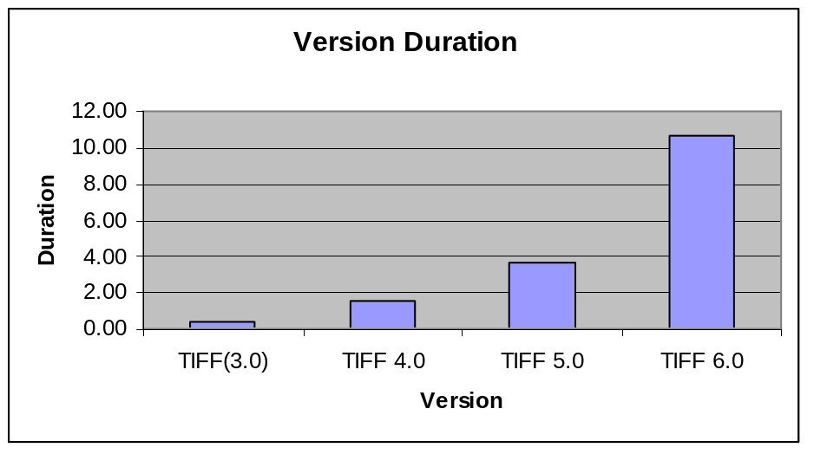

3.3 Expected Newer Versions:
According to graphics newsgroup archives, Adobe developers wrote a TIFF 7.0 draft specification in 1997. An Adobe developer claimed that the new specification added enhancements but was backwards-compatible with TIFF 6.0. The specification was never released to the public. It is rumored that Adobe thought that the TIFF specification, which they had inherited from Aldus, was in direct competition with a product they developed - PDF. Lawrence et. al (2002), attempted to contact the Adobe team regarding the TIFF 7.0 status. He notes that "the TIFF 7.0 development group seems to be determined not to release any information regarding their work". From these details it is questionable whether or not a newer version of TIFF will ever be released by Adobe.

3.4 Existence of Publicly Available Complete Specifications: Available for free download at: http://partners.adobe.com/asn/developer/pdfs/tn/TIFF6.pdf

3.5 Specifications-controlling Body:
TIFF was developed by Aldus and Microsoft Corp, and the specification was owned by Aldus, which in turn merged with Adobe Systems, Incorporated. Adobe Systems now holds the Copyright for the TIFF specification. TIFF is a trademark, formerly registered to Aldus, and which is now claimed (though not yet registered) by Adobe Systems, Inc.

3.6 Related Legal Issues:
A TIFF image may optionally use LZW compression, which is the subject of United States patent number 4,558,302 owned by the Unisys Corporation. This U.S. patent is scheduled to expire on June 20, 2003. There remains uncertainty as to the legal uses of LZW after the expiration. Unisys will still hold foreign LZW patents and the US patent could theoretically be extended if Unisys added extensions to the original patent. In addition, other US companies may also hold LZW patents. These issues could make it less likely for future applications to support the decoding and encoding of LZW-compressed images.

3.7 Application and Platform Support: TIFFs are software and hardware independent. They are supported by the majority of scanners and most image viewing and editing software. They are not supported natively by WWW browsers, but can be viewed using plug-ins and helper applications. Because TIFF is a flexible specification, not all of its features are supported by TIFF readers.

3.8 Limitations: Not natively supported by WWW browsers; can not store vector graphics.
TIFF uses 4-byte integer file offsets to store image data, with the consequence that a TIFF file cannot have more than 4 Gigabytes of raster data. However, this is 4G of compressed data, and so if the compression ratio is high enough, theoretically a TIFF image could be much larger (in fact, 2**32-1 pixels square). Its versatile nature can be problematic, with issues such as large strip sizes (a contiguous portion of the image) overflowing memory allocation, and support for both big-endian and little-endian byte ordering.

3.9 Perceived Popularity: TIFFs are widely used in the areas of archiving, scanning, faxing, prepress, remote sensing and multispectral applications.

4 Related Formats

4.1 Specification Variations: There are many proposed and existing extensions to the TIFF specification, including: GeoTIFF, Adobe extensions foe PageMaker, JPEG-in-TIFF, Zip-in-TIFF, TIFF Class F Revised Specification, TIFF/IT Prepress Interchange Standard, TIFF enhancements for Adobe PageMaker 6.0, RichTIFF, Wang TIFF Image-Annotation Extensions, Kodak TIFF extensions, and many Internet RFC's related to TIFF.

5 Summary and Conclusions

Many factors make TIFF 6.0 a stable format. The TIFF 6.0 specification has been around for a relatively long time - 10.66 years. TIFFs can be used as general purpose image archival formats, supporting many compression schemes, color spaces and color depths. The specification is complete and made freely downloadable on the WWW by Adobe. Historically, the revised TIFF specifications have been backwards-compatible, so it is likely that if the TIFF 7.0 specification is ever published it will be backwards-compatible with TIFF 6.0.

Some TIFF 6.0 features may be problematic for archival purposes. For the reasons discussed in (3.6 Legal Issues), LZW compression should be avoided, at least until Unisys' US patent expires. Additionally, the features that are not part of Baseline TIFF (e.g. advanced color spaces and compression algorithms) are less likely to be widely supported by applications. However, some of these extensions, like the CIE L*a*b color space, have merits such as device-independence that may make them more widely acceptable in the future.

6 References

Adobe Developers Association, "TIFF Revision 6.0", Adobe Systems Incorporated, Final - June 3, 1992. (http://partners.adobe.com/asn/developer/pdfs/tn/TIFF6.pdf)

Lawrence, Gregory W., William R. Kehoe; Oya Y. Rieger; William H. Walters and Anne R. Kenney. "Risk Management of Digital Information: A File Format Investigation", Council on Library and Information Resources, June 2000. (http://www.clir.org/pubs/reports/pub93/contents.html)

Libtiff Mailing List, (www.remotesensing.org)

