Action Plan Background
Author: Andrea Goethals
Date: 1/24/2003

1 General Description

1.1 Format Name: TIFF (Tag Image File Format)

1.2 Version: 6.0

1.3 MIME media type name: image

1.4 MIME subtype: tiff

1.5 Short Description: A tag-based raster image file format

1.6 Common Extensions: .tiff, .tif

1.7 Color depth: Bi-tonal to 24-bit

1.8 Color Space: Palette, RGB, CMYK, YCbCr, CIE L*a*b

1.9 Compression: LZW, JPEG, RLE (Run-length Encoding), raw uncompressed, CCITT (Huffman) Group 3 & 4

1.10 Progressive Display: Possible when using LZW or JPEG compression

1.11 Animation: No

1.12 Magic number(s):
II (little-endian): 49 49 2A 00 hex
MM (big-endian): 4D 4D 00 2A hex

2 Essential and Distinguishing Characteristics
Can describe bilevel, grayscale, palette-color, and full-color image data in several color spaces.
Supports numerous compression schemes; is hardware and software independent; supports the inclusion of private or special-purpose information. It's capable of embedding multiple images within a single file so it can act as a wrapper for a document with multiple images or a single image with multiple alpha channels. Capable of encoding non-image textual information which can be used for metadata. The compression scheme can be lossy or lossless, depending on which compression algorithm was used. Maximum file size is capped at 4GB (2^32-1). Its versatile nature can be problematic, with issues such as large strip sizes (a contiguous portion of the image) overflowing memory allocation, and byte ordering.

3 Usefulness

3.1 Length in Time of Version Existence: 10 years, 8 months

3.2 History of Prior Versions Duration:
- First version: Fall 1986: TIFF (no revision number – should have been TIFF 3.0 because there were two earlier major draft releases) by Aldus Corporation, now Adobe
- Second version: April 1987: TIFF 4.0 (minor enhancements)
- Third version: October 1988: TIFF 5.0 (added support for palette color images and LZW compression)
- Fourth and current version: June 3, 1992: TIFF 6.0
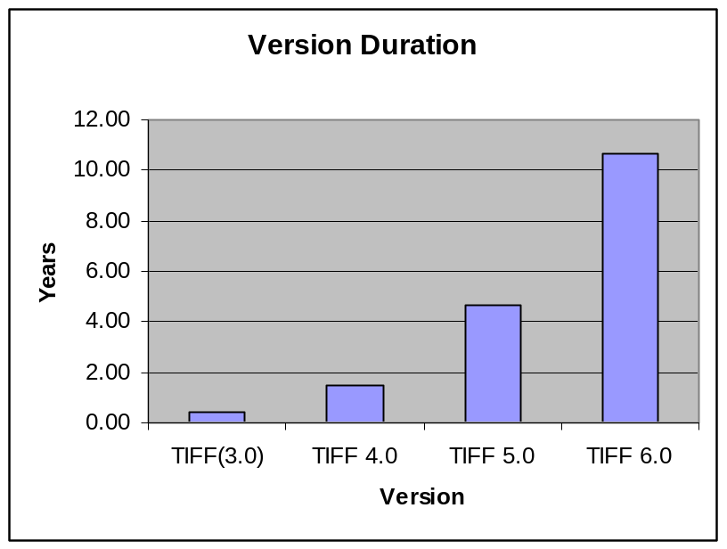

3.3 Expected Newer Versions
According to graphics newsgroup archives, Adobe had a TIFF 7.0 draft specification written in 1997. One of the Adobe developers claimed that the new specification added enhancements and was backwards-compatible with version 6.0. The specification was never released to the public. It is rumored that Adobe thought that the TIFF specification, which they had inherited from Aldus, was in direct competition with a product they had developed - PDF. Lawrence et. al (2002), attempted to contact the Adobe team regarding the TIFF 7.0 status. He notes that "the TIFF 7.0 development group seems to be determined not to release any information regarding their work". From these details it is questionable whether or not a newer version of TIFF will ever be released by Adobe.

3.4 Existence of Publicly Available Complete Specifications: Yes, at: http://partners.adobe.com/asn/developer/pdfs/tn/TIFF6.pdf

3.5 Specifications-controlling Body:
TIFF was developed by Aldus and Microsoft Corp, and the specification was owned by Aldus, which in turn merged with Adobe Systems, Incorporated. Adobe Systems now holds the Copyright for the TIFF specification. TIFF is a trademark, formerly registered to Aldus, and which is now claimed (though not yet registered) by Adobe Systems, Inc.

3.6 Related Legal Issues:
A TIFF image may use LZW compression which Unisys Corporation patented. The TIFF 6.0 specification recommends against using LZW to compress RGB bitmaps stored using the TIFF format.

3.7 Application and Platform Support: TIFFs are software and hardware independent. They are supported by the majority of scanners and most imagery viewing and editing software. They are not supported natively by web browsers.

3.8 Limitations: Not natively supported by web browsers; can not store vector graphics.
TIFF uses 4-byte integer file offsets to store image data, with the consequence that a TIFF file cannot have more than 4 Gigabytes of raster data (and some files have begun to approach this boundary). However, this is 4G of compressed data, and so if the compression ratio is high enough, theoretically a TIFF image could be much larger (in fact, 2**32-1 pixels square).

3.9 Perceived Popularity: widely used in the areas of archiving, scanning, faxing, remote sensing and multispectral applications

4 Related Formats

4.1 Specification Variations: There are many proposed and existing extensions to the TIFF specification, including: GeoTIFF, Adobe extensions foe PageMaker, JPEG-in-TIFF, Zip-in-TIFF, TIFF Class F Revised Specification, TIFF/IT Prepress Interchange Standard, TIFF enhancements for Adobe PageMaker 6.0, RichTIFF, Wang TIFF Image-Annotation Extensions, Kodak TIFF extensions, and many Internet RFC's related to TIFF.

5 Summary and Conclusions

The TIFF 6.0 specification has been around for a relatively long time - 10.66 years. TIFFs can be used as general purpose image archival formats, supporting many compression schemes, color spaces and color depths. The specification is complete and made freely downloadable on the WWW by Adobe. The revised TIFF specifications have been backwards-compatible, so it is likely that TIFF 6.0 images will not become obsolete even after a newer version of the TIFF specification emerges.

6 References

Adobe Developers Association, "TIFF Revision 6.0", Adobe Systems Incorporated, Final - June 3, 1992. (http://partners.adobe.com/asn/developer/pdfs/tn/TIFF6.pdf)

Lawrence, Gregory W., William R. Kehoe; Oya Y. Rieger; William H. Walters and Anne R. Kenney. "Risk Management of Digital Information: A File Format Investigation", Council on Library and Information Resources, June 2000. (http://www.clir.org/pubs/reports/pub93/contents.html)

