**Lab 5 Artificial Potential Field**

Chun Chang, Guojin Li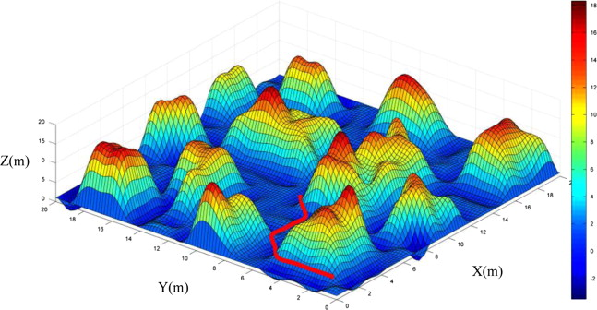

**Method**

**Introduction**

The method we used in this lab was Parabolic Well Potential.

Goal: The algorithm takes start configuration and final configuration as inputs, and is implemented with the setting of obstacles. The output of algorithm is the path by utilizing the artificial potential field method.

In general, the final configuration is set as global minimum in the program, and the robot, where starts in a relatively high potential position, moves gradually to the final position.

Input: angles of every joints in start point [q1, q2, q3, q4, q5,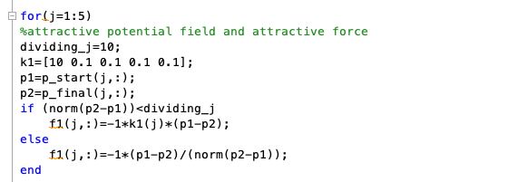 q6]; end point[q’1, q’2, q3’, q’4, q'5, q’6]

In our case, where the lynx is applied, variables of joint 6 will be 0 due to its trivial influence on orientation and position of end effector.

**Attractive potential**

$$U_{att,i}(q)=\frac{1}{2}*ζ_{i}||a_{i}(q)-a_{i}(q_{final})||^{2}---A$$

$$U_{att,i}(q)=d*ζ_{i}*||a_{i}(q)-a_{i}(q_{final})||^{2}-\frac{1}{2}*ζ_{i}*d^{2}---B$$

$d$ is the distance we set up when the robot approaches the end point. Because the force is strong when the distance is large, and the force is too small for robot to reach end point when robot is close to end point. Therefore, there are two equations of potential field to be used to deal with different situation.

$$||a_{i}(q)-a_{i}(q_{final})||⩽d--->A$$

$$||a_{i}(q)-a_{i}(q_{final})||⩾d--->B$$

$$F_{att,i}(q)=-∇U_{att,i}(q)=-ζ_{i}*(a_{i}(q)-a_{i}(q_{final}))---A$$

$$F_{att,i}(q)=-\frac{d*ζ_{i}*(a_{i}(q)-a_{i}(q_{final}))}{||a_{i}(q)-a_{i}(q_{final}||}---B$$

**Code realization**

**Repulsive potential**

$$U_{rep,j}(q)=\frac{1}{2}*η_{j}(\frac{1}{ρ_{0}(a_{j}(q))}-\frac{1}{ρ_{0}})^{2}---C$$

$$U_{rep,j}(q)=0---D$$

There are also two different equations for repulsive potential field, because we don’t want the obstacles to influence the motion of end effector unless they are close. $ρ(a_{j}(q))$ is the shortest distance between control point $a_{j}(q)$ and any point on the obstacle.

$$ρ(a_{j}(q))⩽ρ_{0}--->C$$

$$ρ(a_{j}(q))⩾ρ_{0}--->D$$

$$F_{rep,j}(q)=η_{j}(\frac{1}{ρ(a_{j}((q))}-\frac{1}{ρ_{0}})*\frac{1}{ρ(a_{j}(q))^{2}}∇ρ(a_{j}(q))---C$$

$$F_{rep,j}(q)=0---D$$

$∇ρ(x)|_{x=a_{j}(q)}=\frac{a_{j}(q)-b}{||a_{j}(q)-b||}$, where $b$ is point on boundary of obstacle that is closest to $a_{j}(q)$

Suppose a force, Were applied to a point on the robot arm. Such a force would induce forces and torques on the robot’s joints. If the joints did not resist these forces, a motion will occur.

However, we need floating repulsive point $a_{float,i}$ on the links to find whether the collision happens in the point closet to the obstacles; otherwise, there might be issue of detecting collision due to complexity of physical shape of robot.

**Convert the force in workspace to C-space**

By virtual work theory, we set virtual displacement as

$$(δx,δy,δz)$$

And $F*(δx,δy,δz)^{T}=τ*δq$

Rewritten as $F^{T}*(δx,δy,δz)^{T}=τ^{T}*δq$

Bring the equation below into the equation above

$J*δq=\left[\begin{aligned}δx \\ δy \\ δz \\ . \\ . \\ .\end{aligned}\right]$, in this lab, we need the first three row only.

Then we have $F^{T}*Jδq=τ^{T}*δq$

Which implies $J^{T}*F=τ$

Based on what we did in Lab4, we can get Jacobian of each joint to know the effort of the force,

$J_{1}={\left[\begin{matrix}Z_{0}X(O_{n}-O_{0}) & & 0 & & ... \\ \overset{̂}{z} & & 0 & & ...\end{matrix}\right]}_{6x5}$, $J_{2}={\left[\begin{matrix}Z_{0}X(O_{n}-O_{0}) & & Z_{1}X(O_{n}-O_{1}) & & 0 & & ... \\ \overset{̂}{z} & & R_{1}^{0}\overset{̂}{z} & & 0 & & ...\end{matrix}\right]}_{6x5}$

$$J_{i}={\left[\begin{matrix}Z_{0}X(O_{n}-O_{0}) & & ... & & Z_{i-1}X(O_{n}-O_{i-1}) \\ \overset{̂}{z} & & ... & & R_{i-1}^{0}*\overset{̂}{z}\end{matrix}\right]}_{6x5}$$

Here, we do not ne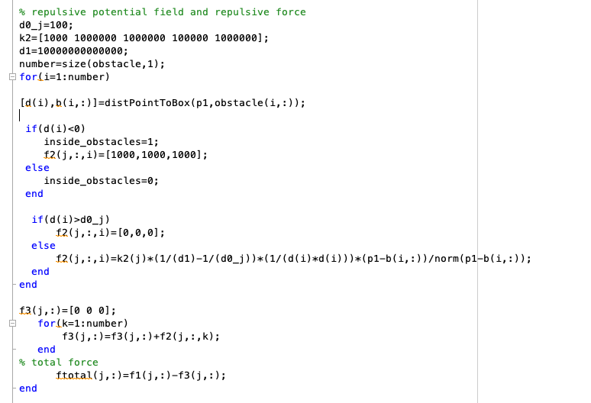ed lower part of Jacobian (rotation part) because the virtual displacement only requires upper part of Jacobian(linear velocity part)

**Code realization**

We changed $b$ from the closet point on obstacles to the center of obstacles. Therefore, the repulsive forces will be always pointing to viable space. Then, in the process of trajectory planning, the forces will lead the robot to more possible paths.

$F_{j}=\underset{i}{∑}F_{att,i}+\underset{i}{∑}F_{rep,i},j=1,2,3...$: the total force that jth joint being applied

$τ=\underset{i}{∑}J_{v,i}^{T}*F_{att,i}$: the total torque that robot, which was seen as a mass point in c space, being applied.

Then, move the robot in c-space with direction of torque $α_{i}*\frac{τ}{||τ||}$

**Random walk for escaping local minima**

For the environment with multiple obstacles, it’s highly possible the point in the C-sp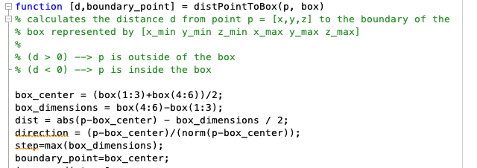ace is stuck in the local minima.

We can apply a detection to check this condition,

**IF $||q^{i}-q^{i+1}||<ϵ$**, where $ϵ$ is a distance representing stuck in C-space.

q go random by [q1+ random num, q2+ random num, …]

Then back to main loop

**Code realization**

In the program, when the distance of consecutive three points is lower than $ϵ$, the situation is seen as local minima. Then the program goes to random walk for an amount of times and attempts to find a viable ways. The length of step will be increased if the robot is keeping stuck in the local minima.

**Parameter Determination**

$ζ_{i}$: Typically, $ζ_{i}$ is higher than other parameters for heading to end position in general direction. However, if the number becomes too large, the program might be easy to stuck in the local minima and cannot find the way out due to strong attractive forces. On the other hand, the computational load might increase if the number is too small because it need to find more steps to the end position.

$η_{j}$, $ρ_{0}$: The possible paths might be limited if the both of the parameters are too large for point in C-space to pass through. But, there might be collision if the parameters are too small to represent the repulsive forces in the field.

$d$: the distance between control point and end point should be set properly; otherwise it is hard for point in C-space to approach end point.