**This forum is to introduce Project 2, which is due on 9/28.**

This project focuses on presentation skills and your ability to break down and summarize technical concepts. These qualities are extremely important in the workplace and we want to be consciously and directly working on them.

**Assignment**

* create a video presentation where you summarize the main points of the reference by Mack, T. titled [Measuring the Variability of Chain Ladder Reserve Estimates](https://www.casact.org/pubs/forum/94spforum/94spf101.pdf).
* Your video should be around 10 minutes. A video that is a lot shorter or a lot longer (say, less than 7 minutes or more than 14 minutes) will lose points. A video that is unclear or doesn't capture the important points in the article will also lose points. In total, the quality of your presentation will account for 10 points. The remaining 5 points have to do with posting 5 comments where you critique or compliment other presenters and mention specific things you liked or thought could be improved.

**Summary of Method**:

* Ref: <https://www.investopedia.com/terms/c/chain-ladder-method-clm.asp>
* The Chain ladder method calculated IBRN los estimates using run-off triangles of paid losses and incurred losses, representing the sum of paid losses as case reserves.
* The primary assumption of the chain ladder method is that historical patters in claims activity will persist in the future.
* Variables that can affect this assumption: 1.) Severity claims, 2.) Changes to product offering, 3.) Regulatory and legal changes, 4.) periods of high severity losses, and 4.) Changes to claims settlement payments.
* Good explanation regarding age to age factors.
  + <https://en.wikipedia.org/wiki/Chain-ladder_method>

**Steps to Applying Method**:

* TBD

**Notes on Paper**:

1.) Introduction & Overview

* + Commonly believe that the method is popular because it requires no assumptions. The author contends that this is a misperception and that “the chain ladder method has far reaching implications”.
  + Importance of implications
    - The “implications” allow us to measure the variability of the chain-ladder method and construct a confidence interval for estimated ultimate claims amount for the estimated reserves.
    - “Such a confidence interval is of great interest for the user because the est of claims can never be exact.
    - Facilitates business decisions as it communicates a probability.
    - Allows for the comparison of models as each will have variability. We can readily see whether the results of one model vary greatly from the other.
  + Paper Structure
    1. First basic assumption underlying the chain ladder method is derived from the formula used to estimate the ultimate claims amount.
    2. Comparison of the age-to-age factor formula used by the chain ladder method establishes the second underlying assumption regarding the variance of the claims amount.
    3. Third assumption of the independence of accident years.
    4. Combine all three to calculate the standard error of the estimated ultimate claims amount.
    5. Finally, plots are used to verify the assumptions and whether or not the chain ladder method should be used.
       1. **Notations & First Analysis of Chain Ladder Method** (Establishing the First Assumption)
          1. **Cik**

total claims amount of accident year I,

where I >=1 and <=I

Up to development year k,

Where k >= 1 and <=I

Notation

* + I = accident years
  + K = development years.

1. **Run-off Triangle**
   * Known to us
   * Values of Cik for I + k <= I + 1
   * And we want to estimate the values for Cik for i+k >= I+1.
   * In particular the ultimate claims loss ratio CiI of each accident year I = 2….I
2. Ri = CiI – Ci, I+1-i

Is the outstanding claims reserve for accident year i

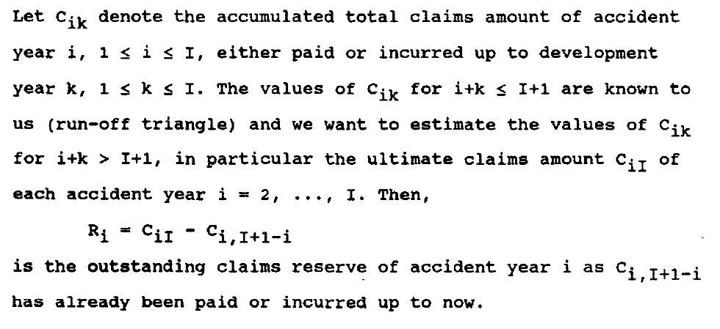

1. Formula for estimating the chain ladder method
   * The author makes emphasis and or explains that each Ci, k+1….CiI (the ultimate) are treated as random variables until they are known and then they convert to scalar quantities.

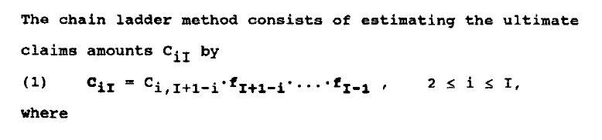



1. Implications of the fact that these are random variables:
   * “The Chain Ladder Method assumes the existence of accident-year-independent factors f1….FI-1
   * Author establishes that the expectation of each value of Ci, k+1 is subject to Ci1…Cik, which are the known values.
   * The author describes other methods that utilize all prior knowledge, but this is not the case with the chain ladder method.
   * **On page 109, the author concludes that the assumption that the chain-ladder method can be used on any loss triangle because it has no assumption is unfounded. Note that formula (3) is the assumption that the author is referring to.

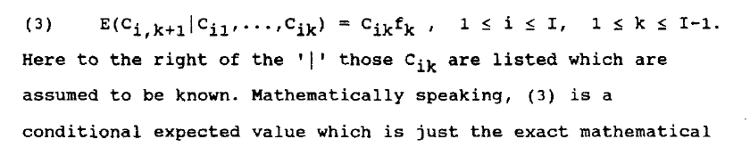

1. **Analysis of the Age-to-Age Factor Formula: The Key to Measuring The Variability**

* Because of the randomness of all realizations of Cik we cannot infer of the increased factors f1….f I-1 from the data.
* They only can be estimated according to formula (2)

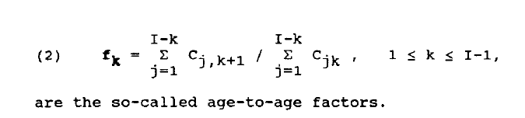

* Quality of the estimator should be unbiased, i.e. that the E(fk) is close to the actual value. The author refers to the appendix where the independence of Cij values for each accident year.
* ***Implicit Assumption: Independence of Accident years
  + Because the chain ladder method neither in formula (1) or (2) takes into account any dependency between the accident years, we can conclude that the accident years are independent.
  + **Note though that this assumption does not hold for all loss-triangles as certain changes in underwriting, like rate increase, can affect multiple years.

**Side Note**:

* All this formula is saying is that f subscript k is the ratio of the next value of CJ (Cj, k+1) divided by the current or former value. So if claims in Cj K+1 = 100, and claims Cjk = 90, then Fk = 100/90.

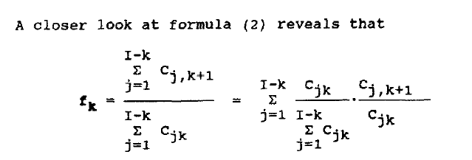

* Why does the chain-ladder method not use the weighted average of the years as opposed to just one?
  + A fundamental tenant of point estimation is to use the simplest estimator and the one with the least variance. Therefore, because both the chain-ladder formulation and weight average are both unbiased, yet the forma has the least variance, the former is used..

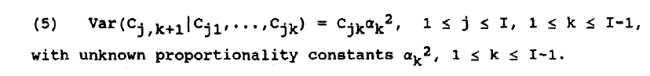

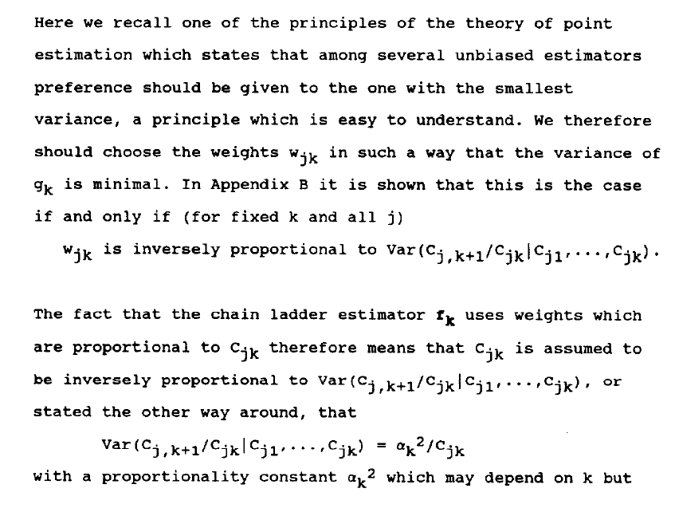

1. **Quantifying the Variability of the Ultimate Claims Amount**

* The chain ladder formula yields a point estimate for CiI
* The author contends that it will normally be wrong and for continuous variables it can be 0 (obviously, as the E(x) for a continuous variable is 0. You need a range for a continuous variable.
* First:
  + would like to know if the estimator CiI is at least on average equal to the meain CiI and how large on average is the error.
* Second:
  + The average distance between the forecast CiI and the future realization CiI. Author uses MSE for this calculation.

Continue on page 116.