1) How many documents are in this corpus?

Answer : 636 Documents

# 2) What are the top 10 tokens and their frequency?

Answer

Feature frequency

1 mr 517849

2 s 294143

3 act 245887

4 section 226094

5 states 203579

6 shall 199942

7 united 189683

8 house 183585

9 b 180166

10 bill 157303

3) From your review of the frequency table, what are the additional stopwords that you would like to drop from the 2018 to 2020 file?

Function

n_toks = 100

tokens <- textstat_frequency(cr_dfm_clean)[1:n_toks, 1]

Answer:

'mr, s, b, h.r, ms, re-, e, c, f, con-, in-, ii, sep, d, d-, com-, pro-, fm,

use, us,

4. Generate Frequency plot top 50 tokens

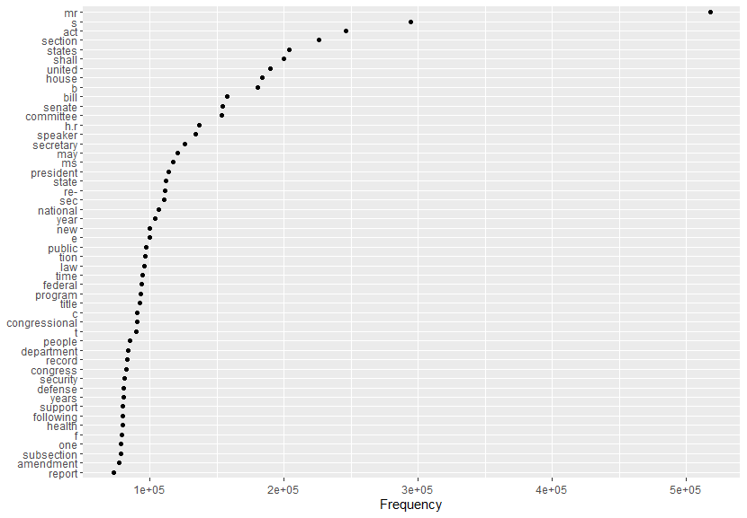

5. Generate Word Cloud

