OPAx227, OPAx228 High-Precision, Low-Noise Operational Amplifiers
1 Features  - Low noise: 3 nV/√Hz  - Wide bandwidth:  - OPA227: 8 MHz, 2.3 V/μs  - OPA228: 33 MHz, 10 V/μs  - Settling time: 5 μs  - High CMRR: 138 dB  - High open-loop gain: 160 dB  - Low input bias current: 10 nA maximum  - Low offset voltage: 75 μV maximum  - Wide supply range: ±2.5 V to ±18 V  - Single, dual, and quad versions  2 Applications  - Data acquisition (DAQ)  - Condition monitoring sensor  - Spectrum analyzer  - Professional audio amplifier (rack mount)  - Industrial AC-DC  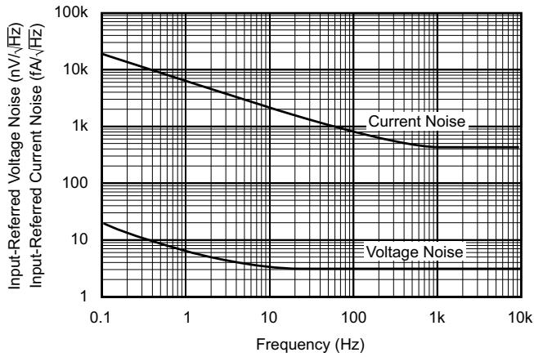  Input Voltage and Current Noise Spectral Density vs Frequency | 3 Description  The OPAx227 and OPAx228 series operational amplifiers combine low noise and wide bandwidth with high precision to make them an excellent choice for applications requiring both ac and precision dc performance.  The OPAx227 are unity-gain stable and features high slew rate (2.3 V/μs) and wide bandwidth (8 MHz). The OPAx228 are optimized for closed-loop gains of 5 or greater, and offers higher speed with a slew rate of 10 V/μs and a bandwidth of 33 MHz.  The OPAx227 and OPAx228 series operational amplifiers are an excellent choice for professional audio equipment. In addition, low quiescent current and low cost make these op amps an excellent choice for portable applications requiring high precision.  The OPAx227 and OPAx228 series operational amplifiers are pin-for-pin replacements for the industry-standard OP27 and OP37 with substantial improvements across the board. The dual and quad versions are available for space savings and per-channel cost reduction.  The OPAx227 and OPAx228, are available in DIP-8 and SO-8 packages. The OPA4227 and OPA4228 are available in DIP-14 and SO-14 packages with standard pin configurations. Operation is specified from -40°C to +85°C .  Device Information  (1) For all available packages, see the orderable addendum at the end of the data sheet.
  PART NUMBER | CHANNELS | PACKAGE⁽¹⁾
  OPA227, OPA228 | Single | P (PDIP, 8)
  OPA227, OPA228 | Single | D (SOIC, 8)
  OPA2227, OPA2228 | Dual | P (PDIP, 8)
  OPA2227, OPA2228 | Dual | D (SOIC, 8)
  OPA4227, OPA4228 | Quad | N (PDIP, 14)
  OPA4227, OPA4228 | Quad | D (SOIC, 14)

