[1]Replication of the Centrality in affiliation networks article

Cristian Jimenez, Jaider Pinto, Jimmy Prieto

*Abstract*— This project aims to explore the strengths and weaknesses of centrality indices when applied to affiliation networks. The case study involves examining the affiliation network of corporate executive officers and their membership in various services such as clubs, health service providers, and recreation service providers. The dataset used for this study consists of membership information of the corporate executives in social organizations, generating a bipartite network where left nodes represent persons and right nodes represent social organizations. The implemented network science approach involves generating a bipartite affiliation network and analyzing the centrality of the network. Additionally, a visual representation of the network will be created from the dataset.

*Index Terms*— Network science, Affiliation networks, Membership networks, Dual networks.

# Introduction

Affiliation networks are social networks that are characterized by the connections between individuals or groups and the organizations they belong to. In affiliation networks, nodes represent individuals or groups, and edges represent the affiliations or connections between nodes and organizations. Centrality in affiliation networks refers to the concept of identifying the most influential individuals or groups within a network based on their connections to different organizations or affiliations.

The identification of central individuals or groups in affiliation networks can be useful for a variety of purposes, such as designing effective strategies for communication and collaboration within the network, understanding the spread of information or influence within the network, and identifying potential targets for interventions or outreach efforts.

# Goal And Scope

This project discusses strengths and weaknesses of centrality indices when applied to affiliation networks and compare the results applying these measures as if it were a normal network versus a bipartite network.

# Literature Review

## Affiliation Networks

Affiliation networks are social networks formed by linkages among actors who participate in social activities or belong to collectivities. These networks are characterized by the multiple memberships of actors, which create ties among collectivities. An affiliation network consists of a set of actors and a collection of subsets of actors, or events, forming a two-mode, non-dyadic network. The affiliation relation relates each actor to a subset of events and each event to a subset of actors. Affiliation networks are sometimes called dual networks because they show the complementary perspectives through which actors are linked to each other as members of collectivities, and collectivities are linked to each other through shared members.[1]

Let's consider a hypothetical example of an affiliation network involving six actors and three events. The group of actors is represented by $N=\{n_{1},n_{2},…, n_{g}\}$, and the set of events is represented by $M=\{m_{1},m,…, m_{h}\}$,. In this network, there are g actors and h events. The matrix that shows the affiliation of the actors with the events is presented in Table 1 and is represented by $A=\{a_{ik}\}$. An '1' in the intersection of row i and column k of A indicates that actor $n_{i}$ is affiliated with event $m_{k}$. In Table 2, we can see the matrix that shows the co-memberships shared by each pair of actors, which is represented by $X^{N}$. On the other hand, Table 3 shows the matrix of event overlaps, which is represented by $X^{M}$. This matrix gives the number of actors that are shared by each pair of events.

|  |  |  |  |
| --- | --- | --- | --- |
|  | $$m_{1}$$ | $$m_{2}$$ | $$m_{3}$$ |
| $$n_{1}$$ | 1 | 0 | 1 |
| $$n_{2}$$ | 0 | 1 | 0 |
| $$n_{3}$$ | 0 | 1 | 1 |
| $$n_{4}$$ | 0 | 0 | 1 |
| $$n_{5}$$ | 1 | 1 | 1 |
| $$n_{6}$$ | 1 | 1 | 0 |

Table Affilitaion Network Matrix

|  |  |  |  |  |  |  |
| --- | --- | --- | --- | --- | --- | --- |
|  | $$n_{1}$$ | $$n_{2}$$ | $$n_{3}$$ | $$n_{4}$$ | $$n_{5}$$ | $$n_{6}$$ |
| $$n_{1}$$ | 2 | 0 | 1 | 1 | 2 | 1 |
| $$n_{2}$$ | 0 | 1 | 1 | 0 | 1 | 1 |
| $$n_{3}$$ | 1 | 1 | 2 | 1 | 2 | 1 |
| $$n_{4}$$ | 1 | 0 | 1 | 1 | 1 | 0 |
| $$n_{5}$$ | 2 | 1 | 2 | 1 | 3 | 2 |
| $$n_{6}$$ | 1 | 1 | 1 | 0 | 2 | 2 |

Table Actor co-membership matrix

|  |  |  |  |
| --- | --- | --- | --- |
|  | $$m_{1}$$ | $$m_{2}$$ | $$m_{3}$$ |
| $$m_{1}$$ | 3 | 2 | 2 |
| $$m_{2}$$ | 2 | 4 | 2 |
| $$m_{3}$$ | 2 | 2 | 4 |

Table Event overlap matrix

The affiliation matrix is related to the actor co-membership matrix and to the event overlap matrix through the following equations:

$X^{N}=AA^{T}$ (1)

And

$X^{M}=A^{T}A$ (2)

## Centrality

Centralities refer to the importance or visibility of actors within a network. The motivations for centrality in one-mode dyadic networks are degree centrality, closeness centrality, betweenness centrality, and eigenvector centrality. Affiliation networks have unique features that require different centrality motivations from those used in one-mode networks. There may be theoretical insights gained from affiliation networks that could suggest new centrality approaches.[1]

To summarize, affiliation networks have unique properties that suggest centrality measures for these networks should have four characteristics. First, they should provide centrality measures for both actors and events. Second, they should be adaptable to subsets of actors and events. Third, they should focus on linkages between actors and events through overlapping memberships. Fourth, they should capture the inclusion relations between actors and events. However, analyses of affiliation networks have often used more traditional centrality measures for one-mode networks instead of considering these unique characteristics. Additionally, many analyses only study one-mode networks derived from the original affiliation network, ignoring the duality inherent in the affiliation relation. In the following sections, the author discusses five centrality measures (degree, eigenvector, closeness, betweenness, and flow betweenness) and applies them to affiliation network data, examining the results considering the unique characteristics of affiliation networks.

# Case Study

We are going to study the brunson_club-membership network: This bipartite network contains membership information of corporate executive officers in social organizations such as clubs and boards.

# Data Set

It is a dataset with membership information of corporate executive officers in social organizations such as clubs and boards. It generates a bipartite network where left nodes represent persons and right nodes represent social organizations. An edge between a person and a social organization shows that the person is a member.

# Implemented Network Science Approach

We generated this bipartite network, and compared the obtained results working as a traditional network vs a bipartite network using Networkx, we left the clubs nodes ending with c, and the users nodes ending in u

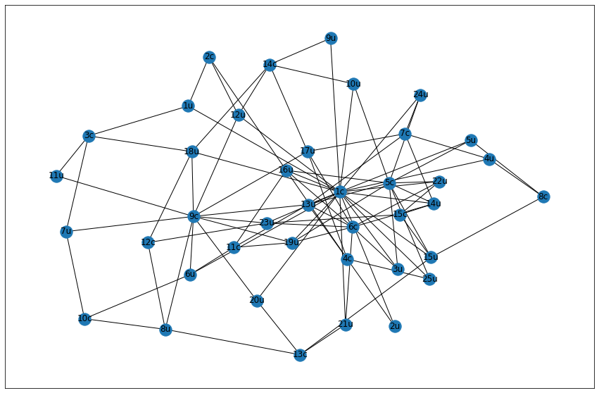

Fig Normal Network

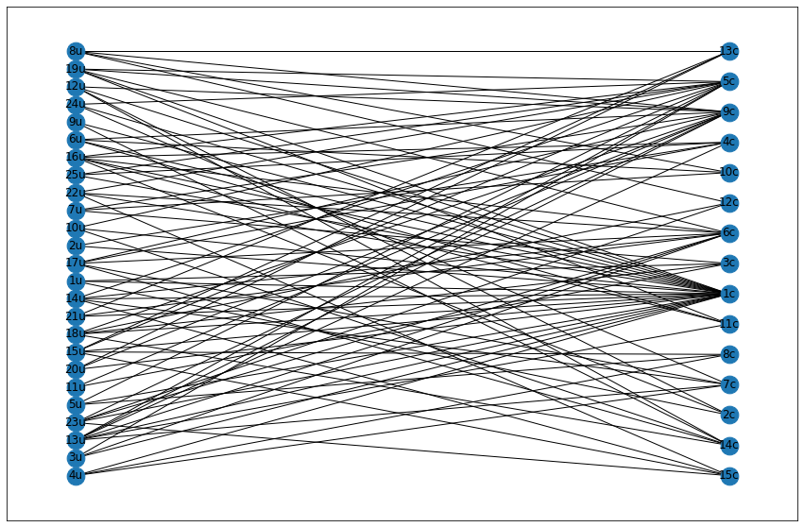

Fig Bipartite Network

This are two representations of the network the first one Fig1, as a normal network, and the second one Fig2 as a bipartite network, where we can see no edges between nodes of the same type (clubs or users).

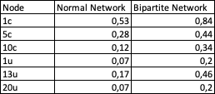

Table Degree Centrality examples

Table Closeness Centrality

As we can see in tables 4 and 5, the results of some of the most representative nodes of the dataset differ to a great extent, if we apply the centrality measures as a normal network, or if we apply them as a bipartite network, obtaining higher results in the bipartite, since it knows that there cannot be connections with 100% of the nodes of the network.

# Links

## Source code

<https://github.com/ccjimenezm/Network_science_G9/blob/main/Network.ipynb>

## Explicative video

<https://drive.google.com/drive/folders/1KvRhQ_wC14-wD0iMv136wMEzdnGn-iBD?usp=share_link>

# Team Members

|  |  |  |
| --- | --- | --- |
| Team Member | Role | Activities |
| Jaider Pinto | Leader | Guide the team for the goal. |
| Cristian Jimenez | Investigator | Discover |
| Jimmy Prieto | Investigator | Apply |

Table 4. Team members

# Conclusions

In conclusion, centrality analyses of affiliation networks are valuable for understanding the relationships between actors and events. In conclusion, we find that bipartite networks must be analyzed differently, since their nature does not allow connections between all nodes, but only between those for which the connection makes sense in this example, user node with club node with a relationship of membership.

References

1. Katherine Faust. (1997). Title. Centrality in affiliation networks. Available: <http://socsci.uci.edu/~kfaust/faust/research/articles/faust_centrality_sn_1997.pdf>
2. Jérôme Kunegis. (2014, October). Title. KONECT – The Koblenz Network Collection. Available: <https://www.researchgate.net/publication/262406956_KONECT_the_Koblenz_network_collection>

1.