**This software is a demo for three point set processing papers:**

[L1-medial skeleton of point cloud](http://web.siat.ac.cn/~huihuang/Skeleton/Skeleton_page.html) (SIGGRAPH 2013)

[Edge-Aware Point Set Resampling](http://web.siat.ac.cn/~huihuang/EAR/EAR_page.html) (TOG 2013)

[Consolidation of Unorganized Point Clouds for Surface Reconstruction](http://web.siat.ac.cn/~huihuang/WLOP/WLOP_page.html) (SIGGGRAPH ASIA 2009)

**How to get a nice display:**

You need to open the optimize quality in the graphics card’s option, for example:

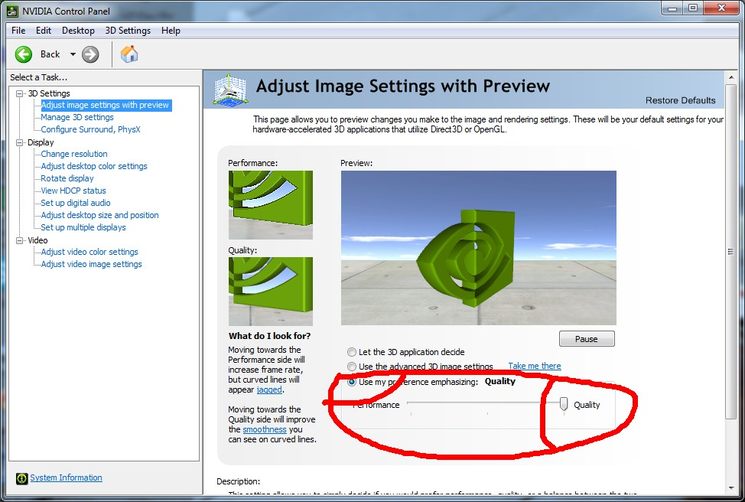

**Quick control(see codes in glarea.cpp please):**

Ctrl + Wheel : Change showing objects size(original points, sample points, skeleton nodes)

**Alt + Wheel : Change neighborhood size parameter (the blue ball)**

Ctrl + Drag : Pan

Shift + Drag: Zoom

Shift + Wheel: Change the down-sample points number parameter / Change the branch size

Ctrl + Shift + Drag: Chang the light position

Ctrl + Alt + Wheel: Chang the point normal length

Alt + Shift + Wheel: Chang blue neighborhood ball transparency

Ctrl + Shift + Wheel: Change the blue bridge point merge threshold

**Icons:**

C:\Users\wish\Desktop\icon images\1.jpg: open ply files, in fact, **you can simply drag files to the UI. (accept *.ply, *.xyz, *.skel)**.[The whole path of the file can not contain any non-English fonts!!!]

C:\Users\wish\Desktop\icon images\2.jpg : save scene result to our format

C:\Users\wish\Desktop\icon images\3.jpg: randomly down-sample original points into sample points

C:\Users\wish\Desktop\icon images\4.jpg : algorithm and data see paper: [L1-medial skeleton of point cloud](http://web.siat.ac.cn/~huihuang/Skeleton/Skeleton_page.html)

C:\Users\wish\Desktop\icon images\8.jpg: algorithm and data see paper: [Edge-Aware Point Set Resampling](http://web.siat.ac.cn/~huihuang/EAR/EAR_page.html)

C:\Users\wish\Desktop\icon images\5.jpg: algorithm and data see paper: [Consolidation of Unorganized Point Clouds](http://web.siat.ac.cn/~huihuang/WLOP/WLOP_page.html)

[for Surface Reconstruction](http://web.siat.ac.cn/~huihuang/WLOP/WLOP_page.html)(It provided another [API](http://people.cs.ubc.ca/~danli/points_consolidation.htm))

C:\Users\wish\Desktop\icon images\7.jpg: compute PCA point normal

(See tutorial videos to get more idea of how to use this software)

**Parameters for skeleton (more see the code of paper please):**

**Initial Radius** (0.0 - 1.0)**:** Set the initial neighborhood size of sample points. (you can also change it by “Alt + Wheel”)

**Radius Growth Rate:** Set the growth rate of neighborhood size for further contraction.

**Repulsion Mu** (0.0 - 0.5)**:** Control the power of repulsion force between sample points.

**Initial Sampling Number**: down sample points number. (you can also change it by “Shift + Wheel”).

*1, How to tune the* ***initial neighborhood size****?*

In our paper, we have provided a formula to estimate the initial neighborhood size h, for arbitrary inputs, according to the bounding box size and points density.

In our experience, the initial neighborhood size should be small enough to capture fine-scale structures. But if it’s too small, it would take more computational time and may produce unnatural branches, like the coral example shown in paper.

*2, How to tune the neighborhood* ***growth rate****?*

The default growth rate is 0.5. It means the enlarged neighborhood size is equal to the previous neighborhood size multiply 1.5.

According to our experience, if the growth rate is too large, it may miss some detail structures.

On the other hand, if the growth rate is too small, it will take more computational time and construct some undesired branches too early.

**(The codes of WLOP and EAR is going to be added to CGAL, more instruction is coming soon.)**

**Configuration for the source code:**

This code complied well on Win7(64bit) + Qt4(64bit) + VS2010.

If you are also working in this environment, you just need to make sure your Qt works well.

If you want to use 32bit QT, just make sure your path of QT is correct and use the right dlls(ANN.dll, glut32.dll that we have provided in the “dlls” floder),very simple.

**Program source code structure overview:**

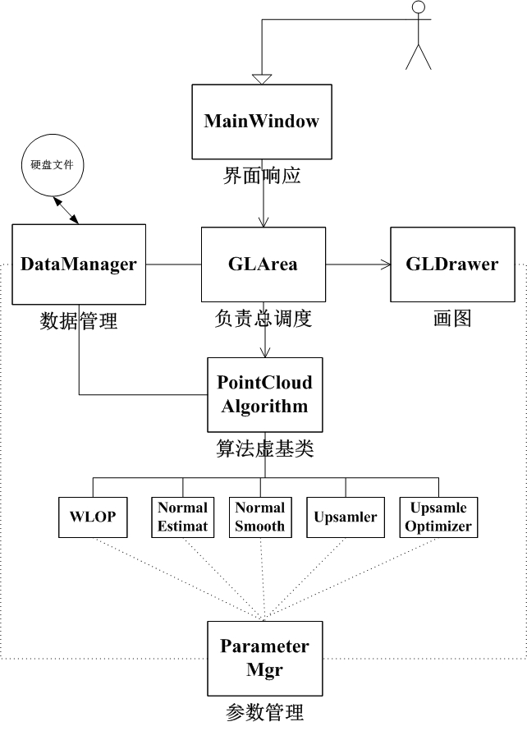

**Any questions or bugs send email to** [**shihao.wu312@gmail.com**](mailto:shihao.wu312@gmail.com) **please.**

**Hope you have fun.**

**(version 1.0 2013-7-19)**