Content-centric Protection in the Cloud

**Christopher C. Lamb*, Gregory L. Heileman\***

* Department of Electrical and Computer Engineering, University of New Mexico

|  |  |  |
| --- | --- | --- |
| **Article Info** |  | **ABSTRACT** |
| ***Article history:***  Received October 10th, 2012  Revised October 20th, 2012  Accepted October 30th, 2012 |  | Information security was becoming even more important as organizations migrate systems to third-party infrastructure providers. Once migrated, previously transparent network topologies, information paths, and systems infrastructure became more opaque. This loss of control when coupled with storage of corporate and personally sensitive information lead to significant increases in potential vulnerability. Herein, we discuss the current state of the art with respect to information flow control with a focus on current military systems, discuss the clear shortcomings of current designs, and propose a novel taxonomy of network-enabled usage control architectures that can solve sensitive information transmission problems. We then close with a description of our information-centric overlay network embody and discussion of our experience using this system to manage real-time sensitive information flow over commercial cloud systems. |
| ***Keyword:***  Security  Cloud Computing  Usage Management  Information-centric Networks |
| *Copyright © 2012 Institute of Advanced Engineering and Science.  All rights reserved.* |
| ***Corresponding Author:***  Christopher C. Lamb,  Department of Electrical and Computer Engineering,  University of New Mexico,  MSC01 1100, 1 University of New Mexico, ECE Bldg., rm 125, Albuquerque, NM 87131-0001.  Email: cclamb@ece.unm.edu | | |

1. **INTRODUCTION**

Current enterprise computing systems are facing a troubling future. As things stand today, they are too expensive, unreliable, and information dissemination procedures are just too slow. Current approaches to partitioning information in cross-domain scenarios are simply unable to migrate to cloud environments. Additionally, the current approach of controlling information by controlling the underlying physical network is too cost ineffective to continue. This leaves large government and commercial organizations concerned with avoiding the exposure of sensitive data in a very uncomfortable position, where they cannot continue doing what they have done, and cannot migrate to what everyone else is doing.

Generally, such systems still do not use current commercial resources as well as they could and use costly data partitioning schemes. Most of these kinds of systems use some combination of systems managed in house by the enterprise itself rather than exploiting lower cost cloud-enabled services. Furthermore, many of these systems have large maintenance loads imposed on them as a result of internal infrastructural requirements like data and database management or systems administration. In many cases networks containing sensitive data are separated from other internal networks to enhance data security at the expense of productivity, leading to decreased working efficiencies and increased costs.

These kinds of large distributed systems suffer from a lack of stability and reliability as a direct result of their inflated provisioning and support costs. Simply put, the large cost and effort burden of these systems precludes the ability to implement the appropriate redundancy and fault tolerance in any but the absolutely most critical systems. Justifying the costs associated with standard reliability practices like diverse entry or geographically separated hot spares is more and more difficult to do unless forced by draconian legal policy or similarly dire business conditions.

Finally, the length of time between when a sensitive document or other type of data artifact is requested and when it can be delivered to a requester with acceptable need to view that artifact is prohibitively long. These kinds of sensitive artifacts, usually maintained on partitioned networks or systems, require large amounts of review by specially trained reviewers prior to release to data requesters. In cases where acquisition of this data is under hard time constraints like sudden market shifts or other unexpected conditional changes this long review time can result in consequences ranging from financial losses to loss of life.

Federal, military, and healthcare computer systems are prime examples of these kinds of problematic distributed systems, and demonstrate the difficulty inherent in implementing new technical solutions. They, like other similar systems, need to be re-imagined to take advantage of radical market shifts in computational provisioning. New approaches to networking and information management present possible solutions to these kinds of problems by providing distributed information-centric approaches to data management and transfer.

Current policy-centric systems are being forced to move to cloud environments and incorporate private clouds are infrastructure that is completely run and operated by a single organization for use and provisioning, while hybrid clouds are combinations of private and public cloud systems. Driven by both cost savings and efficiency requirements, this migration will result in a loss of control of computing resources by involved organizations as they attempt to exploit economies of scale and utility computing.

Robust usage management will become an even more important issue in these environments. Federal organizations poised to benefit from this migration include agencies like the National Security Agency (NSA) and the Department of Defense (DoD), both of whom have large installed bases of compartmentalized and classified data. The DoD realizes the scope of this effort, understanding that such technical change must incorporate effectively sharing needed data with other federal agencies, foreign governments, and international organizations (1). Likewise, the NSA is focused on using cloud-centric systems to facilitate information dissemination and sharing (2).

Cloud systems certainly exhibit economic incentives for use, providing cost savings and flexibility, but they also have distinct disadvantages as well. Specifically, they are not intrinsically as private as some current systems, generally can be less secure than department-level solutions, and have the kinds of trust issues that the best of therapists cannot adequately address (3).

How to address these issues is an open research question. Organizations ranging from cloud service providers to the military are exploring how to engineer solutions to these problems, and to more clearly understand the trade-offs required between selected system architectures (4). The problems themselves are wide ranging, appearing in a variety of different systems. Military and other government systems are clearly impacted by these kinds of trust and security issues, and they also have clear information sensitivity problems. This, coupled with the fact that these organizations have been dealing with these issues in one form or another for decades make them very well suited for prototypical implementation and study.

Current federal standards in place to deal with these issues in this environment are managed by the Unified Cross Domain Management Office (UCDMO). UCDMO stakeholders range from the DoD to the NSA. The current standard architectural model in place and governed by the UCDMO to deal with this kinds of issues are guard-centric cross domain architectures. As we show, the thinking behind these system architectures has remained relatively static over the past 20 years. New thinking with regard to future internet architectures and usage management provide more powerful approaches to securing information as it flows through dynamic systems.

**1.1. Current Solutions**

The Unified Cross Domain Management Office (UCDMO) supports efforts to develop other specific solutions that have been presented over the past few years to handle this kind of information management. The National Security Agency set the standard in this area initially. In 2009, at a conference sponsored by the UCDMO, Booz Allen Hamilton (BAH) and Raytheon presented alternative notional architectures contrasting with current NSA-influenced approaches (5) (6) (7) (8).

These cross-domain solutions are intended to enable sensitive information to easily flow both from a higher sensitivity domain to a lower sensitivity domain, and from lower to higher as well. They generally act over both primary data (say, a document) and metadata over that primary data as well. Note that in these system, in most cases, human intervention is still required to adequately review data prior to passing into lower security domains.

The NSA conducted initial work in this area. Their standard-setting efforts culminated in a reasonable conceptual system architecture, using groups of filters dedicated to specific delineated tasks to process sensitive information (6).

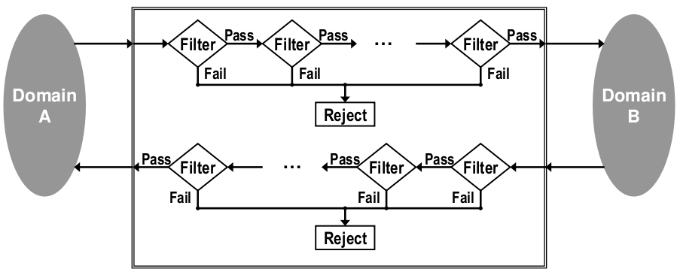

Figure 1. Original Cross-Domain Notional Architecture

In the scenario portrayed in Figure 1, Domain A could very well be a private cloud managed by the U.S. Air Force, while Domain B is a public operational network of some kind shared by coalition partners in a joint operation.

A system user attempts to send a data package consisting of a primary document and associated metadata from Domain A to Domain B. At some point, that submission reaches a guard, which contains at least one filter chain. Each filter chain then contains at least one filter. Individual filters can execute arbitrary actions over a submitted data package and have access to any number of external resources as required. At any point, a filter can examine the data package and reject it, at which point it will frequently wait for human review. If a filter does not reject a data package, it passes that package onto the next filter or submits it for delivery to Domain B.

In recent years, the NSA has extended the legacy system architecture for cross-domain information sharing to exploit service-oriented computing styles (6). Visualized in Figure 2, this model incorporates more modern conceptual elements and componentry.

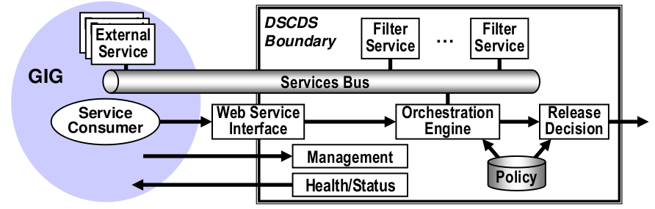

Figure 2. Service-centric Cross-Domain Notional Architecture

We see on the left the Global Information Grid, or GIG. On the right, we have the \Distributed Service-oriented Cross Domain Solution, or DSCDS. The GIG is not a truly open system --- rather, it is a loosely coupled collection of computational services handing data at a variety of levels of sensitivity, federated to provide stakeholders timely access to relevant information (5). The DSCDS is essentially the embodiment of the NSA's cross-domain vision applied to service oriented computing. This model fuses various technology choices with previous cross-domain thinking.

Indicative of this more modern system design thinking, we have a variety of services and service consumers attached to a common service bus within the GIG. Within the DSCDS, we have groups of filters implemented as services inspecting transferred data when moved over the bus. Finally, all of this interaction is managed by a management interface and controlled by an orchestration engine accessing a centralized group of policies. Note that here we have begun to access a common policy repository for various types of security metadata regarding primary data elements.

In the past few years, Raytheon has offered a new model for cross domain use influenced by the NSA service-oriented model (8).

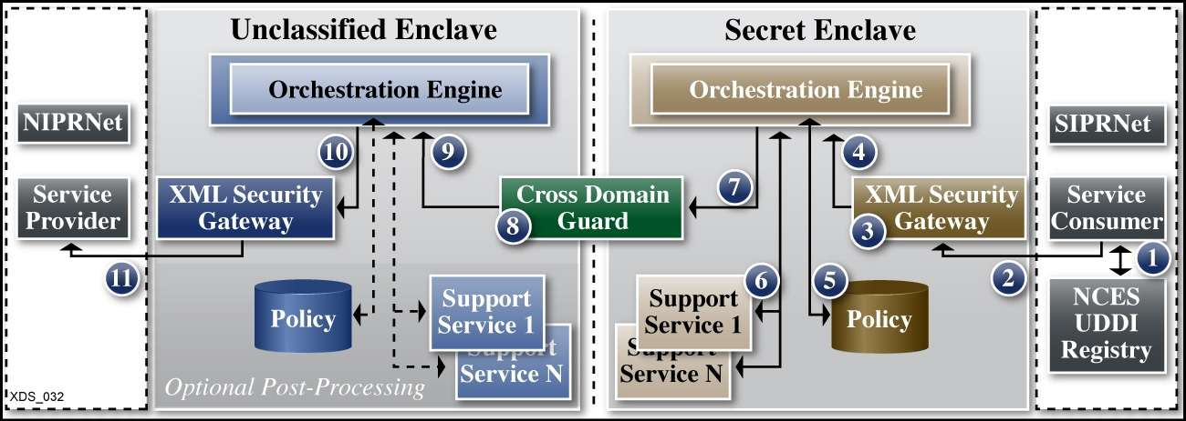

Figure 3. Raytheon’s Notional Architecture

The model in Figure 3 is more grounded in the actual technical environment this kind of solution would be embedded within. Here, we have the Non-secure Internet Protocol Router Network (NIPRNet) as one domain, and the Secret Internet Protocol Router Network (SIPRNet) as the other. Here, NIPRNet is the lower security domain (lowside), and SIPRNet the higher security domain (highside). This particular view shows the motion of data from the high side (SIPRNet) to the low side (NIPRNet).

Here, a data request is submitted from SIPRNet first to the XML Security Gateway which calls into the Orchestration Engine for policy validation. The Orchestration Engine then coordinates calls into a Policy Repository as well as to a collection of external Support Services. Once rectified against these elements, the request is passed into the Cross Domain Guard that routes the request into the Unclassified Enclave in NIPRNet. Here, the request is passed directly through the lowside XML Security Gateway, without rectification, onto the Service Provider. The response from the Service Provider is then passed back to the requester via the inverse path. This model also begins to use a centralized policy repository, just as the NSA Service Model. It also uses a single cross domain guard to transfer information from both the highside to the lowside, and vice-versa.

BAH submitted a competing model, also in 2009 (7). In fact, both Raytheon and BAH presented their models under competitive contract to the UCDMO at the same conference, so the domain application is not coincidental.

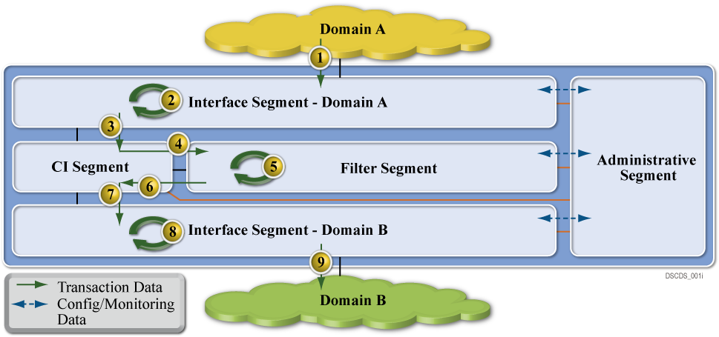

Figure 4. Booz | Allen | Hamilton’s Notional Architecture

Figure 4 embodies BAH's thinking with respect to cross domain information management. We have a Domain A as a high security domain, and Domain B as a low security domain. Here, we again have dataflow from the highside to the lowside through the cross domain management system.

While not as detailed as the Raytheon proposal, this does have similar elements. Here, we data first travels from Domain A into the Interface Segment for Domain A, similar to the secret enclave used in the Raytheon model. From there, it moves into the CI Segment, which in turn submits the transferring data into the Filter Segment. From there, the package is moved into the Interface Segment for Domain B, and then onto Domain B. The Administrative Segment provides management and oversight of the system as a whole. Note the absence of specific policy-centric elements. This system is reliant on specific policy-agnostic content filters as well.

These kinds of cross-domain solutions still have clear similarities, and in fact have not progressed far beyond the initial notions of how these kinds of systems should work. They still, for example, all use some kind of filter chaining mechanism to evaluate whether a given data item can be moved from a classified to an unclassified network. Both NSA models used filters explicitly, as did the BAH model. They all use a single guard as well, a sole point of security and enforcement, providing perimeter data security, but nothing else. In each of these current system architectures, users are only allowed to exchange one type of information per domain. The physical instantiations of these models are locked by operational policy to a single classification level. Users cannot, for example, have Top Secret material on a network accredited for Secret material. Finally, these models violate end-to-end principles in large service network design, centralizing intelligence rather than pushing that intelligence down to the ends of the system (9).

End-to-end principles are generally considered core to the development of extreme scale, distributed systems. Essentially, one of the key design decisions with respect to the early internet was to move any significant processing to system end nodes, keeping the core of the network fast and simple. Known as the end-to-end principles, this design has served the internet well, allowing it to scale to sizes not conceived when originally built. Current cross domain systems are placed at key routing points between sensitive networks. These locations are core to information transfer between systems and ergo violate the initial design principles upon which the internet was founded. There does exist some belief that end-to-end principles need to be modified to support future networks, but nevertheless, current cross domain systems still violate the basic ideas behind large, scalable networks (10).

Future systems will generally demonstrate decentralized policy management capabilities, infrastructural reuse, the ability to integrate with cloud systems, and security in depth. Policy management will need to be decentralized and integrated within the fabric of the system. The system is both more secure and resilient as a result, better able to control information and operate under stressful conditions. Multi-tenancy can lower costs and increase reliability and is furthermore a common attribute of cloud systems. An appropriately secured system facilitates integration of computing resources into multi-tenant environments. The ability to handle multi-tenant environments and to reliably secure both data at rest and data in motion leads to computational environments deployable in cloud systems. Finally, systems must operate under all} conditions, including when they are under attack or compromise (11). They must therefore provide protection to sensitive data in depth.

This work introduces the notion of usage management embedded in a delivery network itself. It also provides an in-depth analysis of the challenges and principles involved in the design of an open, inter-operable usage management framework that operates over this kind of environment. Besides referencing the material we have covered in depth to portray the current state of the art, the analysis includes application of well-known principles of system design and standards (9) (10) (12), research developments in the areas of usage control (13) (14), policy languages design principles (15), digital rights management (DRM) systems (16), and interoperability (17) (18) (19) (20) (21) towards the development of supporting frameworks.

While a large body of work exists on how overlay networks can use policies for network management, very little work has been done on using usage policies for content management. The primary contribution in this area focuses on dividing a given system into specific security domains which are governed by individual policies (22). This system fits into our proposed taxonomy as an α-type system as it has domains with single separating guards.

A large body of work currently exists with respect to security in and over overlay networks. These kinds of techniques and this area of study is vital to the production development and delivery of overlay systems, but is outside the scope of this work.

1. **PROPOSED SOLUTIONS AND TAXONOMY**

A clear taxonomic organization of potential steps in approaching finer-grained policy based usage management helps in describing the difficulties inherent in developing potential solutions as well as aiding in planning system evolution over time. Here, we have five distinct types of integrated policy-centric usage management systems, as shown in Table 1. Of these five, only the first two levels are represented in current system models.

Table 1. Taxonomic Elements

|  |  |
| --- | --- |
| Name | Description |
| ϕ | The initial level of this taxonomy, these systems have a single guard without policy-based control |
| α | These systems have begun to integrate policy-based control |
| β | Systems that have begun to integrate policy-based control with router elements |
| γ | Systems that have integrated policy-based control with routing and computational nodes |

In this taxonomy, it is not required that systems pass through lower levels to reach higher ones. This taxonomy represents a continuum of integration of usage management controls. Systems can very well be designed to fit into higher taxonomic categories without addressing lower categories. That said however, many of the supporting infrastructural services, like identification management or logging and tracing systems, are common between multiple levels.

The taxonomy itself starts with the current state, integrating policy evaluation systems into the network fabric gradually, moving away from filters, then by adding policy evaluation into the routing fabric, then the computational nodes, and finally by incorporating evaluation directly into content.

Our work here certainly contributes to these goals, providing robust cross-domain capabilities, helping mitigate risk, and contributing toward advancing the state of the art in this kind of multi-level security environment.

The ϕ classification consists of systems like the initial NSA and BAH notional models. These systems consist of two distinct domains, separated by a filter-centric single guard. The initial NSA system model is clearly of this type, separating two domains with a guard using filter chains. The BAH model is also of this type, using a Filter Segment to evaluate data packages transmitted between interface segments attached to specific domains.

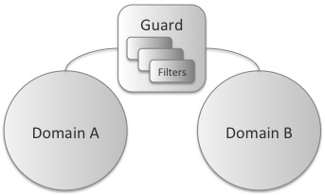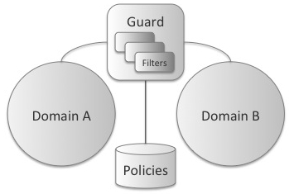

Figure 5. ϕ (on the left) and α (on the right) Conceptual Interaction

Generally one of the domains supports more sensitive information than the other, but that is not always the case. In the models we have examined this has certainly been true, but classified information for example is commonly stored in compartments which are separated by clear need-to-know policies enforced by access lists and classification guides. These kinds of compartments contain information at similar levels of classification, but contain distinct informational elements that should not be combined.

In these kinds of systems, specific rules regarding information transfer and domain characterization are tightly bound to individual filter implementations. They are based on a priori knowledge of the domains the guard connects, and therefore are tightly coupled those domains. Furthermore, the filter elements are standalone within the system, in this classification, not availing themselves of external resources. Rather, they examining information transiting through the filter based purely on the content of that information.

The set of filters that could be developed and deployed within the guard are unlimited. Developers could easily create a filter that inspects and possibly redacts the sections within the document, rather than passing or not passing the entire document through the guard. Indeed, if we assume even very limited processing capabilities within the guard, that is, Turing completeness, then this guard can be made as powerful as any solution we can derive for implementing a cross-domain solution (CDS). Thus the computational power of the guard is not the issue. The real issues are the benefits that can be gained by distributing the capabilities intelligently within the networked environment.

The α overlay classification contains systems that have begun to integrate policy-centric usage management. Both policies and contexts are dynamically delivered to the system. The dynamic delivery of context and policies allows these kinds of systems more flexibility with policy evaluation. The α category begins to integrate policy-centric management rather than using strict content filtering.

Here, we again have at least two domains, Domain A and Domain B, though we could potentially have more. ϕ type systems require domain specific information to be tightly coupled to the filter implementations. Separating the permissions, obligations, and other constraints from the filters and incorporating them into a specific separate policy entity frees the guard from this coupling and provides additional flexibility to the system.

The guard can continue to use filters to process data. These filters however are now more generic and decoupled from the specific domains the guard manages. The choice of using a specific filtering model rather than some other kind of construct is a design detail level to implementers. That said however, individual filters will be remarkably different and still need to understand the ontologies over which specific licenses are defined rather than specific content semantics.

The policy repository is key to the implementation and differentiation of this taxonomy category. This repository can be implemented as a separate repository keyed into via a data artifact's unique URI, for example. It could also represent a policy sent in tandem with a data artifact in a data package.

The policy repository may be implemented as some kind of external service, and as such, represents the first such external service explicitly used in this taxonomy. Other external services may well exist and be used to adjudicate information transfer decisions as well.

The β taxonomic category begins to integrate policy-centric processing with router elements in a given network. While this work is centered on using overlay technology to illustrate and implement these concepts, it is important to note that this kind of distributed policy-centric processing could very well be distributed into the physical routing fabric of a given network as well by extending Software Defined Networking systems like OpenFlow (23).

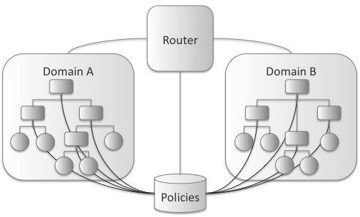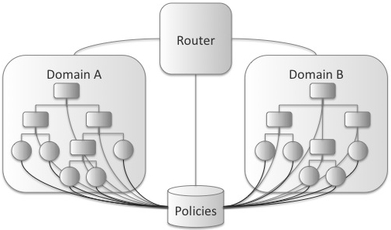

Figure 6. β (on the left) and γ (on the right) Conceptual Interaction

In this model we can also host multiple domains as a result of flexible policy-based content examination. Each domain hosts a network of some kind, though that hosted network could very well be a degenerate network of a single system. Each network hosted in a domain is hierarchical, with specific computational nodes embodied by workstations, tablet computers or mobile devices, and routing points embodied by routers or switches of some kind.

Policy evaluation in this model has begun to penetrate into the routing elements of the specific domain networks. Here, note that we have started to penetrate into the routing fabric of the network by doing content evaluation at router points. Content-based switching networks have been successful in other domains, and such techniques can be used here to provide policy evaluation capabilities (24).

Certain types of traffic are easier to evaluate than others however. For example, HTTP requests and responses are easier to examine that TCP packets. When examining TCP packets, systems generally require additional context to select an appropriate packet window (e.g. the number of packets cached for examination). HTTP traffic does not usually require this kind of flexibility.

This migration of policy evaluation into the routing fabric provides for enhanced data security and better network management, especially if part of a network is compromised. Now that policy decisions can be made at the router level in a given network, we are starting to have network security in depth rather than simple perimeter protection. This not only provides the ability for additional information protection, but also allows for different compartments holding information at different need-to-know levels to be created ad-hoc under different routing segments. In cases of network compromise, this kind of dynamic policy enforcement can also allow for quick node excision as well.

The γ compartment has integrated policy evaluation with compute and routing nodes. Here, policies can be evaluated against content at all network levels --- nodes emitting requests, nodes fielding requests, and all routing elements in between.

We see that the policy repository is supplying services to all computational elements in both domains. This gives us increased granularity with respect to data compartmentalization by integrating information security into each network element. At this point, the network can create compartments of single nodes, while previously in β level systems compartments could only be created under specific routing elements. At this level, we can also provide services revoking data access based on policy evaluation decisions when needed.

Furthermore, individual node exclusion is possible as well. β classified systems could excise network elements under specific routers by dynamic policy application. Now, we can apply the same functionality to individual compute nodes. For example, if a networked device like a smart phone is compromised, that device can be removed from access quickly or used to supply misinformation.

The various levels of the taxonomy vary primarily with respect to the inclusion of policy-based usage management and overlay structure. ϕ type systems are not structured with overlay use in mind, nor do they use policy-centric management. Conversely, γ type systems are both purely policy oriented and completely overlay structured.

As systems move through the various levels of the taxonomy they gradually move from one side of the spectrum to another. Overlay structures, hierarchical or otherwise, gradually migrate into the network beginning with β systems. Policy orientation is injected into the architectures starting with α systems and moving into the network fabric in parallel with overlay inclusion.

A key concept in our current work is the separation of content management from physical communication networks. In the past, content was controlled via partitioning and physical network access management. Physical networks were tightly controlled as a way to manage access to sensitive content. Classified networks in common use today are canonical examples of this kind of approach to content management. Access to these networks is tightly controlled by classification authorities and the ability to transfer content from these networks to more open systems is rigorously managed. Corporate systems have also commonly used this kind of approach, though not usually with so much regulation or rigor.

This kind of approach is not scalable however. It imposes huge costs and infrastructural requirements that are becoming too large to effectively manage. Furthermore, future systems containing sensitive information require similar security features, and simply cannot be developed without custom controlled infrastructure. Health care systems, for example, have huge security needs and a more finely grained level of application than even deployed government systems. These systems will contain exabytes of data, all of which needs to be explicitly controlled, managed, and reviewed by those associated with specific managed records.

Separating content networks from physical networks enables network infrastructure virtualization and multi-tenancy. Use the popular file-sharing system BitTorrent as an example. BitTorrent is a content network optimized for download efficiency. It run over traditional TCP/IP networks, but manages traffic according to specialized algorithms unique to BitTorrent. These algorithms take advantage of the asymmetry between upload and download speeds of typical home-use Internet systems in which upload speeds are regularly an order of magnitude slower than download speeds. By partitioning content into distinct sections and downloading them from multiple clients, a downloading node can effectively use all available download bandwidth and is no longer necessarily constrained by the upload bandwidth of a serving peer system. We use a similar approach, in that our hypothesized systems also overlay TCP/IP traffic, but rather than optimizing download speeds we focus on content usage management.

Just as systems like BitTorrent runs over current established protocols, usage management overlay systems could as well. They support multi-tenant cloud computing systems by providing secure compartmentalized access to managed information. They also support the ability to create and use integrated overlay systems between multiple cloud providers, supporting running of overlay components in systems hosted at Amazon while accessing nodes executing on Rackspace infrastructure.

Content networks must deal with situations analogous to those encountered in previous physical systems. Specific examples include cross-domain monitoring and content mashing. Both problems are currently areas of active research within physical networks and need extensive examination in overlay systems as well.

To begin with, in content-specific overlay networks, cross-domain routing can become an even more pervasive issue. Currently, cross-domain data processing guards are installed on the perimeter of sensitive networks where they can monitor and manage outgoing and incoming traffic. In content networks, these kinds of systems can begin to multiply within the information transmission fabric. In physical networks, the network topology is fixed and is established when the network is installed. After installation, changes in the essential network topology are cost-prohibitive and correspondingly rare. Overlay systems do not suffer from this high cost of change, and can easily morph from one topology to another. As additional content enclaves appear within a given overlay topology, the need for content usage management between those enclaves increases.

Mashup scenarios become similarly common. As additional sources of accessible data appear, opportunities for inappropriate data combinations increase at best geometrically. Data combinations need to be likewise managed to prevent inappropriate data combinations.

1. **RESULTS AND EXPERIENCE**

At this point, we have created and deployed baseline system images in both Amazon's Elastic Compute Cloud (EC2) and Rackspace Servers infrastructures. We have also created and exercised our deployment, configuration, and logging systems to enable distributed monitoring and centralized reporting. Overall, we currently have 20 nodes running with two distinct providers geographically dispersed across the continental United States. This leads to a distinct requirement for a centralized system with distributed access for both initial configuration information as well as logging and auditing. We have implemented this required infrastructure using Amazon's Simple Storage Service (S3), accessible from both Rackspace and Amazon hosted virtual machines.

The specific technical components are Amazon EC2, Amazon S2, Rackspace Servers, and GitHub. Both EC2 and Rackspace nodes are Ubuntu virtual machines, albeit at different versions, as we run Ubuntu version 11.04 in Rackspace and Ubuntu Version 12.04 in Amazon's infrastructures. These systems are provisioned with Git, Ruby, the Ruby Version Manager (RVM), and supporting libraries. They all run as micro-intances or equivalent, and are bootstrapped with the appopriate project information to begin to participate as an overlay network node. While EC2 and Rackspace Server infrastructures are infrastructure-as-a-cloud (IaaS) offerings supporting virtual machine instances of various types, Amazon S3 is a simple key-value store. Running with REST sematics over HTTP, S3 stores arbitrary documents associated with specific keys in buckets. These documents can be downloaded by any authorized participant, where authoriztion state is proven by possention of a secret key. In this way, we can store the global configuration of a specific overlay network in a single location from which every node can access informationm with respect to their pending role and needed configuraiton information. Likewise, all overlay network state can also be saved to centralized buckets for later analysis. Finally, Github is a centralized source code repository used to share code between all participating nodes. Prior to each content network instantiation, each node checks the repository for updates, and downloads them if they exist.

All data saved within S3 is serialized in a text-based data serialization language known as YAML. YAML is a widely supported hierarchical data representation language with support within the Ruby core platform. This enables us easily serialize Ruby-native data structures to text-based representations for storage within S3. More importantly, it simplifies post-experimental data analysis as any information logged to the centralized logging system during a given experimental run can be easily read and analyzed after the fact.

In order to manage and initialize all overlay nodes, we use Capistrano. Capistrano is a distributed deployment system initially used to manage large clusters of Ruby-on-Rails systems. It has since expanded into a general-purpose distributed deployment toolchain, tightly integratd with Git. This allows us to bootstrap different configurations of networks from a single command-and-control node simply and efficiently.

All these infrastructural elements, protocols, and technology components have been successfully tested, allowing for unified control and configuration of large, distributed overlay systems. We have successfully tested our logging systems, and integrated them with the Ruby runtime for ease of access. We have also passed configuration information to both Rackspace and Amazon EC2 systems and verified access from all participating nodes. Finally, we have successfully exercised the ability to dynamically update all participating nodes from Github as well as the capability to manage the system via Capistrano.

The system is a distributed content network distributed across multiple nodes and domains providing cross-domain managed data access. This network consists of clients accessing information through a user interface subsystem that accesses data from external sources and a distributed cross-domain information network. Queries are submitted through a client, to an application server, then to external services and information nodes.

The unique strength of this system is enabling dynamic distributed content control. This includes information retraction, redaction, protection, and secure routing. Information retraction involves quickly removing a user's access to sensitive data. Redaction addresses simple data removal, while protection would operationally involve applying encryption layers of increasing strength based on operational demands. Finally, secure routing would provide the ability to send data over a more secure link if such a link is available and required.

In this system information retraction involves changing the execution context such that access for a given user, perhaps even on a specific device, is removed. This context then propagates through the information network and attached clients. This is useful when a given user, say a coalition partner, is suddenly considered compromised and can no longer be allowed access to sensitive information. Likewise, a specific user's system may likewise be compromised and be forbidden access to specific information.

Information redaction is generally used when a user simply does not have authorization for a specific section of content, generally within a larger document. In these cases, that information and related policy metadata are simply removed from any query responses. Likewise, information protection also addresses specific subsections of information in a larger document, but unlike redaction, a user is in these cases authorized to access information, but one of the links over which the information must travel is not authorized to transmit specific sensitive information. In these cases that information can be encrypted with appropriately strong encryption to allow for more secure information transmission.

Finally, secure routing use directly addresses the ability to select communication links based on information content. In these situations, a network has more than one path over which to return content. Furthermore, these multiple paths have different characteristics providing different levels of service. The system, based on rules contained in a policy and the current context can then select communication links of different security levels when returning content. Likewise, the content network must:

* Support and distribute queries for available content based on submitted constraints including artifact key and hop count.
* Support and distribute queries for specific content based on key.
* Evaluate returned content for suitability for transmission to a requesting node at each transmission step.
* Support partitioning into multiple domains.
* Allow for dynamic information distribution at network start.
* Collect experimental metrics for evaluation.
* Be distributed across multiple nodes.

Overall, the system consists of an HTML 5 based user interface subsystem, external data sources, and a content network, as shown in Figure 1. The user interface layer displays maps and associated metadata to users based on submitted geolocation information and supports two different mobile profiles (tablet and telephone) and a single workstation profile. We use HTML 5 media queries for end device detection, allowing us to format information differently for our three profiles facilitating usability. External data sources could be any data programming interface offered by a third party over which we have no direct control. In this system, we use Google Maps to define, download, display, and format maps. Finally, we have a content network configurable either as a hierarchical network or a non-hierarchical network containing geo-tagged information at various sensitivity levels. This content network can be configured arbitrarily, enabling us to create a virtually unlimited number of different information domains.



In this work, the client systems layer will be replaced with a command-line interface and external services will not be accessed, but a typical deployment operationally would have these elements.

The user interface subsystem processes requests and returns information from both Google Maps and the content network based on those requests. Technically, it is based on the latest version of Ruby on Rails (RoR) using standard RoR configuration conventions running on top of Ruby 1.9.*. We use Rake for deployment, and Gem for component installation. We use Bundler to maintain consistent application dependency state and RVM to manage Ruby virtual machine versions. HTML 5 interface elements are defined using SASS and HAML.

Operationally, typical system use involves query submission, usage management rectification, and result display. We have two distinct types of queries - an initial query for a map of a specific location, generally triggered by entering some kind of geolocation parameters (though potentially using device-generated location information, allowing automatic map alignment with a user's current location) and a query for specific sensitive information. Initial queries have two distinct subqueries, one of map information directed at the Google Maps API, and another of the content network to see what data is available. All content is usage managed to ensure that mashed information is consistent from a data sensitivity perspective prior to display to the user. Currently, no information is cached within the interface subsystem.



The content network can be configured to run as an HTTP overlay system using HTTP routers and nodes or in a peer-to-peer configuration. In either case, queries can be submitted to the network from any one of the constituent nodes - note that routers do not store data; rather, they focus soley on routing queries through a hierarchical network. After initial submission, queries propagate throughout the network based on user-submitted search parameters. The content network physically runs on nodes provisioned from Rackspace Cloud and Amazon Elastic Compute Cloud (EC2). It is built using Sinatra for HTTP processing and uses Capistrano for distributed system deployment and control. We store distributed data in Amazon Simple Storage Service (S3) buckets. We use RVM, Gem, and Bundler in this system as we do with the user interface subsystem.

In both configurations, the common functional flow is built around responding to content queries with information of appropriate sensitivity for a given query context, as shown in Figures \ref{fig:model:node-view} and \ref{fig:model:router-view}. In general, systems are designed with a layered perspective, with an application layer fielding initial requests, a protocol-agnostic domain layer that manages query responses, and an infrastructure layer that contains specific required libraries and other technical artifacts. In these systems, the application layer handles HTTP protocol issues, translating requests from the lingua franca of HTTP into the domain language reflected in the domain layer. The infrastructure layer consists of various data management technologies called upon by the domain layer when needed.

Figures \ref{fig:model:node-view} and \ref{fig:model:router-view} highlights communication ordering within components in a hierarchical content network and also shows the functional components within the system. From a communication perspective, requests come in through the application layer and are then handed off for processing to the domain layer. The domain layer retrieves the current context and is responsible for query dispatch (in the case of a router) or data reponses (in the case of a node) that are managed according to the current environmental context.

The primary components in the router and node systems' application layer are small adapters intended to translate between HTTP protocols and domain components. They are:

* **Context Manager Client Service (ctx\_mgr\_s)}** – This is an adapter between the domain context manager and the external context service.
* **Node Service (node_s)** – The node service provides a RESTful interface to external clients. All content requests are initially sent to a known node service. This is essentially the external interface to a given content network. A content network generally contains many distinct nodes as well.
* **Router Service (router_s)** – The router service is essentially a customized HTTP router that dispatches content requests and responses through a hierarchical content network in accordance with established policies and the current environmental context.
* **Dispatch Service (dispatch_s)** – This service dispatches information requests to known nodes based on known policies and context.

The domain layer components include:

* **Context Manager (ctx\_mgr)** – The context manager client service calls into the context manager service to retrieve the most current contextual information with respect to the content network, attached clients, users, and devices.
* **Node (node)** – The node component contains all logic needed to process and respond to information requests. Nodes manage requests, responses, context evaluation, and usage management mechanism application.
* **Usage Management Mechanism (umm)** – The usage management mechanism will apply rules grouped into policies against a known context to determine the acceptability of an intended action. It will indicate whether or not that action can proceed. It can also make changes to a proposed action so that the alternative action can be executed.
* **Router (router)** – Router domain components manage the distribution of information requests and responses, applying managing information dispersal throughout a content network in accordance with context and policy.
* **Dispatcher (dispatch)** – Dispatchers send requests to known routers or nodes in the larger context network.

Finally, the sole infrastructure component is the **Information and Policy Repository (repo).** Unique to nodes, information and policy repositories contain specific network content, organized by key, and associated policies.

We use the same components to assemble non-hierarchical networks, in which nodes have both content and policy storage as well as request response and dispatching responsibilities. Also note that context management and usage management components are shared between all types of content networks as well as all types of component systems within those networks. Non-hierarchical nodes and hierarchical routers and nodes all need these kinds of services.

\section{Experimental Structure}

Content-centric networks are generalized constructs supplying the ability to manage distributed content more effectively. This work explores specifically how users can control information security and privacy in a more granular way when data is arbitrarily combined. In order to do this effectively however, we must define a simple protocol that allows connected systems to determine what kind of information is available.

We can use a variety of approaches with respect to information storage in these kinds of networks. In many ways, they exhibit behavior very similar to filesystems. In a content-centric network, rather than asking for content via some kind of address, like a uniform resource locator (URL), we use a specific non-ambiguous name. This is very similar to how content management systems and web caches work today. These kinds of systems treat a URL as a name rather than an address, returning a cached image of the requested content rather than the content actually pointed to by the URL. This requires that consumers and caching agents recognize and manage the possibility of stale data, but that risk is generally worth the performance gain. Content-centric networks can similarly optimize various aspects of content retrieval, returning the most local, highest quality, or most reliable data item, for example.

In this content network, we store metadata associated with specific locations as well as the locations themselves. Rather than optimizing with regard to location or quality, this network optimizes security posture. In order to do so, we need to specify a simple data discovery protocol so clients can discover what data is available.

We have proposed two different models for content access in this kind of network. The first, the Cat Model, mimics typical filesystem interaction on unix-centric computers. The second, the Index Model, acts more like a typical website, with a central index providing available options. Both models are can manage hierarchical content, a requirement for managing large volumes of information.

The first system is modeled after a typical filesystem. In this case, a user would have read access to the network via a set of related commands. Filesystems follow a model where you can list the available contents, access specific details of the contents, and then access individual contents themselves. In UNIX and unix inspired systems, these actions correspond to ls, for diretory listings, and programs like cat, to allow access to specific individual content. File details are exposed by options on the ls command.

Command-line access to a content network is certainly feasible. Command-line shells are common in a variety of environments, ranging from development environments like Play to software development systems like Ruby and Python.

In our content network, the ls command would traverse the network returning information describing contents based on the current security context. This context consists of the environment, the resource requested, and the subject requesting the resource. For example, a user with access to a content network via some kind of shell may list network content from a device at a given physical and network location and receive content listing A, while executing a listing from a different device from the same locations may generate content listing B, which can be significantly different from A based on contextual changes.

Another problem arises with listing network contents is the fundamentally different nature of listing a relatively small directory on a local computer as opposed to the contents of a geographically dispersed network. We feel comfortable that the latency involved when reading this kind of local directory is small, and that the number of elements to list is tractable. Networks do not support these kinds of assumptions. The time required to list the available contents on a dispersed content network can be significant.

A cat-like command on a content network suffers from similar problems. As content within an artifact can be marked with different sensitivity, displayed artifact content can change based on context as well. Likewise, large artifacts can take significant time to display on devices because of content dispersion issues.

The proposed Index Model has significant precedent as well. This model is commonly used in world-wide-web systems both large and small. Modified versions have been used to seed BitTorrent networks as well as direct content traffic on early instances of Napster. Here, we have a small index file that lists available content on the network. This index could be associated with a policy and marked for sensitivity, and could contain links to content as well as metadata describing that content. This index would essentially serve the function of the ls command in the Cat Model. Selecting a link from an index via a network client would then serve as the Cat Model's cat command.

Similar issues with respect to network dispersion exist with showing the contents of artifacts in both models, and the index contents can seem to change with respect to changing context, as they are also associated with policy sets describing the use of content. Both models can also be optimized for project-centric content viewing or to show indicators with respect to expected content retrieval latency. Organizationally, any kind of informational hierarchy within the network would need to be based on the semantics of referenced content rather than external factors. Content-centric networks use keys to location content rather than addresses, so this hierarchical name would in fact be such a key rather than an address for the content.

Latency effects and content surprise are characteristics of the underlying content network rather than a specific interface approach. They effect either approach equally. The Cat Model is more general than the Index Model however. You can in fact implement the Index Model with the Cat Model, but not the inverse. Our work is focused on secure mashing of content in a web-centric environment. As a result, the Index Model fits our needs better than the more general Cat Model.

\subsection{Initial Seed Information}

In order to seed network clients, we provide an initial index object that contains location information and associated metadata. This information is classed according to sensitivity and consists of names and latitude/longitude coordinates contained in an XML file, similar to that shown in listing \ref{lst:seed-data}.

\begin{lstlisting}[language=xml, label=lst:seed-data, caption=Seed Information for the Network]

<index>

<location>

<name>The location name; a city name, for example</name>

<lat>The location latitude</lat>

<lon>The location longitude</lon>

<about>Metadata about the location</about>

<key>The detail data object name</key>

<key>...</key>

....

</location>

<location>...</location>

<location>...</location>

...

</index>

\end{lstlisting}

Any of these XML elements can be marked with an attribute, policy-set, which is the name of a policy set contained in the associated policy file. It is contained as an artifact with an associated policy set.

Detail data objects are arbitrary XML documents that support the policy attribute. We support text, images, and shape information. Each different type is ensconced within an XML element corresponding to the type of data contained, and are delivered in a single XML document with associated policy sets.

\par\noindent

\begin{minipage}[t]{.30\textwidth}

\begin{lstlisting}[language=xml, label=lst:image-data, caption=Image]

<artifact>

<policy-set>

...

</policy-set>

<data-object>

<image type=".">

...

</image>

</data-object>

...

</artifact>

\end{lstlisting}

\end{minipage}

\hfill

\begin{minipage}[t]{.30\textwidth}

\begin{lstlisting}[language=xml, label=lst:shape-data, caption=Shape]

<artifact>

<policy-set>

...

</policy-set>

<data-object>

<shape type=".">

...

</shape>

</data-object>

...

</artifact>

\end{lstlisting}

\end{minipage}

\hfill

\begin{minipage}[t]{.30\textwidth}

\begin{lstlisting}[language=xml, label=lst:content-data, caption=Content]

<artifact>

<policy-set>

...

</policy-set>

<data-object>

<content type=".">

...

</content>

</data-object>

...

</artifact>

\end{lstlisting}

\end{minipage}

In these examples, data-objects can be associated with policies contained in the policy-set element. Each policy-set element can contain zero or more policies. Sections within the content element can also be associated with policy sets, and currently type can be either xml or txt. A shape can only be associated with a policy set from the shape element itself. Properties of a shape cannot be associated with a policy set individually. Shape types include marker, circle, and polygon, as shown in listing 3. Data contained within an image element is Base64 encoded and must contain type information to indicate the specific image format. Currently, the supported values are jpg and png.

\par\noindent

\begin{minipage}[t]{.30\textwidth}

\begin{lstlisting}[language=xml, label=lst:marker-shape, caption=Marker]

...

<shape type="marker">

<marker>

<lat>...</lat>

<lon>...</lon>

</marker>

</shape>

...

\end{lstlisting}

\end{minipage}

\hfill

\begin{minipage}[t]{.30\textwidth}

\begin{lstlisting}[language=xml, label=lst:circle-shape, caption=Circle]

...

<shape type="circle">

<center>

<lat>...</lat>

<lon>...</lon>

</center>

</radius>...</radius>

</shape>

...

\end{lstlisting}

\end{minipage}

\hfill

\begin{minipage}[t]{.30\textwidth}

\begin{lstlisting}[language=xml, label=lst:polygon-shape, caption=Polygon]

...

<shape type="polygon">

<vertex>...</vertex>

...

</shape>

...

\end{lstlisting}

\end{minipage}

\subsection{Policies and Attributes}

This system will use attribute based mechanisms for usage management. The policies defined over content must therefore consist of rules that address usage over an ontology of possible user attributes of concern. We are specifically interested in a user's primary attributes: mission affiliation, clearance levels (both sensitivity and category), organization, and computational environment (consisting of both device and operating system). We also make decisions with respect to usage based on a secondary attribute, need-to-use.

Sets differ from orderings in the above table as sets denote membership with no associated value. Orderings on the other hand have distinct values increasing from left to right in the listed enumerations. For example, a user can be affiliated with a specific mission in Domain A, either tropic\_thunder or gallant\_entry, or both. That user is also associated with a sensitivity value, either unclassified, secret, or topsecret, where topsecret is the most sensitive and unclassified the least.

Need-to-use decisions are based on the current context in tandem with mission and organizational affiliation. We use attribute based control in these scenarios, in which we make access decisions based on the attributes of a requesting user rather than defined roles.

User attributes support defined policy elements. Not every policy attribute has a corresponding user attribute as not all policy attributes are associated with users. Some are associated with the user's environment, like operating system or device.

Policies are evaluated either via direct set membership or via membership in a category in an ordering. Content can be affiliated with multiple sets with regard to set-oriented attributes. Likewise, users can belong to multiple sets as well. Both content and users will be associated with a single value from an ordering element, as that value is inclusive of lower values as well. For example, a user can be affiliated with both the tropic\_thunder and gallant\_entry missions, but only one of the clearance values of uncleared, secret, or top secret. In the case of clearance values, secret subsumes uncleared, so a user with a secret attribute set would be able to access any unclassified material.

In the scope of this project, we use a Ruby-based domain specific language (DSL) to describe policies. In larger heterogeneous deployments, a standards-based alternative like XACML would be more suitable. This project however is not focused on developing a complete policy specification language, but rather on using one in a very dynamic environment. XACML, for example, is a very large and complete standard that would require a significant investment of effort to implement. It can also tend to be verbose. A simple DSL focused on our specific needs is a more efficient alternative that allows us to focus our time and effort on the goals of this work rather than implementation of a large standard.

\begin{lstlisting}[language=ruby, label=lst:policy-dsl, caption=Policy DSL Example]

policy_set {

policy(:p1) {

match :all

rule(:mission_affiliation) { |x| x == :tropic_thunder }

rule(:sensitivity) { |x| x == :top_secret }

}

policy(:p2) {

include :p1

match :all

rule(:device) { |d| d == :workstation || d == :phone }

}

policy(:p3) {

include :p1

match :one

rule(:category) { |c| c == :vermillion }

rule(:organization} { |o| == :oceania }

}

}

\end{lstlisting}

This is our simplified DSL supporting a subset of XACML elements. In this example, we have a base policy, p1, that all other policies inherit. That policy requires that all rules evaluate to true. p2 adds another rule based on devices, all of which must evaluate to true as well. Finally, p3 adds two additional rules, only one of which must evaluate to true for the policy to be fulfilled.

**ACKNOWLEDGEMENTS (10 PT)**

Xx xxx

# REFERENCES

x

|  |  |
| --- | --- |
| 1. | U.S. Department of Defense. Chief Information Officer, U.S. Department of Defense. [Online].; 2007 [cited 2012 September 29. Available from: <http://dodcio.defense.gov/Portals/0/Documents/InfoSharingStrategy.pdf>. |
| 2. | Hoover JN. Informationweek. [Online].; 2011 [cited 2012 September 29. Available from: <http://www.informationweek.com/news/government/cloud-saas/229401646>. |
| 3. | Pearson S, Benameur A. Privacy, Security and Trust Issues Arising from Cloud Computing. In Cloud Computing Technology and Science (CloudCom), 2010 IEEE Second International Conference on; 2010. p. 693 -702. |
| 4. | U.S. Air Force. SBIR/STTR Interactive Web Site. [Online].; 2011 [cited 2012 September 29. Available from: <http://www.dodsbir.net/sitis/archives_display_topic.asp?Bookmark=41198>. |
| 5. | U.S. Department of Defense. Department of Defense Global Information Grid Architectural Vision. Informational. U.S. Department of Defense; 2007. |
| 6. | U.S. National Security Agency. Distributed Service Oriented Architecture (SOA)- Compatible Cross Domain Service (DSCDS) DSCDS Overview. In Unified Cross Domain Management Office Conference; 2009. |
| 7. | Booz | Allen | Hamilton. Distributed Service Oriented Architecture (SOA) Compatible Cross Domain Service (DSCDS). In Unified Cross Domain Management Office Conference; 2009. |
| 8. | Raytheon Corporation. Raytheon DSCDS Intro. In Unified Cross Domain Management Office Conference; 2009. |
| 9. | Clark DD. The design philosophy of the DARPA Internet Protocols. SIGCOMM Comput. Commun. Rev. 1995 January 1; 25(1): p. 102-111. |
| 10. | Blumenthal MS, Clark DD. Rethinking the design of the Internet: the end-to-end arguments vs. the brave new world. ACM Trans. Internet Technol. 2001 August 1; 1(1): p. 70-109. |
| 11. | Ross R. Next Generation Risk Management. Unified Cross Domain Management Office. 2009. |
| 12. | Clark DD, Wroclawski J, Sollins KR, Braden R. Tussle in cyberspace: Defining Tomorrow's Internet. In SIGCOMM; 2002; Pittsburg, PA: ACM. p. 347-356. |
| 13. | Park J, Sandhu R. The UCON ABC Usage Control Model. ACM Trans. Inf. Syst. Secur. 2004; 7(1): p. 128-174. |
| 14. | Jamkhedkar PA, Heileman GL, Lamb CC. An Interoperable Usage Management Framework. In Proceedings of the Tenth ACM Workshop on Digital Rights Management; 2010; Chicago. |
| 15. | Jamkhedkar PA, Heileman GL, Martinez-Ortiz I. The Problem with Rights Expression Languages. In Proceedings of the Sixth ACM Workshop on Digital Rights Management; 2006; Alexandria, VA. p. 59-67. |
| 16. | Jamkhedkar PA, Heileman GL. The Role of Architecture in DRM Vendor Economics. In Satish D. Digital Rights Management: An Introduction.: ICFAI University Press; 2009. |
| 17. | Jamkhedkar PA, Heileman GL. DRM as a Layered System. In Proceedings of the Fourth ACM Workshop on Digital Rights Management; 2004; Washington, DC, USA: ACM. p. 11-21. |
| 18. | Heileman GL, Jamkhedkar PA. DRM Interoperability Analysis from the Perspective of a Layered Framework. In Proceedings of the Fifth ACM Workshop on Digital Rights Management; 2005; Alexandria, VA, USA: ACM. p. 17-26. |
| 19. | Koenen RH, Lacy J, MacKay M, Mitchell S. The Long March to Interoperable Digital Rights Management. Proceedings of the IEEE. 2004: p. 883-897. |
| 20. | Coral Consortium. Coral Consortium Whitepaper. [Online].: Coral Consortium; 2006. Available from: <http://www.coral-interop.org/main/news/Coral.whitepaper.pdf>. |
| 21. | Marlin. Marlin Architecture Overview. [Online].; 2006. Available from: <http://www.marlin-community.com>. |
| 22. | Perez GM, Clemente FJG, Skarmeta AFG. Building and Managing Policy-Based Secure Overlay Networks. In Parallel, Distributed and Network-Based Processing, 2008. PDP 2008. 16th Euromicro Conference on; 2008. p. 597-603. |

x

**BIBLIOGRAPHY OF AUTHORS (10 PT)**

|  |  |
| --- | --- |
| First author’s  Photo (3x4cm) | Xxxx (9 pt) |
|  |  |
| Second author’s photo(3x4cm) | Xxxx (9 pt) |
|  |  |
| Thirth author’s photo(3x4cm) | Xxxx (9 pt) |