Product, feature, and architecture guide
Spectrometer GUI audience, use cases, design principles, and component model
Revision date: 2026-09-14

Product definition
A Windows/PySide6 research GUI for coordinated spectroscopy with independently selectable real, emulated, or disconnected spectrometer, power-meter, and laser sources. It supports ordinary spectra, live acquisition, power-dependent scans, software-timed gated/phosphorescence workflows, monitoring, reproducible metadata, and safe instrument lifecycle handling.

Audience and intended use
- Experimental photophysics, photoluminescence, fluorescence, phosphorescence, magneto-optical, and power-dependent spectroscopy laboratories.
- Researchers who need a guided GUI for repeatable acquisition but still require transparent files, diagnostics, and instrument-specific controls.
- Developers adding adapters, coordinators, analysis utilities, or future procedures without coupling vendor drivers to presentation code.
- Teaching and offline development using emulators, with explicit boundaries between simulated capability and bench-verified hardware behavior.

Core design principles
Principle | Application
Instrument independence | Spectrometer, Newport, and OBIS sources select real/emulated/disconnected modes independently. Adapters never call each other.
Single workflow owner | SequenceArbiter prevents Live, manual, background, scans, gated, and auto-tune paths from issuing conflicting acquisitions.
Thread ownership | Only the owning worker calls a native device API. Cross-instrument transactions are host/runtime policy.
Evidence-gated capabilities | Controls are enabled only when support is reported and, where necessary, confirmed by lab behavior.
GUI-first handled errors | Expected absence and recoverable failures appear in status/dialogs and optional rotating logs; terminal errors indicate less-handled faults.
Data truth over widget state | Saved records capture acquisition-time settings, SDK-applied values, selected channels, timing evidence, and background signature.
Bounded operation | Buffers, plans, logs, retries, timing rejection, helper processes, and retained acquisition all have explicit ceilings.
Fail-safe cleanup | Abort/failure/disconnect paths unwind dependent workflows and request laser OFF; normal cold-camera exit requires guided warm-up.
Performance by architecture | Event chaining, independent redraw clocks, lazy plans, cached processing, armed streams, and asynchronous ordered autosave remove avoidable GUI-path work.
Backward-readable persistence | Versioned CSV loaders preserve older files while new writers use conditional analysis-oriented metadata.

Supported hardware and source modes
Family | Backends | Behavior
Spectrometer | Ocean Insight QEPro via SeaBreeze; Andor iDus SDK2 + Kymera ATSpectrograph; emulator | Real / auto / emulated / disconnected; QEPro or Andor can be selected at startup or in Instrument Connections.
Power meter | Newport 2936-R via pythonnet/vendor DLL; emulator | Independent connection/live state; restartable helper process; channel 1/2 spectrum association.
Lasers | Coherent OBIS Laser Boxes over serial; emulator | Independent box discovery; explicit session-only selected laser; enable/readback/setpoint/CDRH; conditional safety polling while verified ON.
Manual optics | Named ND filter-wheel definitions | Transmission calculation, scan feasibility, low-change planning, user prompts, and spectrum metadata.
Future sensors | Field sensor, shutter, trigger/photodiode, beam profiler, other detectors | Planned typed capability/plugin boundary; not active production functionality.

Measurement and analysis-facing features
Area | Features
Spectrum acquisition | Single, Live, background, software/device averaging, integration, corrections, smoothing, SNR evaluation, long-acquisition progress.
Power measurement | Live trace, bounded history, before/after spectrum association, channel selection, status validation, wavelength control, wrong-channel warning.
Power scans | Setpoint or calibrated power, linear/log/custom points, shared repeats-per-point, settling, filter planning, autosave, abort/failure cleanup.
Gated acquisition | ON/OFF pair, delayed after OFF, transition series, interleaved decay, one-file averaging, robust flag/discard, fixed-window retain-until-valid.
Visualization | Spectrum plot, bounded scalar/power monitors, redraw throttling, optional 3-D field-power map, persistent axes/styles, performance indicator.
SNR/tuning | Robust baseline/noise estimate, peak/integrated metrics, evaluation cadence, stored last valid result, bounded recommendation and auto-tune verification.
Files | Atomic/manual save/open, ordered background autosave, generated names/run IDs/notes, spectrum v4, gated-series v5, calibration and trace exports.
Themes/settings | Built-in/custom semantic themes, preview/editor, persisted display/performance/acquisition preferences, restart support.
Diagnostics | Andor ctypes/DLL/timing/stream/control probes, Newport reconnect tests, OBIS probes, import-safe command-line utilities, optional rotating logs.

Component and communication architecture
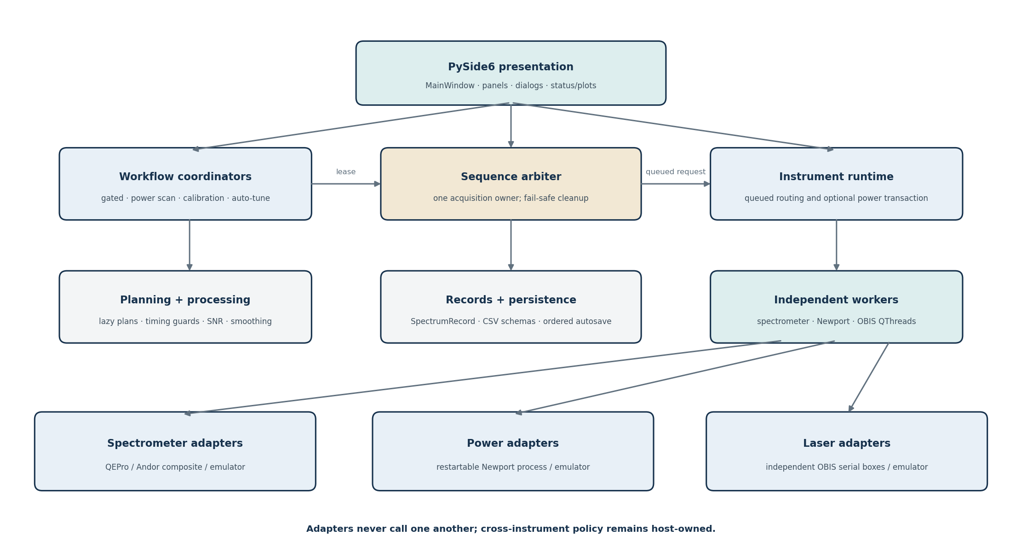
Figure 1. Host-owned coordination across independently owned instrument workers.
Component | Responsibility | Boundary
MainWindow / panels / dialogs | Presentation, user intent, status, plots, settings dialogs, session connection controls. | No vendor API calls.
SequenceArbiter | Exclusive workflow lease and derived UI availability. | One acquisition owner.
Workflow coordinators | Power/calibration scan, gated state machine, SNR auto-tune. | Cross-instrument policy and cleanup.
InstrumentRuntime | Queued worker routing and optional Newport-before/spectrum/Newport-after transaction. | Adapters remain decoupled.
DeviceController / LaserController | Worker-owned adapters, record formation, connection normalization, laser verification. | Only called on owning thread.
Adapters | QEPro, Andor composite, Newport proxy, OBIS, and emulators. | Translate vendor/native contracts.
Planning/processing | Lazy scan/gated plans, timing guards, averaging, SNR, smoothing, background signatures. | Hardware-independent/pure where practical.
FileIOController / serializers | User files, atomic exports, ordered autosave, schema round trips. | Disk writes do not delay automated result routing.

Acquisition lifecycle
1. A panel or coordinator asks MainWindow to acquire under a named origin.
2. SequenceArbiter confirms ownership; MainWindow freezes the applicable settings into AcquisitionSettings.
3. InstrumentRuntime optionally samples selected Newport channels, then queues the spectrometer worker.
4. The worker applies/validates settings, acquires through the selected adapter, performs strict background/processing, and returns SpectrumRecord plus native timing/provenance.
5. MainWindow routes the result to the owning automated coordinator before plot/monitor/autosave work.
6. Automatic file formatting/writing occurs on one ordered executor; the next event-driven acquisition can proceed without synchronous disk work.

Data, metadata, and reproducibility
- Adapter-output counts are canonical raw data. A processed column appears only when background subtraction or smoothing changes the displayed/result array.
- Background subtraction requires an exact signature for backend, serial, wavelength grid, applied exposure, averaging/corrections, and instrument state.
- Feature-group presence replaces redundant active flags. Requested/applied values collapse when equal; abnormal Newport status is retained while normal words are omitted.
- Magnetic field is float-or-None. None alone means not applicable; zero and negative fields are valid.
- Gated files preserve requested delay, request/call/exposure timing families, timing basis, uncertainty, quality, pump duration, and repetition gaps.
- Spectrum CSV schema v4 and averaged gated-series schema v5 are analysis-oriented; legacy readers remain supported.

Use-case boundaries
Boundary | Meaning
Good fit | Steady-state spectra, power dependence, calibrated scans, magneto-PL metadata, slow software-gated decays, repeated averages, instrument diagnostics, offline file viewing.
Conditional | Phosphorescence with weak signals: feasible when collection/background/detector performance is sufficient; timing retention improves consistency but not photon count.
Not claimed | Microsecond-accurate optical gating, analog lock-in behavior, arbitrary safe user code, automatic Step-and-Glue, or detector switching without calibration.
Future | Hardware-referenced triggers, paired phase cycling, typed plugins, declarative procedures, field-sensor acquisition, wider-range stitched scans.

Extensibility direction
- Plugins mean versioned instrument/tool capability providers discovered from manifests; they do not receive MainWindow or raw authority to bypass leases and cleanup.
- Procedures mean validated, bounded measurement recipes compiled into host-owned steps; arbitrary Python is not the default procedure format.
- Third-party code should run in a supervised subprocess or remote service by default; the host retains resource leases, laser authority, validation, cancellation, and audit logs.
- The first pilot remains a read-only field sensor so discovery, capability typing, timestamps/age/uncertainty, and failure isolation can be tested with low actuation risk.

