BCPS

Clyde Clarke

1/8/2021

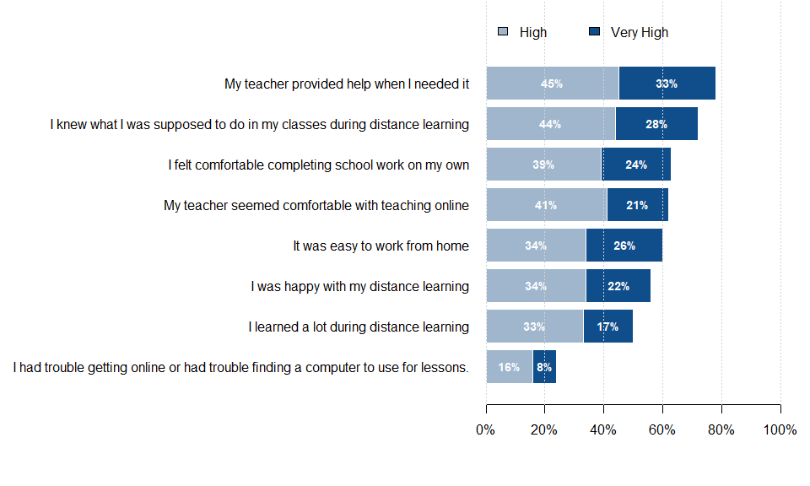

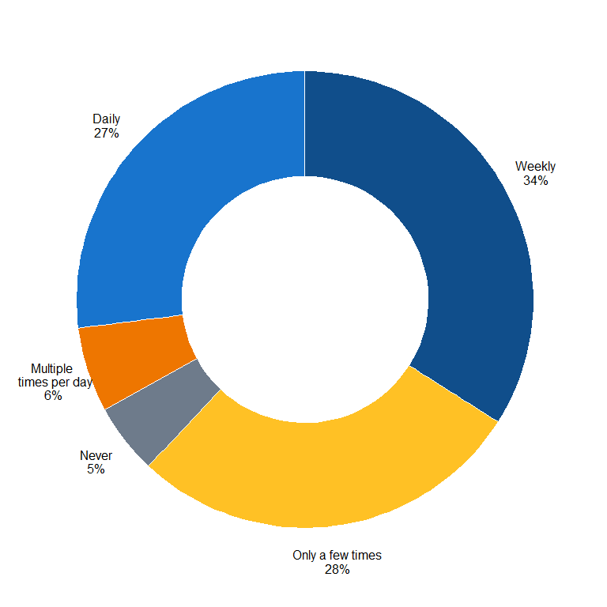

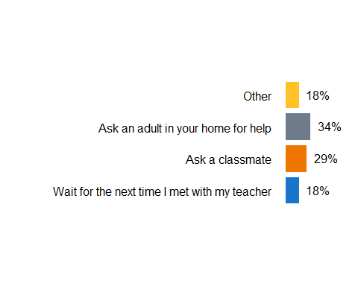



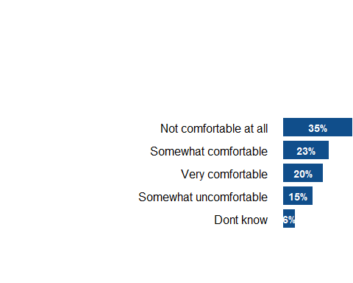 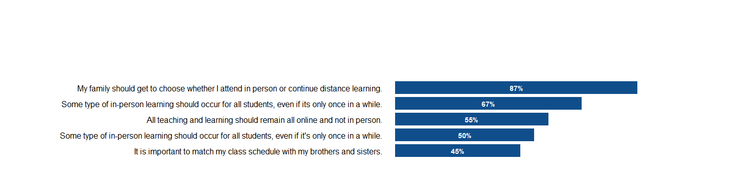

# Graph 4  
  
M <-c("My family should get to choose whether I attend in person or continue distance learning","It is important to match my class schedule with my brothers and sisters","All teaching and learning should remain all online and not in person`, `Some type of in-person learning should occur for all students even if its only once in a while", "Some type of in-person learning should occur for all students even if its only once in a while","I will not be returning for the next school year")  
par(mar=c(5.1, 8, 4, 0))  
  
  
  
H<- c(87,45,55,67,50)  
  
par(las=1)  
bp <- barplot(H, col =c("steelblue4" ), ylim = range(0,110),  
 names.arg = M, horiz = F,  
 border = NA, xlim = range(0,6), las=1,  
 axes = T, yaxt = "n")  
val <- seq(0, 100, 20) #creating Y-axis values  
text(bp, H + 6, paste(H, "%", sep="")) #automates data labels  
par(las=1) #positions y-axis labels horizontally  
axis(2, at = val, labels = paste0(val, '%'), family="Arial" ) #add % to Y-axis

## Warning in axis(2, at = val, labels = paste0(val, "%"), family = "Arial"): font  
## family not found in Windows font database

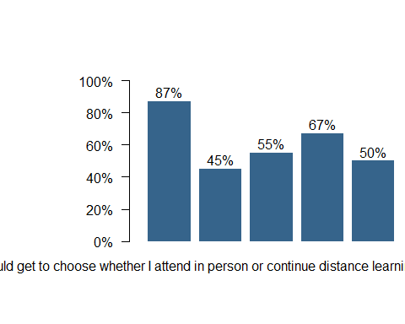

#NOTE: SOMETIMES IT WILL NOT MAKE SENSE TO LABEL X-AXIS, JUST DELETE AXIS LABEL IN THOSE INSTANCES