BCPS

Clyde Clarke

1/8/2021

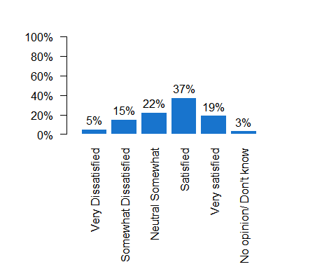

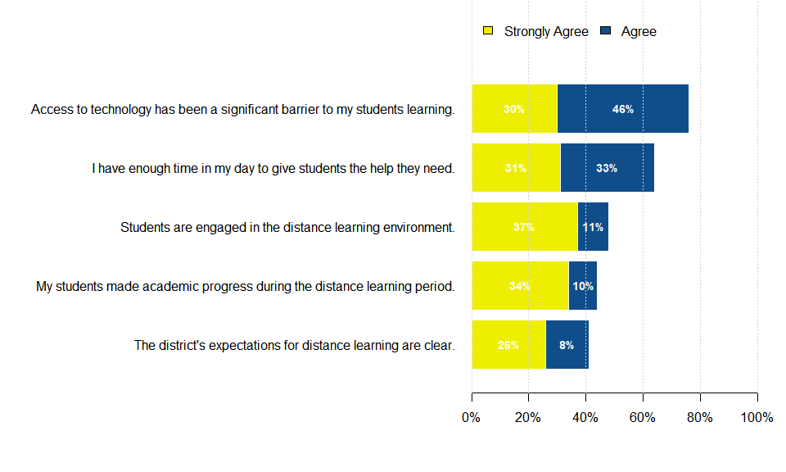

## Loading required package: ggplot2

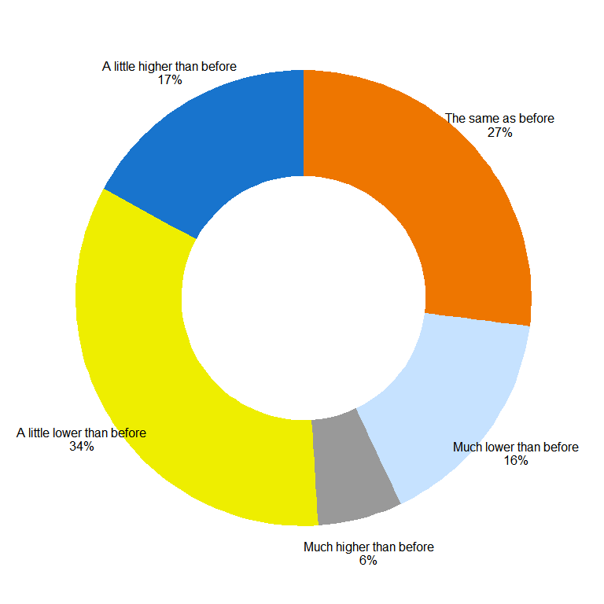

## -- Attaching packages --------------------------------------- tidyverse 1.3.0 --

## v tibble 3.0.4 v dplyr 1.0.2  
## v tidyr 1.1.2 v stringr 1.4.0  
## v readr 1.4.0 v forcats 0.5.0  
## v purrr 0.3.4

## -- Conflicts ------------------------------------------ tidyverse_conflicts() --  
## x dplyr::filter() masks stats::filter()  
## x dplyr::lag() masks stats::lag()

## Warning in axis(if (horiz) 2 else 1, at = at.l, labels = names.arg, lty =  
## axis.lty, : font family not found in Windows font database

