**Integrating Artificial Intelligence into Neural networks**

We ask how artificial intelligence (AI) systems can be integrated into an animal’s nervous system. Our goal is to open new avenues toward a fundamental understanding of both neural and AI networks.

Using AI to replace or augment neural circuits within an animal will allow us to explore the range of computational algorithms that AI employs to solve a behavioral task. We can directly compare how biological and AI algorithms solve the same problems. Ultimately, we want to learn how artificial and biological networks interact with and adapt to each other to guide animal behavior.

Integrating AI networks with animal nervous systems is challenging. A key challenge is to determine the best self-guided learning algorithms and AI network architectures to rapidly learn from and interact with neural circuits in an animal. This proposal aims to address this challenge using a combination of cutting-edge AI, control theory methods (in collaboration with Professor Na Li in SEAS), and neurobiology.

**Approach** We will employ the soil-dwelling nematode *C. elegans* to validate our ideas. *C. elegans* is highly amenable to genetic modification and optical manipulation. Additionally, its nervous system is extremely compact. It has just 300 neurons and 6000 synapses, yet can execute sophisticated search programs to locate bacteria or mates, associatively learn to avoid or pursue biochemical targets, and trigger stress-resistant long-lived states in dire conditions.

We will develop autonomous AI networks that communicate with the nervous system of the animal through optogenetics, in which animals are genetically modified so their neurons can be activated with light. We will design a closed-loop system in which artificial networks receive inputs from the animal in the form of images. Based on these images, the AI network will learn a spatiotemporal pattern of light to excite the nervous system of the animal. By doing so, the AI system can either learn to replace damaged subcircuits within the animal’s nervous system or augment it to drive animal behavior more efficiently.

Our preliminary work provides a proof-of-concept for our idea. We linked a simple computational agent to a key interneuron that can control C. elegans’ movement. After heavily preprocessing the agent’s input (images of the nematode) and a few minutes of real-time computer learning, our agent can direct the nematode solely through optogenetic links (see figure).

**(Top Left)** Nervous system of the animal **(top right)** where a subcircuit has been replaced by an AI network. **(Bottom Left)** Position of an animal as a function of time (time pseudocolored) with an untrained computer agent or **(Bottom Right)** with a trained agent with the goal of making the animal move right.

**Impact** We will (i) take steps toward replacing lost neural function. We can also imagine (ii) augmenting neural function in the form of getting an animal to learn tasks more quickly or use memories stored in an external agent. We note that some work on human and vertebrate brain-machine interfaces has already been done.1 Consequently, our emphasis will be on (iii) achieving a fundamental understanding of how AI and real neural networks adapt and work with each other and (iv) comparing the solutions found by AI networks compared to those of biological ones. In the end, we hope to better understand the algorithms involved in both artificial and biological learning.

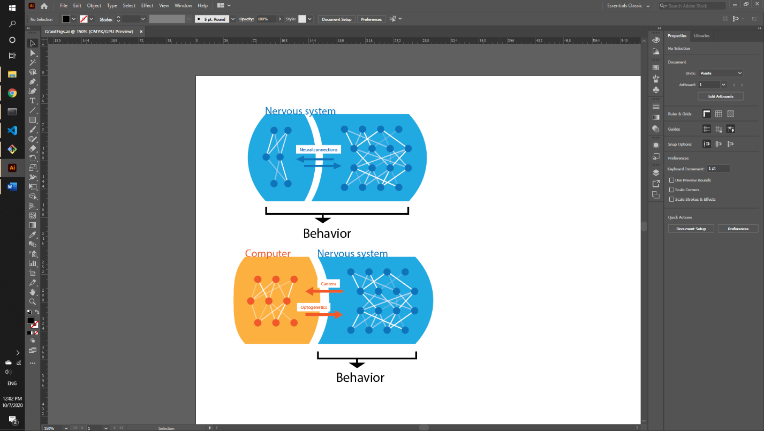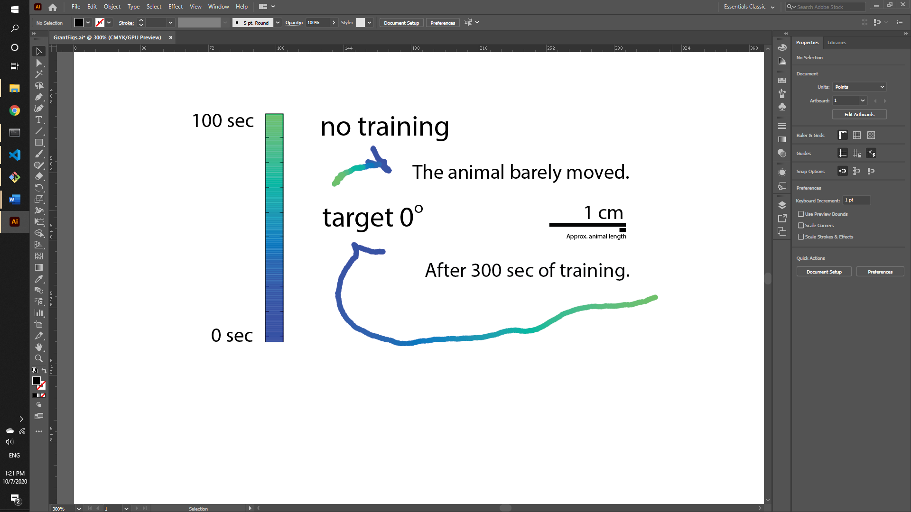

1Lebedev, Mikhail A., Ioan Opris, and Manuel F. Casanova. "Augmentation of Brain Function: Facts, Fiction and Controversy." Augmentation of Brain Function: Facts, Fiction and Controversy: Volume I: Brain-Machine Interfaces (2018): 8.