**Integrating Artificial Intelligence into Neural networks**

**Question** We ask how artificial intelligence (AI) systems can be integrated into an animal’s nervous system. Our goal is to open new avenues toward a fundamental understanding of both neural and AI networks.

**Impact** Using AI to replace or augment neural circuits within an animal will allow us to (i) determine the range of computational algorithms that AI employs to solve a behavioral task, (ii) compare these algorithms to those of the neural networks within the animal to solve the same tasks, (iii) achieve a fundamental understanding of how AI and real neural networks adapt and work with each other. Ultimately, we want to learn how artificial and biological networks interact with and adapt to each other to guide animal behavior. We believe our approach will open novel ways of understanding the algorithms involved in both artificial and biological learning.

**A key challenge** is to determine the best self-guided learning algorithms and AI network architectures to rapidly learn from and interact with neural circuits in an animal. This proposal aims to address this challenge using a combination of different AI approaches. We will use advances in deep reinforcement learning and control theory-based models to integrate AI networks with neural networks. The proposal draws on computer science and control theory (Na Li, SEAS) with optics, optogenetics, and rapid GPU and FPGA-based computational architectures for real-time learning with neurobiology (Ramanathan, FAS, SEAS).

**Approach** We will employ the soil-dwelling nematode *C. elegans* to test and validate our ideas. *C. elegans* is highly amenable to genetic modification and optical manipulation. Its nervous system is also extremely compact. It has just 300 neurons and 6000 synapses, yet can execute sophisticated search programs to locate bacteria or mates, associatively learn to avoid or pursue biochemical targets, and trigger stress-resistant long-lived states in dire conditions.

We will develop autonomous AI networks that communicate with the nervous system of the animal through optogenetics, in which animals are genetically modified so their neurons can be activated with light. We will design a closed-loop system in which artificial networks receive inputs from the animal. Inputs will be in the form of real-time images of neural activity or body posture. Using these images, the AI network will learn a spatiotemporal pattern of light to excite the nervous system of the animal. By doing so, the AI system can either learn to replace damaged subcircuits within the animal’s nervous system or augment these circuits to drive animal behavior more efficiently.

Our preliminary results provide a proof-of-concept for our idea. We linked a computational AI agent to a key interneuron that can control *C. elegans’* movement. With a few minutes of real-time computer learning, our AI agent autonomously learns a sequence of light pulses to direct the nematode to move in desired directions through optogenetic control (see Figure).

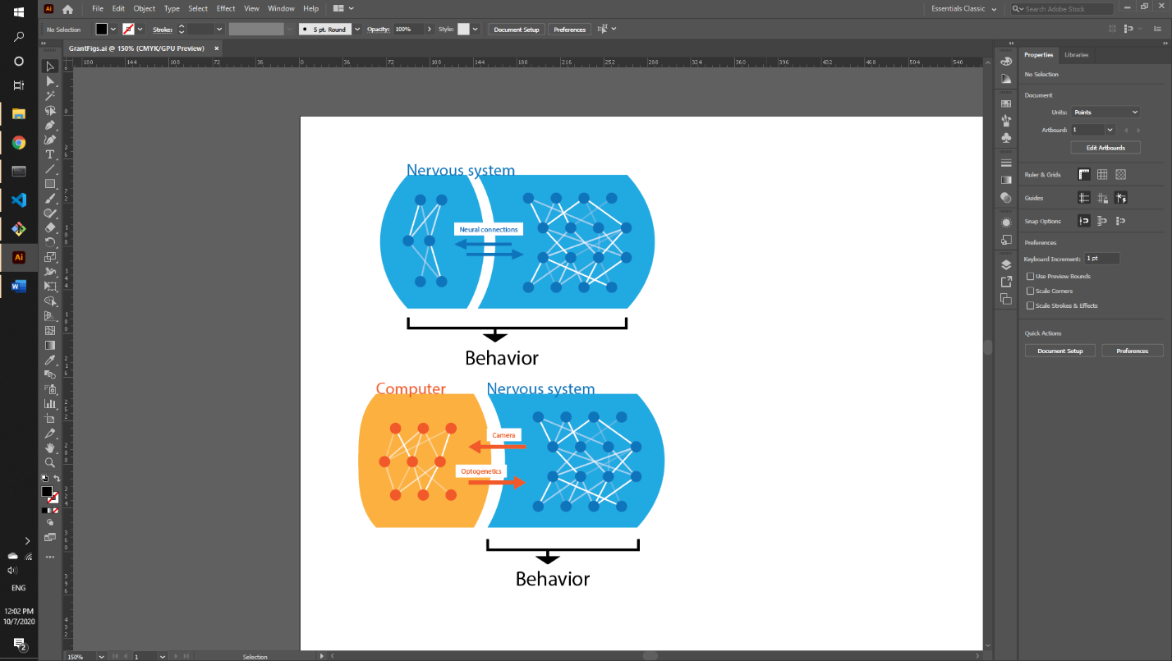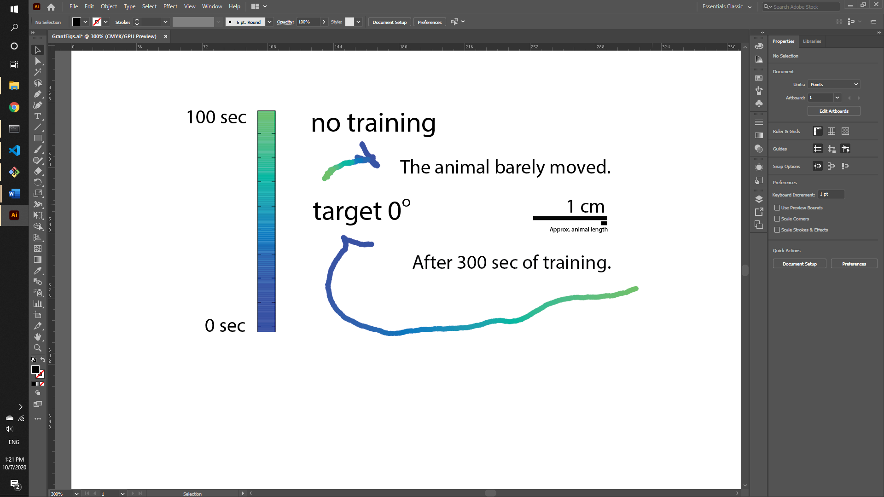

.

**(Top Left)** Nervous system of the animal **(top right)** where a subcircuit has been replaced by an AI network. **(Bottom Left)** Position of an animal as a function of time (time pseudocolored) with an untrained computer agent or **(Bottom Right)** with a trained agent with the goal of making the animal move right.