Testing USB Device with Linux testusb
Guideline to establish Linux testusb environment

Document Information
Application | This document guides how to establish one Linux testusb environment to test USB device

The information described in this document is the exclusive intellectual property of
Nuvoton Technology Corporation and shall not be reproduced without permission from Nuvoton.

Nuvoton is providing this document only for reference purposes of NuMicro microcontroller and microprocessor based system design. Nuvoton assumes no responsibility for errors or omissions.
All data and specifications are subject to change without notice.

For additional information or questions, please contact: Nuvoton Technology Corporation.
www.nuvoton.com

Overview
This document guides how to set up one Linux testusb environment for testing USB device controller and its ported driver for Nuvoton NuMicro family. The testing framework is documented at Test a Linux kernel USB Device Controller driver with testusb and consists of two parts:
- Linux host as test system
This needs one Linux host machine (native or VM) and runs as USB host. On the machine, two programs must be ready:
  - Linux kernel module usbtest
  - Linux user space tool testusb
The Linux Host Environment will walk through setting up the environment.
- USB device as system under test
The USB device must implement Linux Gadget Zero like interface. For Nuvoton NuMicro family, the following platforms can support the test:
  - M460 or friends on Zephyr
For M460 or other Cortex-M based MCUs on Zephyr, the Zephyr source tree has one USB device sample named “testusb” which implements the Linux Gadget Zero like interface, so it can run the test readily.
  - MA35D1 or friends on Linux
For MA35D1 or other Cortex-A based MPUs on Linux, the test needs to extra enable Linux USB Gadget Zero driver via the Linux kernel configuration path below:
Device Drivers ➔ USB support ➔ USB Gadget Support ➔ USB Gadget precomposed configurations ➔ Gadget Zero
Note: The document doesn’t cover how to create the USB device under test in detail. It is related to Zephyr or Embedded Linux development. Ask the related USB driver owner for help.

Linux Host Environment
First, establish Linux host environment. It can be Windows+VirtualBox+Ubuntu or native Ubuntu. This document favors the Windows+VirtualBox+Ubuntu environment for its being feasible establishment on company computers.
- Host operating system: Windows 10 64-bit or later
- VirtualBox

Download Windows hosts version and install
- Ubuntu
Download Ubuntu Desktop ISO image e.g. Ubuntu 26.04 LTS. Choose Intel or AMD 64-bit architecture, not ARM 64-bit architecture.


Install Ubuntu Guest OS
After VirtualBox is installed, the section walks through installation of Ubuntu guest OS on VirtualBox.

- On Windows, launch Oracle VirtualBox
- Click New for creating new VM
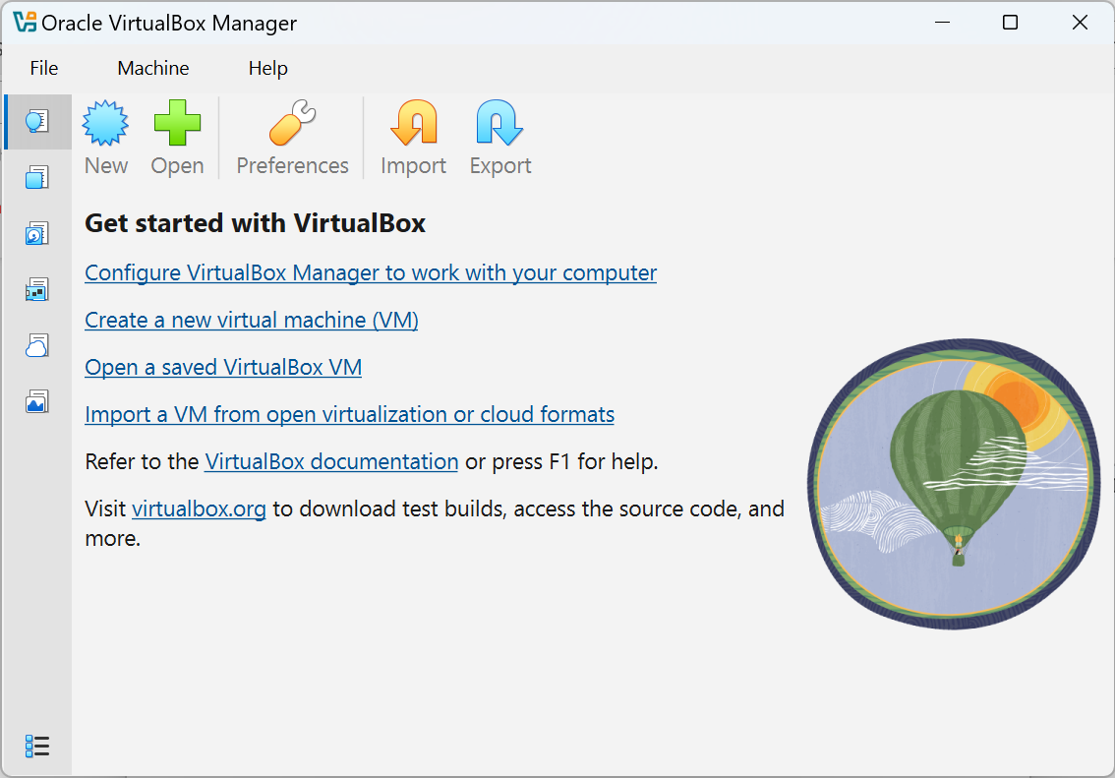
- In New Virtual Machine dialog,
  - Set OS Name to e.g. Ubuntu2604
  - Keep VM Folder unchanged or set it to your preferred path
  - Point ISO Image to above downloaded Ubuntu ISO image path
  - Uncheck Proceed with Unattended installation
  - Click Finish
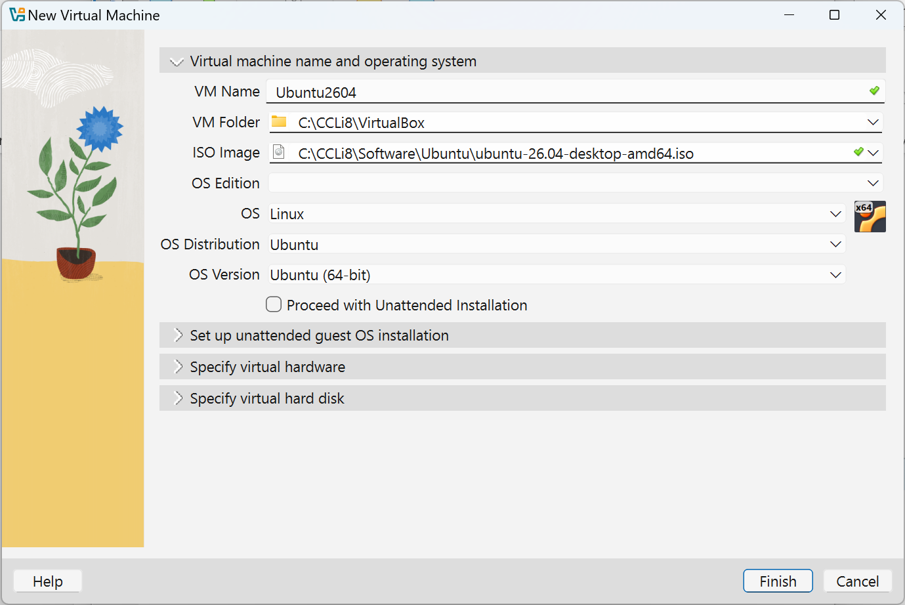
- Repower on VM
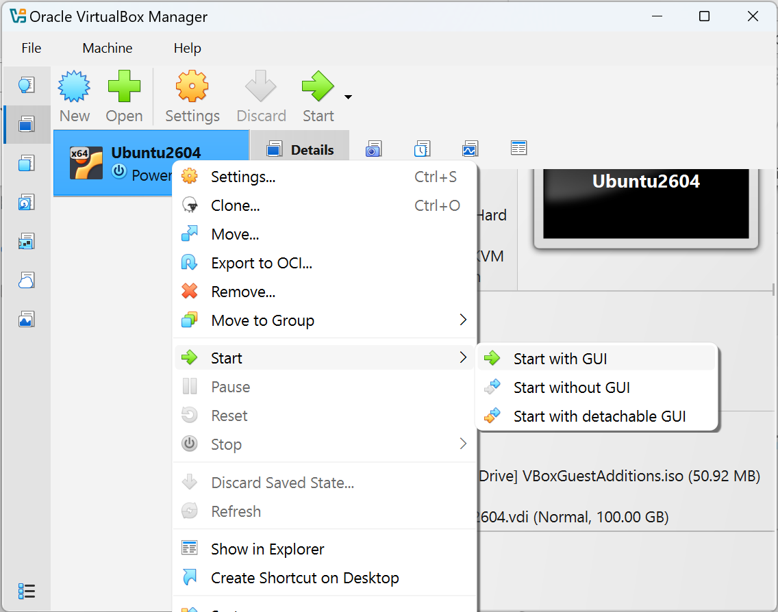
- Install Ubuntu (keep most settings unchanged)
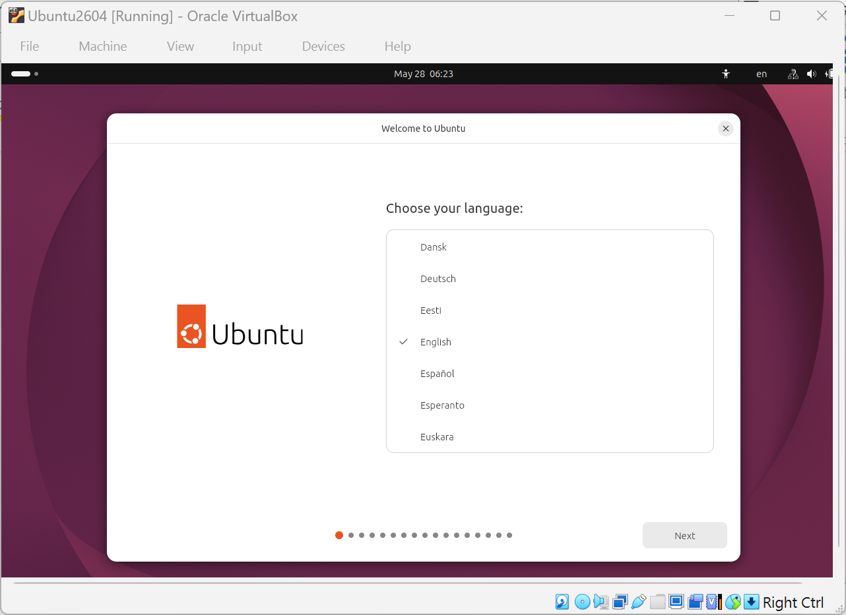
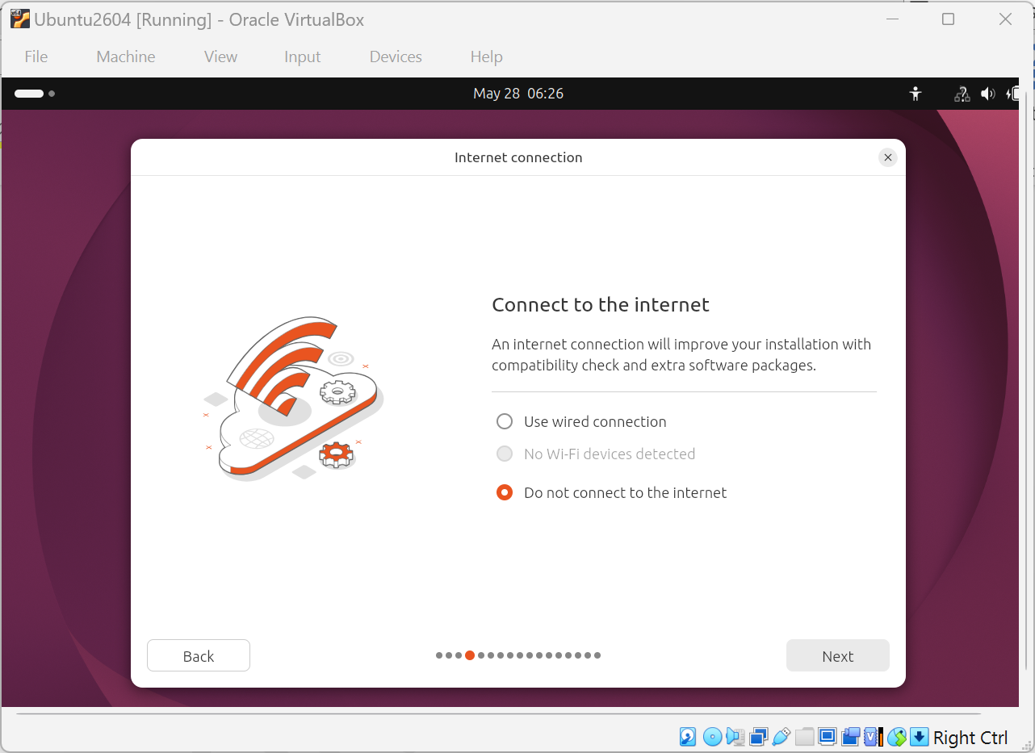
- Installation can be corrupted if internet connection is failed at this stage. Click Do not click to the Internet.
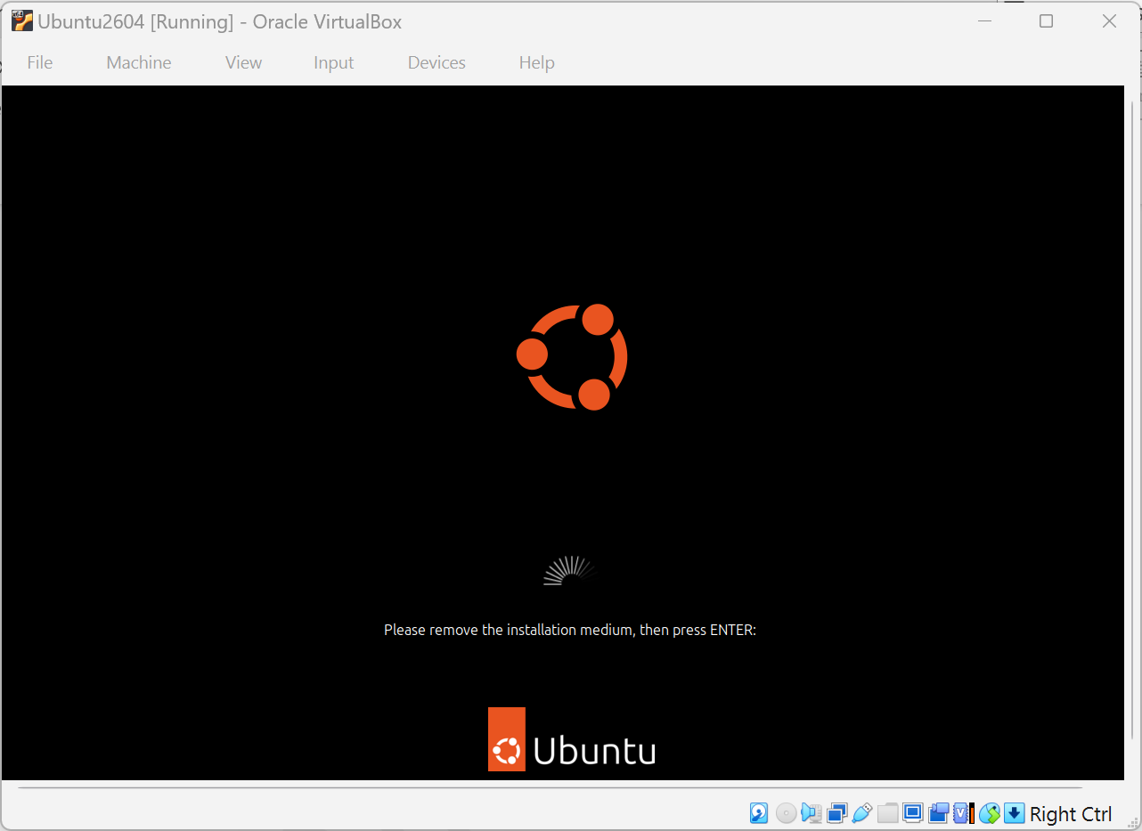
- After installation is completed, restart it Press Enter to continue

Setting up Linux Host Environment
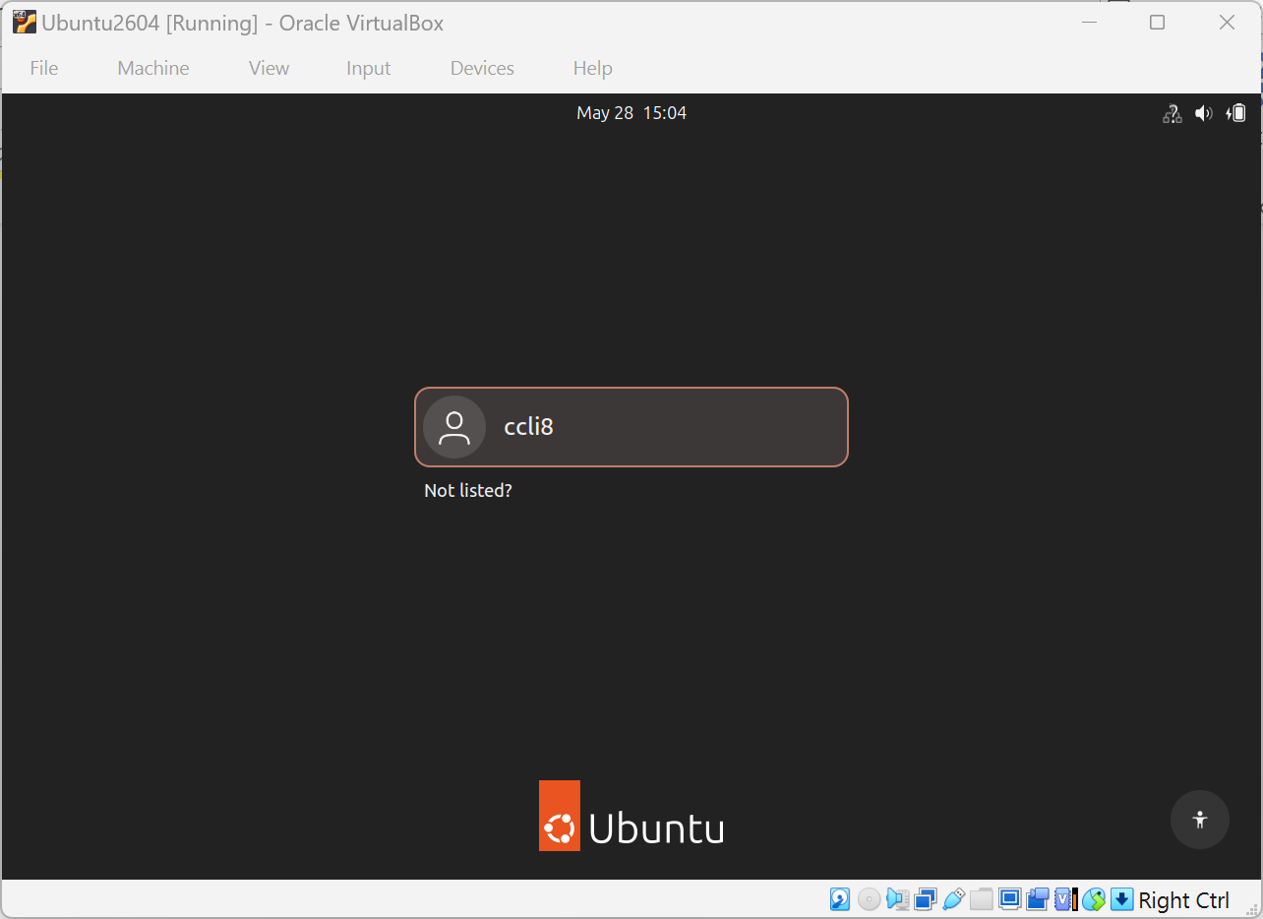
Log on to Ubuntu:
Open one Terminal application and enter it
- Click Show Apps
- Search for Terminal
- Click Terminal

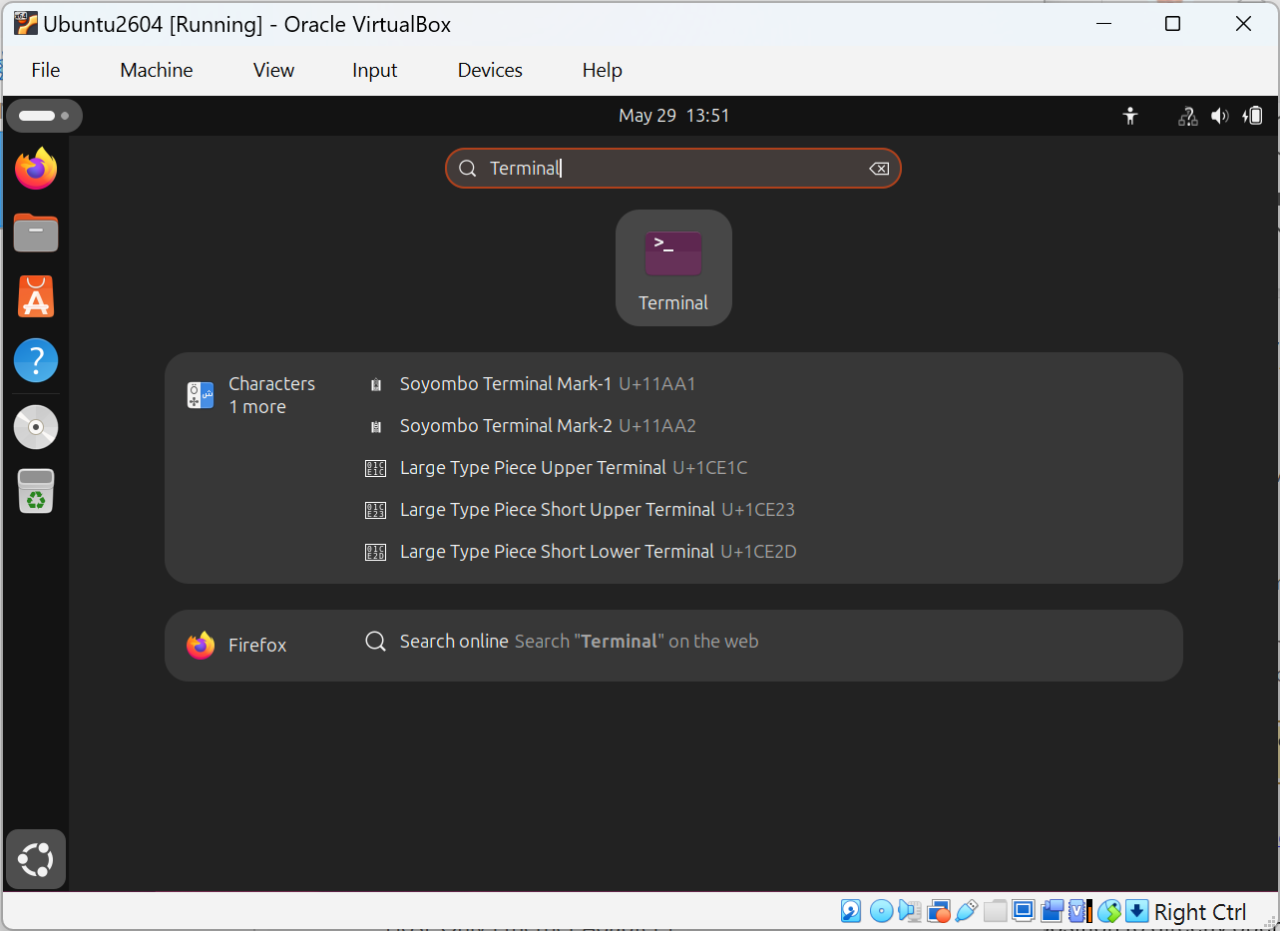
Note: The following operations need internet connection. If your computer is on company intranet, you may fail these operations. Try to switch to another network e.g. phone hot sport.
Update apt package index:
$ cd ~
$ sudo apt update
Download Linux source code. It can be located at /usr/src/Linux-source-<x.y.z>:
$ sudo apt install Linux-source
Unpack Linux source code tarball to home directory:
$ tar -xf /usr/src/linux-source-<x.y.z>/linux-source-<x.y.z>.tar.bz2 -C .
Build testusb tool:
$ cd Linux-source-<x.y.z>/tools/usb/
$ make clean
$ make testusb

Setting up a USB Filter
VirtualBox USB filters allow you to automatically capture physical USB devices plugged into your host machine and route them directly to your virtual machine (guest OS).
Note: At this stage, you need one USB device under test. If you are not the USB driver owner, ask the USB driver owner to prepare one which can support the USB tests mentioned above.
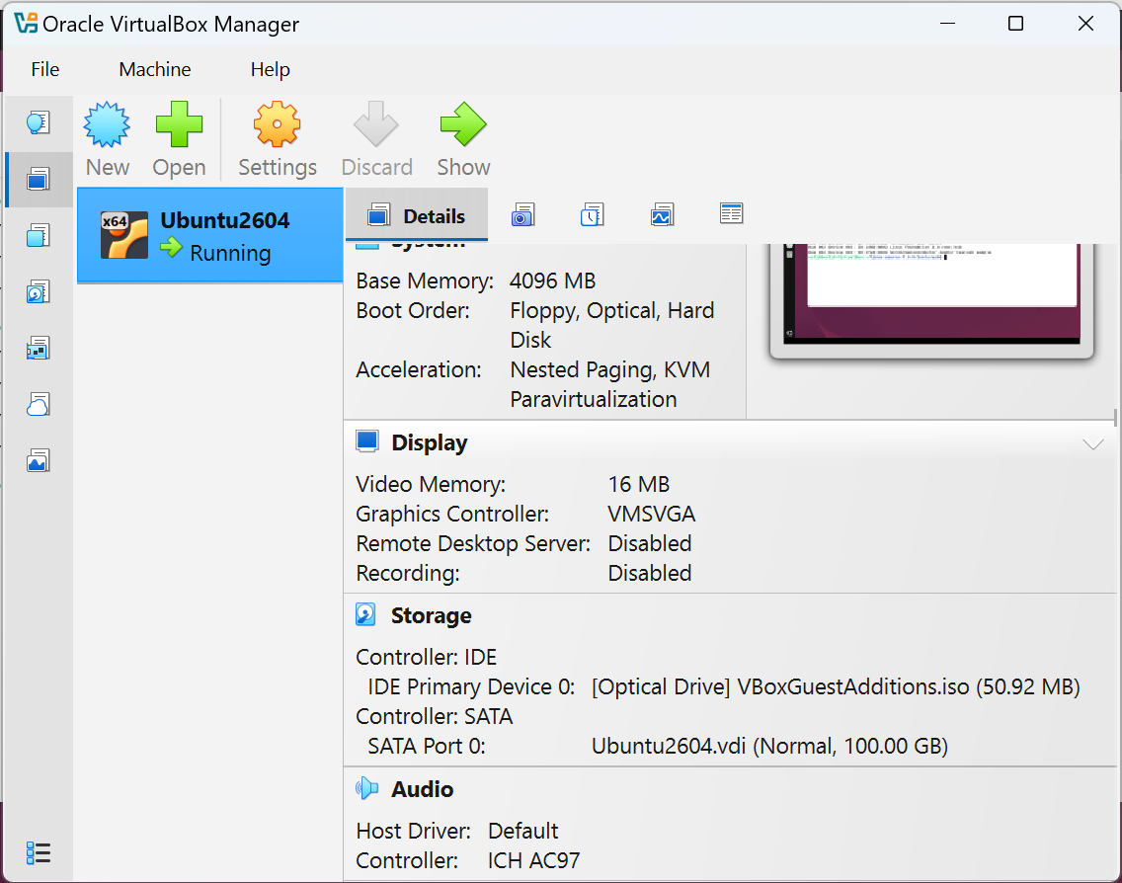
- Click Settings icon:
- In Settings dialog, navigate to USB panel.
  - Plug the USB device under test
  - Click Add new USB filter for the USB device
  - The USB device can have a name like “Zephyr testusb” or “Linux Gzdget Zero”. Click it.
  - The USB device will be added in the USB Device Filters list.
  - Re-plug the USB device
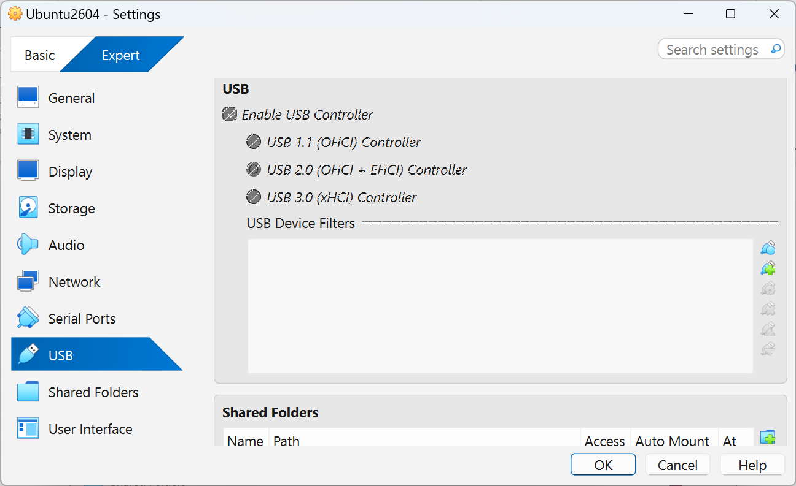
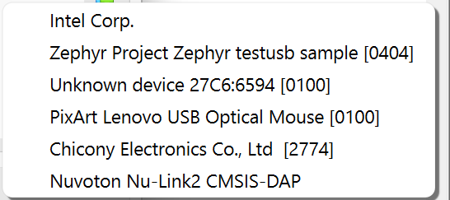
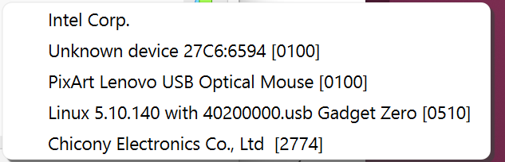

Testing USB Device
After the Linux host environment has settled, the chapter walks through running USB tests.

Running USB tests
Return to Terminal application.
Re-build testusb user space tool: if not yet:
$ cd ~
$ cd Linux-source-<x.y.z>/tools/usb/
$ make clean
$ make testusb
Re-)load usbtest kernel module if not yet:
$ sudo modprobe -r usbtest && sudo modprobe usbtest
Check if usbtest has been loaded successfully:
$ lsmod | grep usbtest
usbtest 49152 0
Check if the USB device under test is successfully recognized. If not, try to re-plug the USB device. Its name would have “Zephyr testusb”:
$ lsusb
Bus 001 Device 001: ID 1d6b:0001 Linux Foundation 1.1 root hub
Bus 001 Device 002: ID 80ee:0021 VirtualBox USB Tablet
Bus 002 Device 001: ID 1d6b:0002 Linux Foundation 2.0 root hub
Bus 002 Device 003: ID 2fe3:0009 Zephyr testusb sample
Or “Linux Gadget Zero”:
$ lsusb
Bus 001 Device 001: ID 1d6b:0001 Linux Foundation 1.1 root hub
Bus 001 Device 002: ID 80ee:0021 VirtualBox USB Tablet
Bus 002 Device 001: ID 1d6b:0002 Linux Foundation 2.0 root hub
Bus 002 Device 003: ID 0525:a4a0 Linux-USB "Gadget Zero"
For “Zephyr testusb” device, its USB VID/PID can be 2fe3/0009, not Gadget Zero’s 0525/a4a0. Map it to Gadget Zero. The step can be skipped for “Linux Gadget Zero” device:
$ sudo sh -c "echo 0x2fe3 0x0009 0 0x0525 0xa4a0 > /sys/bus/usb/drivers/usbtest/new_id"
Make a note of bus number and device number. In this case, bus number is 002 and device number is 003. Note the padding zeros cannot be omitted.
Example: Run test case 1:
$ sudo ./testusb -D /dev/bus/usb/002/003 -t 1
/dev/bus/usb/002/003 test 1, 2.753646 secs
Example: Run all test cases:
$ sudo ./testusb -D /dev/bus/usb/002/003
/dev/bus/usb/002/003 test 0, 0.000008 secs
/dev/bus/usb/002/003 test 1, 2.458935 secs
/dev/bus/usb/002/003 test 2, 2.095423 secs
/dev/bus/usb/002/003 test 3, 2.356359 secs
…
/dev/bus/usb/002/003 test 27, 8.267996 secs
/dev/bus/usb/002/003 test 28, 9.546555 secs
/dev/bus/usb/002/003 test 29, 14.678265 secsTODO

Debugging Test Failure
If there are any test failures like below:
/dev/bus/usb/002/003 test 10 --> 32 (error 32)
The USB driver owner can debug failed test case by:
- Using USB Protocol Analyzer (CATC) to inspect USB bus traffic
- Checking related source code
  - User space tool testusb: linux-source-<x.y.z>/tools/usb/testusb.c
  - Kernel driver usbtest: linux-source-<x.y.z>/drivers/usb/misc/usbtest.c

Known Issues
- verify_still_halted
On VirtualBox Ubuntu VM, the following test cases can be failed. It is caused by USB host which doesn’t re-send to trigger second STALL packet.
/dev/bus/usb/002/003 test 13 --> 22 (error 22)
/dev/bus/usb/002/003 test 14 --> 22 (error 22)
/dev/bus/usb/002/003 test 21 --> 22 (error 22)

Revision History
Date | Revision | Description
2026.06.15 | 0.01 | Initial version.

