Coffee Sales
Claudia Clinchard
2025-08-29
knitr::opts_chunk$set(echo = TRUE)
setwd("~/Desktop/Projects/Coffee_sales")
#load necessary libraries
library(readxl)
library(Hmisc)
##
## Attaching package: 'Hmisc'
## The following objects are masked from 'package:base':
##
## format.pval, units
library(corrplot)
## corrplot 0.95 loaded
library(dplyr)
##
## Attaching package: 'dplyr'
## The following objects are masked from 'package:Hmisc':
##
## src, summarize
## The following objects are masked from 'package:stats':
##
## filter, lag
## The following objects are masked from 'package:base':
##
## intersect, setdiff, setequal, union
library(leaps)
library(ggplot2)
library(car)
## Loading required package: carData
##
## Attaching package: 'car'
## The following object is masked from 'package:dplyr':
##
## recode
#read in data and examine
coffee <- read_excel("Coffee_sales.xlsx") |>
mutate(across(where(is.character), as.factor))
head(coffee)
## # A tibble: 6 × 12
## date datetime hour_of_day cash_type card money
## <dttm> <dttm> <dbl> <fct> <fct> <dbl>
## 1 2024-03-01 00:00:00 2024-03-01 10:15:50 10 card ANON-0000… 38.7
## 2 2024-03-01 00:00:00 2024-03-01 12:19:22 12 card ANON-0000… 38.7
## 3 2024-03-01 00:00:00 2024-03-01 12:20:18 12 card ANON-0000… 38.7
## 4 2024-03-01 00:00:00 2024-03-01 13:46:33 13 card ANON-0000… 28.9
## 5 2024-03-01 00:00:00 2024-03-01 13:48:14 13 card ANON-0000… 38.7
## 6 2024-03-01 00:00:00 2024-03-01 15:39:47 15 card ANON-0000… 33.8
## # ℹ 6 more variables: coffee_name <fct>, Time_of_Day <fct>, Weekday <fct>,
## # Month_name <fct>, Weekdaysort <dbl>, Monthsort <dbl>
colnames(coffee)
## [1] "date" "datetime" "hour_of_day" "cash_type" "card"
## [6] "money" "coffee_name" "Time_of_Day" "Weekday" "Month_name"
## [11] "Weekdaysort" "Monthsort"
Hmisc::describe(coffee) #descriptives
## coffee
##
## 12 Variables 3636 Observations
## --------------------------------------------------------------------------------
## date
## n missing distinct Info Mean pMedian Gmd
## 3636 0 381 1 2024-09-30 1.728e+09 10988019
## .05 .10 .25 .50 .75 .90 .95
## 2024-03-26 2024-04-24 2024-07-03 2024-10-07 2025-01-08 2025-02-26 2025-03-11
##
## lowest : 2024-03-01 2024-03-02 2024-03-03 2024-03-04 2024-03-05
## highest: 2025-03-19 2025-03-20 2025-03-21 2025-03-22 2025-03-23
## --------------------------------------------------------------------------------
## datetime
## n missing distinct Info
## 3636 0 3636 1
## Mean pMedian Gmd .05
## 2024-10-01 02:35:30 1.728e+09 10987103 2024-03-26 18:34:35
## .10 .25 .50 .75
## 2024-04-24 14:39:08 2024-07-03 16:54:06 2024-10-07 02:55:12 2025-01-08 07:55:20
## .90 .95
## 2025-02-26 15:18:43 2025-03-11 10:58:33
##
## lowest : 2024-03-01 10:15:50 2024-03-01 12:19:22 2024-03-01 12:20:18 2024-03-01 13:46:33 2024-03-01 13:48:14
## highest: 2025-03-23 10:34:54 2025-03-23 14:43:37 2025-03-23 14:44:16 2025-03-23 15:47:28 2025-03-23 18:11:38
## --------------------------------------------------------------------------------
## hour_of_day
## n missing distinct Info Mean pMedian Gmd .05
## 3636 0 17 0.995 14.17 14 4.863 8
## .10 .25 .50 .75 .90 .95
## 9 10 14 18 20 21
##
## Value 6 7 8 9 10 11 12 13 14 15 16
## Frequency 5 91 235 247 349 294 249 227 228 245 282
## Proportion 0.001 0.025 0.065 0.068 0.096 0.081 0.068 0.062 0.063 0.067 0.078
##
## Value 17 18 19 20 21 22
## Frequency 245 220 235 171 197 116
## Proportion 0.067 0.061 0.065 0.047 0.054 0.032
##
## For the frequency table, variable is rounded to the nearest 0
## --------------------------------------------------------------------------------
## cash_type
## n missing distinct
## 3636 0 2
##
## Value card cash
## Frequency 3547 89
## Proportion 0.976 0.024
## --------------------------------------------------------------------------------
## card
## n missing distinct
## 3547 89 1316
##
## lowest : ANON-0000-0000-0001 ANON-0000-0000-0002 ANON-0000-0000-0003 ANON-0000-0000-0004 ANON-0000-0000-0005
## highest: ANON-0000-0000-1312 ANON-0000-0000-1313 ANON-0000-0000-1314 ANON-0000-0000-1315 ANON-0000-0000-1316
## --------------------------------------------------------------------------------
## money
## n missing distinct Info Mean pMedian Gmd .05
## 3636 0 20 0.971 31.75 31.84 5.506 23.02
## .10 .25 .50 .75 .90 .95
## 25.96 27.92 32.82 35.76 37.72 37.72
##
## Value 18.12 21.06 23.02 24.00 25.00 25.96 27.92 28.90 29.00 30.00 30.86
## Frequency 36 59 208 14 4 459 334 93 8 11 389
## Proportion 0.010 0.016 0.057 0.004 0.001 0.126 0.092 0.026 0.002 0.003 0.107
##
## Value 32.82 33.80 34.00 35.00 35.76 37.72 38.70 39.00 40.00
## Frequency 490 51 7 8 1014 273 128 18 32
## Proportion 0.135 0.014 0.002 0.002 0.279 0.075 0.035 0.005 0.009
##
## For the frequency table, variable is rounded to the nearest 0
## --------------------------------------------------------------------------------
## coffee_name
## n missing distinct
## 3636 0 8
##
## Americano (578, 0.159), Americano with Milk (824, 0.227), Cappuccino (501,
## 0.138), Cocoa (243, 0.067), Cortado (292, 0.080), Espresso (134, 0.037), Hot
## Chocolate (282, 0.078), Latte (782, 0.215)
## --------------------------------------------------------------------------------
## Time_of_Day
## n missing distinct
## 3636 0 3
##
## Value Afternoon Morning Night
## Frequency 1231 1221 1184
## Proportion 0.339 0.336 0.326
## --------------------------------------------------------------------------------
## Weekday
## n missing distinct
## 3636 0 7
##
## Value Fri Mon Sat Sun Thu Tue Wed
## Frequency 544 561 482 434 520 585 510
## Proportion 0.150 0.154 0.133 0.119 0.143 0.161 0.140
## --------------------------------------------------------------------------------
## Month_name
## n missing distinct
## 3636 0 12
##
## Value Apr Aug Dec Feb Jan Jul Jun Mar May Nov Oct
## Frequency 196 272 259 423 201 237 227 525 267 259 426
## Proportion 0.054 0.075 0.071 0.116 0.055 0.065 0.062 0.144 0.073 0.071 0.117
##
## Value Sep
## Frequency 344
## Proportion 0.095
## --------------------------------------------------------------------------------
## Weekdaysort
## n missing distinct Info Mean pMedian Gmd
## 3636 0 7 0.979 3.848 4 2.257
##
## Value 1 2 3 4 5 6 7
## Frequency 561 585 510 520 544 482 434
## Proportion 0.154 0.161 0.140 0.143 0.150 0.133 0.119
##
## For the frequency table, variable is rounded to the nearest 0
## --------------------------------------------------------------------------------
## Monthsort
## n missing distinct Info Mean pMedian Gmd .05
## 3636 0 12 0.991 6.395 6.5 3.99 1
## .10 .25 .50 .75 .90 .95
## 2 3 6 10 11 12
##
## Value 1 2 3 4 5 6 7 8 9 10 11
## Frequency 201 423 525 196 267 227 237 272 344 426 259
## Proportion 0.055 0.116 0.144 0.054 0.073 0.062 0.065 0.075 0.095 0.117 0.071
##
## Value 12
## Frequency 259
## Proportion 0.071
##
## For the frequency table, variable is rounded to the nearest 0
## --------------------------------------------------------------------------------
str(coffee) #check type
## tibble [3,636 × 12] (S3: tbl_df/tbl/data.frame)
## $ date : POSIXct[1:3636], format: "2024-03-01" "2024-03-01" ...
## $ datetime : POSIXct[1:3636], format: "2024-03-01 10:15:50" "2024-03-01 12:19:22" ...
## $ hour_of_day: num [1:3636] 10 12 12 13 13 15 16 18 19 19 ...
## $ cash_type : Factor w/ 2 levels "card","cash": 1 1 1 1 1 1 1 1 1 1 ...
## $ card : Factor w/ 1316 levels "ANON-0000-0000-0001",..: 1 2 2 3 4 5 6 7 8 8 ...
## $ money : num [1:3636] 38.7 38.7 38.7 28.9 38.7 33.8 38.7 33.8 38.7 33.8 ...
## $ coffee_name: Factor w/ 8 levels "Americano","Americano with Milk",..: 8 7 7 1 8 2 7 2 4 2 ...
## $ Time_of_Day: Factor w/ 3 levels "Afternoon","Morning",..: 2 1 1 1 1 1 1 3 3 3 ...
## $ Weekday : Factor w/ 7 levels "Fri","Mon","Sat",..: 1 1 1 1 1 1 1 1 1 1 ...
## $ Month_name : Factor w/ 12 levels "Apr","Aug","Dec",..: 8 8 8 8 8 8 8 8 8 8 ...
## $ Weekdaysort: num [1:3636] 5 5 5 5 5 5 5 5 5 5 ...
## $ Monthsort : num [1:3636] 3 3 3 3 3 3 3 3 3 3 ...
coffee$hour_of_day <- as.factor(coffee$hour_of_day )
sapply(coffee, nlevels)
## date datetime hour_of_day cash_type card money
## 0 0 17 2 1316 0
## coffee_name Time_of_Day Weekday Month_name Weekdaysort Monthsort
## 8 3 7 12 0 0
# Create bar charts to show proportions
coffee %>%
ggplot(aes(x = coffee_name, y = after_stat(count))) +
geom_bar(fill = "#7B3F00") +
labs(y = "Proportion", x = "Coffee Type")
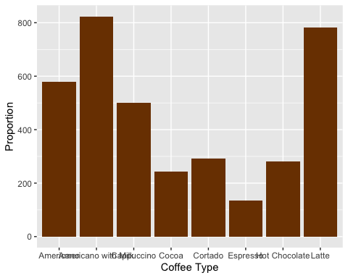
coffee %>%
ggplot(aes(x = hour_of_day, y = after_stat(count))) +
geom_bar(fill = "#A52A2A") +
labs(y = "Proportion", x = "Hour of Day")
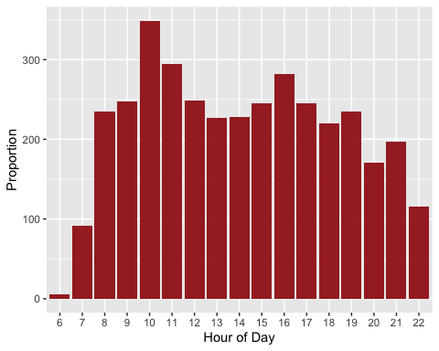
coffee %>%
ggplot(aes(x = cash_type, y = after_stat(count))) +
geom_bar(fill = "#C19A6B") +
labs(y = "Proportion", x = "Cash Type")
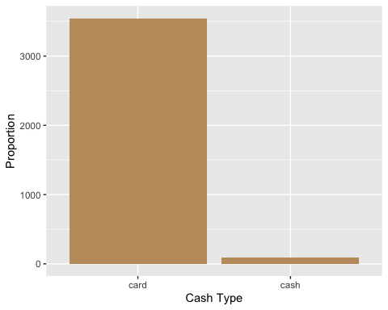
coffee %>%
ggplot(aes(x = Time_of_Day, y = after_stat(count))) +
geom_bar(fill = "#7B3F00") +
labs(y = "Proportion", x = "Time of Day")
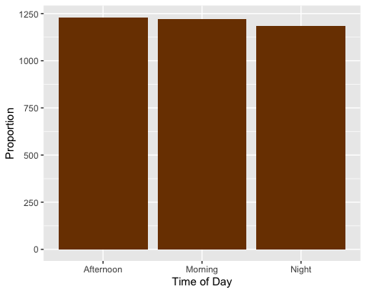
coffee$Weekday <- factor(coffee$Weekday, levels = c("Mon", "Tue", "Wed", "Thu", "Fri", "Sat", "Sun"))
coffee %>%
ggplot(aes(x = Weekday, y = after_stat(count))) +
geom_bar(fill = "#A52A2A") +
labs(y = "Proportion", x = "Weekday")
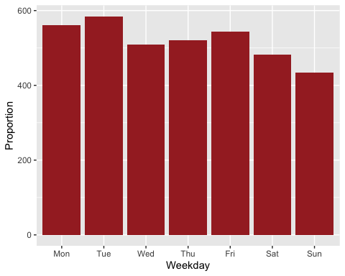
coffee$Month_name <- factor(coffee$Month_name, levels = c("Jan", "Feb", "Mar", "Apr", "May", "Jun", "Jul", "Aug", "Sep", "Oct", "Nov", "Dec"))
coffee %>%
ggplot(aes(x = Month_name, y = after_stat(count))) +
geom_bar(fill = "#A52A2A") +
labs(y = "Proportion", x = "Month")
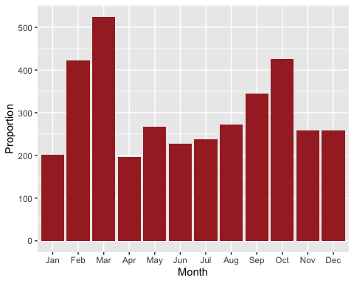
#Q1: What are the most important predictors when it comes to price?
#stepwise regression
full_mod <- lm(money ~ hour_of_day + cash_type + coffee_name + Time_of_Day + Weekday + Month_name, data = coffee)
summary(full_mod)
##
## Call:
## lm(formula = money ~ hour_of_day + cash_type + coffee_name +
## Time_of_Day + Weekday + Month_name, data = coffee)
##
## Residuals:
## Min 1Q Median 3Q Max
## -1.3567 -0.2320 -0.0483 0.1209 4.3153
##
## Coefficients: (2 not defined because of singularities)
## Estimate Std. Error t value Pr(>|t|)
## (Intercept) 25.645216 0.334405 76.689 < 2e-16 ***
## hour_of_day7 0.071920 0.337161 0.213 0.831
## hour_of_day8 0.050867 0.331896 0.153 0.878
## hour_of_day9 -0.048117 0.331707 -0.145 0.885
## hour_of_day10 0.334347 0.330704 1.011 0.312
## hour_of_day11 0.143590 0.331332 0.433 0.665
## hour_of_day12 0.343650 0.331706 1.036 0.300
## hour_of_day13 0.360206 0.331873 1.085 0.278
## hour_of_day14 0.270522 0.331749 0.815 0.415
## hour_of_day15 0.120046 0.331488 0.362 0.717
## hour_of_day16 0.307500 0.331310 0.928 0.353
## hour_of_day17 0.232654 0.331439 0.702 0.483
## hour_of_day18 0.294557 0.332106 0.887 0.375
## hour_of_day19 0.291602 0.332028 0.878 0.380
## hour_of_day20 0.169620 0.333712 0.508 0.611
## hour_of_day21 0.126837 0.333312 0.381 0.704
## hour_of_day22 0.423108 0.335846 1.260 0.208
## cash_typecash 1.964582 0.081920 23.982 < 2e-16 ***
## coffee_nameAmericano with Milk 5.012150 0.040706 123.130 < 2e-16 ***
## coffee_nameCappuccino 9.889347 0.045679 216.495 < 2e-16 ***
## coffee_nameCocoa 9.795944 0.057125 171.481 < 2e-16 ***
## coffee_nameCortado 0.293612 0.053672 5.470 4.8e-08 ***
## coffee_nameEspresso -4.703701 0.070536 -66.685 < 2e-16 ***
## coffee_nameHot Chocolate 9.917046 0.054781 181.030 < 2e-16 ***
## coffee_nameLatte 9.892567 0.041291 239.583 < 2e-16 ***
## Time_of_DayMorning NA NA NA NA
## Time_of_DayNight NA NA NA NA
## WeekdayTue -0.026541 0.043443 -0.611 0.541
## WeekdayWed -0.035230 0.045053 -0.782 0.434
## WeekdayThu -0.040851 0.044772 -0.912 0.362
## WeekdayFri 0.009731 0.044355 0.219 0.826
## WeekdaySat 0.042835 0.045983 0.932 0.352
## WeekdaySun -0.005094 0.047310 -0.108 0.914
## Month_nameFeb 0.028122 0.063605 0.442 0.658
## Month_nameMar 1.118593 0.061499 18.189 < 2e-16 ***
## Month_nameApr 2.467791 0.075238 32.800 < 2e-16 ***
## Month_nameMay 1.885148 0.069117 27.275 < 2e-16 ***
## Month_nameJun 1.947274 0.071755 27.138 < 2e-16 ***
## Month_nameJul -2.284526 0.070524 -32.394 < 2e-16 ***
## Month_nameAug -2.928784 0.068395 -42.822 < 2e-16 ***
## Month_nameSep -2.647035 0.065460 -40.438 < 2e-16 ***
## Month_nameOct 0.016222 0.062915 0.258 0.797
## Month_nameNov 0.001979 0.069245 0.029 0.977
## Month_nameDec -0.009027 0.069112 -0.131 0.896
## ---
## Signif. codes: 0 '***' 0.001 '**' 0.01 '*' 0.05 '.' 0.1 ' ' 1
##
## Residual standard error: 0.7303 on 3594 degrees of freedom
## Multiple R-squared: 0.9782, Adjusted R-squared: 0.978
## F-statistic: 3937 on 41 and 3594 DF, p-value: < 2.2e-16
The NAs for time_of_day indicate a potential multicollinearity, probably with hour of day.
#Perform a Chi-square test
contingency_table_hour_time <- table(coffee$hour_of_day, coffee$Time_of_Day)
contingency_table_hour_time
##
## Afternoon Morning Night
## 6 0 5 0
## 7 0 91 0
## 8 0 235 0
## 9 0 247 0
## 10 0 349 0
## 11 0 294 0
## 12 249 0 0
## 13 227 0 0
## 14 228 0 0
## 15 245 0 0
## 16 282 0 0
## 17 0 0 245
## 18 0 0 220
## 19 0 0 235
## 20 0 0 171
## 21 0 0 197
## 22 0 0 116
chi_square_hour_time <- chisq.test(contingency_table_hour_time)
## Warning in chisq.test(contingency_table_hour_time): Chi-squared approximation
## may be incorrect
chi_square_hour_time
##
## Pearson's Chi-squared test
##
## data: contingency_table_hour_time
## X-squared = 7272, df = 32, p-value < 2.2e-16
#Let's remove hour of day
full_mod2 <- lm(money ~ + cash_type + coffee_name + Weekday + Time_of_Day + Month_name, data = coffee)
summary(full_mod2)
##
## Call:
## lm(formula = money ~ +cash_type + coffee_name + Weekday + Time_of_Day +
## Month_name, data = coffee)
##
## Residuals:
## Min 1Q Median 3Q Max
## -1.3374 -0.2181 -0.0238 0.0841 4.4583
##
## Coefficients:
## Estimate Std. Error t value Pr(>|t|)
## (Intercept) 25.9139422 0.0684211 378.742 < 2e-16 ***
## cash_typecash 1.9802737 0.0823471 24.048 < 2e-16 ***
## coffee_nameAmericano with Milk 5.0057017 0.0408044 122.676 < 2e-16 ***
## coffee_nameCappuccino 9.8830809 0.0458336 215.630 < 2e-16 ***
## coffee_nameCocoa 9.7781591 0.0573313 170.555 < 2e-16 ***
## coffee_nameCortado 0.2853874 0.0539868 5.286 1.32e-07 ***
## coffee_nameEspresso -4.7079629 0.0710491 -66.264 < 2e-16 ***
## coffee_nameHot Chocolate 9.9202282 0.0550183 180.308 < 2e-16 ***
## coffee_nameLatte 9.8891122 0.0413919 238.914 < 2e-16 ***
## WeekdayTue -0.0246388 0.0437592 -0.563 0.573
## WeekdayWed -0.0246380 0.0452819 -0.544 0.586
## WeekdayThu -0.0373324 0.0450740 -0.828 0.408
## WeekdayFri 0.0127268 0.0445290 0.286 0.775
## WeekdaySat 0.0545793 0.0461465 1.183 0.237
## WeekdaySun 0.0068974 0.0474683 0.145 0.884
## Time_of_DayMorning -0.1413870 0.0303413 -4.660 3.28e-06 ***
## Time_of_DayNight -0.0289976 0.0308801 -0.939 0.348
## Month_nameFeb 0.0374102 0.0636929 0.587 0.557
## Month_nameMar 1.1354185 0.0616499 18.417 < 2e-16 ***
## Month_nameApr 2.5134302 0.0751563 33.443 < 2e-16 ***
## Month_nameMay 1.8980183 0.0695500 27.290 < 2e-16 ***
## Month_nameJun 1.9407303 0.0718231 27.021 < 2e-16 ***
## Month_nameJul -2.2735113 0.0710149 -32.015 < 2e-16 ***
## Month_nameAug -2.9331765 0.0688366 -42.611 < 2e-16 ***
## Month_nameSep -2.6505856 0.0658523 -40.250 < 2e-16 ***
## Month_nameOct 0.0157993 0.0633468 0.249 0.803
## Month_nameNov 0.0136413 0.0696321 0.196 0.845
## Month_nameDec 0.0008563 0.0695487 0.012 0.990
## ---
## Signif. codes: 0 '***' 0.001 '**' 0.01 '*' 0.05 '.' 0.1 ' ' 1
##
## Residual standard error: 0.7366 on 3608 degrees of freedom
## Multiple R-squared: 0.9778, Adjusted R-squared: 0.9776
## F-statistic: 5873 on 27 and 3608 DF, p-value: < 2.2e-16
both_step <- step(full_mod2, direction = 'both', scope = formula(full_mod2))
## Start: AIC=-2195.28
## money ~ +cash_type + coffee_name + Weekday + Time_of_Day + Month_name
##
## Df Sum of Sq RSS AIC
## - Weekday 6 3 1960 -2202.0
## <none> 1958 -2195.3
## - Time_of_Day 2 13 1971 -2175.2
## - cash_type 1 314 2271 -1656.7
## - Month_name 11 9136 11094 4090.1
## - coffee_name 7 69509 71466 10871.2
##
## Step: AIC=-2202
## money ~ cash_type + coffee_name + Time_of_Day + Month_name
##
## Df Sum of Sq RSS AIC
## <none> 1960 -2202.0
## + Weekday 6 3 1958 -2195.3
## - Time_of_Day 2 13 1974 -2181.4
## - cash_type 1 315 2276 -1661.9
## - Month_name 11 9144 11104 4081.4
## - coffee_name 7 69609 71570 10864.5
summary(both_step)
##
## Call:
## lm(formula = money ~ cash_type + coffee_name + Time_of_Day +
## Month_name, data = coffee)
##
## Residuals:
## Min 1Q Median 3Q Max
## -1.3779 -0.2104 -0.0323 0.0805 4.4260
##
## Coefficients:
## Estimate Std. Error t value Pr(>|t|)
## (Intercept) 25.914439 0.061813 419.239 < 2e-16 ***
## cash_typecash 1.983629 0.082286 24.106 < 2e-16 ***
## coffee_nameAmericano with Milk 5.006651 0.040735 122.908 < 2e-16 ***
## coffee_nameCappuccino 9.883933 0.045764 215.976 < 2e-16 ***
## coffee_nameCocoa 9.778838 0.057181 171.015 < 2e-16 ***
## coffee_nameCortado 0.288743 0.053864 5.361 8.82e-08 ***
## coffee_nameEspresso -4.712276 0.070935 -66.431 < 2e-16 ***
## coffee_nameHot Chocolate 9.918291 0.054940 180.529 < 2e-16 ***
## coffee_nameLatte 9.888638 0.041367 239.048 < 2e-16 ***
## Time_of_DayMorning -0.144187 0.030230 -4.770 1.92e-06 ***
## Time_of_DayNight -0.034801 0.030741 -1.132 0.258
## Month_nameFeb 0.032814 0.063534 0.516 0.606
## Month_nameMar 1.134756 0.061584 18.426 < 2e-16 ***
## Month_nameApr 2.513781 0.075035 33.501 < 2e-16 ***
## Month_nameMay 1.893257 0.069415 27.275 < 2e-16 ***
## Month_nameJun 1.942431 0.071607 27.126 < 2e-16 ***
## Month_nameJul -2.276208 0.070836 -32.134 < 2e-16 ***
## Month_nameAug -2.931563 0.068703 -42.670 < 2e-16 ***
## Month_nameSep -2.649189 0.065580 -40.396 < 2e-16 ***
## Month_nameOct 0.011780 0.063205 0.186 0.852
## Month_nameNov 0.018451 0.069508 0.265 0.791
## Month_nameDec 0.002605 0.069300 0.038 0.970
## ---
## Signif. codes: 0 '***' 0.001 '**' 0.01 '*' 0.05 '.' 0.1 ' ' 1
##
## Residual standard error: 0.7365 on 3614 degrees of freedom
## Multiple R-squared: 0.9777, Adjusted R-squared: 0.9776
## F-statistic: 7552 on 21 and 3614 DF, p-value: < 2.2e-16
red_mod <- lm(money ~ cash_type + coffee_name + Time_of_Day +
Month_name, data = coffee)
summary(red_mod)
##
## Call:
## lm(formula = money ~ cash_type + coffee_name + Time_of_Day +
## Month_name, data = coffee)
##
## Residuals:
## Min 1Q Median 3Q Max
## -1.3779 -0.2104 -0.0323 0.0805 4.4260
##
## Coefficients:
## Estimate Std. Error t value Pr(>|t|)
## (Intercept) 25.914439 0.061813 419.239 < 2e-16 ***
## cash_typecash 1.983629 0.082286 24.106 < 2e-16 ***
## coffee_nameAmericano with Milk 5.006651 0.040735 122.908 < 2e-16 ***
## coffee_nameCappuccino 9.883933 0.045764 215.976 < 2e-16 ***
## coffee_nameCocoa 9.778838 0.057181 171.015 < 2e-16 ***
## coffee_nameCortado 0.288743 0.053864 5.361 8.82e-08 ***
## coffee_nameEspresso -4.712276 0.070935 -66.431 < 2e-16 ***
## coffee_nameHot Chocolate 9.918291 0.054940 180.529 < 2e-16 ***
## coffee_nameLatte 9.888638 0.041367 239.048 < 2e-16 ***
## Time_of_DayMorning -0.144187 0.030230 -4.770 1.92e-06 ***
## Time_of_DayNight -0.034801 0.030741 -1.132 0.258
## Month_nameFeb 0.032814 0.063534 0.516 0.606
## Month_nameMar 1.134756 0.061584 18.426 < 2e-16 ***
## Month_nameApr 2.513781 0.075035 33.501 < 2e-16 ***
## Month_nameMay 1.893257 0.069415 27.275 < 2e-16 ***
## Month_nameJun 1.942431 0.071607 27.126 < 2e-16 ***
## Month_nameJul -2.276208 0.070836 -32.134 < 2e-16 ***
## Month_nameAug -2.931563 0.068703 -42.670 < 2e-16 ***
## Month_nameSep -2.649189 0.065580 -40.396 < 2e-16 ***
## Month_nameOct 0.011780 0.063205 0.186 0.852
## Month_nameNov 0.018451 0.069508 0.265 0.791
## Month_nameDec 0.002605 0.069300 0.038 0.970
## ---
## Signif. codes: 0 '***' 0.001 '**' 0.01 '*' 0.05 '.' 0.1 ' ' 1
##
## Residual standard error: 0.7365 on 3614 degrees of freedom
## Multiple R-squared: 0.9777, Adjusted R-squared: 0.9776
## F-statistic: 7552 on 21 and 3614 DF, p-value: < 2.2e-16
AIC(full_mod2)
## [1] 8125.239
AIC(red_mod)
## [1] 8118.52
#To answer Q3
modpred <- lm(money ~ hour_of_day + Weekday, data = coffee)
summary(modpred)
##
## Call:
## lm(formula = money ~ hour_of_day + Weekday, data = coffee)
##
## Residuals:
## Min 1Q Median 3Q Max
## -15.0469 -3.9076 0.7681 3.6993 10.1282
##
## Coefficients:
## Estimate Std. Error t value Pr(>|t|)
## (Intercept) 29.91932 2.14989 13.917 <2e-16 ***
## hour_of_day7 2.55819 2.20364 1.161 0.2458
## hour_of_day8 0.08776 2.16837 0.040 0.9677
## hour_of_day9 0.31595 2.16740 0.146 0.8841
## hour_of_day10 1.74875 2.16203 0.809 0.4187
## hour_of_day11 0.35690 2.16539 0.165 0.8691
## hour_of_day12 1.04782 2.16843 0.483 0.6290
## hour_of_day13 1.58026 2.17016 0.728 0.4666
## hour_of_day14 2.09163 2.16967 0.964 0.3351
## hour_of_day15 2.03518 2.16819 0.939 0.3480
## hour_of_day16 2.83247 2.16561 1.308 0.1910
## hour_of_day17 2.74605 2.16801 1.267 0.2054
## hour_of_day18 3.12789 2.17081 1.441 0.1497
## hour_of_day19 4.16844 2.16954 1.921 0.0548 .
## hour_of_day20 3.34706 2.17845 1.536 0.1245
## hour_of_day21 3.08302 2.17453 1.418 0.1563
## hour_of_day22 2.54123 2.19101 1.160 0.2462
## WeekdayTue -0.09947 0.28378 -0.351 0.7260
## WeekdayWed -0.40866 0.29420 -1.389 0.1649
## WeekdayThu -0.40446 0.29244 -1.383 0.1667
## WeekdayFri -0.06553 0.28971 -0.226 0.8211
## WeekdaySat -0.24108 0.29963 -0.805 0.4211
## WeekdaySun 0.04178 0.30832 0.136 0.8922
## ---
## Signif. codes: 0 '***' 0.001 '**' 0.01 '*' 0.05 '.' 0.1 ' ' 1
##
## Residual standard error: 4.792 on 3613 degrees of freedom
## Multiple R-squared: 0.05724, Adjusted R-squared: 0.0515
## F-statistic: 9.972 on 22 and 3613 DF, p-value: < 2.2e-16

