**Лабораторная работа №11**

**ЗАПРОСЫ НА ОБЪЕДЕНЕНИЕ И ФУНКЦИЯ COUNT.**

1. Вывести информацию о продуктах, которые поставлялись двумя и более мастерами.

Листинг 1 – Вывод информации

USE SUPIR;

WITH products_masters AS (

SELECT DISTINCT

p.p_id,

p.p_name,

m.m_id,

m.m_name

FROM products p

JOIN supplies s ON s.s_product = p.p_id

JOIN masters m ON m.m_id = s.s_master

)

SELECT

p_m.p_id,

p_m.p_name,

COUNT(p_m.m_id) AS master_count,

STRING_AGG(p_m.m_name, ', ') WITHIN GROUP (ORDER BY p_m.m_name) AS [master(s)]

FROM products_masters p_m

GROUP BY p_m.p_id, p_m.p_name

HAVING COUNT(p_m.m_id) > 1

ORDER BY p_m.p_id

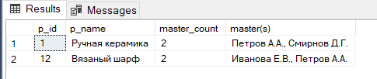

Рис. 1 – Вывод информации

1. Вывести информацию о количестве продуктов на складе.

Листинг 2 – Вывод информации

USE SUPIR;

WITH count_products AS

(

SELECT

p.p_id,

p.p_name,

SUM(s.s_quantity) AS sypplies_quantity,

SUM(m2m.p_o_quantity) AS sell_quantity

FROM supplies s

FULL JOIN products p ON p.p_id = s.s_product

FULL JOIN m2m_products_orders m2m ON m2m.p_id = p.p_id

GROUP BY p.p_name, p.p_id

)

SELECT

c_p.p_id,

c_p.p_name,

(ISNULL(c_p.sypplies_quantity, 0) - ISNULL(c_p.sell_quantity, 0)) AS product_in_stoks

FROM count_products c_p

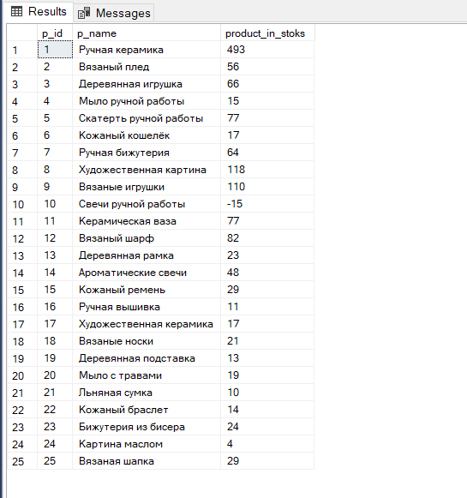

Рис. 2 – Вывод информации

1. Вывести информацию о количестве поставок каждым мастером.

Листинг 3 – Вывод информации

USE SUPIR;

SELECT

m.m_id,

m.m_name,

COUNT(s.s_master) AS supplies

FROM supplies s

JOIN masters m ON m.m_id = s.s_master

GROUP BY m.m_id, m.m_name

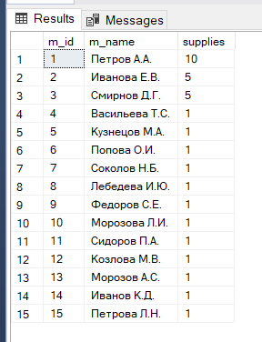

Рис. 3 – Вывод информации