**Лабораторная работа №13**

**ЗАПРОСЫ НА ОБЪЕДЕНЕНИЕ.**

**ПОИСК МИНИМУМА, МАКСИМУМА, ДИАПАЗОНОВ.**

1. Вывести информацию о мастере, который первым сделал поставку.

Листинг 1 – Вывод информации

USE SUPIR;

SELECT

m.m_name

FROM masters m

WHERE m.m_id =

(

SELECT

s.s_master

FROM supplies s

WHERE s.s_id =

(

SELECT

MIN(s.s_id)

FROM supplies s

)

)

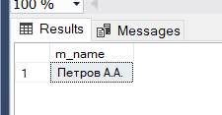

Рис. 1 – Вывод информации

1. Вывести информацию о клиенте(клиентах), который(которые) быстрее всех получил(и) свой заказ.

Листинг 2 – Вывод информации

USE SUPIR;

WITH speed_of_delivery AS

(

SELECT

o.o_id,

c.c_name AS Client,

DATEDIFF(day, o.o_date, o.o_date_finish) AS delivery_days,

RANK() OVER

(

ORDER BY

DATEDIFF(day, o.o_date, o.o_date_finish) ASC

) AS rank

FROM orders o

JOIN customers c ON c.c_id = o.o_client

WHERE o.o_status = 'Y'

)

SELECT

sd.o_id,

sd.Client,

sd.delivery_days AS [days]

FROM speed_of_delivery sd

WHERE rank = 1

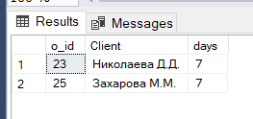

Рис. 2 – Вывод информации

1. Вывести информацию о продукте (продуктах), который(которые) каждый клиент заказывал в свой первый раз.

Листинг 3 – Вывод информации

USE SUPIR;

WITH step_1 AS

(

SELECT

o.o_client,

MIN(o.o_date) AS [o_date]

FROM orders o

JOIN customers c ON c.c_id = o.o_client

GROUP BY o.o_client

),

step_2 AS

(

SELECT

o.o_client,

p.p_name,

o.o_date

FROM orders o

JOIN m2m_products_orders m2m ON m2m.o_id = o.o_id

JOIN products p ON p.p_id = m2m.p_id

LEFT JOIN step_1 s1 ON o.o_client = s1.o_client AND o.o_date = s1.o_date

)

SELECT

s2.o_client,

c.c_name,

STRING_AGG(s2.p_name, ', ') AS products,

s2.o_date

FROM customers c

JOIN step_2 s2 ON c.c_id = s2.o_client

GROUP BY s2.o_client, c.c_name, s2.o_date

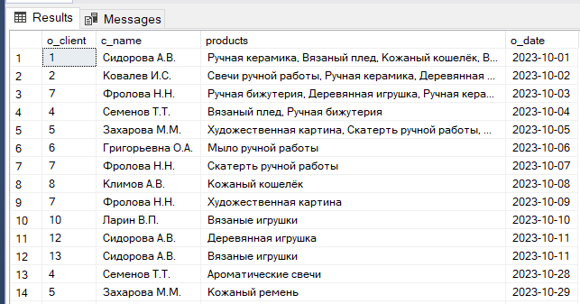

Рис. 3 – Вывод информации

1. Вывести информацию о продукте (продуктах), который(которые) каждый клиент заказывал в последний раз.

Листинг 4 – Вывод информации

USE SUPIR;

WITH step_1 AS

(

SELECT

o.o_client,

o.o_date,

ROW_NUMBER() OVER (PARTITION BY o.o_client ORDER BY o.o_date DESC) AS order_rank

FROM orders o

JOIN customers c ON c.c_id = o.o_client

GROUP BY o.o_client, o.o_date

),

step_2 AS

(

SELECT

s1.o_client,

s1.o_date,

s1.order_rank

FROM step_1 s1

WHERE s1.order_rank = 1

)

SELECT

c.c_name,

s2.o_client,

STRING_AGG(p.p_name, ', '),

s2.o_date

FROM customers c

JOIN step_2 s2 ON s2.o_client = c.c_id

JOIN orders o ON o.o_client = c.c_id

JOIN m2m_products_orders m2m ON m2m.o_id = o.o_id

JOIN products p ON p.p_id = m2m.p_id

GROUP BY c.c_name, s2.o_client, s2.o_date

ORDER BY o_client

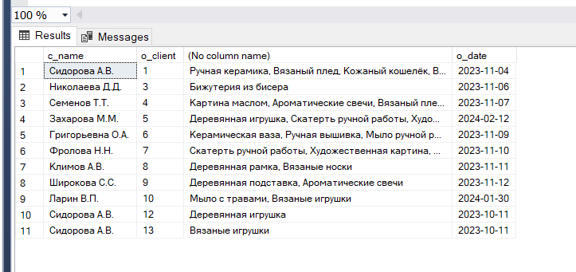

Рис. 4 – Вывод информации