

CCL Localizer
Reference Manual

© 2023 CCL Software Licensing GmbH. All Rights Reserved.

Introduction

CCL Localizer is a simple translations editor, specifically tailored for editing string tables used with localization of applications based on the CCL Cross-platform Framework. It primarily supports the workflow and file formats of GNU gettext, as well as simple text files.

For more information on CCL, please see https://ccl.dev.
For more information on GNU gettext, please refer to https://www.gnu.org/software/gettext/.

This manual is targeted to translators already familiar with the basic concepts of software localization.

Besides translation editing, CCL Localizer can also create language packs, which contain all resources for a language in a single file. Support for a new language can be tested simply by putting the .langpack file in the "languages" subfolder of the program, without having to recompile or reinstall it.

The CCL Localizer Window

After launching CCL Localizer its main window appears. The main parts are Files List, Context List, String List and the Edit/Search area.

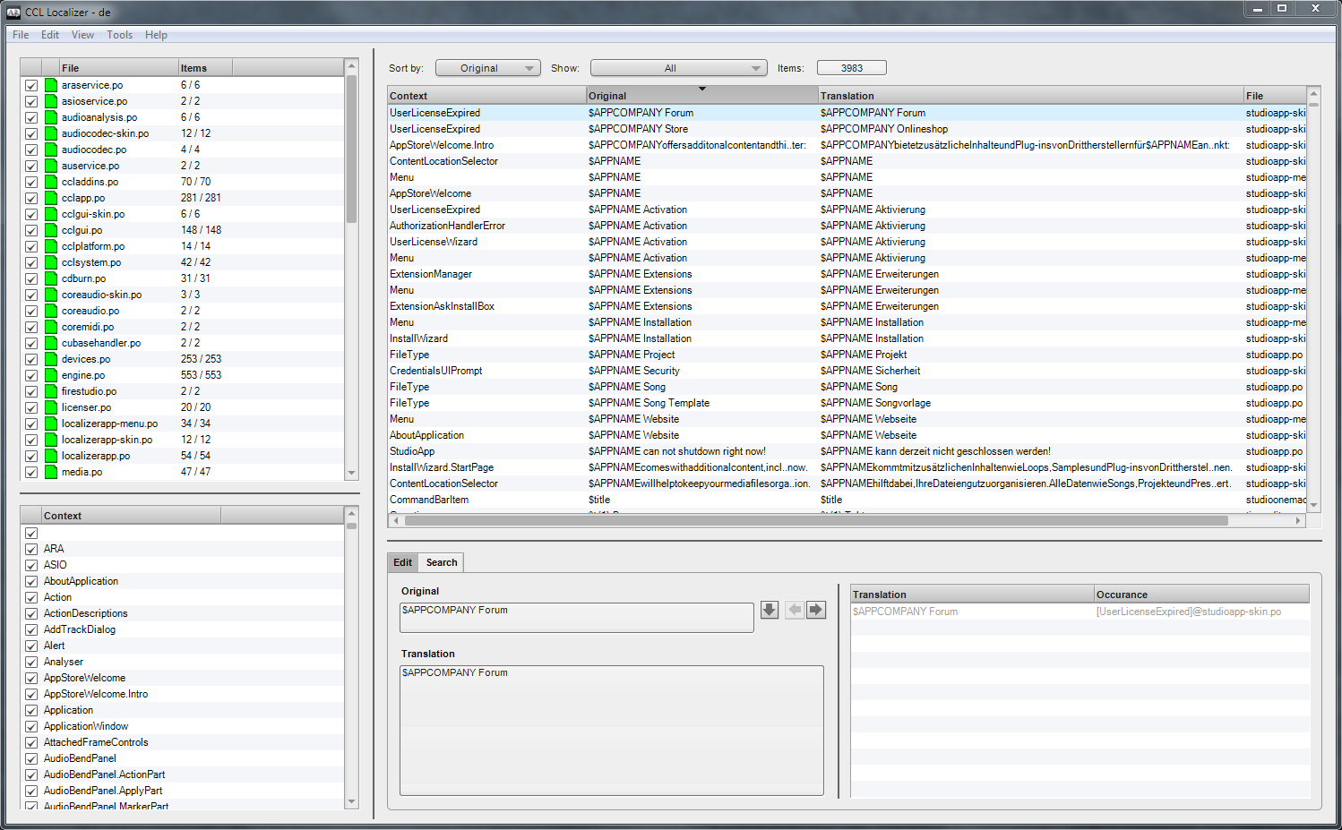
The Files List

Use File/Open to open an .lzproject, .po, or .txt file for editing. Alternatively, choose File/Open Folder from the main menu to open a folder with .po or .txt files. The Files List will be populated with all files found in the folder or referenced from the project, and show a statistics of how many items per file are translated already.

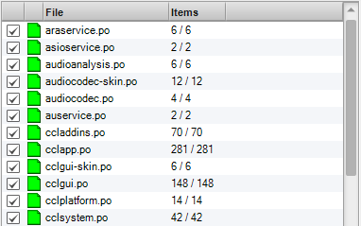
The icon next to the file name indicates the file state:
    - green = all strings translated
    - yellow = some strings not translated
    - asterisk = file has been modified but not saved

When files have been modified, please note that choosing File/Save from the main menu will save all files at once.

The Files List can be used to filter the items displayed in the String List on a per-file basis. Double-click on a filename to show its items exclusively or use the check marks either with single-click or Alt/Option-click to set the desired filters. The filter can be reset either with the View/Reset Filter command or by right-clicking and choosing "Reset Filter" from the contextual menu.

The Context List

The Context List shows the available context identifiers depending on which files are currently loaded and activated in the Files List. A context string defines where a specific translation is used in the program and it also helps with disambiguation in the target language when the same English original needs different translations.

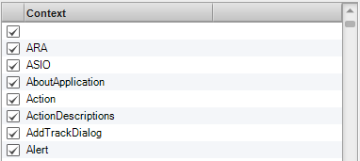
The Context List can also be used as a filter in the same way as the file list to narrow down the items displayed in the string list.

The String List

The String List shows all items for translation in a flat view, depending on the filters defined in the Files and Context Lists. It can be filtered and sorted further in various ways. Translations can be edited directly in the String List via double-click and you can navigate between items with the cursor and Tab keys. The focused item is always displayed in the Edit Area.

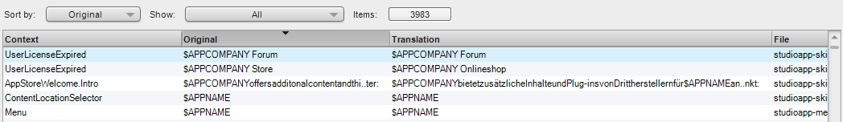
The preferred view when working on translations incrementally, is to show untranslated and orphaned items. Orphaned items occur when an English original which has been translated before was changed or has been removed from the program. They appear in red text color in the String List. After review, orphaned items can be removed permanently from all files by using the Edit/Cleanup command.

When an item has been modified but the file was not saved yet, the text color of this item changes to blue. Additionally, if the current filter would cause the item to go out of view immediately after editing, it is kept visible until the file has been saved.

 | To copy translated text between items, simply drag-and-drop them onto each other.

The Edit Area

The Edit Area shows a multiline view of the item currently focused in the String List, as well as navigation arrows to copy the English original to the translation and to focus the next/previous item. These commands are also available in the main Edit menu.

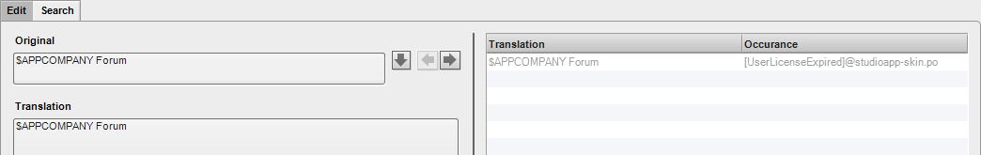
On the right side, a list shows occurances of the same English original in all available contexts. This helps to create a more consistent translation. Similar to the String List, items can be copied via drag-and-drop. A double-click will focus the item in the main String List.

The Edit Area can be flipped to a search field with several options. The items matching the search terms will be listed below. It features the usual drag-and-drop and double click behavior as the other list views.

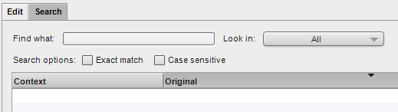

When editing translations the English original often contains placeholders like "%(1)", "$APPNAME", "@cmd.title[Edit|Copy]", "@value[]" or espaced character like "\n", etc. This placeholders need to be preserved in their correct form in the translated text. The order of arguments like "%(1)" can be changed to accommodate to the grammer rules of the target language.

The File Menu Functions

Open | Open .lzproject, .po, or .txt file
Open Folder | Open a folder with .po or .txt files
Save | Save all modified files
Save As | Save a copy of all currently open files to a new folder
Revert | Revert all files to their state on disk
Close | Close all files
Update | Update loaded .po files from templates. A folder containing the .pot template files needs to be selected. Files will be matched by name, i.e. xyz.po will be updated with xyz.pot.
Compile All | Create binary .mo files for all loaded .po files in the same folder
Import | Import translations from file. All currently loaded items with a matching context and English original will be updated with the translation loaded from the chosen file.
Export | Export all items currently visible in the String List to a new .po file. The import/export functions can be used to send a subset of the whole translations project to a translator when e.g. only items that changed between program versions need to be worked on.
Recent Files | List of recently opened files and folders for quick access
Quit | Quit the CCL Localizer

Please note that when editing .txt files with CCL Localizer, the file name will be displayed in the original column and the file content in the translation column. The content of the file will be replaced during the translation process. If the .txt file does not contain a BOM (Byte Order Mark) UTF-8 encoding will be assumed.

The Edit Menu Functions

Undo / Redo | Undo/redo last translation
Copy / Paste | Copy/paste selected translation
Set To Original | Set translation of focused item to the English original
Autocomplete | Fill untranslated items with existing translations sharing the same English original but in a different context. Be careful when using this function as the existing translation might not fit in another context!
Strip Context | Legacy versions of the CCL framework prepend the context identifier to the English original in square brackets when saving files in PO format*, which must not be repeated in the translated text. This is transparent to the translator when working with CCL Localizer, but not with other localization tools. The Strip Context functions removes any accidentally repeated context identifier from the translation.  Current versions of the CCL framework export the context identifier via the PO msgctxt attribute which separates it from the English original in the PO file on message level. The msgctxt attribute is supported by most localization tools. This should prevent it from being accidentally included or repeated in the translation.
Cleanup | Remove orphaned items from all files
Pseudo-Localization | This set of functions allows to create pseudo translations by decorating the English original or the existing translations with special Unicode characters readable to English speakers for testing purpose.

The View Menu Functions

Filter by Context | Set the context filter to all context identifiers found in the currently selected items of the string list.
Filter by File | Set the files filter to all files found in the currently selected items of the String List.
Reset Filter | Reset all filters completely
Previous / Next Item | Navigate between items in String List

The Tools Menu

Build Language Pack | Create a language pack. For this function to work, you need the required build files provided by the application vendor. All currently open files will be compiled first as most of the time the language pack will be built for the translations currently being worked on.

The Application Menu

Appearance | Switch between Dark and Light Mode
Language | Select the application language for CCL Localizer

The Help Menu

Contents | Brings up this reference manual
About* | Show version and copyright information of CCL Localizer

* On macOS, these menu items are available from the application menu.
Frequently Asked Questions

Q: I have updated the .langpack file in the program "languages" folder, but some of my new translations do not show up in the program.

A: The program might cache some translated strings in its settings files. Please increment the "LanguagePack:Revision" number in the metainfo.xml file of your language pack. Alternatively, you can open the settings folder of the program and delete "x86/Plugins-xx.settings" and "x64/Plugins-xx.settings" (xx is the language code).

Appendix A – Description of "Navigation" commands for translators

Important concepts for understanding the navigation commands are the focus item (the item at the current navigation position) and the selection. In a File Explorer/Finder-like browser view, selected items appear with a highlighted background color, while the focus item is marked with a dotted rectangle.

A navigation command starts with a direction, optionally followed by options.

These commands usually move the focus item in the given direction. Possible directions are Left, Right, Up, Down, Page up, Page Down, Start, End.

The options determine how the selection changes:

(none): selects only the new focus item
Extend: selects a range of items between the old and the new focus item
Add: all previously selected items stay selected
Skip: selection is not changed at all, only the focus item moves

With these commands you can make a non-contiguous selection without using the mouse, e.g. select a range of items (extend), skip over some some items and add another range (extend add).

