A Report
On

Simulation of 2D Ising Model

By
Angad Singh Gill
ID No. 2005S5P3460
&
C Hanuma Chaitanya
ID No. 2005S5P3755

A report submitted in the partial fulfillment of the requirements of
Physics Project Lab

15 March 2007
Birla Institute of Technology and Science, Pilani – Goa Campus

Acknowledgement

I would like to thank Dr. Raghunath Ratabole and Dr. Toby Joseph for encouraging us to undertake this project, for the all the help and guidance given to write this report. I specially wish to thank the librarian without whose cooperation this report would not have been possible.

Abstract

The part of the project taken up under Physics Project Lab covered in this report consists of ‘Simulation of 2D Ising Model’. This report documents the results and plots obtained after running the simulations. The algorithm used was Metropolis-Hastings Monte Carlo Algorithm and the coding was done in C.

Table of Contents

Acknowledgement
Abstract

- Introduction 1

- Magnetic Materials 2
- Ferromanetism
- Paramagnetism

3. Phase Transition 3
- Modern Classification of phase transition
- Properties of phase transitions
- Critical exponents and universality classes

4. Ising Model 5

5. Monte Carlo Methods 7

6. Metropolis Hastings Algorithm 7

7. The Algorithm 8

8. The Plots 9

9. Conclusion 13

Appendix 14
The Code
List of References 19

Introduction

The part of the project taken up under Physics Project Lab covered in this report consists of ‘Simulation of 2D Ising Model’. This report documents the results and plots obtained after running the simulations. The algorithm used was Metropolis-Hastings Monte Carlo Algorithm and the coding was done in C.

Magnetic Materials

Ferromagnetism

Ferromagnetism is the phenomenon by which materials, such as iron, in an external magnetic field become magnetized and remain magnetized after the material is no longer in the field.

Paramagnetism

Paramagnetism is a form of magnetism which occurs only in the presence of an externally applied magnetic field. However, unlike ferromagnets which are also attracted to magnetic fields, paramagnets do not retain any magnetisation in the absence of an externally applied magnetic field.

Phase Transition

In thermodynamics, phase transition or phase change is the transformation of a thermodynamic system from one phase to another. The distinguishing characteristic of a phase transition is an abrupt sudden change in one or more physical properties, in particular the heat capacity, with a small change in a thermodynamic variable such as the temperature. In the English vernacular, the phrase is most commonly used to describe transitions between solid, liquid and gaseous states of matter, in rare cases including plasma.An example can be the transition between the ferromagnetic and paramagnetic phases of magnetic materials at the Curie point.

Modern classification of phase transitions

In the modern classification scheme, phase transitions are divided into two broad categories:
- First-order phase transition
- Second-order phase transition

The first-order phase transitions are those that involve a latent heat. During such a transition, a system either absorbs or releases a fixed (and typically large) amount of energy. Because energy cannot be instantaneously transferred between the system and its environment, first-order transitions are associated with "mixed-phase regimes" in which some parts of the system have completed the transition and others have not. This phenomenon is familiar to anyone who has boiled a pot of water: the water does not instantly turn into gas, but forms a turbulent mixture of water and water vapor bubbles. Mixed-phase systems are difficult to study, because their dynamics are violent and hard to control. However, many important phase transitions fall in this category, including the solid/liquid/gas transitions and Bose-Einstein condensation.

The second class of phase transitions are the continuous phase transitions, also called second-order phase transitions. These have no associated latent heat. Examples of second-order phase transitions are the ferromagnetic transition and the superfluid transition.

Properties of phase transitions
In systems containing liquid and gaseous phases, there exist a special combination of pressure and temperature, known as the critical point, at which the transition between liquid and gas becomes a second-order transition. Near the critical point, the fluid is sufficiently hot and compressed that the distinction between the liquid and gaseous phases is almost non-existent.

This is associated with the phenomenon of critical opalescence, a milky appearance of the liquid, due to density fluctuations at all possible wavelengths (including those of visible light).

Critical exponents and universality classes
Continuous phase transitions are easier to study than first-order transitions due to the absence of latent heat, and they have been discovered to have many interesting properties. The phenomena associated with continuous phase transitions are called critical phenomena, due to their association with critical points.

The behavior of the heat capacity near a transition. We vary the temperature T of the system while keeping all the other thermodynamic variables fixed, and find that the transition occurs at some critical temperature Tc , When T is near Tc , the heat capacity C typically has a power law behaviour
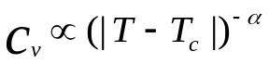

Ising Model

The Ising model, named after the physicist Ernst Ising, is a mathematical model in statistical mechanics. It can be represented on a graph where its configuration space is the set of all possible assignments of +1 or −1 to each lattice point of the graph.
The graph can exhibit periodic boundary conditions or free space boundary conditions depending on the system being modeled. To complete the model, a function, H({Si}) must be defined, giving the difference between the energy of the "bond" associated with the edge when the spins on both ends of the bond are opposite and the energy when they are aligned.

Energy for the Ising model is evaluated by the following formula
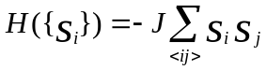

Where: {Si} denotes the set of all the spin variables
<ij> denotes that i and j are nearest neighbours
J is a constant taken as 1 for this project
For example:
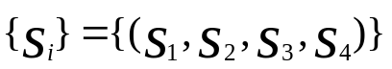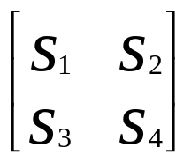

Where S1,S2,S3,S4 can take values +1 or -1
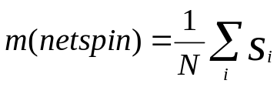
The netspin is defined as:

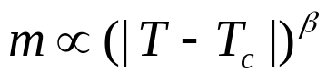

Where is theoretically found to be 1/8 for a 2D Ising model
Tc is the critical temperature.

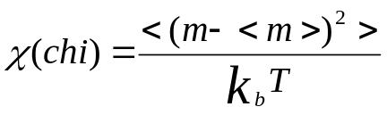The suseptebility is defined as:

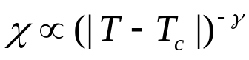
and

where is 7/4 for a 2D Ising model

From statistical mechanics the probability of existence of a configuration is
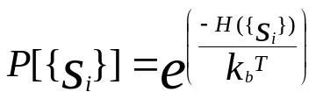

Monte Carlo methods

Monte Carlo methods are a widely used class of computational algorithms for simulating the behavior of various physical and mathematical systems, and for other computations. Because of the repetition of algorithms and the large number of calculations involved, Monte Carlo is a method suited to calculation using a computer, utilizing many techniques of computer simulation.A Monte Carlo algorithm is often a numerical Monte Carlo method used to find solutions to mathematical problems (which may have many variables) that cannot easily be solved, for example, by integral calculus, or other numerical methods.

Metropolis-Hastings algorithm
In mathematics and physics, the Metropolis-Hastings algorithm is a rejection sampling algorithm used to generate a sequence of samples from a probability distribution that is difficult to directly sample from.

The Algorithm

The following is the algorithm used for the simulations.

Start with a new config [n x n]
Choose flip point, flip this lattice point [p,q]
Compute the enrgy of this config [E1]

Compute the energy after the flip [E2]
Is E2 < E1
1)Accept the flip
2)Update E1=E2
3)Update the next flip point to the next lattice point
Is r1 > r2
1)Compute r1=
exp(-∆E/(Kb T)
2)Generate a random number between 0 and1.[=r2]
1)Do not accept the flip
2)Flip back to original config
3)Update the next flip point
yes
yes
no
no

The Plots

The following are the plots that where generated in MATLAB after executing the code written in C (refer to the appendix for the code).

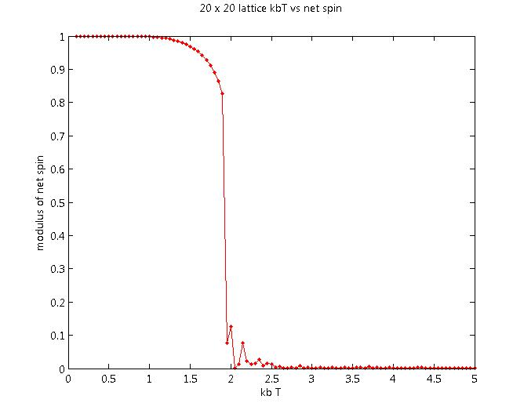

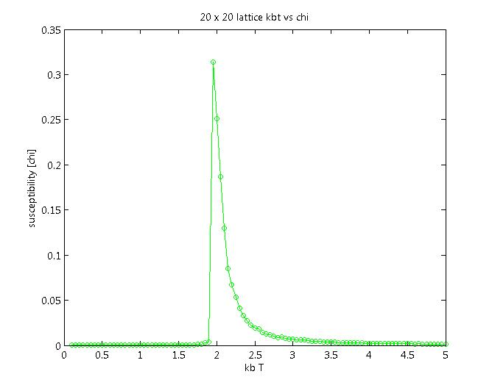

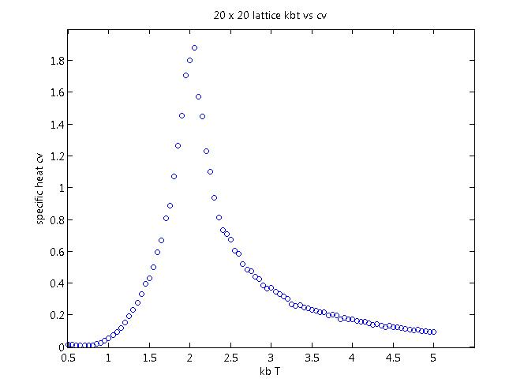

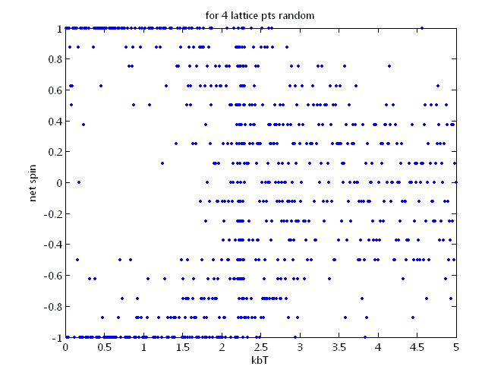

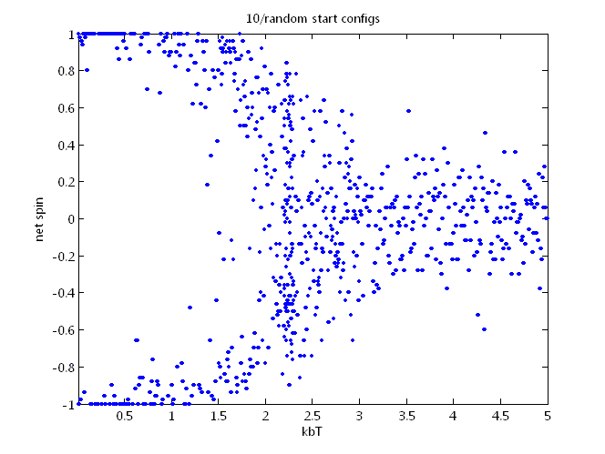
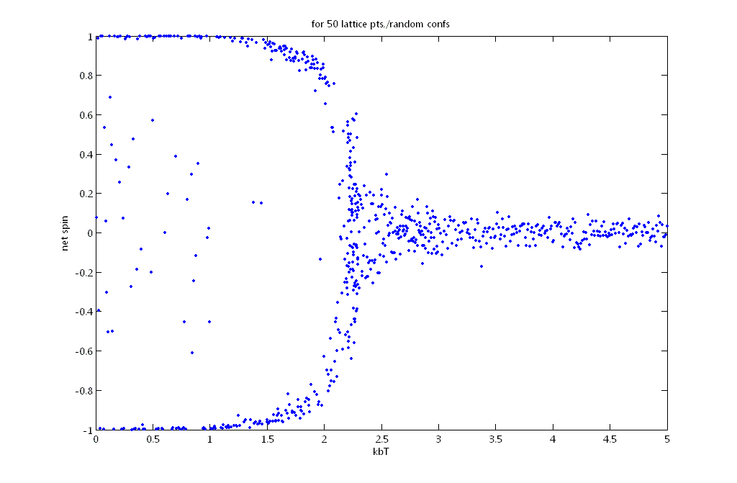
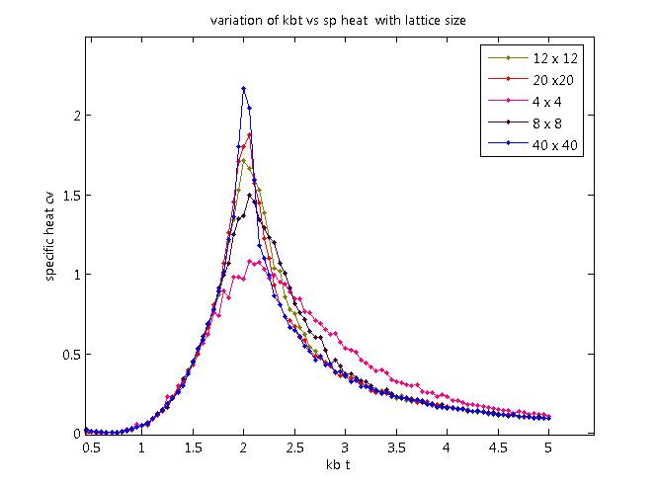

Conclusion

Simulation of a 2D Ising Model was successfully done as a part of the Physics Project Lab. The results and plots obtained have been documented in this report.

Appendix

The Code
//Monte Carlo Simulation of 2D Ising Model
// by C Hanuma Chaitanya and Angad Singh Gill
// Birla Institute of Technology and Science, Pilani – Goa Campus

#include <stdio.h>
#include <stdlib.h>
#include <time.h>
#include <conio.h>
#include <math.h>
main()
{
int conf[42][42],e[2501];unsigned int l;
int r,i,j,s,n,p,q,J=1;
int a,b,z;
float spin=0,kbT,m[2501],x[2501],h[2501];
double r1,r2,energy,power,chi,ham,fef=0,ftef=0,ef=0,tef=0;

FILE *obj;
obj=fopen("ising.dat","w");

clrscr ();
randomize();
printf ("enter the size of lattice: ");
scanf ("%d",&n);

for (j=1;j<=n;j++) /*random matrix*/
{
for (i=1;i<=n;i++)/*printing the first conf and calculating the first spin*/
{

r=rand();

if (r%2==1)
{
printf (" 1");
conf[j][i]=1;
spin=spin+1;
}

else
{
printf ("-1");
conf[j][i]=-1;
spin=spin-1;
}
}
printf ("\n");

}
/*SPIN CALCULATION*/
s=n*n;
printf("net spin of start config is %f\n",spin/s);

{
for(i=1;i<n+1;i++)
{
for (j=1;j<n+1;j++)
{ if(i==1||i==n||j==1||j==n)

{ conf[j][0]=conf[j][n];/*boundary conditions*/
conf[j][n+1]=conf[j][1];
conf[0][i]=conf[n][i];
conf[n+1][i]=conf[1][i];
}
ef=(conf[j-1][i]+conf[j][i+1]+conf[j+1][i]+conf[j][i-1])*conf[j][i] ;
tef=tef+ef;
}
}
tef=(tef/2)*-1*J; /*total energy*/
printf ("total enery at start(tef) %d(J)\n",tef);

}

printf("Working please wait..");

for(kbT=5;kbT>0.05;kbT=kbT-0.05)
{
z=1;
for(l=1;l<=10000;l++)
{
for(q=1;q<=n;q++)
{
for(p=1;p<=n;p++)
{
conf[q][p]=conf[q][p]*-1 ; /*flipped*/

if(p==1||p==n||q==1||q==n)
{
conf[q][0]=conf[q][n]; /*boundary conditions*/
conf[q][n+1]=conf[q][1];
conf[0][p]=conf[n][p];
conf[n+1][p]=conf[1][p];
}
fef=(conf[q-1][p]+conf[q][p+1]+conf[q+1][p]+conf[q][p-1])*conf[q][p] ;
/*energy cntrib of flipped pt*/

fef=-2*fef;
ftef=(tef+fef); /*energy after flip*/

/*basic initial check*/

if (fef<=0)
{
/*if accepted changes*/
tef=ftef;

}
else /*second check compare exp wid random#*/
{

power=(double)fef/kbT;
r1=exp(-1*power);
r=random(32000);
r2=(double)r/32000;

if(r1>=r2)
{
tef=ftef;

}
else /*rejected no changes to config*/
{
conf[q][p]=conf[q][p]*-1 ;

}
}
}

}
if (l>=200&&l%5==0)
{
spin=0;
for(b=1;b<=n;b++)
{
for(a=1;a<=n;a++)
{
spin=conf[b][a]+spin;
}
}

m[z]=(float)spin/s;
e[z]=tef;
z++;
}
}

spin=0;/*net spin*/
energy=0;/*net energy*/
chi=0;
ham=0;/*sp heat*/
z=z-1;

for(a=1;a<=z;a++)
{
spin=m[a]+spin;
energy=e[a]+energy;
}

spin=(float)spin/z;/*spin is avg of m[]*/
energy=(float)energy/z;/*energy is avg of e[]*/

for(a=1;a<=z;a++)
{
x[a]=m[a]-spin;
h[a]=e[a]-energy;
x[a]=x[a]*x[a];
h[a]=h[a]*h[a];
chi=x[a]+chi;
ham=h[a]+ham;
}

chi=chi/(z*kbT);/*chi is avg of x[]^2*/
ham=ham/(s*kbT*kbT*z);/*ham is avg of h[]^2*/

fprintf(obj,"%f, %.8lf, %.8lf, %.8lf, %.8lf\n",kbT,spin,energy,chi,ham);/*file */

}

printf(" done!!!\a");

fclose(obj);
getch();
}

List of References

- http://en.wikipedia.org
- “14:The Ising Model,16:Critical Phenomena”
Huang ,Kerson.“Statistical mechanics”
- Kogut , JB. “Phases of Quantum Chromodynamics”

