A Report
On

Simulation of 2D 3State Potts Model

By
Angad Singh Gill
ID No. 2005S5P3460
&
C Hanuma Chaitanya
ID No. 2005S5P3755

A report submitted in the partial fulfillment of the requirements of
Physics Project Lab

20 April 2007
Birla Institute of Technology and Science, Pilani – Goa Campus

Acknowledgement

I would like to thank Dr. Raghunath Ratabole and Dr. Toby Joseph for encouraging us to undertake this project, for the all the help and guidance given to write this report. I specially wish to thank the librarian without whose cooperation this report would not have been possible.

Abstract

The part of the project taken up under Physics Project Lab covered in this report consists of ‘Simulation of 2D 3State Potts Model’. This report documents the results and plots obtained after running the simulations. The algorithm used was Metropolis-Hastings Monte Carlo Algorithm and the coding was done in C.

Table of Contents
Acknowledgement
Abstract

- Corrections in Ising Model Simulation

- Potts Model

3. 2D 3 State Potts Model

4. Monte Carlo Simulation

5. Critical Exponents

6. Conclusion

Appendix
Random Number Generator
The Code

Corrections in Ising Model Simulation
The following plot was obtained after a Monte Carlo Simulation for a 2D Ising model
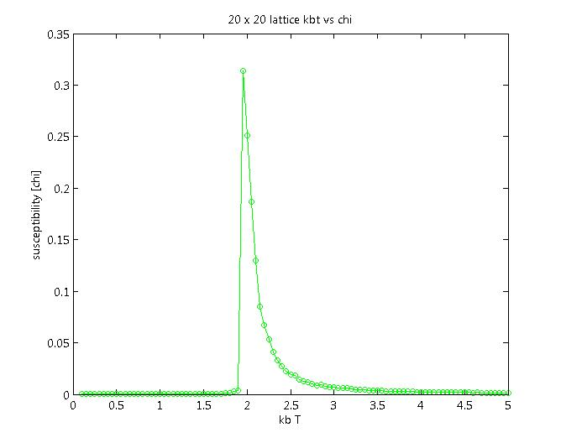
In the above figure the behavior of susceptibility is not as expected. The plot is expected to be symmetric about critical temprature. It was realized that the problem was due to the inefficacy of the random number generator used. A better random number generator was used in the code and the following plot was obtained after running the simulation.
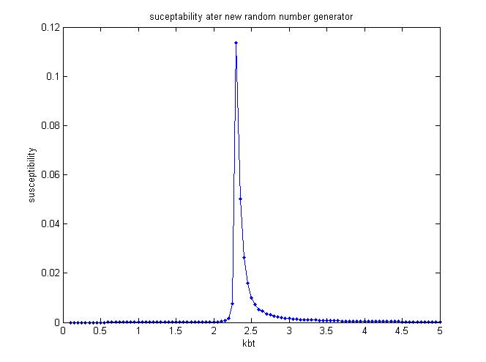

Potts Model
A Potts Model is a generalization of an Ising model. In the Potts Model the spin variable can take 2 or more states. By studying the Potts model, one may gain insight into the behavior of ferromagnets and certain other phenomena of solid state physics. This report deals with the study of 2D 3state Potts model.

2D 3 State Potts Model
As in the case 2D Ising Model, a square lattice of size N(number of lattice points) is considered. Each lattice point corresponds to a spin variable. The spin variable can take 3 values (unlike in Ising, in which the spin variable can take only 2 values).

The Hamiltonian is given by:
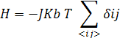

The Magnetisation is given by:
Where β=2π/3

The Specific Heat is given by:
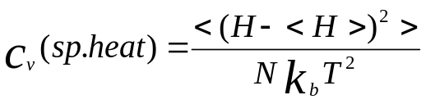

The Susceptibility is given by:
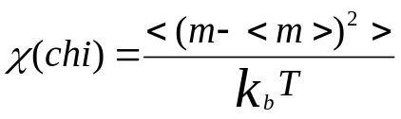

Monte Carlo Simulations
Metropolis Algorithm was used in the Monte Carlo Simulations and the following plots were obtained. [for a square lattice]
The Critical Temperature in the first figure below can be seen to be 1(approx).
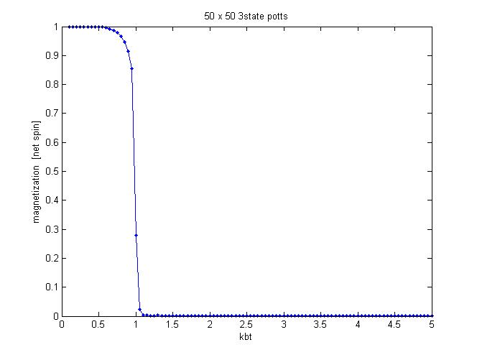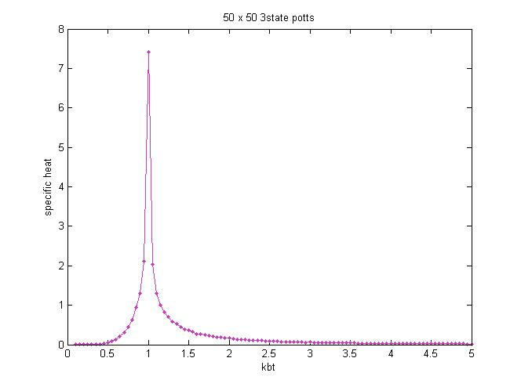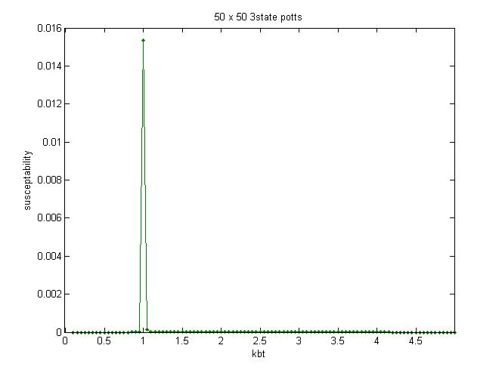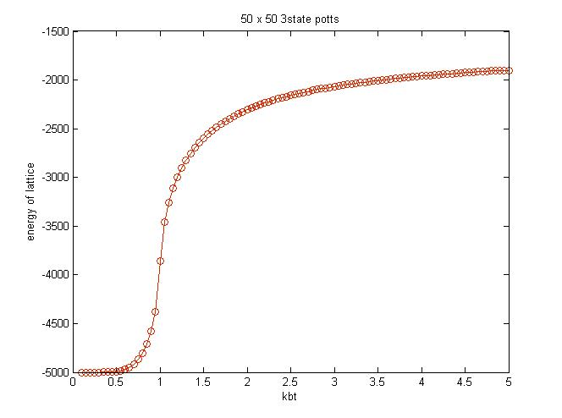
The plots shown above are generated using MatLab. The plots are concurrent with the theory. The C Code used for the simulation is given in the Appendix.

The following is a 3D plot with X axis as KbT, Y axis as Specific Heat and the Z axis as Lattice Size.

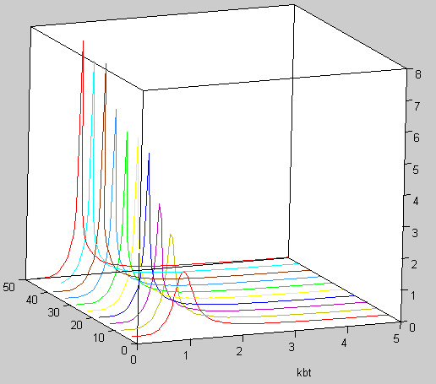
Lattice Size

Specific Heat
It can be observed from the plot that the peak rises as the lattice size increases. This would further imply that-with the lattice size tendind to infinity the specific heat also goes to infinity.The same effect can be seen in the following 2D plot.
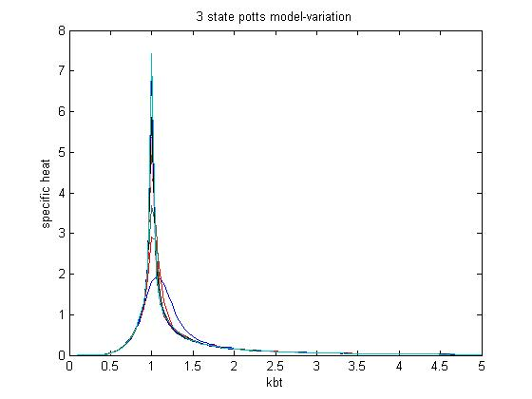
In the above plot corresponding to 10 different lattice sizes it can be observed that the peak of specific heat rises and also shifts to the left with the increase in lattice size.

Critical Exponents
In order to verify the following equation:
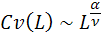
A graph of Log(Max(Specific Heats of different lattice sizes)) is to be plotted against Log(Lattice Sizes)
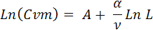
Where: L=
The plot is expected to be linear. The figure given below is the one obtained from the simulation. It can be seen that the plot is linear for the greater part of the graph. A best fit linear curve(y = 0.59*x-0.26) is obtained.

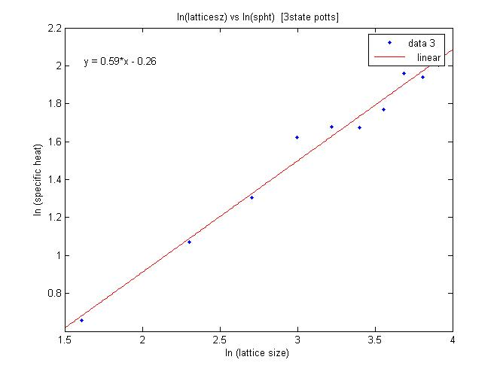

However, the therotical exact value of the slope given by the above equation evaluates to 0.4.The difference can be explained by the limitation in the number of data points over large ranges. The graph corresponds to only 10 lattice sizes viz. L=[5, 10, 15, 20, 25, 30, 35, 40, 45, 50]. This limitation is because of the limitation of computational power as a Desktop PC has been used to perform the simulations.

Similarly critical exponents for Susceptibility can obtained:
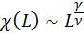
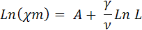

Conclusion
Random numbers are crucial in Monte Carlo Simulations and the choice of a good Random Number Generator dictates the correctness of the simulation. The Critical Temperature of Ising Model after using a better random number generator was observed to be concurrant with the theoretical value. The Monte Carlo Simulation of a 2D 3-State Potts Model [for a square lattice] using Metropolis-Hastings Algorithm was successfully completed. The Critical Exponents were also determined.
The largest lattice size computed using a personal computer having a 2.26GHz Intel P4 Processsor and 512MB RAM was 50x50. The time taken corresponding to this computation was about 2 hours [for both Ising and 3state potts].

Appendix
The following new random number generator was used:
#if !defined( _RNGS_ )
#define _RNGS_

double Random(void);
void PlantSeeds(long x);
void GetSeed(long *x);
void PutSeed(long x);
void SelectStream(int index);
void TestRandom(void);

#endif
#include <stdio.h>
#include <time.h>

#define MODULUS 2147483647
#define MULTIPLIER 48271
#define CHECK 399268537
#define STREAMS 256
#define A256 22925
#define DEFAULT 123456789

static long seed[STREAMS] = {DEFAULT}; /* current state of each stream */
static int stream = 0; /* stream index, 0 is the default */
static int initialized = 0; /* test for stream initialization */

double Random(void)
/* ----------------------------------------------------------------
* Random returns a pseudo-random real number uniformly distributed
* between 0.0 and 1.0.
* ----------------------------------------------------------------
*/
{
const long Q = MODULUS / MULTIPLIER;
const long R = MODULUS % MULTIPLIER;
long t;

t = MULTIPLIER * (seed[stream] % Q) - R * (seed[stream] / Q);
if (t > 0)
seed[stream] = t;
else
seed[stream] = t + MODULUS;
return ((double) seed[stream] / MODULUS);
}

The code(for 3 State Potts Model)
#include <stdio.h>
#include <stdlib.h>
#include <time.h>
#include <conio.h>
#include <math.h>
#define MODULUS 2147483647
#define MULTIPLIER 48271
#define CHECK 399268537
#define STREAMS 256
#define A256 22925
#define DEFAULT 123456789
#if !defined( _RNGS_ )
#define _RNGS_
double Random(void);
void PlantSeeds(long x);
void GetSeed(long *x);
void PutSeed(long x);
void SelectStream(int index);
void TestRandom(void);

#endif

main()
{
int conf[52][52],confp,e[2501];unsigned int l;
int r,i,j,s,n,p,q,J=1;
int a,b,z;
float spin=0,kbT,m1[2501],m2[2501],x[2501],h[2501],spin1=0,spin2=0,spin3=0;
double r1,r2,energy,power,chi,ham,fef=0,ftef=0,ef=0,tef=0;

FILE *obj;
obj=fopen("3potts.dat","w");

clrscr ();
randomize();
printf ("enter the size of lattice: ");
scanf ("%d",&n);

for (j=1;j<=n;j++) /*random matrix*/
{
for (i=1;i<=n;i++)/*printing the first conf and calculating the first spin*/
{
r=rand();
if (r%3==0)
{
printf (" 1");
conf[j][i]=1;
spin1=spin1+1;
}
else if (r%3==1)
{
printf (" 2");
conf[j][i]=2;
spin2=spin2-0.5;/*REAL PART*/
spin3=spin3+0.8660;/*IMAGINARY PART*/
}
else
{
printf (" 3");
conf[j][i]=3;
spin2=spin2-0.5;/*REAL PART*/
spin3=spin3-0.8660;/*IMAGINARY PART*/
}
}
printf ("\n");
}
/*SPIN CALCULATION*/
s=n*n;
spin=spin1+spin2;
printf("net spin of start config is %f+i%f\n",spin/s,spin3/s);
{
for(i=1;i<n+1;i++)
{
for (j=1;j<n+1;j++)
{ if(i==1||i==n||j==1||j==n)
{ conf[j][0]=conf[j][n];/*boundary conditions*/
conf[j][n+1]=conf[j][1];
conf[0][i]=conf[n][i];
conf[n+1][i]=conf[1][i];
}
ef=0;
if(conf[j-1][i]-conf[j][i]==0)
{ef=1;}
if(conf[j][i+1]-conf[j][i]==0)
{ef=ef+1;}
if(conf[j+1][i]-conf[j][i]==0)
{ef=ef+1;}
if(conf[j][i-1]-conf[j][i]==0)
{ef=ef+1;}
tef=tef+ef;
}
}
tef=(tef/2)*-1; /*total energy*/
printf ("total enery at start(tef) %f\n",tef);
}

printf("Working please wait..");
for(kbT=5;kbT>0.05;kbT=kbT-0.05)
{
z=1;
for(l=1;l<=15000;l++)
{
for(q=1;q<=n;q++)
{
for(p=1;p<=n;p++)
{ if(p==1||p==n||q==1||q==n)
{
conf[q][0]=conf[q][n]; /*boundary conditions*/
conf[q][n+1]=conf[q][1];
conf[0][p]=conf[n][p];
conf[n+1][p]=conf[1][p];
}
ef=0;/*energy contrib of point before flip*/
if(conf[q-1][p]-conf[q][p]==0)
{ef=1;}
if(conf[q][p+1]-conf[q][p]==0)
{ef=ef+1;}
if(conf[q+1][p]-conf[q][p]==0)
{ef=ef+1;}
if(conf[q][p-1]-conf[q][p]==0)
{ef=ef+1;}
ef=ef*-1;
confp=conf[q][p];/*saving prev conf*/

r=random(32000);/*flipped*/
if (r%2==0)
{
conf[q][p]=conf[q][p]+1;
if (conf[q][p]==4)
{conf[q][p]=1;}
}

else
{
conf[q][p]=conf[q][p]-1;
if(conf[q][p]==0)
{conf[q][p]=3;}
}

fef=0;/*energy contrib of point after flip*/
if(conf[q-1][p]-conf[q][p]==0)
{fef=1;}
if(conf[q][p+1]-conf[q][p]==0)
{fef=fef+1;}
if(conf[q+1][p]-conf[q][p]==0)
{fef=fef+1;}
if(conf[q][p-1]-conf[q][p]==0)
{fef=fef+1;}
fef=fef*-1;
ftef=tef+fef-ef;/*energy after flip*/

/*basic initial check*/

if (ftef<=tef)
{
/*if accepted changes*/
tef=ftef;

}
else /*second check compare exp wid random#*/
{

power=(double)(ftef-tef)/kbT;
r1=exp(-1*power);
/*r=random(32000);*/
r2=(double)Random();

if(r1>=r2)
{
tef=ftef;

}
else /*rejected no changes to config*/
{
conf[q][p]=confp ;

}
}
}

}
if (l>=200&&l%5==0)
{
spin=0;spin1=0;spin2=0;spin3=0;
for(b=1;b<=n;b++)
{
for(a=1;a<=n;a++)
{ if(conf[b][a]==1){spin1=spin1+1;}
else if(conf[b][a]==2){ spin2=spin2-0.5;/*REAL PART*/
spin3=spin3+0.8660;/*IMAGINARY PART*/}
else{spin2=spin2-0.5;/*REAL PART*/
spin3=spin3-0.8660;/*IMAGINARY PART*/}

}
}
spin=spin2+spin1;
m1[z]=(float)spin/s;m2[z]=(float)spin3/s;
e[z]=tef;
z++;
}
}

spin=0;
spin2=0;spin3=0;/*net spin*/
energy=0;/*net energy*/
chi=0;
ham=0;/*sp heat*/
z=z-1;

for(a=1;a<=z;a++)
{
spin2=m1[a]+spin2;
spin3=m2[a]+spin3;
energy=e[a]+energy;
}

spin2=(float)spin2/z;/*spin2 is avg of m1[]*/
spin3=(float)spin3/z;/*spin3 is avg of m2[]*/

energy=(float)energy/z;/*energy is avg of e[]*/

spin=spin2*spin2;/*magnitude*/
spin3=spin3*spin3;

spin=spin+spin3;
spin=(float)sqrt(spin);

for(a=1;a<=z;a++)
{
x[a]=m1[a]-spin2;

h[a]=e[a]-energy;
x[a]=x[a]*x[a];
h[a]=h[a]*h[a];
chi=x[a]+chi;
ham=h[a]+ham;
}

chi=chi/(z*kbT);/*chi is avg of x[]^2*/
ham=ham/(s*kbT*kbT*z);/*ham is avg of h[]^2*/
chi=chi*chi;

fprintf(obj,"%f, %.8lf, %.8lf, %.8lf, %.8lf\n",kbT,spin,energy,chi,ham);/*file */
}

printf(" done!!!\a");

fclose(obj);
getch();
}

static long seed[STREAMS] = {DEFAULT}; /* current state of each stream */
static int stream = 0; /* stream index, 0 is the default */
static int initialized = 0; /* test for stream initialization */

double Random(void)
{
const long Q = MODULUS / MULTIPLIER;
const long R = MODULUS % MULTIPLIER;
long t;

t = MULTIPLIER * (seed[stream] % Q) - R * (seed[stream] / Q);
if (t > 0)
seed[stream] = t;
else
seed[stream] = t + MODULUS;
return ((double) seed[stream] / MODULUS);
}

