Maddison Chin
CMP-129-80235
Week 2 Lab 2
Special Instructions/Comments:

Problems Encountered:

Complete Java Source Code:
Person.java

PersonTest.java

Input Screenshots (if applicable):
Person.java

PersonTest.java

Output Screenshots:
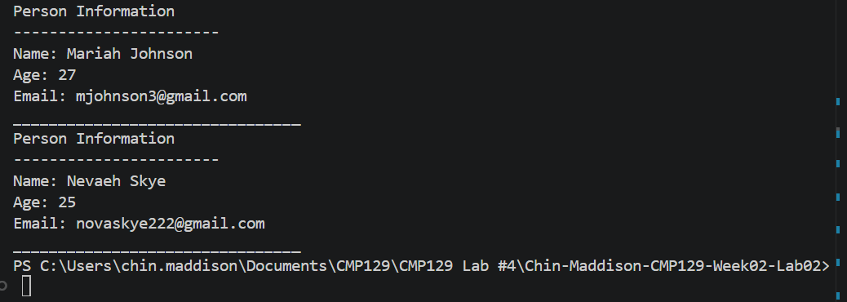
GitHub Copilot Use Report:

Link to Public GitHub Repository:
https://github.com/ccmaddisonc/Chin-Maddison-CMP129-Week02-Lab02.git

