NAME: CLARUS KAYOMB LEMAN DATE:15/03/25

**PERSONAL PORTFOLIO**

**1.Portfolio Websites**

**Analyzing different personal websites provides insight into common design trends, layout structures, and essential features. Minimalist and professional designs often work best, ensuring the content remains the focal point.**

**Understanding HTML & CSS**

**Since the website will be built using HTML for structure and CSS for styling, it’s important to follow best practices. Clean code, responsive design, and simple navigation will make the site more user-friendly.**

**Identifying the Target Audience**

**The website will be viewed by students, teachers, and potential future employers or colleges. It should be professional yet personal, reflecting both achievements and aspirations in a clear and engaging manner.**

**Defining the Website’s Purpose**

**The site serves as a digital introduction, highlighting skills, interests, and future goals. It should be a space to showcase work and leave a strong impression on visitors.**

**2.Content Planning**

**The website consists of three main pages:**

**• Home – A brief introduction.**

**• About Me – Personal background, interests, and goals.**

**• Portfolio – A collection of work, including photography and projects.**

**3.Developing ldeas**

**• Layout and Pages:**

**There are three pages: Home, About Me, and Portfolio. The Home page has a header with a menu, a main section for important text, and a footer at the bottom. The About Me page tells who I am and what I like. The Portfolio page shows my work and pictures.**

**• Colors and Fonts:**

**The design uses a few soft colors that go well together. The fonts are simple and easy to read. Big text is used for titles and smaller text for details.**

**• Visual Elements:**

**Pictures, icons, and buttons are added in good places. They help make the website look interesting without being too busy.**

**• User Experience:**

**The site is made so that anyone can use it easily. The menu is simple and works well.**

**Creating the Solution**

**I built my website using HTML and CSS. Here is what I did:**

**• Wrote the Code:**

**I created the structure with HTML and styled it with CSS. I made sure the code was neat and worked correctly.**

**• Tested the Website:**

**I checked the website on my computer and phone to make sure it looks good and works well on both.**

**• Took Screenshots:**

**I saved pictures of my code and the website to show my work and progress.**

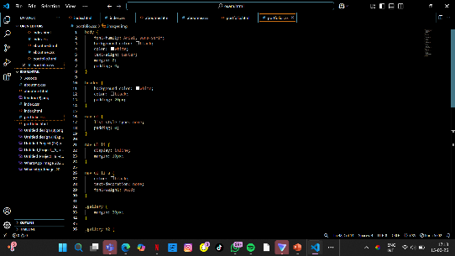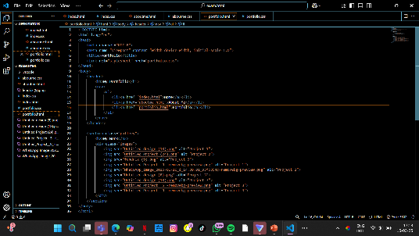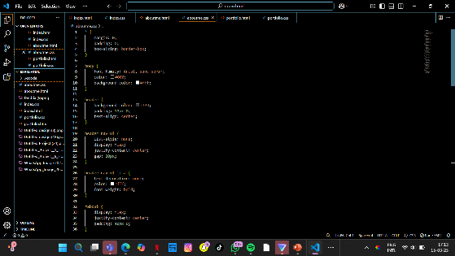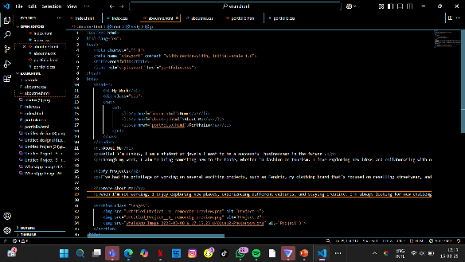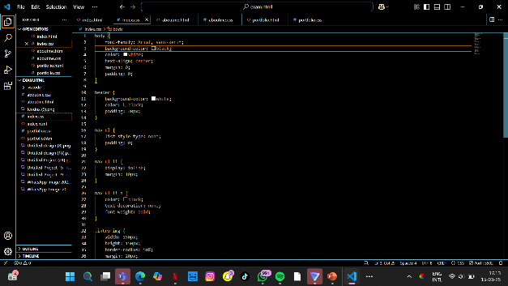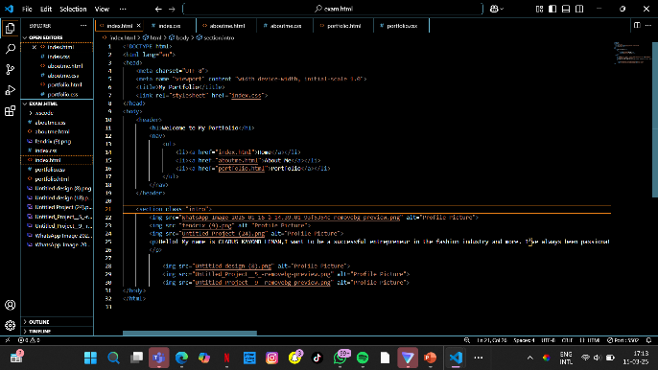

**Evaluation**

**I checked my website to see how well it worked. Here is what I did:**

**• Tested the Website:**

**I looked at my website on a computer and a phone to make sure it was easy to use and looked good on both.**

**• Got Feedback:**

**I asked my friends and teacher for their opinions. They said the website was clear and simple to navigate.**

**• Fixed Problems:**

**I made small changes based on the feedback to improve the look and the ease of use.**

**• Wrote My Thoughts:**

**I wrote down what I liked about the website and what could be better next time.**

**WEBSITE SCETCHES**

