Etasha **ICT report**

**CRITERI A- Inquiring and Analyzing**

As the demand for modernization increases, so does the need to adapt ourselves to the changes in the society and workforce. In the 21st century, having an online platform to display our skills, hobbies and interests has become increasingly important. Thus, there is a need to create a personal website to showcase my personal skills, interests, future aspirations, achievements and personality.

**The website’s audience would be anyone among my peers, potential future employers, colleagues, family members or acquittances wishing to know more about me.**

**My audience would need a user friendly clear and concise website that would help them no more about me to employ me or just to know more about me.**

If a solution is not found, I may lose a potentially perfect way to attract employers that may not help much in securing the future.

Primary Research methodology

I could ask for insights from my seniors who have experience in this area and might have experienced a similar situation when they were in my grade. I could ask the necessary questions for building a website and pose certain to my ICT teachers to gain what they may think I need to know about this.

Secondary research methodology

To get other insights into Website design I went online and scoured the internet for personal websites, how they can be made, and what is required. I used several sites in order to reaffirm the reliability of my sources. The sources used are cited.

Research questions

|  |  |  |
| --- | --- | --- |
| Question | Priority | Justification |
| What are some examples of personal websites and effective web design principles? | High | personal websites have some principles that need to be followed, and examples would be the best way to find them. |
| What is a personal website and what is its goal? | High | Since our aim is to create a personal website we should know everything about it from it is to what it aims to achieve. |
| What are the most efficient layouts that people have used in their personal website and what layout can make maximum impact on my audience? | Medium | To create a website, we need to know what the layout we're going to use in order to make the website efficient and appealing. So I can use my secondary research to see which layouts were the most appealing to the eye. |
| What are the different tags in HTML that I need to know in order to make this website and what is the function of each? | High | Since we're going to be using HTML and CSS to make this website I need to know how to efficiently and correctly use the tags and commands in these coding languages. |
| What are the elements of a personal website? | High | For us to make a personal website we must know what a personal website contains or involves. |
| How can I make my website mobile-friendly? | Medium | Since we wish my website to be accessible for all we should ensure that the website is mobile meaning that if the user is on a phone or on a laptop the website should work just as well. |
| What are the most common CSS properties I should know for styling my site (e.g., margin, padding, font-family, display)? | Medium | Since we would be using CSS for designing and styling the HTML website we would need to know the common properties that are used in CSS. |

I will design a personal website for future employers, colleagues, current peers and family members to showcase my hobbies, interests, future aspirations and characters.

Research findings

**What are some examples of personal websites and effective web design principles?**

Examples**:**

Ine Agresta: Showcases a neat, concise design with easy navigation, showing the designer's portfolio effectively.

Neil Oseman: Features an engaging layout with interactive elements, emphasizing the person’s work and achievements.

Vytautas Vy: Combines a professional aesthetic with personal touches, offering insights into the designer's journey and projects.

Minimalist Baker: Utilizes a simple, user-friendly interface to present recipes, focusing on content with minimal distractions.

Rafal Bojar: Employs a modern design with bold typography, effectively showcasing photography work.

Principles:

Usability: we always need to make sure that our website is user friendly and is navigable.

Consistency: the layout design and the color schemes in the website must be consistent meaning it should not change every single page.

Visual Layout: the layout of the website must be appealing and organized.

Responsive Design: Optimize the website for various devices and screen sizes, ensuring a seamless experience across platforms.

Content Quality: Provide clear, concise, and engaging content that aligns with your personal brand and objectives.

**What is a personal website and what is its goal?**

A personal website is an online platform on which an individual can showcases his/her own unique identity, skills, hobbies, interests and achievements. It is your own space in which a person has the freedom to design and structure their information and content. It’s similar to a reflection of who you are.

The goal of a personal website depends on its use case. For example,

* Portfolio websites are used to display creative forms of art like photography, designs etc. to show artistic skills that one possesses.
* Blogs are personal websites that share certain experiences or recommend certain things for a large audience. Its aim is to provide useful information.
* Career websites are a form of personal websites that showcase one’s life experiences, skills etc. all packed into one making it easier for job search efforts.
* Project showcases are websites that enable an interested audience to get an overview of past projects..

**What are the most efficient layouts that people have used in their personal websites and what layout can make maximum impact on my audience?**

1. F-shape-Layout: this design copies the natural reading of people and tries to engage them using this layout.

2. Z-shape-Layout: This zig zag layout attracts the reader's eye and it's catchy when seen from a layout point of view.

3. Grid Layout: in the structure all the elements of the website are structured into a gridlike shape to keep the content neat and organized.

4. Single Column Layout: This is a single column layout which is pretty straightforward and simple.

5. Asymmetrical Layout: An unconventional design that creates visual interest through uneven distribution of elements, drawing attention to key areas.

6. Card Layout: This layout uses card-like components to group related information, making it easy for users to scan and digest content.

7. Split Screen Layout: A design that divides the screen into two or more sections, allowing for contrasting content or visuals side by side.

Personally, I feel that the magazine layout, the asymmetrical layout, the card layout and the F&Z layouts would be most impactful on my audience because they have not only an aesthetic feel to it but such an organizational pattern that would look neat and beautiful at the same time. These layouts offer a variety of approaches to web design, catering to different types of content and user experiences.

**What are the different tags in HTML that I need to know in order to make this website and what is the function of each?**

Some of the essential HTML Tags:

1. <!DOCTYPE html
2. <html>
3. <head>
4. <title>
5. <meta>( Provides metadata like character encoding and viewport settings.)
6. <body>
7. <header>
8. <nav>: Defines navigation links.
9. <footer>: Contains footer information, such as contact details or copyright notices.
10. <h1> to <h6>
11. <p>
12. <a href>
13. <img>
14. <ul>, <ol>, <li>
15. <form>, <input>, <button>
16. <div>:
17. <span>: An inline container for styling a portion of text or other inline elements.

**What are the elements of a personal website?**

* An About page: is the page that talks about a person, his or her life background, age and all whatever they want to talk about themselves.
* A Portfolio page: shows a person's best projects and achievements.
* Resume: which displays professional achievements.
* Contact us page: that allows the users or visitors to reach you through a provided contact or email link.
* Personal touches: People can include different elements for example hobbies or fun facts to make your site memorable.

**How can I make my website mobile-friendly?**

To make your website mobile-friendly you can use the @media tag in CSS and change properties using the ID's and classes that you have assigned each element in the HTML and make sure that it works on a smaller screen by using maximum width. I can design your website with mobile users in mind, focusing on essential content and touch-friendly navigation to enhance the mobile experience.

**What are the most common CSS properties I should know for styling my site (e.g., margin, padding, font-family, display)?**

The main CSS Properties are as follows:

1. color
2. font-family
3. font-size
4. font-weight
5. text-align
6. margin
7. padding
8. background-color
9. border and border radius
10. width`` and height`
11. display
12. position
13. grid
14. transition
15. media queries

THE NEED OF AUDIENCE: The need of my peers is to see my products resources and achievements. My teachers might also want to do the same. However, for potential future employers it is the capabilities and skills that I have that would interest them.

PURPOSE OF WEBSITE: Thus, the purpose of my website as a 10th grade student learning how to use HTML and CSS, is that my website must be user friendly, navigable, neat and organized for my peers to see my achievements and products and my potential future employers to see my capabilities and skills.

Citations:

Minasyan, Arto. “51 Most Impressive Personal Websites to Inspire in 2024” *10web,* Nalbandyan Araks,November 07, 2024

<https://10web.io/blog/personal-websites/>

Spivak. Eden “17 personal website examples for a polished online presence” *WIX Blog*, Feb 25, 2022

<https://www.wix.com/blog/personal-website-examples>

Envato Market. "2025's Best Selling Themes on ThemeForest." *ThemeForest*, 2025,

<https://themeforest.net/top-sellers>.

Boag, Paul. "10 Good Website Layout Ideas (with Examples)." *WebsiteSetup*,

<https://websitesetup.org/website-layouts/>

The Website Architect. "How to Properly Layout A Website (For Beginners)." *YouTube*, uploaded by, Apr 9, 2022

<https://www.youtube.com/watch?v=3C_22eBWpjg>.

**Payton Clark Smith**. "18 Hero Section Designs You Can Steal." *YouTube*, uploaded by Payton Clark Smith, 2022

<https://www.youtube.com/watch?v=kJb6BZwqCGM>.

Halpin, Seán. "Seán Halpin • Product Designer." *seanhalpin.xyz*,

<https://www.seanhalpin.xyz/>

Sakhnenko, Oleksandr. "Oleksandr Sakhnenko Photography." *shpro.info*,

<https://shpro.info/>

**CRITERION B: Developing Ideas**

**SKETCHES**

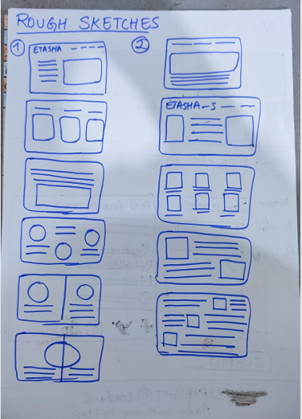

**I just drew these rough sketches just to see which ones would look good.**

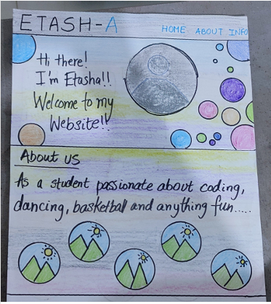



**I plan to use this layout because of its simplicity and just a stunning layout. It is feasible as well as organized.**

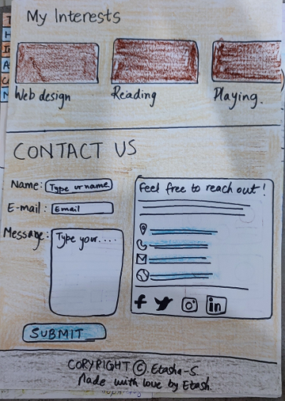



**I also plan to use this layout because this is also neat and organized .**

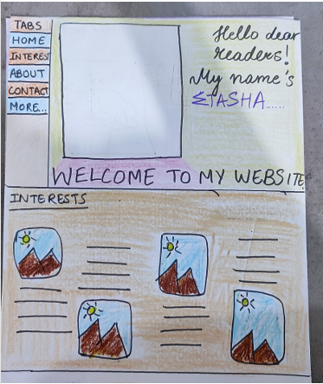

I have chosen a light color palette that would be neat, beautiful at the same time soothing for the audience to look at. I aim to take an AI generated image that would have that sort of effect on my audience. I also wish to use the colors Peach, pink, purple light blue in my palette. The font that I would be using is Poppins sans serif I chose this particular font because it looks beautiful on personal websites.

I chose the two layouts on which an arrow has been drawn in black and highlighted in Aqua color because they were the most neat and organized looking as well as because it was the most easy to do within a short period of time. It was the feasibility of the layout that attracted me the most.

CRITERION C

Form my website I followed all the steps we used in class while using VS code since I used Visual Studio Code to make my website, used generated images to get an aesthetic background, and took feedback from peers and family members. I got feedback from my family my mom dad and sister and asked them for their feedback.

To make my website, I took help with YouTube videos to understand the important CSS properties and html codes. I asked for help from my design teachers whenever I got stuck in some particularly tight spot.

I changed the color of several elements in my website a few times before I actually stuck to the layout that I had taken and the colors that I had decided before.

I researched again when I thought about some of the things I need I didn’t research on much. Using the results of each research I gradually started getting things correct.

I ensured that my website would be usable on most kinds of devices including mobiles laptops and computers by using the *@media* CSS element. So now if the screen of the website is reduced the content is still visible and as neat as ever.

I have also attached my CSS and HTML file by the name of index.html and style.css in the DESIGN Summative zip file that is attached to the managebac task.

CRITERION D

I went through the design brief and through all strands of all criteria and I ensured that everything that has been mentioned in the success criteria including the constraints and necessities have been met.

My mother: wow that's pretty cool how did you make that? I love the colors, and the gradients are beautiful in fact the way it comes to the exact page that is required when I click on that link is wonderful that its great well done.

Riona: Nice Etasha! I like it though you could have changed the color on the contact page a bit so that the letters are more visible on that GIF image that you've put. But overall, it is nice. The home page is absolutely stunning.

My sister: I like it! It’s got the coolest background image. It’s beautifully designed. And overall, it is nice. I never knew you liked basketball that much.

REFLECTION:

I faced multiple challenges while making this website including the fact that I'm new to coding and I'm not much aware of the elements and properties that we have in the HTML and CSS. I had a lot of help from my teachers who were supportive as well as my family who helped me while I got frustrated in the process of making this website. Personally, I'm satisfied with the outcome it is way better than I hoped and I enjoyed it throughout the process though sometimes when it's did not give the desired outcome it was a little frustrating. Though I thank my teachers for this lovely opportunity to learn how to work with CSS and HTML and integrate them both to create a functional interactive website and do this as part of our curriculum.

Most of all I loved the coding part. I loved researching the css properties, critically thinking to debug any errors and creatively thinking to create the best website.

Thank you!