**MYP Year 5 Digital Design Brief**

**Name: Mantasha Zehra Mughal**

**Project Title:** Crafting a Personal Website with HTML and CSS

**Grade Level:** Year 5 (Grade 10)

**Unit Topic:** Web Design and Personal Branding

**Duration:** [2-3 weeks]

***Context:***In today’s digital world, having a strong online presence is essential to showcase my skills, interests, and personality. I recognize that a personal website is not only a digital portfolio of my work and passions but also a reflection of who I am, what I value, and my creative journey. Through this project, I will design and develop a website using HTML for structure and CSS for styling. This site will act as my personal hub—a place where I can share my achievements, hobbies (like my love for cooking and the cultural influences that shape my identity), and my aspirations for the future.

***Design Challenge:***  
My challenge is to create a website that genuinely represents my identity. I must develop at least three functional pages (such as Home, About Me, and Portfolio/Contact) that are engaging, easy to navigate, and visually appealing. I plan to incorporate images, text, and links (to social media and email) that highlight my hobbies, accomplishments, and future dreams. The design should be both functional and responsive, adapting gracefully to desktops and mobile devices, all while showcasing my unique style and technical abilities in web design—all without the use of JavaScript or pre-built templates.

***Target Audience****:*• **Who:** My peers, teachers, and potential future employers/colleges (ages 15–30).   
• **Needs:** They require an engaging and intuitive website that reflects my personality and provides clear, easily accessible information about who I am, my creative passions, and my achievements.

***Design Specifications***

1. **Content (HTML):**
   * The site will have a minimum of three pages/sections (for example: Home, About Me, and Portfolio/Interests).
   * I will include text, images, and interactive links (such as those directed to social media and my email).
   * I will use semantic HTML tags (like <header>, <nav>, and <footer>) to ensure my site is accessible and well-structured.
2. **Styling (CSS):**
   * I will apply a consistent color scheme and typography that reflects my personal style—blending cool pastels with vibrant accents.
   * The design will be responsive, ensuring that it displays correctly on both desktop and mobile browsers.
   * I will add at least three interactive elements (like hover effects on buttons, animated navigation menus, and subtle transitions) to enhance user engagement.

**Constraints:**

* I will use only HTML and CSS (without JavaScript or any pre-built templates).
* The website will be hosted locally or on a free platform like GitHub Pages for presentation purposes.
* I will ensure that file sizes remain reasonable, optimizing images to a total of under 1 MB.

**Success Criteria:**

• The website must have a clear structure with at least three fully-functional pages/sections.  
 • The design should be visually appealing, consistently styled, and reflective of my personality.   
• The site needs to be easy to navigate and function well on various screen sizes.   
• The project will be completed on schedule, with thorough documentation of the entire design process.

***Design Cycle Stages***

1. **Inquiring and Analyzing:** I researched various personal websites and effective web design principles, analyzing how a well-organized site can communicate a strong personal brand. I deepened my understanding of how HTML and CSS work together to create functional, accessible websites. I also identified the unique needs of my audience—peers, teachers, and future employers—and clear objectives for my site.
2. **Developing Ideas:** I sketched at least three layout ideas (wireframes) for the website. My wireframes ranged from a minimalist layout with a full-width header and simple content sections, to a more creative layout with engaging visuals and dynamic project galleries. I planned my content and styling carefully, choosing a color palette of cool pastels, a modern typography style, and engaging interactive elements. I selected the creative layout as it best represents both my personal story and my technical capabilities, justifying this choice as the ideal balance between aesthetics and function.

**Layout 1:**

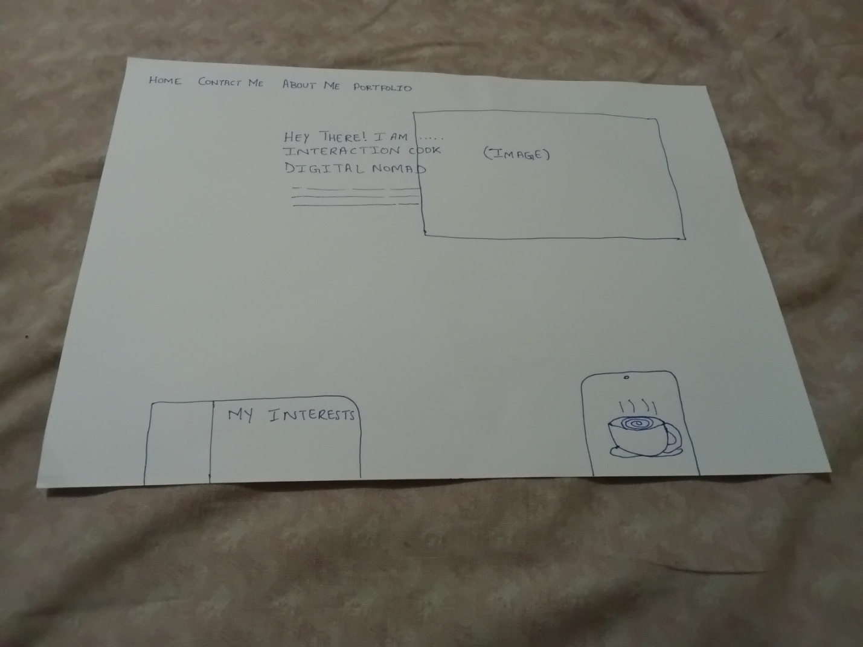

**Layout 2:**

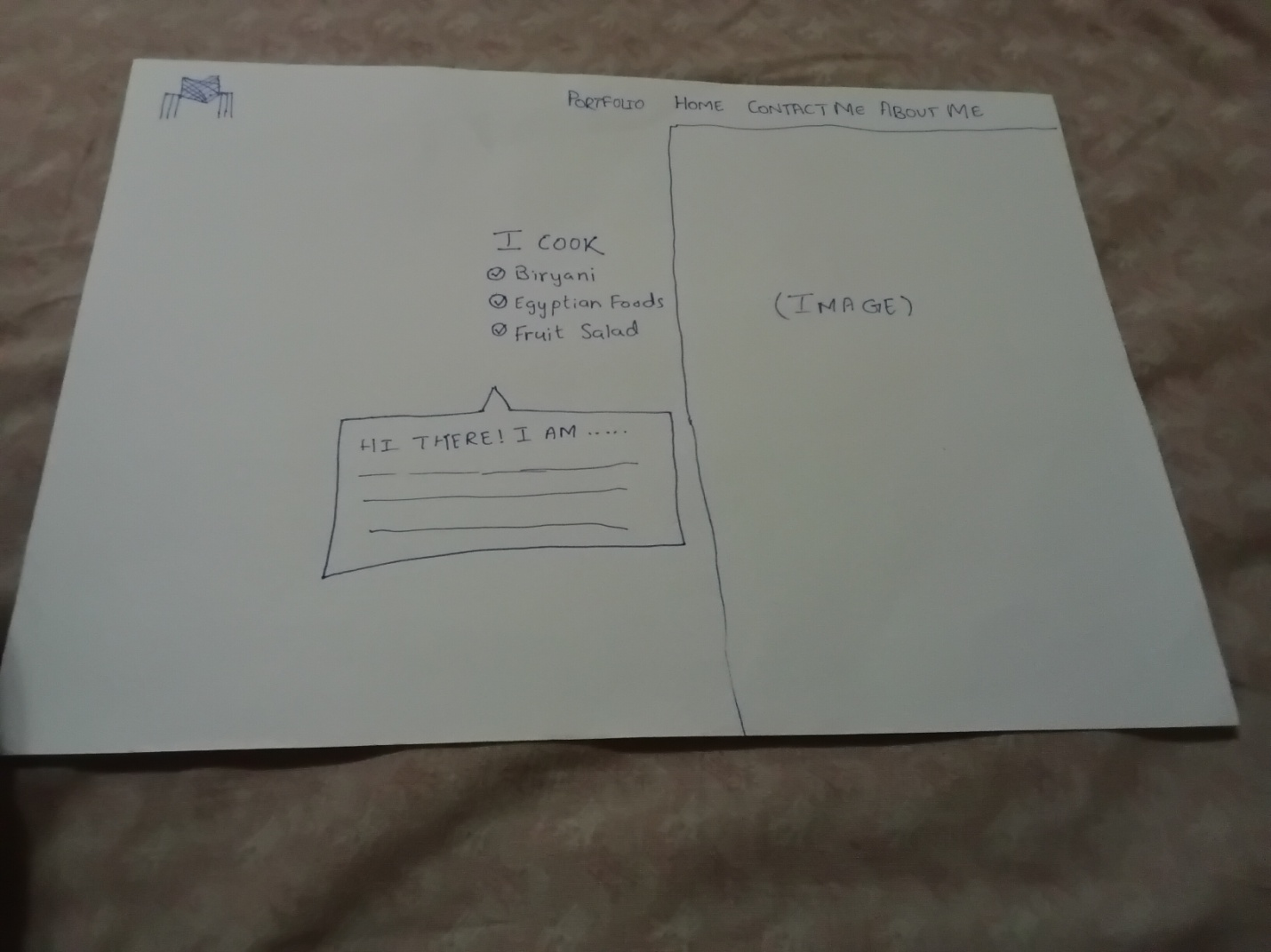

**Layout 3:**

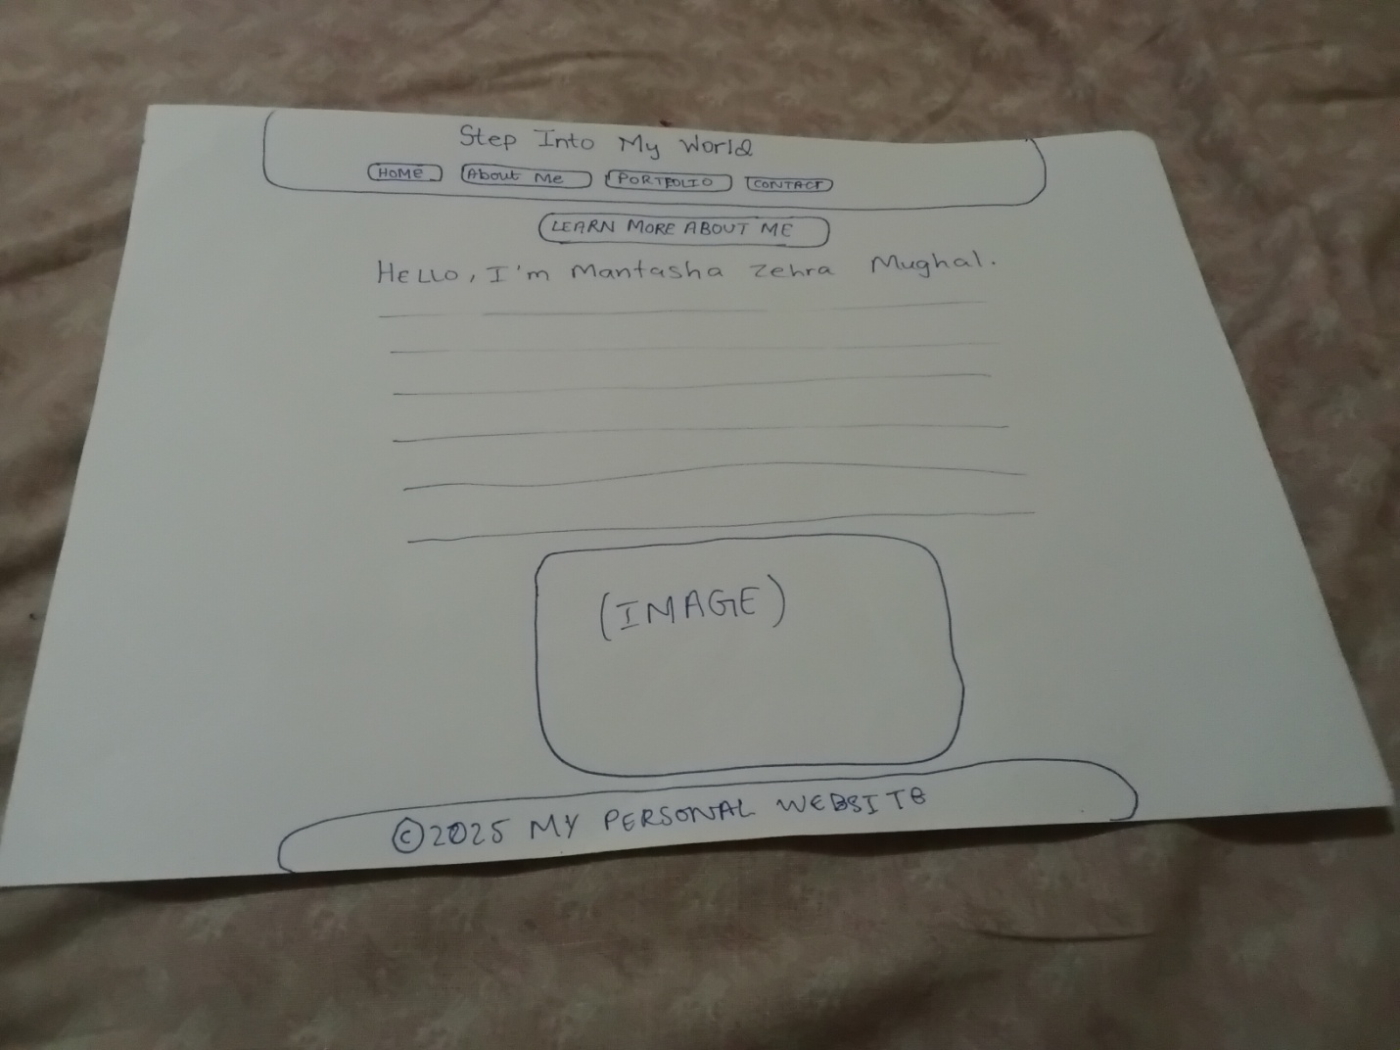

***From all these 3 layouts I have selected Layout 3. Because, in choosing this layout, I aimed to create a digital space that is as engaging and personal as it is functional. I selected a full-width header with evenly distributed navigation buttons—placing 'Home' on the left, 'About Me' in the center, and 'Portfolio' on the right—to provide clear, intuitive access to every section of my site. The prominent inclusion of a 'Learn More About Me' call-to-action immediately invites visitors to delve deeper into my story, which is deeply rooted in my passion for cooking and my rich cultural heritage. With a clean, grid-based structure, the layout not only organizes my content seamlessly but also uses a cool pastel color palette to evoke warmth and creativity. This design strikes the perfect balance between simplicity and visual appeal, ensuring that my personal narrative and digital skills shine through while offering a user-friendly experience for peers, teachers, and future employers alike***.

1. **Creating the Solution:** To transform my design concepts and wireframes into a fully functional website, I will carefully implement my solution in stages. I will begin by constructing the framework of the website using HTML. Every page will be meticulously organized with semantic tags—such as <header>, <nav>, <main>, <section>, and <footer>—to create a clear and logical document structure. This not only helps in defining distinct content areas but also improves accessibility and search engine optimization. I plan to break down the site’s content into modular sections, ensuring that navigation is intuitive and that users can easily move from one section to another.

Once the HTML framework is in place, I will focus on the visual presentation by applying CSS. I will use CSS to implement a consistent color palette, typography, and spacing that align with my personal style. My design includes interactive elements—such as hover effects on buttons and navigation links—that enhance the user experience, making the site feel both modern and engaging. By integrating layout techniques like Flexbox and CSS Grid, I will ensure that the website is fully responsive, adapting gracefully to various screen sizes ranging from wide desktop monitors to compact mobile phones. This approach will help deliver a uniform experience to all users, regardless of their device.

After coding the initial version of the website, I will proceed to an extensive testing phase. I will run the website on multiple browsers—Chrome, Firefox, Safari, and Edge—and on several devices (desktop, tablet, and mobile) to identify any inconsistencies, broken layouts, or performance issues. Tools like the W3C Validator will aid in checking the HTML and CSS for any syntax errors, ensuring that the code adheres to web standards. I will take careful notes of any issues that arise during testing so that each problem can be addressed in the subsequent refinement phase.

Feedback will play a vital role in this phase. I will collect insights from peers, teachers, and mentors regarding the usability, visual appeal, and overall effectiveness of the design. Their reviews will help me pinpoint areas for improvement—whether it’s fine-tuning the spacing between elements, enhancing interactive components, or streamlining the navigation system. Based on this feedback, I will iteratively refine the website, adjusting both the HTML structure and the CSS styling to better meet the success criteria.

Performance optimization is another critical component of my plan. I will compress image files and optimize media content to ensure that the website loads quickly, even on slower connections. Additionally, I will streamline my CSS code by removing redundancies and ensuring that it’s as efficient as possible. Every optimization step will be aimed at reducing file sizes while maintaining high visual quality, so the final product is not only attractive and functional but also efficient and user-friendly.

By following these detailed steps—from building a strong HTML backbone and applying a consistent CSS design to rigorously testing, gathering feedback, and optimizing performance—I aim to create a polished, responsive, and truly personal website. This solution will not only meet the technical and creative requirements of the project but also effectively represent my identity, passions, and future aspirations.

1. **Evaluating:** Once the website is completed, I will assess its success against the criteria: clear structure, visual appeal, consistency, and responsiveness. I will collect detailed feedback from peers, teachers, and mentors to understand areas of strength and those needing improvement. I will reflect on challenges encountered during the process, the skills I developed, and ways to enhance the site in the future.

**Deliverables:**• A fully functional personal website (including HTML and CSS files).  
• A screenshot or live link to the website if it’s hosted online (e.g., on GitHub Pages).   
• A design portfolio that documents my process—from research and initial wireframes to final reflections and feedback.

***Feedback Received:***

* **Salman (Technology Teacher):** "Your website exhibits a solid understanding of web design fundamentals and demonstrates impressive creativity. The structured layout and responsive design are well executed. To further enhance engagement, consider integrating more interactive elements."
* **Hina (Graphic Designer):** "I appreciate the cohesive color scheme and typography which make your site both vibrant and professional. One suggestion for improvement would be to vary the visual hierarchy further with larger headings or featured images to grab attention."
* **Shehnaz (Aspiring Chef):** "Your passion for cooking and your cultural heritage shine through in the content. Adding a short video or gallery of your culinary creations might help bring your story to life even more."
* **Kaniz (UI/UX Specialist):** "The navigation and layout are user-friendly and intuitive. To refine the design further, consider subtle animations for smoother transitions, which can enrich the user experience."
* **Ashfaq (Career Counselor):** "The website effectively showcases your talents and aspirations, and is a strong example of personal branding. It might be beneficial to include a skills section or resume link so potential employers gain a more robust understanding of your proficiencies."
* **Mehak (Student Mentor):** "Your personal story is engaging and the site is aesthetically pleasing. Enhancing the quality of images and adding interactive elements could further elevate the overall presentation."
* **Ahmed (Web Developer):** "The code is clean and well-structured, and the responsive design is commendable. Refining the CSS to eliminate redundant rules would improve performance and maintainability."
* **Mohsin (Peer Programmer):** "Great job on presenting a clear personal identity through the website. Consider adding a blog section for ongoing updates and reflections that can showcase your evolving skills and achievements."
* **Zehra (Industry Mentor):** "You’ve beautifully interwoven your personal narrative with your professional aspirations. In the future, integrating advanced CSS effects and perhaps a lightweight CMS could open up more dynamic interaction possibilities."