**Project Title: Creating My Personal Website**

**Name:** Riona Khoja  
**Date:** 27/09/2024

**CRITERION A – Inquiring and Analyzing**

1. **Problem Statement:**  
   In today’s world, having a personal website is important to show who I am and what I love. The goal is to create a website that reflects my interests and personality.
2. **Research:**  
   I will look at examples of personal websites to learn what makes them effective. I’ll also explore how HTML and CSS work together to create nice and functional web pages.
3. **Target Audience:**  
   My website is for my peers, teachers, and potential future employers or colleges (ages 15-30). It should be engaging and showcase my personality.

**CRITERION B – Developing Ideas**

1. **Design Specifications:**
   * The website will have at least 4pages home, about me, services, and contact
   * It will include text, images, and links to my social media.
   * I will use clear HTML tags to make it accessible.
2. **Styling:**
   * I will choose a color scheme and fonts that match my style.
   * The design will be responsive, so it looks good on both computers and mobile devices.
   * I will add interactive elements like buttons and hover effects.



1. **Wireframes:**
   * I will sketch 3 layout ideas for my website.
   * I’ll plan the content and colors for each section.



* + I will choose the best design and explain why I picked it.



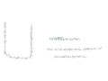

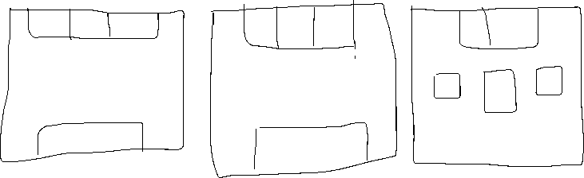

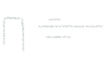



**CRITERION C – Creating the Solution**

1. **Building the Website:**
   * I will code the website using HTML for the structure and CSS for the style.
   * Each page will be organized and visually appealing.
   * I’ll test it on different devices to make sure it works well.
2. **Refinement:**
   * I will get feedback from friends and teachers and make improvements.
   * Based on testing, I’ll adjust the design to enhance the user experience.
3. **Documentation:**
   * I will keep a record of my design process, including research, sketches, and reflections.

**CRITERION D – Evaluating**

1. **Assessment of Success Criteria:**
   * I will check how well my website meets the goals for structure, design, and audience engagement.
   * I’ll gather feedback to see what works well and what can be improved.
2. **Reflection:**
   * I will think about the challenges I faced and the skills I learned during this project.
   * I’ll consider how I can use this knowledge for future projects.
3. **Deliverables:**
   * A fully functional personal website (HTML and CSS files).
   * A screenshot or link to the website (if I host it).
   * A design portfolio documenting my process.