Final Report Demo

Caitlin Mothes

2023-03-22

# Abstract

This is my abstract…..

# Introduction

Enter intro text here

# Methods

We used the car package to test for equal variances.

# Results

library(palmerpenguins)  
  
data("penguins")

State some results (P = 0.12, Figure 1).

# test for equal variances  
  
  
  
# conduct appropriate t-test

ggplot(penguins)+  
 geom_histogram(aes(x = bill_length_mm))

## `stat_bin()` using `bins = 30`. Pick better value with `binwidth`.

## Warning: Removed 2 rows containing non-finite values (stat_bin).

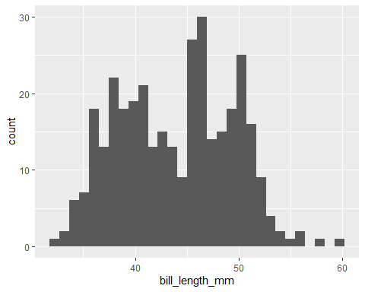

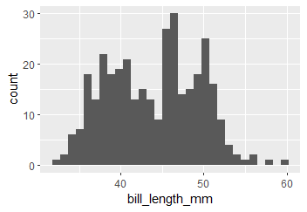

Figure 1. Histogram of bill length for Palmer Penguins

**Figure 1.** Histogram of bill length

# References

1. Albert, C. H., Rayfield, B., Dumitru, M., & Gonzalez, A. (2017). Applying network theory to prioritize multispecies habitat networks that are robust to climate and land-use change: Prioritizing a network for biodiversity. *Conservation Biology*, *31*(6), 1383–1396. <https://doi.org/10.1111/cobi.12943>