学术学位论文封面




博/硕 士 学 位 论 文
根据申请学位类型选博士或硕士学位论文

论文题目
二号黑体，居中

培养单位 （学院全称）
学科专业 （与招生专业一致）
论文作者
指导教师 （导师姓名 职称）
合作指导教师

年 月
月份按照学位会召开月份填写

专业学位论文封面

博/硕 士 学 位 论 文
根据申请学位类型选博士或硕士学位论文

论文题目
二号黑体，居中

培养单位 （学院全称）
专业学位类别
专业学位领域 （限农业和工程类填写）
论文作者
指导教师
合作指导教师

年 月
月份按照学位会召开月份填写

Dissertation Submitted to Northwest A&F University
in Partial Fulfillment of the Requirements
for the Degree of
Doctor/Master of
根据申请类型选Doctor或Master。Doctor of 后一律填Philosophy；Master Of后填授予学位门类，例如：Engineering；Agriculture；Managements等。

Title
二号Times New Roman，首字母大写

Colleges:
Major:
Candidate:
Supervisor:
Co- Supervisor:

June,2023
月份按照学位会召开月份填写

Dissertation Submitted to Northwest A&F University
in Partial Fulfillment of the Requirements
for the Professional Degree of
Doctor/Master of
根据申请类型选Doctor或Master。 Of后填专业学位类别，例如： Veterinary Medicine，Agricultural等.

Title
二号Times New Roman，首字母大写

Colleges:
Major:
Candidate:
Supervisor:
Co- Supervisor:

June,2023
月份按照学位会召开月份填写

分类号： 学校代码：10712
UDC： 研究生学号：
密级：

西北农林科技大学博/硕士学位论文

中文论文题目

论文作者:
指导教师:
指导小组：
限博士填写

答辩委员会：
（单位、姓名、职称）
XXXXXXXXXX大学XX学院XXX教授（主席）
XXXXXXXX研究所XXX研究员

答辩日期：

本研究得到某某基金（编号：□□□）资助。(三号黑体)

研究生学位论文的独创性声明
本人声明：所呈交的学位论文是我个人在导师指导下独立进行的研究工作及取得的研究成果；论文中的研究数据及结果的获得完全符合学术道德的有关规定,如有违反，一切后果与法律责任均由本人承担。
尽我所知，除了文中特别加以标注和致谢的地方外，论文中不包含其他人已经发表或撰写过的研究成果，也不包含为获得西北农林科技大学或其它教育机构的学位或证书而使用过的材料。与我一同工作的同事对本研究所做的任何贡献均已在论文的致谢中作了明确的说明并表示了谢意。

研究生签名： 时间： 年 月 日

导师指导研究生学位论文的承诺
本人承诺：我的研究生 所呈交的学位论文是在我指导下独立开展研究工作及取得的研究成果，并严格遵守学术道德的有关规定。如有违反，我愿接受按学校有关规定的处罚处理并承担相应导师连带责任。

导师签名： 时间： 年 月 日

关于研究生学位论文使用授权的说明
本学位论文的知识产权归属西北农林科技大学。本人及导师同意学校保存或向国家有关部门或机构送交论文的纸质版和电子版，允许论文被查阅和借阅；同意学校将本学位论文的全部或部分内容授权汇编录入《中国博士/硕士学位论文全文数据库》和《中国学位论文全文数据库》进行出版，并享受相关权益。
本人保证，在毕业离开（或者工作调离）西北农林科技大学后，发表或者使用本学位论文及其相关研究成果时，将以西北农林科技大学为第一署名单位，否则，愿意按《中华人民共和国著作权法》等有关规定接受处理并承担法律责任。
任何收存和保管本论文各种版本的其他单位和个人(包括研究生本人)未经本论文作者的导师同意，不得有对本论文进行复制、修改、发行、出租、改编等侵犯著作权的行为，否则，按违背《中华人民共和国著作权法》等有关规定处理并追究法律责任。
（保密的学位论文在保密期限内，不得以任何方式发表、借阅、复印、缩印或扫描复制保存）

研究生签名： 时间： 年 月 日

导师签名： 时间： 年 月 日

（留学生用独创性声明）
Northwest A&F University
Declaration on the Originality of Graduate Thesis

I hereby declare that the copy of my graduate thesis , which I have presented for consideration for my graduate degree, embodies the results of my own course of study and research, has been composed by myself and has been seen by my supervisor___________________ before presentation. The research data and results involved in the dissertation are in compliance with related rules of academic integrity. I shall bear all the consequences and legal responsibilities if any violation is found against the provision .
To the best of my knowledge, except for the parts acknowledged in the acknowledgement and footnotes, my dissertation does not contain research results published or written by others, nor does it contain materials used by any others or by myself for degrees or certificates already obtained from Northwest A&F University or any other authorized institutions. Appreciations are given in the acknowledgement to my coworkers who have contributed related work to this dissertation.

Declared by (Name in print) _________________ (Signature)__________________

Date (dd/mm/yy)_________________

Supervisor's Commitment of Graduate Student’s Dissertation
I confirm that the dissertation submitted by_____________________ is the result of his or her independent research under my supervision. The research results in the dissertation are in compliance with related rules of academic integrity. If any violation is found against the provision, I am liable to related penalty and would bear supervisory responsibility.

Name of Supervisor (in print) ____________________, (Signature)__________________

Date (dd/mm/yy)_________________

Authorization to Use the Graduate Thesis
The intellectual property of this thesis belongs to Northwest A&F University. The thesis’ author and supervisor hereby certify that Northwest A&F University may keep the hardcopies as well as electronic copies of the thesis, and submit them to the relevant authorized departments or institutions for non-commercial purposes; The author of the thesis confirms that Northwest A&F University authorizes this dissertation in total or in part to be compiled into the Full-text Database of Chinese Doctoral/Master's Dissertations and the Full-text Database of Chinese Dissertations for publication while preserving related propriety rights.
The author of the thesis promises that Northwest A&F University will be listed as the first author organization in any publication or research work related to this thesis after he or she graduates from Northwest A&F University; He or she will be liable to related penalty and bear legal responsibility in accordance with the Copyright Law of People's Republic of China and other relevant regulations.
Any other institutions and individuals (including the graduate student himself or herself) who keep different formats of this thesis should not, without authorization of this thesis’ supervisor, infringe its copyright by any means of reproduction, alteration, publication, renting, adaptation, etc. Copyright infringement shall be investigated and punished in accordance with the Copyright Law of People's Republic of China and other relevant regulations.
(The confidential dissertation within the time of confidentiality is not permitted to be published, lent, copied, reprinted, scanned or reproduced by any means for keeping or compilation)

Signed by:
(Name of Student)_________________ Date (dd/mm/yy)_________________

(Name of Supervisor)_________________ Date (dd/mm/yy)_________________

摘要
黑体三号，居中，段前
空2行，段后空1行
宋体五号，居中
XXXXXXXXXXXXXXXXXXXXXXXXXXXXXXXXXXXXXXXXXXXXXXXXXXXXXXXXXXXXXXXXXXXXXXXXXXXXXXXXXXXXXXXXXXXXXXXXXXXXXXXXXXXXXXXX……。
小四号宋体字书写，固定值20磅，两端对齐
…………
…………

关键词： ； ； ；
五号宋体
五号宋体（加粗）

ABSTRACT
Times New Roman体居中，
段前空2行，段后空1行
Times New Roman体
五号字，居中
XXXXXXXXXXXXXXXXXXXXXXXXXXXXXXXXXXXXXXXXXXXXXXXXXXXXXXXXXXXXXXXXXXXXXXXXXXXXXXXXXXXXXXXXXXXXXXXXXXXXXXXXXXXXXXXX……。
小四号Times New Roman字体书写，固定值20磅，两端对齐
………….
………….

Key Words: ； ； ； ；
五号Times New Roman
五号Times New Roman加粗

目录
黑体小四号字，固定行距20磅，段前空6磅，段后0磅
黑体三号，居中，固定行距20磅，段前空2行，段后空1行
摘要 I
ABSTRACT II
第一章 XXXXX 1
1.1 XXXXX 1
1.1.3 XXXXX 1
第二章 XXXXX 3
2.1 XXXXX 3
2.1.1 XXXXX 3
………….
宋体小四号字，固定行距20磅，段前，段后0磅
………….

第六章 XXXX 5
参考文献 7
附录 9
致谢 11
个人简历 13

第一章 XXXXX
黑体三号，居中，固定行距20磅，段前空2行，段后空1行
XXXXXXXXXXXXXXXXXXXXXXXXXXXXXXXXXXXXXXXXXXXXXXXXXXXXXXXXXXXXXXXXXXXXXXXXXXXXXXXXXXXXXXXXXXXXXXXXXXXXXXXXXXXXXXXX……。

1.1 XXXXX
左对齐顶格，小三号字，黑体，固定行距20磅，段前空1行，段后空0.5行
XXXXXXXXXXXXXXXXXXXXXXXXXXXXXXXXXXXXXXXXXXXXXXXXXXXXXXXXXXXXXXXXXXXXXXXXXXXXXXXXXXXXXXXXXXXXXXXXXXXXXXXXXXXXXXXX……。

1.1.3 XXXXX
左对齐顶格，四号字，黑体，段前空0.5行，段后不空行
XXXXXXXXXXXXXXXXXXXXXXXXXXXXXXXXXXXXXXXXXXXXXXXXXXXXXXXXXXXXXXXXXXXXXXXXXXXXXXXXXXXXXXXXXXXXXXXXXXXXXXXXXXXXXXXX……。
…………
宋体小四号字（英文用Times New Roman体），固定行距20磅
…………

表2-1培养基种类对“日本红”菊花茎尖培养成活率和再生率的影响
Table 2-1 Effects of different media on survival and shoot regrowth rates of shoot tips of Chrysanthemum morifolium ‘Japanese Red’
培养基种类*  Types of medium* | 成活率 (%)  Survival (%) | 再生率 (%)  Shoot regeneration (%)
SRM 1 | 94.6 ± 5.2a | 61.7 ± 2.1a
SRM2 | 80.8 ± 4.4b | 45.4 ± 2.5b
SRM3 | 85.8 ± 4.1b | 50.0 ± 2.6b
表中数据为平均值±标准误。同处理中带不同字母的数据表示差异显著(P<0.05)。显著性检验方法为Student’s t-test.
*培养基的成分分别是：SRM 1= MS + 1.0 mg/L BA + 2.0 mg/L NAA; SRM 2= MS + 1.0 mg/L BA + 0.1 mg/L NAA; SRM 3= MS + 0.05 mg/L GA_{3.}
Data were presented as means ± SE and with different letters in the same column indicate significant difference at P < 0.05 analyzed by Student’s t-test.
*SRM1=MS + 1.0 mg/L BA + 2.0 mg/L NAA; SRM2=MS + 1.0 mg/L BA + 0.1 mg/L NAA; SRM3= MS + 0.05 mg/L GA3.
表为5号字，行距为固定值18磅，中英文对照

第二章 XXXXX

2.1 XXXXX

2.1.1 XXXXX
XXXXXXXXXXXXXXXXXXXXXXXXXXXXXXXXXXXXXXXXXXXXXXXXXXXXXXXXXXXXXXXXXXXXXXXXXXXXXXXXXXXXXXXXXXXXXXXXXXXXXXXXXXXXXXXX……。
……
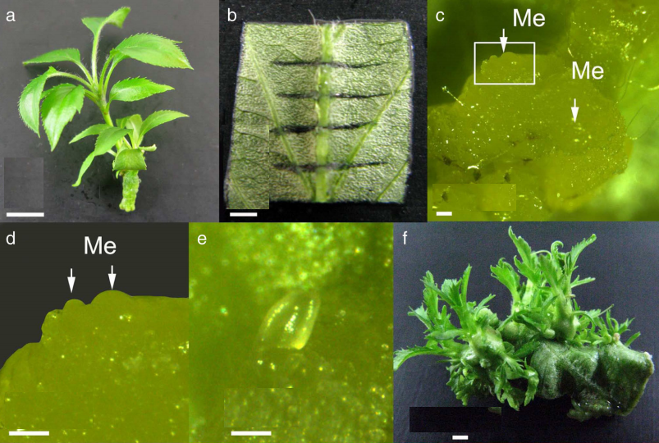

图2-1 “Gala”苹果叶片不定芽再生
用于不定芽再生4周苗龄的试管苗 (a)；叶片外殖体 (b)；培养11天后形成的不定芽突起 (c)；c图中不定芽突起的放大图 (d)；发育完整的不定芽 (e)；不定芽萌发后形成的茎 (f)。
a图的比例尺为1.0 cm；d和f图的比例尺为1.0 mm；c、d和e图的比例尺为0.1 mm。
Figure 2-1. Adventitious shoot regeneration from leaf segments of apple ‘Gala’.
A 4-wk-old stock shoots (a). A leaf segment with four transverse cuts across the midvein on the abaxial side, used for shoot regeneration (b). Small meristemoids (Me) formed from callus after 11 d of culture (c). Magnified view of the rectangular area in (c), showing meristems (d). An adventitious bud with leaf primordia after 16 d of culture (e). Adventitious shoots regenerated from leaf segments after 11 wk of culture.
Bars in a =1.0 cm; in b and f =1.0 mm, and in c, d and e=0.1 mm.
图注为5号字，行距为固定值18磅，中英文对照

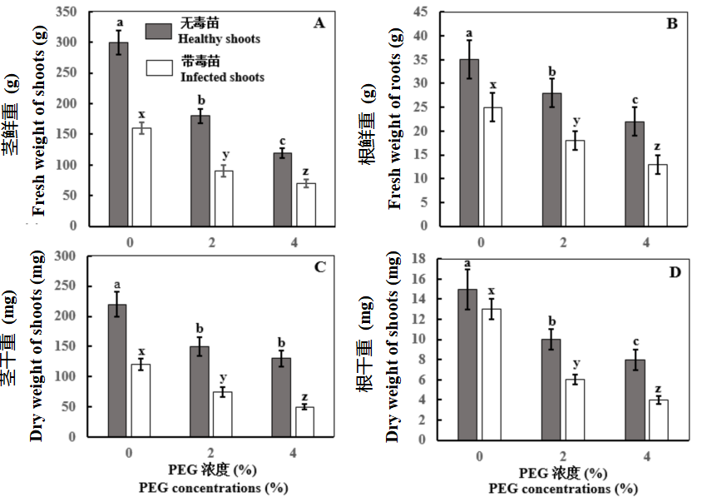
图2-2.PEG诱导的干旱胁迫对‘解百纳’葡萄 (Vitis vinifera）试管苗感染葡萄卷叶病毒-3和无毒苗营养生长的影响。
(A) 茎鲜重；(B) 茎干重；(C) 根鲜重；(D) 根干重。图中柱为平均数±标准误。同参数间带不同字母的数据表示差异显著 (P<0.05). 显著性检验方法用Student’s t-test。
Figure 2-2. Effects of PEG-induced drought stress on vegetative growth of in vitro shoots of ‘Cabernet Sauvignon’ grapevine (Vitis vinifera) infected with and without grapevine leafroll virus-3 (GLRaV-3).
(A) Fresh weight of shoots. (B) Dry weight of shoots. (C) Fresh weight of roots. (D) Dry weight of roots. Data were presented as means ± SE a nd with different letters within the same parameter are significantly different at P < 0.05 analyzed by Student’s t-test.

图注为5号字，行距为固定值18磅，中英文对照

参考文献
黄骥,王建飞,张红生. 2004.植物戊糖磷酸途径及其两个关键酶的研究进展[J].植物学报, 21(2): 139-145.
李振声,曾士迈.2002.中国小麦条绣病[M].北京:中国农业出版社.
刘光华,王伟,张伟中.2004.食品中还原型抗坏血酸的测定GB/T5009[S].中国标准出版社.159-173.
刘加林.1993-04-14.多功能一次性压舌板[P].中国发明专利,92214985.
王关林,方宏筠.2002. 植物基因工程（第二版）[M].北京：科学出版社.
王明亮.关于中国学术期刊标准化数据库系统工程的进展[EB/01]. http://www.cajcd.cn/pub/wml.txt/980810-2.html.
殷丽华. 2013.苹果属资源对苹果褐斑病的抗性机理及抗性诱导研究[D].杨凌:西北农林科技大学.
张桂芳,丁在松,赵明.2015.稗草(Echinochloa crusgalli)根型ppc基因对水转化及其对光合速率的调节效应[J].作物学报,41(3):507-514.
周涛,朱敏,周颖,国立耘.2009.我国部分苹果主产区病毒病检测初报[C].中国植物病理学会学术年会论文集,29-35.
Hull R. 2002. Matthews’ Plant Virology[M]. London :Academic Press.
ISAAA. Global status of commercialized biotech/GM Crops, the first fourteen years, 1996 to 2009. ISAAA Brief 41. Executive Summary; 2009. https:// www.isaaa.org/resources/publications
Joshi RK, Bharat SS, Rukmini MR. 2022. Engineering drought tolerance in plants through CRISPR/Cas genome editing. Plant Biotechnology Journal[J], 10 (9): 400. doi: 10.1007/s13205-020-02390-3.
Kreuze J. 2002. Molecular analysis on the sweet potato virus disease and its two causal agents[D]. Ph. D. Dissertation, Swedish University of Agricultural Sciences, Uppsala, Sweden.
Nawaz MA, Huang Y, Bie Z, Ahmed W, Reiter RJ, Niu M, Hameed S. 2016. Melatonin: current status and future perspectives in plant science. Frontiers in Plant Science, 6:1230. doi.org/10.3389/ fpls.2015.01230.
Reed BM, Lambardi O, Jari PT. 2014. Roles of antioxidants in plant stress biology. The 3rd International Symposium on Plant Stress Biology[C]. New York, United States of America, pp. 1-8.
Wu H, Qu X, Dong Zh, Luo X, Shao C, Forner J, Lohmann JU, Su M, Xu M, Liu X, Zhu L, Zeng J, Liu S, Tian Zh, Zhao Zh. 2020. WUSCHEL triggers innate antiviral immunity in plant stem cells[J]. Science, 370: 227-231.
Zhang LM, Wang QM, Liu QC, Wang QC. 2009. Sweetpotato in China. In: Loebenstein G, Thottappilly G (editors), Biology and Biotechnology of Sweetpotato. Springer, London, pp. 325–358.
悬挂缩进2个汉字符，正文部分用五号字，汉字用宋体，西文用Times New Roman，行距采用固定值16磅，段前空3磅，段后空0磅，标点符号用半角符号

题
目

作
者
姓
名

西
北
农
林
科
技
大
学
博士学位论文书脊
3cm左右
3cm左右
博士学位论文书脊

