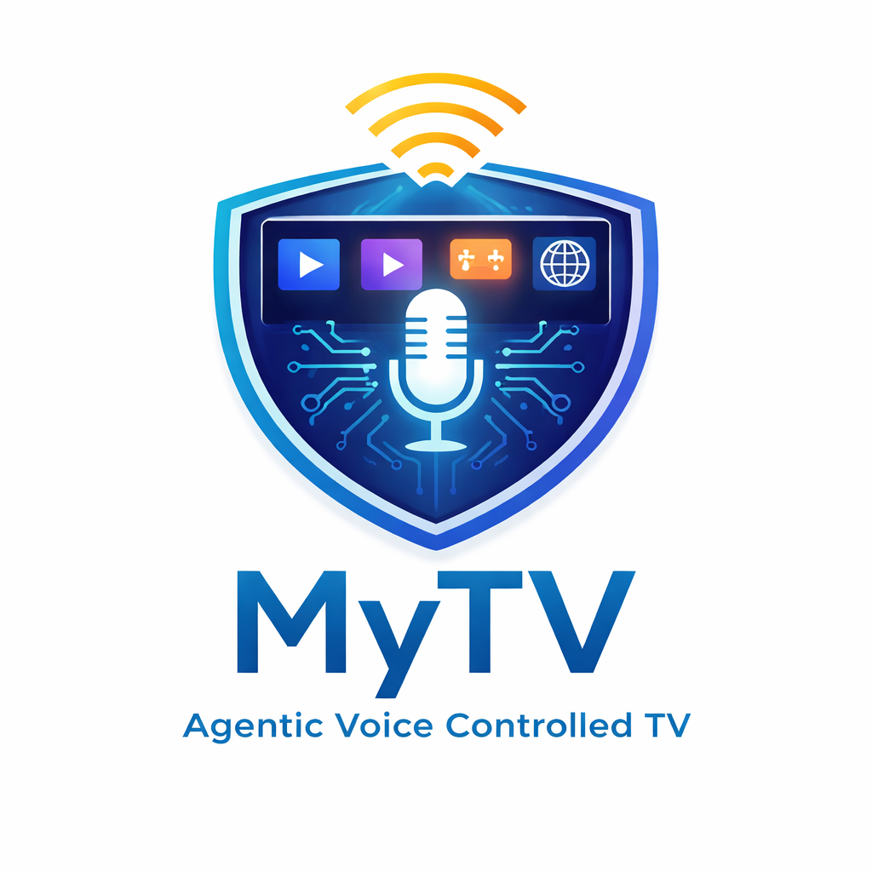
Architecture Roadmap
The World's First Voice-Operated Agentic TV Platform
A MyPhone Family Product · Version 1.0 · Confidential

1. Executive Summary
MyTV is an AI-powered television platform that turns any large-format display into an intelligent, voice-controlled room computer.

MyTV is a sister product to MyPhone, sharing the same philosophy of privacy, offline capability, and user control. Where MyPhone is the secure smartphone for the individual, MyTV brings that same intelligence to the shared living space — a unified device that replaces three products: a media system, a video conference station, and a workstation, all controlled by natural voice through an AI agent running entirely on-device.

The product model is deliberately simple. The large-format display has multiple HDMI inputs. Users connect their existing cable boxes, satellite receivers, and other devices to those inputs exactly as they always have. MyTV occupies one HDMI input and contributes what no external device can: a deep voice-control layer, a unified media library, end-to-end encrypted video calling, retro gaming and PC game streaming, and seamless integration with MyPhone.

Dimension | Specification
Platform | Raspberry Pi 5 8GB · Hailo-8L 13 TOPS NPU · 256GB NVMe · Infineon SLB9670 hardware TPM · Argon ONE V3 enclosure
Voice pipeline | Hybrid intent architecture: fine-tuned MiniLM-L6 classifier for 90% of commands (~605ms end-to-end). Gemma 2 2B IT INT4 (Google DeepMind) for complex queries (~2,100ms). Whisper Small INT8 on Hailo-8L NPU for speech-to-text.
Microphone | Blue Yeti Nano (fixed installation, hardware mute, PipeWire WebRTC AEC) or Rode Wireless ME (large room, body-worn, natural 25-30dB echo rejection + PipeWire AEC).
Media library | Custom MyTV Media Center — first-party unified library (audio, video, photos, documents). Three-tier encrypted access: USB local · MyPhone Cast (TLS 1.3 + device cert) · MyPhone Secure Cloud (client-side E2EE).
Video calling | Matrix-native. 1:1 via Matrix VoIP (E2EE via Olm/Megolm). Group via Element Call (MSC3401, E2EE via Megolm). Served from MyPhone Secure Cloud. Requires subscription.
Gaming | RetroPie retro gaming (NES–PS1). Parsec: couch co-op hosting, remote workstation access, AAA game streaming from local or cloud PC. RetroArch Netplay for distributed two-device multiplayer.
Security | Hardware TPM 2.0 disk encryption (PCR-bound LUKS). Signed A/B OTA updates. Suspend-to-RAM primary power mode (2s resume). nftables default-deny firewall. AppArmor application sandboxing.
MyPhone integration | Screen cast (WebRTC, device cert auth, 1080p30). Matrix E2EE call handoff. Shared media library via MyPhone Cast. Phone-as-remote. Presence-based profile unlock.
Subscription | MyTV box operates fully standalone for media, gaming, and workstation functions. MyPhone Secure Cloud subscription ($24.99/month) unlocks: Matrix E2EE video calling, encrypted media cloud sync, and cross-device continuity features.

2. Product Positioning
MyTV delivers what no commercial smart TV platform provides: a complete intelligence layer with deep local AI, end-to-end encrypted communication, and a unified voice-controlled experience that works without the cloud.

2.1 What MyTV Does Exceptionally Well
- Local media at full quality — 4K hardware decode (H.264, H.265, VP9) via Pi 5 VideoCore VII. Unified offline-first library covering all media types. No subscription required for local content.
- YouTube and non-DRM streaming — VP9 hardware-decoded up to 4K via Chromium. YouTube, Twitch, Plex, and all non-DRM streaming services at full quality.
- End-to-end encrypted video calls — Matrix VoIP for 1:1 calls. Element Call for group calls. Megolm encryption throughout. Served from MyPhone Secure Cloud — no third-party server has access to call media. Requires subscription.
- Retro gaming and PC game streaming — RetroPie covers NES through PS1 emulation at 1080p upscaled. Parsec streams modern AAA titles from a local or cloud gaming PC. The Pi 5 decodes H.265 in hardware — no additional load.
- Voice control depth — Every function is voice-accessible via the "Hey MyTV" wake word. The hybrid intent classifier makes common commands respond in under one second. Context window enables multi-turn conversation.
- MyPhone ecosystem integration — Screen cast, call handoff, shared media library, phone-as-remote, and presence-based profile switching — features no commercial smart TV platform offers.
- Display input switching — MyTV voice commands switch between all HDMI inputs on the display. "Hey MyTV, switch to cable" activates while any input is showing. Users keep all their existing devices.

2.2 Platform Limitations — Documented Honestly
Platform constraint: The Raspberry Pi 5 supports Widevine L3 content protection only. Netflix, Disney+, and Amazon Prime Video require Widevine L1 for HD and 4K content. With L3, these services deliver SD quality only. This is a Broadcom BCM2712 hardware constraint that no software update can resolve.

MyTV's strength is the combination of capabilities it delivers that no dedicated streaming device provides: full local media library, deep voice control, encrypted video calling, gaming, workstation access, and MyPhone integration. Users who require HD streaming from DRM-protected services connect those devices to the display's other HDMI inputs — which they already own and can switch to by voice.

- YouTube 4K — VP9 hardware-decoded to 4K via Chromium with codec flags. AV1 (YouTube's default 4K codec) is software-only on Pi 5 VideoCore VII; VP9 is forced via launch flags. Visually indistinguishable from AV1 at streaming bitrates.
- AAA gaming — Not native to Pi 5 GPU. Parsec routes this correctly: GPU-intensive work happens on a powerful host machine; MyTV receives and decodes the H.265 stream in hardware. RetroPie covers the classic gaming catalogue.

3. Hardware Stack

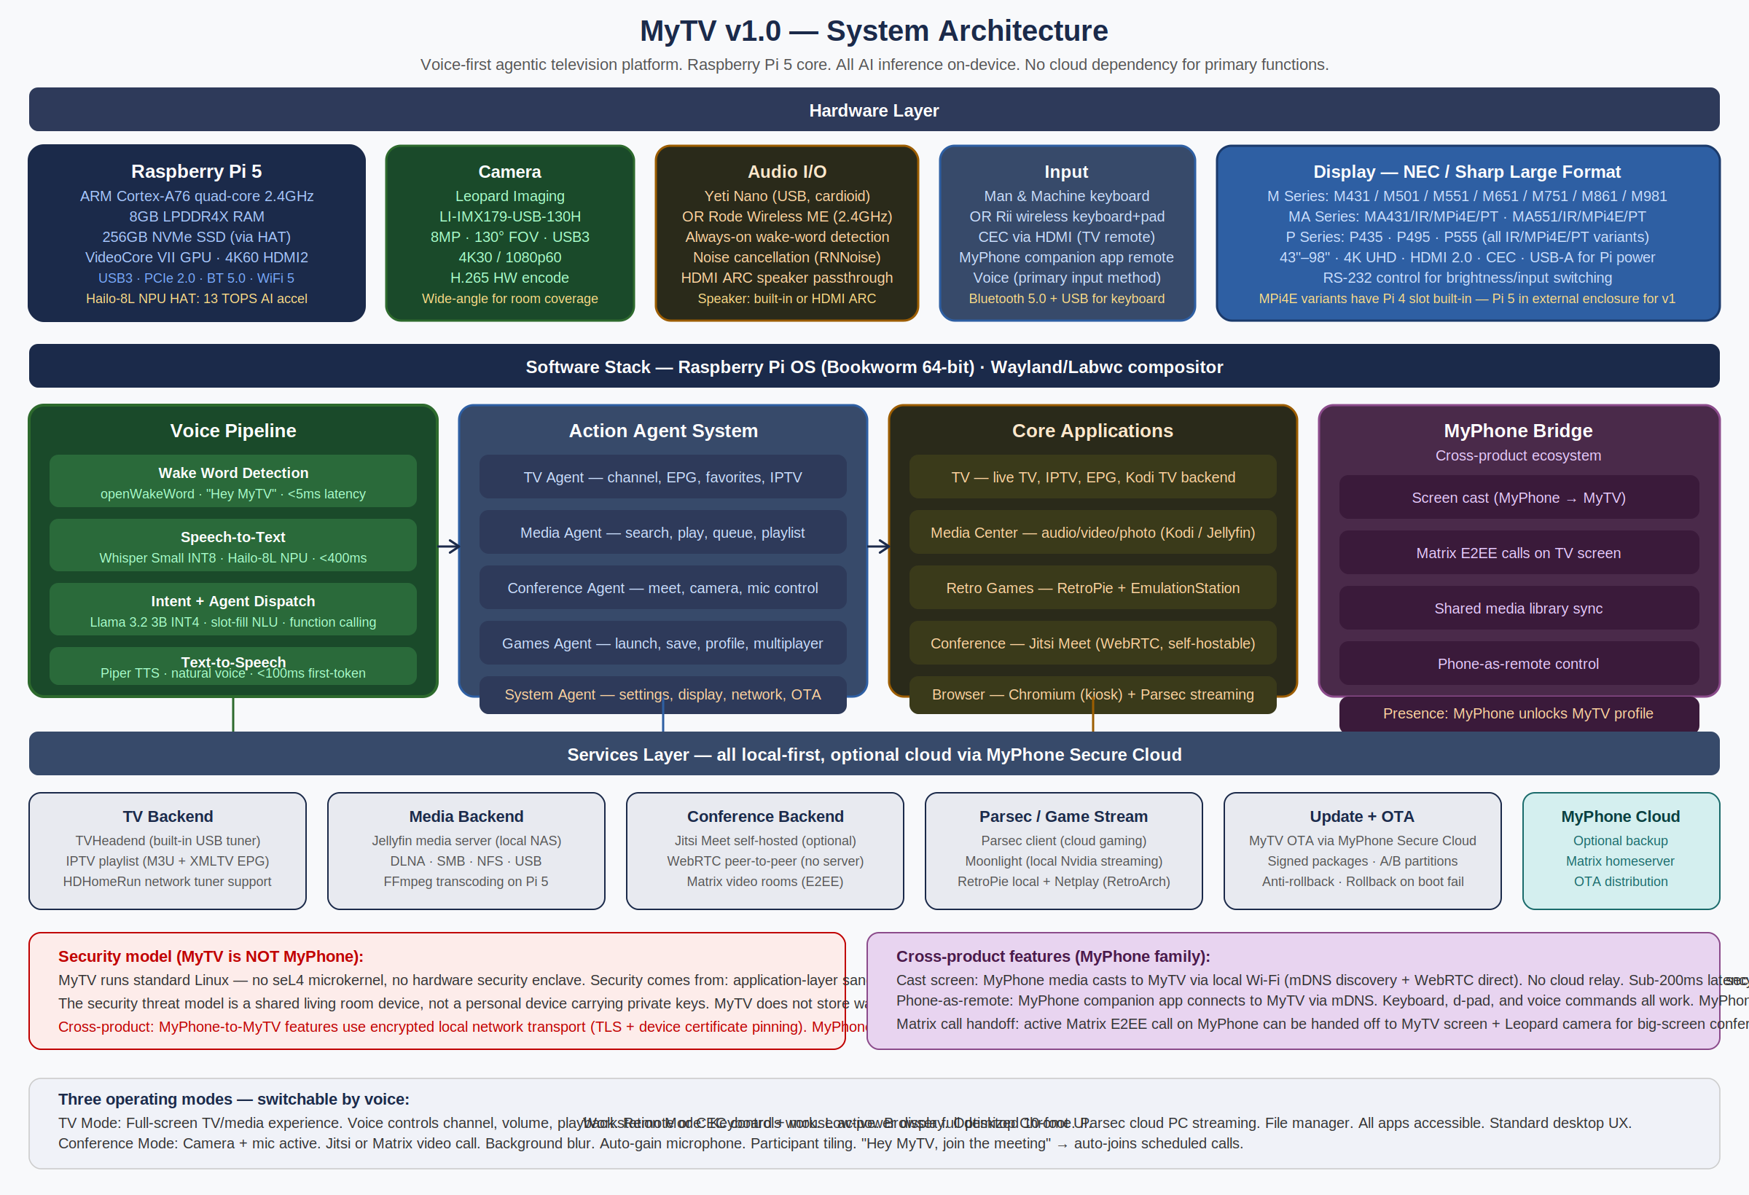
Figure 3.1 — MyTV system architecture. Hardware layer (top), software stack (centre), services layer (bottom). Three operating modes: TV, Conference, Workstation.

3.1 Core Compute Platform — Raspberry Pi 5
Component | Specification | Role in MyTV
CPU | ARM Cortex-A76 quad-core 2.4GHz (overclockable to 3.0GHz with active cooling) | OS, agent system, MiniLM-L6 classifier, Gemma 2 2B inference, application layer
RAM | 8GB LPDDR4X — mandatory minimum. zram compression (4GB configured) yields ~12GB effective headroom. | Gemma 2 2B INT4 requires ~1.5GB. Remaining headroom for OS, media playback, conference client.
GPU / display output | VideoCore VII. Dual HDMI 2.0. 4K60 on HDMI 0. Hardware decode: H.264, H.265, VP9. | 4K local media and Parsec stream decoding in hardware. AV1 decode is software-only — VP9 forced for YouTube.
Storage | 256GB NVMe SSD via PCIe M.2 HAT (sole PCIe device). Hailo-8L on USB3 (separate). | OS (A/B OTA partitions), user media library, AI models, application data.
Connectivity | Wi-Fi 5 (802.11ac), Bluetooth 5.0, 2× USB 3.0, 2× USB 2.0, Gigabit Ethernet. | Gigabit Ethernet recommended for media-intensive installs. Wi-Fi 5 adequate for most home use.
Power | Official Raspberry Pi 27W USB-C PD PSU (5V/5A). Mandatory. | Standard 3A USB-C PSUs insufficient for Pi 5 + Hailo USB3 + active cooling under sustained load.

3.2 Hailo-8L NPU — Speech Recognition Accelerator
The Hailo-8L AI HAT+ connects via USB3 (Hailo USB3 SDK). It runs Whisper Small INT8 only — it is a CNN and vision accelerator, not an LLM engine. The large language model (Gemma 2 2B) and intent classifier (MiniLM-L6) run on the Pi 5 ARM CPU via llama.cpp NEON optimisation. This architecture is the correct one: Whisper is a valid Hailo Model Zoo entry with hardware-accelerated inference; LLMs require autoregressive decoder attention that the Hailo-8L does not support.

Model | Hardware | Latency | Role
openWakeWord | Pi 5 CPU (single core) | <5ms | Always-on "Hey MyTV" detection. <0.1 false trigger per hour.
Whisper Small INT8 | Hailo-8L NPU via USB3 | ~400ms | Speech-to-text transcription of user utterance.
MiniLM-L6 classifier | Pi 5 CPU · 22MB | <50ms | Fast intent classification. 15 classes. Handles 90% of commands.
Gemma 2 2B IT INT4 | Pi 5 CPU · llama.cpp NEON · 1.5GB | ~1,600ms | LLM fallback for complex, ambiguous, or multi-turn queries (10% of commands).
Piper TTS | Pi 5 CPU | <100ms | Natural spoken confirmation after each executed command.

3.3 Camera — Leopard Imaging LI-IMX179-USB-130H-CONN
- Sensor — Sony IMX179 · 8MP · 130° diagonal FOV · USB 3.0 UVC · plug-and-play on Linux · no driver required
- Video modes — 4K@15fps · 1080p60 · 720p60 · MJPEG hardware compression
- Conference use — 130° wide-angle captures the full room without pan or tilt hardware. Appropriate for 2–6 person meeting rooms and living rooms.
- Mounting — Top-of-display via 1/4-20 tripod thread or bezel clip. 1.8m active USB3 extension cable for installations where the Pi 5 enclosure is rack-mounted or behind the display.

3.4 Microphone
Device | Best for | Echo cancellation | Hardware mute
Blue Yeti Nano | Fixed desk / media console. Cardioid polar pattern faces user; rejects TV speaker direction passively. | PipeWire WebRTC AEC module. HDMI ARC audio output as loopback echo reference. Effective at TV levels up to ~75dB at 2m. | Dedicated hardware button with LED indicator (red = muted).
Rode Wireless ME | Large rooms, mobile users. Body-worn transmitter 15-20cm from mouth; TV speaker 2-3m away. | Natural acoustic rejection ~25-30dB from body-worn proximity (primary). PipeWire AEC secondary layer. | Physical mute button on transmitter body. 30m wireless range.

PipeWire AEC configuration is identical for both microphones — a single config file routes either USB source through the WebRTC echo-cancel module with the HDMI ARC output as the speaker reference signal.

3.5 Hardware Security — Infineon SLB9670 TPM 2.0
A Waveshare TPM2.0 Module (Infineon SLB9670) connects via SPI GPIO header. This is a hardware TPM 2.0 chip — the same Infineon family as the MyPhone OPTIGA security element. It provides tamper-resistant key storage for the LUKS full-disk encryption key, which is sealed against TPM PCR values representing the verified boot chain. Extracting the NVMe SSD and connecting it to a different system will not yield the LUKS key without the TPM.

3.6 Compatible Displays
MyTV is designed and validated for NEC MultiSync and Sharp NEC large-format commercial displays. These are preferred for 24/7 operational reliability, quality HDMI-CEC implementations, and the MA/P series MPi4E variants that include an on-panel Raspberry Pi Compute Module slot.

Series | Sizes | Key capabilities | Recommended configuration
M Series | 43"–98" | 4K UHD · HDMI 2.0 (multiple inputs) · HDMI-CEC · RS-232 control · 24/7 operation rated | M551 (55") for home living room. M651 (65") for larger spaces. M751/M861/M981 for commercial conference rooms.
MA Series | 43"–55" | All M features + optional IR touchscreen · Raspberry Pi compute module slot (-MPi4E variant) | MA431-MPi4E: compact 43" installation with Pi slot. External Pi 5 enclosure used for v1 (Pi CM4 currently in slot; Pi CM5 support planned).
P Series | 43"–55" | Premium commercial grade · 700cd/m² · IR touch · Pi slot · Precision touch variants | P555-MPi4E: highest quality MyTV display. Future single-cable display+compute unit when Pi CM5 available for the MPi4E slot.
Note: All NEC/Sharp M, MA, and P series displays have multiple HDMI inputs. Users connect all their existing external devices to those inputs unchanged. MyTV occupies one input and voices-commands can switch between any input: "Hey MyTV, switch to HDMI 2."

4. Voice Pipeline
From "Hey MyTV" to completed action in under one second for 90% of commands. All inference on-device. No audio sent to any server.

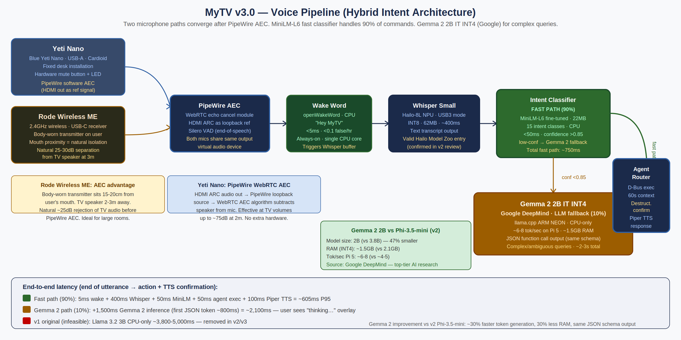
Figure 4.1 — Voice pipeline end-to-end. Two microphone paths converge after PipeWire AEC. MiniLM-L6 fast classifier for 90% of commands (~605ms). Gemma 2 2B IT INT4 from Google DeepMind for complex queries (~2,100ms).

4.1 Pipeline Stages
- openWakeWord continuously monitors the microphone stream on a single CPU core. Detects "Hey MyTV" in under 5ms with fewer than 0.1 false triggers per hour in a normal home environment.
- PipeWire WebRTC AEC subtracts the TV speaker signal from the microphone input using the HDMI ARC output as a loopback reference. Both the Yeti Nano and Rode Wireless ME route through the same AEC virtual device. Echo cancellation is effective at TV audio levels up to ~75dB.
- Whisper Small INT8 transcribes the utterance on the Hailo-8L NPU (USB3 mode) in approximately 400ms. Real-time factor ~1.0. Output: a UTF-8 text string.
- The MiniLM-L6 intent classifier evaluates the transcribed text against 15 intent classes in under 50ms on CPU. If confidence exceeds 0.85, the intent routes directly to the agent. If below threshold, it falls through to Gemma 2.
- Gemma 2 2B IT INT4 (Google DeepMind, 1.5GB RAM) handles complex, ambiguous, or multi-turn queries via llama.cpp with ARM NEON optimisation. Produces a JSON function call in approximately 1,600ms. A "thinking…" indicator appears on screen within 500ms of invocation.
- The agent router validates the JSON schema, executes the action via D-Bus, and speaks a confirmation via Piper TTS within ~100ms of execution. The user hears the result approximately 605ms after finishing their sentence for common commands.

4.2 Hybrid Intent Architecture — Why Not a Single LLM
90% of television voice interactions come from a closed vocabulary: "play [title]," "tune to [channel]," "start a meeting," "volume up," "switch to HDMI 2." A 22MB sentence transformer fine-tuned on 5,000 annotated TV command utterances classifies these in under 50ms on CPU. Running a 1.5GB language model for these interactions would add 1,600ms of latency with no benefit.

The LLM handles the 10% where genuine language understanding is required: ambiguous entity resolution ("the Batman one" referencing a previous search), multi-entity extraction ("find a comedy from the 80s with Eddie Murphy"), and conversational context where the previous turn must be interpreted. A 60-second context window stores the previous intent and response so that follow-up commands resolve correctly.

4.3 Agent System
Agent | Responsibilities
Media Agent | Search and playback across the unified MyTV Media Center library. Source routing across USB, MyPhone Cast, and MyPhone Secure Cloud. Playlist and queue management. MyPhone media library access.
Conference Agent | Matrix VoIP 1:1 calls. Element Call group calls. Call mute, unmute, camera, screen share, end. CalDAV calendar auto-join. Matrix call handoff from MyPhone. All call state controlled via D-Bus interface to native Matrix client.
Games Agent | RetroPie local launch. Parsec couch co-op session hosting. Parsec workstation and gaming PC connection. RetroArch Netplay session management. Multiplayer invitations via Matrix messages. Agent auto-selects Parsec or Netplay based on voice command context.
System Agent | Volume. Display brightness via RS-232. Operating mode switching (TV, Conference, Workstation). Settings navigation. Suspend/wake. OTA update trigger.
Input Agent | HDMI-CEC display input switching: "Hey MyTV, switch to HDMI 2," "Hey MyTV, switch to cable," "Hey MyTV, come back." Active regardless of which display input is currently showing.
MyPhone Bridge Agent | Screen cast receive (WebRTC DTLS-SRTP). Matrix E2EE call handoff coordination. MyPhone media library source management. Phone-as-remote service. Presence-based profile unlock.

4.4 Safety and Robustness
- Destructive action gate — Actions categorized as destructive (delete, format, factory reset, unpair) require a secondary voice confirmation — "Hey MyTV, confirm" — within 10 seconds. Protects against adversarial voice injection from TV audio.
- Voice failure recovery — Three-attempt hierarchy: (1) re-prompt; (2) on-screen "Did you mean?" suggestions from the classifier's nearest matches; (3) automatic fallback to remote control mode. Users are never left in a dead state.
- Context window — 60-second conversation context. "Find Batman movies" → "Play the 1989 one" resolves correctly without restating the subject.

5. Software Stack

5.1 Operating System and Compositor
- OS — Raspberry Pi OS Bookworm (64-bit Debian 12). Required for Hailo-8L NPU support and Gemma 2 2B INT4 memory addressing. 64-bit build only.
- Compositor — Labwc (wlroots-based Wayland compositor). Lightweight, fast startup, full Pi 5 VideoCore VII driver support. Presents the TV-mode 10-foot UI shell on startup.
- Audio system — PipeWire handles microphone routing, HDMI ARC output, WebRTC AEC echo cancellation, and application audio mixing. A single PipeWire configuration file routes both Yeti Nano and Rode Wireless ME through the same AEC virtual device.
- Boot time — Cold boot target: 22 seconds. Suspend-to-RAM (S2RAM) is the primary power-off mode — 2 second resume. Power button triggers S2RAM. Full cold boot is reserved for OTA update installation.
- Security hardening — nftables firewall (default-deny inbound). AppArmor profiles for all media and conference applications. SSH disabled in production firmware. No root login. Minimum exposed network surface.

5.2 Display Input Model
MyTV occupies one HDMI input on the NEC/Sharp display. The display's remaining inputs are available for any external devices the user chooses to connect — exactly as if MyTV were not present. MyTV does not intercept, manage, or record signals on those inputs.

Input | Source | Managed by
HDMI 1 (example) | MyTV (Raspberry Pi 5) | MyTV software and voice agent. Native applications, MyPhone integration.
HDMI 2, 3… (example) | Any external device: cable box, satellite receiver, games console, streaming device | The external device and its own controls. MyTV does not touch these inputs.
HDMI ARC | Audio return channel (all inputs share this for speaker output) | Shared. MyTV uses HDMI ARC audio as the echo reference for its AEC pipeline.

The Input Agent enables voice switching between all inputs. "Hey MyTV, switch to cable" sends a CEC command to the display to activate that input. "Hey MyTV, come back" returns to the MyTV input. The voice pipeline continues listening regardless of which input is active — so the user can always call MyTV back by voice.

5.3 Operating Modes
Mode | How to activate | UI optimisation | Primary input method
TV Mode | Default on startup. "Hey MyTV, TV mode." | 10-foot interface. Large fonts, high contrast, d-pad navigation. MyTV Media Center as the home screen. | Voice (primary), HDMI-CEC remote, Rii keyboard, MyPhone companion app remote.
Conference Mode | "Hey MyTV, call [name]" or "start a meeting." Calendar auto-join. | Fullscreen video tile layout. Self-view. Mute and camera status indicators. | Voice for all call control. Keyboard for text chat.
Workstation Mode | "Hey MyTV, workstation." Connecting keyboard and mouse. Parsec auto-activates. | Standard desktop with taskbar, windowed applications, and mouse cursor. | Keyboard and mouse primary. Voice for application launch and search.

6. Native Applications

6.1 MyTV Media Center
A first-party unified offline media library. Same design philosophy as the MyPhone Media Center — one library, all media types, no cloud dependency for local content.

Pillar | Supported formats | Decode engine | TV-optimised features
Audio | MP3, FLAC, AAC, OGG, OPUS, WAV, M4A, AIFF | FFmpeg / GStreamer pipeline | Background playback with lock-screen transport controls. Smart playlists. Podcast engine (RSS, chapter support, auto-download). Equalizer. 10-foot artist and album browser.
Video | MP4, MKV, WebM, AVI, MOV, H.265/HEVC, VP9 | FFmpeg + VideoCore VII HW decode | Auto-thumbnail generation. Subtitle support (SRT, ASS, VTT). Resume playback. Series and collection grouping. Picture-in-picture mode.
Photos | JPG, PNG, HEIC, WebP, RAW (DNG, ARW, NEF, CR2) | libraw + ImageMagick + gdk-pixbuf | Timeline and album views. TV slideshow mode. EXIF viewer. Non-destructive edits: crop, rotate, exposure, colour correction.
Documents | PDF, EPUB, MOBI, TXT, Markdown, HTML | poppler (PDF), foliate (EPUB), Pandoc | Full-screen reader mode with large typography for TV viewing distance. PDF annotations and bookmarks. eBook reading progress synced with MyPhone.

- Unified library engine — Single SQLite database with FTS5 full-text search indexes all four media types. A single voice query — "Hey MyTV, find anything about space" — searches across movies, albums, documents, and photos simultaneously.
- Import pipeline — USB drive auto-mount and index on insertion. yt-dlp integration for downloading audio and video to the local library offline (not streaming — downloaded to the device). Import daemon generates metadata and thumbnails automatically.

6.2 Conference — Matrix-Native Video Calling
End-to-end encrypted video calling. 1:1 and group. Served from MyPhone Secure Cloud. The same Matrix protocol used by MyPhone — no second video system, no bridge required.

The Conference application uses a native Linux Matrix client built on the Matrix Rust SDK. This provides clean D-Bus interfaces for voice control — the Conference Agent calls org.myphone.matrix.call.mute(), .hangup(), and .camera_toggle() directly. No browser kiosk, no JavaScript injection, no fragile accessibility workarounds.

Call type | Protocol | E2EE | Requires
1:1 video call | Matrix VoIP (WebRTC signalled via Matrix). DTLS-SRTP for media. | Olm key exchange. The MyPhone Secure Cloud server relays signalling only — it cannot see media. | MyPhone Secure Cloud subscription
Group video call | Element Call (Matrix MSC3401). LiveKit-based SFU on MyPhone Secure Cloud. | Megolm group encryption. The SFU forwards encrypted packets without decrypting. Server cannot see call media. | MyPhone Secure Cloud subscription
Call handoff from MyPhone | "Hey MyTV, take the call." MyTV joins the active Matrix room directly. | E2EE preserved throughout. MyTV joins as a second device identity. MyPhone remains in the room. | Both devices registered on MyPhone Secure Cloud
External participants | Matrix federation: any Matrix user on any homeserver can be invited by their Matrix ID. | E2EE maintained for all federated participants. | Participant has a Matrix account (any server)

CalDAV calendar integration enables automatic meeting join. Calendar events with Matrix room links generate a "Your 2pm call starts in 5 minutes" voice announcement, and "Hey MyTV, join the meeting" or automatic join on confirmation.

6.3 Retro Games and Parsec

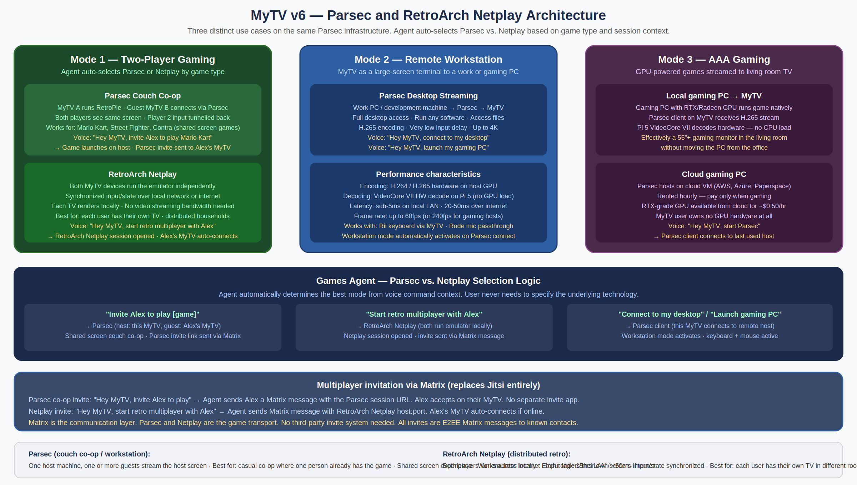
Figure 6.1 — Parsec and RetroArch Netplay architecture. Three distinct Parsec modes plus distributed Netplay. Games Agent auto-selects mode from voice command context. Multiplayer invitations sent via Matrix messages.

6.3.1 RetroPie — Local Retro Gaming
RetroPie with EmulationStation provides a curated retro gaming hub. The Pi 5 at 3.0GHz (overclocked with active cooling) handles NES through PlayStation 1 emulation smoothly, with N64 games running at 1080p upscaled. ROM files are user-provided. USB import and local NVMe storage. Controller support via the Linux HID input system for USB and Bluetooth gamepads with automatic RetroArch button mapping.

6.3.2 Parsec — Three Modes
Mode | What happens | Voice commands
Couch co-op | This MyTV runs the RetroPie game (host). A second MyTV or any Parsec-connected device joins as a guest and streams the host's screen. Both see the same display; the guest's controller input tunnels back to the host. The emulator sees two controllers on the same machine. Best for shared-screen games: Mario Kart split screen, Street Fighter, Contra. | "Invite Alex to play Mario Kart" → game launches, Parsec session opened, Matrix message with session link sent to Alex. Alex says "accept the invite" on their device.
Remote workstation | MyTV connects to a work PC, development machine, or any Parsec host. Full desktop access on the living room TV. H.265 encoded on host GPU → H.265 hardware decoded on Pi 5 VideoCore VII. Sub-5ms input latency on LAN. Workstation Mode activates automatically on connect. | "Connect to my desktop" · "Connect to the work PC" · "End the remote session"
AAA gaming | A gaming PC with a dedicated GPU (local or cloud VM) runs the game natively. Parsec streams H.265 to MyTV. Pi 5 decodes in hardware with no CPU overhead. The living room TV becomes a high-end gaming display without moving the PC. Cloud VM option makes AAA gaming accessible without owning GPU hardware. | "Launch gaming PC" · "Start Parsec" · "End the gaming session"

6.3.3 RetroArch Netplay — Distributed Two-Device Multiplayer
When two players each have their own MyTV in separate rooms or households, RetroArch Netplay enables distributed multiplayer. Both devices run the emulator independently; Netplay synchronises controller input and emulator state. Each TV renders the game locally — no video streaming, minimal bandwidth. The Games Agent hosts a Netplay session and sends the host address to the other player as a Matrix message.

The Games Agent selects between Parsec and Netplay automatically: "invite Alex to play" triggers Parsec (shared screen, one host); "start retro multiplayer with Alex" triggers Netplay (each player renders locally). The user does not need to understand the distinction.

6.4 Browser
- TV mode — Chromium kiosk with a large-button streaming service launcher page. VP9 forced via launch flags for YouTube 4K hardware decode. d-pad navigation optimised for remote control.
- Workstation mode — Full Chromium with uBlock Origin and Privacy Badger pre-installed. DNS-over-HTTPS to Cloudflare 1.1.1.1. No Google account sync by default.
Note: Chromium is an on-demand application in v1, not a permanent resident process. This frees approximately 300-500MB RAM when the browser is not in use — meaningful headroom on an 8GB device running Gemma 2 2B.

7. Media Access Architecture
Three-tier encrypted architecture. DLNA and SMB are intentionally absent — they provide no authentication and no encryption. MyPhone Cast delivers the same capability — encrypted, authenticated, seekable media streaming — using infrastructure already present in both products.

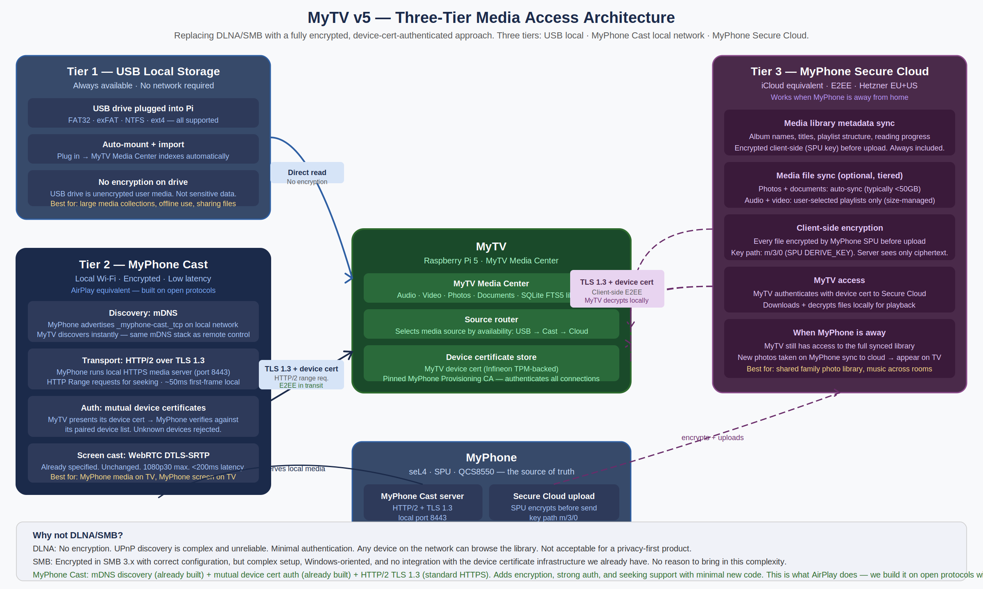
Figure 7.1 — Three-tier media access. Tier 1: USB (direct, always available). Tier 2: MyPhone Cast (mDNS + HTTP/2 + TLS 1.3 + device cert mutual auth). Tier 3: MyPhone Secure Cloud (client-side E2EE, SPU key derivation). MyPhone is the encryption authority for cloud-stored media.

7.1 Tier 1 — USB Local Storage
A USB drive plugged into the Pi 5 is auto-mounted and indexed by the MyTV Media Center. Supports FAT32, exFAT, NTFS, and ext4. The import daemon fingerprints new files, extracts metadata via FFmpeg and libraw, generates thumbnails, and populates the SQLite library within approximately 30 seconds of drive insertion. Voice: "Hey MyTV, eject the USB drive" performs a clean unmount before physical removal.

7.2 Tier 2 — MyPhone Cast (encrypted local network)
When MyPhone joins the same Wi-Fi network as a paired MyTV, it advertises a secure media server via mDNS (_myphone-cast._tcp) and opens a local HTTPS server on port 8443. MyTV discovers this service and connects using mutual TLS 1.3 with device certificate authentication — both devices present their device certificates, and MyPhone verifies MyTV's certificate against its paired device list. Unknown devices are refused before any media is served.

The API uses HTTP/2 with Range request headers, enabling arbitrary seeking in large video and audio files without buffering the full file. First-frame latency is approximately 50ms on a local 5GHz Wi-Fi network. A WebSocket event channel delivers real-time library change notifications — a photo taken on MyPhone appears in the MyTV Media Center within seconds.

Property | DLNA (replaced) | MyPhone Cast
Encryption in transit | None — all media served in plaintext | TLS 1.3 unconditionally. All media bytes encrypted.
Authentication | None — any device on the network can browse and stream | Mutual device certificate auth. MyPhone verifies caller cert against its paired device list.
Integration with device certs | None | Full. Uses the device certificate infrastructure already built for MyPhone.
Forward secrecy | N/A | TLS 1.3 mandates ephemeral key exchange. Past sessions cannot be decrypted if device keys are later compromised.
Seeking in large files | Limited and unreliable | Native HTTP Range headers. Arbitrary byte-range seeking. Same technology CDNs use for video.

7.3 Tier 3 — MyPhone Secure Cloud (encrypted sync)
The cloud tier enables MyTV to access the MyPhone media library when MyPhone is not on the local network — at work, travelling, or away from home. It extends the existing MyPhone Secure Cloud encrypted backup infrastructure.

- Client-side encryption — Every file is encrypted by the MyPhone SPU before upload. Key derivation path: m/3/0 via the cryptod DERIVE_KEY operation. Algorithm: AES-256-GCM. The server holds only ciphertext. The MyPhone Secure Cloud server cannot decrypt any media file.
- Decryption authority — MyTV downloads cloud-stored files and requests decryption keys from MyPhone Cast. MyPhone derives and returns keys only to paired devices. If MyPhone is completely offline, MyTV cannot decrypt cloud-stored media — the SPU remains the encryption authority.
- Sync policy — Photos and documents auto-sync (typically under 50GB). Audio and video are user-selected playlists only — file sizes make automatic sync impractical. Library metadata (album structure, playlists, reading progress, thumbnails) always syncs and is small.
- Family use case — Photos taken on a family member's MyPhone appear on the home MyTV within minutes via the cloud, even when that person is not home. The family photo library is always current on the living room display.

7.4 Source Router
The MyTV Media Center source router automatically selects the best available source for each media item. From the user's perspective, the library is a single unified collection — they say "play my Venice photos" and the system finds them on whichever tier has them.

# Source priority (simplified)
for each media request:
if file present on USB drive → stream from USB (fastest, no network)
elif MyPhone reachable on local Wi-Fi → stream via Cast (encrypted, ~50ms)
elif file synced to Secure Cloud → stream from cloud (E2EE, requires subscription)
else → show unavailable indicator

8. Security Model
MyTV is a shared room device. Its security model is calibrated for that threat model — not the hardware enclave model of MyPhone, and not naively under-specified. The fundamental principle: MyTV never stores wallet keys, biometric data, or any MyPhone TCB secrets.

8.1 Verified Boot and Hardware Disk Encryption
- Pi 5 BootROM validates the EEPROM bootloader against the OTP-burned MyTV Boot Key (stored in the production HSM, 2-of-5 quorum).
- The bootloader validates the Linux kernel. The kernel hash is extended into the Infineon SLB9670 hardware TPM PCR 0.
- systemd-cryptenroll unseals the LUKS disk encryption master key from the hardware TPM against the expected PCR values. On the verified boot path: disk unlocks and the OS starts. On any deviation (tampered bootloader, different kernel, NVMe extracted to another machine): PCRs do not match, disk remains locked.
- The Data partition (user media, application data, AI models) is encrypted separately from the root filesystem. OTA updates overwrite Root-A or Root-B but never touch the Data partition.

8.2 OTA Updates — Signed A/B Partitions
NVMe partition layout: Boot (256MB FAT32), Root-A (30GB ext4), Root-B (30GB ext4), Data (remaining ext4). One root partition is active; the other is standby for OTA writes. OTA packages are signed by the MyTV OTA Signing Key (2-of-5 HSM quorum, subordinate to the MyPhone/MyTV shared Root CA). APT verifies signatures before installation.

On OTA update: the signed package is written to the standby root partition, the boot flag is updated, and the device reboots. If the new partition fails to boot after 3 attempts, the boot flag reverts to the previous working partition. Users never lose a working system.

8.3 Network Security
Port | Protocol | Service | Scope | Notes
5353 | UDP | mDNS — presence detection, MyPhone Cast discovery, remote control service | Local subnet | Existing service, no change.
8443 | TCP | MyPhone remote control API and Cast client inbound from paired MyPhone | Local subnet | Device certificate mutual auth required. Non-paired devices refused.
443 | TCP | Outbound: Matrix client to MyPhone Secure Cloud. Parsec client to host. Secure Cloud media download. | Outbound only | All outbound HTTPS. No inbound ports required for these services.
All others |  | No SSH, no VNC, no Telnet, no other services. | Blocked | nftables default-deny inbound. Attack surface minimised.

8.4 Application Sandboxing
- AppArmor profiles — All media and conference applications run under AppArmor profiles that restrict filesystem access to declared paths. Parsec is restricted to /tmp and its data directory — it cannot access the media library, Matrix client data, or any other application.
- HDMI-CEC whitelist — CEC commands from external HDMI devices are whitelisted: volume control, d-pad navigation, power, and input switching. Arbitrary CEC commands from non-display sources are blocked. Prevents a malicious HDMI device from manipulating MyTV.
- Parsec trust boundary — When MyTV is in Parsec client mode, it displays output from a remote machine. MyTV does not expose any local data to the Parsec host. The session security depends on the security of the remote machine — this is a known and documented tradeoff.

8.5 MyPhone Pairing Revocation
Settings → Paired Devices lists all paired MyPhone devices. Removing a device revokes its certificate from MyTV's trust store immediately. Remote revocation via MyPhone Secure Cloud propagates to all paired MyTV devices within 60 seconds of a loss report. Offline MyTV devices receive the revocation on next network connection, queued until delivery is confirmed.

8.6 Security Boundary — MyTV and MyPhone TCB
Architectural boundary: MyPhone's seL4 TCB (cryptod, walletd, biometricd) is never accessible from MyTV over any interface. The Bitcoin wallet private keys and biometric templates live in the MyPhone SPU hardware and never leave it. Cross-product features use content signals (screen pixels, media metadata) and presence signals (device certificate identity) only. MyTV cannot perform cryptographic operations on the user's behalf as a proxy for MyPhone.

9. MyPhone + MyTV Ecosystem
The MyPhone product family works together the way Apple's iPhone and Apple TV work together — but without the walled garden. All real-time features use local Wi-Fi when both devices are on the same network. No cloud relay for latency-sensitive operations.

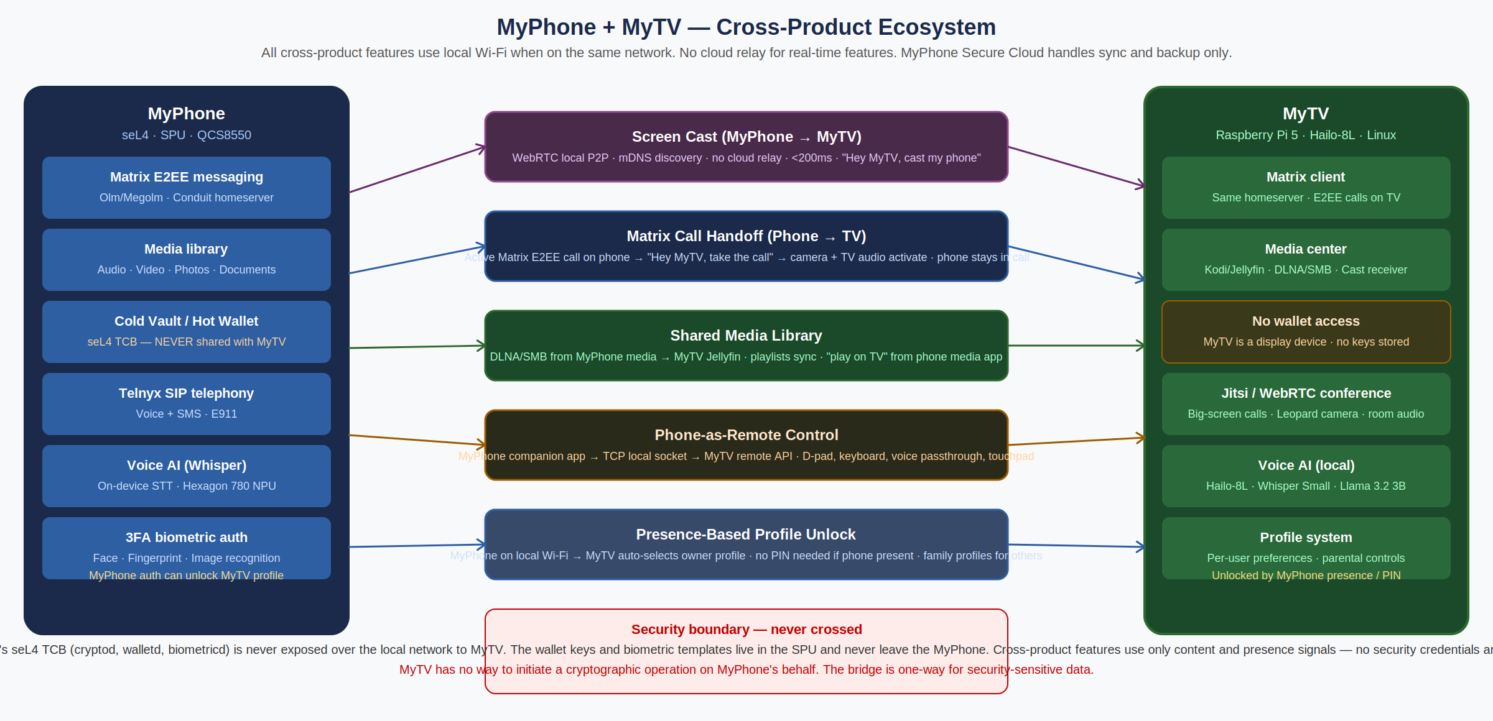
Figure 9.1 — MyPhone + MyTV cross-product integration. All real-time features use local Wi-Fi. MyPhone Secure Cloud handles backup, sync, and OTA only. MyPhone seL4 TCB never accessible from MyTV.

Feature | How it works | Network requirement
Screen cast | MyTV advertises a WebRTC casting service via mDNS. MyPhone discovers it automatically. Mutual device certificate authentication before connection. WebRTC DTLS-SRTP encrypted stream. Maximum 1080p30 on 5GHz Wi-Fi, 1080p60 on Ethernet. | Local Wi-Fi (same network). No cloud relay.
Matrix call handoff | "Hey MyTV, take the call." An active MyPhone Matrix E2EE call transfers to MyTV's Leopard camera and room audio. MyTV joins the Matrix room with its own device identity. E2EE preserved throughout. MyPhone remains in the room as a second participant. | Local Wi-Fi or internet — Matrix protocol works either way.
Shared media library | MyPhone Cast serves its media library via encrypted HTTPS to MyTV. No separate sync step — the library is browseable live from MyTV when MyPhone is on the local network. When MyPhone is away, Tier 3 cloud sync provides access. | Tier 2: local Wi-Fi. Tier 3: internet.
Phone-as-remote | MyPhone companion app connects to MyTV's remote API via mDNS discovery and device cert authentication. Provides d-pad, keyboard, touchpad, media transport controls, and voice passthrough (speak a command into MyPhone, it executes on MyTV). | Local Wi-Fi only.
Presence profile unlock | MyTV detects registered MyPhone devices via mDNS with approximately 10 seconds of detection latency. When the owner's phone is detected on the network, MyTV silently switches to the owner's profile. Multiple family members each get their own profile activated when their phone is home. | Local Wi-Fi only.
Multiplayer invitations | Parsec session links and RetroArch Netplay host addresses are sent as E2EE Matrix messages to known contacts via MyPhone Secure Cloud. No separate invite system. The recipient's MyTV auto-connects on acceptance. | Matrix (local or internet).

10. MyPhone Secure Cloud — Subscription Integration
MyTV operates fully standalone for media, gaming, and workstation functions. The MyPhone Secure Cloud subscription unlocks encrypted communication, cloud media sync, and cross-device continuity.

Feature | Without subscription | With subscription ($24.99/mo)
MyTV Media Center — local and USB media | Full access | Full access
Voice control — all agents | Full access | Full access
Retro Games — RetroPie | Full access | Full access
Parsec — all three modes | Full access | Full access
Browser | Full access | Full access
Display input switching | Full access | Full access
Cross-product: screen cast, phone-as-remote, presence unlock | Full access (local Wi-Fi) | Full access
Matrix E2EE video calling (1:1 and group) | Not available | Full access via MyPhone Secure Cloud Matrix service. Zero-day metadata retention.
MyPhone media library sync (Tier 3 cloud) | Not available | Photos and documents auto-sync. Audio and video user-selected playlists. Client-side E2EE.
Encrypted settings and profile backup | Not available | MyTV settings, profiles, and media library metadata backed up to encrypted cloud blob.
OTA updates | Via public MyTV OTA repository | Via MyPhone Secure Cloud CDN — same distribution network used for MyPhone firmware.

The subscription model means the MyTV hardware can be sold as a standalone product — users benefit immediately from local media, gaming, and voice control without any account requirement. The subscription provides the communication and cloud layer for users who want it, creating a recurring revenue stream from the same monthly plan that covers their MyPhone services.

11. Development Roadmap

Phase 0 — Validation Sprint (Weeks 1–2)
Proof-of-concept validation before committing to production hardware. All targets must be met before Phase 1 begins.

- Gemma 2 2B IT INT4 on Pi 5: download GGUF file, run llama.cpp NEON benchmark. Target: >6 tokens/sec.
- Hailo-8L USB3 mode + Whisper Small INT8: end-of-utterance to transcript. Target: <450ms.
- PipeWire WebRTC AEC with Yeti Nano: TV audio at 70dB, openWakeWord false trigger rate. Target: <0.1 per hour.
- Rode Wireless ME echo rejection at 3m room scale: same false trigger rate target.
- Infineon SLB9670 via SPI GPIO: tpm_tis_spi driver load, systemd-cryptenroll LUKS enrollment, PCR-bound unlock verified.
- CEC input switching to NEC M-series display: "switch to HDMI 2" command validated.
- MyPhone Cast prototype: mDNS advertisement, TLS 1.3 mutual cert handshake, HTTP/2 Range request video seek. Target: <100ms first frame on local 5GHz Wi-Fi.
- Parsec client on Pi 5: H.265 hardware decode during stream (VideoCore VII acceleration confirmed). Input latency measured on LAN.

Phase 1 — Foundation (Weeks 3–8)
- Raspberry Pi OS Bookworm 64-bit base build. Labwc Wayland compositor. TV-mode 10-foot shell.
- PipeWire audio stack with AEC module configured for both Yeti Nano and Rode Wireless ME.
- Hailo-8L USB3 Whisper pipeline. openWakeWord integration. End-to-end voice pipeline validated.
- MiniLM-L6 fine-tuned intent classifier (training dataset: 5,000 TV command utterances + 2,000 negative examples). Gemma 2 2B IT INT4 fallback integration.
- Infineon SLB9670 hardware TPM + LUKS disk encryption + PCR binding. A/B partition OTA layout on NVMe. Suspend-to-RAM.
- MyPhone Cast server (production): full media library API, WebSocket events, thumbnail serving, device cert authentication.
- MyTV Media Center source router: USB, Cast, and Cloud tiers. Source indicator in UI.
- CEC input switching and nftables firewall configuration.

Phase 2 — Applications (Weeks 9–18)
- MyTV Media Center: all four media pillars, unified SQLite library, 10-foot browser UI, yt-dlp integration.
- Conference: native Matrix client (Matrix Rust SDK), D-Bus interface for Conference Agent, 1:1 VoIP, Element Call group calls, CalDAV integration, call handoff from MyPhone.
- Games: RetroPie + EmulationStation, Parsec client (all three modes), RetroArch Netplay, Games Agent voice command routing, Matrix multiplayer invitation flow.
- Browser: Chromium TV mode (VP9 forced) and Workstation mode.
- MyPhone Secure Cloud media sync: photos and documents auto-sync pipeline, audio/video user-selection UI, client-side encryption via SPU, MyTV decrypt flow.
- Initial setup flow: language selection, Wi-Fi configuration, MyPhone pairing, display calibration, media source setup.

Phase 3 — Cross-Product Integration (Weeks 19–24)
- Screen cast (WebRTC, 1080p30, device cert auth). MyPhone companion app.
- Matrix call handoff end-to-end test with E2EE verification. Presence-based profile unlock.
- Pairing revocation flow: local Settings UI and remote revocation via MyPhone Secure Cloud.
- Multiplayer invitation via Matrix: Parsec session links and Netplay host addresses delivered as E2EE messages.

Phase 4 — Launch Preparation (Weeks 25–30)
- User testing with 15 households. Focus areas: voice command coverage, MyPhone Cast discovery reliability, Matrix call quality, Parsec latency across all three modes.
- Manufacturing setup: NVMe pre-image, TPM provisioning at assembly, factory acceptance test including AEC validation for both Yeti Nano and Rode Wireless ME configurations.
- Documentation: user quick-start guide, microphone installation guide, MyPhone pairing guide.

