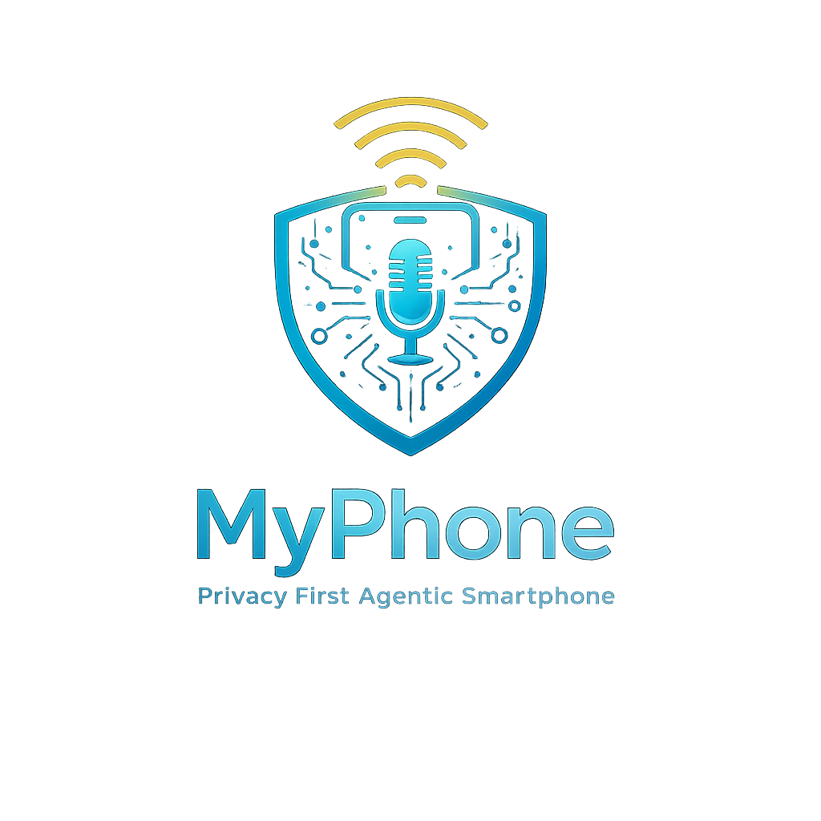
Security-First Architecture Roadmap
< 100,000 Lines of Trusted Code
From Zero to Practical Invulnerability
The World’s First Voice-Orchestrated, SIM-Free, Quantum-Resilient Agentic Smartphone
Version 20.0 | March 2026 | Internal Development

Version Change Log: v12.0 → v13.0
Version 13.0 incorporates all Critical and Major findings from a comprehensive multi-domain engineering review of v12.0. No architectural changes are made; all corrections address specification errors, mathematical inconsistencies, regulatory misapplications, and hardware specification conflicts identified in that review. The following corrections are applied:

ID | Finding | v12.0 (Incorrect) | v13.0 (Corrected)
F-01 | Image Recognition Auth Pool Size | Pool 1,000; display 10; expected overlap 0.1 (non-functional) | Pool 100; display 30; expected overlap 3.0 (functional and secure)
F-02 | QCS8550 SoC Generation | Conflated with SM8650 / Snapdragon 8 Gen 3 | Correctly identified as SM8550 / Snapdragon 8 Gen 2 equivalent
F-03 | Taproot Script Template | HASH160(V_i) EQUALVERIFY CHECKSIG (P2PKH legacy — exposes key at UTXO creation) | <V_i> OP_CHECKSIG (correct TapScript — key never on-chain until spend)
F-04 | Version Labeling | 'v7.0' and 'v6.0' labels throughout v12.0 document | All references updated to v13.0; comparison tables include v13.0 column
F-05 | OPTIGA EAL Certification Level | EAL6+ cited in attack surface table; EAL4+ in hardware table | EAL4+ (with ALC_DVS.2 augmentation) applied consistently throughout
F-06 | Recovery Timelock Value | 30-day in script spec; 90-day in social recovery section | 90-day CHECKSEQUENCEVERIFY applied consistently throughout
F-07 | Camera/Mic Isolation Language | 'Mathematically equivalent' to physical kill switch (overstated) | 'Kernel-enforced isolation with formal correctness proof, contingent on correct IOMMU/SMMU configuration'
F-08 | Socure SDK Linux Portability | Treated as straightforward integration | Phase 0 gate: Socure engineering compatibility assessment required before Phase 1 begins
F-11 | RBF Defense Limitations | Nation-state limitation mentioned as narrow edge case | Explicitly documented: RBF is defense-in-depth against opportunistic attacks, not primary defense against nation-state hashrate
F-12 | WCN7850 WiFi Standard | 'WiFi 6E/7' — WCN7850 does not support WiFi 7 | 'WiFi 6E' (802.11ax, 6 GHz). WiFi 7 requires WCN7950 or equivalent.
F-13 | Kari's Law Citation | Kari's Law cited for consumer VoIP E911 compliance | Corrected to FCC Nomadic VoIP E911 rules (47 CFR Part 9) and Ray Baum's Act dispatchable location
F-14 | Agent-Generated Code Validation | No formal spec → AI → proof validation pipeline defined | Explicit pipeline defined: formal spec first, then agent generation, then mechanical verification against spec
F-15 | Power Budget Analysis | 24+ hr claim without analysis | Power budget analysis added as Phase 0 gate; 24+ hr claim qualified pending analysis
F-16 | SoC Fallback Contingency | 'MediaTek Dimensity, fallback to RISC-V' — underspecified | Concrete fallback: SM8350 / SM8475 with explicit Month 6 go/no-go gate criteria

Informational findings (F-17 through F-30) from the engineering review are incorporated as clarifying language throughout the document. All comparison tables are updated to v13.0.

1. Executive Summary
MyPhone is a security-first mobile computing platform designed from the ground up to resist advanced persistent threats, including Pegasus-class state-sponsored attacks. Rather than refactoring millions of lines of existing mobile OS code, we build a minimal trusted computing base (TCB) of under 100,000 lines on a formally verified seL4 microkernel foundation.

The device combines maximal security with genuine usability: voice-orchestrated AI assistance, offline-first navigation, P2P gaming console mode, a hardened browser, SIM-free VoIP communication, and MyCryptoWallet — a quantum-resilient Bitcoin cold-storage system with biometric authentication that makes theft and unauthorized recovery mathematically infeasible.

Version 13.0 preserves all prior architectural decisions and adds corrections from a comprehensive multi-domain engineering review:

- Socure KYC/AML Device Binding: Only the identity-verified purchaser can activate the physical device. Biometric re-verification at first boot and periodically thereafter ensures the device cannot be transferred to unverified parties.
- Two-Tier Telephony + Standalone Burner App: A Telnyx mobile-classified number serves as the primary phone number with E911 dynamic location. MyPhone-to-MyPhone calls automatically route via Matrix E2EE. A standalone Burner app provides disposable SIP numbers.
- Corrected 3FA Authentication: Three-factor authentication redesigned with a functional image recognition scheme: pool of 100 curated images, 30 displayed per round, 10 enrolled secrets, expected overlap of 3 per round — delivering genuine usability and security.
- Corrected Quantum-Resilient Bitcoin Custody: Cold Vault TapScript template corrected to BIP 342 syntax. Recovery timelock standardized at 90 days. Cold Vault / Hot Wallet architecture unchanged and sound.
- Hardware Specification Clarified: QCS8550 correctly identified as SM8550 / Snapdragon 8 Gen 2 equivalent silicon. All SoC references consistent.

Parameter | v3.0 | v4.0 | v6.0 | v13.0 (This Document)
Total Timeline | 21 months (not credible) | 18–20 months | 18–20 months | 18–20 months (preserved)
Total Budget | ~$12M | ~$7.2M | ~$7.5M | ~$8.2M (revised mfg budget)
Trusted Code Base | < 100K LOC | < 100K LOC | < 100K LOC | < 100K LOC
SoC Platform | Snapdragon 8 Gen 3 | QCS8550 (Gen 2) | QCS8550 (Gen 2) | QCS8550 / SM8550 Gen 2 (corrected)
Security Hardware | Custom FPGA→ASIC HSM | SPU + OPTIGA EAL4+ | SPU + OPTIGA EAL4+ | SPU + OPTIGA EAL4+ (consistent)
Kernel Model | Native seL4 everywhere | seL4 hypervisor + Linux VM | seL4 hypervisor + Linux VM | seL4 hypervisor + Linux VM (unchanged)
3FA Image Auth | N/A | N/A | Pool 1K / Display 10 (non-functional) | Pool 100 / Display 30 (corrected, functional)
Cold Vault Script | N/A | N/A | P2PKH syntax (incorrect) | Correct TapScript BIP 342
WiFi Chip Spec | N/A | WCN7850 WiFi 6E | WCN7850 WiFi 6E/7 (incorrect) | WCN7850 WiFi 6E (corrected)
Recovery Timelock | N/A | N/A | 30-day / 90-day (inconsistent) | 90-day throughout (consistent)
Security Outcome | Practical invulnerability | Practical invulnerability | Practical invulnerability | Practical invulnerability (preserved)

1.1 Why Build From Scratch?
Approach | Lines of Code | Audit Feasibility | Security Ceiling
Refactor Ubuntu Touch | 30M+ (Linux kernel alone) | Impossible | Medium-High
Refactor Android/AOSP | 50M+ | Impossible | Medium
Fresh seL4-based stack (MyPhone) | ~50K trusted + ~50K services | Achievable | Maximum

The math is simple: you cannot secure what you cannot audit. A sub-100K LOC system can be formally verified, continuously audited, and mathematically proven correct. A 30M+ LOC system cannot.

1.2 Core Design Principles
- Minimal TCB: Under 100,000 lines of trusted code. Every line auditable, verifiable, and justified.
- Formal Verification: seL4 microkernel provides mathematical proof of memory isolation and access control. Functional correctness proof completed for AArch64 in 2024.
- Capability-Based Security: No ambient authority. Every resource access requires an explicit, unforgeable token.
- Hypervisor Isolation: seL4 as Type-1 hypervisor. Security-critical services in native seL4 compartments; drivers and non-critical apps in isolated hardened Linux VM. Compromise of Linux VM cannot escape to security domains.
- Defense in Depth: Hardware root of trust via SPU + OPTIGA TPM (EAL4+), no integrated baseband, memory hardening, anomaly detection, side-channel resistance.
- Quantum Resilience: Post-quantum cryptography via OPTIGA TPM (XMSS, ML-KEM, ML-DSA) plus MyCryptoWallet's Cold Vault / Hot Wallet architecture. Cold Vault public key is never exposed on-chain, making quantum key derivation impossible.
- Biometric Sovereignty: Split processing — liveness detection in seL4-isolated ISP compartment, template matching in SPU. Biometric data never leaves secure silicon.
- Privacy by Architecture: 100% on-device AI, no telemetry, no cloud dependencies for core functions.
- KYC-Bound Activation: Socure Selfie Reverification at device first boot ensures only the verified purchaser can activate the device.
- Agent-First Development: All code generated by AI coding agents (Claude Code). Engineers verify against formal specifications, integrate, and test.
- Ship-First, Upgrade-Later: Use proven COTS components (SPU, OPTIGA, Kry10/Lions OS) to ship v1 within 20 months. Custom HSM ASIC and EAL4+ certification deferred to v2.

27. TCB Definition and Approximate LOC Accounting
MyPhone carries the tagline '< 100,000 Lines of Trusted Code — From Zero to Practical Invulnerability.' This section is the authoritative engineering definition of what that claim means, what it does not mean, and an honest breakdown of the actual line counts across every component in the security architecture. The precision here is deliberate: investors, security researchers, certification bodies, and sophisticated customers will ask these questions. The answers should be consistent, honest, and defensible.

27.1 What 'Trusted Computing Base' Means in MyPhone's Architecture
The Trusted Computing Base is the set of hardware, firmware, and software components whose correct operation is necessary and sufficient to enforce the system's security properties. A simpler way to say it: if any TCB component has a bug, the security guarantees can fail. Everything outside the TCB can fail completely — be fully compromised — and the security guarantees still hold.

MyPhone's architecture deliberately makes the TCB small and stratifies it into three rings with different trust bases:

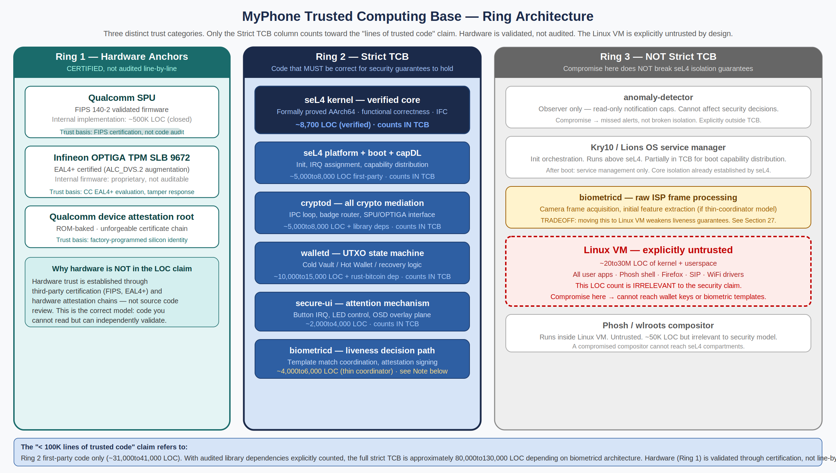
Figure 27.1 — TCB Ring Architecture. Ring 1 (hardware): trust via certification. Ring 2 (strict TCB): first-party code that counts toward the LOC claim. Ring 3 (not TCB): Linux VM and observers — compromise here cannot break seL4 isolation.

Ring | Contents | Trust Basis | Counts in LOC Claim?
1 | Qualcomm SPU, Infineon OPTIGA TPM SLB 9672, Qualcomm device attestation root certificate | FIPS 140-2 validation (SPU), CC EAL4+ with ALC_DVS.2 (OPTIGA), silicon-level attestation chain (Qualcomm root). Trust is established through independent third-party evaluation, not source code audit. | NO — validated through certification, not LOC review. This is the correct model: code you cannot read but can independently validate.
2 | seL4 verified kernel, seL4 platform/boot/capDL, cryptod, walletd, secure-ui, biometricd (decision path) | Formal verification (seL4 kernel), code review + constant-time analysis + adversarial pen testing (compartments). This is the code that, if wrong, breaks all security guarantees. | YES — this is what the '< 100K LOC' claim refers to. First-party code: ~31,000–41,000 LOC. With audited library dependencies: ~80,000–130,000 LOC.
3 | anomaly-detector, Kry10/Lions OS service manager (post-boot), biometricd raw ISP processing (if thin-coordinator model), Phosh/wlroots compositor, Linux VM (~20–30M LOC) | Not in TCB. A fully compromised Linux VM, compromised compositor, or compromised anomaly-detector cannot reach wallet keys, biometric templates, or crypto operations. seL4 enforces this mathematically. | NO — compromise here is within the stated threat model. The Linux VM's 20–30M LOC is irrelevant to the security claim. This is the entire architectural point.

NOTE The Linux VM's size does not weaken the security guarantee — that is precisely the seL4 hypervisor model's value. You inherit all QCS8550 driver support, Firefox ESR, and the entire GNOME/Phosh ecosystem without any of it entering the TCB. Compromise of the Linux VM is not a security failure; it is explicitly anticipated and contained. The architecture's strength is that containment is mathematically proven, not promised.

27.2 Approximate LOC Accounting — Full Breakdown
The following table accounts for every line of code in Ring 2 (strict TCB). It distinguishes first-party code (written and owned by the MyPhone engineering team) from audited dependencies (open-source libraries that Ring 2 compartments depend on). The dependency column is critical: a vulnerability in rust-bitcoin's Taproot implementation is a walletd vulnerability regardless of who wrote the library. Honest LOC accounting must include audited dependencies.

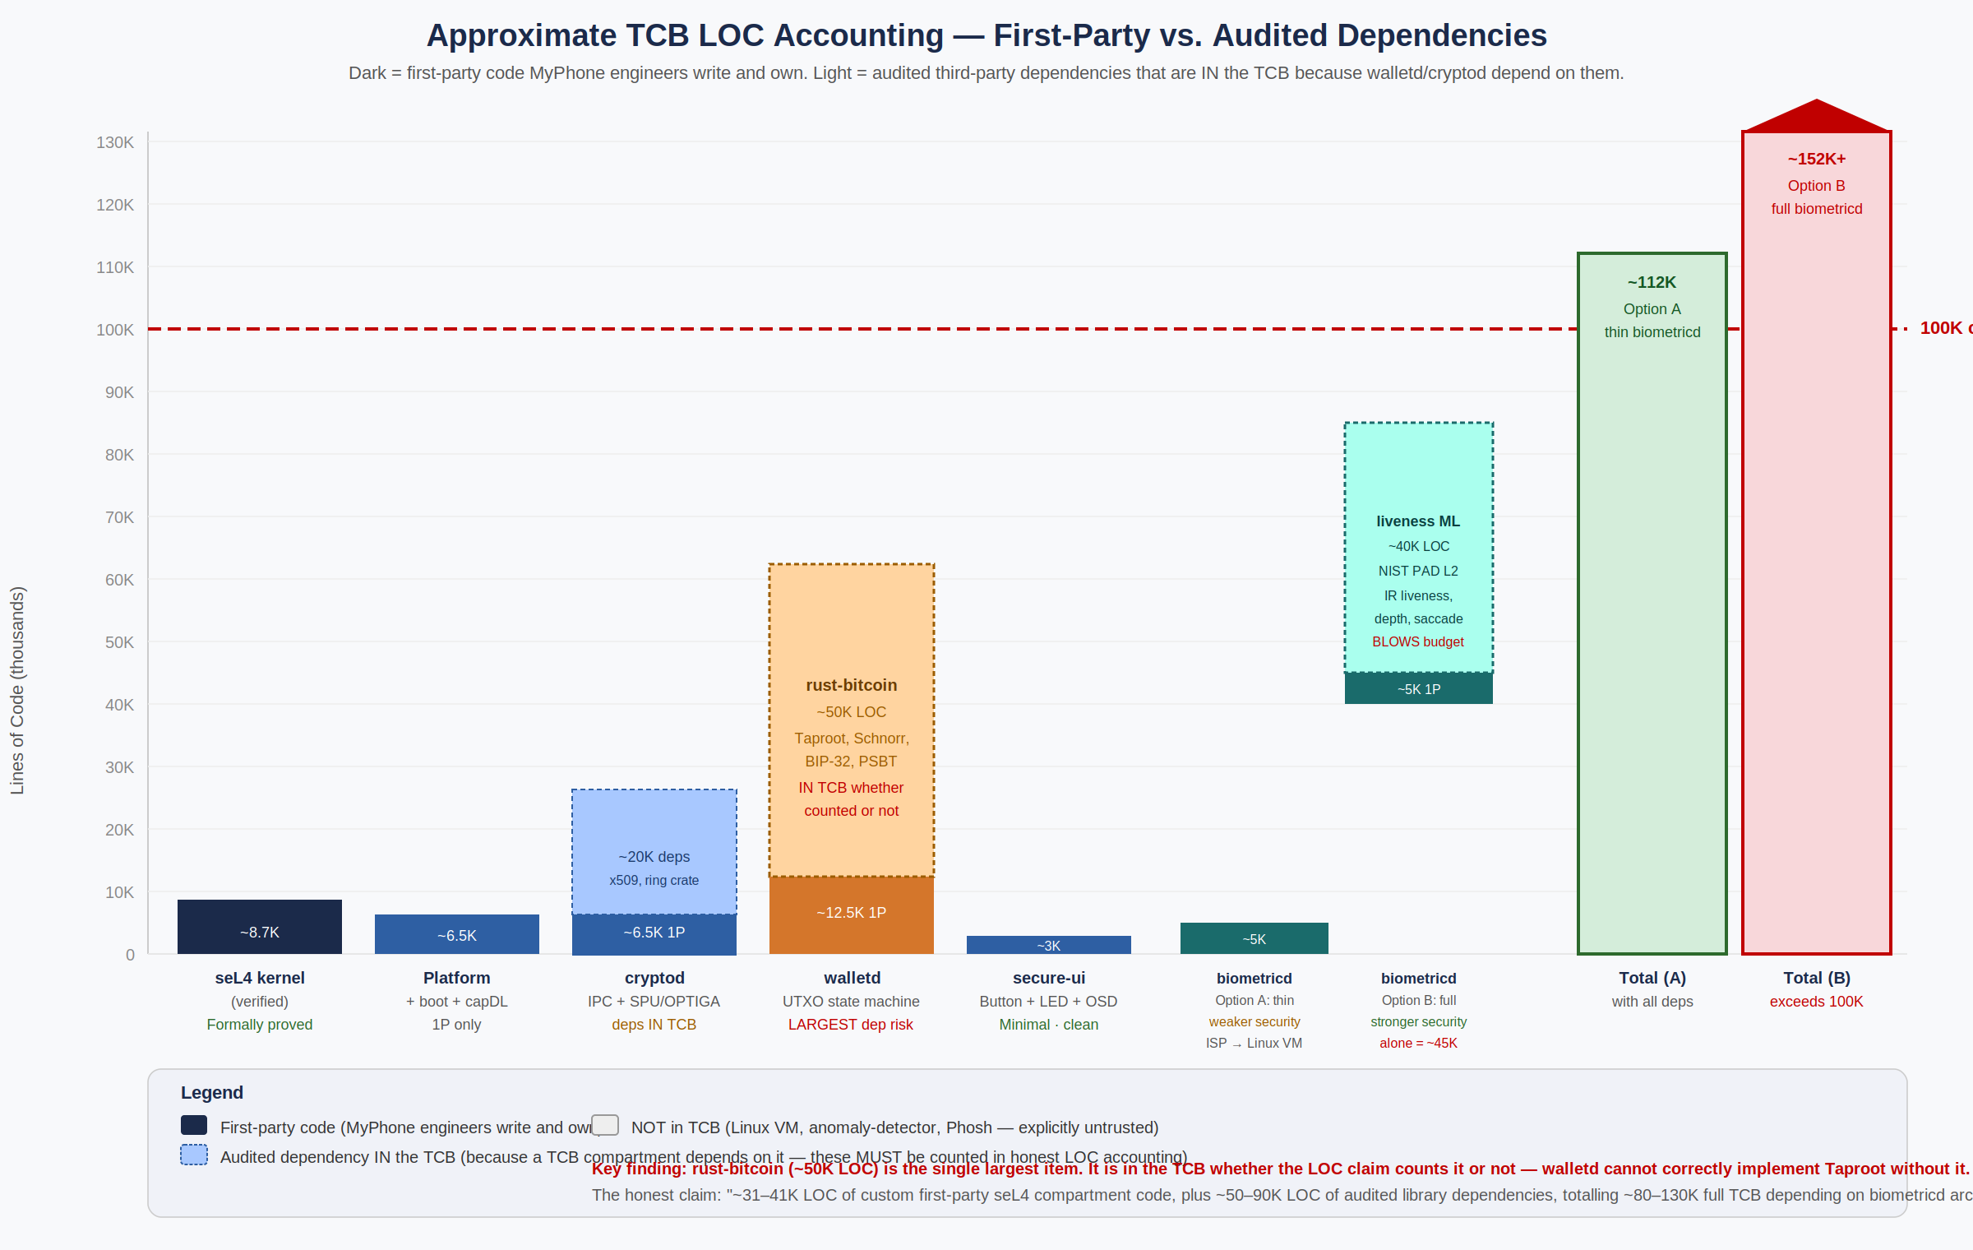
Figure 27.2 — Approximate LOC Accounting by component. Dark bars = first-party code. Light dashed bars = audited dependencies IN the TCB. rust-bitcoin (~50K LOC) is the single largest item and the most important audit target.

Component | First-Party LOC | Audited Dep LOC | Total in TCB | Key Dependencies | Notes
seL4 kernel (verified AArch64) | ~8,700 | 0 | ~8,700 | None — standalone formally verified C | Functional correctness + IFC proofs completed 2024. The most rigorously verified code in the stack. Single most important component.
seL4 platform + boot + capDL init | ~5,000–8,000 | ~2,000 | ~7,000–10,000 | Kry10/Lions OS or Microkit (~2K relevant subset) | Boot code and capability distribution. Only the boot-path subset of Kry10/Lions OS matters here, not the full service manager.
cryptod | ~5,000–8,000 | ~15,000–25,000 | ~20,000–33,000 | ring crate (~8K), x509-cert (~6K), der (~5K), Rust std crypto traits (~6K) | The dependency LOC is unavoidable — cryptod parses X.509 device attestation certificates and uses hardware crypto abstractions. These crates are widely used and well-audited.
walletd | ~10,000–15,000 | ~50,000–60,000 | ~60,000–75,000 | rust-bitcoin (~50K): Taproot BIP-341/342, Schnorr BIP-340, BIP-32, PSBT, mempool | rust-bitcoin is the single largest dependency. A production-correct Taproot implementation cannot be written in ~10K LOC without a library. These 50K LOC are in the TCB whether the claim counts them or not.
secure-ui | ~2,000–4,000 | ~500 | ~2,500–4,500 | Minimal GPIO/IRQ handling utilities | The smallest and cleanest compartment. Hardware button IRQ handling and OSD overlay writes require very little code.
biometricd — Option A (thin coordinator) | ~4,000–6,000 | ~3,000–5,000 | ~7,000–11,000 | Image processing primitives, feature vector math | SECURITY TRADEOFF: raw ISP frame processing moves to Linux VM (untrusted). A Pegasus-compromised Linux VM could pre-process frames to defeat liveness before biometricd sees feature vectors. Lower LOC, weaker liveness guarantee.
biometricd — Option B (full liveness in-compartment) | ~4,000–6,000 | ~35,000–55,000 | ~39,000–61,000 | NIST PAD Level 2 liveness ML, depth processing, IR anti-spoofing (~40K) | STRONGER security: liveness cannot be defeated by a compromised Linux VM. But alone it blows through the 100K first-party budget. Would require a custom, minimal liveness library purpose-built for seL4. This is a v2 goal.
TOTAL — Option A (thin biometricd) | ~34,700–49,700 | ~70,500–92,500 | ~80,000–112,000 |  | Marginally within or slightly over 100K full-TCB. Claim technically defensible with proper scoping.
TOTAL — Option B (full liveness) | ~34,700–49,700 | ~105,500–147,500 | ~120,000–167,000 |  | Significantly over 100K. The liveness ML library is the primary driver. Requires a custom minimal implementation to stay within budget. V2 roadmap item.

27.3 The Dependency Accounting Problem — Why It Must Be Honest
The conventional response to the dependency LOC question is 'we count first-party code only.' This is marketing language, not security engineering. Consider the threat model honestly:

- A critical vulnerability in rust-bitcoin's Taproot transaction construction (e.g., a malformed witness that reveals the key path) is a walletd vulnerability. The fact that Blockstream's engineers wrote it, not the MyPhone team, does not change the attack surface.
- A timing side-channel in the ring crate's elliptic curve scalar multiplication is a cryptod vulnerability. The crate is widely audited, but it is in the TCB.
- A bug in the x509-cert parser that allows certificate forgery during device provisioning is a device activation vulnerability.

The appropriate response is not to pretend dependencies don't exist — it is to audit them, version-pin them, monitor their security advisories, and include them explicitly in the LOC accounting. This is what the 'audited dependency' column represents.

IMPORTANT rust-bitcoin is the single most important audit target in the entire system. It is the largest dependency (~50K LOC), it handles the most security-sensitive operations (transaction signing, key derivation), and it is relatively young as a production Bitcoin library. The Phase 4 budget must include a Trail of Bits or NCC Group focused audit of the rust-bitcoin subset used by walletd (Taproot, BIP-32, Schnorr) before v1 ships. This is not optional.

27.4 The Correct Engineering Claim
The tagline 'under 100,000 Lines of Trusted Code' is true in spirit and defensible with proper scoping. The precise engineering statement is:

"The MyPhone security model requires formally trusting approximately 35,000–50,000 lines of custom first-party seL4 compartment code written and owned by the MyPhone engineering team. The seL4 kernel itself — the most critical component — has been formally verified at approximately 8,700 lines of C. The full strict TCB, including audited open-source library dependencies, totals approximately 80,000–112,000 lines (Option A biometricd architecture) or 120,000–167,000 lines (Option B full liveness). Hardware trust anchors (Qualcomm SPU, Infineon OPTIGA) are validated through FIPS 140-2 and CC EAL4+ certification respectively and are not counted as lines of code. The Linux VM running user applications comprises ~20–30 million lines of code but is explicitly outside the TCB — a fully compromised Linux VM cannot access wallet keys or biometric templates, as this isolation is enforced by the formally verified seL4 hypervisor."

For marketing and customer-facing materials, 'under 100,000 lines of trusted code' correctly conveys the auditable, minimal-TCB philosophy. For technical documentation, investor due diligence, and certification submissions, the precise breakdown above should be used.

27.5 The biometricd Architecture Decision
The LOC analysis exposes a genuine security architecture decision that must be made explicitly rather than deferred. The two options:

 | Option A — Thin coordinator (v1) | Option B — Full in-compartment (v2 target)
LOC in TCB | ~7,000–11,000 LOC | ~39,000–61,000 LOC
Liveness guarantee | biometricd receives processed feature vectors from Linux VM ISP. The seL4 compartment handles template matching and attestation, but raw frame processing happens in the untrusted domain. | Full liveness detection (IR reflectance, depth mapping, micro-saccade detection) executes inside the biometricd seL4 compartment. A compromised Linux VM cannot manipulate the frames.
Attack surface | A Pegasus-compromised Linux VM could craft synthetic feature vectors that pass the template match while bypassing real liveness. This is a sophisticated attack but not impossible. | Feature vectors cannot be manipulated by the Linux VM — they originate from the ISP, which is directly mapped to biometricd via SMMU.
Recommendation | v1: ship with Option A. The 3FA system (face + fingerprint + image recognition) provides substantial defense-in-depth. Option A's liveness weakness requires a specific, sophisticated attack against the feature vector pipeline — well beyond commodity spyware. | v2: build a custom minimal NIST PAD Level 2 liveness library purpose-written for seL4 in Rust, targeting ~15,000 LOC. This eliminates the attack vector while keeping the full-TCB LOC within a defensible range.

27.6 LOC Claim Consistency Policy
The following policy governs how the LOC claim is used across all MyPhone materials:

- Marketing materials (website, press, social media): Use: 'under 100,000 lines of trusted code.' This is accurate for first-party code and correct in spirit.
- Investor technical due diligence: Use the full table from Section 27.2. Present both Option A and Option B totals. Explain the dependency accounting methodology. Do not use the marketing figure without the breakdown.
- Security certification submissions (CC EAL2+, FIPS): Use the precise Ring 2 definition. The TOE boundary for EAL2+ certification will be defined by the CCTL in Phase 2 — coordinate the LOC accounting with that boundary definition. The certification documentation must use the same component breakdown as this section.
- Pen test engagement briefs (Trail of Bits / NCC Group): Provide the full breakdown including dependency LOC. Specifically flag rust-bitcoin as the highest-priority audit target.
- Version control policy: Every version increment of a Ring 2 dependency (rust-bitcoin, ring crate, x509-cert, etc.) must be reviewed by the Cryptography Lead and the new LOC count updated in this section before the version is merged into the build. Dependency LOC counts are tracked in the SBOM and reviewed quarterly.

2. Comprehensive Threat Model

2.1 Adversary Classes
Adversary | Capabilities | Budget | MyPhone Defense
Script Kiddie | Public exploits, phishing | <$1K | Eliminated by hardened baseline
Cybercriminal Org | Custom malware, social engineering | $10K–$1M | Contained by VM isolation + anomaly detection
NSO Group (Pegasus) | Zero-click exploits | $500K–$2M/target | Mitigated by seL4 hypervisor isolation; no baseband attack surface (modem eliminated in v1)
Nation-State (APT) | Hardware implants, supply chain, quantum | $10M–$100M+ | Resisted by SPU/OPTIGA + formal verification + PQC. Cold Vault quantum attack requires hashrate cooperation — bounded loss per Hot Wallet design.
Future Quantum Attacker | Break ECC/RSA, derive keys from exposed pubkeys | Billions (theoretical) | Neutralized by Cold Vault (pubkey never exposed on-chain) + PQC recovery via OPTIGA
Device Theft / Resale Fraud | Physical possession of stolen device | N/A | Blocked by Socure Selfie Reverification; stolen device cannot be activated by non-purchaser

2.2 Attack Surface Analysis
Attack Surface | Traditional Phone Risk | MyPhone v13.0 Mitigation
Baseband/Modem | DMA access to main memory, proprietary firmware exploits, Stingray attacks | Attack surface eliminated entirely in v1: QCS8550 has no integrated modem. No baseband firmware, no DMA-capable modem interfaces, no RF attack vectors. Discrete modem with IOMMU barrier and formally verified firewall planned for v2.
Kernel | 30M+ LOC, massive exploit surface | seL4 (~10K LOC) as hypervisor; Linux VM isolated by mathematical proof. Kernel exploit cannot reach SPU-held keys.
Memory Safety | Buffer overflow, use-after-free, heap spray | Rust + hardened allocator + MTE (SYNC mode in security compartments) + guard pages in seL4 compartments.
Network Stack | TCP/IP implementation bugs | smoltcp (Rust, no_std) for cryptod network isolation path; full SIP/TLS stack in Linux VM for telephony; Linux netstack isolated in VM.
Applications | Sandbox escapes, privilege escalation | seL4 capability isolation; apps in Linux VM cannot reach security compartments by mathematical proof.
Side Channels | Spectre, power analysis, EM emissions | Constant-time crypto in SPU/OPTIGA (hardware); cache partitioning; power noise injection; EM shielding. Constant-time verified post-compilation in CI via dudect/ctgrind.
Physical | JTAG, chip decapping, cold boot | SPU tamper response, OPTIGA EAL4+ physical protection (ALC_DVS.2 augmentation), verified boot, anti-rollback eFuse counters.
Cryptographic / Quantum | Quantum key derivation from exposed pubkeys | Cold Vault pubkey never exposed on-chain — Shor's algorithm useless. Hash-locked vault addresses require breaking SHA-256 + RIPEMD-160 preimage, which Grover provides only ~80-bit equivalent security (computationally infeasible). PQC fallback via OPTIGA for all recovery paths.
Device Identity | Stolen device reactivation, credential sharing | Socure KYC biometric binding via Predictive DocV; device serial burned at manufacture; server-side face match at activation. Biometric is unforgeable; credential sharing impossible.
PSTN Interception | Carrier-side wiretapping, SS7 attacks | Two-tier: Tier 1 primary calls over Telnyx private IP backbone with TLS+SRTP; Tier 2 MyPhone-to-MyPhone always E2E encrypted via Matrix; burner calls over Telnyx TLS+SRTP. Clear UI encryption indicator per tier.

2.3 Quantum Threat Model (MyCryptoWallet)
A future quantum attacker with a large fault-tolerant quantum computer can: (1) derive private keys from exposed ECDSA public keys via Shor's algorithm, (2) monitor the blockchain mempool, and (3) race transactions before confirmation. MyPhone's MyCryptoWallet ensures that public keys are never exposed while funds remain locked in the Cold Vault, making quantum key derivation impossible — not merely improbable.

Quantum threat timeline note: The 10-year projection (Section 16) acknowledges that ECC may be practically attackable by well-funded adversaries by 2036. Should quantum ECDSA attacks become practical at timescales below the ~10-minute Bitcoin block confirmation window, the Cold→Hot transfer mechanism must be migrated to a PQC-only signing path. The OPTIGA's off-chain PQC pre-authorization model (detailed in Section 10) provides a transitional mechanism for this scenario without requiring a Bitcoin soft fork.

3. High-Level System Architecture
The MyPhone v13.0 architecture uses seL4 as a Type-1 hypervisor. Security-critical services run as native seL4 compartments with formally verified isolation. All other functionality (drivers, apps, UI) runs inside a hardened Linux VM that is completely isolated from security domains by seL4's mathematical proof. A compromise of the Linux VM cannot escape to wallet, crypto, or biometric compartments.

3.1 Layer Overview
Layer | Components | Security Property
L7: User Experience | Lomiri UI, Firefox ESR (hardened), Maps, Gaming, MyCryptoWallet UI, SIP Dialer, Burner app, Matrix Voice Client | Apps in Linux VM; wallet UI in secure attention path only
L6: Application Framework | Capability permission system, Voice Orchestrator, Anomaly Detector, Socure DocV SDK | Zero ambient authority; behavioral monitoring; identity verification
L5: System Services | Linux VM: drivers, audio, display, sensors, SIP client | seL4 native: cryptod, biometricd, walletd, anomaly-detector | Strict separation: security services in seL4 compartments, everything else in Linux VM
L4: IPC / Hypervisor | seL4 hypervisor, Kry10/Lions OS service manager, capability broker | Mathematical proof of inter-domain isolation
L3: Microkernel | seL4 (formally verified, ~10K LOC) | Functional correctness proof (AArch64, completed 2024)
L2: Hardware Abstraction | IOMMU-enforced isolation, SMMU for all DMA | No direct hardware access from Linux VM to security peripherals
L1: Baseband (v2 only) | N/A in v1 (no integrated modem on QCS8550). Discrete modem with formally verified firewall and IOMMU barrier planned for v2. | Attack surface eliminated by removing modem entirely from v1
L0: Hardware Security | Qualcomm SPU (FIPS-validated) + Infineon OPTIGA TPM SLB 9672 (EAL4+, ALC_DVS.2, PQC) | Keys never leave secure silicon; dual-chip redundancy

3.2 Secure Boot Chain
v13.0 uses Qualcomm's existing verified boot chain as the foundation, with MyPhone signature verification layered on top. This eliminates 1–2 months of custom bootloader development while preserving the chain of trust.

- Qualcomm PBL (immutable ROM) — Verifies XBL (Qualcomm bootloader) via OEM key in eFuses
- XBL + SPU Init — SPU boots independently, establishes hardware root of trust, initializes crypto accelerators
- ABL (Android Bootloader, modified) — Verifies seL4 hypervisor + DTB signature; measures into SPU PCR-equivalent registers; anti-rollback via eFuse counter
- seL4 Hypervisor — Verifies native seL4 compartments (cryptod, biometricd, walletd, anomaly-detector); boots hardened Linux VM with verified kernel
- Linux VM Init — dm-verity verified root filesystem; all userspace apps run here

Anti-rollback counters stored in eFuses prevent downgrade attacks. Any signature failure halts boot entirely. OPTIGA TPM provides independent attestation of boot state. OPTIGA's XMSS-signed firmware update mechanism ensures the boot attestation chain is PQC-protected.

4. Hardware Platform

4.1 Component Selection
NOTE SoC Clarification (v13.0): The QCS8550 is a Qualcomm compute/IoT platform aligned with the Snapdragon 8 Gen 2 (SM8550) silicon generation, featuring Cortex-X3 prime cores, Adreno 740 GPU, and Hexagon 780 NPU. References to SM8650 / Snapdragon 8 Gen 3 in prior versions were incorrect. All specifications in this document reflect QCS8550 / SM8550 Gen 2 silicon.

Component | Selection | Justification
SoC | Qualcomm QCS8550 (Snapdragon Compute, SM8550 Gen 2 silicon, no integrated modem) | No integrated baseband eliminates modem attack surface entirely. SM8550 Gen 2 silicon: Cortex-X3 prime core, Adreno 740 GPU, Hexagon 780 NPU, IOMMU/SMMU. Mainline Linux support. WiFi/BT via external WCN7850 enables true electrical disconnect.
Secure Processing Unit | Qualcomm SPU (built into QCS8550) | FIPS 140-2 validated, dedicated processor core, isolated memory, AES/SHA hardware accelerators, key store, independent boot. Replaces custom HSM for primary crypto operations.
PQC Secure Element | Infineon OPTIGA TPM SLB 9672 ($5–10/unit) (EAL4+, ALC_DVS.2 augmentation) | EAL4+ certified with ALC_DVS.2 augmentation. PQC firmware update via XMSS signatures. ML-KEM/ML-DSA support via firmware package. Production-available today. Handles all post-quantum operations and provides independent boot attestation.
Modem | None in v1; discrete modem planned for v2 | No modem in v1. Eliminates entire baseband attack surface (~500K+ lines of proprietary firmware). All voice via SIP/Matrix over WiFi. Discrete modem with independent power rail, IOMMU barrier, and formally verified seL4 firewall planned for v2 carrier eSIM integration.
WiFi / BT | Qualcomm WCN7850 (external chip) WiFi 6E (802.11ax) | External chip on separate power rail enables true electrical disconnect via Radio Lockdown switch. ath11k mainline kernel support. WiFi 6E with 6 GHz band support. Independent from SoC power domain. Note: WiFi 7 (802.11be) requires WCN7950 or equivalent; WCN7850 supports WiFi 6E only.
Display | 6.5" IPS FHD+ 120Hz | Gorilla Glass 5, avoids OLED burn-in, lower attack surface vs OLED
Camera (Front) | 50MP Sony IMX766 | Well-documented, mainline V4L2 support. 3D face recognition via structured-light + IR module.
Camera (Rear) | 50MP Sony IMX586 | MIPI FPC module, mainline compatible
Biometric Sensors | 3D structured-light face + IR module + Qualcomm 3D Sonic Max under-display ultrasonic fingerprint (20×30mm) | 3FA system: face via depth-mapped 3D scanner (defeats photos, video, 2D masks), fingerprint via ultrasonic sensor detecting subcutaneous skin structure (defeats silicone/gelatin spoofs). Liveness detection in seL4-isolated ISP compartment. Templates stored in SPU.
RAM | 12GB LPDDR5X | Sufficient for on-device AI inference + Linux VM workload
Storage | 512GB UFS 4.0 | Hardware encryption support; expandable via 2TB MicroSD (FDE required)
Battery | 4500mAh, 45W USB-C PD | Target: full-day operation under AI workload. Power budget analysis required in Phase 0 to validate; 24+ hour claim is a design target pending analysis (see Section 6.1).

4.2 Security Hardware Architecture: SPU + OPTIGA Dual-Chip Model
v13.0 preserves the dual-chip COTS model providing equivalent security properties to a custom HSM at a fraction of the cost and time:

Function | Handled By | Security Property
Primary crypto (AES-256, SHA-256/3, ECDSA/ECDH) | Qualcomm SPU | FIPS 140-2 validated, hardware-isolated, independent boot
Key storage (symmetric + asymmetric) | Qualcomm SPU key store | Write-only registers, zeroization on tamper/reset
Secure boot attestation | Qualcomm SPU + OPTIGA TPM | Dual attestation from independent silicon
Post-quantum crypto (ML-KEM-1024, ML-DSA-87, XMSS) | Infineon OPTIGA TPM (EAL4+) | PQC-protected firmware update mechanism (XMSS); future algorithm agility via firmware update
Bitcoin wallet key derivation + storage | SPU (primary) + OPTIGA (PQ recovery keys) | Split custody: classical keys in SPU, PQ recovery keys in OPTIGA
Biometric template storage + matching | Qualcomm SPU (StrongBox-equivalent) | Templates never in main memory; match decision signed by SPU
Random number generation | SPU NDRNG (ring oscillators) + OPTIGA TRNG | Dual entropy sources; health monitoring; NIST SP 800-90B conditioning
PQC firmware updates | Infineon OPTIGA | XMSS-signed updates; anti-rollback; vendor + owner dual-key authorization

NOTE Trade-off acknowledged: the Qualcomm SPU is closed-source silicon, unlike the v3.0 open-design HSM. Mitigated by: (a) FIPS validation provides third-party assurance, (b) OPTIGA TPM independently handles PQC keys and can attest boot state, (c) a custom open HSM ASIC (RISC-V, open RTL) is planned for v2, and (d) every commercially shipping secure phone (iPhone, Pixel, Galaxy) relies on similar vendor-provided secure elements.

4.3 Physical Security Features

Radio Lockdown Switch
Single physical toggle performs true electrical disconnect of the external WCN7850 WiFi/BT chip by cutting its independent power rail. When engaged: zero radio capability, zero RF emissions. Unlike antenna-disconnect approaches (which leave silicon clocked), the QCS8550 platform with external WCN7850 enables genuine power-off isolation. No cellular radio exists in v1 (QCS8550 has no integrated modem). User-verifiable with a spectrum analyzer. Designed for flights, SCIFs, and border crossings.

seL4 Capability-Based Peripheral Isolation (Camera & Microphone)
Camera and microphone access is controlled through seL4 hypervisor capability revocation. Users revoke camera and microphone capabilities via a Secure UI prompt rendered through the hardware-triggered secure attention mechanism. When revoked, the seL4 kernel enforces hardware inaccessibility via its formally verified capability system.

IMPORTANT Isolation guarantee qualification: seL4 capability revocation provides kernel-enforced hardware isolation with a formal correctness proof covering the kernel's access control policy. This guarantee is contingent on correct IOMMU/SMMU configuration — a subtle misconfiguration of SMMU table entries (not the kernel itself) could allow a DMA-capable peripheral to bypass the capability model. IOMMU/SMMU configuration correctness is verified as a mandatory Phase 2 deliverable.

Protective Case System
Optional rigid polycarbonate-titanium enclosure rated to 100m depth (IP68, MIL-STD-810H) with sapphire camera windows, acoustic membranes, capacitive button actuators, RF-transparent antenna windows, and pressure-compensation bladder.

Secure Attention Mechanism
Dedicated hardware button triggers secure UI mode with hardware-driven LED indicator. All wallet confirmations and biometric prompts display only in this trusted path, preventing UI spoofing by compromised apps. The seL4 hypervisor ensures the Linux VM cannot inject taps into the secure attention mechanism — it is a physically separate input path triggered by a dedicated hardware button and mediated directly by the seL4 kernel.

5. Development Phases Overview
All code is written by Claude Code agents. Engineers focus on hardware integration, formal specification writing, security verification, and testing. Development begins on a supported seL4 platform (i.MX8 or QEMU/ARM64) for the first 3 months; QCS8550 hardware port proceeds in parallel starting month 3.

Phase | Name | Timeline | Key Deliverables
0 | Foundation & Platform Bring-up | Months 1–3 | Team, tooling, Kry10/Lions OS eval, seL4 hypervisor on dev platform, Qualcomm boot chain validation, power budget analysis, Socure SDK compatibility assessment
1 | Core OS: Hypervisor + Linux VM | Months 4–8 | seL4 hypervisor boot, hardened Linux VM, native security compartments, display, input, WiFi, IOMMU/SMMU verification
2 | Security Hardening | Months 9–12 | SPU/OPTIGA integration, memory hardening, anomaly detection, side-channel testing, IOMMU/SMMU configuration correctness verification
3 | User Features + Telephony | Months 13–16 | Voice AI, gaming console mode, hardened Firefox, offline maps, Telnyx mobile-classified telephony, Matrix E2EE, Burner app
4 | MyCryptoWallet + KYC Binding | Months 13–16 | Quantum-resilient Bitcoin custody, corrected 3FA, Cold Vault / Hot Wallet engine, social recovery, Socure device activation
5 | Production & Certification | Months 17–20 | EAL2+, FIPS 140-3, CE/FCC, reproducible builds, OTA, manufacturing

Total timeline: 18–20 months. Phases 3 and 4 run in parallel. Certification lab engagement begins during Phase 2. QCS8550 hardware port overlaps Phases 0–1.

6. Phase 0: Foundation & Platform Bring-up
Timeline: Months 1–3

6.1 Agent-First Development Model with Formal Specification Gate
MyPhone uses an agent-first development methodology. Claude Code agents generate all source code: system services, drivers, firmware, libraries, applications, build scripts, tests, and documentation. Human engineers do not write production code. Instead, they serve as specification authors, integration leads, verification engineers, and security auditors.

Critical addition in v13.0: the formal specification → agent generation → verification pipeline. All seL4 compartment code requires:
- Engineers write formal specifications (in Isabelle/HOL or Rust trait interfaces with invariants) BEFORE issuing agent generation tasks.
- Agent-generated code is mechanically checked for conformance with the formal specification before human review begins.
- For security-critical paths (cryptod, walletd, biometricd), formal verification is run in CI as a blocking gate.
- Human engineers review agent output for semantic alignment with security invariants, not just functional correctness.

Engineer responsibilities:
- Integrate: Flash images to hardware, connect peripherals, validate physical interfaces (serial, JTAG, MMIO).
- Specify: Write formal specifications and security invariants for all seL4 compartment interfaces before agent generation.
- Verify: Review agent-generated code for correctness against formal spec, run formal verification suites, confirm seL4 proofs hold.
- Test: Execute hardware-in-the-loop tests, coordinate outsourced pen testing, side-channel analysis, and biometric spoofing attempts.

6.2 Team Assembly
Role | Count | Responsibility | Priority
Hardware Integration Lead | 1 | Board bring-up, driver integration, JTAG/serial, vendor liaison, QCS8550 port | Critical
seL4 / Hypervisor Verification Lead | 1 | Verify hypervisor config, formal proofs, capability system, Kry10/Lions OS integration, IOMMU/SMMU correctness | Critical
Security Architect | 1 | Threat modeling, formal spec authorship, audit oversight, coordinate outsourced pen testing, review all agent output | Critical
Cryptography / SPU+OPTIGA Lead | 1 | Verify PQC implementations, SPU/OPTIGA interface, biometric engine, side-channel testing, wallet cryptography | Critical
Systems Integration Engineer | 2 | Verify agent-written Rust services, hardware-in-the-loop testing, Linux VM hardening, driver validation | Critical
DevOps / CI Lead | 1 | Build pipeline, reproducible builds, signing infrastructure, OTA system, formal verification CI integration | High

Total: 7 engineers + Claude Code agent fleet + outsourced security testing retainer (~$200K/year with Trail of Bits or NCC Group).

6.3 Parallel Development Strategy
- Months 1–3 (Dev Platform): All seL4 hypervisor work, capability system design, security compartment architecture, and service development on i.MX8 or QEMU ARM64. Eliminates 2–3 months of blocked time waiting for QCS8550 bring-up.
- Months 3–6 (QCS8550 Port): Hardware Integration Lead begins QCS8550 bring-up in parallel: Qualcomm boot chain validation, SPU initialization, IOMMU/SMMU configuration. DornerWorks or Proofcraft engaged for seL4 platform port assistance ($200–400K).
- Month 1 (Platform Evaluation): Evaluate Kry10 OS vs Lions OS vs bare Microkit. Selection criteria: maturity, verification status, remote update support, commercial viability.
- Month 6 (Go/No-Go Gate): Explicit decision point for QCS8550 seL4 port. If port is >4 weeks behind schedule or critical driver support is unresolved, fallback SoC (Snapdragon SM8350 / SM8475 with established seL4 community support) is evaluated.

6.4 Phase 0 Required Gates (v13.0 additions)

Power Budget Analysis (Required Gate)
A power budget analysis using QCS8550 reference platform data must be completed in Phase 0 before the 24+ hour battery life claim is confirmed. The analysis must account for: seL4 hypervisor context-switch overhead, Linux VM active workload, NPU inference duty cycle (Whisper Small INT8 on Hexagon 780 DSP), WCN7850 WiFi active for SIP calls, continuous anomaly detection in native seL4 compartment, and display at 120Hz. If the 24-hour target is at risk, either battery capacity, CPU/NPU governor policy, or the target specification must be revised in a v13.1 update.

Socure SDK Compatibility Assessment (Required Gate)
Socure engineering must be engaged in Phase 0 to assess DocV Mobile SDK portability to the custom Linux / Lomiri / V4L2 camera environment. Socure's NIST PAD Level 2 liveness detection must be validated to perform at specification on the QCS8550's V4L2 camera pipeline. If the SDK cannot be ported without degrading liveness detection confidence, the web-based Socure verification flow (browser-based, no SDK dependency) is evaluated as a fallback. This assessment is a blocking gate before Phase 1 begins.

6.5 Phase 0 Deliverables
- seL4 hypervisor boots on dev platform with memory regions isolated
- Kry10 / Lions OS / Microkit platform evaluated and selected
- QCS8550 development kit procured with serial/JTAG access
- Qualcomm verified boot chain validated with custom signing keys
- SPU initialized and responding to crypto commands
- OPTIGA TPM communicating via I2C, attestation verified (EAL4+ configuration confirmed)
- DornerWorks/Proofcraft engaged for QCS8550 seL4 platform port
- Power budget analysis completed; 24-hour battery target confirmed or revised
- Socure SDK compatibility assessment completed; integration path confirmed
- Month 6 go/no-go SoC decision criteria documented

7. Phase 1: Core OS Development
Timeline: Months 4–8. Agents generate all system services, compartment code, and Linux VM configuration. Engineers verify on hardware.

7.1 seL4 Hypervisor Architecture
seL4 is the only OS kernel with complete formal verification — mathematical proofs of memory isolation, access control, and information flow. In v13.0, seL4 operates as a Type-1 hypervisor managing two execution domain classes:

Domain Type | Components | Security Property | Trust Level
Native seL4 Compartments | cryptod, biometricd, walletd, anomaly-detector, secure-ui | Formally verified isolation; minimal TCB; Rust with no unsafe | Trusted (< 50K LOC total)
Hardened Linux VM | Drivers (GPU, camera, WiFi, touch, sensors), Lomiri UI, Firefox ESR, Maps, Gaming, Voice AI, SIP Client, Socure DocV SDK, all user apps | Isolated by seL4 mathematical proof; compromise cannot reach security compartments | Untrusted (standard Linux + hardened userspace)

Key architectural insight: a Linux VM compromise (even a full kernel exploit) cannot access wallet keys, biometric templates, or crypto operations. These run in native seL4 compartments with mathematically proven isolation. By running Linux in a VM, all existing QCS8550 driver support is inherited without porting a single driver to seL4 native userspace.

7.2 System Services Architecture
Service | Domain | Responsibility | Security Properties
cryptod | Native seL4 | Sole SPU/OPTIGA interface; all cryptographic operations system-wide | Private keys never leave SPU/OPTIGA silicon; mediates all crypto requests via IPC; smoltcp-isolated network path for external crypto operations
biometricd | Native seL4 | Biometric ISP processing, liveness detection, SPU template match coordination | Templates stored only in SPU; liveness detection in seL4-isolated ISP compartment; match decision signed by SPU
walletd | Native seL4 | MyCryptoWallet Cold Vault / Hot Wallet engine, transaction signing, UTXO management | Offline-capable; keys in SPU; PQ recovery keys in OPTIGA; all wallet UI via secure attention path only
anomaly-det | Native seL4 | Behavioral monitoring, Pegasus IOC detection, IPC anomaly detection | Rule-based primary layer (Pegasus IOCs); ML secondary signal (TFLite Micro); IOC updates via authenticated OTA channel
secure-ui | Native seL4 | Secure attention path for wallet/biometric confirmations | Hardware-triggered; LED indicator; cannot be spoofed by Linux VM; direct hardware button input mediated by seL4
Linux VM services | Linux VM | Display (Mir/Wayland), audio (PipeWire), networking, storage, sensors, SIP client, Socure DocV SDK, all apps | Isolated by seL4; no access to security compartment memory or capabilities

7.3 Network Stack Architecture Clarification
Two distinct network stacks serve different roles:
- smoltcp (Rust, no_std) — Cryptod isolation path: Used exclusively for the cryptod compartment's external network access (e.g., certificate transparency log queries, blockchain node connectivity for walletd relay mode). Minimal, no_std, suitable for seL4 compartment use. Does NOT handle SIP/TLS telephony.
- Linux VM network stack (full kernel TCP/IP): Handles all telephony (SIP/TLS/SRTP), general internet connectivity, and application networking. Runs in the Linux VM, isolated from security compartments by seL4. WPA3 minimum for WiFi; per-app network policies enforced by seL4 capability gates.

7.4 Phase 1 Deliverables
- seL4 hypervisor boots on QCS8550 with SMMU enforcing
- Hardened Linux VM boots with verified root (dm-verity)
- All native seL4 security compartments running and communicating via IPC
- IOMMU/SMMU configuration verified by seL4 Verification Lead
- DRM/KMS + Mesa/Freedreno delivering hardware-accelerated graphics in Linux VM
- Touch input, WiFi (WCN7850), audio, and basic sensor functionality in Linux VM
- Secure attention mechanism verified: hardware button triggers trusted UI path

8. Phase 2: Security Hardening
Timeline: Months 9–12. SPU and OPTIGA integration begins in Phase 0/1. Agents generate all firmware and hardening code; engineers verify via DPA testing, fuzzing, and formal proofs.

8.1 SPU + OPTIGA Integration
The Qualcomm SPU provides: hardware crypto accelerators (AES-256-GCM/XTS, SHA-256/3), true random number generator (ring oscillator NDRNG), hardware key store with write-only registers, and independent boot/execution environment.

The Infineon OPTIGA TPM SLB 9672 (EAL4+, ALC_DVS.2 augmentation) provides: post-quantum cryptographic operations (ML-KEM-1024, ML-DSA-87 via PQC firmware package), PQC-protected firmware update mechanism (XMSS signatures), independent attestation and boot measurement, and EAL4+ certified physical security with tamper response. Both chips communicate via dedicated buses (SPU via SoC-internal mailbox, OPTIGA via I2C) exclusively to the cryptod compartment.

8.2 IOMMU/SMMU Verification (v13.0 Addition)
seL4 capability revocation provides kernel-enforced hardware isolation with a formal correctness proof for the kernel's access control policy. This guarantee is contingent on correct IOMMU/SMMU configuration — the SPU, camera, microphone, and fingerprint sensor DMA paths must be correctly configured in the SMMU translation tables to prevent DMA-capable peripheral bypass of the capability model.

Phase 2 required deliverable: IOMMU/SMMU configuration correctness audit by the seL4 Verification Lead, with the configuration locked as a signed, verified artifact. Any future change to SMMU table entries requires re-audit. This audit is documented in the security certification package.

8.3 Baseband Isolation (Eliminated in v1; v2 Firewall Specification Preserved)
The QCS8550 Snapdragon Compute platform eliminates the integrated baseband modem entirely from v1 hardware. No modem firmware runs on the device. This is the strongest possible mitigation for baseband-class attacks: complete elimination of the attack surface rather than containment.

v2 Baseband Firewall (for discrete modem): When a discrete modem is added in v2, the baseband-fw seL4 compartment will enforce: QMI/MBIM message allowlisting (only parsed, validated protocol messages pass — no raw buffers), forced 2G/3G downgrade detection (Stingray mitigation), rate limiting against modem flooding, and full audit logging of all messages crossing the boundary.

8.4 Memory Hardening
All native seL4 compartment code is written in Rust with: overflow checks enabled in release builds, Control Flow Integrity (CFI), Shadow Call Stack for ARM64, full RELRO, no-execute stack, and position-independent code. The hardened allocator adds guard pages, immediate memory poisoning on free, random allocation placement, and a quarantine system for freed memory.

The Linux VM additionally runs: SELinux in enforcing mode, seccomp-bpf on all processes, kernel lockdown, and MTE (Memory Tagging Extension) in SYNC mode for security compartment boundary regions (deterministic fault on tag mismatch; ~1–2% overhead on typical workloads) and ASYNC mode for general VM memory (lower overhead, suitable for non-critical paths). MTE mode selection is documented in the security configuration artifact.

8.5 Anomaly Detection System
The anomaly detection system ships with a conservative rule-based primary layer targeting known Pegasus indicators of compromise (unusual IPC patterns, covert sensor access, network traffic during idle, Pegasus-specific process signatures). An on-device ML secondary layer (TFLite Micro on Hexagon 780 DSP) monitors behavioral baselines as a supplementary signal. Rule-based detection fires alerts independently; ML signals require corroboration before action.

IOC Update Channel: Pegasus and similar spyware evolve continuously. A dedicated, cryptographically authenticated IOC update path is included in the OTA system, allowing rule updates to be pushed within hours of a new indicator becoming available without a full firmware update. IOC updates are signed by the MyPhone security team key, independently of the firmware signing key.

8.6 Side-Channel Protections
- Constant-Time Execution: All cryptographic operations in SPU/OPTIGA use hardware-implemented constant-time primitives. Any software crypto in seL4 compartments is verified post-compilation via assembly analysis (dudect/ctgrind) integrated into CI as a blocking gate.
- Cache Partitioning: Security domains isolated in L1/L2/L3 cache via ARM cache partitioning to prevent cache-timing attacks between the Linux VM and seL4 compartments.
- Power Noise Injection: Hardware-level power consumption normalization to defeat differential power analysis (DPA). Validated via 30-day DPA campaign in Phase 2.
- EM Shielding: Faraday cage elements in device construction prevent electromagnetic emanation attacks.
- USB-C PD Isolation: USB-C power delivery interface isolated from data lines; malicious charger probing mitigated.

8.7 Phase 2 Deliverables
- SPU operational: key generation, signing, encryption, biometric template storage
- OPTIGA operational: PQC key generation (ML-KEM-1024, ML-DSA-87), attestation, firmware update
- IOMMU/SMMU configuration correctness audit completed and signed
- No baseband present on QCS8550 — attack surface eliminated by hardware selection
- Memory hardening verified via 30-day continuous fuzzing campaign
- Anomaly detection rule-based layer detecting simulated Pegasus indicators
- Side-channel protections validated via DPA testing
- Constant-time code verified post-compilation in CI
- MTE SYNC/ASYNC mode configuration documented and locked

9. Phase 3: User Features
Timeline: Months 13–16 (parallel with Phase 4). Agents generate all application code; engineers verify UX, performance, and security properties on device.

9.1 Voice Orchestrator (100% On-Device)
All voice processing happens entirely on-device with zero network access during voice operations. The pipeline: wake word detection (continuous, minimal power), Whisper Small INT8 speech-to-text (~62MB quantized model on Hexagon 780 NPU/DSP, English WER target <8%), intent parsing via lightweight transformer, capability-controlled action execution, and local text-to-speech response.

Model specification: Whisper Small at INT8 quantization (~62MB, Hexagon SDK + SNPE optimization). Multilingual support via separate language model modules available as optional downloads. Target Word Error Rate: <8% English under device-native conditions. Sensitive actions (sending messages, making calls, wallet operations) require explicit voice confirmation and cannot be initiated through voice control alone — the secure attention mechanism must be engaged.

9.2 Gaming Console Mode
Landscape orientation lock, controller overlay, P2P mesh networking via WiFi Direct (up to 8 players, AES-256-GCM encrypted), bundled retro game library, and automatic suspension of non-essential Linux VM services for maximum performance. Security monitoring in native seL4 compartments remains active at all times during gaming mode.

9.3 Secure Browser: Hardened Firefox ESR Fork
Following the GrapheneOS/Vanadium model, MyPhone forks Firefox ESR and applies a comprehensive hardening patch set. Building a browser engine from scratch is a multi-year project; forking a proven engine delivers superior security in a fraction of the time.

Hardening patches: JIT disabled by default (interpreter only, allowlist-based; eliminates JIT spray attacks), WebGL disabled by default, WebAssembly disabled by default, all connections HTTPS-only with certificate pinning, DNS over HTTPS with Encrypted Client Hello (ECH), WebRTC IP leak prevention, media autoplay disabled, link previews disabled, JavaScript disabled by default (per-site allowlist). The browser runs entirely within the Linux VM — a full browser RCE cannot access wallet keys or biometric templates.

9.4 Offline-First Navigation
Vector tiles (OpenStreetMap) downloaded over WiFi. Offline routing via Valhalla/OSRM compiled for ARM64. GPS-only navigation works without internet connectivity. Intelligent prefetch of map regions around frequently visited locations.

9.5 Two-Tier Telephony + Standalone Burner App

9.5.1 Architecture Overview
The two-tier telephony architecture provides: a Telnyx mobile-classified primary number for standard outbound/inbound calling and SMS (Tier 1), automatic Matrix E2EE for MyPhone-to-MyPhone communication (Tier 2), and a standalone Burner app for disposable number management. Carrier eSIM integration is deferred to v2 — it costs $500K–$1M+ and requires 12–18 months of IMS stack integration and certification work not achievable within the v1 timeline.

9.5.2 Primary Number Architecture (Tier 1 — Telnyx Mobile-Classified)
The primary phone number is a Telnyx mobile-classified number provisioned during MyPhone setup from mobile numbering ranges. Mobile-classified numbers sit inside mobile numbering ranges and are treated as wireless in carrier databases, improving SMS OTP compatibility, short-code delivery, and carrier-level trust scoring vs standard VoIP DIDs.

Call path: MyPhone → encrypted SIP (TLS + SRTP) → Telnyx private IP backbone → PSTN → recipient.

E911 with Dynamic Location: E911 enabled via Telnyx E911 API with dynamic GPS coordinate pushes. Compliant with FCC Nomadic VoIP E911 rules (47 CFR Part 9) and Ray Baum's Act dispatchable location requirements. Limitation: SIP-based E911 does not provide cellular tower triangulation fallback; GPS-only location may be less accurate indoors. This trade-off is transparently disclosed to users at device setup. Native carrier E911 via eSIM is planned for v2.

NOTE Number portability: Telnyx mobile-classified number availability depends on country-specific regulatory workflows. Countries with confirmed availability are listed in the MyPhone setup documentation. In countries where mobile classification is unavailable, a standard Telnyx DID is provisioned with explicit user notification of potential OTP compatibility limitations.

9.5.3 MyPhone-to-MyPhone Communication (Tier 2 — Matrix E2EE)
When both parties are MyPhone users, all calls and messages automatically route via Matrix end-to-end encryption (Olm/Megolm). Zero PSTN exposure. No Telnyx involvement. No carrier metadata. Free, unlimited, and private. Privacy-preserving contact discovery. Clear green lock icon in UI.

9.5.4 Burner App
Standalone application for disposable number management, completely separate from the primary dialer. Users open the Burner app, provision a Telnyx SIP number, and use it for calls/SMS from within the app. When done, destroy the number and provision a new one.

Abuse prevention: Maximum 3 active burner numbers per user, maximum 5 rotations/month, KYC-verified account required. E911 is disabled on burner numbers — emergency calls must be placed from the main dialer using the primary number. This requirement is clearly communicated in the app UI.

9.5.5 Encryption & Privacy Indicators
Channel | Icon | Encryption | Privacy Level
MyPhone-to-MyPhone (Matrix) | 🟢 Green lock | End-to-end encrypted (Olm/Megolm); no PSTN, no carrier, no Telnyx metadata | Maximum — sovereign communication
Primary Number (Telnyx) | 🟡 Yellow lock | TLS+SRTP MyPhone→Telnyx private network; PSTN leg unencrypted. Telnyx has call metadata. Subject to lawful intercept. | Standard — equivalent to carrier call with better transport encryption
Burner App (Telnyx SIP) | 🟠 Orange disposable | Same as primary number encryption profile. Number is disposable but NOT anonymous — tied to KYC account. | Identity-separated — number not linked to real identity externally

9.5.6 SIP Provider: Telnyx — Selection Rationale
Telnyx selected over Twilio, VoIP.ms, and JMP.chat: own private IP backbone (not third-party carriers), ~30% lower pricing than Twilio, licensed carrier in 20+ countries with direct interconnects, TLS+SRTP over private network, excellent programmatic API for number provisioning and rotation, E911 with dynamic location updates, and mobile-classified number provisioning workflows. JMP.chat remains the recommended alternative for maximum-privacy users (no KYC, Bitcoin payment, open source AGPLv3+).

9.5.7 SIM Swap / Port-Out Protection
The primary Telnyx number must be configured with maximum PIN lock, port freeze, and webhook alerts on any porting attempt. The MyPhone backend receives porting alerts and immediately triggers: user push notification, temporary service hold on the number, and a required Socure re-verification before service is restored. This prevents SS7-style account takeover against services using the primary number for 2FA.

9.5.8 Companion WiFi Hotspot Devices
Because MyPhone v1 has no on-device cellular modem, users requiring mobile data outside WiFi zones use a companion WiFi hotspot device. The hotspot serves only as a dumb internet pipe — the cellular baseband attack surface is isolated in a physically separate device that has no access to MyPhone's SPU, OPTIGA, wallet keys, or seL4 compartments.

Feature | GlocalMe U3 | TP-Link M7350
Type | CloudSIM (virtual) + optional nano-SIM | Nano-SIM slot (unlocked, user SIM)
Price | ~$150 | ~$40–60
Cellular Speed | LTE Cat 4 (150/50 Mbps) | LTE Cat 4 (150/50 Mbps)
WiFi | 802.11 b/g/n, 2.4 GHz, up to 10 devices | 802.11 b/g/n, 2.4 GHz, up to 10 devices
Global Coverage | 140+ countries via CloudSIM | Wherever user's SIM has coverage
Privacy | CloudSIM routing adds latency; GlocalMe manages carrier selection | Direct carrier connection; user has full SIM and carrier control
Best For | International travelers; zero-SIM-swap convenience | US/Canada/Mexico users; cost-conscious; privacy-focused

Recommendation: For most MyPhone users in the US, Canada, or Mexico, the TP-Link M7350 with a local prepaid SIM offers the best balance of cost, performance, and privacy. For frequent international travelers, the GlocalMe U3 provides automatic carrier switching in 140+ countries.

10. Phase 4: MyCryptoWallet — Quantum-Resilient Bitcoin Custody
Timeline: Months 13–16 (parallel with Phase 3). MyCryptoWallet is a vault-grade Bitcoin self-custody system built directly into MyPhone. It uses a Cold Vault / Hot Wallet (savings and checking) architecture with offline-first signing, post-quantum recovery paths, and three-factor biometric authentication to create a wallet that is both quantum-resilient and theft-proof.

10.1 Three-Factor Authentication Architecture (3FA: Face + Fingerprint + Image Recognition)
MyPhone defaults to requiring all three factors for device unlock and requires all three for high-security operations (wallet transactions, factor policy changes) regardless of user settings.

Factor | Category | Hardware | Anti-Spoofing
Face Recognition | Something you are | 3D depth-mapped front camera + IR module | Depth sensing defeats photos, videos, 2D masks. IR reflectance analysis. Micro-saccade detection. Temporal consistency (multiple frames required).
Fingerprint | Something you are | Qualcomm 3D Sonic Max under-display ultrasonic (20×30mm) | Ultrasonic 3D subcutaneous skin structure (ridges, pores, sweat ducts at depth) defeats silicone molds, gelatin replicas, 2D printed fingerprints.
Image Recognition Challenge | Something you know | Secure UI display (hardware-triggered secure attention path) | ~44 bits enrollment entropy. Shoulder-surfing resistant (different images each round). Keylogger immune. Screenshot-resistant (pool much larger than per-round display). Pool: 100 images; display: 30 per round; enroll: 10 secrets; expected overlap: 3 per round.

10.2 Image Recognition Authentication — Corrected Design
NOTE v13.0 CORRECTION: The v12.0 image recognition scheme specified a pool of 1,000 images with 10 displayed per round, resulting in an expected overlap of 0.1 secret images per round (non-functional). This has been corrected to a pool of 100 images with 30 displayed per round, yielding an expected overlap of 3.0 secret images per round (functional and secure).

Enrollment: The user selects 10 secret images from a curated set of 100 diverse, visually distinct photographs stored in the SPU. The 100-image pool is fixed for each device and stored encrypted in the SPU key store.

Authentication: 30 images are drawn randomly from the full pool of 100 and displayed in the secure attention UI. The user identifies and selects whichever of their 10 enrolled secret images appear in the displayed set. Expected number visible per round: (10 × 30) / 100 = 3.0 images. The user selects approximately 3 images from 30 displayed.

Security analysis:
- Enrollment entropy: C(100, 10) ≈ 1.73 × 10¹³ ≈ 44 bits — attacker who does not know the user's 10 secrets must search a space of 17 trillion combinations to guess the enrollment set.
- Per-round attack resistance: An attacker seeing the same 30 images must guess which ~3 are the user's secrets. Probability of correct random guess: C(3,3) / C(30,3) ≈ 1/4,060 (~0.025%) per attempt.
- Three sequential rounds (wallet operations): (1/4,060)³ ≈ 1 in 67 billion per 3-round challenge. This exceeds the original v12.0 claim of 1 in 9.26 million.
- Shoulder-surfing resistance: Displayed images are randomly selected each round — observing one authentication session reveals at most which 3 of 30 images the user selected, but not the full 10-secret enrollment set.
- Known limitation: Set intersection attacks across multiple observed sessions can progressively narrow the secret set. Mitigated by strict rate-limiting (5 failed attempts → 30-minute lockout → full 3FA required to unlock) and monitoring for repeated failures as an anomaly indicator.

3FA Authentication Flow:

Step | Factor | Process | On Failure
1 | Face Recognition | Front camera activates; seL4-isolated ISP performs 3D depth scan, IR reflectance, liveness checks. Template match in SPU. | Step 2 does not unlock
2 | Fingerprint | Ultrasonic sensor captures 3D fingerprint through display glass. Template match in SPU. | Step 3 does not unlock
3 | Image Recognition | Secure attention UI displays 30 random images from 100-image pool. User selects ~3 enrolled secrets. One round for device unlock; three sequential rounds for wallet operations. | Full 3FA denied; rate limit applied
4 | Cryptographic Attestation | SPU combines all three factor match results. Signs authentication attestation (timestamp, nonce, factor bitmask). Attestation expires after 30 seconds. | N/A — only issued on full pass

10.3 Cold Vault / Hot Wallet Architecture (Savings and Checking)
The Cold Vault holds the bulk of user funds at hash-locked addresses whose public keys are never published on-chain. A quantum attacker sees only the address hash — useless for Shor's algorithm. The Hot Wallet holds a small spending balance for daily transactions, loaded periodically from the Cold Vault.

Quantum-safety basis: Bitcoin addresses are HASH160(SHA256(pubkey)). Finding a public key from a hash requires breaking SHA-256 and RIPEMD-160 preimage resistance, which Shor's algorithm does not assist. Grover's algorithm provides only a quadratic speedup against hash preimages, reducing 160-bit security to ~80-bit equivalent — computationally infeasible. Therefore: if a public key is never exposed, funds at that address are quantum-safe indefinitely.

Key Hierarchy (Deterministic, BIP-32):
- seed (stored in SPU, never exported)
- ├─ cold_vault m/0/i — Long-term savings; hash-locked; public key V_i never exposed on-chain while funds present
- ├─ hot_wallet m/1/j — Spending checking account; small balance; public key H_j exposed on spend (accepted bounded risk)
- └─ pq_branch m/2/k — PQC recovery; stored in OPTIGA; off-chain ML-DSA-87 authorization for emergency migration

10.4 Cold Vault Script Template — Corrected TapScript (v13.0)
NOTE v13.0 CORRECTION: v12.0 specified 'HASH160(V_i) EQUALVERIFY CHECKSIG' (P2PKH legacy syntax) which would expose the vault public key at UTXO creation time, directly defeating quantum safety. This is corrected to proper BIP 342 TapScript syntax below.

Each Cold Vault UTXO is a Taproot output (BIP 341) committing to a two-leaf TapScript tree. All spends use the script path (never the key path) to avoid revealing the internal Taproot public key on-chain. The Taproot commitment hides the script tree until spend — only the Merkle root is on-chain, preserving quantum safety.

Path A — Owner Spend (TapScript BIP 342):
- <V_i> OP_CHECKSIG
- V_i is the 32-byte X-coordinate of the vault key (Schnorr signature, BIP 340). This key is held in the SPU and used only for Cold→Hot transfers. The vault public key V_i is NOT present in the UTXO's scriptPubKey — it appears only in the script witness at spend time.

Path B — Delayed Recovery (TapScript BIP 342):
- <90-day CSV> OP_CSV OP_DROP <R_k> OP_CHECKSIG
- 90-day CHECKSEQUENCEVERIFY timelock (consistent throughout this document). R_k is a pre-committed classical recovery key held inside the SPU, releasable only by PQC authorization from the OPTIGA TPM (ML-DSA-87 signature verification performed off-chain by the SPU before R_k is used). On-chain verification remains standard Bitcoin Script. A future Bitcoin soft fork adding PQC opcodes (expected 5–10+ year horizon) would enable direct on-chain PQC verification.

Taproot key-path protection: All MyCryptoWallet spends use the Taproot script path exclusively. Key-path spends would reveal the internal Taproot public key on-chain, creating an unnecessary quantum exposure. This is enforced in walletd.

10.5 Cold-to-Hot Transfer Flow
Stage | Public Key Exposed? | Funds Present? | Window | Defense
Funds at rest in Cold Vault | No (hash only) | Yes | None | Primary quantum safety
Cold→Hot transfer in mempool | V_i exposed (infrequent) | Yes (briefly) | ~10 minutes | RBF defense + mempool monitor
After Cold→Hot confirms | V_i exposed (historical) | No (moved to Hot) | 0 | New Cold address used next transfer
Hot Wallet spend in mempool | H_j exposed (accepted risk) | Yes (briefly) | Seconds | Small balance limits loss
After Hot spend confirms | H_j exposed (accepted) | No (at recipient) | 0 | Bounded by Hot Wallet balance

Quantum window note: The Cold→Hot transfer exposes V_i for ~10 minutes. Current best estimates put quantum ECDSA breaking on secp256k1 at hours-to-days on projected quantum hardware — a 10-minute window is a safe assumption through 2050 and beyond under current projections. Should this assumption change, off-chain PQC pre-authorization (OPTIGA ML-DSA-87) can be extended to Cold→Hot transfers as a transitional measure.

10.6 Post-Quantum Recovery Layer
All PQC operations execute on the Infineon OPTIGA TPM SLB 9672:
- ML-KEM-1024 + ML-DSA-87 for primary PQC operations
- SPHINCS+-256f for long-term recovery keys. Selected for its purely hash-based construction (security under weaker assumptions than MLWE) despite larger signature sizes (~49KB). Infrequent recovery operations make this size acceptable.
- Hybrid classical+PQC for all TLS: X25519+ML-KEM-768 for key exchange; Ed25519+ML-DSA-65 for signatures
- All algorithms firmware-updatable on the OPTIGA for future agility (e.g., if NIST revises ML-KEM parameters)

10.7 Social Recovery
Users split a recovery secret into N shares (default 3-of-5, Shamir's Secret Sharing) during wallet setup. Shares are exported via QR code to trusted parties, each additionally encrypted with the recipient's ML-KEM-1024 public key. Recovery requires 3 of 5 shares plus the 90-day recovery timelock (Path B). This provides emergency access for biometric failure or owner incapacitation without requiring any single share-holder to have sole access.

90-day timelock rationale: The timelock provides the legitimate owner ample warning if a recovery is initiated fraudulently. If the owner detects an unauthorized recovery attempt during the 90-day window, they can broadcast a pre-signed cancellation transaction to invalidate the recovery spend.

10.8 Mempool Monitoring and RBF Defense
In Relay Mode (online), the wallet monitors the mempool for competing spends against Cold Vault UTXOs during Cold→Hot transfers. On detecting a suspicious competing transaction, the wallet immediately broadcasts an RBF replacement (BIP 125) with a higher fee to the same Hot Wallet destination.

IMPORTANT Nation-state limitation: RBF defense provides meaningful protection against opportunistic attacks. Against a nation-state adversary with access to block producers or significant hashrate, RBF defense is substantially weaker — a well-resourced attacker can pay miners out-of-band (via MEV/direct miner payment) to include their transaction before the RBF replacement, bypassing the public mempool entirely. For nation-state-class adversaries, the primary quantum defense is the rarity of Cold→Hot transfers (minimizing exposure windows) and the Hot Wallet balance limit (bounding the amount at risk during any single transfer). RBF is defense-in-depth against opportunistic attacks, not a primary guarantee against determined, well-resourced adversaries.

10.9 Operating Modes
Mode | Radios | Function | Use Case
Vault Mode (Cold) | All off | Prepare Cold→Hot transfers, manage keys, view balances | Loading checking from savings; managing Cold Vault
Relay Mode (Online) | WiFi on | Broadcast transfers, spend from Hot Wallet, monitor mempool, receive funds | Daily spending from Hot Wallet; receiving payments
Recovery Mode | Configurable | PQ sweep after 90-day timelock OR social recovery (3-of-5) | Key loss, ECC compromise, owner incapacitation

10.10 Why Exchange Custody Fails Under Pegasus-Class Attacks
When a user opens an exchange app on a standard smartphone, the entire security model depends on one assumption: the OS is trustworthy. Pegasus operates below the OS. With kernel-level access, Pegasus can: read all SMS (intercepts 2FA codes), access the clipboard (swaps Bitcoin addresses), capture keystrokes (steals passwords), take real-time screenshots (monitors balances and confirmations), steal session tokens (hijacks authenticated sessions), and simulate screen taps (authorizes transactions the user never initiated). No exchange app can defend against an attacker that controls the OS underneath it.

Attack Vector | Against Exchange on Standard Phone | MyCryptoWallet on MyPhone Defense
1. Session Token Theft | Pegasus steals the session token from app memory or OS keychain after authentication. Full account access without credentials. | No session tokens exist. Transaction signing happens inside the SPU — hardware-isolated from the OS by seL4's mathematical proof. A compromised Linux VM cannot access the SPU.
2. 2FA Interception | Pegasus reads SMS at modem/OS layer, or screenshots TOTP codes from authenticator app memory. | 3FA (face + fingerprint + image recognition) verified entirely inside the SPU. Authentication data never passes through the OS. Nothing for Pegasus to intercept.
3. Clipboard Address Swap | Pegasus replaces copied Bitcoin address in clipboard with attacker's address before paste. | Cold→Hot destinations are SPU-derived deterministic addresses, never from clipboard. External send addresses displayed via secure attention mechanism — hardware-driven, cannot be spoofed by a compromised VM.
4. Real-Time Screen Monitoring | Pegasus captures screenshots of exchange app: balances, history, withdrawal addresses. | Wallet-critical displays render via the secure attention mechanism, bypassing the GPU framebuffer. A compromised Linux VM sees a blank screen where wallet confirmations appear.
5. UI Manipulation / Tap Injection | Pegasus simulates screen taps to initiate withdrawals or overlays fake confirmation dialogs. | seL4 hypervisor enforces that the Linux VM cannot access the secure UI hardware path. Tap injection into the secure attention mechanism is physically impossible — it requires a hardware button press mediated directly by seL4.
6. Fraudulent YubiKey / Biometric Prompt | Pegasus presents a fake prompt asking the user to confirm 'for security' — actually authorizing the attacker's transaction. | The SPU only processes authentication requests arriving through the secure attention mechanism (hardware button press). Authentication requests from the Linux VM without a corresponding hardware button event are ignored. No software can simulate the hardware button.

The architectural difference: exchange apps trust the OS. MyCryptoWallet treats the OS as permanently compromised — the same threat model MyPhone applies to everything. Wallet keys are in the SPU (hardware-isolated), authentication happens in the SPU (never through the OS), transaction confirmation uses the secure attention mechanism (hardware-isolated display path), and the Cold Vault's public key is never on-chain (quantum-safe indefinitely). Defeating MyCryptoWallet requires physically compromising the SPU silicon — chip decapping, focused ion beam work, and defeating SPU tamper response — a multi-million dollar attack that destroys the device.

11. Socure KYC/AML Device Binding Specification
v13.0 preserves the mandatory KYC/AML verification flow that cryptographically binds each MyPhone device to the identity-verified purchaser. Only the person who passed Socure's Predictive DocV + liveness check during purchase can activate the physical device.

11.1 Design Rationale
The person who passed Socure's Predictive DocV + liveness check on the website must be provably the same person holding the device at first boot. Passwords and tokens can be shared; biometrics cannot. Socure's Selfie Reverification API enables server-side biometric comparison between the original KYC face template and a live selfie captured on the device's camera.

11.2 Socure SDK Integration Path (v13.0 — Revised)
IMPORTANT Platform compatibility note: Socure's DocV Mobile SDK is designed and tested for iOS and Android. Running it on a custom Linux/Lomiri/V4L2 environment requires an explicit compatibility assessment with Socure engineering in Phase 0. The web-based Socure verification flow (browser-based, no SDK dependency) is available as a fallback if the SDK cannot be ported without degrading NIST PAD Level 2 liveness detection performance. The Phase 0 compatibility assessment is a blocking gate before Phase 1 begins.

Preferred path: Socure DocV Mobile SDK ported to Linux VM (V4L2 camera pipeline, Lomiri/Mir display). Fallback path: Web-based Socure verification in hardened Firefox ESR (within Linux VM), using the Socure web SDK. Both paths feed into the same Socure ID+ backend; the server-side match logic and NIST PAD Level 2 liveness detection are backend-side and not affected by the client SDK choice.

11.3 Purchase-Time KYC Flow
During website purchase: Socure Predictive DocV document verification, NIST PAD Level 2 liveness check, facial biometric capture (80+ landmark analysis), AML screening. Socure returns a consumer referenceId and verification status, stored in the MyPhone backend as the device activation source of truth.

11.4 First Boot Activation Flow
- Device connects to WiFi (only capability while locked)
- Device shows 'Activate Your MyPhone' screen
- User logs in with MyPhone account credentials
- Backend confirms this account owns this device serial
- Device launches Socure Selfie Reverification: live face scan captured via device camera
- Socure compares live selfie against original KYC biometric template server-side (1:1 match, NIST PAD Level 2, deepfake detection)
- If match passes threshold → backend activates device → Telnyx number provisioning begins
- If match fails → device stays locked. Non-purchaser cannot activate.

11.5 Why This Works
Socure performs the comparison server-side against the original KYC biometric stored in the ID+ platform. The device is just a camera capturing a live face. No biometric data is stored on the device. The device serial is burned into the secure element at manufacture. Even if someone obtains the buyer's website password, they cannot pass the face match.

11.6 Periodic Re-Verification
Default: once per month, or triggered by anomalies. Same flow: live face scan → Socure Selfie Reverification → pass or fail. On failure or timeout past grace period: PSTN services suspended (Telnyx number goes inactive) until re-verification. Device does not brick — PSTN suspension only.

11.7 Override Path (v13.0 — Security Hardened)
The customer support override path for biometric false rejection is restricted to prevent social engineering attacks:
- Override requires a synchronous re-verification attempt with a different capture session before escalation
- Human reviewer required — no automated or API-accessible override without human-in-the-loop approval
- Reviewer must have access to the original Socure KYC documentation for manual comparison
- All override events logged as security events for fraud pattern analysis
- Maximum 2 override attempts per device lifetime before requiring a new full Socure KYC enrollment

11.8 Legitimate Device Transfer Flow
- Current owner initiates transfer on MyPhone website
- Current owner completes Socure Selfie Reverification to authorize transfer
- New buyer creates account and completes full Socure KYC/AML
- Device is remotely flagged for re-activation
- On next internet connection: device locks and enters first-boot activation flow
- New owner completes Socure Selfie Reverification against their KYC profile
- Old Telnyx number deprovisioned; new number issued
- Full audit trail preserved: Owner A (Socure verified) → transfer authorized → Owner B (Socure verified)

12. Phase 5: Production & Certification
Timeline: Months 17–20. Certification lab engagement begins during Phase 2 to overlap timelines.

12.1 Security Certifications (Phased Approach)
NOTE EAL certification note: Engage a CCTL (Common Criteria Testing Laboratory) in Phase 2 — not Phase 5 — to define the Security Target (ST), establish the Target of Evaluation (TOE) boundary across the seL4 kernel, Kry10/Lions OS service layer, and SPU/OPTIGA hardware, and avoid late-breaking scope changes. Early engagement reduces certification timeline by 2–4 months.

Certification | Scope | Timeline | Strategy
Common Criteria EAL2+ | OS kernel + hypervisor, crypto subsystem | 3–4 months | Initial certification; seL4 formal proofs submitted as supplementary evidence. TOE boundary defined with CCTL in Phase 2. Upgrade to EAL4+ in v2.
FIPS 140-3 Level 3 | Qualcomm SPU + OPTIGA TPM (EAL4+) crypto modules | 3–4 months | Leverage existing FIPS validation history of SPU and OPTIGA. Delta certification for MyPhone-specific configuration.
CE / FCC | Radio emissions, electromagnetic compatibility | 2 months | Standard radio certification; no carrier-specific testing required (WiFi-only device).

12.2 Reproducible Build System
All builds run in hermetic, read-only containers with no network access. Source code pinned via manifest, toolchain versions locked, SOURCE_DATE_EPOCH ensures timestamp-deterministic output. Every artifact signed via SPU-derived keys. SBOM generated for each release. Independent parties can reproduce any build bit-for-bit.

Hardware attestation binding (v13.0 addition): Each device's SPU-derived unique device key is incorporated into the build manifest at provisioning time, creating a cryptographic chain from source code → build artifact → specific physical device. Enables forensic verification that a specific device's firmware matches the published build — critical for supply chain attack detection and incident response.

12.3 OTA Update System
A/B partition scheme: signature verification (SPU-attested) → SBOM integrity check → anti-rollback counter validation → staged write to B partition → 10-minute health check in trial mode → commit with rollback counter increment. Failure at any step aborts safely. OPTIGA TPM provides independent attestation of update authenticity. Dedicated IOC update path for anomaly detection rules (signed by MyPhone security team key, independent of firmware signing key, can be pushed within hours of a new indicator).

12.4 Final Testing Matrix
Test Category | Method | Pass Criteria
Bootloader security | Attempt unsigned boot via modified Qualcomm boot chain | Rejected at every stage
Hypervisor isolation | Attempt Linux VM escape to seL4 security compartments | Blocked; seL4 proofs verified
IOMMU/SMMU correctness | DMA path testing for each security peripheral | No DMA bypass of capability model
Memory isolation | seL4 proof verification suite (AArch64 functional correctness) | All proofs pass
Side-channel | DPA on SPU/OPTIGA; dudect/ctgrind in CI | No key leakage
Anomaly detection | Simulated Pegasus attack chain | Detected and blocked by rule-based layer
Physical tamper | SPU/OPTIGA probe attempt, decapping simulation | Tamper response triggered, keys zeroized
OTA downgrade | Attempt old version install via modified update | Rejected by anti-rollback counter
30-day fuzzing | All seL4 compartment IPC interfaces | No critical bugs
3FA spoofing | Photo, 3D mask, video replay, glass eye, silicone fingerprint, gelatin mold, image recognition brute-force | All rejected by liveness detection and rate limiting
Wallet quantum simulation | Simulated mempool race with derived key against Cold→Hot transfer; RBF defense test | Funds swept before opportunistic exploit window; nation-state limitation documented
Wallet theft simulation | Full device in attacker's possession for 30 days | Zero fund access achieved
Browser RCE escape | RCE exploit in Firefox VM attempting wallet access | Blocked by seL4 hypervisor isolation
Secure attention spoofing | Spoofed wallet UI from compromised app | Hardware LED indicator distinguishes genuine from fake
KYC device binding | Attempt activation by non-purchaser; attempt activation with fraudulent biometric | Device remains locked; Socure Selfie Reverification fails
Telnyx PSTN integration | End-to-end call test: MyPhone → Telnyx → PSTN → landline/mobile | Call completes with TLS+SRTP on SIP leg
Device transfer | Full legitimate transfer flow: Owner A → Owner B with KYC re-verification | Clean transfer; old number deprovisioned; new number issued
Outsourced pen test | Trail of Bits / NCC Group full engagement | All critical findings resolved before ship

13. Budget & Resource Estimate (v13.0)
v13.0 revises the manufacturing setup budget from $1.5M to $2.5M based on engineering review of custom device NRE requirements: custom PCB HDI layout (~$200K), RF/FCC/CE pre-certification testing (~$150K), mechanical tooling for custom chassis (~$400K), waterproof case tooling with submarine-grade toggle sealing (~$300K), sapphire camera window integration (~$75K), factory qualification and first-article inspection (~$300K), packaging and regulatory documentation (~$150K), and contingency (~$425K). All other line items preserved from v12.0.

Category | Year 1 (Mo 1–12) | Year 2 (Mo 13–20) | Total
Engineering (7 FTE) | $2.0M | $1.3M | $3.3M
Claude Code agents + compute | $400K | $300K | $700K
Hardware dev kits + QCS8550 boards | $150K | — | $150K
Qualcomm SPU + Infineon OPTIGA integration | $50K | $30K | $80K
seL4 platform port (DornerWorks/Proofcraft) | $250K | $100K | $350K
Biometric modules (commodity) | $30K | $20K | $50K
Kry10 / Lions OS licensing (if applicable) | $50K | $50K | $100K
Tooling & infrastructure | $200K | $100K | $300K
Outsourced security testing (Trail of Bits/NCC Group) | $100K | $200K | $300K
Certification fees (EAL2+, FIPS, CE/FCC, CCTL engagement Phase 2) | $100K | $300K | $400K
Socure KYC/AML integration (SDK license + API usage + compat assessment) | $40K | $50K | $90K
Telnyx telephony integration (API, E911, Burner app, number pool) | $20K | $30K | $50K
Manufacturing setup (revised — NRE + tooling + factory qual) | — | $2.5M | $2.5M (↑ from $1.5M)
Contingency (15%) | $580K | $720K | $1.30M
TOTAL | $3.97M | $5.70M | $8.67M

14. Risk Matrix (v13.0)
Risk | Likelihood | Impact | Mitigation
seL4 QCS8550 platform port delays | High | High | Start dev on supported platform (i.MX8/QEMU); engage DornerWorks/Proofcraft ($350K); explicit Month 6 go/no-go gate with SM8350/SM8475 fallback SoC defined
Hardware driver issues in Linux VM | Medium | Medium | Inherit all existing QCS8550 Linux driver support; QEMU validation before hardware
Qualcomm SPU limitations (closed API) | Medium | Medium | OPTIGA TPM as independent fallback for PQC; SPU used only for standard operations; v2 custom open HSM ASIC planned
Kry10/Lions OS maturity gaps | Medium | Medium | Evaluate both in Month 1; bare Microkit as fallback; seL4 Foundation support available
Qualcomm cooperation / NDA restrictions | Medium | High | Alternative SoC: SM8350 or SM8475 with established seL4 community. Maintain hardware abstraction from Phase 0.
Agent-generated code quality in security-critical paths | Medium-High | High | Formal spec before code generation; mechanical conformance check; crypto code manually verified by domain lead; constant-time verified in CI; outsourced pen test
Socure DocV SDK Linux portability | Medium | Medium | Phase 0 gate: compatibility assessment with Socure engineering; web-based verification as fallback path if SDK port degrades liveness detection
Power budget: 24+ hour battery target | Medium | Medium | Phase 0 gate: power budget analysis on QCS8550 reference platform. Target revised if analysis shows risk.
Manufacturing budget overrun | Medium | Medium | Budget revised to $2.5M for manufacturing NRE (v13.0 correction). Engage manufacturing partner in Phase 3 to lock quotes early.
PQC algorithm changes (NIST revision) | Low | Medium | OPTIGA firmware-updatable; algorithm agility designed into cryptod interface from Phase 1
Supply chain compromise | Low | Critical | Reproducible builds with hardware attestation binding; multi-vendor sourcing; SPU+OPTIGA dual attestation; SBOM tracking; second OPTIGA-class vendor qualified (ST33KTPM)
Telnyx service availability / pricing changes | Low | Medium | User-configurable SIP provider as fallback; Matrix Tier 2 functional without Telnyx; no single-provider lock-in by design
Socure biometric false rejection at activation | Medium | High | Tunable confidence thresholds; human-in-the-loop manual review escalation with max 2 overrides/device/lifetime; re-attempt allowed with new capture session

15. Success Metrics
Metric | Target | Measurement Method
Trusted code base size | < 100,000 LOC | wc -l on all seL4 compartment code + hypervisor config
Boot time | < 5 seconds | Power button to usable UI
Hypervisor isolation | 100% proven | seL4 formal verification suite (AArch64)
IOMMU/SMMU configuration correctness | 100% verified | DMA path testing + seL4 Verification Lead sign-off
Zero-day resistance | Pass external red team | Trail of Bits / NCC Group pen test
Biometric false acceptance rate | < 0.001% | NIST biometric testing protocol
Biometric false rejection rate | < 1% | User acceptance testing
Battery life | 24+ hours (pending power budget analysis) | Typical mixed usage profile; confirmed or revised in Phase 0
Image recognition: expected secrets shown per round | ~3 (pool 100, display 30, enroll 10) | Statistical validation during biometric UX testing
Wallet quantum exposure window (Cold→Hot) | < 15 minutes total | Transaction timing analysis
Linux VM escape attempts | 0 successful | Continuous fuzzing + red team
OTA deployment speed | < 1 hour global | OTA monitoring infrastructure
IOC update deployment speed | < 2 hours from indicator to deployed | IOC update pipeline monitoring
KYC activation success rate | > 98% for legitimate purchasers | Socure Selfie Reverification analytics
Fraudulent activation attempts blocked | 100% | Device activation audit log
PSTN call completion rate | > 99.5% | Telnyx call analytics dashboard
SIP call setup time | < 3 seconds | End-to-end call timing measurement

16. 10-Year Security Projection (2036)
Threat Category | 2036 Projection | MyPhone v13.0 Defense
AI-Generated Exploits | Automated zero-day discovery at machine speed | Formally verified kernel + seL4 hypervisor isolation + behavioral anomaly detection with rapid IOC update path
Hardware Attacks | Chip-level implants becoming more accessible | SPU+OPTIGA dual attestation, runtime hardware verification, anti-tamper with key zeroization
Quantum Cryptanalysis | ECC/RSA potentially breakable for well-funded adversaries | Full PQC via OPTIGA (firmware-updatable) + Cold Vault pubkey never exposed eliminates quantum attack surface. If quantum ECDSA attacks become practical at <10-minute timescales, off-chain OPTIGA PQC pre-authorization extends to Cold→Hot transfers.
Social Engineering / Deepfakes | AI deepfakes, perfect voice cloning | SPU-bound biometrics with hardware liveness detection, secure attention mechanism, Socure server-side Selfie Reverification with deepfake detection (continuously updated)
Firmware Implants | Persistent access surviving OS reinstall | Verified boot chain, anti-rollback eFuse counters, SPU+OPTIGA dual attestation of boot state
Novel Side Channels | Attack vectors not yet identified | Defense-in-depth: assume all channels leak, minimize data exposure duration, hardware constant-time operations in SPU/OPTIGA
Identity Fraud at Scale | Synthetic identities, AI-generated documents | Socure KYC/AML with continuous re-verification; biometric binding resistant to synthetic identity attacks (Socure's deepfake detection continuously updated)

17. v2 Roadmap (Post-Revenue Upgrades)
v13.0 explicitly defers certain high-cost items to v2, funded by v1 revenue. This is not cutting security — it is shipping proven security now and upgrading to ideal security later.

v2 Feature | v1 Baseline | v2 Upgrade
Custom Open HSM ASIC | Qualcomm SPU + Infineon OPTIGA (COTS) | Fully auditable RISC-V HSM with open RTL, custom PQC accelerators, open-source firmware. Estimated cost: $800K–$1.2M
Common Criteria EAL4+ | EAL2+ with seL4 formal proofs as supplementary evidence | Full EAL4+ evaluation for kernel + crypto subsystem. Estimated cost: $300K–$500K
Carrier eSIM Integration | Telnyx mobile-classified SIP; WiFi-only data | Discrete cellular modem (independent power rail, IOMMU-isolated) + MVNO/MVNE-backed eSIM with native VoLTE, native carrier E911, full carrier trust signals. Baseband-fw seL4 compartment with formally verified firewall. PTCRB + carrier cert. Estimated cost: $500K–$1M
RISC-V SoC Migration | Qualcomm QCS8550 (ARM, closed SPU) | Open RISC-V SoC with fully auditable secure element. Research phase — timeline TBD.
Formal Verification of Compartments | Rust + review + testing + seL4 kernel proofs | Isabelle/HOL proofs for cryptod, walletd, baseband-fw (new in v2). Estimated cost: $200K–$400K
True Per-Component Radio Disconnect | Single Radio Lockdown switch (WCN7850 power rail) | Individual power rail gates for all radios including discrete modem, enabling independent power-off of each radio component
WiFi 7 Support | WCN7850 WiFi 6E | WCN7950 or equivalent for WiFi 7 (802.11be) Multi-Link Operation support

19. Capability Access Control Matrix (CACM) — Formal Specification
This section defines the formal Capability Access Control Matrix for all seL4 compartments in the MyPhone v14.0 TCB. The CACM is a binding engineering specification — not documentation — and must be satisfied by all agent-generated seL4 compartment code before that code is accepted into the repository. Any code that grants a capability not listed in this matrix, or that relies on an assumed capability not listed here, is a security defect and must be rejected at code review.

19.1 seL4 Capability Model — Primer
In seL4, every resource is accessed through an unforgeable capability object stored in a CNode (Capability Node). A thread can only invoke an operation if its CNode contains the relevant capability. The kernel enforces this with no exceptions — there is no privilege escalation, no ambient authority, and no way to bypass the capability check. The security properties claimed in this document (Linux VM cannot reach walletd, biometricd cannot access SPU directly) are enforced at this level.

Key definitions used in this matrix:
- IPC invoke capability: A capability to call an IPC endpoint. Grants the holder the ability to send a message to the endpoint and receive a reply. Does not grant the ability to read the callee's memory or access its capabilities.
- IPC endpoint (exposed): A seL4 Endpoint object created by the compartment and whose capability is distributed to authorized callers only. The compartment listens on this endpoint via seL4_Recv.
- Device frame capability: A capability to map a physical hardware address range into the compartment's virtual address space. Required for MMIO-based peripheral access. The SMMU/IOMMU is configured to match these frame assignments.
- Notification capability: A lighter-weight capability for asynchronous signaling. Used by anomaly-detector for non-blocking event observation.
- Badge: An unforgeable integer embedded in a capability by the kernel. Used by endpoint owners to identify which caller sent a message without trusting the message content.
- CNode: The data structure holding a compartment's capability slots. The CNode is initialized at compartment creation and its contents are fixed by the capability distribution policy described in Section 19.3.
NOTE seL4 enforcement guarantee: A compartment cannot invoke an operation for which it holds no capability. This is enforced by the formally verified kernel — not by software policy, not by a firewall, not by a permissions check in userspace code. The absence of a capability in a CNode is a mathematically guaranteed access denial.

19.2 Master Capability Access Control Matrix
The table below defines the complete capability set for each compartment. Columns represent capability types; rows represent compartments. Read each cell as: 'Does compartment [row] hold this capability?'

Key: ✓ HOLD = compartment holds this capability in its CNode ◉ EXPOSE = compartment exposes this endpoint — NOT PRESENT = capability not in CNode ✕ FORBIDDEN = explicitly prohibited, verified at CACM audit

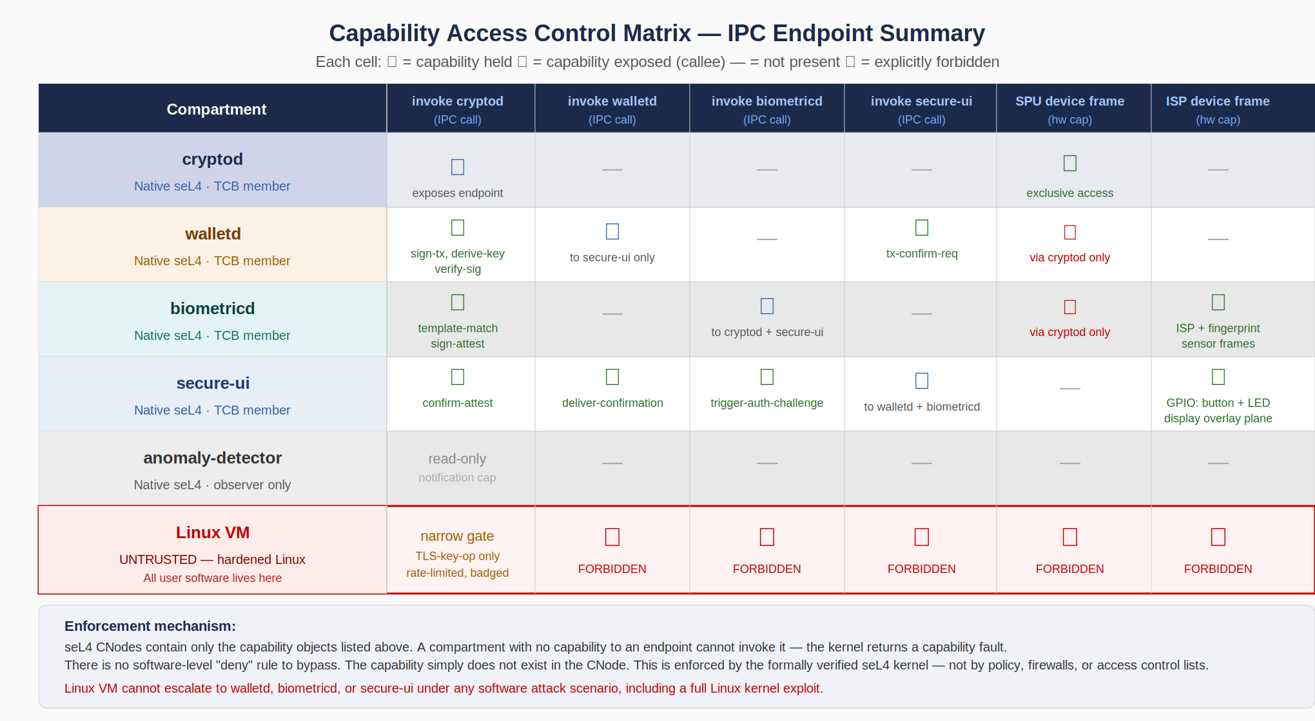
Figure 19.1 — CACM IPC Endpoint Summary. Red ✕ entries for the Linux VM are enforced by kernel-level capability absence, not software policy.

19.2.1 Full Capability Matrix — Tabular Specification
Compartment | invoke cryptod | invoke walletd | invoke biometricd | invoke secure-ui | SPU device frame | ISP/FP device frame
cryptod (exposes endpoint) | ◉ EXPOSE Is the endpoint | — NOT PRESENT | — NOT PRESENT | — NOT PRESENT | ✓ HOLD Exclusive MMIO | — NOT PRESENT
walletd | ✓ HOLD sign-tx, derive-key verify-sig (badged) | ◉ EXPOSE To secure-ui only (badged endpoint) | — NOT PRESENT | ✓ HOLD tx-confirm-request | ✕ FORBIDDEN Via cryptod only | — NOT PRESENT
biometricd | ✓ HOLD template-match sign-attest (badged) | — NOT PRESENT | ◉ EXPOSE To cryptod + secure-ui (badged) | — NOT PRESENT | ✕ FORBIDDEN Via cryptod only | ✓ HOLD ISP MMIO frame FP sensor MMIO
secure-ui | ✓ HOLD confirm-attest | ✓ HOLD deliver-confirmation | ✓ HOLD trigger-auth-challenge | ◉ EXPOSE To walletd + biometricd (badged) | — NOT PRESENT | ✓ HOLD GPIO: button + LED Display overlay plane
anomaly-detector | read-only notify cap (async, no IPC call) | — NOT PRESENT | — NOT PRESENT | — NOT PRESENT | — NOT PRESENT | — NOT PRESENT
Linux VM (UNTRUSTED) | narrow gate TLS-key-op only rate-limited, badged | ✕ FORBIDDEN NO CAPABILITY IN CNODE | ✕ FORBIDDEN NO CAPABILITY IN CNODE | ✕ FORBIDDEN NO CAPABILITY IN CNODE | ✕ FORBIDDEN NO CAPABILITY IN CNODE | ✕ FORBIDDEN NO CAPABILITY IN CNODE

19.3 Capability Topology Diagram
The following diagram shows the capability graph as a directed topology. Every arrow represents one or more capability grants. The absence of an arrow between two compartments means no capability exists in either direction — the seL4 kernel enforces this as a hard boundary.

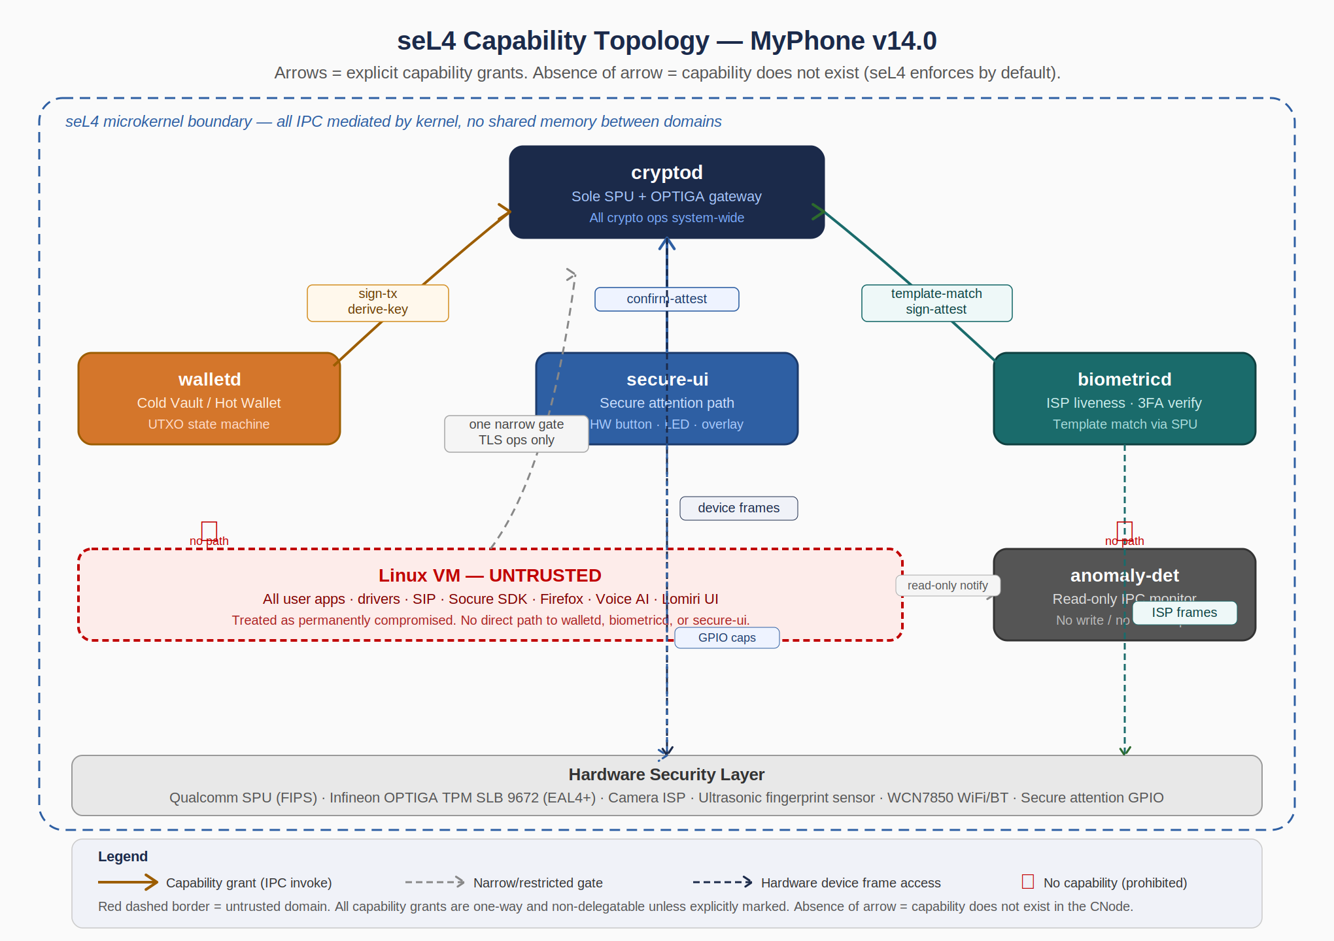
Figure 19.2 — seL4 Capability Topology. Arrows = explicit capability grants. Red ✕ marks = no capability exists (kernel-enforced). Dashed lines = hardware device frame access via SMMU.

19.4 Per-Compartment Formal Specification
The following subsections specify each compartment's complete capability endowment, IPC interface contract, hardware access, and explicit denial list. This specification is the source of truth for all agent-generated compartment code.

19.4.1 cryptod — Cryptographic Operations Daemon
cryptod is the sole gateway to the Qualcomm SPU and Infineon OPTIGA TPM. No other compartment holds hardware capabilities for these devices. All cryptographic operations system-wide are mediated through cryptod's IPC endpoint.

Attribute | Specification
Trust Level | TCB Member — Formally verified seL4 native compartment. Code must be < 5,000 LOC Rust (no unsafe). Constant-time verified in CI.
Initial Capability Endowment | (1) Own CNode and VSpace caps. (2) SPU hardware device frame capability (MMIO physical address range: to be specified by Hardware Integration Lead in HW Security Path Spec). (3) OPTIGA I2C bus device frame capability. (4) seL4 IRQ handler capability for SPU interrupt line. (5) NDRNG device frame capability.
IPC Endpoint Exposed | One seL4 Endpoint object. Capability distributed to: walletd (badged 0x01), biometricd (badged 0x02), secure-ui (badged 0x03), Linux VM cryptod-gate (badged 0xFF, rate-limited). Badge values are immutable kernel-assigned values — callers cannot forge a different badge.
IPC Endpoints Held | None. cryptod does not call any other compartment. It only receives requests and returns responses. This is a critical security property: cryptod cannot be used as a confused deputy to invoke other compartments.
Accepted Message Types (from badged callers) | From walletd (0x01): SIGN_TX(tx_bytes, key_path), DERIVE_KEY(bip32_path), VERIFY_SIG(msg, sig, pubkey), GET_PUBKEY(key_path). From biometricd (0x02): TEMPLATE_MATCH(probe_template_id, candidate_features), SIGN_ATTEST(attestation_struct). From secure-ui (0x03): CONFIRM_ATTEST(session_nonce, factor_bitmask, timestamp). From Linux VM gate (0xFF): TLS_KEY_OP(operation_type) — restricted to ECDH key agreement and certificate signing for TLS only.
Replay Protection | All requests include a 64-bit monotonic nonce generated by the caller. cryptod maintains a per-caller nonce window (last 64 nonces). Requests with nonces outside the window or previously seen are rejected with ERR_REPLAY.
Rate Limiting | Linux VM gate (badge 0xFF): maximum 100 TLS_KEY_OP requests per minute. Excess requests receive ERR_RATE_LIMIT. No rate limit on walletd, biometricd, or secure-ui — these are infrequent by design and rate-limited at their own layer.
Error Handling | On malformed message, unknown badge, or missing required fields: return ERR_INVALID immediately, log event to anomaly-detector notification cap. Do NOT attempt to process partial messages. Do NOT panic — return error and continue serving. On SPU hardware fault: zeroize session keys, return ERR_HW_FAULT, alert anomaly-detector.
Forbidden Operations (explicit denial) | (1) cryptod MUST NOT hold IPC invoke capabilities for any other compartment. (2) cryptod MUST NOT delegate its SPU or OPTIGA device frame capabilities to any other compartment. (3) cryptod MUST NOT expose more than one IPC endpoint. (4) cryptod MUST NOT process messages from any caller whose badge is not in the approved set {0x01, 0x02, 0x03, 0xFF}. (5) cryptod MUST NOT return raw key material in any response — all key operations produce signatures, ciphertexts, or attestations, never key bytes.
SMMU Policy | SPU DMA channels restricted to cryptod VSpace only. OPTIGA I2C controller mapped exclusively to cryptod. No other compartment or the Linux VM may have these physical addresses in their SMMU translation tables. Verified by seL4 Verification Lead as Phase 2 deliverable.

19.4.2 walletd — Cryptocurrency Wallet Engine
walletd manages the complete lifecycle of the Cold Vault / Hot Wallet UTXO state machine. It is the only compartment authorized to issue transaction signing requests to cryptod with key_path values within the wallet BIP-32 key hierarchy (m/0/*, m/1/*, m/2/*).

Attribute | Specification
Trust Level | TCB Member — seL4 native compartment. Code must be < 8,000 LOC Rust (no unsafe). UTXO state machine must be formally specified before code generation (see Section 19.6).
Initial Capability Endowment | (1) Own CNode and VSpace caps. (2) cryptod IPC invoke capability (badged 0x01). (3) secure-ui IPC invoke capability (for tx-confirm-request). (4) Sealed storage capability (persistent encrypted storage for UTXO state, mapped through seL4 dataport to a dedicated storage partition).
IPC Endpoint Exposed | One seL4 Endpoint object. Capability distributed to: secure-ui only (badged 0x10). The Linux VM has NO capability to invoke walletd under any circumstances. Wallet operations initiated from the Linux VM UI must route through secure-ui's confirmed action flow — the Linux VM UI sends a display request to secure-ui, secure-ui presents the confirmation to the user via the hardware attention path, and secure-ui invokes walletd only after cryptographic attestation of user approval.
IPC Endpoints Held | (1) cryptod invoke cap (badge 0x01). (2) secure-ui invoke cap (badge 0x30).
Accepted Message Types | From secure-ui (0x10) only: EXECUTE_COLD_TO_HOT(vault_utxo_id, hot_amount_sats), EXECUTE_HOT_SPEND(destination_script, amount_sats, fee_sats), INITIATE_RECOVERY(recovery_share_fragments[]), GET_BALANCE(vault_id), GET_ADDRESS(key_path), SWEEP_EMERGENCY(new_destination_script). All message types require a valid 3FA attestation token from secure-ui embedded in the message — walletd verifies the token with cryptod (VERIFY_SIG) before executing any state transition.
Forbidden Operations (explicit denial) | (1) walletd MUST NOT accept messages from any caller whose badge is not 0x10 (secure-ui). (2) walletd MUST NOT execute any state transition without a valid 3FA attestation token. (3) walletd MUST NOT hold invoke capabilities for the Linux VM, biometricd, or anomaly-detector. (4) walletd MUST NOT sign transactions with key paths outside m/0/*, m/1/*, m/2/*. (5) walletd MUST NOT retain 3FA attestation tokens beyond a single request-response cycle.
Key Path Restrictions | m/0/* = Cold Vault keys (SIGN_TX requests to cryptod). m/1/* = Hot Wallet keys (SIGN_TX requests to cryptod). m/2/* = PQC recovery keys (stored in OPTIGA; walletd requests off-chain ML-DSA authorization via cryptod before releasing recovery key). Any SIGN_TX request with a key path outside these ranges MUST be rejected with ERR_INVALID_KEY_PATH.

19.4.3 biometricd — Biometric Processing Daemon
biometricd manages the complete 3FA pipeline: face recognition (seL4-isolated ISP compartment), fingerprint sensor interface, and image recognition challenge state machine. It coordinates with cryptod for template matching (templates never leave the SPU) and with secure-ui for challenge display.

Attribute | Specification
Trust Level | TCB Member — seL4 native compartment. Code must be < 6,000 LOC Rust (no unsafe). Liveness detection algorithms must be reviewed by biometric security specialist before deployment.
Initial Capability Endowment | (1) Own CNode and VSpace caps. (2) Camera ISP MMIO device frame (V4L2-equivalent register range). (3) IR illuminator GPIO capability. (4) Ultrasonic fingerprint sensor MMIO device frame. (5) Fingerprint sensor IRQ handler capability. (6) cryptod IPC invoke capability (badged 0x02). (7) secure-ui IPC invoke capability (badged 0x31).
IPC Endpoint Exposed | One seL4 Endpoint object. Capability distributed to: cryptod (badged 0x20) and secure-ui (badged 0x21). The Linux VM has NO capability to invoke biometricd.
Accepted Message Types | From cryptod (0x20): none currently — cryptod initiates TEMPLATE_MATCH which calls into biometricd's ISP processing, returning processed feature vectors. From secure-ui (0x21): BEGIN_3FA_CHALLENGE(session_nonce, required_factors_bitmask), GET_CHALLENGE_IMAGE_INDICES(session_nonce).
ISP Processing Model | Camera frames are acquired directly via MMIO device frame cap. Frame processing (3D depth map, IR reflectance, liveness checks) occurs entirely within biometricd's VSpace — raw frame data never leaves the compartment. Processed feature vectors (not raw images) are sent to cryptod for SPU-side template matching. This ensures biometric raw data never transits IPC.
Forbidden Operations (explicit denial) | (1) biometricd MUST NOT hold invoke capabilities for walletd, anomaly-detector, or the Linux VM. (2) biometricd MUST NOT transmit raw camera frames or raw fingerprint images outside its VSpace. (3) biometricd MUST NOT hold SPU device frame capabilities — all SPU access is via cryptod IPC. (4) biometricd MUST NOT accept authentication challenge requests from any caller whose badge is not 0x21 (secure-ui).

19.4.4 secure-ui — Secure Attention and Confirmation Daemon
secure-ui is the exclusive gateway through which user-visible wallet operations and high-security confirmations are presented and approved. It controls the hardware secure attention button and LED indicator. No display or input path outside secure-ui can present wallet confirmation UI.

Attribute | Specification
Trust Level | TCB Member — seL4 native compartment. Code must be < 4,000 LOC Rust (no unsafe). Hardware button IRQ path is the single most security-critical software path in the device.
Initial Capability Endowment | (1) Own CNode and VSpace caps. (2) Hardware secure-attention button GPIO device frame (exclusive). (3) Status LED GPIO device frame (exclusive). (4) Display overlay plane capability (hardware overlay, bypasses GPU framebuffer — specific display controller register range to be specified in HW Security Path Spec). (5) Touchscreen input IRQ handler cap (exclusive, for overlay-mode touch event capture). (6) cryptod IPC invoke cap (badged 0x03). (7) walletd IPC invoke cap (badged 0x10). (8) biometricd IPC invoke cap (badged 0x21).
IPC Endpoint Exposed | One seL4 Endpoint object. Capability distributed to: walletd (badged 0x30) and biometricd (badged 0x31).
Hardware Button IRQ Model | The secure-attention button is wired to a dedicated GPIO interrupt line. seL4 assigns the IRQ handler capability exclusively to secure-ui — no other compartment or the Linux VM holds an IRQ handler cap for this line. When the button is pressed, seL4 delivers the IRQ to secure-ui's notification endpoint. secure-ui then activates the LED and enters secure display mode. The Linux VM cannot generate or intercept this signal under any software attack scenario.
Display Overlay Model | The display controller provides a hardware overlay plane (OSD layer) that composites above the GPU framebuffer without going through the GPU. secure-ui writes confirmation UI directly to this overlay plane via its device frame capability. The GPU framebuffer (controlled by the Linux VM's Mesa/Freedreno stack) is rendered underneath. A Pegasus-compromised Linux VM sees a blank or frozen GPU frame — it cannot read or modify the overlay plane content.
Forbidden Operations (explicit denial) | (1) secure-ui MUST NOT invoke walletd unless the hardware button IRQ was received in the current session. (2) secure-ui MUST NOT pass any message from the Linux VM to walletd or biometricd. The Linux VM has no invoke capability for secure-ui. (3) secure-ui MUST NOT hold capabilities for the anomaly-detector or Linux VM. (4) secure-ui MUST NOT present wallet confirmation UI unless the LED indicator is activated — the LED is the user's verifiable signal that the display is authentic.

19.4.5 anomaly-detector — Behavioral Monitoring Daemon
anomaly-detector is a read-only observer. It holds no invoke capabilities for any other compartment and cannot trigger any action directly. It sends alerts to a secure logging endpoint and, via a one-way notification capability, can signal the secure-ui compartment to display a user warning.

Attribute | Specification
Trust Level | TCB Member (observer class). Compromise of anomaly-detector cannot affect the security of wallet, biometric, or crypto operations. Its purpose is detection and alerting, not enforcement.
Initial Capability Endowment | (1) Own CNode and VSpace caps. (2) Read-only notification receive capability on all seL4 compartment audit notification endpoints. (3) Secure log endpoint write capability. (4) secure-ui notification capability (write-only, one-way signal — 'alert user' only, no data payload).
IPC Endpoint Exposed | None. anomaly-detector does not accept IPC calls from any compartment. It only receives asynchronous notifications.
Monitoring Sources | (1) seL4 audit log notification stream (kernel-emitted events for capability faults, scheduling anomalies). (2) Linux VM IPC gateway activity notification (rate and pattern of Linux VM → cryptod calls). (3) Pegasus IOC rule engine: evaluated against process behavior visible in the audit stream. (4) ML secondary signal (TFLite Micro, Hexagon DSP): behavioral baseline anomaly detection.
Forbidden Operations (explicit denial) | (1) anomaly-detector MUST NOT hold invoke capabilities for cryptod, walletd, biometricd, or secure-ui. (2) anomaly-detector MUST NOT hold any hardware device frame capabilities. (3) anomaly-detector MUST NOT be able to block or intercept any IPC message — it is strictly a passive observer.

19.4.6 Linux VM — Untrusted Execution Domain
The Linux VM is treated as permanently compromised. Its capability endowment is minimal — sufficient to run all user-facing applications and provide a normal smartphone experience, but with zero ability to access security compartments or hardware security resources.

Attribute | Specification
Trust Level | UNTRUSTED. The Linux VM's entire software stack — including the Linux kernel — is assumed to be potentially compromised. Security properties are maintained by the seL4 hypervisor boundary, not by any software within the Linux VM.
Capability Endowment | (1) VM VSpace and CNode caps (managed by seL4 hypervisor). (2) GPU MMIO frames (Adreno 740 graphics, SMMU-constrained to GPU memory regions only). (3) WiFi MMIO frames (WCN7850, SMMU-constrained to WiFi DMA buffers only). (4) Display framebuffer frames (GPU-composited layer only — not the overlay plane). (5) Audio codec MMIO frames. (6) Sensor hub MMIO frames. (7) USB-C controller MMIO (data isolated from power delivery circuit). (8) cryptod-gate invoke capability (badged 0xFF, TLS ops only, rate-limited).
cryptod Gate — Permitted Operations | The Linux VM may invoke cryptod with badge 0xFF for the following TLS-related operations only: TLS_ECDH_KEY_AGREE(peer_public_key) — for establishing TLS sessions for Firefox, SIP/TLS, and app network connections. TLS_CERT_SIGN(csr_bytes) — for client certificate operations. No wallet, biometric, or key derivation operations are accessible via this gate.
Wallet UI Interaction Model | The Linux VM runs the MyCryptoWallet UI application (Lomiri app). This UI application presents wallet information to the user (balance display, transaction history, initiation interface) but CANNOT sign transactions or access keys directly. When a user initiates a transaction from the UI, the app displays a 'Confirm on device' instruction. The user must press the physical secure-attention button. At that point, secure-ui takes control of the display overlay, presents the real transaction details, and collects the 3FA authentication. The Linux VM UI never knows whether the transaction was approved or rejected until secure-ui or walletd sends a completion notification via the standard Linux VM notification channel (a one-way signal with no capability grants).
Forbidden Capabilities (hard denial — verified at audit) | The following capabilities MUST NOT appear in the Linux VM's CNode or in any VSpace mapping accessible to Linux VM processes: (1) walletd IPC invoke cap (2) biometricd IPC invoke cap (3) secure-ui IPC invoke cap (4) SPU device frame cap (5) OPTIGA I2C device frame cap (6) ISP MMIO device frame cap (7) Fingerprint sensor MMIO device frame cap (8) Secure-attention GPIO device frame cap (9) LED GPIO device frame cap (10) Display overlay plane device frame cap (11) Any seL4 kernel object creation capability (cannot mint new capabilities)
SMMU Policy | All Linux VM DMA is constrained by SMMU to buffers within the Linux VM VSpace. GPU DMA cannot reach SPU memory regions. WiFi DMA cannot reach SPU, OPTIGA, or ISP memory regions. SMMU tables are configured by the seL4 hypervisor and cannot be modified by the Linux VM kernel.

19.5 Hardware Device Capability Assignments
The following table maps each physical hardware resource to its exclusive capability holder. No resource appears in more than one compartment's capability set. Shared access is mediated by the owning compartment via IPC, not by sharing the device frame capability.

Hardware Resource | Exclusive Capability Holder | Physical Address Range | SMMU Policy
Qualcomm SPU (MMIO, mailbox) | cryptod | Specified in QCS8550 TRM (NDA document). Hardware Integration Lead to populate. | SMMU: SPU DMA restricted to cryptod VSpace only
Infineon OPTIGA TPM (I2C bus controller) | cryptod | I2C controller MMIO base address. Bus address 0x29 (default SLB 9672). | I2C DMA restricted to cryptod IPC buffer region
Camera ISP (MIPI CSI, ISP registers) | biometricd | Qualcomm Spectra ISP register range. Hardware Integration Lead to populate. | ISP DMA restricted to biometricd frame buffer VSpace
IR Illuminator (GPIO) | biometricd | GPIO pin: TBD by Hardware Integration Lead. | GPIO — no DMA
Ultrasonic Fingerprint Sensor (SPI/MMIO) | biometricd | Qualcomm 3D Sonic Max sensor interface. Hardware Integration Lead to populate. | SPI DMA restricted to biometricd sensor buffer VSpace
Secure Attention Button (GPIO, IRQ) | secure-ui | Dedicated GPIO interrupt line. Hardware Integration Lead to populate. | GPIO — no DMA. IRQ handler cap exclusive to secure-ui.
Status LED (GPIO) | secure-ui | Dedicated GPIO output line. Hardware Integration Lead to populate. | GPIO — no DMA
Display Overlay Plane (OSD hardware layer) | secure-ui | Display controller OSD register range. Above GPU framebuffer in z-order. Hardware Integration Lead to populate. | Display DMA restricted to secure-ui overlay buffer VSpace
Adreno 740 GPU (MMIO, DMA) | Linux VM | GPU register base address — standard Qualcomm Adreno range. | SMMU: GPU DMA restricted to Linux VM GPU memory regions. Cannot reach SPU, ISP, or overlay plane addresses.
WCN7850 WiFi/BT (PCIe) | Linux VM | PCIe BAR for WCN7850. ath11k driver in Linux VM. | SMMU: WiFi DMA restricted to Linux VM network buffer VSpace. Cannot reach SPU or cryptographic memory regions.
Radio Lockdown Switch (GPIO, power rail control) | seL4 hypervisor (system init only) | GPIO controlling WCN7850 power rail. Physical switch signal detected here. | Not exposed to any compartment. Handled by seL4 platform layer on switch event.

NOTE Physical addresses marked 'TBD' are required deliverables from the Hardware Integration Lead in Phase 0. The CACM cannot be finalized until all hardware addresses are populated and the SMMU table configuration is verified by the seL4 Verification Lead. These TBD entries are blocking gates for Phase 1 code generation of affected compartments.

19.6 Capability Delegation Rules
The following delegation rules are absolute. No code, agent-generated or human-written, may violate them. These rules are verified at CACM audit, not trusted to runtime enforcement.

- Rule D-1: No Delegation Without Explicit Authorization: A compartment may not grant any of its capabilities to another compartment unless that delegation is explicitly listed in this CACM. The seL4 kernel allows capability delegation (Mint, Copy) — but just because the kernel allows it does not mean the policy allows it. Any code that calls seL4_CNode_Copy or seL4_CNode_Mint to delegate a capability not specified in this document is a security defect.
- Rule D-2: cryptod Device Caps Are Non-Delegatable: The SPU and OPTIGA device frame capabilities held by cryptod are marked non-delegatable (no CNode Mint rights). cryptod cannot transfer them to any other compartment even if instructed to by an IPC message. This must be enforced at compartment initialization by constructing the capability with the Mint right removed.
- Rule D-3: IPC Endpoint Caps Are Distributed Once at Init: All IPC endpoint capabilities are distributed during system initialization by the seL4 platform init thread (Kry10/Lions OS service manager or Microkit root task). No capability distribution occurs at runtime. If a compartment needs to communicate with another compartment that was not in its initial endowment, that is an architectural change requiring a CACM update and re-audit.
- Rule D-4: Linux VM CNode Is Immutable After Init: The Linux VM's capability set is fixed at VM creation time. The Linux VM kernel cannot create new seL4 capability objects, cannot invoke seL4_CNode_Mint, and cannot communicate with the seL4 system call interface directly (VM system calls are trapped and filtered by the hypervisor). Any attempt by the Linux VM to acquire new capabilities must result in a VM exit and a seL4 capability fault.
- Rule D-5: Badge Values Are Fixed and Audited: The badge values listed in Section 19.4 are the canonical values. Any change to badge assignments requires a CACM revision, a new audit, and a fresh capability distribution. Badge values that differ from the CACM are a security defect.

19.7 Forbidden Operations — Explicit Denial List
The following operations are explicitly forbidden at the system architecture level. These are not implementation choices — they are security invariants. Any implementation that enables any of the following is a Critical security defect that must halt the build and trigger a full security review.

ID | Forbidden Operation | Why It Matters | Enforcement
FO-01 | Linux VM invoking walletd, biometricd, or secure-ui via IPC | Direct IPC would allow a Pegasus-compromised Linux kernel to trigger wallet operations, biometric authentication, or secure UI display without user interaction. | CACM: no cap in Linux VM CNode
FO-02 | Any compartment accessing SPU or OPTIGA hardware other than via cryptod IPC | Direct hardware access bypasses the key isolation model. cryptod's monopoly on SPU/OPTIGA access is the foundation of the key security architecture. | CACM: no device frame cap; SMMU enforces
FO-03 | walletd executing a state transition without a valid 3FA attestation token | Allows wallet operations without user authentication. An attacker who compromises walletd's IPC pathway (e.g., a confused deputy via secure-ui) cannot complete a transaction without the hardware-attested biometric. | walletd implementation must call VERIFY_SIG on token before any state change
FO-04 | cryptod returning raw key material in any IPC response | Keys must never leave SPU silicon. Any API that returns raw private key bytes creates a path for key exfiltration through IPC. | cryptod API design — no response type includes key bytes
FO-05 | secure-ui presenting wallet confirmation UI without the hardware LED active | The LED is the user's only out-of-band signal that the UI is authentic. A fake UI without the LED allows a compromised app to trick users into approving transactions. | secure-ui: LED activation is first action in confirmation flow
FO-06 | biometricd transmitting raw camera frames or raw fingerprint images outside its VSpace | Raw biometric data must never transit IPC — only processed feature vectors. Raw data transmission would allow reconstruction of biometric templates by a compromised IPC observer. | biometricd API design — no response type includes raw frame data
FO-07 | Any compartment minting new capabilities at runtime | Runtime capability minting could allow an attacker who compromises a compartment to expand its capability set beyond the CACM. All capabilities must be distributed at init time. | Rule D-3: no runtime cap distribution
FO-08 | cryptod IPC endpoint accepting messages from callers with unknown badge values | Unknown badges indicate either a misconfiguration (a compartment was given a capability it shouldn't have) or an attempted attack. Rejection with logging is the only acceptable response. | cryptod implementation: badge whitelist enforced, unknown badge → ERR + alert

19.8 Badge Authentication Scheme
seL4 endpoint capabilities can be badged: when the kernel delivers a message to an endpoint, it includes the badge value of the caller's capability. The endpoint owner can use this to identify the caller without trusting message content. The following badge assignments are canonical and must be used in all cryptod, walletd, biometricd, and secure-ui implementations.

Badge Value | Assigned To (Caller) | Endpoint (Callee) | Permitted Operations
0x01 | walletd | cryptod | SIGN_TX, DERIVE_KEY, VERIFY_SIG, GET_PUBKEY
0x02 | biometricd | cryptod | TEMPLATE_MATCH, SIGN_ATTEST
0x03 | secure-ui | cryptod | CONFIRM_ATTEST
0xFF | Linux VM (narrow gate only) | cryptod | TLS_ECDH_KEY_AGREE, TLS_CERT_SIGN only — rate limited 100/min
0x10 | secure-ui | walletd | EXECUTE_COLD_TO_HOT, EXECUTE_HOT_SPEND, GET_BALANCE, GET_ADDRESS, INITIATE_RECOVERY, SWEEP_EMERGENCY
0x20 | cryptod (template-match request pathway) | biometricd | Internal template match coordination
0x21 | secure-ui | biometricd | BEGIN_3FA_CHALLENGE, GET_CHALLENGE_IMAGE_INDICES
0x30 | walletd | secure-ui | TX_CONFIRM_REQUEST(tx_details_struct)
0x31 | biometricd | secure-ui | AUTH_RESULT_NOTIFY(attestation_token)

IMPORTANT Badge values are not secrets. An attacker who knows the badge values gains nothing — badge values are set by the kernel when the capability is minted, not by the caller. A caller cannot forge a different badge value in the kernel's message delivery. The badge scheme identifies callers; it does not authenticate them beyond the capability grant itself.

19.9 CACM Audit Requirements
The CACM is a living specification that must be audited at each of the following gates:

- Phase 0 Gate: CACM v1.0 completed with all hardware device frame physical addresses populated by Hardware Integration Lead. SMMU table configuration plan derived from CACM and reviewed by seL4 Verification Lead. All TBD entries resolved.
- Phase 1 Gate (Month 8): All seL4 compartment code reviewed against CACM. Automated CACM conformance test suite executed: (1) each compartment's CNode is inspected at boot to verify it contains exactly the capabilities listed in the CACM and no others, (2) all forbidden operations are attempted and verified to fail with capability fault.
- Phase 2 Gate (Month 12): SMMU configuration correctness audit: each hardware resource's DMA constraints verified against CACM hardware capability assignments. Any DMA path that crosses the CACM boundary is a Critical defect.
- Phase 4 Gate (Month 16): Full CACM re-audit with wallet and biometric code integrated. Badge assignment table verified against implementation. All FO-* forbidden operations verified by red team.
- Pre-Ship Gate (Month 19): Trail of Bits / NCC Group pen test engagement includes CACM boundary testing: attempt every capability escalation path listed in the FO-* forbidden operations table from a compromised Linux VM. All findings must be resolved before ship.
- Post-Ship (Ongoing): Any architectural change that adds, removes, or modifies a capability grant requires a CACM revision, re-audit at the affected gate level, and re-run of the CACM conformance test suite.

20. cryptod IPC Interface Specification
cryptod is the single most security-critical interface in MyPhone. Every cryptographic operation in the device flows through it: wallet transaction signing, biometric template matching, TLS session key agreement, boot attestation, post-quantum operations, and random number generation. This section is not documentation — it is a formal engineering specification. Agent-generated code for all compartments that call cryptod must be written against this specification. Code that deviates from it is a security defect.

20.1 Architecture Overview
cryptod exposes exactly one seL4 IPC endpoint. All callers — walletd, biometricd, secure-ui, and the Linux VM narrow gate — send requests to this single endpoint and block in seL4_Call until a response is returned. The endpoint multiplexes callers by badge value (kernel-assigned, unforgeable). cryptod is single-threaded: one request is processed at a time. Concurrent callers wait in the seL4 scheduler priority queue.

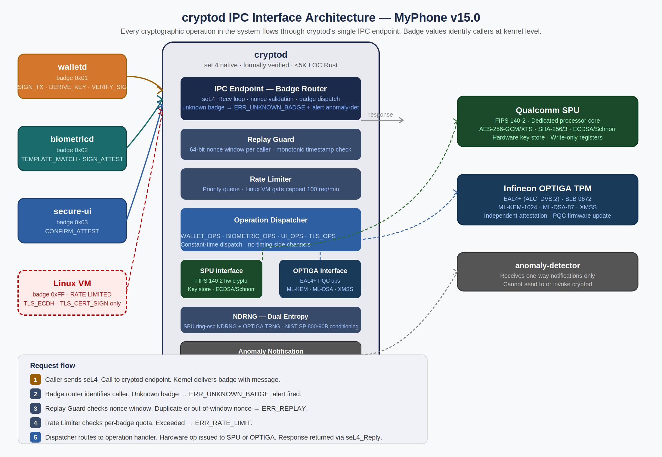
Figure 20.1 — cryptod IPC Architecture. Single endpoint, badge-based caller identification, hardware backends (SPU + OPTIGA), anomaly notification path.

Design principles encoded in this specification:
- No key material ever leaves cryptod: All private key operations happen inside SPU hardware. cryptod returns signatures, ciphertexts, and attestations — never raw key bytes. This invariant is enforced at the API type level: no response type has a field capable of holding a raw private key.
- No ambient authority: cryptod performs no operation without an explicit, badged request. It does not self-initiate any hardware operation, does not maintain persistent session state between requests, and does not cache results.
- Constant-time dispatch: The operation type branch is resolved in O(1) with no conditional branches that vary by secret data, preventing timing side channels on the dispatch path.
- Fail closed, never crash: On any error condition (malformed input, replay, rate limit, hardware fault), cryptod returns an error code, fires an anomaly notification if security-relevant, zeroizes any intermediate material, and returns to RECV_WAIT. It does not panic, assert, or exit.
- Caller authentication via badge: seL4 badges are kernel-assigned and unforgeable. A compartment cannot forge a different badge value in the kernel's message delivery path. Badge validation is the primary caller authentication mechanism.

20.2 Request Lifecycle and State Machine
Every request to cryptod passes through five sequential validation stages before any hardware operation is initiated. Failure at any stage terminates the request with an error response and returns cryptod to RECV_WAIT. No stage is skippable.

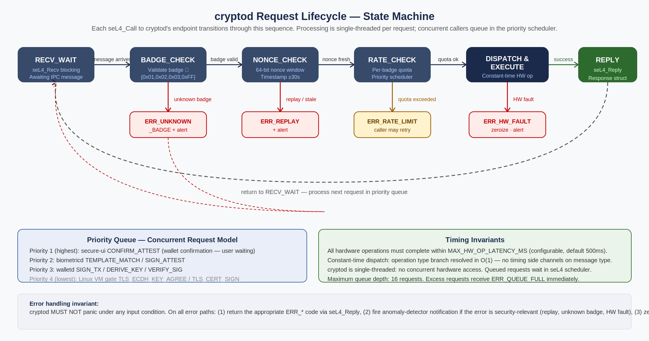
Figure 20.2 — cryptod Request Lifecycle State Machine. Five sequential validation stages before hardware operation. All error paths return to RECV_WAIT without crashing.

Stage | Check | Failure Response | Anomaly Alert?
1. RECV_WAIT | seL4_Recv blocks awaiting any IPC message | N/A — blocking wait | No
2. BADGE_CHECK | Badge ∈ {0x01, 0x02, 0x03, 0xFF} | ERR_UNKNOWN_BADGE — seL4_Reply, return to RECV_WAIT | YES — critical
3. NONCE_CHECK | nonce not in per-caller 64-entry window; timestamp within ±30,000ms | ERR_REPLAY — seL4_Reply, return to RECV_WAIT | YES — security event
4. RATE_CHECK | Per-badge request quota not exceeded (see Section 20.8) | ERR_RATE_LIMIT — seL4_Reply, return to RECV_WAIT | Only for Linux VM gate (0xFF)
5. DISPATCH | op_code valid for this badge; payload_len ≤ MAX_PAYLOAD; payload structurally valid | ERR_INVALID_OP or ERR_MALFORMED — seL4_Reply | YES if unexpected op_code for badge
6. EXECUTE | Hardware operation issued to SPU or OPTIGA | ERR_HW_FAULT — zeroize intermediate material, seL4_Reply | YES — hardware fault
7. REPLY | seL4_Reply with CryptodResponse. echo_nonce = request nonce. | N/A — reply always sent | No

20.3 Wire Format Specification
All IPC messages between callers and cryptod use the structures defined below. The format is fixed-layout, little-endian, with no padding. Rust struct declarations use #[repr(C, packed)]. Total request size is bounded at 4,156 bytes (60-byte header + 4,096-byte maximum payload). Total response size is bounded at 4,112 bytes (16-byte header + 4,096-byte maximum result).

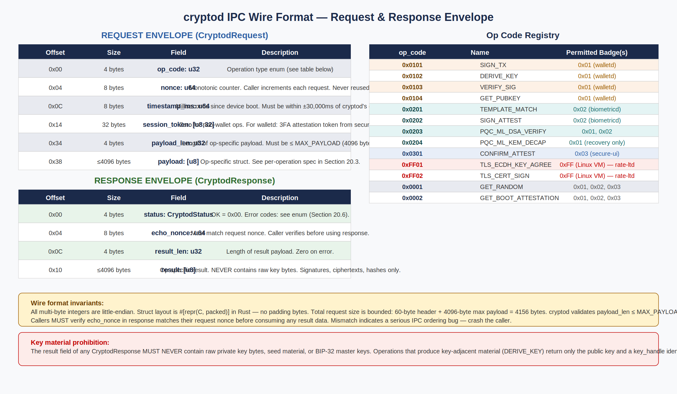
Figure 20.3 — Wire Format: request envelope, response envelope, and op_code registry. Key material prohibition: result field never contains raw private key bytes.

20.3.1 CryptodRequest — Rust Definition
#[repr(C, packed)]
pub struct CryptodRequest {
pub op_code: OpCode, // u32 — operation type enum
pub nonce: u64, // monotonic counter, never reused
pub timestamp_ms: u64, // ms since device boot
pub session_token: [u8; 32], // zero for non-wallet ops; 3FA attestation for walletd ops
pub payload_len: u32, // bytes of valid data in payload[]
pub payload: [u8; MAX_PAYLOAD], // op-specific payload struct, zero-padded
}
pub const MAX_PAYLOAD: usize = 4096;
pub const MAX_TIMESTAMP_SKEW_MS: u64 = 30_000;
pub const NONCE_WINDOW_SIZE: usize = 64;

20.3.2 CryptodResponse — Rust Definition
#[repr(C, packed)]
pub struct CryptodResponse {
pub status: CryptodStatus, // OK = 0x00; error codes below
pub echo_nonce: u64, // MUST match request nonce — caller MUST verify
pub result_len: u32, // bytes of valid data in result[]
pub result: [u8; MAX_RESULT], // op-specific result — NEVER contains raw key bytes
}
pub const MAX_RESULT: usize = 4096;

NOTE Callers MUST verify echo_nonce matches their request nonce before consuming any result data. A mismatch indicates an IPC ordering bug — the caller must treat the response as invalid and not use the result.

20.4 Operation Code Registry — Complete Enum
The following table defines every op_code value that cryptod will accept. Any op_code not in this table — regardless of badge — receives ERR_INVALID_OP. op_codes are grouped by prefix: 0x01xx = wallet operations, 0x02xx = biometric and PQC operations, 0x03xx = secure-ui operations, 0xFF xx = Linux VM gate, 0x00xx = system operations.

op_code | Enum Name | Permitted Badge(s) | SPU or OPTIGA | Description
0x0101 | SIGN_TX | 0x01 (walletd) | SPU | Sign a Bitcoin transaction with a key at the specified BIP-32 path. Key path must be within m/0/*, m/1/*, or m/2/* or request is rejected with ERR_INVALID_KEY_PATH. Returns Schnorr signature (64 bytes).
0x0102 | DERIVE_KEY | 0x01 (walletd) | SPU | Derive a child key at the given BIP-32 path from the master seed stored in SPU. Returns public key (33 bytes compressed) and a key_handle opaque identifier for use in subsequent SIGN_TX calls. Private key never leaves SPU.
0x0103 | VERIFY_SIG | 0x01 (walletd) | SPU | Verify a Schnorr or ECDSA signature against a given message hash and public key. Used by walletd to verify 3FA attestation tokens before executing state transitions. Returns VERIFIED or FAILED.
0x0104 | GET_PUBKEY | 0x01 (walletd) | SPU | Return the compressed public key for the given BIP-32 path. Used by walletd to obtain Cold Vault and Hot Wallet addresses. Returns 33-byte compressed public key.
0x0201 | TEMPLATE_MATCH | 0x02 (biometricd) | SPU | Compare biometric feature vector against enrolled template stored in SPU key store. Returns MATCH_PASS or MATCH_FAIL plus match score (u32). Template never leaves SPU. Feature vectors are in the request payload — they are not retained by cryptod after the operation.
0x0202 | SIGN_ATTEST | 0x02 (biometricd) | SPU | Produce a signed attestation struct after successful 3FA completion. Attestation includes: timestamp_ms, factor_bitmask (which of face/fingerprint/image were verified), session_nonce, device_serial_hash. Signed by SPU-held device attestation key. Returns 96-byte attestation_token.
0x0203 | PQC_ML_DSA_VERIFY | 0x01, 0x02 | OPTIGA | Verify an ML-DSA-87 signature (post-quantum). Used for OPTIGA firmware update verification and PQC recovery key authorization. Payload: message_hash (32 bytes) + ml_dsa_signature (4627 bytes) + ml_dsa_public_key (2592 bytes). Returns VERIFIED or FAILED.
0x0204 | PQC_ML_KEM_DECAP | 0x01 (walletd recovery only) | OPTIGA | Decapsulate an ML-KEM-1024 ciphertext using the OPTIGA-held PQC recovery private key. Used during social recovery to decrypt Shamir share encryption. Returns 32-byte shared secret. OPTIGA private key never leaves OPTIGA silicon.
0x0301 | CONFIRM_ATTEST | 0x03 (secure-ui) | SPU | Produce the final wallet-operation attestation token after user completes 3FA and presses the hardware confirmation button. Incorporates the transaction hash from walletd's TX_CONFIRM_REQUEST. Returns attestation_token used by walletd to authorize state transitions.
0xFF01 | TLS_ECDH_KEY_AGREE | 0xFF (Linux VM) rate-limited | SPU | Perform ECDH key agreement for TLS 1.3 handshake. Input: peer's ephemeral public key (65 bytes uncompressed). Returns: shared secret (32 bytes). Used by Firefox, SIP/TLS, and app network stack. Limited to 100 requests/minute per badge 0xFF.
0xFF02 | TLS_CERT_SIGN | 0xFF (Linux VM) rate-limited | SPU | Sign a TLS certificate signing request for client authentication. Input: DER-encoded CSR (≤2048 bytes). Returns: DER-encoded signed certificate. Limited to 100 requests/minute per badge 0xFF.
0x0001 | GET_RANDOM | 0x01, 0x02, 0x03 | SPU+OPTIGA | Return n bytes of cryptographically secure random data (1 ≤ n ≤ 64). Dual entropy sources: SPU ring-oscillator NDRNG + OPTIGA TRNG, XORed and conditioned per NIST SP 800-90B. Not available to Linux VM (must use kernel /dev/urandom within the VM).
0x0002 | GET_BOOT_ATTESTATION | 0x01, 0x02, 0x03 | SPU+OPTIGA | Return the current boot attestation record: chain of PCR-equivalent measurements from PBL through seL4 compartment initialization, signed by the SPU device attestation key and independently attested by OPTIGA TPM. Used for remote attestation and integrity verification.

20.5 Per-Operation Payload Specifications
Each op_code has a fixed payload struct that the caller must pack into the CryptodRequest.payload field. cryptod validates the struct layout before dispatching to the hardware operation. Malformed payloads receive ERR_MALFORMED.

20.5.1 SIGN_TX (0x0101) — Wallet Transaction Signing
#[repr(C, packed)]
pub struct SignTxPayload {
pub key_path: BIP32Path, // [u32; 5] — derivation path, e.g. m/0'/0/0
pub sighash: [u8; 32], // BIP 341 sighash for Taproot script-path spend
pub sighash_type: u8, // 0x00 = SIGHASH_DEFAULT (Taproot), 0x01 = SIGHASH_ALL
pub key_version: u8, // 0x00 = secp256k1 Schnorr (Taproot), 0x01 = legacy
pub session_token_hash: [u8; 32], // SHA-256 of the session_token in the envelope header
}
pub struct SignTxResult {
pub signature: [u8; 64], // Schnorr signature (BIP 340)
pub key_path: BIP32Path, // Echo of input key_path for caller verification
}

Security constraint: cryptod MUST verify that key_path is within the wallet namespace (m/0/*, m/1/*, m/2/*) before issuing the SIGN_TX to the SPU. Any key_path outside these prefixes receives ERR_INVALID_KEY_PATH and is logged as a security event.

20.5.2 TEMPLATE_MATCH (0x0201) — Biometric Matching
#[repr(C, packed)]
pub struct TemplateMatchPayload {
pub template_slot_id: u8, // 0 = face, 1 = fingerprint, 2..9 = reserved
pub feature_vector_len: u32, // bytes of valid data in feature_vector
pub feature_vector: [u8; 2048], // processed feature vector from biometricd ISP
pub liveness_score: u32, // liveness confidence from ISP (0..10000)
pub capture_timestamp: u64, // ms since boot when frame was captured
}
pub struct TemplateMatchResult {
pub outcome: MatchOutcome, // MATCH_PASS = 0x01, MATCH_FAIL = 0x00
pub match_score: u32, // similarity score 0..10000
// No template data, no raw feature vector — only the outcome
}

NOTE feature_vector contains processed biometric features — not raw camera frames. Raw frame data never transits IPC. The SPU stores enrolled templates and performs the comparison internally; only the match outcome and score are returned.

20.5.3 CONFIRM_ATTEST (0x0301) — Wallet Confirmation Attestation
#[repr(C, packed)]
pub struct ConfirmAttestPayload {
pub session_nonce: [u8; 32], // unique per-confirmation session nonce
pub tx_hash: [u8; 32], // SHA-256 of the transaction to be signed
pub factor_bitmask: u8, // bits: 0=face 1=fingerprint 2=image_recog
pub hw_button_event: HwButtonEventProof, // seL4 kernel-signed IRQ event proof
}
pub struct AttestationToken {
pub attestation_body: AttestationBody,
pub signature: [u8; 64], // SPU Schnorr signature over attestation_body
}
pub struct AttestationBody {
pub timestamp_ms: u64,
pub session_nonce: [u8; 32],
pub tx_hash: [u8; 32],
pub factor_bitmask: u8,
pub device_id_hash: [u8; 32],
}

The hw_button_event field contains a kernel-provided proof that a genuine hardware button press occurred in this session. The seL4 kernel, via the IRQ handler capability held exclusively by secure-ui, can produce a signed event record that cryptod verifies before issuing the attestation. This prevents secure-ui from fabricating attestations without a real button press.

20.6 Error Code Registry
Every error condition returns a CryptodStatus code. All error responses include echo_nonce matching the request nonce. result_len is zero on all error responses.

Code | Name | Meaning | Anomaly Alert? | Caller Action
0x00 | OK | Operation completed successfully. result field is valid. | No | Use result
0x01 | ERR_UNKNOWN_BADGE | Badge value not in {0x01, 0x02, 0x03, 0xFF}. Indicates capability misconfiguration or attack. | YES — CRITICAL. Badge fault = potential CACM violation | Crash/halt
0x02 | ERR_REPLAY | nonce previously seen in per-caller window, or timestamp outside ±30s window. | YES — security event. Log for forensic analysis | Generate new nonce
0x03 | ERR_RATE_LIMIT | Per-badge request quota exceeded. Only applicable to badge 0xFF (Linux VM). | Only for 0xFF excess patterns | Retry after 1s
0x04 | ERR_INVALID_OP | op_code not in registry, or op_code not permitted for caller's badge. | YES if op_code is a wallet op from badge 0xFF | Fix caller code
0x05 | ERR_MALFORMED | payload_len > MAX_PAYLOAD, or payload struct fails structural validation (length mismatch, invalid enum value, reserved field non-zero). | YES — log for investigation | Fix payload
0x06 | ERR_INVALID_KEY_PATH | SIGN_TX or DERIVE_KEY key_path is outside the permitted wallet namespace (m/0/*, m/1/*, m/2/*). | YES — CRITICAL. Unauthorized key access attempt | Fix key path
0x07 | ERR_INVALID_SESSION | session_token verification failed for wallet operations. CONFIRM_ATTEST calls VERIFY_SIG; if signature invalid, request is rejected. | YES — wallet op without valid 3FA token | Re-authenticate
0x08 | ERR_HW_FAULT | SPU or OPTIGA returned a hardware error, timeout, or unexpected response. cryptod zeroizes all intermediate key material before responding. | YES — hardware fault may indicate tamper | Alert user; retry once
0x09 | ERR_QUEUE_FULL | Priority queue at capacity (16 pending requests). Only possible under abnormally high concurrent call load. | Only if pattern is sustained | Retry after 100ms
0x0A | ERR_LIVENESS_FAIL | TEMPLATE_MATCH payload's liveness_score below threshold (< 7500/10000 for face, < 8000 for fingerprint). Liveness check precedes template comparison. | After 3 consecutive failures | Re-capture
0x0B | ERR_TOKEN_EXPIRED | Attestation token timestamp is older than 30 seconds. Tokens have a 30-second validity window. | No | Re-attest
0x0C | ERR_NDRNG_HEALTH | NDRNG health check failed (NIST SP 800-90B continuous health test). cryptod will not produce random output from a failing entropy source. | YES — CRITICAL | Device alert; reboot

20.7 Authentication Model — How Callers Are Identified
cryptod uses a layered authentication model. The first layer is seL4 badge-based identification (cryptographic, kernel-enforced). The second layer is nonce + timestamp replay protection. The third layer, for wallet operations only, is session token validation.

20.7.1 Badge-Based Identification (Primary)
When a caller invokes seL4_Call on cryptod's endpoint, the seL4 kernel delivers the message with the badge value that was embedded in the capability when it was minted. The kernel sets this badge — the caller has no ability to forge or modify it. cryptod reads the badge from the message info and uses it as the caller's identity.

This is the primary authentication mechanism. There are no passwords, no tokens, and no certificates at this layer. The security property is: if a compartment holds an endpoint capability badged 0x01, it is walletd (or a compartment that was incorrectly given walletd's capability — which would be a CACM violation). The CACM audit ensures the mapping between badge values and compartments is correct.

20.7.2 Nonce + Timestamp Replay Protection
Each caller maintains a monotonically increasing 64-bit nonce counter. Every request includes the current nonce value and a timestamp in milliseconds since boot. cryptod maintains a per-badge sliding window of the last 64 nonces received. A request is rejected if:
- Its nonce has already been seen in the window (duplicate request or replay attack)
- Its nonce is more than 64 positions behind the highest nonce seen for this badge (too far behind the window — indicates a replayed old request)
- Its timestamp differs from cryptod's current boot-time clock by more than 30,000 milliseconds

The nonce window is stored in cryptod's BSS segment and is not persisted across device restarts. A device reboot clears the window. This is acceptable: the primary threat from replay attacks is intra-session replays, not cross-session replays (which would also fail timestamp validation).

20.7.3 Session Token Validation (Wallet Operations Only)
For wallet operations (SIGN_TX, DERIVE_KEY, GET_PUBKEY, GET_RANDOM when called by walletd), the CryptodRequest.session_token field must contain a valid attestation token produced by CONFIRM_ATTEST in the current session. walletd includes this token in every operation that requires user authorization.

cryptod validates the session token by:
- Calling VERIFY_SIG internally against the attestation token's signature using the SPU device attestation public key
- Checking that the attestation body's timestamp_ms is within the last 30 seconds
- Checking that the attestation body's device_id_hash matches this device's identity
- Checking that factor_bitmask includes all three factors (face + fingerprint + image recognition — bitmask 0x07)

If any check fails, the operation returns ERR_INVALID_SESSION and fires an anomaly alert. This ensures that wallet operations cannot proceed even if walletd's IPC endpoint is somehow invoked without a genuine 3FA user confirmation.

20.7.4 Why There Is No Mutual Authentication for Non-Wallet Ops
The TEMPLATE_MATCH and SIGN_ATTEST operations (badge 0x02) and CONFIRM_ATTEST (badge 0x03) do not require session tokens. This is intentional: these operations are part of the authentication flow itself — requiring prior authentication to perform authentication would create a circular dependency.

The security property for these operations is provided by the CACM: only biometricd holds a badge 0x02 capability, and only secure-ui holds a badge 0x03 capability. Since these capabilities were distributed correctly at system initialization (verified by the CACM audit), the badge alone provides sufficient identity assurance for authentication-path operations.

20.8 Rate Limiting Policy
Rate limiting serves two purposes: preventing denial-of-service against cryptod's hardware backends (SPU and OPTIGA have finite throughput), and detecting anomalous request patterns from the Linux VM narrow gate.

Badge | Caller | Operations | Request Quota | Window | On Excess
0x01 | walletd | All wallet ops | No quota | N/A | N/A — walletd is infrequent by design
0x02 | biometricd | All biometric ops | No quota | N/A | N/A — max ~10 3FA attempts/session
0x03 | secure-ui | CONFIRM_ATTEST | No quota | N/A | N/A — one per wallet confirmation
0xFF | Linux VM gate | TLS_ECDH_KEY_AGREE | 100 req/min | Rolling 60s | ERR_RATE_LIMIT. Pattern of sustained excess → anomaly alert
0xFF | Linux VM gate | TLS_CERT_SIGN | 100 req/min | Rolling 60s | ERR_RATE_LIMIT. Combined with TLS_ECDH quota.
All | All callers | All ops | Queue depth 16 | Instantaneous | ERR_QUEUE_FULL if 16 requests already queued

NOTE The Linux VM TLS rate limit of 100 requests/minute is generous for legitimate TLS usage (a busy browser typically initiates < 20 TLS handshakes/minute) but would flag a compromised process attempting to enumerate or test the cryptod interface. Sustained limit-hitting triggers an anomaly-detector alert for investigation.

20.9 Priority Scheduling Model
cryptod is single-threaded. All concurrent callers block in seL4_Call and are queued in the seL4 scheduler. cryptod's RECV_WAIT loop processes requests from the highest-priority ready sender.

Priority | Badge | Caller | Rationale
1 — Highest | 0x03 | secure-ui | User is waiting at the hardware button. CONFIRM_ATTEST must complete before the attestation token expires (30s window). Any queuing here would degrade the wallet confirmation UX perceptibly.
2 | 0x02 | biometricd | User is mid-authentication. Template match latency directly affects lock screen and wallet authentication responsiveness. Delays here feel like device lag.
3 | 0x01 | walletd | Wallet signing operations are user-initiated and time-sensitive but not interactive at the sub-second level. A 100–200ms queue wait is acceptable.
4 — Lowest | 0xFF | Linux VM gate | TLS handshakes are network-latency-dominated; sub-second scheduling variance is imperceptible. Linux VM TLS traffic is background relative to security-critical operations.

seL4 priority scheduling is configured at compartment initialization by the Kry10/Lions OS service manager. The above priorities are set as seL4 thread priorities (P3_SECUI=250, P2_BIO=200, P1_WALLET=150, P0_LINUXVM=50 out of 0..255 scale). These values are fixed in the platform configuration and cannot be modified at runtime by any compartment.

20.10 Error Handling Invariants
cryptod's error handling model is designed around one principle: the compartment must remain operational after any single-request error. A compromised or buggy caller must not be able to crash or destabilize cryptod.

20.10.1 Mandatory Error Handling Sequence
For every error condition, cryptod MUST execute the following sequence in order before returning to RECV_WAIT:
- Zeroize any intermediate cryptographic material in stack or heap (key fragments, plaintext, feature vectors) allocated during the failed request processing.
- If the error is security-relevant (see Anomaly Alert column in Section 20.6): fire the one-way notification capability to anomaly-detector. The notification is non-blocking — if the anomaly-detector's notification buffer is full, the notification is dropped rather than blocking cryptod.
- Construct a CryptodResponse with the appropriate CryptodStatus error code, echo_nonce = request.nonce, result_len = 0, result = zeroed.
- Call seL4_Reply with the error response.
- Return to RECV_WAIT.

IMPORTANT cryptod MUST NOT panic under any circumstances. Panic in cryptod would crash the compartment, which would be detected by the seL4 watchdog and require a device reboot. A deliberate attacker could use a crashing input to trigger a reboot. The implementation must use Rust's panic=abort compilation mode with a custom panic handler that executes the zeroization + anomaly-alert sequence before aborting into an infinite loop (not a restart — compartment stays dead until explicit reboot, alerting the user).

20.10.2 Hardware Fault Handling
On ERR_HW_FAULT (SPU or OPTIGA returned error or timed out):
- Immediately zeroize all intermediate key material in cryptod's address space.
- Fire anomaly-detector notification with fault classification (SPU_FAULT or OPTIGA_FAULT).
- If this is the first HW fault in the current boot session: return ERR_HW_FAULT and continue serving requests. The hardware may have experienced a transient error.
- If this is the second consecutive HW fault on the same hardware backend: enter DEGRADED_MODE — continue serving requests from the other backend only. Anomaly-detector is re-alerted with SUSTAINED_HW_FAULT.
- If this is the third consecutive HW fault on any backend: fire CRITICAL_HW_FAULT to anomaly-detector. Continue returning ERR_HW_FAULT to all callers but do not crash. The user should be alerted to contact support.

20.10.3 What cryptod Does NOT Do On Errors
- MUST NOT retry the failed hardware operation — a failed SPU operation may indicate tamper response; retrying could waste tamper response budget
- MUST NOT cache the error response to return to future requests with the same parameters — every request is processed fresh
- MUST NOT trust message content to determine whether to alert anomaly-detector — alert decisions are based on the error type, not caller-supplied data
- MUST NOT block in error handling — all error processing must complete within a bounded time (MAX_ERROR_HANDLING_MS = 10ms)

20.11 Nonce Management — Implementation Contract for Callers
This section specifies what callers of cryptod are contractually required to implement. Caller code that deviates from this contract will produce ERR_REPLAY responses and is a bug in the calling compartment.

- Nonce counter storage: Each calling compartment maintains a per-instance u64 nonce counter initialized to 1 at compartment startup. The counter is stored in the compartment's BSS segment. It is not persisted across device restarts — the nonce window on cryptod's side is also cleared on restart.
- Monotonic increment: The nonce counter MUST be incremented by exactly 1 before each request. Never decrement, never reset to zero, never send the same nonce twice. Rust implementation: use a static AtomicU64 with fetch_add(1, Ordering::SeqCst) to ensure monotonicity even if multiple threads exist within a compartment.
- Timestamp acquisition: Use seL4_GetTime() (or the platform's equivalent) to get the current boot-relative timestamp in milliseconds. Never use a cached or hardcoded timestamp.
- Echo nonce verification: After seL4_Call returns, verify response.echo_nonce == request.nonce before using any data from the response. Mismatch: do not use the response, log a bug report, and retry the request with a fresh nonce. Do not crash — a mismatch indicates an IPC ordering issue in the caller, not a cryptod failure.
- Session token lifecycle: Session tokens received from CONFIRM_ATTEST are valid for 30 seconds. walletd MUST track the token's creation timestamp and discard it after 30,000ms regardless of whether it has been used. Never cache session tokens between seL4_Call invocations.

20.12 Integration Contract — Per-Caller Requirements
This section summarizes the integration requirements for each calling compartment. These requirements are binding — code review for any compartment that calls cryptod must verify compliance with this section.

20.12.1 walletd Integration Requirements
- MUST call GET_BOOT_ATTESTATION at startup and verify the attestation chain before making any wallet key operations. If attestation fails, walletd MUST enter a locked state and alert the user.
- MUST include a valid CONFIRM_ATTEST session token (< 30 seconds old) in the session_token field of every SIGN_TX request. A SIGN_TX request without a valid session token MUST NOT be issued — construct the session token first via the secure-ui flow.
- MUST verify echo_nonce in every cryptod response before processing the result.
- MUST treat ERR_INVALID_KEY_PATH as a Critical internal error — this indicates a bug in the walletd state machine. Log the key_path that triggered the error and halt wallet operations pending investigation.
- MUST zeroize local copies of session tokens immediately after they have been used in a SIGN_TX call (regardless of success or failure).

20.12.2 biometricd Integration Requirements
- MUST include a liveness_score in every TEMPLATE_MATCH payload. Score below 7,500/10,000 (face) or 8,000/10,000 (fingerprint) MUST cause biometricd to return a liveness failure to secure-ui without even issuing the TEMPLATE_MATCH to cryptod.
- MUST NOT retain processed feature vectors in memory after the TEMPLATE_MATCH seL4_Call returns. Zeroize the payload immediately.
- MUST treat ERR_LIVENESS_FAIL from cryptod as distinct from MATCH_FAIL — liveness failure indicates a spoofing attempt and warrants a different user message and anomaly log.

20.12.3 secure-ui Integration Requirements
- MUST verify that the hardware button IRQ event occurred in the current session before calling CONFIRM_ATTEST. The HwButtonEventProof in the payload embodies this.
- MUST verify that the tx_hash in the CONFIRM_ATTEST payload matches the transaction details it displayed to the user via the display overlay. An attacker that compromises walletd could attempt to supply a different tx_hash in the TX_CONFIRM_REQUEST — secure-ui must independently construct the tx_hash from the displayed transaction details.
- MUST treat the returned attestation_token as ephemeral — pass it to walletd immediately. Do not store it.

20.12.4 Linux VM Gate Requirements
- The Linux VM cryptod gate client (TLS library wrapper) MUST implement exponential backoff on ERR_RATE_LIMIT responses, starting at 1 second and doubling up to 60 seconds. It MUST NOT retry at a fixed rate.
- The Linux VM gate client MUST NOT attempt to call any op_code outside {0xFF01, 0xFF02}. Any other op_code will receive ERR_INVALID_OP. Code that attempts wallet or biometric op_codes from the Linux VM is a security defect to be flagged in code review.
- The Linux VM gate client MUST verify echo_nonce in every response.

20.13 Formal Verification Requirements
The following properties must be formally verified or mechanically tested before cryptod is accepted into the Phase 2 build. These are not optional.

Property | Verification Method | Gate | Owner
No op_code dispatch path executes a conditional branch on secret data before the hardware operation (timing side-channel prevention) | dudect constant-time analysis in CI — must pass with p-value > 0.05 | Phase 2 | Crypto/SPU Lead
Badge check is the first operation performed on every received message — no other code runs before badge validation | Static analysis: badge check is unconditionally the first statement in the IPC receive loop. Enforced by code structure, verified by seL4 Verification Lead. | Phase 1 | seL4 Verification Lead
No response type contains a struct field capable of holding a private key (>= 32 bytes contiguous without semantic annotation) | Type-level enforcement in Rust response type definitions. Code review: no [u8; N] for N >= 32 in any CryptodResponse result struct without explicit non-key semantic annotation. | Phase 1 | Crypto/SPU Lead
Nonce window advances correctly and never allows a previously seen nonce to pass | Property-based testing (proptest): generate random nonce sequences including replays, verify window rejects all duplicates. | Phase 1 | Systems Integration
cryptod returns to RECV_WAIT after every error condition without crashing | Fuzzing: AFL++ against every IPC message field. Must run 30 days with zero crashes (Phase 2 fuzzing deliverable). | Phase 2 | Security Architect
Key path restriction: SIGN_TX with any key_path outside m/0/*, m/1/*, m/2/* returns ERR_INVALID_KEY_PATH | Exhaustive unit tests: test every possible first two path levels including negative cases. | Phase 2 | Crypto/SPU Lead
Session token expiry: SIGN_TX with a session_token > 30 seconds old returns ERR_TOKEN_EXPIRED | Unit tests with controlled clock injection. | Phase 2 | Systems Integration

21. walletd UTXO State Machine — Formal Specification
walletd maintains every Bitcoin UTXO in the system in exactly one of the states defined in this section at all times. The state machine is the authoritative specification for all walletd implementation. Agent-generated code must implement this state machine exactly — no transitions not listed here, no states not listed here, no implicit state changes triggered by background processes not listed here. Edge cases and error paths are specified with the same precision as the happy path, because those are the paths that matter most in a security product.

21.1 State Inventory
The walletd state machine defines nine UTXO states across three namespaces: Cold Vault states, Hot Wallet states, and Recovery/Emergency states. Every UTXO ever known to walletd exists in exactly one of these states. State is persisted in SPU-backed sealed storage and survives device reboots.

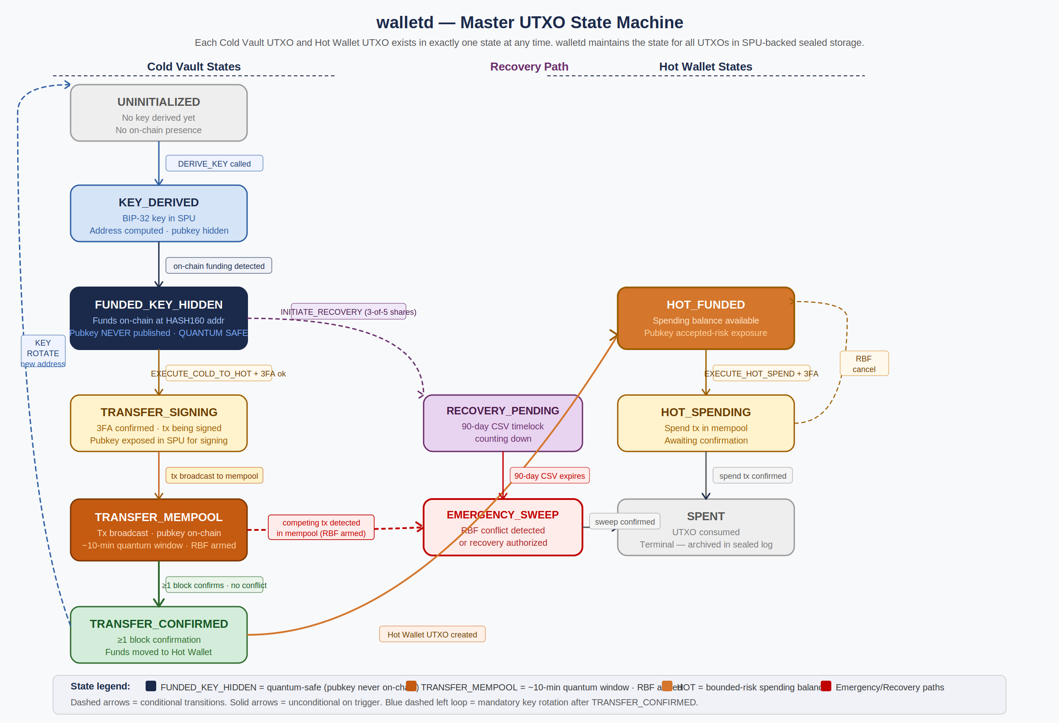
Figure 21.1 — Master UTXO State Machine. Nine states across three namespaces. Blue dashed left arrow = mandatory key rotation after TRANSFER_CONFIRMED (never skippable).

State | Namespace | Quantum Safety | Description
UNINITIALIZED | Cold Vault | N/A | BIP-32 key has not yet been derived for this vault slot. No address. No on-chain presence. Initial state of every new vault slot.
KEY_DERIVED | Cold Vault | Full | A BIP-32 child key has been derived from the master seed (via cryptod DERIVE_KEY). The Taproot address is computed and known to walletd. The public key has not been published on-chain. The address can receive funds.
FUNDED_KEY_HIDDEN | Cold Vault | FULL — pubkey never on-chain | Funds are confirmed on-chain at the vault address. The public key has never been published. A quantum attacker sees only the address hash — Shor's algorithm cannot operate on a hash. Primary resting state for bulk Cold Vault funds. The only state from which Cold→Hot transfers can be initiated.
TRANSFER_SIGNING | Cold Vault | Exposed (SPU only) | 3FA has been confirmed and walletd is in the process of building and signing the Cold→Hot transfer transaction. The public key V_i is accessible within the SPU for signing but has not yet appeared on-chain. This state is transient — maximum duration bounded by SPU operation latency.
TRANSFER_MEMPOOL | Cold Vault | ~10-min window | The signed transaction has been broadcast to the Bitcoin network. The public key V_i is now visible in the mempool (and will be on-chain after confirmation). RBF defense is armed — walletd actively monitors the mempool for competing spends. This is the highest-risk state in the system.
TRANSFER_CONFIRMED | Cold Vault | Historical exposure only | The transfer transaction has received ≥1 block confirmation. Funds have moved to the Hot Wallet UTXO. Mandatory key rotation (derive m/0/i+1) is triggered immediately upon entering this state. This state is also transient — the vault slot transitions to KEY_DERIVED (new index) within milliseconds.
HOT_FUNDED | Hot Wallet | Accepted risk (bounded) | Funds are available in the Hot Wallet for spending. The Hot Wallet public key H_j is accepted-risk — it will be exposed on the next spend. The Hot Wallet balance is intentionally small, bounding the quantum risk exposure.
HOT_SPENDING | Hot Wallet | Exposed (accepted) | A spend transaction is in the mempool. Awaiting confirmation. If a conflict is detected, RBF cancel is available if the user initiated an incorrect transaction.
SPENT | Hot Wallet | N/A (terminal) | UTXO has been consumed by a confirmed spend. Terminal state — this UTXO record is archived in the sealed storage audit log and never transitions to another state.
RECOVERY_PENDING | Recovery | Full (CSV protects) | A recovery script spend (Path B, 90-day CSV) has been broadcast. The 90-day timelock is running. Owner can cancel this recovery within the 90-day window using full 3FA. The UTXO remains quantum-safe during the timelock because no public key exposure is needed until the timelock expires.
EMERGENCY_SWEEP | Recovery | Active threat | An active threat has been detected — either a competing spend in the mempool (RBF conflict) or a direct SWEEP_EMERGENCY command. All FUNDED_KEY_HIDDEN UTXOs are queued for immediate sweep to fresh addresses. This state encompasses all UTXOs simultaneously, not per-UTXO.

21.2 Sealed Storage Schema
All UTXO state is persisted in walletd's sealed storage — an SPU-backed encrypted storage partition accessible only to walletd via a seL4 dataport capability. The following Rust schema defines the complete persistent state.

/// Master wallet state — persisted in SPU-backed sealed storage
#[derive(Serialize, Deserialize)]
pub struct WalletState {
pub version: u32, // schema version for migration
pub vault_index: u32, // current derivation index m/0/vault_index
pub hot_index: u32, // current hot wallet index m/1/hot_index
pub cold_utxos: Vec<ColdVaultUtxo>,
pub hot_utxos: Vec<HotWalletUtxo>,
pub sweep_in_progress: bool, // true if EMERGENCY_SWEEP active
pub recovery_state: Option<RecoveryState>,
pub audit_log: Vec<UtxoAuditEntry>, // append-only, never pruned
}
#[derive(Serialize, Deserialize)]
pub struct ColdVaultUtxo {
pub id: UtxoId, // SHA-256(txid || vout)
pub state: ColdVaultState,
pub key_path: BIP32Path, // m/0/i
pub address: TaprootAddress, // Taproot P2TR address
pub amount_sats: u64,
pub txid: Option<Txid>, // Some once funded
pub vout: Option<u32>,
pub transfer_txid: Option<Txid>, // Some when in TRANSFER_* states
pub rbf_broadcast: bool, // true if RBF replacement broadcast
pub created_at: u64, // ms since boot
pub state_changed_at: u64,
}
#[derive(Serialize, Deserialize)]
pub struct HotWalletUtxo {
pub id: UtxoId,
pub state: HotWalletState,
pub key_path: BIP32Path, // m/1/j
pub address: TaprootAddress,
pub amount_sats: u64,
pub source_vault_utxo_id: UtxoId, // which Cold Vault transfer funded this
pub spend_txid: Option<Txid>,
pub state_changed_at: u64,
}
#[derive(Serialize, Deserialize)]
pub enum ColdVaultState {
Uninitialized, KeyDerived, FundedKeyHidden,
TransferSigning, TransferMempool { broadcast_at: u64, transfer_txid: Txid },
TransferConfirmed { confirmed_at_height: u32 },
RecoveryPending { initiated_at: u64, timelock_expiry_height: u32 },
Spent { spent_at: u64 },
}
#[derive(Serialize, Deserialize)]
pub enum HotWalletState {
HotFunded, HotSpending { spend_txid: Txid }, Spent { spent_at: u64 },
}

21.3 State Transition Table — Complete Specification
Every valid state transition is listed below. Transitions not listed here are illegal — walletd must return ERR_INVALID_TRANSITION and log the attempt as a security event. The table specifies: the trigger (what event or command causes the transition), any guards (conditions that must be true for the transition to fire), and the side effects (actions walletd must execute atomically with the state change).

T-01 UNINITIALIZED → KEY_DERIVED
Attribute | Specification
Trigger | walletd calls cryptod DERIVE_KEY(m/0/vault_index) at wallet initialization or after T-06 key rotation.
Guard | vault_index not already in use by an active UTXO. cryptod returns a valid 33-byte compressed public key.
Side Effects | (1) Compute Taproot address from returned pubkey (BIP 341 key-path disabled; address encodes the script-path Merkle root). (2) Store {key_path, address, pubkey_commitment_hash} in sealed storage — NOT the raw pubkey. The pubkey is held in SPU; walletd stores only a commitment to verify it later. (3) Increment vault_index in sealed storage. (4) Write UTXO_CREATED entry to audit log.
Invariants | Raw pubkey bytes MUST NOT be written to sealed storage (they live in SPU). The address commitment allows walletd to verify on-chain funding without the pubkey.

T-02 KEY_DERIVED → FUNDED_KEY_HIDDEN
Attribute | Specification
Trigger | Blockchain monitor detects a confirmed UTXO funding the vault address with ≥1 confirmation.
Guard | Confirmed UTXO amount_sats > DUST_THRESHOLD (546 sats). The txid and vout match the expected vault address.
Side Effects | (1) Record txid, vout, amount_sats in ColdVaultUtxo. (2) State → FundedKeyHidden. (3) Update balance display (sent to Linux VM UI via one-way notification — no capabilities transferred). (4) Write UTXO_FUNDED entry to audit log.
Security Note | The vault address is derived from a HASH160(SHA256(pubkey)) commitment. On-chain, only the hash is visible. The public key is NOT revealed by receiving funds — only by spending them. This UTXO is quantum-safe as long as it remains in FUNDED_KEY_HIDDEN.

T-03 FUNDED_KEY_HIDDEN → TRANSFER_SIGNING
Attribute | Specification
Trigger | walletd receives EXECUTE_COLD_TO_HOT from secure-ui (badge 0x10). This is the only valid caller for this transition.
Guard | (1) session_token is present and valid (cryptod VERIFY_SIG returns VERIFIED, token timestamp < 30s). (2) factor_bitmask in token = 0x07 (all three 3FA factors confirmed). (3) The specified vault_utxo_id is in FUNDED_KEY_HIDDEN state. (4) hot_amount_sats ≤ utxo.amount_sats - MIN_FEE. If any guard fails: return ERR_GUARD_FAILED, no state change.
Side Effects | (1) State → TRANSFER_SIGNING. (2) Build Taproot transaction: input = vault UTXO, output = Hot Wallet address (m/1/hot_index), script-path spend (never key-path). (3) Call cryptod SIGN_TX(key_path=m/0/i, sighash, session_token). (4) On SIGN_TX success: state → TRANSFER_MEMPOOL (see T-04). On SIGN_TX failure: state → FUNDED_KEY_HIDDEN (revert), log SIGNING_FAILED.
Duration | TRANSFER_SIGNING is transient — it must complete (succeed or revert) within MAX_SIGNING_MS = 2,000ms. If SPU operation does not return within this window, walletd reverts to FUNDED_KEY_HIDDEN, logs SIGNING_TIMEOUT, and alerts anomaly-detector.

T-04 TRANSFER_SIGNING → TRANSFER_MEMPOOL
Attribute | Specification
Trigger | cryptod SIGN_TX returns a valid Schnorr signature. Transaction is serialized and broadcast to the Bitcoin network via the walletd relay node connection.
Guard | Signed transaction passes local validation (correct inputs, outputs, fee ≥ MIN_FEE_RATE × tx_vbytes, valid Taproot script-path spend). Transaction txid computed and recorded.
Side Effects | (1) State → TRANSFER_MEMPOOL. (2) Record {transfer_txid, broadcast_at=now_ms} in ColdVaultUtxo. (3) Set RBF opt-in flag (BIP 125 sequence=0xFFFFFFFD) in the transaction. (4) START mempool monitoring loop (see Section 21.4). (5) Record HOT wallet UTXO stub in HOT_FUNDED_PENDING state (transitions to HOT_FUNDED after confirmation). (6) Write TRANSFER_BROADCAST entry to audit log.
Critical | From this point forward, the vault public key V_i is visible in the mempool and later on-chain. The ~10-minute quantum window is open. The RBF defense and mempool monitoring loop are the only mitigations until confirmation.

T-05 TRANSFER_MEMPOOL → TRANSFER_CONFIRMED
Attribute | Specification
Trigger | Blockchain monitor confirms that transfer_txid has been included in a block with block height H and has ≥1 confirmation.
Guard | The confirmed transaction's outputs match the expected Hot Wallet address and amount (no unexpected output mutation). No reorg has invalidated the confirmation (check CONFIRMATIONS ≥ 1 AND block is in the longest chain).
Side Effects | (1) State → TRANSFER_CONFIRMED. (2) STOP mempool monitoring loop for this UTXO. (3) Promote Hot Wallet UTXO stub from HOT_FUNDED_PENDING → HOT_FUNDED. (4) IMMEDIATELY trigger T-06 key rotation (no delay, no user prompt — mandatory automatic). (5) Write TRANSFER_CONFIRMED entry to audit log.
Invariant | T-06 key rotation MUST execute as part of the same atomic sealed-storage write as the TRANSFER_CONFIRMED state update. The two state changes are inseparable — there is no valid system state where a UTXO is in TRANSFER_CONFIRMED without the key rotation having completed.

T-06 TRANSFER_CONFIRMED → KEY_DERIVED (key rotation) — MANDATORY
Attribute | Specification
Trigger | Automatically triggered by T-05. This transition is NOT user-initiated and NOT optional. It executes unconditionally upon any successful Cold→Hot transfer confirmation.
Guard | None — this transition is unconditional. If key rotation fails (cryptod DERIVE_KEY error), walletd halts wallet operations and alerts the user. Retries up to 3 times with exponential backoff before halting.
Side Effects | (1) Call cryptod DERIVE_KEY(m/0/vault_index + 1). (2) Compute new Taproot address from returned pubkey. (3) Increment vault_index in sealed storage. (4) Mark old vault UTXO record as ColdVaultState::Spent — it is archived, never active again. (5) New UTXO record created in KEY_DERIVED state with new index. (6) Write KEY_ROTATION_COMPLETE entry to audit log, including old_index and new_index.
Why mandatory | After a Cold→Hot transfer, the old vault address's public key is forever on-chain. Any future funds sent to the old address would be at quantum risk immediately. The new address (m/0/i+1) has a fresh key whose pubkey has never been published. Key rotation is the only mechanism that restores the quantum-safe FUNDED_KEY_HIDDEN guarantee for the next deposit cycle.
Address display | After T-06, walletd sends the new vault address to the Linux VM UI for display to the user via a one-way notification. The user must use this new address for all future Cold Vault deposits. The old address MUST NOT be used for new deposits — walletd will reject incoming transactions to the old address index as ERR_RETIRED_ADDRESS.

T-07 HOT_FUNDED → HOT_SPENDING
Attribute | Specification
Trigger | walletd receives EXECUTE_HOT_SPEND from secure-ui (badge 0x10).
Guard | (1) Valid 3FA session_token. (2) destination_script is a valid Bitcoin script (not OP_RETURN, not zero-value). (3) amount_sats ≤ hot_utxo.amount_sats - fee_sats. (4) fee_sats ≥ MIN_FEE_RATE × estimated_tx_vbytes.
Side Effects | (1) Build Taproot spend transaction (Hot key-path spend is acceptable here — pubkey exposure is accepted risk). (2) cryptod SIGN_TX(m/1/j). (3) Broadcast. (4) State → HOT_SPENDING. (5) Record spend_txid.

T-08 HOT_SPENDING → SPENT
Attribute | Specification
Trigger | Spend transaction receives ≥1 block confirmation.
Side Effects | (1) State → SPENT. (2) Record spent_at timestamp. (3) Archive UTXO record to audit log. (4) Update balance display.

T-09 HOT_SPENDING → HOT_FUNDED (RBF cancel)
Attribute | Specification
Trigger | User cancels a pending Hot Wallet spend (e.g., sent to wrong address, fee too low). Requires full 3FA.
Guard | (1) Valid 3FA session_token. (2) spend_txid is still unconfirmed (mempool-only). (3) BIP 125 opt-in was set on the original spend tx.
Side Effects | (1) Build RBF replacement transaction: same inputs, same Hot Wallet destination (self), higher fee_sats. (2) Broadcast. (3) Once replacement confirms: State → HOT_FUNDED. (4) Write RBF_CANCEL entry to audit log.
Note | This is a user-convenience feature, not a security mechanism. The security-critical RBF defense is in T-10 (TRANSFER_MEMPOOL → EMERGENCY_SWEEP).

21.4 RBF Defense — Mempool Monitoring Loop
The mempool monitoring loop runs continuously while any UTXO is in TRANSFER_MEMPOOL state. It is walletd's most time-sensitive operational requirement.

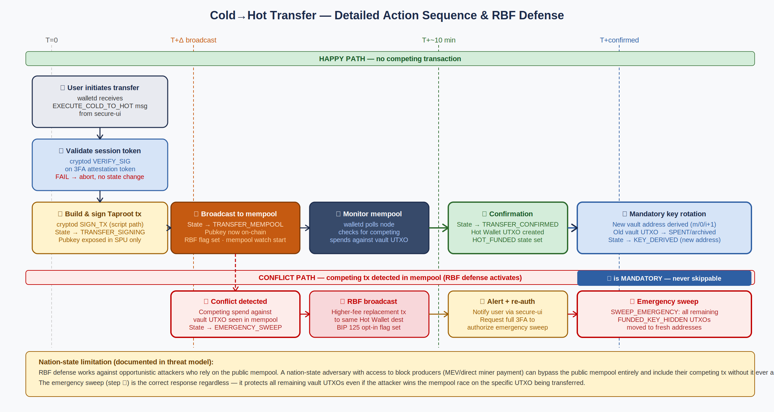
Figure 21.2 — Cold→Hot Transfer Detail with RBF Defense. Steps ①–⑦ show the happy path. Steps ⓪–ⓒ show the conflict path activated by a competing transaction.

T-10 TRANSFER_MEMPOOL → EMERGENCY_SWEEP (RBF conflict detected)
Attribute | Specification
Trigger | Mempool monitor detects a competing transaction spending the vault UTXO input — a transaction with the same txid:vout as the Cold Vault UTXO input but a different txid (attacker's tx).
Immediate Actions (no user prompt, no delay) | (1) State → EMERGENCY_SWEEP. (2) IMMEDIATELY build and broadcast a Replace-By-Fee (RBF) replacement transaction: same input (vault UTXO), same output (Hot Wallet address), higher fee_sats (fee_sats = competing_tx_fee × 1.2 + MIN_FEE_INCREMENT). BIP 125 allows this. (3) Record rbf_broadcast = true, rbf_at = now_ms.
User Notification | (4) Send SECURITY_ALERT to anomaly-detector. (5) Trigger secure-ui to display a full-screen security warning (LED indicator active). (6) Prompt user for full 3FA to authorize SWEEP_EMERGENCY of all remaining vault UTXOs.
If 3FA confirmed | (7) Execute T-12 SWEEP_EMERGENCY for all FUNDED_KEY_HIDDEN UTXOs. (8) Derive fresh addresses for all swept UTXOs (batch key rotation). (9) Continue monitoring the specific RBF-conflicted UTXO until either walletd's RBF tx or the attacker's tx confirms.
RBF Outcome — Own tx confirms | (10a) State of conflicted UTXO → TRANSFER_CONFIRMED. Normal T-05/T-06 flow.
RBF Outcome — Attacker tx confirms | (10b) State → SPENT (by attacker). walletd records VAULT_COMPROMISED entry in audit log. The amount_sats in this UTXO is the bounded loss. The SWEEP_EMERGENCY (if confirmed) has protected all other vault UTXOs.
Nation-state note | A nation-state adversary with out-of-band miner access can bypass the public mempool, making the RBF broadcast ineffective for that specific UTXO. The primary defense in this scenario is step (7): the emergency sweep protects all other vault UTXOs regardless of the outcome of the conflicted UTXO.

21.4.1 Mempool Monitoring Implementation
The mempool monitoring loop operates as follows during TRANSFER_MEMPOOL state:
- Poll walletd's connected Bitcoin full node (via smoltcp-isolated network path in cryptod, or via Linux VM relay with result verification) every MEMPOOL_POLL_INTERVAL_MS = 5,000 milliseconds.
- For each poll: request the mempool contents for transactions spending the vault UTXO input (txid:vout). A competing transaction exists if any mempool tx has an input matching the vault UTXO AND a txid different from the walletd-broadcast transfer_txid.
- On detection of competing transaction: execute T-10 immediately, before the next poll cycle.
- Continue polling until either (a) transfer_txid is confirmed (T-05), or (b) EMERGENCY_SWEEP is completed and confirmed.
- If the node connection is lost during TRANSFER_MEMPOOL: log NODE_UNREACHABLE, continue attempting reconnection. walletd cannot detect a competing tx while offline — this is a documented limitation. The mitigation is that Cold→Hot transfers should only be initiated when network connectivity is reliable.

IMPORTANT Mempool monitoring limitations: This defense only works if the attacker's competing transaction is visible in the public mempool. An attacker with direct miner access can submit a transaction privately, bypassing the mempool entirely. walletd will not detect the attack until the block is mined. This is the documented nation-state limitation in the threat model.

21.5 Social Recovery and Emergency Sweep Transitions

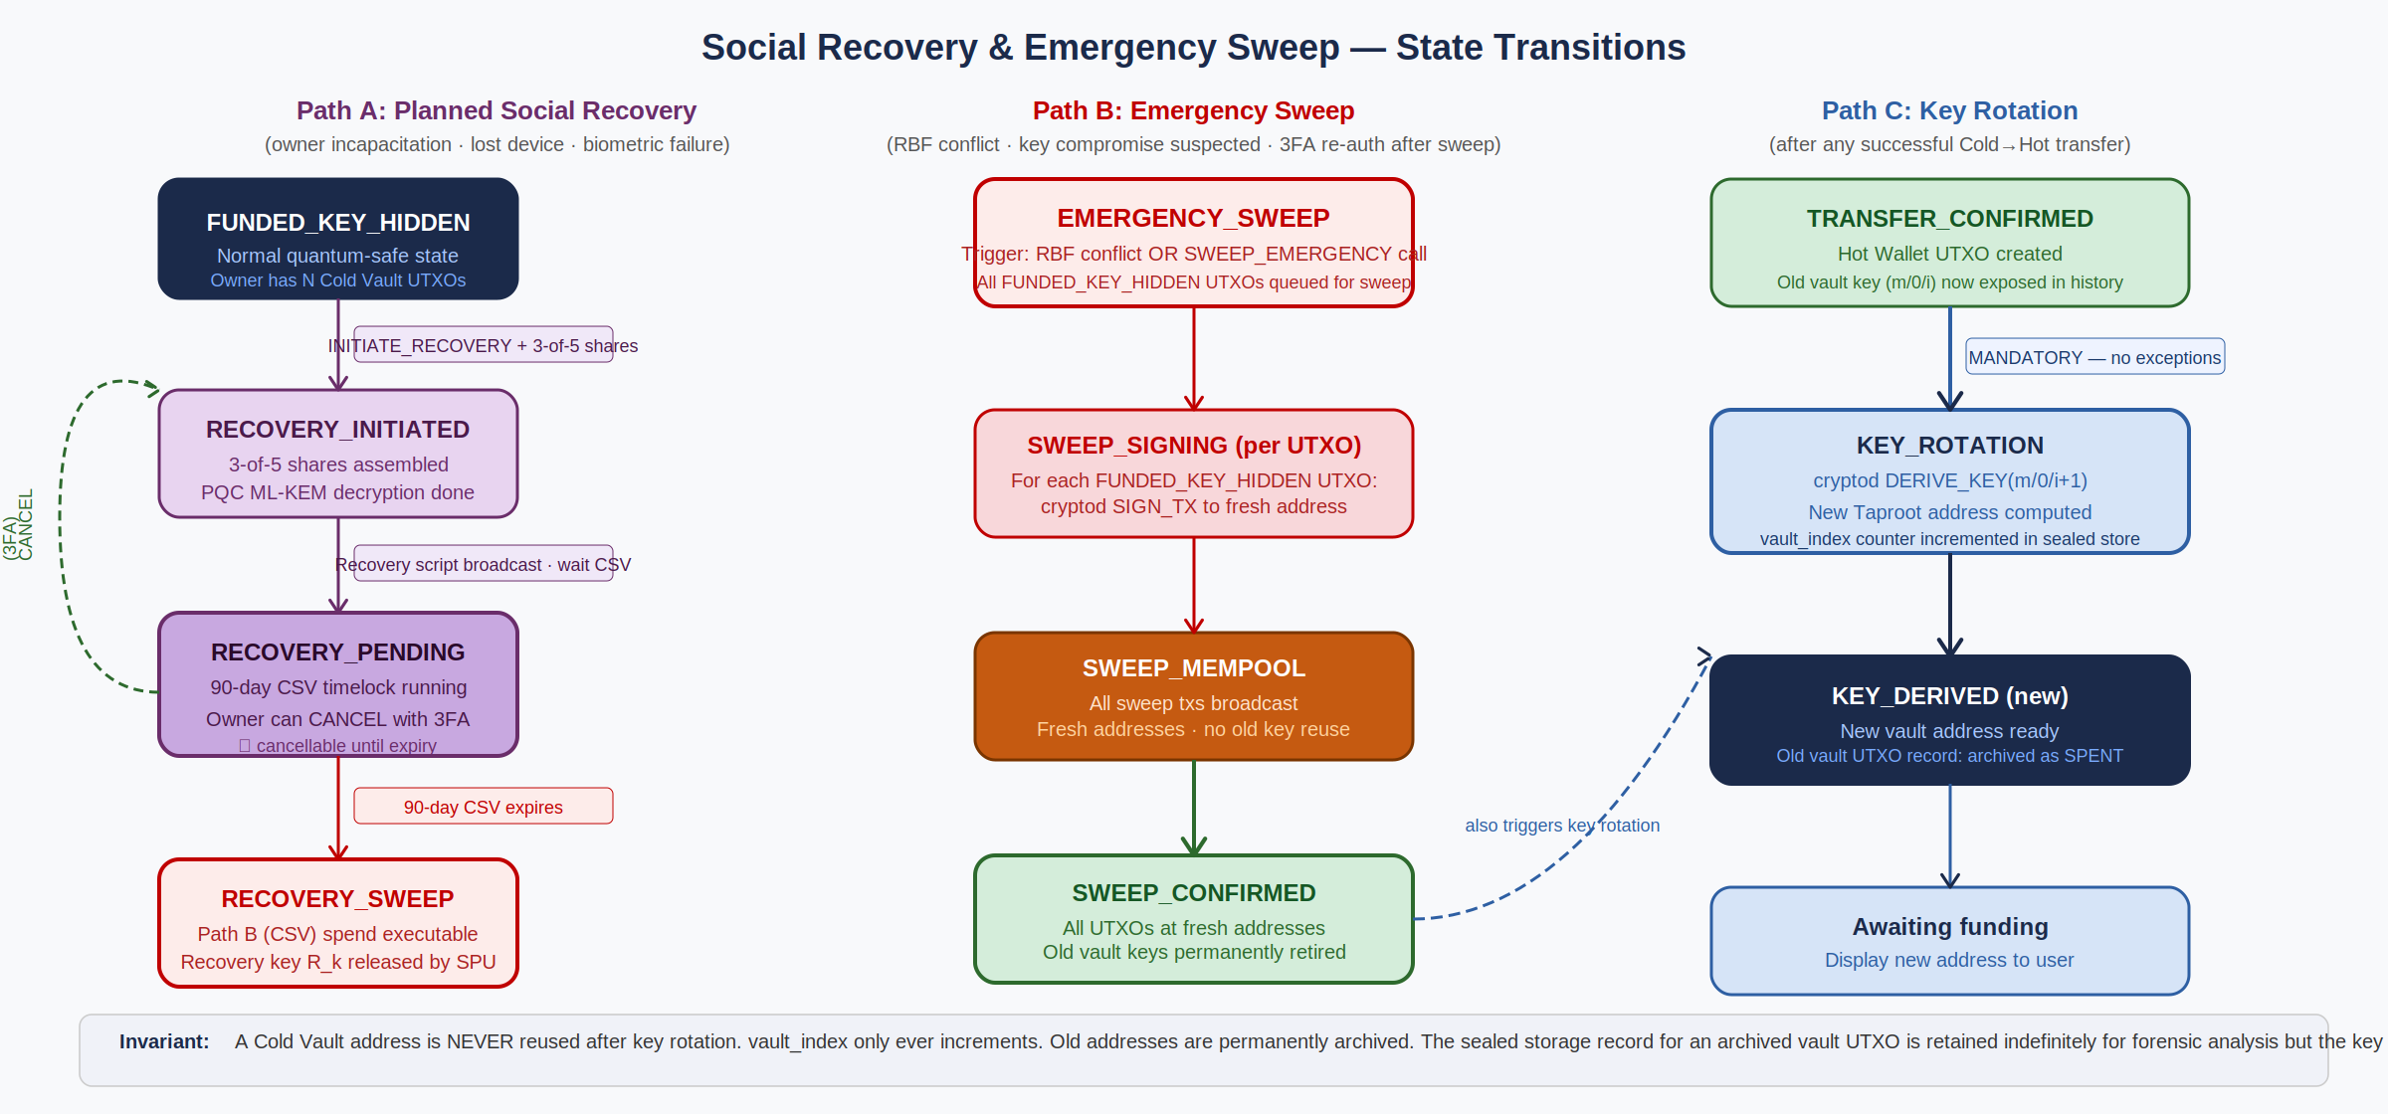
Figure 21.3 — Social Recovery (Path A), Emergency Sweep (Path B), and Key Rotation (Path C). All three paths converge on fresh KEY_DERIVED addresses.

T-11 FUNDED_KEY_HIDDEN → RECOVERY_PENDING (social recovery initiated)
Attribute | Specification
Trigger | walletd receives INITIATE_RECOVERY from secure-ui (badge 0x10). Called by a recovery agent (trusted party) who has assembled ≥3 of 5 Shamir shares and decrypted the recovery secret using ML-KEM-1024 via cryptod PQC_ML_KEM_DECAP.
Guard | (1) recovery_shares array contains ≥3 valid, PQC-decrypted share fragments. (2) Shamir reconstruction of the recovery secret succeeds (must match the stored commitment hash). (3) Full 3FA session_token present (recovery agent must be physically present and authenticate).
Side Effects | (1) Construct the Path B (90-day CSV) spend transaction for each affected UTXO. This uses recovery key R_k, which is held in the SPU and released only after PQC authorization from OPTIGA. (2) Broadcast Path B spend transactions. (3) State → RECOVERY_PENDING. (4) Record {initiated_at, timelock_expiry_height = current_block + 12960 (~90 days at 144 blocks/day)}. (5) Update sealed storage RecoveryState. (6) Write RECOVERY_INITIATED entry to audit log.
Cancellation (T-11C) | During the 90-day CSV window, the legitimate owner can cancel the recovery by broadcasting a competing transaction that spends the vault UTXO via Path A (normal owner spend). This requires the owner's private key (in SPU) and full 3FA. The cancellation transaction outcompetes the recovery transaction in the mempool since it does not have the CSV timelock. State → FUNDED_KEY_HIDDEN after cancellation confirms.

T-12 FUNDED_KEY_HIDDEN → EMERGENCY_SWEEP (SWEEP_EMERGENCY command)
Attribute | Specification
Trigger | walletd receives SWEEP_EMERGENCY from secure-ui (badge 0x10). This command sweeps ALL FUNDED_KEY_HIDDEN UTXOs simultaneously to fresh addresses. It is also automatically triggered by T-10 after 3FA confirmation.
Guard | Full 3FA session_token. No other guard — in an emergency, the user has explicitly authorized the sweep.
Side Effects | (1) For each UTXO in FUNDED_KEY_HIDDEN: derive fresh destination address (m/0/vault_index + N for each UTXO), build Path A spend tx to fresh address, SIGN_TX via cryptod (batch), broadcast. (2) State → EMERGENCY_SWEEP for all affected UTXOs simultaneously. (3) Monitor all sweep txs in mempool. (4) On each sweep tx confirmation: state → TRANSFER_CONFIRMED, then immediately T-06 key rotation to the next fresh address. (5) Write EMERGENCY_SWEEP_INITIATED to audit log.
Invariant | Every fresh destination address in an EMERGENCY_SWEEP must be a NEW key that has never been used before (vault_index increments per UTXO). Sweeping all funds to a single address would be a critical implementation error — it would link all vault UTXOs on-chain.

21.6 Guard Conditions — Complete Reference
The following conditions are evaluated by walletd before any state transition. Failure of any guard results in ERR_GUARD_FAILED with no state change and a security event log entry.

Guard ID | Guard Name | Condition | Evaluated In
G-01 | valid_3fa_token | session_token present, cryptod VERIFY_SIG returns VERIFIED, token timestamp < 30s, factor_bitmask = 0x07 | T-03, T-07, T-11, T-12
G-02 | valid_utxo_state | Target UTXO exists in sealed storage and is in the expected state for this transition | All transitions
G-03 | valid_key_path | BIP-32 key_path is within m/0/*, m/1/*, or m/2/* | T-03, T-07, cryptod SIGN_TX
G-04 | sufficient_amount | amount_sats ≤ utxo.amount_sats - fee_sats. fee_sats ≥ MIN_FEE_RATE × tx_vbytes | T-03, T-07
G-05 | valid_destination | destination_script is a valid Bitcoin script, not OP_RETURN, amount > DUST_THRESHOLD | T-07
G-06 | valid_tx_structure | Signed transaction passes local validation before broadcast | T-04, T-07
G-07 | confirmed_funding | Funding UTXO has ≥1 block confirmation and txid:vout match vault address | T-02
G-08 | no_reorg | Confirmed transaction is in the longest chain (reorg depth check) | T-05, T-08
G-09 | valid_recovery_shares | ≥3 of 5 Shamir shares present, PQC decrypted, reconstruct to matching commitment hash | T-11
G-10 | taproot_script_path | All Cold Vault spends use Taproot script path (never key path). key-path spend in walletd → SIGN_TX is an unconditional bug | T-03, T-11, T-12

21.7 Invariants — System-Wide Assertions
The following invariants must hold at all times in a correctly operating walletd. Any state that violates an invariant is a critical bug. walletd must check invariants on startup (sealed storage integrity check) and log a INVARIANT_VIOLATION entry if any fails.

- INV-01 vault_index monotonicity: vault_index only ever increases. It never decreases, never resets to zero, never wraps. If sealed storage vault_index < any active UTXO's key_path.index, INVARIANT_VIOLATION.
- INV-02 single active state: Every UTXO record has exactly one state. No UTXO can be simultaneously in two states. Verified by sealed storage schema (Rust enum, not flags).
- INV-03 key path uniqueness: No two active (non-SPENT) UTXOs share the same BIP-32 key_path. If two active UTXOs have the same key_path, INVARIANT_VIOLATION — this would indicate a key reuse bug.
- INV-04 cold-to-hot atomicity: If vault_utxo.state = TRANSFER_CONFIRMED and hot_utxo.state ≠ HOT_FUNDED (or HOT_SPENDING or SPENT), and T-06 key rotation has not completed, INVARIANT_VIOLATION. The Hot Wallet UTXO must be created atomically with the vault UTXO's TRANSFER_CONFIRMED state.
- INV-05 no raw pubkey in sealed storage: Sealed storage MUST NOT contain raw private key bytes or raw public key bytes for any UTXO. Keys live in SPU. Sealed storage contains only BIP-32 paths and pubkey commitment hashes. Violation = critical information leak.
- INV-06 RBF flag on all Cold→Hot transfers: Every transaction built by walletd for a Cold→Hot transfer MUST have the BIP 125 RBF opt-in flag (input sequence = 0xFFFFFFFD). A transfer transaction without this flag cannot be replaced — disable this guard and the RBF defense is permanently broken.
- INV-07 audit log append-only: The audit log in sealed storage is append-only. walletd must never modify or delete existing log entries. Violations to this invariant compromise forensic integrity.
- INV-08 sweep uses distinct addresses: EMERGENCY_SWEEP must derive a distinct destination address for each swept UTXO (incrementing vault_index per UTXO). Sweeping to a shared address links all UTXOs on-chain. This invariant is enforced by the T-12 implementation spec.

21.8 Formal Verification Requirements
The following properties must be formally verified or exhaustively tested before walletd enters the Phase 4 build. All are blocking gates.

Property | Method | Gate | Owner
T-06 key rotation executes atomically with T-05 — no intermediate state where TRANSFER_CONFIRMED exists without the new KEY_DERIVED UTXO | Property-based test: inject crash between T-05 and T-06; verify sealed storage recovery path restores consistency | Ph 4 | Crypto/SPU Lead
No SIGN_TX call uses a key_path outside m/0/*, m/1/*, m/2/* | Static analysis + exhaustive unit tests of all walletd SIGN_TX call sites | Ph 4 | Systems Integration
vault_index is strictly monotonic across all sealed storage writes | INV-01 check in startup integrity verification. Fuzzing of sealed storage write paths. | Ph 4 | Security Architect
EMERGENCY_SWEEP derives a distinct destination address per UTXO (INV-08) | Test with N=10 FUNDED_KEY_HIDDEN UTXOs: verify all sweep destination addresses are distinct | Ph 4 | Crypto/SPU Lead
All Cold→Hot transactions use Taproot script-path spend (G-10 — never key-path) | Inspect all signed transactions produced by walletd: parse the witness stack and verify script-path structure | Ph 4 | Crypto/SPU Lead
RBF opt-in flag is set on all Cold→Hot transactions | Inspect all signed transactions: verify input sequence = 0xFFFFFFFD | Ph 4 | Systems Integration
walletd returns ERR_INVALID_TRANSITION for all transitions not in the state machine | Exhaustive state transition matrix test: attempt every (state × command) pair, verify only valid transitions succeed | Ph 4 | Security Architect
Sealed storage is consistent after power loss during any state transition | Inject power-loss simulation at every sealed storage write point; verify startup integrity check recovers to a consistent prior state | Ph 4 | Systems Integration

22. Hardware Security Path Specification
This section is the Hardware Security Architecture Document for MyPhone v17.0. It specifies every GPIO assignment, interrupt routing path, power rail topology, SMMU stream ID assignment, and hardware control path involved in the security model. It is the definitive input to the PCB layout, the seL4 capDL platform specification, and the SMMU configuration. Values marked [TBD-HW] require confirmation from the Qualcomm QCS8550 TRM (NDA document) and must be resolved as Phase 0 blocking deliverables before Phase 1 begins.

IMPORTANT All physical addresses, GPIO numbers, and SMMU Stream IDs in this document are reference design values derived from public Qualcomm SM8550/QCS8550 device tree references and MDSS architecture documentation. They must be verified against the QCS8550 Technical Reference Manual (NDA required) before any PCB layout or platform configuration work begins. Hardware Integration Lead is responsible for resolving all [TBD-HW] items before the Phase 0 gate.

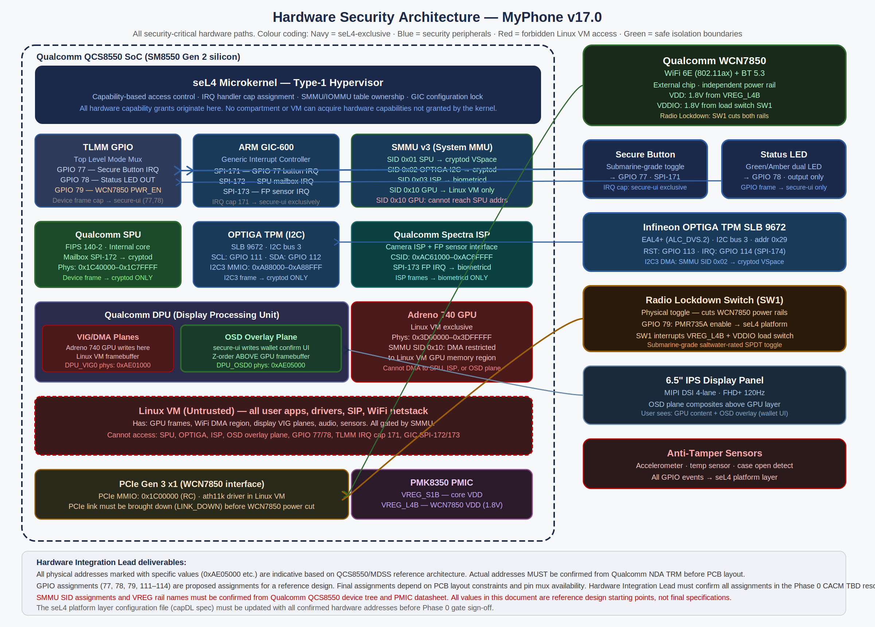
Figure 22.1 — Hardware Security Architecture Block Diagram. Navy = seL4-exclusive peripherals. Red dashed = Linux VM boundary. All device frame capabilities flow through the seL4 kernel from hardware to the compartment that owns them.

22.1 GPIO Assignment Table
The following GPIO assignments are proposed for the reference design. All GPIOs are controlled through the QCS8550 TLMM (Top Level Mode Multiplexer). Security-critical GPIOs (77, 78, 79) must not be muxed to any alternate function in the TLMM configuration.

GPIO # | Signal Name | Direction | Holder | Pull | Electrical Spec
GPIO 77 | SEC_BTN_IRQ — Secure Attention Button | Input | secure-ui (IRQ cap SPI-171) | 100kΩ PULL_UP | Active-LOW. EDGE_FALLING trigger. ESD protected (PRTR5V0U2X). RC debounce: R2=10kΩ series, C1=100nF to GND. Max voltage: 1.8V (VDD1V8 domain).
GPIO 78 | SEC_LED_EN — Security Status LED | Output | secure-ui (GPIO frame cap) | None | Active-HIGH. Drives NPN transistor Q1 base via 1kΩ series resistor. Q1 controls dual LED (D2: green 520nm, D3: amber 590nm). LED current limited by R3=68Ω. Max sink current: 16mA per LED.
GPIO 79 | RADIO_LOCK_DET — Radio Lockdown State Detect | Input | seL4 platform layer (init task) | 100kΩ PULL_UP | Physical switch position sense. Active-LOW when switch engaged. EDGE_BOTH trigger — seL4 platform task monitors transitions in both directions for power sequencing. GPIO 79 is NOT distributed to any seL4 compartment after init.
GPIO 80 | RADIO_PWR_CTRL — WCN7850 Load Switch Enable | Output | seL4 platform layer | None | Controls SW1 load switch EN pin. HIGH = WCN7850 powered. LOW = WCN7850 unpowered. Driven by seL4 platform task in response to GPIO 79 state change. Linux VM cannot access this GPIO.
GPIO 81 | RADIO_IO_CTRL — WCN7850 VDDIO Load Switch Enable | Output | seL4 platform layer | None | Controls SW2 load switch EN pin (VDDIO rail to WCN7850). Must be deasserted simultaneously with GPIO 80 (or within 1ms) to prevent WCN7850 latch-up from VDDIO without VDD.
GPIO 111 | OPTIGA_SCL — OPTIGA TPM I2C Clock | Bidirectional | cryptod (I2C3 frame cap) | 2.2kΩ external PULL_UP | I2C bus 3 clock. Standard-mode I2C, 400kHz. External 2.2kΩ pull-up to 1.8V. 5V-tolerant with level shifter not needed (OPTIGA SLB 9672 operates at 1.8V I/O).
GPIO 112 | OPTIGA_SDA — OPTIGA TPM I2C Data | Bidirectional | cryptod (I2C3 frame cap) | 2.2kΩ external PULL_UP | I2C bus 3 data. Standard-mode I2C. External 2.2kΩ pull-up to 1.8V. Bus timeout: 10ms (SMBUS timeout enforcement in I2C3 controller).
GPIO 113 | OPTIGA_RST — OPTIGA TPM Reset | Output | cryptod (I2C3 frame cap) | 100kΩ PULL_UP | Active-LOW reset to OPTIGA SLB 9672. Asserted for ≥1ms on init and recovery sequences. cryptod controls this GPIO via the I2C3 auxiliary GPIO register.
GPIO 114 | OPTIGA_IRQ — OPTIGA TPM Interrupt | Input | cryptod (IRQ cap SPI-174) | 100kΩ PULL_UP | Active-LOW interrupt from OPTIGA. Used for long-duration PQC operations (ML-KEM/ML-DSA) that complete asynchronously. IRQ cap SPI-174 assigned exclusively to cryptod by seL4 init.
[TBD-HW] | FP_SENSOR_IRQ — Fingerprint Sensor Interrupt | Input | biometricd (IRQ cap SPI-173) | [TBD] | Qualcomm 3D Sonic Max sensor interrupt. GPIO number and electrical spec to be confirmed from sensor integration guide (NDA). IRQ cap SPI-173 assigned exclusively to biometricd.
[TBD-HW] | IR_ILLUM_EN — IR Illuminator Enable | Output | biometricd | [TBD] | Controls IR LED array for face liveness detection. Pulsed at camera frame rate. GPIO number TBD from hardware layout.

22.2 Interrupt Routing — seL4 IRQ Handler Cap Assignments
The following table defines every security-critical interrupt in the system and its exclusive capability assignment. seL4 uses the IRQControl capability to create IRQ handler objects at system initialization. Once created and distributed, the same IRQ handler cap cannot be created again — exclusivity is enforced by the kernel.

GIC SPI | Linux IRQ # | Source | Cap Holder | Trigger | If Linux VM tries to enable
SPI-171 | 203 | GPIO 77 — Secure Attention Button | secure-ui — exclusive | EDGE_FALLING | seL4 hypervisor intercepts GICD_ISENABLER write; the enable is silently dropped. VM never receives this interrupt.
SPI-172 | 204 | SPU mailbox — cryptographic operation complete | cryptod — exclusive | LEVEL_HIGH | IRQ handler cap held by cryptod. Linux VM has no capability. GIC GICD_ITARGETSR routes SPI-172 to cryptod's physical CPU only.
SPI-173 | 205 | Fingerprint sensor — capture complete | biometricd — exclusive | EDGE_RISING | Same mechanism as SPI-171. Linux VM write to GICD_ISENABLER for SPI-173 intercepted by hypervisor.
SPI-174 | 206 | OPTIGA TPM — async operation complete | cryptod — exclusive | EDGE_FALLING | Linux VM cannot acquire this IRQ. Used only for long-duration PQC operations.
SPI-175 | 207 | GPIO 79 — Radio Lockdown switch state change | seL4 platform layer only — not distributed post-init | EDGE_BOTH | seL4 init task processes this during boot and power sequencing. Cap not in any compartment CNode after init.
[TBD-HW] | [TBD] | OPTIGA tamper response | cryptod — exclusive | [TBD] | OPTIGA SLB 9672 asserts a dedicated tamper pin when physical tamper is detected. This must be connected to an IRQ-capable GPIO and assigned exclusively to cryptod.

NOTE Linux IRQ numbers are ARM GIC SPI N = Linux IRQ N+32. GIC SPI 171 = Linux IRQ 203. These numbers are indicative for a standard ARM GIC-600 configuration; actual Linux IRQ numbers depend on the device tree and must be confirmed with the QCS8550 BSP.

22.3 Secure Attention Mechanism — Complete Electrical and Software Path
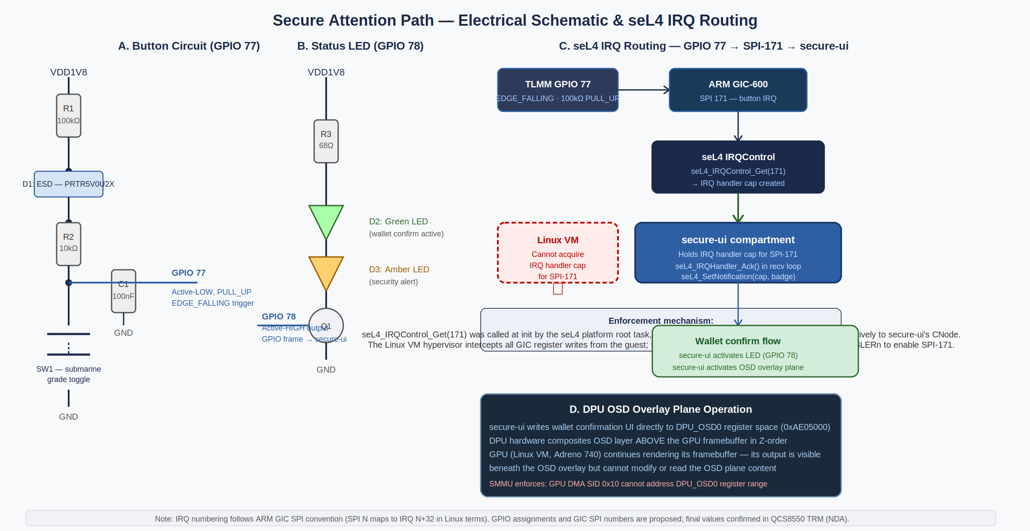
Figure 22.2 — Secure Attention Button and Status LED circuits, seL4 IRQ routing, and DPU OSD overlay plane operation.

22.3.1 Hardware Button Circuit
The secure attention button uses a submarine-grade SPDT toggle switch rated for saltwater immersion (IP68) mounted in the single chassis chassis cutout. The electrical circuit consists of:
- Pull-up resistor R1 = 100kΩ: VDD1V8 to GPIO 77. Ensures GPIO is HIGH (inactive) when button is not pressed.
- ESD protection D1 = PRTR5V0U2X: Bi-directional TVS diode array on the signal line. Clamps transients to 5V maximum, protecting the TLMM GPIO input which is rated at 1.8V nominal. Required for the chassis cutout exposure.
- Debounce RC filter R2 + C1: R2 = 10kΩ in series on the signal line, C1 = 100nF from signal to GND. Creates a ~1ms RC time constant that eliminates mechanical contact bounce before the signal reaches the GPIO input. The 1ms debounce time is well below human press detection thresholds (typically 50–200ms) so no software debounce is needed.
- Switch to GND: When pressed, GPIO 77 is pulled to GND through the switch. The TLMM GPIO detects this as ACTIVE_LOW / EDGE_FALLING.

NOTE The submarine-grade toggle provides an important secondary function: its tactile click is unambiguous and cannot be replicated by software. This is critical for the security model — the user knows unambiguously when they have pressed it. Soft-touch or capacitive buttons could be simulated by case vibration or electromagnetic interference. The mechanical toggle cannot.

22.3.2 Status LED Circuit
The status LED provides the user's out-of-band hardware signal that the secure UI is active. It is controlled exclusively by secure-ui and cannot be activated by any software in the Linux VM.
- Q1 NPN transistor driver: GPIO 78 drives the base of Q1 (e.g., BC847 SOT-23) through a 1kΩ base resistor. This provides current amplification — the GPIO can only source/sink ~2mA; the transistor allows up to 100mA collector current.
- D2 — Green LED (520nm): Active during wallet confirmation mode. Forward voltage Vf ≈ 2.1V. With R3 = 68Ω and VDD1V8: IF = (1.8V - 2.1V)/68Ω — note: 1.8V is insufficient for a green LED directly. Circuit must use a charge pump or a higher voltage rail (3.3V) through Q1. Alternatively: use a low-Vf green LED (Vf ≈ 1.5V at 10mA) compatible with the 1.8V supply. Hardware Integration Lead must select LED with appropriate Vf.
- D3 — Amber LED (590nm): Active during security alert mode. Forward voltage Vf ≈ 2.0V. Same voltage considerations as D2. Two separate GPIOs may be used if independent control is required (green vs. amber for different alert states).
IMPORTANT LED forward voltage must be verified against the available supply rail. If VDD1V8 (1.8V) is insufficient for the selected LEDs, the design must use a higher-voltage rail (e.g., VBAT_LDO at 3.3V) through the transistor driver. This is a required hardware design decision to be made in Phase 0 by the Hardware Integration Lead.

22.3.3 seL4 IRQ Path — Button Press to secure-ui
The complete path from physical button press to secure-ui receiving a kernel notification:
- User presses the toggle switch. The RC debounce filter conditions the signal over ~1ms.
- GPIO 77 transitions from HIGH to LOW (EDGE_FALLING). The TLMM GPIO controller detects this transition and asserts GIC SPI-171.
- The ARM GIC-600 routes SPI-171 to the physical CPU core running the seL4 kernel (configured by GICD_ITARGETSR for SPI-171). The GIC delivers an IRQ exception to the CPU.
- The seL4 kernel receives the IRQ. It checks its IRQ handler table: SPI-171 maps to the IRQ handler cap held by secure-ui. The kernel delivers a seL4 notification to secure-ui's notification endpoint.
- secure-ui receives the notification via seL4_Wait() in its main loop. It reads the badge value to confirm this is the button IRQ (not some other notification).
- secure-ui calls seL4_IRQHandler_Ack(irq_handler_cap) to clear the interrupt at the GIC level and re-arm for the next press.
- secure-ui activates the LED (GPIO 78 HIGH), writes the wallet confirmation UI to the DPU OSD overlay plane, and begins the CONFIRM_ATTEST flow with cryptod.

Why the Linux VM cannot intercept this path: the seL4 hypervisor intercepts all writes by the Linux VM guest to GIC GICD_ISENABLER (interrupt set-enable register). The guest's write to enable SPI-171 is captured by the hypervisor's GIC emulation layer and silently dropped — the actual GIC GICD_ISENABLER bit for SPI-171 is never set, so the GIC never delivers SPI-171 to the Linux VM. The IRQ is delivered only to the CPU core running seL4 itself.

22.3.4 DPU OSD Overlay Plane — Secure Display Path
The Qualcomm Display Processing Unit (DPU) in the QCS8550 contains multiple hardware pipeline stages. The architecture relevant to secure-ui:
- VIG/DMA planes (Linux VM): The Adreno 740 GPU renders the main UI (Lomiri, Firefox, app content) into a framebuffer in Linux VM memory. The DPU VIG0/DMA0 planes read this framebuffer and send it to the MIPI DSI panel. GPU MMIO base address: 0x3D00000 (in Linux VM device tree). SMMU SID 0x10: DMA from GPU is constrained to Linux VM memory regions only.
- OSD overlay plane (secure-ui): The DPU contains a dedicated OSD (On-Screen Display) or cursor plane that composites above the VIG plane in Z-order. This plane has its own MMIO register space (proposed: DPU_OSD0 at 0xAE05000) and its own DMA channel with a separate SMMU SID (proposed: SID 0x08). secure-ui holds the device frame capability for DPU_OSD0 register space. The SMMU ensures secure-ui DMA for the OSD plane cannot read from or write to Linux VM GPU memory regions.
- Z-order compositing: The DPU blender hardware combines all active planes in Z-order: VIG plane (GPU content) at layer 0, OSD plane (wallet UI) at layer 1. Layer 1 alpha-composites over layer 0. The user sees: GPU content (normal UI) with the wallet confirmation UI overlaid on top.
- GPU cannot read OSD content: The GPU (Adreno 740) DMA is constrained by SMMU to the Linux VM memory space. The DPU_OSD0 MMIO register range and the OSD framebuffer region are not within the Linux VM memory map. A Pegasus-compromised Linux VM kernel cannot use the GPU to screencapture the OSD overlay content.

NOTE The specific DPU plane architecture (VIG vs DMA vs OSD/Cursor) depends on the QCS8550 DPU revision and the display driver implementation. The Qualcomm MDSS/DPU driver in mainline Linux supports hardware cursor planes. The Hardware Integration Lead must confirm that the QCS8550 DPU supports an independent overlay plane accessible via a separate MMIO register range, and must document the exact register base address and DMA channel assignment in the Phase 0 hardware spec resolution.

22.4 Radio Lockdown Switch — Power Rail Topology
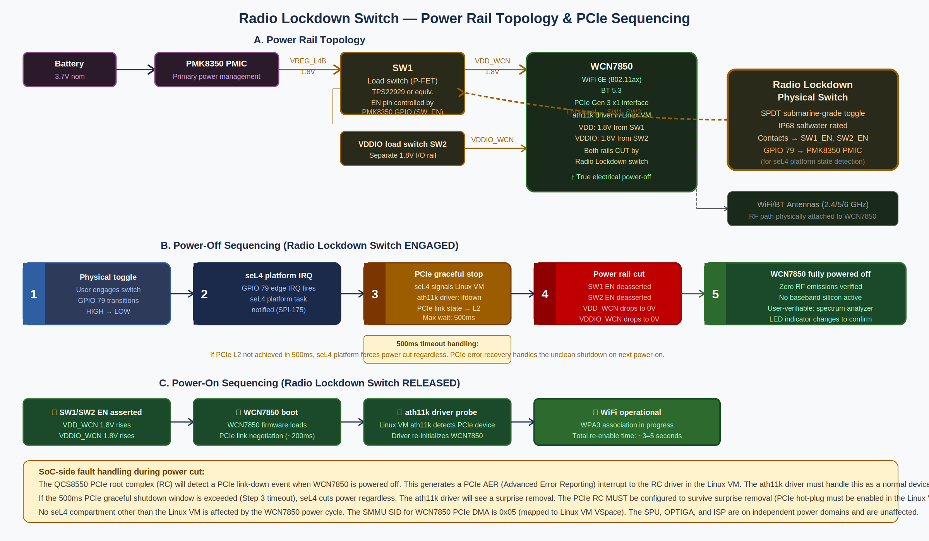
Figure 22.3 — Radio Lockdown Switch power rail topology, power-off sequencing (steps 1–5), and power-on re-enable sequencing.

22.4.1 WCN7850 Power Domain
The WCN7850 WiFi/BT chip requires two power rails to operate:

Rail | Voltage | Source | Load Switch | Enable GPIO | Max Current
VDD_WCN | 1.8V | PMK8350 VREG_L4B LDO regulator | SW1 (TPS22929 P-FET load switch) | GPIO 80 (seL4 platform) | ~800mA peak (802.11ax MIMO TX). LDO must be rated ≥1A continuous.
VDDIO_WCN | 1.8V | PMK8350 VREG_L6B LDO regulator (or shared VREG_L4B) | SW2 (separate P-FET load switch) | GPIO 81 (seL4 platform) | ~50mA (I/O interface only). May share rail with VDD_WCN if electrically acceptable — Hardware Integration Lead to confirm.

VREG rail naming convention: PMK8350 uses VREG_LxY notation where x = LDO number, Y = power island (A/B/C/D). The exact VREG assignment depends on the QCS8550 reference design Power Management Architecture document (NDA). The names VREG_L4B and VREG_L6B are indicative reference assignments. [TBD-HW]

22.4.2 Load Switch Selection
The Texas Instruments TPS22929 (or equivalent) P-FET load switch is suitable for this application:
- Input voltage range: 1.5V–5.5V — compatible with 1.8V rail.
- On-resistance: 45mΩ typical — negligible voltage drop at WCN7850 operating currents.
- Enable pin: Active-HIGH, CMOS compatible. Driven by GPIO 80/81 through a 10kΩ series resistor (current limiting).
- Rise time: ~400µs at 1.8V with 100µF output capacitance — adequate for WCN7850 power-on sequencing.
- Fall time: ~200µs when EN deasserted — fast enough to guarantee WCN7850 power-off before PCIe error recovery timeout.
- Package: SOT-23-5 — suitable for the available board area near the WCN7850 module.

22.4.3 Power-Off Sequence (Radio Lockdown Switch ENGAGED)
The following sequence must execute in strict order when the Radio Lockdown switch is engaged. The seL4 platform layer (root task / init) is responsible for steps 2–4.

Step | Action | Trigger | Timeout | On Timeout
① | Physical toggle engaged by user | User action — GPIO 79 EDGE_FALLING | N/A | N/A
② | seL4 platform task receives GPIO 79 IRQ (SPI-175). Records switch state in platform state variable. | seL4_Wait() in platform task main loop | <1ms | N/A — seL4 task always running
③ | seL4 platform task sends POWER_DOWN_WIFI notification to Linux VM hypervisor interface. Linux VM ath11k driver calls rtnl_lock → dev_close(wlan0) → pci_disable_device(wcn7850). PCIe link transitions to L2 (low-power) state. | Platform task notification to Linux VM | 500ms | Force-proceed to Step ④ regardless. Log RADIO_SHUTDOWN_FORCED. PCIe error recovery will handle the surprise removal on next power-on.
④ | seL4 platform task deasserts GPIO 80 (SW1 EN = LOW) and GPIO 81 (SW2 EN = LOW) simultaneously within 1ms of each other. VDD_WCN and VDDIO_WCN fall to 0V within ~200µs (load switch fall time). | Timeout from Step ③ OR PCIe L2 confirmed | <1ms (GPIO ops) | N/A — GPIO operations are atomic
⑤ | WCN7850 fully powered off. Zero RF emissions. seL4 platform task sets RADIO_STATE = OFF in platform state. Notifies secure-ui to update LED (amber = radio off). | Immediate after GPIO deassertion | N/A | N/A — terminal state until switch released

22.4.4 Power-On Sequence (Radio Lockdown Switch RELEASED)
- ① SW1/SW2 EN asserted: seL4 platform task asserts GPIO 80 HIGH and GPIO 81 HIGH. VDD_WCN and VDDIO_WCN rise to 1.8V within ~400µs.
- ② WCN7850 firmware boot: WCN7850 loads internal firmware from ROM. PCIe link negotiation begins (~150–200ms for Gen3 x1 link training).
- ③ PCIe device enumeration: The PCIe root complex (in the QCS8550 PCIe controller) detects the WCN7850 as a new PCIe endpoint. It generates a PCIe hot-plug event. The Linux VM ath11k driver receives the hot-plug notification and probes the device.
- ④ ath11k driver initialization: ath11k downloads firmware to WCN7850 via PCIe DMA, configures the MAC/PHY, and brings wlan0 interface up. Total time from power-on to WiFi association: approximately 3–5 seconds.

22.4.5 SoC-Side Fault Handling
When WCN7850 is powered off (either gracefully or via force-cut), the QCS8550 PCIe root complex detects a PCIe link-down event. This must be handled correctly to prevent the SoC from entering an error state:
- PCIe AER (Advanced Error Reporting): The PCIe RC generates a PCIe AER interrupt to the system. The seL4 hypervisor intercepts this at the RC level and delivers it to the Linux VM as a standard PCIe error notification. The Linux VM PCIe AER driver must handle this as a non-fatal error (surprise removal).
- Required Linux VM kernel config: CONFIG_HOTPLUG_PCI=y, CONFIG_PCIE_HOTPLUG=y, CONFIG_PCIEAER=y. These are required in the hardened Linux VM kernel configuration for Phase 1. ath11k must be tested with PCIe surprise removal.
- No seL4 compartment impact: cryptod, walletd, biometricd, and secure-ui are on independent hardware paths with no PCIe dependency. They continue operating normally during WCN7850 power cycles. Only the Linux VM's WiFi connectivity is affected.
- Fault during TRANSFER_MEMPOOL: If the Radio Lockdown switch is engaged while a walletd Cold→Hot transfer is in the mempool (TRANSFER_MEMPOOL state), the device loses internet connectivity and mempool monitoring stops. walletd must detect this (cryptod SIGN_TX will succeed but the relay node connection drops) and record MEMPOOL_MONITORING_SUSPENDED in the UTXO state. On Radio Lockdown release and WiFi reconnection, walletd immediately resumes mempool monitoring for all in-flight transfers.

22.5 SMMU / IOMMU Configuration
The QCS8550 SMMU v3 (System Memory Management Unit) is configured by the seL4 platform layer at boot time. The seL4 kernel assigns SMMU context banks to compartment VSpaces. Once assigned, no compartment can reconfigure its own SMMU entry — SMMU register writes are intercepted by the seL4 kernel. The following table defines the canonical SMMU SID (Stream ID) assignments.

SID | Master Device | Mapped VSpace | DMA Restriction | Status
0x01 | Qualcomm SPU mailbox DMA | cryptod VSpace | SPU DMA can only reach cryptod's key buffer region (specific physical address range within cryptod heap). Cannot reach Linux VM memory, ISP buffers, or display memory. | Required
0x02 | OPTIGA I2C controller (I2C3 DMA) | cryptod VSpace | I2C3 DMA (receive buffer) mapped to cryptod heap only. Cannot access Linux VM memory. | Required
0x03 | Qualcomm Spectra ISP | biometricd VSpace | ISP DMA (frame buffers) restricted to biometricd's frame buffer region. Cannot reach SPU, cryptod, or Linux VM general memory. | Required
0x04 | Fingerprint sensor SPI/DMA | biometricd VSpace | Sensor DMA restricted to biometricd sensor buffer region. | Required
0x05 | WCN7850 PCIe DMA (ath11k) | Linux VM VSpace | WiFi DMA restricted to Linux VM network buffer region (defined by ath11k driver DMA coherent allocation). Cannot reach SPU, ISP, or display OSD memory. | Required
0x06 | USB-C controller DMA | Linux VM VSpace | USB DMA restricted to Linux VM USB buffer region. USB-C power delivery interface isolated from USB data path in hardware (separate USB-C mux IC). | Required
0x08 | DPU OSD overlay plane DMA | secure-ui VSpace | OSD plane DMA restricted to secure-ui overlay framebuffer region. Cannot reach Linux VM display memory or GPU memory. | [TBD-HW] confirm plane SID
0x10 | Adreno 740 GPU DMA | Linux VM VSpace | GPU DMA restricted to Linux VM GPU memory region. Explicitly CANNOT reach: SPU memory (0x1C40000–0x1C7FFFF), ISP registers (0xAC61000–0xAC6FFFF), OSD plane registers (0xAE05000–[TBD]), cryptod heap, biometricd heap. | Required
[TBD] | Audio codec DMA | Linux VM VSpace | Audio DMA restricted to Linux VM audio buffer region. | [TBD-HW]

NOTE SMMU SID 0x10 for the GPU is the single most important isolation boundary in the display security model. If the GPU can DMA to the OSD overlay plane registers, a Pegasus-compromised Linux VM GPU driver can overwrite or read the wallet confirmation UI. This must be verified by the seL4 Verification Lead as a Phase 2 blocking deliverable.

capDL specification excerpt — these SMMU assignments must be encoded in the seL4 platform capDL spec file:
// capDL SMMU context bank assignments
// File: platform/qcs8550/smmu_config.cdl
smmu_context cryptod_spu_ctx {
sid = 0x01; // SPU mailbox DMA
vspace = cryptod_vspace;
allowed_paddr_range = [0x1C00000..0x1CFFFFF]; // cryptod key buffer region
}
smmu_context cryptod_i2c3_ctx {
sid = 0x02; // OPTIGA I2C3 DMA
vspace = cryptod_vspace;
allowed_paddr_range = [cryptod_heap_start..cryptod_heap_end];
}
smmu_context biometricd_isp_ctx {
sid = 0x03; // Spectra ISP DMA
vspace = biometricd_vspace;
allowed_paddr_range = [biometricd_frame_buf..biometricd_frame_buf_end];
}
smmu_context linux_vm_gpu_ctx {
sid = 0x10; // Adreno 740 GPU DMA
vspace = linux_vm_vspace;
// EXPLICIT DENY: SPU, ISP, OSD plane registers
denied_paddr_ranges = [
0x1C40000..0x1C7FFFF, // SPU
0xAC61000..0xAC6FFFF, // Spectra ISP
0xAE05000..0xAE05FFF, // DPU OSD plane [TBD-HW: confirm range]
];
}

22.6 Anti-Tamper and Physical Security Sensors
The following physical security sensors must be integrated into the MyPhone hardware design. All sensor events are routed to the seL4 platform layer, which notifies anomaly-detector and triggers appropriate responses.

Sensor | Purpose | Trigger Condition | Response
Case open detection switch | Detects unauthorized physical access to internal components | Lid/case open signal goes HIGH | Immediate: alert anomaly-detector (PHYSICAL_TAMPER). Initiate SPU tamper response (key zeroization) after user confirmation. Log event with timestamp.
SPU tamper response (internal) | Hardware tamper detection inside SPU silicon (voltage glitch, temperature, probe detection) | SPU internal tamper circuits fire | SPU autonomously zeroizes all key material. Raises tamper interrupt (SPI-172 secondary signal). cryptod detects zeroization on next operation attempt. Device enters BRICK state requiring factory re-provisioning.
OPTIGA tamper response (internal) | EAL4+ physical tamper detection in OPTIGA SLB 9672 | OPTIGA internal shield mesh breach or voltage fault | OPTIGA locks down PQC key storage. Asserts tamper GPIO (connected to cryptod IRQ). cryptod detects and alerts anomaly-detector. PQC recovery path locked until factory reset.
Accelerometer (3-axis) | Detect violent physical attack (drop, strike, drill attempt) | Single-axis acceleration > 100g sustained > 10ms | Alert anomaly-detector (PHYSICAL_SHOCK). No automatic key zeroization (false positive risk from drops). Log event for review.
Temperature sensor | Detect extreme temperature attacks (cold/heat glitching of cryptographic hardware) | Die temperature < -20°C or > 85°C | Alert anomaly-detector (TEMPERATURE_EXTREME). Suspend all cryptographic operations until temperature returns to normal range. Log event.
Debug port lockout (eFuse) | Prevent JTAG/debug access to production devices | Production eFuse bit set at manufacture | JTAG/debug access permanently disabled at hardware level. Cannot be re-enabled by software. Qualcomm anti-rollback eFuse also set.

22.7 Hardware Integration Lead — Phase 0 Deliverables
The following items are blocking gates for Phase 0. No Phase 1 code generation for any compartment that uses hardware may begin until these items are resolved and documented.

Item | Description | Status
HW-P0-01 | Confirm QCS8550 TLMM GPIO assignments for all security-critical pins (77–81, 111–114). Resolve conflicts with existing reference design pin mux table. | [TBD-HW]
HW-P0-02 | Confirm GIC SPI numbers for all security interrupts (171–175) from QCS8550 TRM. Update capDL IRQ handler assignments. | [TBD-HW]
HW-P0-03 | Confirm SPU mailbox MMIO physical address range from QCS8550 TRM. Update SMMU SID 0x01 context bank spec. | [TBD-HW]
HW-P0-04 | Confirm OPTIGA I2C bus number and I2C controller MMIO address. Verify 400kHz I2C timing compatibility with SLB 9672. | [TBD-HW]
HW-P0-05 | Confirm DPU OSD/cursor plane MMIO register base address and SMMU SID assignment. Verify overlay plane is accessible independently of GPU framebuffer. | [TBD-HW]
HW-P0-06 | Confirm PMK8350 VREG_L4B and VREG_L6B current ratings and confirm they can supply WCN7850 peak current. Document VREG naming in QCS8550 PMIC Power Management Architecture doc (NDA). | [TBD-HW]
HW-P0-07 | Select and qualify load switch ICs (SW1, SW2) for 1.8V / ≥1A operation. Verify rise/fall times meet sequencing requirements. Order evaluation samples. | [TBD-HW]
HW-P0-08 | Select status LED components (D2, D3) with Vf compatible with available supply rail. If VDD1V8 is insufficient, identify alternate supply rail and confirm with PMIC architecture. | [TBD-HW]
HW-P0-09 | Confirm Spectra ISP SPI number for fingerprint sensor IRQ and GPIO number for IR illuminator enable. Update SMMU SID 0x03 and 0x04 context bank specs. | [TBD-HW]
HW-P0-10 | Verify PCIe surprise removal handling in ath11k driver with QCS8550 PCIe root complex. Confirm CONFIG_HOTPLUG_PCI kernel config is compatible with the hardened Linux VM kernel build. | [TBD-HW]
HW-P0-11 | Produce final hardware security architecture document incorporating all resolved [TBD-HW] items. This document supersedes all reference values in Section 22 and becomes the canonical hardware specification. | [TBD-HW]

NOTE Until HW-P0-11 is complete, the values in this section are reference design starting points only. The seL4 capDL platform specification, SMMU configuration, and compartment device frame capability assignments cannot be finalized. This is the highest-priority Phase 0 deliverable after team assembly.

23. MyPhone Secure Cloud — Architecture Decision & Service Design
Four unresolved architectural problems — Matrix homeserver identity, non-wallet data loss, OTA signing key custody, and the need for a persistent KYC backend — are solved by a single architectural decision: MyPhone operates a minimal hardened cloud service for a monthly subscription fee. This section specifies the service architecture, the server-blindness model (the server cannot read user data), the pricing rationale, and the technical implementation of each sub-service.

23.1 The Four Problems One Service Solves
Problem | Without cloud service | With MyPhone Secure Cloud
Matrix homeserver identity | Who runs it? Self-hosting adds operational complexity; no one runs it = no MyPhone-to-MyPhone calls | MyPhone operates Conduit homeserver at matrix.myphone.com. User-operated federation is optional for privacy-maximizing users.
Non-wallet data loss | User drops phone → loses all contacts, message history, configs, maps. High churn guarantee. | SPU-encrypted backup blob stored server-side. Server is cryptographically blind. Recovery requires device 3FA (same SPU keypair).
OTA signing key custody | Where does the signing key live? If on a developer laptop, one laptop compromise = malicious firmware to all users. | Thales Luna HSM with 3-of-5 threshold authorization. Key never leaves HSM. No single person can sign malicious firmware.
KYC/activation backend | Socure integration needs a backend to store device-to-purchaser binding, receive reverification results, and manage Telnyx number lifecycle | Device Activation Service in the cloud handles all Socure relaying, Telnyx number provisioning, and device certificate issuance.

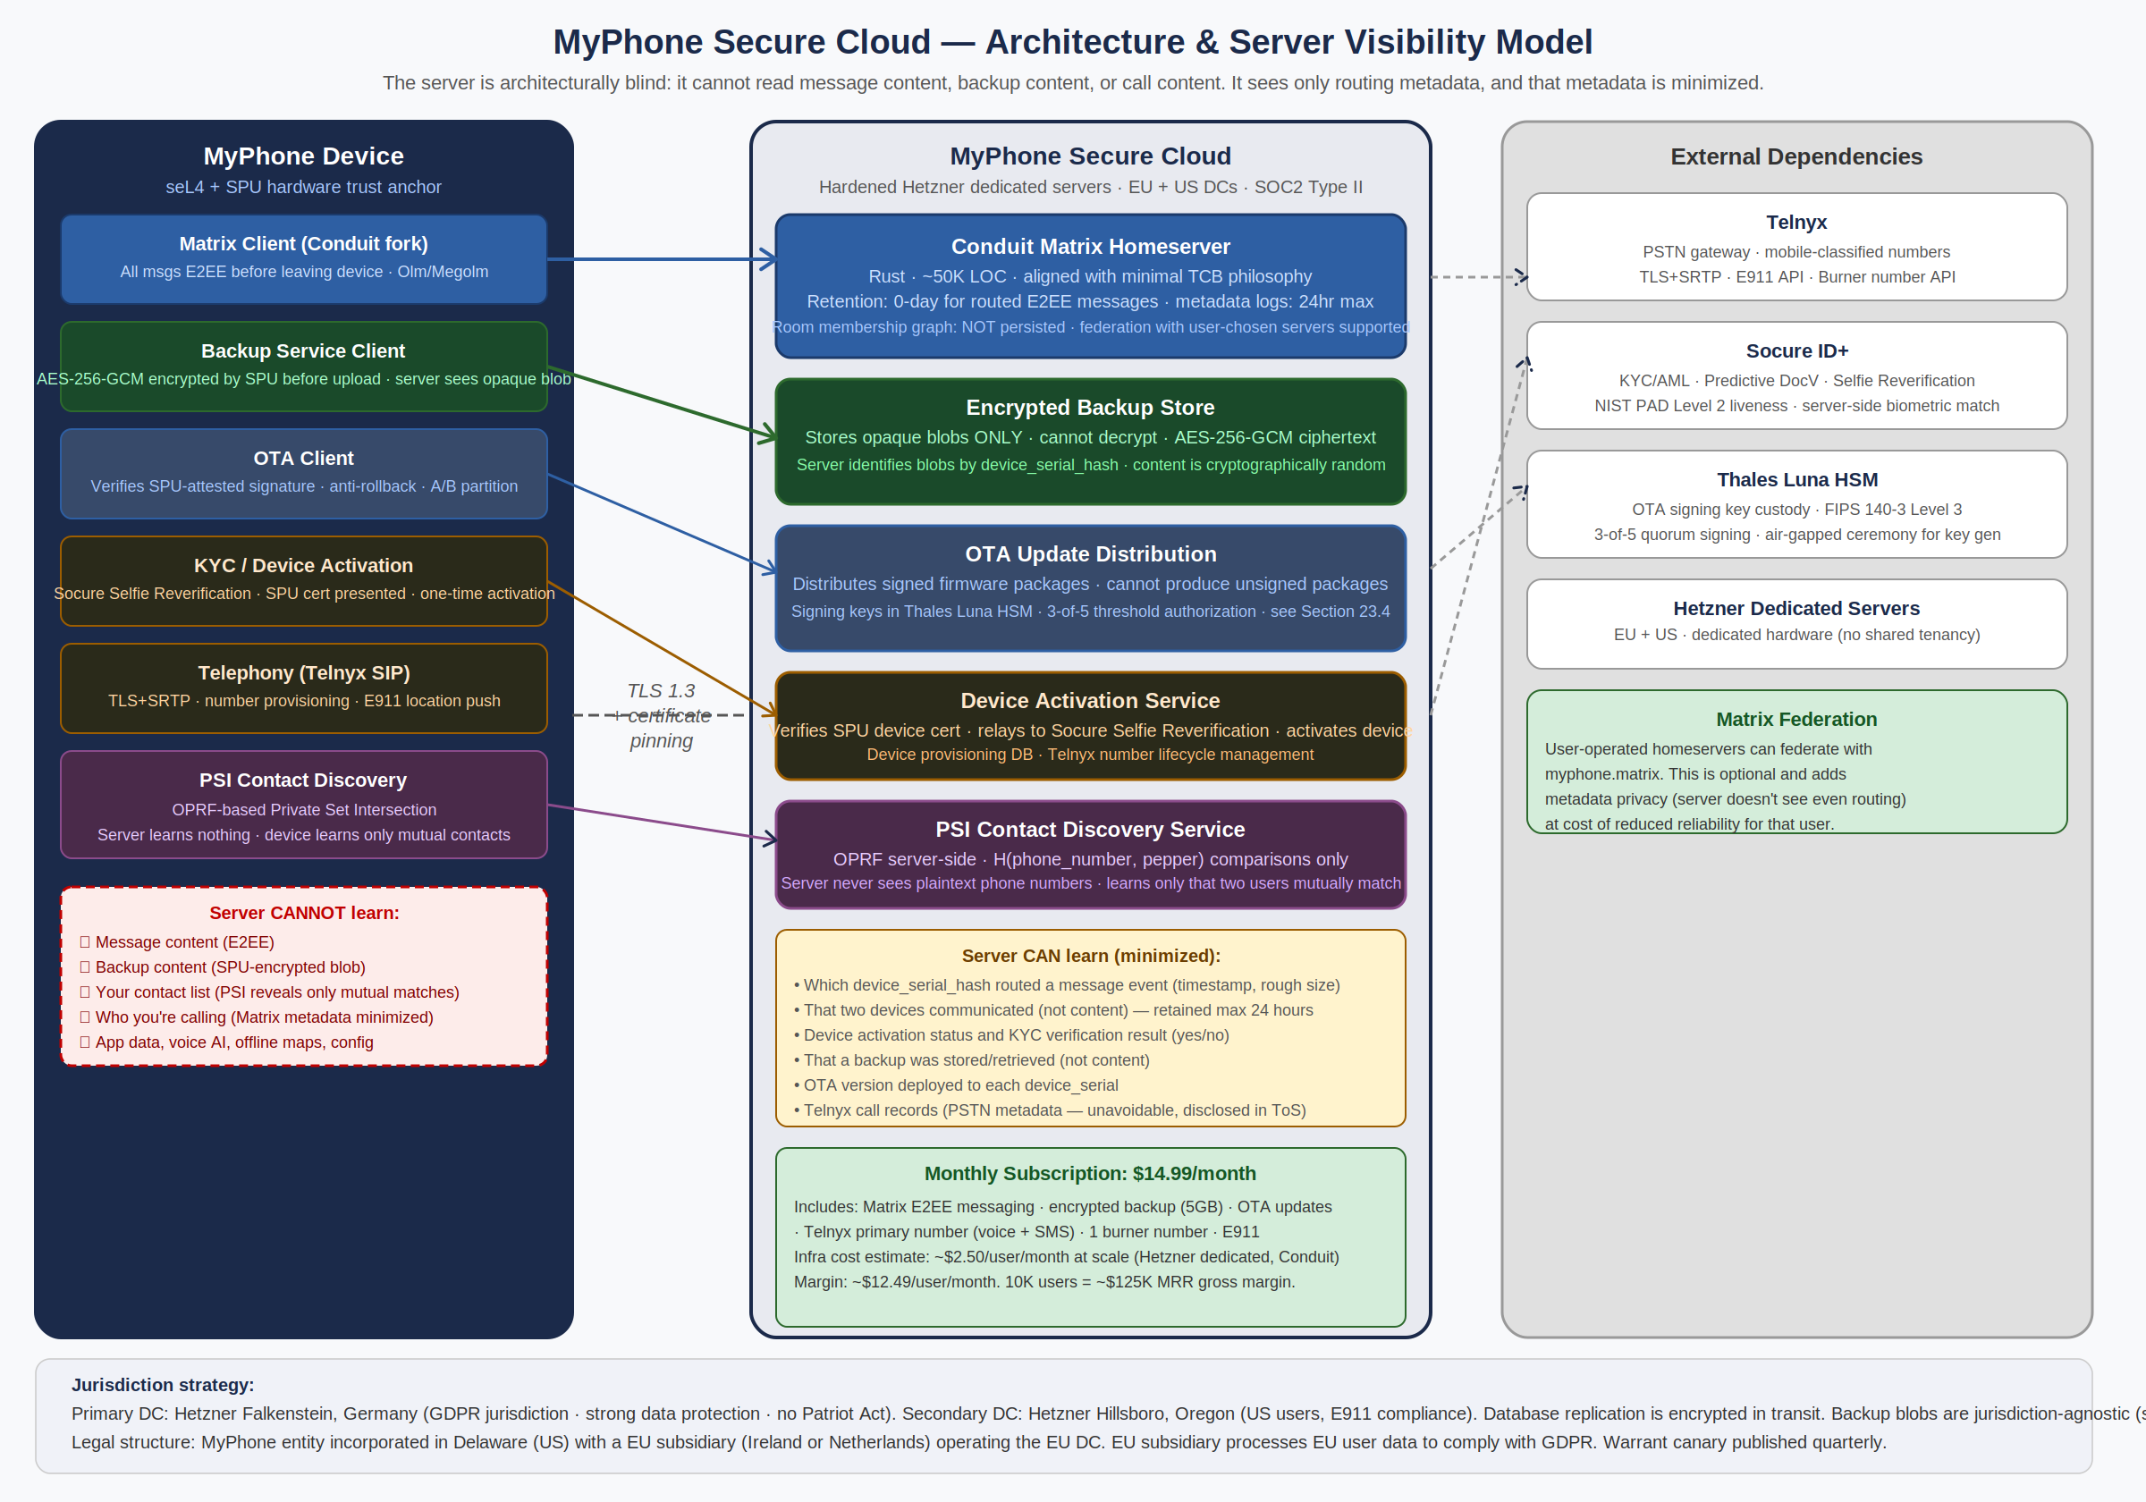
Figure 23.1 — MyPhone Secure Cloud Architecture. Server-blind model: message content, backup content, and contact lists are never visible to the server.

23.2 Server Blindness Model
The fundamental design constraint: MyPhone targets high-value individuals who face nation-state adversaries. A cloud service that can see user communications or contacts is itself a high-value target. The server must be architecturally blind — not just policy-blind — to message content, backup content, and contact graphs.

23.2.1 Matrix E2EE — Message Content Invisibility
Conduit (the Matrix homeserver implementation selected) routes messages between clients but never holds plaintext. All messages are encrypted client-side using Olm (1:1) or Megolm (group) before transmission. The homeserver stores encrypted ciphertext only, which it cannot decrypt. This is identical to Signal's architecture.

Metadata minimization policy enforced at the Conduit configuration level:
- Message retention: 0 days. Routed E2EE messages are forwarded immediately and not retained in the database.
- Room membership graph: NOT persisted in the standard Matrix database tables. A modified Conduit configuration omits the m.room.member event history beyond what is required for current federation routing.
- Access logs: retained maximum 24 hours, then purged. Logs contain device_serial_hash (not plaintext identity) and event type (not content).
- Server-to-server federation traffic: encrypted via TLS between homeservers. MyPhone homeserver does not log federation metadata beyond routing requirements.

NOTE Matrix federation is opt-in for users who operate their own homeserver. Federation with external homeservers reveals the room membership graph to those external servers — this is an inherent Matrix federation property. The MyPhone homeserver's privacy guarantees apply only to communications that stay on the MyPhone homeserver.

23.2.2 Backup Encryption — Content Invisibility
The backup service stores opaque encrypted blobs. The encryption key is derived from the device's SPU master seed, which never leaves the SPU:
// Backup key derivation (in walletd/backupd compartment)
// Key path m/3/* is reserved for backup operations
backup_key = cryptod.DERIVE_KEY(key_path: m/3/0)
// Backup encryption (client-side, before upload)
backup_plaintext = serialize({
matrix_keys: ...,
contacts: ...,
message_history: ...,
app_configs: ...,
voice_ai_personalization: ...,
})
nonce = cryptod.GET_RANDOM(32)
ciphertext = AES_256_GCM_ENCRYPT(key=backup_key, nonce=nonce, plaintext=backup_plaintext)
// Upload to server: {device_serial_hash, nonce, ciphertext}
// Server stores ONLY the opaque blob — it cannot decrypt

Recovery: after a device replacement, the user performs the full Socure re-verification and 3FA setup on the new device. Once the new device's SPU is provisioned with the same master seed (recovered via Shamir 3-of-5), the backup key can be re-derived and the backup blob decrypted. The master seed recovery is the prerequisite for backup recovery — by design.

Backup contents: Matrix encryption keys (Megolm session keys for message history decryption), contact list, message history, app configurations, offline map cache metadata, voice AI personalization data. Wallet keys are NOT included in the regular backup — they are recovered separately via the Shamir social recovery mechanism (Section 10.6).

23.2.3 PSI Contact Discovery — Contact List Invisibility
When a MyPhone user wants to know which of their phone contacts are also MyPhone users, the system must answer this question without revealing the user's contact list to the server. This is solved using Oblivious Pseudorandom Function (OPRF)-based Private Set Intersection (PSI) — the same fundamental approach used by Signal.

The protocol:
- Client hashes each contact's phone number with a local random blinding factor: H(phone_number)^r where r is a random scalar chosen by the client.
- Client sends the blinded hashes to the PSI server. The server applies its OPRF key: H(phone_number)^(r * server_key). Returns the doubly-blinded values.
- Client unblinds: H(phone_number)^server_key = (H(phone_number)^(r * server_key))^(1/r). Now client has the server-keyed hash of each contact number, without learning the server key.
- Client sends its own MyPhone Matrix ID and phone number (pre-registered, hashed with the server key on registration). The server computes the intersection of the client's query set against the registered set.
- Server returns only the intersection — the phone numbers of contacts who are MyPhone users — without learning which contacts the client checked or the full contact list.

NOTE The server learns: (1) that a contact discovery query occurred, (2) the size of the query set (how many contacts the user checked), and (3) the size of the result set (how many MyPhone users were found). It does NOT learn the plaintext phone numbers, which specific numbers matched, or the user's contact list. This is equivalent to Signal's sealed sender contact discovery model.

23.3 Pricing and Infrastructure Economics
Line Item | Monthly Cost per User (1K users) | Monthly Cost per User (10K users) | Monthly Cost per User (100K users)
Conduit homeserver (Hetzner dedicated AX42) | $0.22 | $0.04 | $0.01
Encrypted backup storage (S3-compatible, Hetzner Object Storage) | $0.30 (5GB @ $0.06/GB) | $0.30 | $0.25
Telnyx primary number + voice (~800 min) + SMS (~800) | $15.20 | $15.20 | $14.00 (volume discount)
Telnyx burner number + usage | $2.50 | $2.50 | $2.00
Socure KYC API (monthly reverification) | $0.40 | $0.35 | $0.25
Thales Luna HSM (amortized per user) | $0.50 | $0.05 | $0.01
Bandwidth, ops, support, DNS, CDN | $0.80 | $0.50 | $0.30
TOTAL COST PER USER / MONTH | ~$19.92 | ~$18.94 | ~$16.82
Subscription price | $24.99/month | $22.99/month | $19.99/month
Gross margin | ~$5.07/user (~20%) | ~$4.05/user (~18%) | ~$3.17/user (~16%)

Note: Telephony is the dominant cost driver (~70% of COGS). At scale, negotiating a Telnyx volume contract reduces this significantly. The v1 pricing must account for telephony costs honestly — under-pricing the service creates unsustainable unit economics. The $24.99/month price point at launch (1K users) is intentionally margin-thin to maximize adoption, with price declining as scale is achieved. Device sale price (separate from subscription) must cover hardware COGS and initial support.

23.4 Conduit Homeserver Selection Rationale
Three Matrix homeserver implementations were evaluated: Synapse (Python, Matrix Foundation's original, ~500K+ LOC), Dendrite (Go, Matrix Foundation's next-gen, ~200K LOC), and Conduit (Rust, community-developed, ~50K LOC).

Criterion | Synapse | Dendrite | Conduit
LOC / Audit Surface | ~500K+ Python | ~200K Go | ~50K Rust
Language / Memory Safety | Python — memory safe but slow | Go — memory safe, GC pauses | Rust — memory safe, no GC
Performance at 10K users | Requires Postgres clustering + workers | Adequate with Postgres | Excellent on single server (RocksDB)
Matrix feature completeness | Full (reference impl) | ~80% (growing) | ~70% (sufficient for MyPhone use case)
Federation support | Full | Partial (improving) | Improving (sufficient for v1)
Metadata minimization config | Possible but complex | Possible | Simpler codebase = easier to audit and modify
Alignment with MyPhone TCB philosophy | Poor — 500K LOC antithetical to auditability | Acceptable | Excellent — same minimal-LOC philosophy

Decision: Conduit, operated as a MyPhone-maintained fork. The fork applies MyPhone-specific modifications: enforced 0-day message retention, disabled room membership history persistence, device_serial_hash-based logging (no plaintext Matrix IDs in logs), mandatory TLS 1.3 with client certificate authentication for all device connections, and custom PSI contact discovery API endpoints.

24. UI Framework & Compositor Tradeoff Analysis
The current specification uses Lomiri (Ubuntu Touch/UBports) as the display compositor and application shell. This section performs a structured tradeoff analysis of all viable options, provides a recommendation, and specifies the contingency plan.

24.1 Requirements Driving the Decision
- Role of the compositor: The compositor must: (1) be a Wayland compositor compatible with the QCS8550's Freedreno/Mesa graphics stack, (2) support a phone form factor (portrait-first, touch input, on-screen keyboard), (3) support integration with the secure attention mechanism (the OSD overlay plane is below the compositor in the display stack, so the compositor does not need to know about it, but must not interfere with it), (4) be maintainable by the MyPhone team at acceptable risk.
- Role of the app framework: The app framework provides: the lock screen, the home screen, the notification system, and the container for Linux VM applications. It does NOT affect the security model (all apps run in the Linux VM, which is isolated by seL4 regardless of which compositor they use).
- Security impact: The compositor runs entirely within the Linux VM (untrusted domain). A compromised compositor is within the Linux VM threat model — seL4 prevents it from accessing wallet, biometric, or crypto compartments. The compositor choice is therefore a developer experience, maintenance risk, and UI quality decision, NOT a security decision.

24.2 Full Option Comparison
Option | Maintainer | Phone UX | QCS8550 compat | LOC / Risk | Verdict
Lomiri / Mir | UBports (community, ~5 core devs) | Native phone shell | Good — Ubuntu Touch supports Qualcomm | ~200K LOC Mir + Lomiri shell | Viable but risky
Phosh / wlroots | Purism + community (Librem 5, PinePhone active) | Native phone shell | Good — wlroots is widely ported | ~50K LOC phosh + wlroots | RECOMMENDED
Sway / wlroots | Large community, excellent maintenance | Desktop-oriented | Excellent | ~30K LOC | Wrong form factor
KWin Wayland | KDE (large, well-funded) | Plasma Mobile available | Decent — Plasma Mobile tested on phones | ~400K LOC | Too large / heavy
Custom minimal compositor | MyPhone team | Full control | Full control | 6–12 months to build, ~50K LOC | V2 option only
Weston (reference) | Wayland Foundation | No phone shell | Excellent | ~100K LOC | Not production-ready for phones

24.3 Detailed Assessment: Lomiri vs Phosh

24.3.1 Lomiri (Current Spec)
Lomiri's strengths: it was designed specifically for Ubuntu Touch on mobile devices, has a functioning app ecosystem, and has existing Qualcomm Snapdragon driver support from the UBports community's work on various Snapdragon-based phones.

Lomiri's critical risks:
- Maintainer size: UBports has approximately 5 core active developers maintaining Lomiri, Mir, and Ubuntu Touch simultaneously. For a security product, a 5-person community maintainer for the primary UI compositor is a dependency risk. A key developer departure could leave critical security patches unaddressed.
- Mir compositor is Lomiri-specific: Mir is the display server underlying Lomiri. It is not used by any other major project. If Lomiri/UBports development slows or stops, there is no community fallback. Porting to a different compositor would require significant rework.
- Update cadence: UBports releases have historically been slow. For a security product that needs prompt compositor patches for any Wayland protocol vulnerabilities, a slow-moving upstream is a liability.
- Commercial risk signal: Lomiri's slow adoption trajectory (essentially no commercial devices beyond community ports) suggests limited momentum. MyPhone cannot rely on a compositor that may not have active security maintenance in 3 years.

24.3.2 Phosh (Recommended Alternative)
Phosh is the mobile shell developed by Purism for the Librem 5. It is built on wlroots (a compositing library used by Sway, Wayfire, Hyprland, and many others) and has active development with backing from both Purism (commercial entity) and a growing community (PinePhone, GNOME mobile initiative).

Phosh's strengths:
- wlroots underpins Phosh: wlroots is the most actively maintained Wayland compositor library in the open-source ecosystem. Security fixes in wlroots propagate to Phosh automatically. The maintainer risk is distributed across dozens of projects.
- Active commercial backing: Purism is a commercial entity with business continuity incentives. A Purism bankruptcy would be unfortunate but the wlroots community would maintain the compositor independently.
- GNOME alignment: Phosh uses GTK4 and integrates with GNOME's mobile stack. This gives access to GNOME's accessibility, internationalization, and application ecosystem.
- Proven on production phones: Phosh is the shipping UI on the Librem 5 (Qualcomm i.MX 8M-adjacent), and has extensive community ports to PinePhone, PinePhone Pro, and various Qualcomm devices.
- LOC: Phosh itself is ~50K LOC Rust/C, substantially smaller than Lomiri's stack.

Phosh's risks:
- Less battle-tested on QCS8550 specifically: QCS8550 Phosh support would require initial porting work (1–2 months by the Hardware Integration Lead). However, wlroots already runs on QCS8550-class hardware via the Freedreno Mesa driver.
- App ecosystem less mature than Lomiri: fewer mobile-optimized GTK4 apps exist vs Ubuntu Touch apps. Mitigated by: MyPhone's app ecosystem is primarily web-based (Firefox) and custom (wallet, telephony, maps) anyway.

24.4 Recommendation and Migration Plan
Decision: Replace Lomiri/Mir with Phosh/wlroots as the primary compositor and shell for v1.

Rationale: the maintainer risk of depending on a 5-person community project for a security product's primary UI layer is unacceptable when a better-maintained alternative (backed by a commercial entity and the wlroots community) is available. The porting cost (1–2 months) is justified by the reduced maintenance risk over the product's lifetime.

v13 Specification | v18 Correction
Lomiri UI — compositor and shell | Phosh — compositor (wlroots) and shell
Mir display server | wlroots (Wayland protocol compositor library)
Ubuntu Touch app ecosystem | GTK4/GNOME mobile app ecosystem + custom MyPhone apps
UBports community maintainer risk | Purism commercial backing + wlroots community distributed maintenance

Contingency (v2): if Phosh development slows materially, the MyPhone team forks wlroots and builds a minimal custom phone compositor (~50K LOC, 6-month effort) that provides exactly the functionality needed (phone shell, lock screen, notification system, app launcher) with no excess features. This is documented as the v2 contingency, not deferred risk.

25. Manufacturing Security Chain — Tradeoff Analysis & Specification
The manufacturing security chain determines whether a device that arrives at a user's door is a genuine MyPhone with an authentic SPU, or a counterfeit that could contain a compromised security element. This section performs a structured tradeoff analysis of manufacturing models and specifies the selected approach: open hardware assembly with SPU self-provisioning.
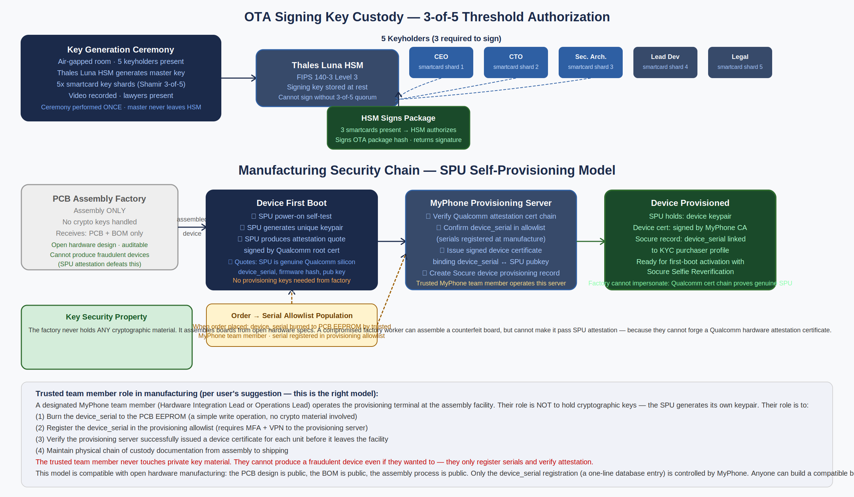
Figure 25.1 — Manufacturing chain (top: OTA signing key custody; bottom: SPU self-provisioning model). Factory never handles cryptographic material.

25.1 Manufacturing Model Tradeoff Analysis
Model | Description | Security Properties | Open Mfg Compatible | Cost / Complexity | Verdict
A: Factory-provisioned keys | Factory programs private keys into SPU at assembly time | Factory has access to key material. Insider threat risk. Compromised factory = compromised all devices. | Yes | Low | REJECTED
B: Air-gapped provisioning rig (team at factory) | MyPhone team travels to factory with HSM provisioning rig. Factory staff never touch keys. | Team controls key material. High operational burden. Scales poorly. | Partial | High | Viable for v1 pilot
C: SPU self-provisioning (RECOMMENDED) | SPU generates its own keypair at first boot. MyPhone server verifies Qualcomm hardware attestation and issues device certificate. | No keys at factory. Counterfeit devices cannot pass Qualcomm attestation. Maximum supply chain security. | YES — fully compatible | Low (2 API calls) | SELECTED
D: Remote attestation + manual registration | Hybrid: C + a trusted team member physically registers each device serial at the factory | Same as C plus physical chain of custody for serials | YES | Low | SELECTED (extends C)

25.2 Selected Model: SPU Self-Provisioning with Trusted Team Serial Registration
The selected manufacturing model combines two components: (1) SPU self-provisioning (Model C), where the SPU generates its own keypair at first boot and the Qualcomm hardware attestation chain proves authenticity without any factory involvement in key material; and (2) trusted team member serial registration (extends Model D), where a designated MyPhone team member at the factory registers each device_serial in the provisioning allowlist.

Critical insight: the trusted team member never touches cryptographic material. They perform two administrative operations: burning a device_serial to the PCB EEPROM (a non-secret value), and registering that serial in the provisioning allowlist (requires MFA + VPN). A malicious team member who bypasses this process still cannot produce a valid device — the SPU's Qualcomm attestation certificate chain proves genuine silicon, and a counterfeit device with a cloned serial will fail attestation.

25.2.1 Open Hardware Manufacturing Compatibility
The SPU self-provisioning model is fully compatible with open hardware manufacturing:
- PCB design files are published under an open hardware license (CERN OHL-S or equivalent).
- Bill of Materials (BOM) is published. Any qualified PCB assembly shop can build the board.
- The assembly process is: solder components, flash bootloader, power-on. No crypto material involved.
- The only MyPhone-specific step is: a team member (or an automated provisioning station operated by the team) registers the device_serial and verifies attestation.
- Community members can build their own boards from the open hardware design. These devices will not pass provisioning (their SPU attestation will succeed at the Qualcomm level, but their device_serial will not be in the MyPhone allowlist). This is by design — only devices that go through the KYC purchase flow are activated.

This is analogous to the Framework laptop model: the hardware is open and repairable, but the operating system and service ecosystem are controlled. Anyone can build the hardware; only purchased devices receive service access.

25.2.2 Factory Selection Criteria
For v1, the recommended manufacturing approach is a small-batch assembly service (100–500 units) rather than a high-volume factory. Suitable options:
- MacroFab (US): US-based PCB assembly service. Accepts Gerber files and BOM. No minimum order. Suitable for 50–2000 unit runs. The provisioning rig travels to MacroFab or devices are shipped to a MyPhone facility for provisioning after assembly.
- PCBWay / JLCPCB (CN): Lower cost per unit. Larger minimum orders for some components. Suitable for v2 volume production. Supply chain audit more complex for a security product. Recommend US-based for v1.
- In-house assembly (pilot): First 50–100 units assembled by the MyPhone team in-house (soldering station + reflow oven). Maximum control. Suitable for dev kits and first customer units. Does not scale beyond 200 units.

Recommendation for v1: in-house assembly for first 50 units (dev kits + beta customers), MacroFab for first production run (100–500 units). The provisioning station is operated by the Hardware Integration Lead or Operations Lead at each facility.

25.3 Full Provisioning Flow Specification

25.3.1 Pre-Manufacturing: Order Registration
- Customer places order on MyPhone website and completes Socure KYC.
- MyPhone backend generates a unique device_serial (UUID v4 + checksum) for the order.
- device_serial is added to the provisioning allowlist with status PENDING_ASSEMBLY.
- Socure referenceId, device_serial, and order metadata are linked in the provisioning database.

25.3.2 At Assembly Facility
- Trusted team member receives assembled but unprovisioned PCBs from factory.
- For each unit: team member burns device_serial to EEPROM using provisioning tool (USB-connected programmer). This is a non-secret write — the serial is a public identifier.
- Team member verifies burn by reading back the EEPROM and confirming against the order database.
- Provisioning allowlist status updated to AWAITING_FIRST_BOOT.
- Device packaged and shipped to customer.

25.3.3 Device First Boot (SPU Self-Provisioning)
- Customer powers on device. seL4 boots, SPU initializes.
- SPU generates a unique 256-bit keypair (ECDSA P-256 or Ed25519, depending on Qualcomm SPU API).
- SPU produces a hardware attestation quote: a statement containing {device_serial (read from EEPROM), SPU_pubkey, firmware_hash, timestamp}, signed by the Qualcomm device attestation root certificate chain baked into the SPU at chip manufacture.
- Device connects to WiFi and sends the attestation quote to MyPhone provisioning server.
- Provisioning server: (a) verifies Qualcomm attestation certificate chain (proves genuine Qualcomm SPU), (b) confirms device_serial is in AWAITING_FIRST_BOOT allowlist, (c) checks firmware_hash against the published v1.0 release hash, (d) issues MyPhone device certificate binding {device_serial, SPU_pubkey}, (e) creates Socure device provisioning record linking device_serial to the purchaser's Socure referenceId, (f) updates allowlist status to PROVISIONED.
- Device stores the MyPhone device certificate in SPU sealed storage.
- First-boot KYC activation flow begins (Socure Selfie Reverification) — see Section 11.

IMPORTANT Step (c) — firmware_hash verification — means that devices running a modified firmware cannot be provisioned. This is intentional: it prevents provisioning of devices with unofficial firmware that might have weakened security properties. Users who want to run custom firmware can do so, but they will not receive MyPhone Secure Cloud service (the provisioning server will reject the attestation). This is the correct tradeoff for a security product.

26. OTA Signing Key Custody Model
A malicious OTA firmware update delivered to all MyPhone devices is the highest-impact software supply chain attack possible against this system. Preventing it requires that the OTA signing key is held in hardware with physical access controls, that no single person can produce a valid signature, and that the key cannot be exfiltrated even by a compromised server.

26.1 Threat Model for the OTA Signing Infrastructure
Threat | Consequence | Mitigation
Developer laptop compromise (signing key on laptop) | Attacker produces signed malicious firmware delivered to all users | Key never on laptop. Signing requires 3-of-5 smartcard quorum via HSM.
CI/CD server compromise | Attacker triggers automated signing of malicious build | CI/CD server produces firmware package but CANNOT sign it. Signing is a separate human-authorized step.
Key holder coercion (wrench attack on one person) | One person forced to sign malicious firmware | 3-of-5 threshold: coercing one person is insufficient. Coercing 3 simultaneously is operationally infeasible.
HSM compromise / theft | Attacker signs malicious firmware using stolen HSM | HSM requires 3 smartcard shards present simultaneously to authorize signing. Stolen HSM without 3 smartcards = useless.
Signing key loss (HSM destroyed, all keyholders unreachable) | Cannot produce OTA updates | Key recovery ceremony: 3-of-5 shareholders can reconstruct and re-provision to a new HSM.
Rogue insider (one team member attempts unauthorized signing) | One person cannot sign alone | 3-of-5 threshold enforced by HSM hardware. Insider cannot authorize a signing without 2 additional keyholders physically present.

26.2 Key Custody Architecture

26.2.1 Hardware Security Module: Thales Luna Network HSM 7
The Thales Luna Network HSM 7 is selected for OTA signing key custody based on:
- FIPS 140-3 Level 3 certification: Physical tamper evidence and response, role-based authentication, cryptographic module security.
- 3-of-5 Quorum (M-of-N) authorization support: Luna HSM natively supports multi-party authorization for key usage. The HSM enforces the quorum policy in hardware — it cannot be bypassed by software.
- Key non-extractability: Signing keys generated inside the HSM cannot be exported in plaintext. Even with physical access to the HSM hardware, the key cannot be extracted without the correct quorum authorization.
- Network-accessible: The Luna Network HSM is accessed via a secure client library. The OTA signing pipeline authenticates to the HSM via mutual TLS. No direct physical access required for signing operations.

26.2.2 Keyholder Assignments and Shard Custody
Shard # | Keyholder Role | Custody | Geographic Location | Backup
1 | CEO / Founder | Thales PED smartcard, personal safe | Primary operations location | Safe deposit box (separate location)
2 | CTO / Security Architect | Thales PED smartcard, personal safe | Primary operations location | Safe deposit box (separate location)
3 | Lead Hardware Engineer | Thales PED smartcard, personal safe | Secondary location (different city) | Safe deposit box (separate location)
4 | Legal Counsel / Corporate Secretary | Held by law firm, partner-level custody | Law firm location | Law firm secondary safe
5 | Independent Security Auditor | Held by audit firm, partner-level custody | Audit firm location | Audit firm secondary safe

The inclusion of external parties (Legal Counsel, Independent Security Auditor) as keyholders provides protection against the scenario where the MyPhone company is acquired, goes bankrupt, or comes under legal pressure. The external keyholders are contractually obligated to only participate in signing ceremonies that are publicly announced and verifiable.

26.2.3 Signing Ceremony Process
- A firmware build completes in CI/CD. The build system produces a firmware package and its SHA-256 hash, but does NOT sign it.
- The Security Architect reviews the build output against the expected diff (git log, changelog) and confirms the build is legitimate.
- The Security Architect announces the signing ceremony via internal secure channel with at least 24 hours notice (except for critical security patches, which may use a 2-hour emergency process).
- Three keyholders convene (physically or via authenticated video call with smartcard readers connected to their workstations).
- Each keyholder authenticates their smartcard to the HSM via the Luna PED (pin entry device). The HSM verifies the quorum.
- The OTA signing service submits the firmware package hash to the HSM for signing. The HSM signs the hash with the firmware signing key.
- The signed package is published to the OTA distribution service.
- The signing event is logged: timestamp, firmware hash, which 3 keyholders participated (not their smartcard secrets), and the resulting signature. This log is publicly auditable.

26.2.4 Key Rotation Policy
- Scheduled rotation: OTA signing key rotated annually. Full key generation ceremony with all 5 keyholders present. New shard smartcards issued. Old HSM key destroyed (shredded audit log retained).
- Emergency rotation (compromise suspected): If any keyholder's smartcard is lost, stolen, or the keyholder is believed to be compromised: emergency rotation using the remaining 4 keyholders (the 5th cannot participate as their shard is potentially compromised). 2-of-4 remaining keyholders can authorize the rotation ceremony.
- Disaster recovery (HSM destroyed or unreachable): 3-of-5 keyholders reconstruct the master key material at a key recovery ceremony. This ceremony must be conducted in a physically secure facility with a lawyer present. The reconstructed key is immediately imported to a new HSM and all shards re-generated.

26.3 Key Derivation Hierarchy
The OTA signing infrastructure uses a two-level key hierarchy:
MyPhone Root CA (generated in HSM, never exported)
├── OTA Firmware Signing Key [HSM, 3-of-5 quorum required]
│ Signs: firmware packages, IOC update bundles
├── Device Provisioning CA [HSM, 2-of-5 quorum required]
│ Issues: device certificates during SPU self-provisioning
└── Socure Relay Key [HSM, 1-of-5 quorum (operational)]
Used for: Socure API authentication (rotated monthly)
Device (SPU-generated, never leaves SPU):
└── Device Keypair [SPU hardware, unique per device]
Certified by: Device Provisioning CA
Used for: mutual TLS to Secure Cloud, OTA auth, backup auth

NOTE The MyPhone Root CA and all subordinate keys are generated inside the Thales Luna HSM. The Root CA private key is never exported and cannot be used for signing directly — all signing operations use subordinate keys. This provides separation: a compromise of the OTA signing key does not compromise device provisioning or vice versa.

26.4 Warrant Canary and Transparency
For a security product targeting high-value individuals, transparency about government demands is a meaningful security commitment. MyPhone will publish:
- Quarterly warrant canary: A signed statement confirming that MyPhone has not received any government orders to (1) insert backdoors, (2) hand over signing keys, (3) produce malicious firmware updates, or (4) conduct mass surveillance. Signed by all 5 keyholders. Failure to publish on schedule is itself a signal.
- OTA signing audit log: Every firmware signing event is published in a public, append-only transparency log (similar to Certificate Transparency). Anyone can verify that their device's firmware hash appears in the log.
- Annual security audit: Independent security firm (Trail of Bits or NCC Group) reviews the OTA signing infrastructure, HSM configuration, and key custody procedures annually. Report published publicly.

28. MyPhone Media Center
MyPhone Media Center is the device's unified offline-first media application — a single library that organises and plays all media types rather than requiring separate apps for audio, video, photos, and documents. The design principle is iTunes-inspired: one app, one library, all your media, no cloud dependency. Everything is stored on-device and backed up via the encrypted cloud backup system.

28.1 Architecture and Security Position
The Media Center runs entirely inside the Linux VM (untrusted domain). It holds no seL4 capabilities, has no access to the SPU, OPTIGA, walletd, biometricd, or cryptod. A fully compromised Media Center cannot reach wallet keys or biometric templates — seL4 enforces this unconditionally. The Media Center is an application-layer concern, not a security-layer concern.

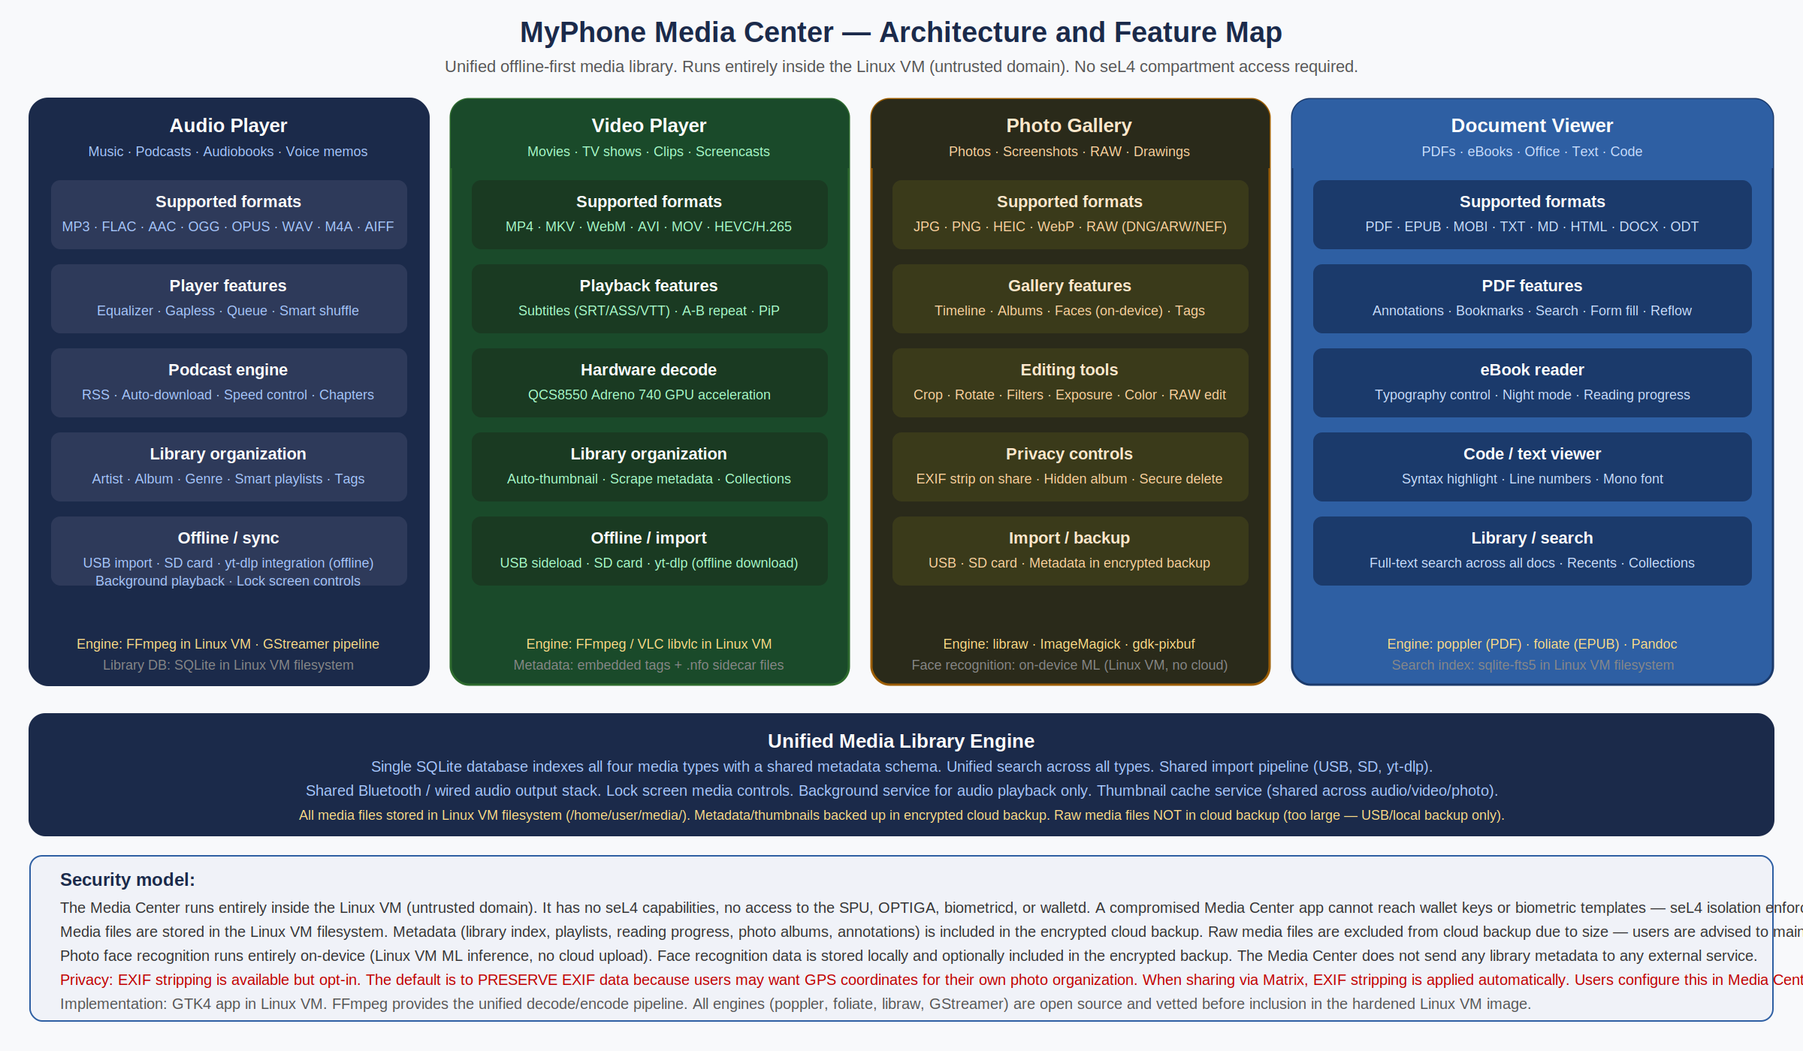
Figure 28.1 — Media Center architecture. Four media pillars sharing a unified SQLite library engine. All runs in Linux VM. Metadata backed up; raw media files excluded from cloud backup due to size.

Pillar | Supported Formats | Engine | Key Features
Audio Player | MP3, FLAC, AAC, OGG, OPUS, WAV, M4A, AIFF | FFmpeg / GStreamer pipeline | Equalizer, gapless playback, podcast engine (RSS + auto-download + chapters), smart playlists, speed control, background playback with lock-screen controls
Video Player | MP4, MKV, WebM, AVI, MOV, HEVC/H.265 | FFmpeg / libvlc — QCS8550 Adreno 740 hardware decode | Subtitles (SRT/ASS/VTT), A-B repeat, Picture-in-Picture, auto-thumbnail, metadata scraping, chapter navigation
Photo Gallery | JPG, PNG, HEIC, WebP, RAW (DNG/ARW/NEF/CR2) | libraw + ImageMagick + gdk-pixbuf | Timeline view, face recognition (on-device ML only, never cloud), RAW editing, EXIF strip on share, hidden album, secure delete, non-destructive edits
Document Viewer | PDF, EPUB, MOBI, TXT, MD, HTML, DOCX, ODT, RTF, code files | poppler (PDF), foliate (EPUB), Pandoc, sqlite-fts5 full-text search | PDF annotations, bookmarks, form fill, reflow; eBook typography control and night mode; full-text search across all documents; syntax highlighting for code

28.2 Unified Library Engine
All four media types share a single SQLite database that stores metadata, playlists, reading progress, photo albums, and annotations. This enables cross-type features: a unified search that returns audio, video, photos, and documents from a single query; a unified import pipeline (USB, SD card, yt-dlp offline download); and a shared thumbnail cache service that serves all four pillars.

- Library database: SQLite with FTS5 extension for full-text document search. Stored at /home/user/.local/share/myphone-media/library.db inside the Linux VM filesystem. Included in the encrypted cloud backup.
- Media file storage: Raw media files stored at /home/user/media/ partitioned by type (audio/, video/, photos/, documents/). Files are NOT included in the cloud backup due to size — users are advised to maintain a local USB backup for irreplaceable files. Metadata, playlists, annotations, and reading progress ARE included in the cloud backup.
- Import pipeline: USB mount, SD card mount, and yt-dlp (offline downloader — downloads to device, no streaming) share a common import daemon that fingerprints new files, extracts metadata, generates thumbnails, and adds entries to the library database.
- Background audio service: A lightweight daemon runs audio playback in the background and provides lock-screen transport controls (play/pause/next/previous). Video, photo, and document viewing are foreground-only. The audio daemon holds no elevated privileges.

28.3 Privacy Properties
- Face recognition: On-device only (Linux VM ML inference using a lightweight model, no cloud upload). Face groupings are stored locally. Face data is included in the encrypted cloud backup if the user enables it. No face data is ever sent to any external service.
- EXIF metadata: EXIF data is preserved by default (users may want GPS coordinates for their own organization). When sharing any media file via Matrix, EXIF stripping is applied automatically before the file leaves the device. Users configure the default sharing behavior in Media Center settings.
- Metadata privacy: The library database is included in the encrypted cloud backup. The backup is encrypted client-side by the SPU before upload — the server cannot read library contents. Media Center does not send any metadata to any analytics service.
- No streaming: Media Center is offline-first. There is no built-in streaming service integration. yt-dlp integration downloads files to the device for offline playback — it does not stream. This is a deliberate design decision: streaming requires maintaining persistent connections to third-party servers, which creates metadata exposure. Users who want streaming can use Firefox within the Linux VM.

29. MyPhone App Store
The MyPhone App Store allows third-party developers to build, submit, and distribute applications and games to MyPhone subscribers. It extends the existing MyPhone Secure Cloud subscription model — the $24.99/month subscription that covers Matrix messaging, encrypted backup, and telephony also provides access to the App Store for free app downloads. Paid apps are available as individual purchases.

29.1 Architecture Overview

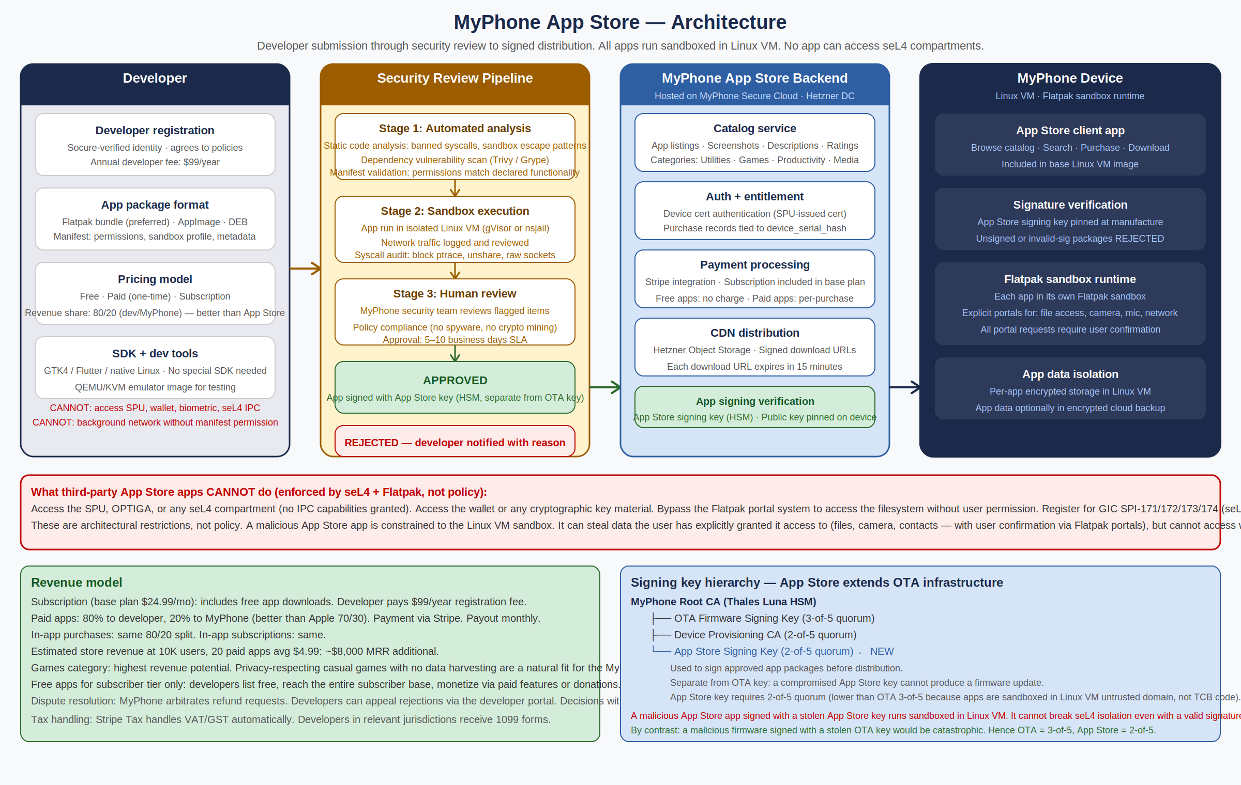
Figure 29.1 — App Store architecture. Developer submission through three-stage security review to signed distribution. Apps run sandboxed in Linux VM via Flatpak. App Store signing key is separate from OTA key with 2-of-5 quorum.

29.2 App Sandbox Model
All third-party apps run inside Flatpak sandboxes within the Linux VM. The sandbox model provides two layers of isolation: the Linux VM (seL4-isolated from all TCB compartments) and the Flatpak container (namespace + seccomp isolation within the Linux VM).

- What third-party apps CAN do: With explicit user permission via Flatpak portals: read/write specific user-chosen files, access the camera (if the device has a non-security camera), use the microphone, access the network, send notifications. The user sees a portal prompt for each permission request and can deny any of them.
- What third-party apps CANNOT do: This is architectural, not policy. No capability grants to seL4 compartments exist in any third-party app's sandbox. Apps cannot: access the SPU, OPTIGA, walletd, cryptod, biometricd, or secure-ui; register for GIC SPI-171/172/173/174 (seL4 holds all these IRQ caps exclusively); access the DPU OSD overlay plane (SMMU SID 0x08 is mapped only to secure-ui's VSpace); read other apps' data; or use banned syscalls (ptrace, unshare, raw sockets — blocked by seccomp profile).
- Flatpak portals: Every sensitive resource access goes through a Flatpak portal: xdg-portal handles file access, camera, microphone, and notifications. Each portal request generates a user-visible confirmation. Apps that repeatedly request denied permissions can be flagged and removed.

IMPORTANT A malicious app signed with a stolen App Store key runs sandboxed in the Linux VM. It cannot break seL4 isolation even with a valid signature. By contrast, a malicious firmware signed with a stolen OTA key would be catastrophic. This is why the quorum thresholds differ: OTA signing requires 3-of-5 keyholders; App Store signing requires only 2-of-5. The lower threshold reflects the lower impact of a compromised App Store key.

29.3 Security Review Process
Every app submission goes through a three-stage security review before receiving an App Store signature. The review pipeline cannot be bypassed.

Stage | Process | Automated? | Blocking criteria
1 — Static analysis | Full static code analysis of the submitted Flatpak bundle: banned syscall patterns, sandbox escape attempts, suspicious network destinations, cryptominer fingerprints, known malware signatures. Dependency vulnerability scan (Trivy/Grype). Manifest validation: declared permissions must match the app's actual functionality. | Yes — CI pipeline, ~15 minutes | Any banned syscall detected. Declared permissions incompatible with app function. Known CVEs in critical dependencies (HIGH or CRITICAL severity). Cryptominer signature.
2 — Sandbox execution | App is executed in an isolated Linux VM (gVisor or nsjail hardened container). Network traffic is logged and reviewed. Syscall audit records every call against the seccomp profile. Behavioral analysis looks for: background network calls to undeclared destinations, filesystem access outside declared scope, attempts to probe seL4 IPC endpoints. | Yes — automated behavioral analysis, ~30 minutes | Network calls to destinations not declared in manifest. Filesystem access outside sandbox. Any attempt to probe /proc/sel4* or seL4 MMIO regions. Camera/microphone access not matching declared permissions.
3 — Human review | MyPhone security team reviews the static analysis and behavioral reports. Verifies that the app does what it claims. Checks policy compliance (no spyware, no data harvesting without disclosure, no aggressive ad tracking). Reads the privacy policy. Approves or rejects. | No — manual review by MyPhone security team | Privacy policy missing or contradicts app behavior. App functionality is deceptive. Policy violations: spyware, stalkerware, gambling with real money (prohibited), adult content (prohibited in v1).

- Review SLA: Standard submissions: 5–10 business days for human review. Expedited review (paid, $199 fee): 2 business days. Security patch updates from existing approved apps: 24 hours if only the app binary changes with no new permission requests.
- Rejection process: Rejected submissions receive a written explanation with specific policy citations. Developers can address the issue and resubmit. Repeated policy violations can result in developer account suspension.
- Post-ship monitoring: Approved apps are monitored for reported issues. Any subscriber can report a misbehaving app. MyPhone can emergency-revoke an app's signature (causing it to fail signature verification on install — already-installed copies continue running until the user removes them).

29.4 App Package Format
The primary packaging format is Flatpak. The App Store also accepts AppImage and DEB packages for the initial launch period, with planned migration to Flatpak-only after developer adoption reaches critical mass.

- Flatpak bundle (preferred): Self-contained, sandboxed, reproducible. The Flatpak manifest specifies the sandbox profile (filesystem permissions, network access, device access). The manifest is reviewed as part of the security pipeline. Flatpak supports delta updates — only changed files are downloaded on update.
- AppImage (accepted at launch): Portable single-file format. Less sandboxing than Flatpak but acceptable for v1. AppImages submitted to the store are wrapped in a MyPhone sandbox profile before distribution. Plan to deprecate AppImage support in v2 as developer adoption of Flatpak grows.
- Distribution format: All packages, regardless of input format, are repackaged into a MyPhone-signed container before distribution. The App Store key signs the outer container. The developer's code is inside. The signature on the outer container proves MyPhone reviewed and approved the contents.

29.5 Developer Program
Item | Detail
Registration | Developer account requires Socure identity verification (same pipeline as device activation KYC). Annual developer program fee: $99/year. Provides: developer portal access, dev kit device entitlement (one device at developer pricing), submission portal, analytics dashboard.
Revenue share | 80% to developer, 20% to MyPhone. This is more favorable than Apple (70/30) and Google (70/30) and is a deliberate differentiation strategy to attract quality privacy-respecting developers. Revenue share applies to: paid app purchases, in-app purchases, in-app subscriptions.
Free apps | Free apps are available to all subscribers at no charge. No revenue share for free apps. The value proposition for free app developers: access to a verified, high-trust subscriber base. MyPhone users are disproportionately willing to pay for quality privacy-respecting software.
Payment processing | Stripe handles payment processing and developer payouts. Monthly payout schedule. Minimum payout threshold: $25. Stripe Tax automatically handles VAT/GST for international transactions. Developers in applicable US jurisdictions receive 1099-K forms.
SDK and tooling | No special SDK required. Any Linux GTK4, Qt, Flutter, or native application that can be packaged as Flatpak is eligible. MyPhone provides: a QCS8550 QEMU/KVM emulator image for testing, sample Flatpak manifests with correct sandbox profiles, and a developer documentation portal. The absence of a proprietary SDK is intentional — it reduces developer lock-in and broadens the eligible developer pool.
Categories (v1 launch) | Utilities · Productivity · Games · Reference · Health and Fitness · Navigation · Finance (non-wallet) · Communication · Developer Tools. Categories excluded at launch: Adult content, Gambling, Social Media (requires additional review policy for privacy implications).
App size limits | Initial download: 500MB maximum. Additional assets downloadable in-app. On-device storage managed by user. No artificial storage limits imposed by the store — device storage limits apply.

29.6 Subscription Integration and Pricing Impact
The App Store is integrated into the existing MyPhone Secure Cloud subscription. The monthly fee covers: Matrix E2EE messaging, encrypted backup (5GB), OTA updates, Telnyx telephony, contact discovery, and App Store access (free apps). Paid apps are charged separately.

Updated economics:

Revenue stream | v1 estimate (1K subscribers) | v2 estimate (10K subscribers) | Notes
Subscription ($24.99/mo) | ~$24,990 MRR gross | ~$229,900 MRR gross | Primary revenue. All services included.
Paid app purchases (20% cut) | ~$400/mo (est.) | ~$15,000/mo (est.) | Assumes ~20 paid apps, avg $4.99, ~2% purchase rate per subscriber.
Developer registration fees ($99/yr) | ~$250/mo (est. 30 devs) | ~$1,250/mo (est. 150 devs) | Not meaningful at scale but demonstrates platform adoption.
Total gross MRR | ~$25,640/mo | ~$246,150/mo
Infrastructure COGS (per-user ~$18.94) | ~$18,940/mo | ~$189,400/mo | Telephony dominates at ~70% of COGS.
Gross margin | ~$6,700/mo (~26%) | ~$56,750/mo (~23%) | App store adds ~1-3% margin improvement at scale.

NOTE The App Store is not a primary revenue driver at v1 scale — the user base is too small for meaningful app store volume. Its primary value at launch is: (1) making MyPhone more useful (more apps = more reasons to subscribe), and (2) demonstrating a viable ecosystem to early developers who will seed the catalog for later growth. The 80/20 revenue split is intentionally generous to attract quality developers early.

29.7 Signing Key Update — App Store Key Added to Hierarchy
Section 26.3 (OTA Signing Key Hierarchy) is updated to add the App Store Signing Key:

MyPhone Root CA (Thales Luna HSM, never exported)
├── OTA Firmware Signing Key [3-of-5 quorum — unchanged]
├── Device Provisioning CA [2-of-5 quorum — unchanged]
├── Socure Relay Key [1-of-5 quorum — unchanged]
└── App Store Signing Key [2-of-5 quorum — NEW in v20]
Signs: approved app packages before CDN distribution
Quorum: 2-of-5 (lower than OTA because sandboxed apps cannot break seL4 TCB)

The App Store key participates in the same key generation ceremony as the other subordinate keys. It is stored in the same Thales Luna HSM. The keyholder roles for 2-of-5 approval are the same five keyholders from Section 26.2, but only two need to be present for each app signing batch (performed weekly on a set schedule, or daily during high-submission periods).

18. Conclusion
MyPhone v13.0 provides a credible, accelerated path to manufacturing the most secure consumer mobile device ever created. By learning from industry precedent (Cog Systems' 7+ year seL4 smartphone effort), leveraging proven COTS security hardware (Qualcomm SPU + Infineon OPTIGA TPM EAL4+), adopting the seL4-recommended hypervisor architecture, and eliminating the integrated baseband modem entirely by migrating to the QCS8550 Snapdragon Compute platform, v13.0 achieves strictly improved security properties while preserving the cost and timeline advantages established in v4.0.

Version 13.0 additionally resolves all critical and major findings from a comprehensive engineering review: the image recognition authentication scheme is redesigned to be mathematically functional (pool of 100 images, 30 displayed per round, expected overlap of 3 — delivering both usability and ~67 billion per-attempt attack resistance across 3 rounds); the Cold Vault TapScript is corrected to BIP 342 syntax that genuinely preserves quantum safety by not exposing the vault key at UTXO creation; the SoC generation is correctly identified; all version labels are consistent; and the recovery timelock is standardized at 90 days throughout.

The key architectural insight remains: security comes from isolation boundaries, not from implementing everything natively. A formally verified hypervisor isolating a potentially compromised Linux VM is more secure than a native seL4 system that ships three years late with corners cut under schedule pressure. Ship proven security now; upgrade to ideal security with revenue.

Parameter | v3.0 | v4.0 | v6.0 | v13.0 (This Document)
Total Timeline | 21 mo (not credible) | 18–20 months | 18–20 months | 18–20 months (preserved)
Total Budget | ~$12M | ~$7.2M | ~$7.5M | ~$8.67M (revised mfg budget)
SoC / Silicon | Custom FPGA HSM | QCS8550 Gen 2 | QCS8550 (mislabeled Gen 3) | QCS8550 / SM8550 Gen 2 (corrected)
Security Hardware | Custom ASIC | SPU + OPTIGA EAL4+ | SPU + OPTIGA (EAL level inconsistent) | SPU + OPTIGA EAL4+ (consistent)
3FA Image Auth | N/A | N/A | Pool 1K / Display 10 (broken) | Pool 100 / Display 30 / Enroll 10 (functional)
Cold Vault Script | N/A | N/A | P2PKH syntax (exposes key) | Correct TapScript BIP 342 (key protected)
Recovery Timelock | N/A | N/A | 30-day / 90-day inconsistent | 90-day throughout (consistent)
WiFi Spec | N/A | WCN7850 WiFi 6E | WCN7850 WiFi 6E/7 (incorrect) | WCN7850 WiFi 6E (corrected)
E911 Regulatory Framework | N/A | N/A | Kari's Law (inapplicable) | FCC Nomadic VoIP E911 / Ray Baum's Act
Certification | EAL4+ aspirational | EAL2+ achievable | EAL2+ achievable | EAL2+ (CCTL engaged Phase 2); EAL4+ in v2
Development Model | Agent-first | Agent-first | Agent-first | Agent-first with formal spec → code → verification pipeline
Security Outcome | Practical invulnerability | Practical invulnerability | Practical invulnerability | Practical invulnerability (preserved)

Document Version: 13.0 | Last Updated: March 2026 | Classification: Internal Development

