Randall C. O’Reilly

Professor

**Departments of Psychology & Computer Science, Center for Neuroscience**

1544 Newton Ct (530) 757-8870

Davis, CA 95816 Email: [oreilly@ucdavis.edu](mailto:oreilly@ucdavis.edu)

November 7, 2021

We are hereby submitting our manuscript, “Correcting the Hebbian Mistake: Toward a Fully Error-Driven Hippocampus” for publication in PLoS Computational Biology. This paper represents a major update to the Ketz et al (2013) paper “Theta coordinated error-driven learning in the hippocampus” which was published in this journal. The paper is formatted for the convenience of reviewers, with figures inline and regular spacing — it is formatted in LaTeX and thus easy to produce an alternative version as needed.

Sincerely,

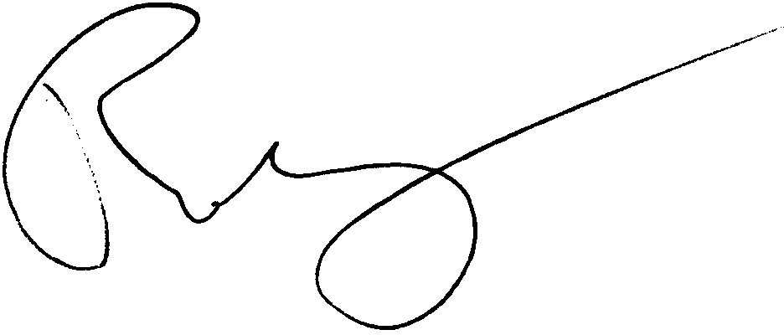

Randall O’Reilly