Appendix: Implementational Details
The model is implemented using a subset of the Leabra framework (O'Reilly & Munakata, 2000; O'Reilly, 1998). The two relevant properties of this framework for the present model are a) the use of a point neuron activation function; and b) the k-Winners-Take-All (kWTA) inhibition function that models the effects of inhibitory neurons. These two properties are described in detail below. In addition, the gating equations for modulating the intracellular maintenance ion currents in the PFC are described.

Appendix: Implementational Details
The model was implemented using the Leabra framework, which is described in detail in O’Reilly and Munakata (2000) and O’Reilly (2001), and summarized here. See Table 1 for a listing of parameter values, nearly all of which are at their default settings. These same parameters and equations have been used to simulate over 40 different models in O’Reilly and Munakata (2000), and a number of other research models. Thus, the model can be viewed as an instantiation of a systematic modeling framework using standardized mechanisms, instead of constructing new mechanisms for each model. The model can be obtained by emailing the first author at oreilly@psych.colorado.edu.

Pseudocode
The pseudocode for Leabra is given here, showing exactly how the pieces of the algorithm described in more detail in the subsequent sections fit together.
Outer loop: Iterate over events (trials) within an epoch. For each event:
1. Iterate over minus and plus phases of settling for each event.
(a) At start of settling, for all units:
i. Initialize all state variables (activation, v_m, etc).
ii. Apply external patterns (clamp input in minus, input & output in plus).
(b) During each cycle of settling, for all non-clamped units:
i. Compute excitatory netinput ( or , eq 3).
ii. Compute kWTA inhibition for each layer, based on 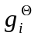 (eq 7):
A. Sort units into two groups based on : top and remaining to .
B. If basic, find and highest; if avg-based, compute avg of & .
C. Set inhibitory conductance from 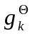 and 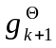 (eq 6).
iii. Compute point-neuron activation combining excitatory input & inhibition (eq 1).
(c) After settling, for all units:
i. Record final settling activations as either minus or plus phase (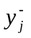 or 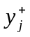).
2. After both phases update the weights (based on linear current weight values), for all connections:
(a) Compute error-driven weight changes (eq 9) with soft weight bounding (eq 10).
(b) Compute Hebbian weight changes from plus-phase activations (eq 8).
(c) Compute net weight change as weighted sum of error-driven and Hebbian (eq 11).
(d) Increment the weights according to net weight change.

Point Neuron Activation Function
--------------------------------------------
Insert Table 1 about here.
--------------------------------------------

Leabra uses a point neuron activation function that models the electrophysiological properties of real neurons, while simplifying their geometry to a single point. This function is nearly as simple computationally as the standard sigmoidal activation function, but the more biologically-based implementation makes it considerably easier to model inhibitory competition, as described below. Further, using this function enables cognitive models to be more easily related to more physiologically detailed simulations, thereby facilitating bridge-building between biology and cognition.
The membrane potential V_{m} is updated as a function of ionic conductances g with reversal (driving) potentials E as follows:
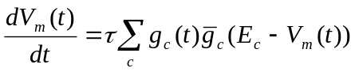 (1)
with 4 channels (c) corresponding to: e excitatory input; l leak current; i inhibitory input.
OPTIONAL: and h for a hysteresis channel that reflects the action of a switchable persistent excitatory input --- this h channel is used for the intracellular maintenance mechanism described below.
Following electrophysiological convention, the overall conductance is decomposed into a time-varying component g_{c}(t) computed as a function of the dynamic state of the network, and a constant 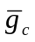that controls the relative influence of the different conductances. The equilibrium potential can be written in a simplified form by setting the excitatory driving potential (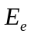) to 1 and the leak and inhibitory driving potenials (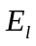 and 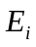) to 0:
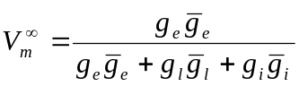 (2)
which shows that the neuron is computing a balance between excitation and the opposing forces of leak and inhibition. This equilibrium form of the equation can be understood in terms of a Bayesian decision making framework (O’Reilly & Munakata, 2000).
The excitatory net input/conductance g_{e}(t) or η_{j} is computed as the proportion of open excitatory channels as a function of sending activations times the weight values:
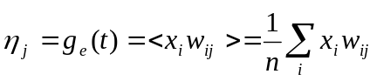 (3)
The inhibitory conductance is computed via the kWTA function described in the next section, and leak is a constant.
Activation communicated to other cells (y_{j}) is a thresholded (Θ) sigmoidal function of the membrane potential with gain parameter χ:
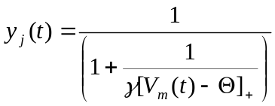 (4)
where [x]₊ is a threshold function that returns 0 if x<0 and x if x>0. Note that if it returns 0, we assume y_{j}(t) = 0, to avoid dividing by 0. As it is, this function has a very sharp threshold, which interferes with graded learning mechanisms (e.g., gradient descent). To produce a less discontinuous deterministic function with a softer threshold, the function is convolved with a Gaussian noise kernel (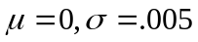), which reflects the intrinsic processing noise of biological neurons:
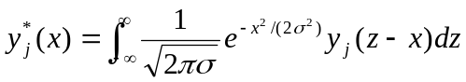 (5)
where x represents the [V_{m}(t) - Θ]₊ value, and y*_{j}(x) is the noise-convolved activation for that value. In the simulation, this function is implemented using a numerical lookup table.

k-Winners-Take-All Inhibition
Leabra uses a kWTA function to achieve inhibitory competition among units within a layer (area). The kWTA function computes a uniform level of inhibitory current for all units in the layer, such that the k+1th most excited unit within a layer is below its firing threshold, while the kth is above threshold. Activation dynamics similar to those produced by the kWTA function have been shown to result from simulated inhibitory interneurons that project both feedforward and feedback inhibition (O’Reilly & Munakata, 2000). Thus, although the kWTA function is somewhat biologically implausible in its implementation (e.g., requiring global information about activation states and using sorting mechanisms), it provides a computationally effective approximation to biologically plausible inhibitory dynamics.
KWTA is computed via a uniform level of inhibitory current for all units in the layer as follows:
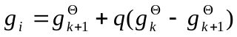 (5)
where 0<q<1 is a parameter for setting the inhibition between the upper bound of g^{Θ}_{k} and the lower bound of g^{Θ}_{k+1}. These boundary inhibition values are computed as a function of the level of inhibition necessary to keep a unit right at threshold:
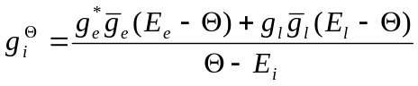 (6)
where 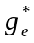 is the excitatory net input without the bias weight contribution --- this allows the bias weights to override the kWTA constraint.
OPTIONAL: In the basic version of the kWTA function, which is relatively rigid about the kWTA constraint, and are set to the threshold inhibition value for the kth and k+1th most excited units, respectively. Thus, the inhibition is placed exactly to allow k units to be above threshold, and the remainder below threshold. For this version, the q parameter is almost always .25, allowing the kth unit to be sufficiently above the inhibitory threshold.
OPTIONAL: In the average-based kWTA version, 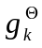 is the average value for the top k most excited units, and is the average of for the remaining n-k units. This version allows for more flexibility in the actual number of units active depending on the nature of the activation distribution in the layer and the value of the q parameter (which is typically between .5 and .7 depending on the level of sparseness in the layer, with a standard default value of .6).

Hebbian and Error-Driven Learning
For learning, Leabra uses a combination of error-driven and Hebbian learning. The error-driven component is the symmetric midpoint version of the GeneRec algorithm \cite{OReilly96}, which is functionally equivalent to the deterministic Boltzmann machine and contrastive Hebbian learning (CHL). The network settles in two phases, an expectation (minus) phase where the network's actual output is produced, and an outcome (plus) phase where the target output is experienced, and then computes a simple difference of a pre and postsynaptic activation product across these two phases. For Hebbian learning, Leabra uses essentially the same learning rule used in competitive learning or mixtures-of-Gaussians which can be seen as a variant of the Oja normalization. The error-driven and Hebbian learning components are combined additively at each connection to produce a net weight change.
The equation for the Hebbian weight change is:
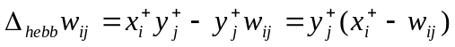 (8)
and for error-driven learning using CHL:
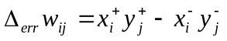 (9)
which is subject to a soft-weight bounding to keep within the 0-1 range:
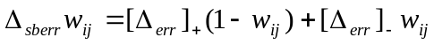 (10)
The two terms are then combined additively with a normalized mixing constant 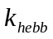:
(11)

OPTIONAL (PURE HEBBIAN):

Hebbian Learning
The simplest form of Hebbian learning adjusts the weights in proportion to the product of the sending (x_{i}) and receiving (y_{j}) unit activations: 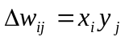. The weight vector is dominated by the principal eigenvector of the pairwise correlation matrix of the input, but it also grows without bound. Leabra uses essentially the same learning rule used in competitive learning or mixtures-of-Gaussians (Rumelhart & Zipser, 1986; Nowlan, 1990; Grossberg, 1976), which can be seen as a variant of the Oja normalization (Oja, 1982):
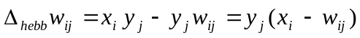 (10)
Rumelhart and Zipser (1986) and O’Reilly and Munakata (2000) showed that, when activations are interpreted as probabilities, this equation converges on the conditional probability that the sender is active given that the receiver is active.
To renormalize Hebbian learning for sparse input activations, equation 10 can be re-written as follows:
(11)
Where an m value of 1 gives equation 10, while a larger value can ensure that the weight value between uncorrelated but sparsely active units is around .5. Specifically, we set 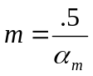 and 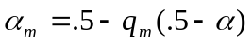, where is the sending layer’s expected activation level, and q_{m} (called savg_cor in the simulator) is the extent to which this sending layer’s average activation is fully corrected for (q_{m} = 1 gives full correction, and q_{m} = 0 yields no correction).

OPTIONAL:

Weight Contrast Enhancement
One limitation of the Hebbian learning algorithm is that the weights linearly reflect the strength of the conditional probability. This linearity can limit the network’s ability to focus on only the strongest correlations, while ignoring weaker ones. To remedy this limitation, we introduce a contrast enhancement function that magnifies the stronger weights and shrinks the smaller ones in a parametric, continuous fashion. This contrast enhancement is achieved by passing the linear weight values computed by the learning rule through a sigmoidal nonlinearity of the following form:
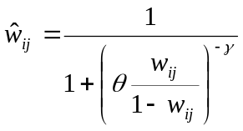 (12)
Where 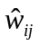 is the contrast-enhanced weight value, and the sigmoidal function is parameterized by an offset and a gain (standard defaults of 1.25 and 6, respectively, used here).

OPTIONAL:

Temporal Differences and Adaptive Critic Gating Mechanisms
To implement the temporal-differences (TD) algorithm in Leabra, the adaptive critic (AC) unit in the VTA layer has plus-minus phase states that correspond to the expected reward at the previous time step (minus) and the current time step (plus). The difference between these two states is the TD error , which is essentially equivalent to the more standard kinds of error signals computed by the error-driven learning component of Leabra, except that it represents an error of prediction over time, instead of an instantaneous error in the network output.
The AC–PFC relationship is formalized in the model with the following equations for the gating (multiplicative scaling) terms (the weight scaling of the PFC inputs) and (the weight-scaling of the PFC self-maintenance connections):
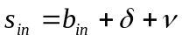 (12)
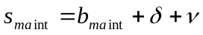 (13)
where is the change in AC activation (TD error), and is a Gaussian random noise value that allows for random trial-and-error exploration (, ). The base-level parameters and determine the basic level of each weight-scaling (gain) parameter, and are set to 0 and 1, respectively. Both of the weight-scaling terms are bounded between 0 and 1. These differences in input and maintenance connections could result from different dopamine receptor affinities, and have the effect that the inputs tend to weakly impact the PFC units except during a positive , while the maintenance connections are relatively strong except during a negative .

OPTIONAL:

Intracellular Ion Currents for PFC Maintenance
The gating function for switching on maintenance was implemented as follows: if any unit in the PFC Gating layer has activation that exceeds the maintenance threshold, the corresponding unit in the PFC Maintenance layer has its intracellular excitatory current (g_{h}) set to the value of the sending unit's (in PFC_Gate) activation, times the amount of excitatory input being received from the sensory input layer:
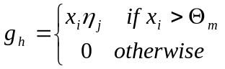 (7)
where x_{i} is the sending activation, η_{j} is the net input from the sensory input, and Θ_{m} is the maintenance threshold. If the g_{h} conductance is non-zero, it contributes a positive excitatory influence on the unit's membrane potential.

