Introduction
Bridging the gap between biology and cognition
eCortex and the Computational Cognitive Neuroscience Lab at CU Boulder
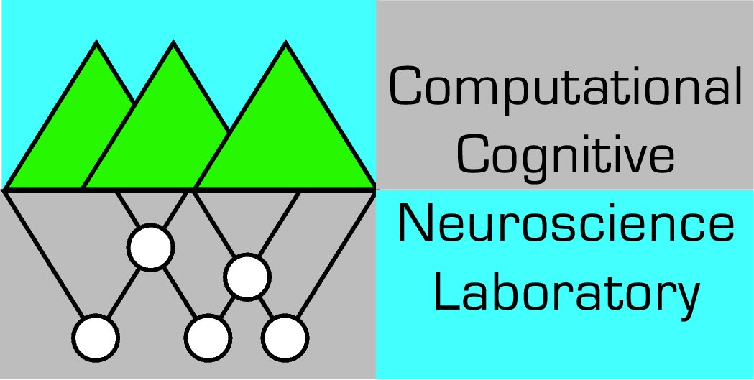
We founded eCortex, Inc. in 2006 to commercialize the scientific research conducted in the Computational Cognitive Neuroscience (CCN) laboratory at the University of Colorado in Boulder, headed by Dr. O’Reilly. The company and the lab collaborate on much of their work, but each plays a somewhat different role in the overall research program.
For over 15 years, we have been asking two fundamental questions: “how does the brain think?” and “how can I capture that process in a computer program?” The brain is made of neurons, and at a high level our computer programs are straightforward implementations of standard “integrate and fire” equations that describe how neurons integrate information from, and send the results of the computation to, many thousands of other neurons.
What distinguishes our approach from others like it are the special equations (called Leabra – local, error-driven & associative, biologically-realistic algorithm – suggestive of a balance of different learning forces, as in the Libra scale) that we use for getting our simulated neurons to learn in response to experience, as well as the kinds of biological and cognitive data we use to evaluate how our computer models are functioning. We configure the neurons in our models so that they capture the essential network circuitry and dynamic neural properties that are empirically observed in different brain areas, and then test the extent to which the models actually reproduce the kinds of learning and behavior that we know to occur in these brain areas.
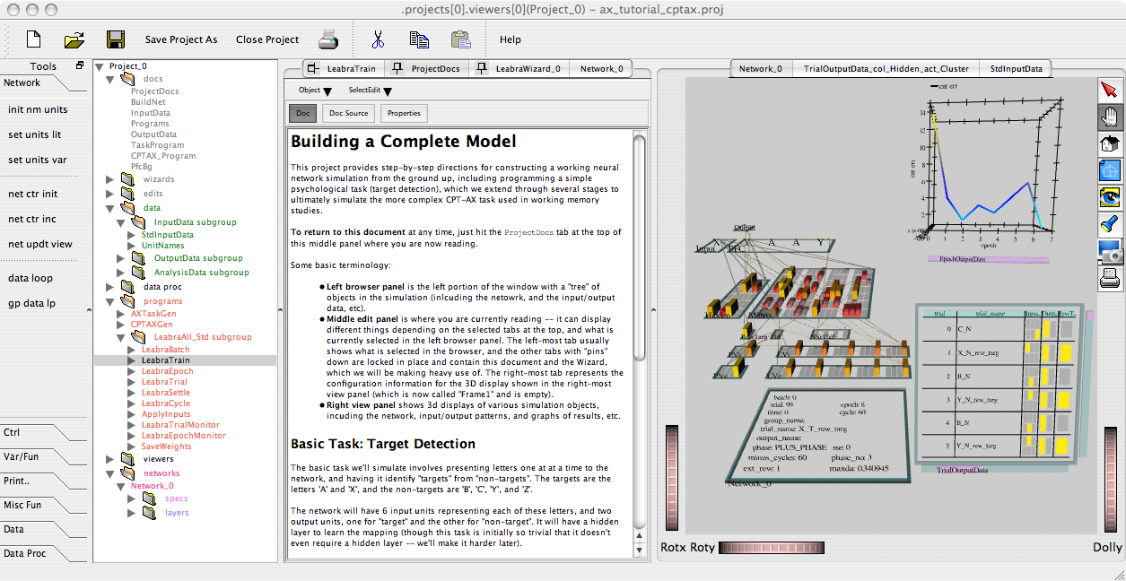
Figure 1: Screenshot of the emergent neural network simulation system, showing left-panel tree-browser of objects (network, control programs, documents, etc), middle editing panel, and right 3D visualization panel.
We build these models using a software program called Emergent (http://grey.colorado.edu/emergent -- see Figure 1), which was developed in the CCN lab. Emergent is a comprehensive simulation environment for neural models, providing a graphical development environment, a highly flexible training and simulation engine, and powerful graphing and output capabilities. Emergent is available under the GPL open source license, and eCortex is its exclusive commercial licensee.
A historical example illustrates the power of our approach. It is now widely agreed that the hippocampus (a relatively old brain structure, in evolutionary terms, which is located inside the temporal lobes of the mammalian brain) is essential for forming much of what we typically think of as “memories” – the cataloging of daily events, facts, etc. In some of our earliest work with neural models, we showed that certain biological features of the hippocampus are critical for its ability to achieve this remarkable feat, and that these features are fundamentally in conflict with features characteristic of the cerebral cortex, where much of cognitive processing takes place (e.g., perception and language). Thus, we were able to clearly understand in explicit computational terms why the brain needs to have a specialized structure (the hippocampus) for “episodic” memories, in contrast to the relatively (but not entirely) homogeneous configuration of the cortex. In contrast to the hyper-specific mnemonic abilities of the hippocampus, the cortex excels at extracting generalities from among all the specific facts and events of our lives, and these “semantic” memories are essential for allowing us to behave sensibly when we confront new situations, where we have to apply our common-sense general world-knowledge.

The Common-sense Problem
More recently, we have been focusing on this common-sense ability, which many have argued is the most important differentiator between human and artificial intelligence. In addition to integrating over many particular experiences, human common sense is built upon a foundation of sensory and motor primitives that we learn early in childhood development. In essence, all abstract forms of cognition are “anchored” in concrete sensory-motor neural representations, and the particular “natural logic” that we learn so well in its concrete manifestations (i.e., an intuitive understanding of space, time, and everyday physics) can be leveraged when we launch off into new realms of understanding. In other words, all our knowledge and cognition is based on an analogy to something else, except that the buck stops at the eyeballs and the muscles.
Our approach to this problem is to apply the powerful Leabra learning mechanisms to fundamental sensory-motor tasks, such as visual object recognition, eye and head gaze control for scanning the environment, and manually reaching and interacting with objects in the world. To facilitate rapid development of this type of model, we have built a virtual simulation environment and incorporated a simulated robotic agent (Figure 2) within the Emergent software.
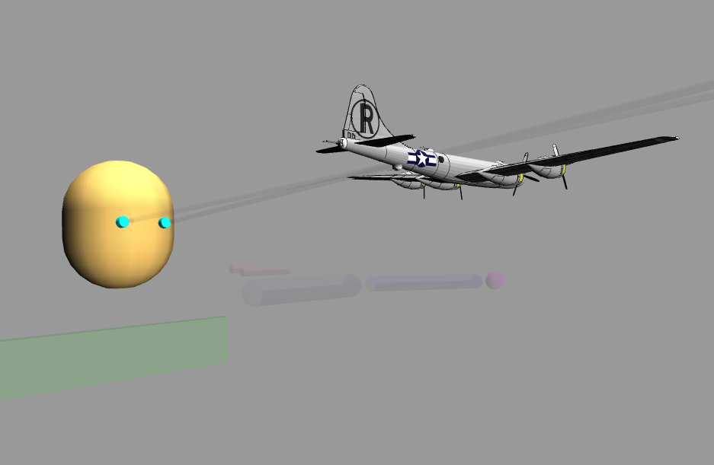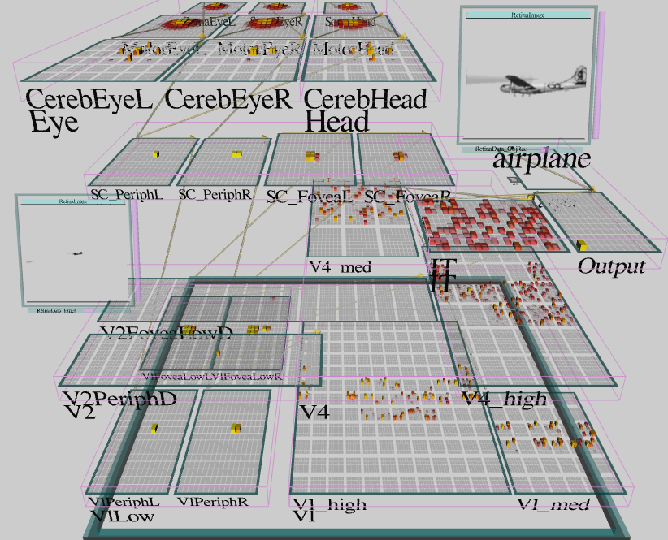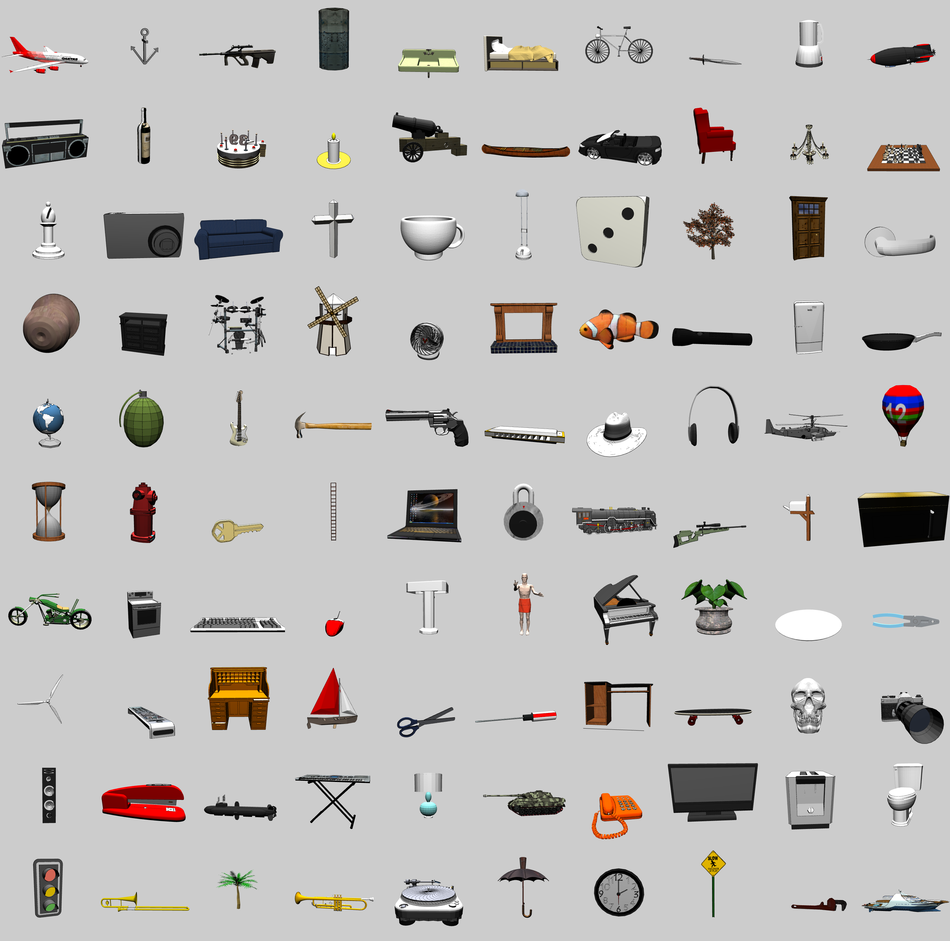
Figure 2: Our virtual agent (named “emer”) shown fixating a 3D object within its virtual environment (left), which it can then name with high levels of accuracy, using biologically-based visual and motor pathways in its simulated brain (middle), and the 100 object categories used for visual object recognition testing (right).

The virtual agent, named “emer,” learns to recognize 100 different object categories with high levels of accuracy and, crucially, can then generalize this knowledge to novel object exemplars from the same categories, with 92.8% average generalization accuracy. Unlike other object recognition models, this ability emerges out of a set of neural processing units that all use the same learning algorithm, operating over hierarchically-organized neural layers. This network learns to break down the recognition problem over these layers, resulting in what can be described as a sensible “divide and conquer” approach. This outcome, which was not pre-wired, enables the network to handle the conflicting problems of distinguishing different object categories, while also collapsing across all of the spatial and other variability of objects within a category. Furthermore, the network is fully bidirectional (as is the brain). We have demonstrated that this architectural feature enables the model to deal with noisy or partially-occluded images much more robustly than the purely feed-forward models that are prevalent in the literature.
One goal of eCortex is to commercialize this robust object recognition ability. Under a U.S. Navy SBIR (Small Business Innovation Research) project, we applied the model to the problem of distinguishing floating objects in variable seas, and found it to be highly successful at this task. Other applications are under development, and we are always interested in new challenges, so please contact us if you have a problem that could be solved with this visual object recognition capability.
The motor abilities of the emer agent depend on specialized learning mechanisms and neural architecture associated with the cerebellum, in addition to the above more general-purpose cortical learning mechanisms. Together with its object recognition abilities, emer has a solid sensory-motor foundation for subsequent cognitive learning upon which to build. Importantly, we have found that simply by virtue of having a (simulated) body and a “point of view” within a 3D (simulated) environment, emer obtains a large quantity of highly informative training signals to shape sensory-motor learning. For example, the simple act of visually fixating an object provides several inputs that can be considered training signals: the fixation operates as a self-correcting feedback loop, and with slight extension, provides feedback information for the process of reaching for objects. Fixations also can naturally inform the visual system about what is figure versus ground. All of these natural training signals could be artificially generated in one way or another, but the fact that they come “for free” through normal everyday interactions with the environment suggests that they are an important component of human learning. Furthermore, any classification of these training signals is bound to be incomplete and less “holistic” than the interaction as a whole, and will miss the integration of the signal, wherein we suspect much of common-sense arises. This is just one example of how embodiment (having a physical body in a 3D world) is essential for developing common-sense knowledge, and one step along the longer path toward imbuing an artificial system with robust human-like intelligence.

Executive Control and Abstract Cognition
Another major focus of our research is on the prefrontal cortex (PFC) and basal ganglia (BG) (Figure 3), which are brain systems that play a central role in executive control – our ability to overcome habitual or inappropriate behaviors, and “stay on task”. In effect, the PFC/BG system is crucial for enabling our sense of “free will” – without these systems, behavior and thoughts become almost entirely driven by the immediate environment, and people lose the ability to initiate new actions based on internal plans and goals. The PFC/BG system has unique neural circuitry that enables it to function somewhat like a computer logic gate, where control signals can operate on content signals in a systematic fashion. This, combined with powerful reinforcement-learning mechanisms based on the neuromodulator dopamine, enables the system to learn to operate according to internal rules and plans, and to maintain elaborate internal context that renders behavior more independent of immediate environmental influences.
Around the time that eCortex was formed, we began a collaboration with the ACT-R group at Carnegie Mellon University to develop a Synthesis of ACT-R and Leabra (SAL), which integrates the best ideas from both frameworks (Figure 4). ACT-R is a popular cognitive modeling environment and architecture that is cast at a higher level of abstraction than Leabra, and can readily perform abstract cognitive tasks like solving algebra problems or operating complex equipment like airplanes or air traffic control stations. Nevertheless, ACT-R reflects a remarkably similar conception of the overall cognitive architecture, in particular with respect to the function of the PFC/BG system and reinforcement learning, so there is great potential for synthesis and cross-fertilization from these different levels of analysis.
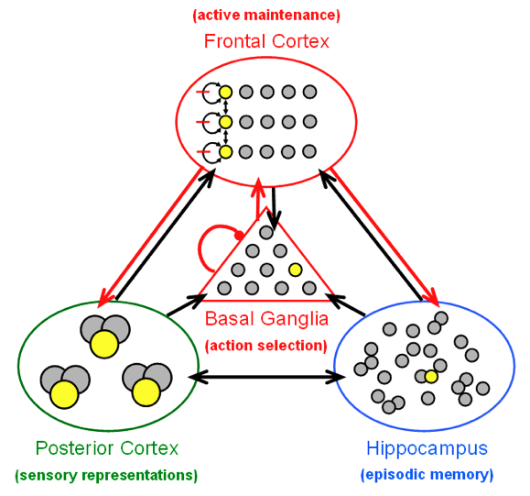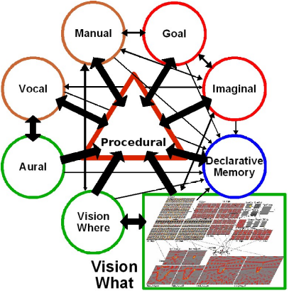
Figure 4. Synthesis of ACT-R and Leabra (SAL) – Leabra brain-scale architecture (PBWM plus hippocampus) (left) has same general structure as ACT-R system (right) – right panel also shows one version of SAL where ACT-R provides control over a Leabra-based visual model. Also in progress are more synthetic models combining best features from each architecture.
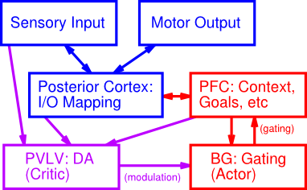

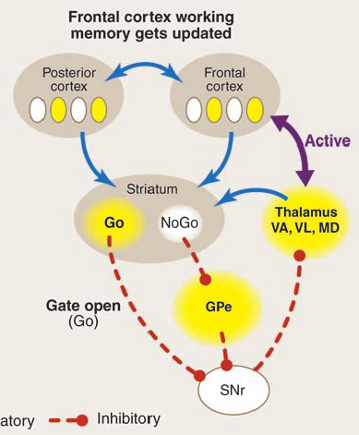

Figure 3. Prefrontal-cortex Basal ganglia Working Memory (PBWM) architecture for simulating executive control tasks, based on relevant brain areas (top), and dynamics of interaction between PFC and BG in updating working memory.
The ultimate goal of this collaboration is to develop a system that has the more robust and fine-grained learning mechanisms of Leabra, with the higher-level planning and execution abilities of ACT-R. Given the widespread adoption of ACT-R for practical applications in many arenas, from military to education, this could be an important development.
eCortex is positioned to commercialize components of this research as it transitions to the application stage. The company’s efforts center around commercialization opportunities and applications of the research performed in the CCN lab. Application-oriented work often requires a broader set of skills and more complex management and organization than can be realistically accomplished in a research laboratory. Furthermore, in the short run, applications can be a distraction to the deeper scientific research efforts. Nevertheless, lessons learned with models in application areas feed into the lab’s research projects at appropriate intervals and inform the research. The true test of a model and modeling approach is whether it works, and applications provide a powerful test environment to that end.

Contact Information

David J. Jilk,
CEO, eCortex, Inc.:
djilk@e-cortex.com
Dr. Randall C. O’Reilly,
CTO, eCortex, Inc. and
head of CCN Lab:
randy.oreilly@colorado.edu

http://www.e-cortex.com

