Manuscript

Draft 2014-0307

Perceiving patterns from randomness:

Emergence of structures and cognitive biases in time

Yanlong Sun

Randall C. O’Reilly

Hongbin Wang

Abstract

Recent developments in psychology and neuroscience suggests that the human mind develops structured probabilistic representations about the world and performs near-optimal Bayesian inferences. However, it remains elusive how the structured probability space has originated in the first place, and how cognitive biases can arise from normative probabilistic models. Here we show that without a pre-defined hypothesis space, structured representations of the learning environment, as well as “biases”, can naturally emerge through efficient neural encodings of the sensory inputs over time. We demonstrate the idea with a biologically realistic neural network model to simulate randomness perception. Our findings reveal that rich semantics can be developed in associative learning through temporal integration, providing the building blocks for the structured hypothesis space required by Bayesian inference. We further suggest that the statistical structures in the learning environment and the competition between implicit representations are the keys to bridging the gaps from object representation to probability induction and the gaps from low-level sensory processing to high-level cognition.

[Introduction]
How can the mind extract abstract regularities from probabilistic sequences of events, when these regularities are not directly observable? For example, how can we <insert good real-world example here!, e.g., “determine that a baseball player is batting above average, when the probabilities are relatively low”>. Recent developments in psychology and neuroscience suggest that the human mind develops structured probabilistic representations about the world according to Bayesian principles . In this framework, the brain encodes probability distributions and performs probabilistic inference with a generative model, a statistical model that describes the unobserved processes or latent variables giving rise to the learner’s observations. Bayesian models have shown great potential in explaining how people can learn abstract structured knowledge. However, they face at least two major challenges. First, Bayesian computation starts with a structured hypothesis space and a prior probability distribution over hypotheses, which are high-level descriptions that may or may not be actually formulated by people . Second, normative Bayesian models can have a difficult time explaining the vast literature on human irrationality, biases and systematic errors in human memory .
Here we demonstrate that, without a pre-defined hypothesis space, structured representations of a probabilistic environment, as well as biases, can naturally emerge through efficient neural encodings of the environmental statistics over time. We used a biologically realistic neural network model to simulate randomness perception. With minimal configuration and unsupervised learning, the model was able to develop asymmetric associations between the observable and latent variables from an initially symmetric and undifferentiated representation of the learning environment. Crucially, the model showed systematic biases that have been well documented in literature on randomness perception. Our findings reveal that rich semantics can be achieved through temporal integration at the level of sensory processing, and, such a mechanism may provide building blocks for higher-level computations such as the structured hypothesis space required by Bayesian inference.

[Randomness Perception]
The study of randomness perception (or, subjective randomness) concerns with people’s intuitive judgment on whether observed events appear random or contain some statistical regularities . It is an ideal candidate for investigating the emergence of structured representations as well as biases for at least two reasons. First, randomness perception may start early without a structured hypothesis space, particularly due to the difficulty of enumerating the alternative hypotheses. Even with the simplest sensory inputs (e.g., binary sequences of heads and tails when tossing a coin), there could be a myriad of possibilities to describe the observable events of patterns, the underlying processes, and their relationships . In this respect, the study of randomness perception highlights the challenge faced by nearly all models in neuroscience—implicit assumptions have to be made that the learner knows which variables matter and which actions to perform . Second, there is robust literature on biases in randomness perception yet to be accounted for by normative probabilistic models. Probably the best known example is the representativeness bias, one of the pillar stones in the entire human heuristic and bias program . When observing a sequence of events generated by a certain process, people expect characteristics of the process to be represented not only globally in the entire sequence, but also locally in each of its parts. For instance, in considering tosses of a coin for heads (H) or tails (T), people regard a repetition pattern such as HHHH, to be less representative of a fair coin or less random than a pattern ended with an alternation HHHT. Such a “misconception of chance” has been regarded as the origin of the notorious gambler’s fallacy and the hot hand belief .
Efforts have been made to explain both randomness perception and representativeness bias with a rational basis in the form of Bayesian inferences . By this account, representativeness, the extent to which some observed evidence X is representative of a “random” process rather than a “regular” process, is defined as the log likelihood ratio,
.
The formulation of the representativeness as Bayesian inference has the advantage of using normative statistical principles to describe human intuitive senses and biases in randomness perception. However, it requires the alternative hypotheses about regularities to be explicitly specified beforehand. Critically, it requires at least one alternative hypothesis with pre-defined asymmetric associations in order to distinguish observations that are not distinguishable under the null hypothesis of randomness. For instance, 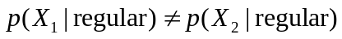 means that the same process would predict a different observation with a different probability, and, 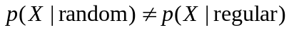 means that different processes would predict the same observation differently. In other words, the Bayesian account of randomness perception relies on a pre-defined structure in the hypothesis space. It remains to be answered how the structure has originated in the first place.

[Asymmetric Association]
To search for the origin of the structured representations of randomness and the representativeness bias, we look at the origin of asymmetric associations between the representations of the local observable events and the representation of a global latent variable that characterizes the underlying process. We consider two types of pattern events in a binary sequence produced by coin tossing, repetition (HH, TT) and alternation (HT, TH). The global latent variable in our study is the probability of alternation (P_{A}), the probability that the outcome of any single toss is different from the previous one. The reason for our selection is that these measures have been extensively documented in randomness perception literature . In particular, when the underlying process is truly random (i.e., P_{A} = ½), repetition and alternation patterns have the same probability to occur. However, a general finding is that people expect more alternations than repetitions from a random sequence. That is, repetition patterns HH and TT are underrepresented than the alternation patterns TH and HT in people’s intuitive judgment of randomness, and hence the representativeness bias.
From a probabilistic perspective, an observation can be meaningfully encoded only when it is embedded with time (or space) or in ensembles with different hypotheses about the world structures. This means that asymmetric associations can be achieved in different ways depending on how observations of local events are integrated (Figure 1A).

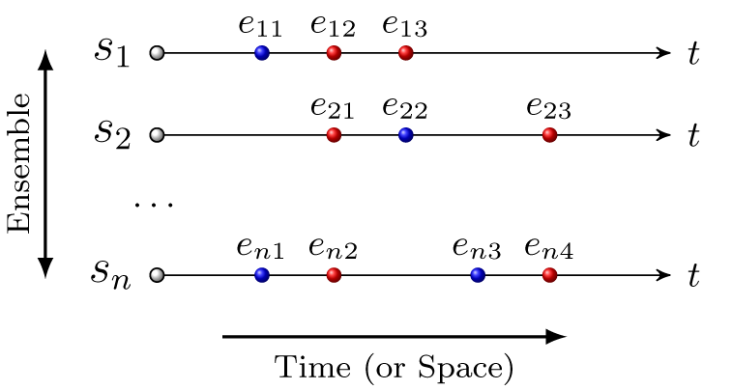
A
B
C
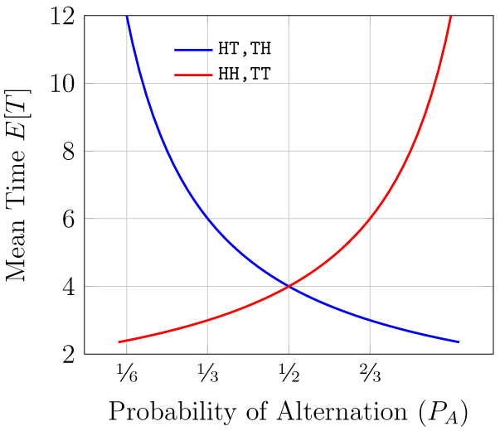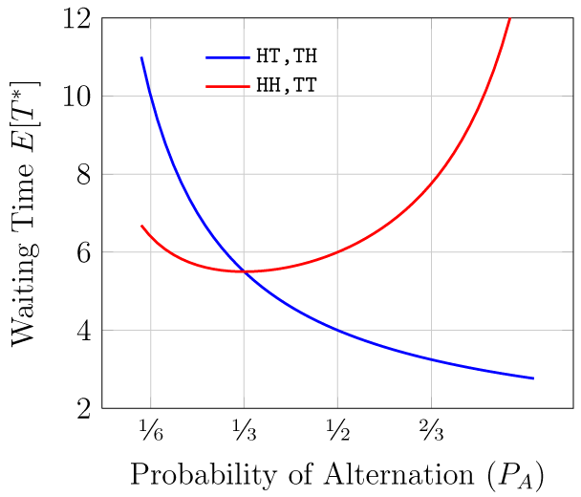
Figure 1. (A) Integration over time (or space) versus integration across ensembles. By temporal integration, observations are aggregated over time. By ensemble integration, observations are aggregated across multiple candidate world structures simultaneously. The advantage of temporal integration is that without considering alternative world structures, associative learning can take place early and rich environmental statistics, such as the mean and variance in the event arrival times, can be captured over time in a single environment. (B) and (C) The mean time and waiting time for patterns of length two in coin tossing as the functions of the probability of alteration. Note that at P_{A} = ½, mean time does not dissociate events of repetition (HH, TT) and alternation (HT, TH), but waiting time does. As long as 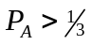, HH and TT have longer waiting times than HT and TH.

Let e denote the local observable events, s denote the global latent variable that characterizes the candidate world structure, and A denote their association. We consider two aspects of the asymmetry in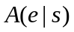. First, 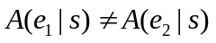 means that observations of events e₁ and e₂ are dissociated at the same level of s, which can be achieved by temporal or spatial integration without considering alternative world structures. Second,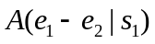 ≠ 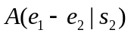 means that the same observations of e₁ and e₂ are dissociated differently at different levels of s, which is achieved by ensemble integration where multiple candidate world structures are considered simultaneously.
On the one hand, the ensemble integration is convenient if the learner already has a structured representation of the learning environment such that she knows which variables matter under which hypothesis. On the other hand, the temporal (or spatial) integration has the advantage that associative learning can start early before there is a hypothesis space. Regarding the temporal integration, statistical regularities in the learning environment can be discovered over time even when the underlying process appears to be completely random. Particularly, normative probability theories provide various measures over the temporal distribution of events: mean time measures how often an event would arrive (the mean of consecutive arrival times), and, waiting time measures when an event would first arrive in an observation starting from scratch (also containing the variance in consecutive arrival times). It has been posited that the biases in randomness perception are driven by the waiting time rather than the mean time statistics . For instance, when tossing a fair coin independently (i.e., P_{A} = ½), any sequence of the same length has the same mean time or the same frequency to occur. However, it takes on average 4 tosses to observe the first occurrence of HT or TH, but 6 tosses for the first occurrence of HH or TT (see Figure 1B and C). In other words, whereas the mean time may not dissociate between local patterns, the waiting time (or variance) does. This means that without specifying any alternative hypotheses, it is possible to achieve a dissociation of local patterns, namely, an asymmetrical association between local patterns and randomness (see Supplementary Material for details on pattern waiting time statistics).

[A Minimum Model of Pattern Dissociation]
The distinction between mean time and waiting time is important as it showcases the rich statistical structures that already exist in the learning environment. Here we show that these environmental statistics can be automatically captured by a neural network model through temporal integration, and consequently, asymmetric associations underpinning the representativeness bias naturally emerge without a pre-defined hypothesis structure.
A
B
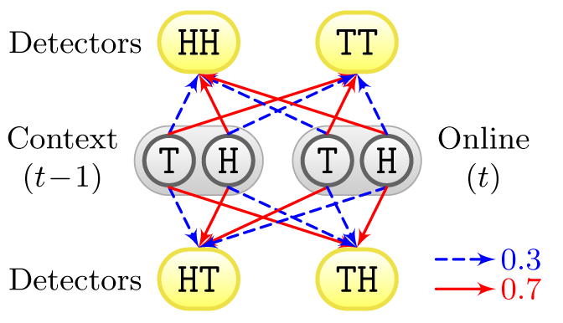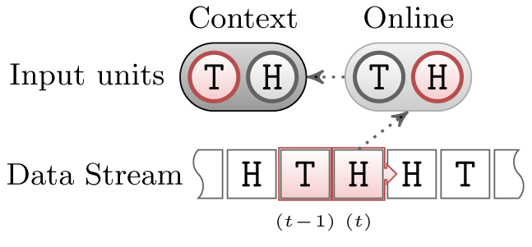
Figure 2. A minimum model of temporal pattern dissociation. (A) Model architecture. The model has two input layers (“online” and “context”, each consists of two units) and one hidden layer (four “detector” units). At the input level, the online layer represents the outcome of the current trial (i.e., H for heads and T for tails), and the context layer keeps a copy of the online layer from the previous trial. On the hidden layer, each of the detector units receives a connection from each of the input units. The initial connection weights are controlled symmetrically so that initially any input pattern of length two will produce the same amount of activation on the corresponding detector unit. In addition, each unit has a bias weight connection (not shown here), whose initial value is set to zero. (B) Example inputs. A sequence of binary digits is generated at a certain level of probability of alternation (P_{A}, unknown to the model). In any given trial, the model “sees” the digit at time (t) and “remembers” the digit at time (t – 1). Learning takes place as the model scans through the entire sequence.

The model is implemented with Emergent-Leabra, a biologically based computational modeling framework that has been used to explain the neural basis of cognition in a wide range of different domains . Figure 2 shows the model architecture and example inputs (see Supplementary Material for details). For generality, the model is minimally configured as a deep network with only eight units for two levels of coding. At the input level, a two-unit “online” layer represents the outcome of a single coin toss, and a two-unit “context” layer keeps the memory of the previous toss by making a copy of the online layer activation. At the deeper level, a hidden layer consisting of four “detector” units recodes the input signals, corresponding to all possible local sequential patterns of length two (e.g., HH, HT, HT, and TH). The overall structure of the model is similar to that of the simple recurrent network , which has been shown to be capable of capturing subtle long-distance probabilistic dependencies in syntax acquisition without explicit syntactic rules .
The model has two sets of learnable weights: the receiving weights from each input unit to each detector, and the bias weights for each unit that determines the baseline excitability of individual neurons . When these weights are initiated with random values, the population activity on the hidden layer would naturally allow various pattern detectors because of the variability in unit responses. For the purpose of a controlled experiment, however, we set the initial receiving weights symmetrically and set all initial bias weights to zero, so that each of the input patterns would produce exactly the same amount of activation on the corresponding detector (Figure 2A). That is, the model initially had a unbiased representation towards all input patterns. If there was any association between the input patterns and some latent variables, it was completely symmetrical at the beginning of the training.
The model was trained with sequences of binary digits. Each training sequence consisted of 50,000 trials, generated at a certain level of probability of alternation (P_{A}). In any given trial, the model saw the digit at time (t) and remembered the digit at time (t – 1). Learning took place as the model scanned through the entire sequence one digit a trial (Figure 2B). Crucially, learning only concerned maximizing the likelihood of reconstructing the input data and no supervision signals are provided.
We were interested in finding out how aforementioned asymmetric associations would emerge over time within or across various ensembles (i.e., within or across different levels of probability of alternation P_{A}), and critically, how the representativeness bias (e.g., underrepresentation of repetition patterns when P_{A} = ½) would arise by temporal integration without a structured hypothesis space (see Figure 1). We examined three forms of representations that were learned by the detectors: their receiving weights from the context input units, bias weights, and activations given different input patterns (see Figure 3). (No differentiating effects were found regarding the receiving weights from the online input units and the bias weights on either online or context input units, thus they are not discussed here. See Supplementary Material.)

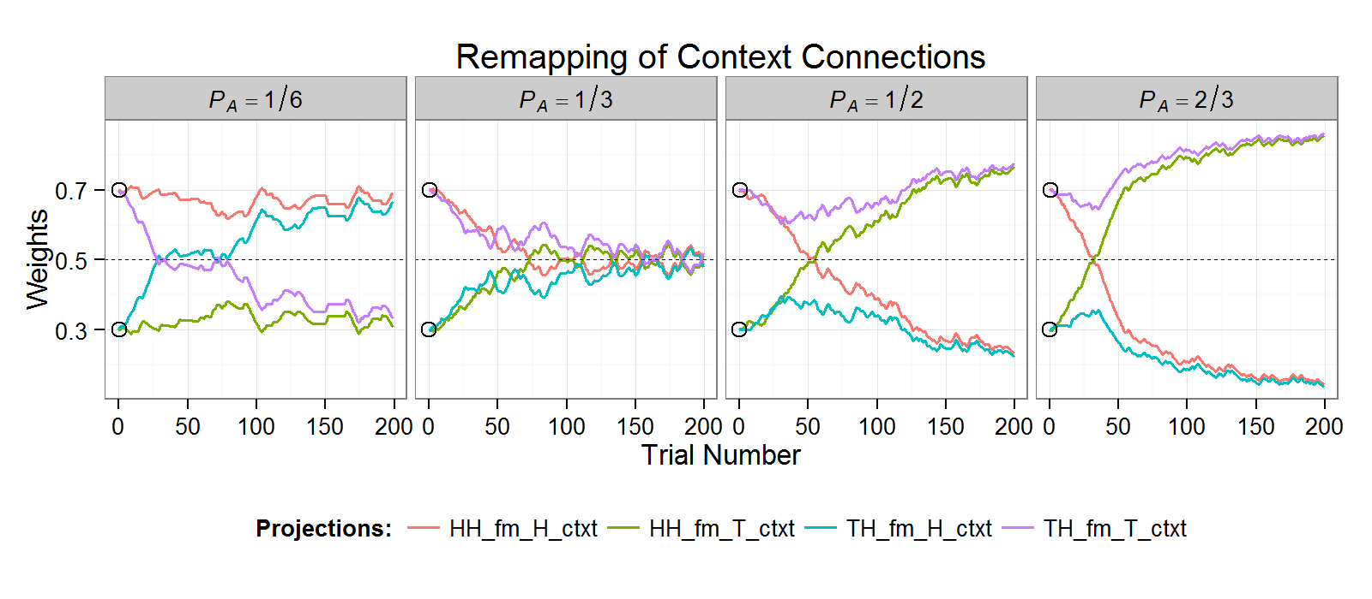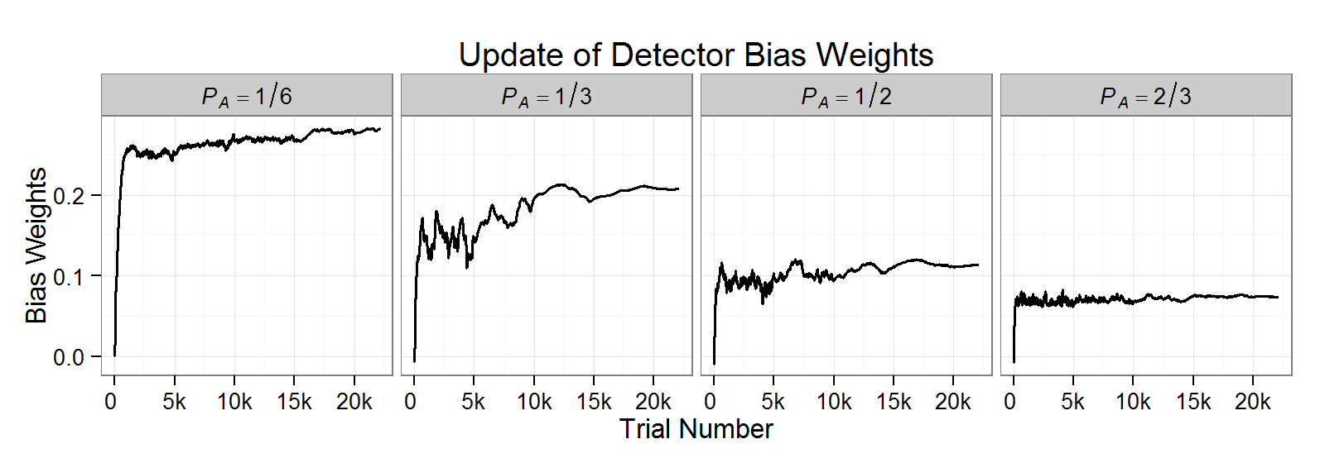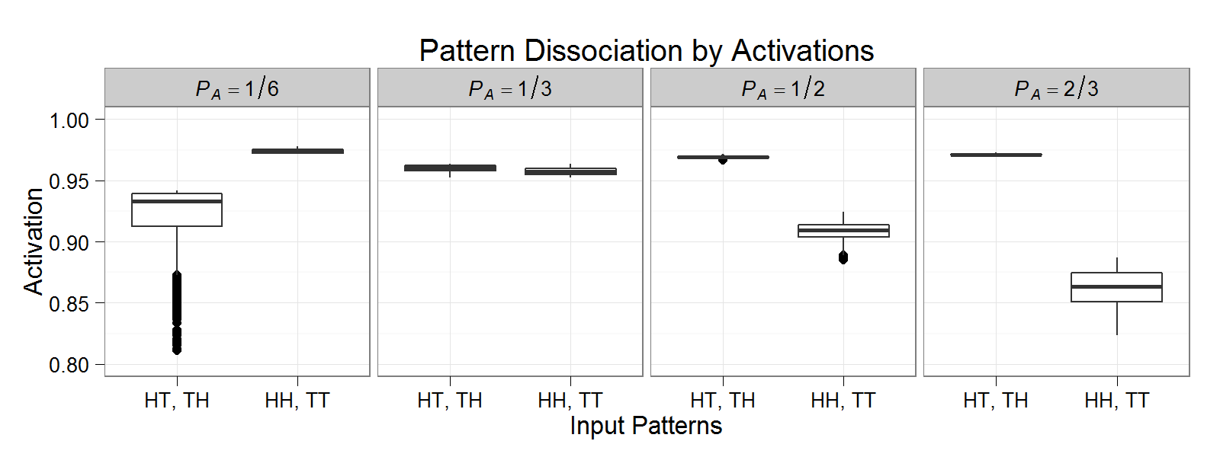
A
B
C
Figure 3. Detector behaviors at various levels of the probability of alternation P_{A}. (A) Detectors’ receiving weights from the context input units showed rapid remapping (initial weights are marked by circles). For example, at P_{A} = ½, the original HH detector became a TH detector after 50 trials. Detectors TT and HT behaved in the same way as detectors HH and TH, respectively, thus are not plotted here. (B) At different P_{A} levels, detector bias weights approached different values. Within each P_{A} level, all detectors showed similar updates in bias weights so that only averaged values are plotted here. (C) Detector activation values given different input patterns over 10,000 trials after 40,000 trials of training. Boxes represent distribution quantiles. For example, at P_{A} = ½, repetition patterns HH and TT were significantly underrepresented (with lower mean and larger variance) than alternation patterns HT and TH.

[Results]
We first notice that depending on the specific P_{A} values, the detectors’ receiving weights from the context input unites were rapidly remapped (Figure 3A). For example, the repetition detector HH’s initial sensitivity to input pattern HH was determined by receiving a stronger signal from the context input unit H (weight > 0.5) than from the context input unit T (weight < 0.5). After training, such sensitivity was maintained at about the same level when P_{A} < 1/3 (e.g., weights stayed at the same side of 0.5), attenuated when P_{A} = 1/3 (e.g., weights approaching 0.5), and, reversed its direction when P_{A} > 1/3 (e.g., the HH detector became a TH detector when the signal from the context input unit T was stronger than that from the context input unit H). In contrast, the alternation detector TH’s status was reversed when P_{A} < 1/3 (i.e., became an HH detector), attenuated when P_{A} = 1/3, and maintained or strengthened when P_{A} > 1/3. Second, all detectors acquired bias weights that were similar among different detectors but specific to the underlying P_{A} value, indicating that P_{A} was captured as a latent variable in an implicit representation (Figure 3B). Third, as the consequence of adjusted receiving and bias weights, detector activations showed a dissociation between the repetition (HH or TT) and alternation (HT or TH) input patterns to different extents across different levels of P_{A} (Figure 3C). Together, asymmetric associations emerged from the initial symmetrically structured representation of the learning environment. That is, measured by detector activations, 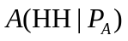≠ 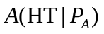 within the same P_{A} level, and, 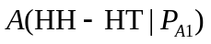≠ 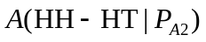 across different P_{A} levels.
Most interestingly, the acquired asymmetric associations corresponded exactly to the input pattern’s waiting time but not the mean time statistics in that a longer waiting time would result in a lower activation value (e.g., comparing Figure 1C and Figure 3C). In particular, we observed the representativeness bias when the input sequence was truly random (i.e., P_{A} = ½). That is, in spite of the initially symmetrical setup and the equal frequency of input patterns (i.e., the same mean time), the repetition detectors would eventually lose the competition against the alternation detectors. As the consequence, repetition patterns HH and TT were significantly underrepresented (with lower mean and larger variance) than alternation patterns HT and TH. Crucially, pattern dissociation occurred in unsupervised learning without any knowledge of alternative P_{A} values. This result is consistent with findings from both behavioral and neuroimaging studies. For example, it has been reported that the perceived randomness of a sequence is better predicted by an implicit encoding scheme, in which alternation patterns (HT or TH) are weighted more heavily than continuation patterns (HH or TT) . In an fMRI study, although participants were informed that the stimulus sequence was random, increased activation was observed in a number of prefrontal foci for a local pattern ending with an alternation rather than a repetition even when the pattern length was only two (e.g., HT versus HH), as if the participants had spontaneously committed the gambler’s fallacy .

[Discussion]
Overall, our analyses demonstrate that structured representations of the world and cognitive biases may have a common origin at the level of sensory processing. One important feature in our treatment is the emphasis on the competition between implicit representations over time. In our model, such a competition resides in the neurons’ variability and population activity (e.g., among various associative weights and simple pattern detectors). Thinking of population activity as encoding probability distributions has been a new perspective on neural coding and neural computation . For example, it has been shown that near-optimal probabilistic encoding may arise from sensory integration of spatial information . Here we show that accurate probabilistic encoding may also arise from sensory integration of temporal information. Specifically, neurons’ variability and population activity may evolve over time in response to the rich statistical structures in the temporal distribution of pattern events (e.g., comparing Figure 1 with Figure 3). When the environmental statistics are captured, asymmetrical associations and structured representations of the learning environment would naturally arise.
Another important feature of our analyses lies in our model’s simplicity and the lack of a predefined asymmetry or a fixed hypothesis structure. We use a model with a minimum structure and only bottom-up sensory processing. Critically, we avoid making high-level assumptions that the model already knows which variables matter and what functional form the internal representations should take. Nevertheless, the critical issue is not whether to start at the top or at the bottom, but whether to start at the beginning . In the case of randomness perception, it has been posited that by exposing to the various environmental statistics, human mind may have evolved an accurate sense of randomness but may fail to reveal it by the standard of a particular measuring device . That is, the characterization of a cognitive bias such as the representativeness may well depend on the presumed representational structures. By adjusting the high-level representational structures at the symbolic level, Bayesian models have shown some promising results in revealing the rational basis in human probabilistic reasoning . Our analyses suggest that as a consequence of the spatio-temporal integration of the environmental statistics, high-level representational structures may have an early origin at the level of sensory processing. In this regard, the present study offers a perspective to bridge the gaps between object representation and probability induction and the gaps between the low-level sensory processing and high-level cognition.

References:

