Laboratory work №8
Nonlinear Dimension Reduction

Task
Perform dimension reduction using Isomap, Locally Linear Embedding, Multi-dimensional Scaling (MDS), t-distributed Stochastic Neighbor Embedding (t-SNE) onto 2D and 3D space.
Analyze results. Find, which methods gives best results for Wholesale customers data.csv dataset

The script implements four dimensionality reduction methods – Isomap, Standard Locally Linear Embedding (LLE), Multidimensional Scaling (MDS), and t-SNE each configured to project the data into a 2D space. These methods are applied with specific parameters, such as n_neighbors=10 for Isomap and LLE to define local neighborhoods, and n_init=4 for MDS to control the number of initializations for stability. The 2D embeddings are visualized using matplotlib, with each method's results displayed in a subplot grid, allowing for a comparative view of how the data is structured in reduced dimensions.
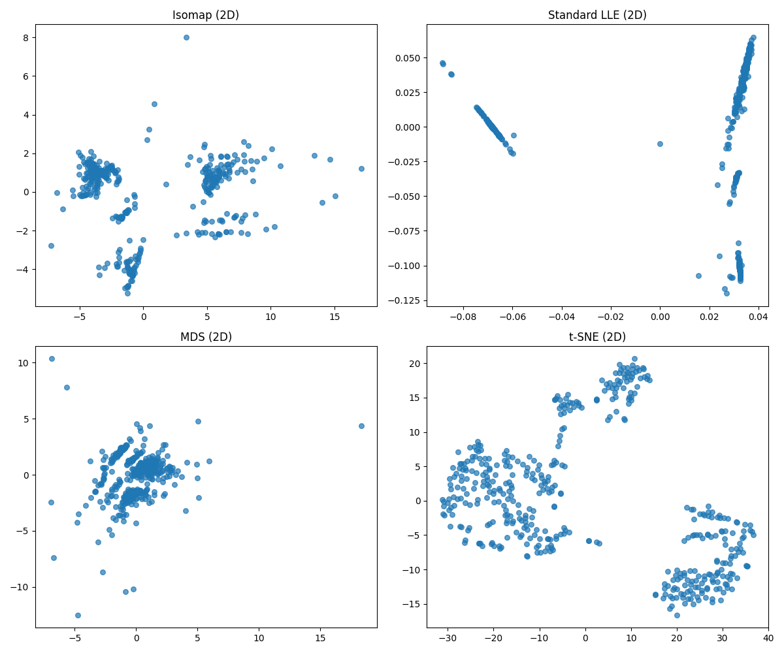
Figure 1 – 2D visualization

The 3D embeddings are presented in an identical 2×2 grid using 3D scatter plots, maintaining the same visual parameters (s=30, alpha=0.7) and labeling axes as Component 1, 2, and 3. Isomap in 3D reveals a smooth, folded manifold with clear intrinsic curvature, suggesting the data lies on a low-dimensional nonlinear surface. MDS maintains balanced global spread, LLE forms dense local chains, and t-SNE produces well-separated, spherical clusters — enhancing visibility of potential customer segments.
In 2D, t-SNE reveals the clearest cluster separation, ideal for identifying distinct customer types based on spending patterns. Isomap and MDS preserve global structure but mix groups. In 3D, t-SNE maintains excellent cluster clarity with improved spatial separation, while Isomap uncovers the underlying smooth manifold — indicating the data’s intrinsic geometry is better captured in higher dimensions. LLE struggles with global coherence in both cases. Overall, t-SNE in 3D provides the best results for customer segmentation, and Isomap in 3D is superior for understanding the data manifold.
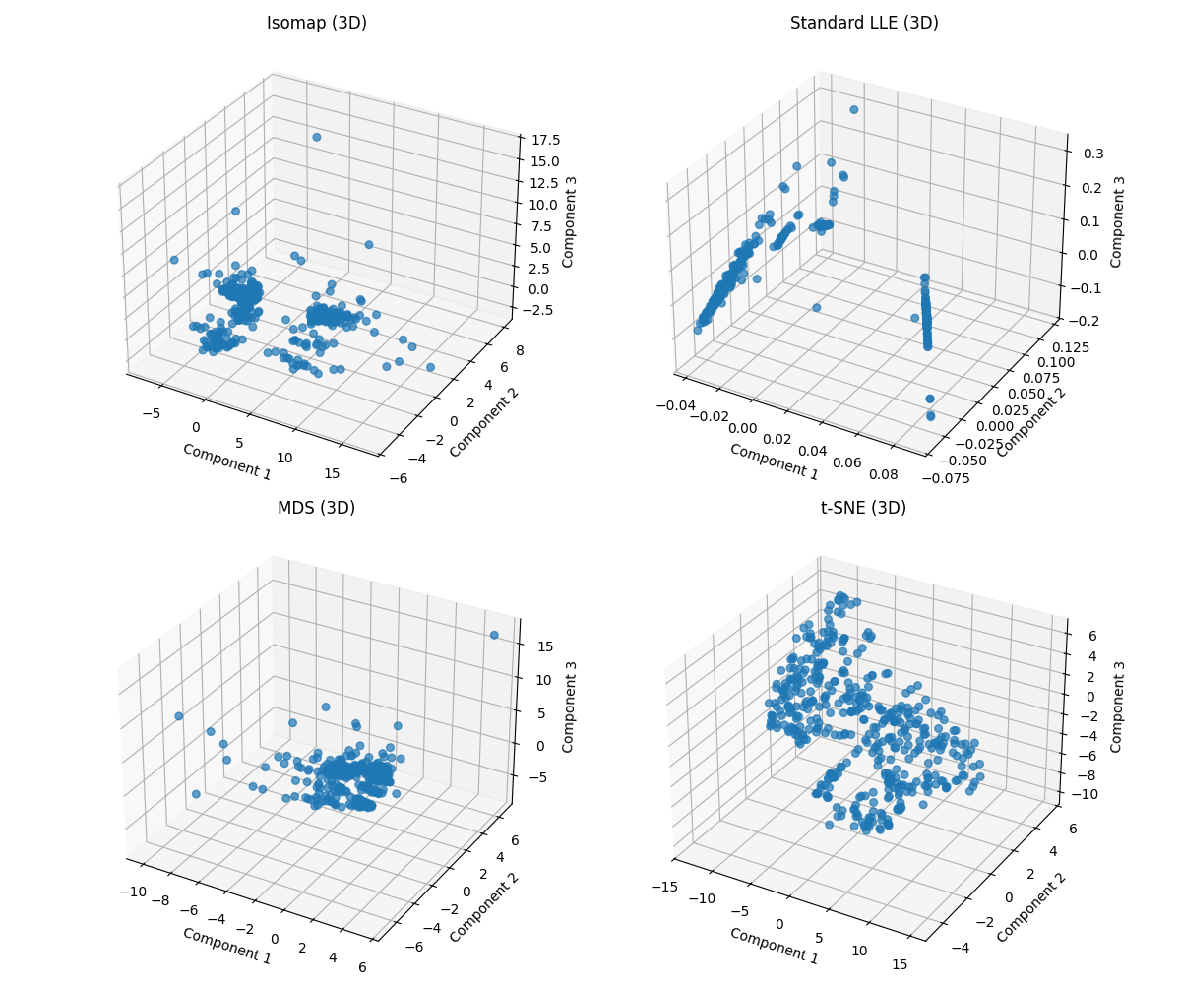
Figure 2 – 3D visualization

