Laboratory work 1
Drawing plots via Matplotlib

Tasks
Plot graphs of functions, surfaces and bar charts. On all graphs, sign the axes, display the grid, and the legend. For 2D plots, write the equation of the graphs as text on the plot.
- Plot graphs of functions:
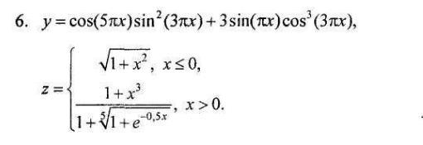
This function combines multiple trigonometric terms to illustrate oscillatory behavior. The plot highlights the amplitude modulation and periodicity over the interval [−2,2]
The piecewise definition demonstrates two distinct behaviors, providing a clear visualization of conditional mathematical expressions.
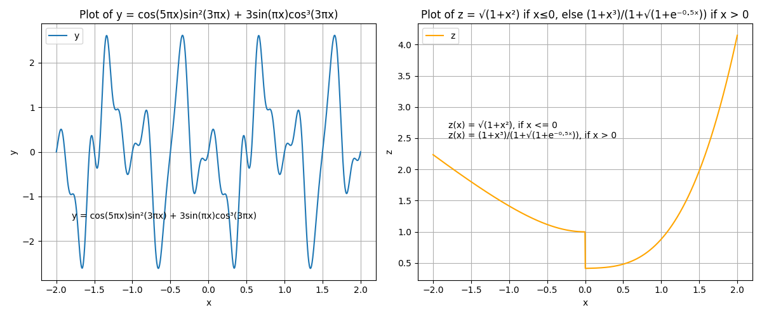
Figure 1– 2D Plots of y(x) and z(x)
- Plot surfaces
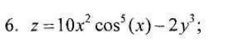
The 3D plot uses a uniform grid in the [−2,2] range for both x and y axes. The color mapping highlights the variation in z-values, showing the complex interaction between the quadratic and cubic terms combined with cosine modulation.
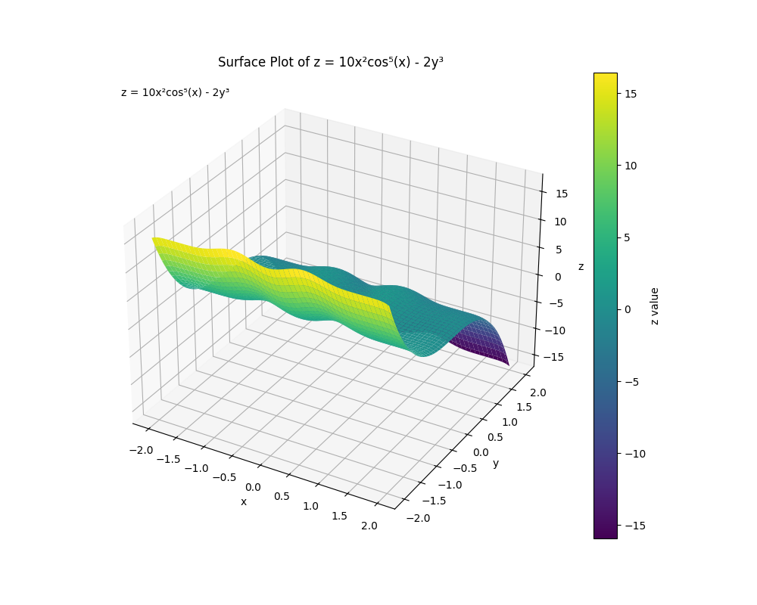
Figure 2 - Surface Plot: z = 10x²cos⁵(x) - 2y³

- Plot surface plot
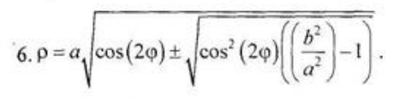
First, a 2D polar plot at the equatorial plane (θ=π/2) was generated to visualize the radial variation as a function of the azimuthal angle ϕ∈[0,2π]. This plot reveals the symmetric pattern of ρ around the center, clearly showing the peaks and valleys caused by the cosine term.

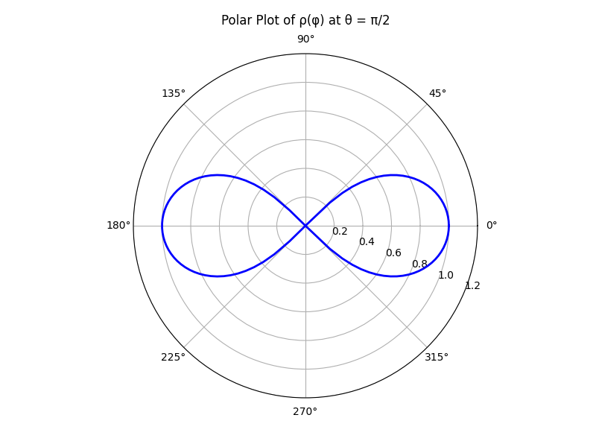
Figure 3 – Polar axis plot (ρ function)

Next, the corresponding 3D surface plot was created by converting polar-like coordinates (ρ,ϕ,θ) into Cartesian coordinates (X,Y,Z). The resulting surface illustrates the complete three-dimensional shape of the function, demonstrating symmetry along both angular directions and providing insight into its complex geometry.
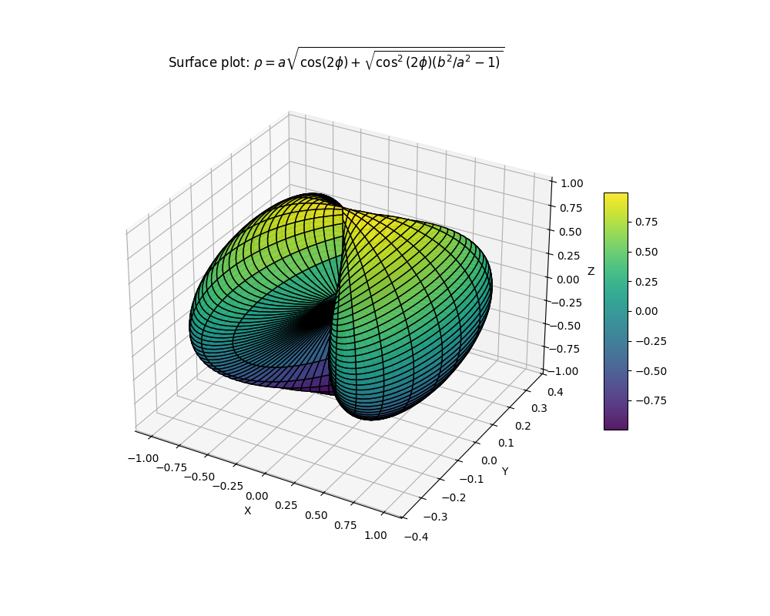
Figure 4 - 3D Surface Plots (ρ function)

- Build surfaces of the 2nd order. a, b, c are constants
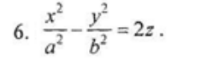
This elliptic paraboloid surface demonstrates the geometric interpretation of quadratic forms. Different semi-major (a) and semi-minor (b) axes allow observing the stretching of the surface along different directions.
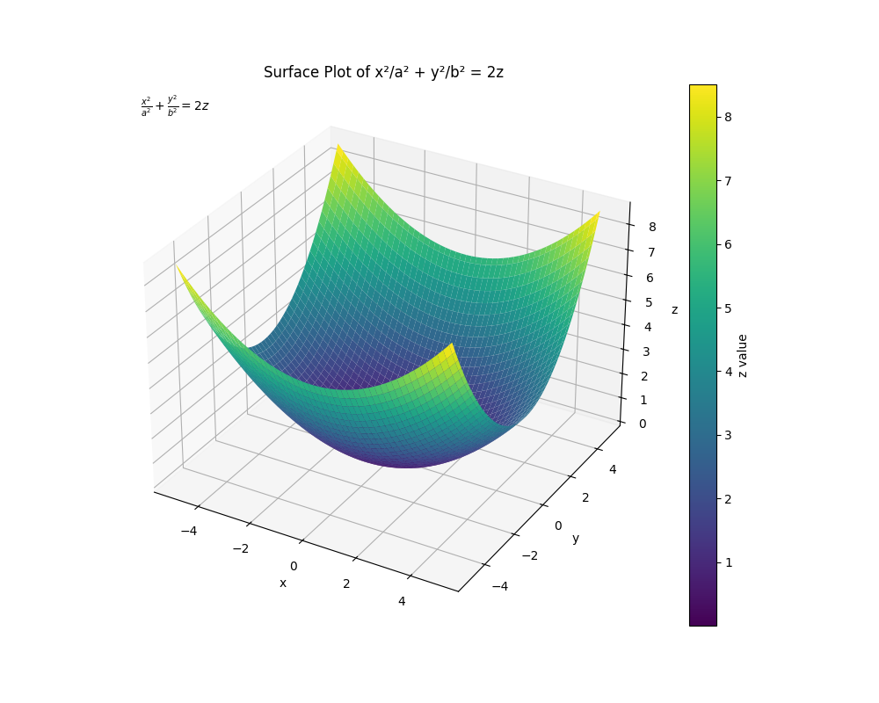
Figure 5 - Surface of 2nd Order (Elliptic Paraboloid)

- Based on the data from the tables, build 2d and 3d bar charts 1. Population, million people.
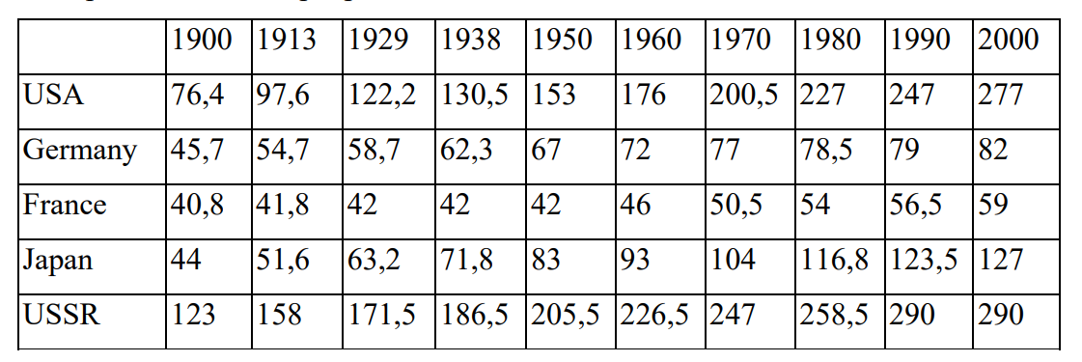
The final part visualizes historical population data for five countries (USA, Germany, France, Japan, USSR) over ten years (1900–2000):
2D Bar Chart: Shows population trends per country across time, with grouped bars for comparison.
3D Bar Chart: Adds depth to the data presentation, allowing comparison of populations by country and year simultaneously. Color and height represent population magnitude, providing a clear visual summary of demographic evolution.

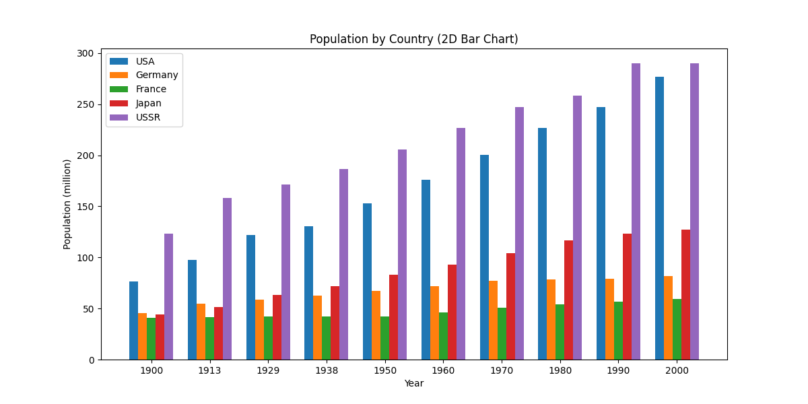
Figure 6 - 2D Bar Charts of Population by Country
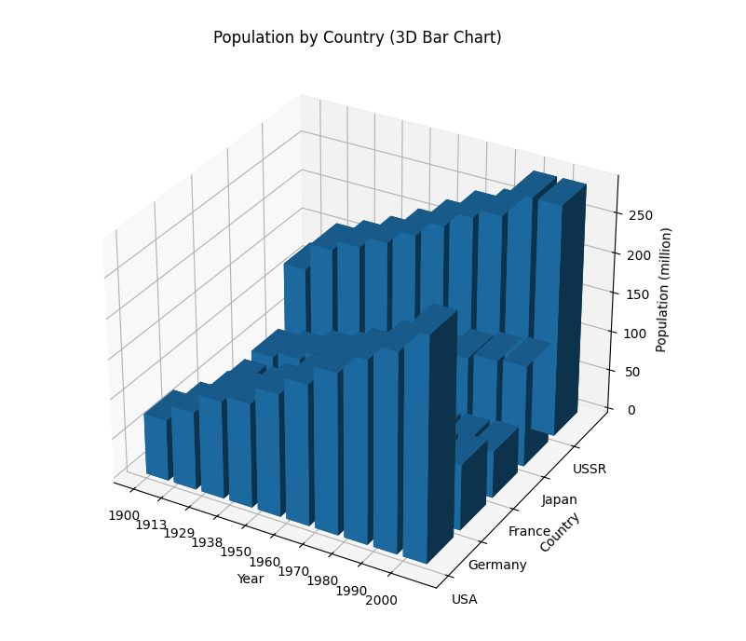
Figure 7 - 3D Bar Charts of Population by Country

