Laboratory work 2
Drawing tensor fields via Matplotlib

Task
Build according to your number in group list:
1. Visualize the scalar field. Find its gradient and visualize it as a flat vector field;
2. Visualize a plane vector field both with the help of vectors and current lines from the matplotlib library and with the code from the listing;
3. Construct a three-dimensional visualization of the vector field; For an additional point (optional), modernize the algorithm for constructing current lines in the case of a 3-dimensional field.
4. Construct a visualization of a tensor field using ellipsoids, cuboids, cylinders, and any superquadrant.
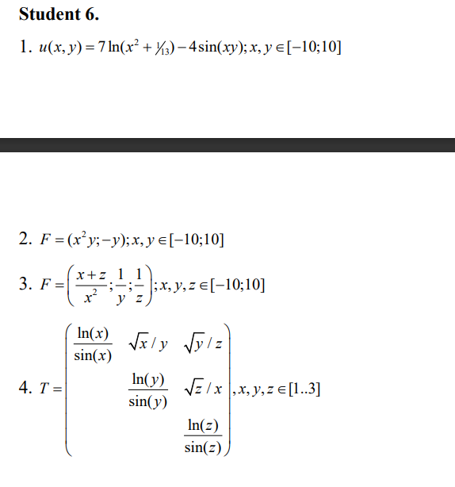

- Scalar Field Visualization and Its Gradient as a Vector Field
A scalar field . The field was visualized using a color map with contour lines for clarity. The gradient was computed numerically using finite differences and displayed as a quiver plot (white arrows), showing the direction and rate of change of the scalar field.
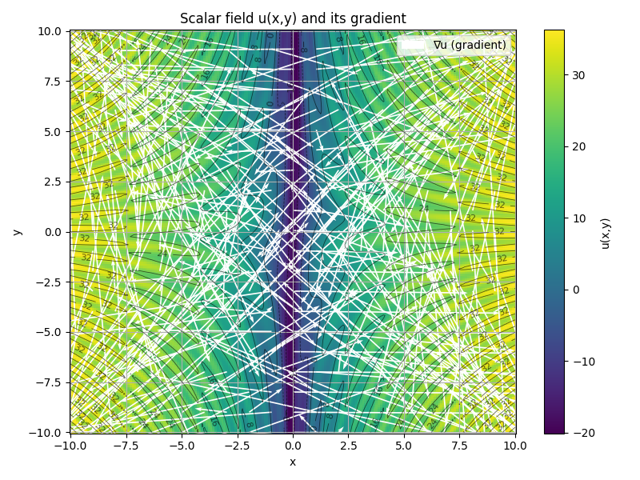
Figure 1 – Scalar Field.

- 2D Vector Field Visualization with Vectors and Streamlines
A plane vector field was constructed. It was visualized in two ways: first, by using a quiver plot that displays vectors as arrows; and second, with a streamplot that shows continuous flow lines. This combination highlights both the local vector directions and the global flow structure of the field.
Additionally, streamlines were computed using the Euler integration method, which allows tracing the trajectory of a particle in the vector field.
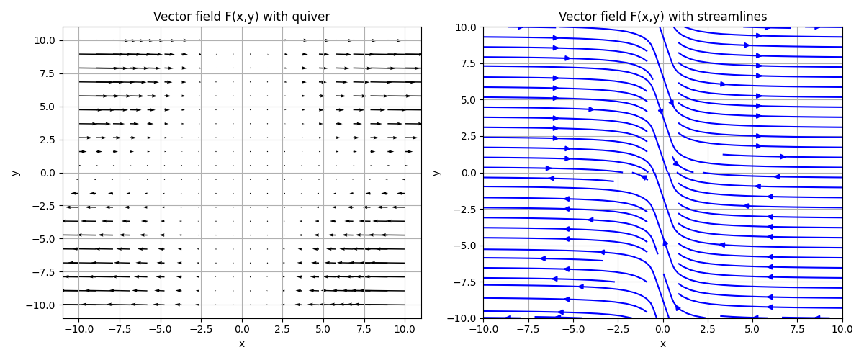
Figure 2.1 – 2D Vector Field.

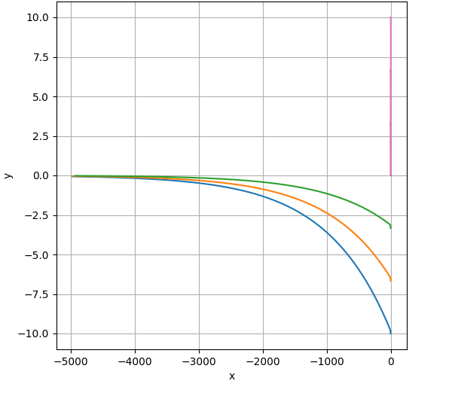
Figure 2.2 – Visualization of current lines

- 3D Vector Field Visualization and 3D Streamlines
A 3D vector field was implemented, with normalization applied for clearer visualization. The field was plotted using a 3D quiver diagram, which demonstrates how the vector directions vary in three-dimensional space. An optional improvement could include extending streamlines into 3D for more advanced flow visualization.
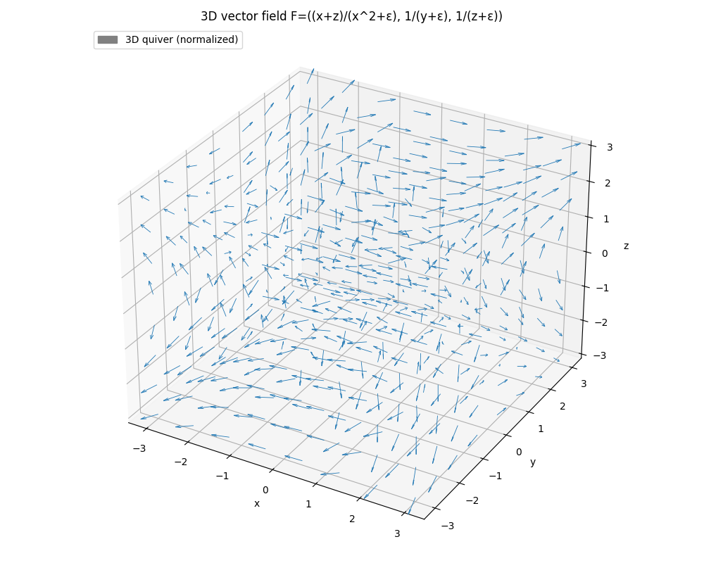
Figure 3 – 3D Vector Field
- Tensor Field Visualization with Superquadric Glyphs.
A tensor field was defined by a 3×3 matrix depending on spatial coordinates. At selected grid points, the symmetric part of the tensor was extracted, and its eigenvalues and eigenvectors were used to determine glyph shapes. The tensor field was represented using multiple geometric glyphs: ellipsoids, cuboids, cylinders, and superquadrics. Each glyph encodes tensor properties, enabling a comparative visualization of tensor magnitudes and orientations.
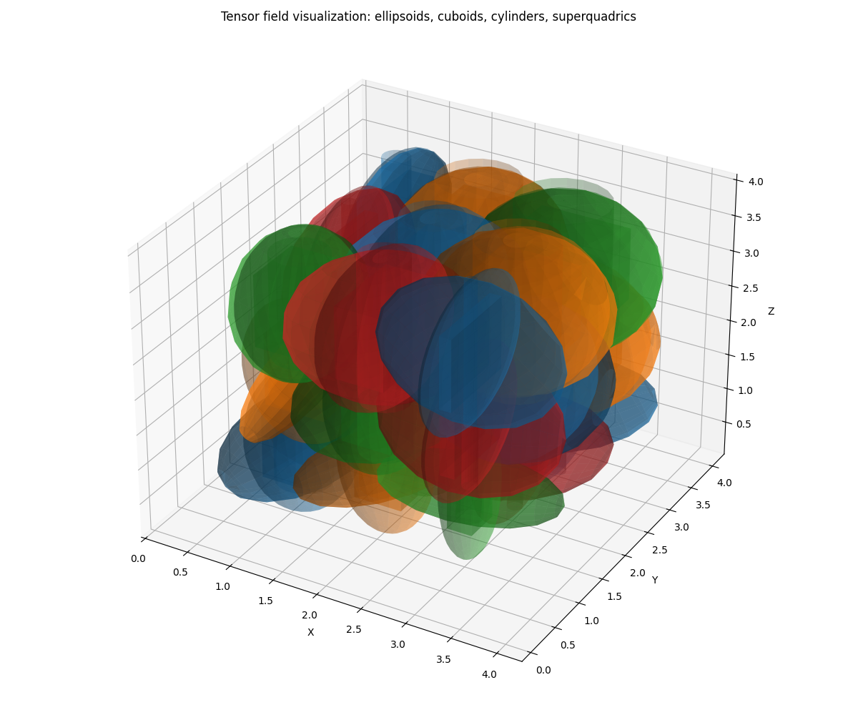
Figure 4 – Tensor Field

